Programme: Software Development
Module: ACCA4017
Title: Programs in C and Documentation

Student Name: Matthew Banwell-Clode
Student ID: 1811077

PART A

A.1. Define what a variable is and its importance in programs
A.1.1 A variable is a way of storing a value or a set of values in a in a programming language such as C [1]. It is a container in which data value can be stored within the computers memory. The stored value can be referenced by using the variables name A variable name can be whatever you decide to call it, although the C programming language does have a series of ‘Naming Rules’ that must be adhered too which can be seen below:
Naming Rule [2]
Naming Rule | Example
CANNOT contain any of the C keywords | Volatile
CANNOT contain arithmetic operators | A+b*c
CANNNOT contain punctuation characters | %$~@!
CANNOT contain spaces | Not a variable name
CANNOT start with a number | 1Variable,2Variable
CAN contain numbers elsewhere | Variable1, Variable200
CAN contain mixed case | VariabelName
CAN use an underscore | This_is_a_valid_Variable_Name

There are four basic types of data values that can be used within the C environment:
Data Type | Details | Example
Char | A single value of one character | ‘a’
Int | An integer (whole number) | 3
Float | A floating point number (to 6 decimal placeds) | 3.141592
Double | A floating-point number correct to 10 deciamal places | 3.1415926535

A.2. Explanation of the ‘FOR-LOOP’ and why it also called the ‘COUNTING-LOOP’ with examples
A.2.1: The ‘For-Loop’ can also be referred to as a ‘counting-loop’ as it is a means of repeating code within the C programming language for a set number of times, with each iteration been counted and run until the ‘count’ is equal to the pre-designated number of times at which point the repetition is exited. [3]
You would only use a ‘for-loop’ where you require a piece of code to be repeated for a set number of times and when there is no need to allow the program to exit the iteration until the set number of ‘loops’ has been met, i.e. when an exact number of repetitions is required.
Below is an example of when a ‘For-Loop’ could be used and the C code for the execution:
If you wanted to display all the numbers from 1 to 1000, rather than repeating the same section of code 1000 times a ‘FOR-LOOP’ could easily run this procedure with a minimal amount of code.

Rather than;
Printf (“1”);
Printf(“n/2”);
Printf(“/n3”;
.
.
.
Printf(“/n1000”);

After declaring a variable to use you could simple use a for loop as below:
For(i=1; i<1000;i++)
{ Printf(“/n %d”,i);
}

Both sets of code would result in the same output, but using the FOR-LOOP would save hours of programming.

A.3 Explanation of an array with examples
A.3.1: An array is a variable that has the ability to store multiple items of data. A variable (as mentioned above in answer A1) only has the ability to store a single item of data.
Although an array can store a set number of values, all must be of the same data-type. The use of an array is to drastically reduce the repetition in storing such values of the same type. As an example, if it was necessary to store 100 values of a integer value, rather than creating 100 single variables (such as Number1, Number2, Number2……..Number100) you could simply create an array of integer types (such as Number[99]) and assign values to it by accessing each individual element (such as Number[1], Number[2], Number[3]……….Number[99]). In C numbering starts at zero, as such the initial element of any array is accessed with number 0 (e.g. Number[0] would be the initial element of an array and Number[99] been the 100th element of the array).

In C programming the array for the example above would be created as follows:
int Number[99];

In this example the array is known as a single-dimension array. It is possible to create multi-dimensional arrays too. In C this would be completed as follows:
int Number[99][9];
If you can imagine an array as a list of columns and rows there would be 100 rows consisting each of 10 rows, therefore a total of 1000 separate data stores.

Part B

Exercise B.1

B.1.1 Identify the problem:
1. User enters a name
2. Store name to variable (ARRAY of type STRING)
3. User enters height
4. Store height to decimal variable (of type FLOAT)
5. User enters age
6. Store age to whole number variable (of type INTEGER)
7. Display name
8. Display height
9. Display age

B.1.2 Program Listing
#include <stdio.h> //include the standard library of features

void main() //the MAIN function of the program
{
char FirstName[20], SecondName[20]; //Declare two array variables of a CHAR type to hold the persons name
int Age;//Declare an integer variable to hold the details of the persons age (whole numbers only)
float Height;//Declare a float variable to store the persons height (allows for decimal input

printf("Please enter the first name: "); //Display the details of what input is required
scanf("%s", &FirstName); //scan the details entered and move that data into the FirstName array variable
printf("\nPlease enter the second name: "); //Display the details of what input is required
scanf("%s", &SecondName); //scan the details entered and move that data into the SecondName variable
printf("\nPlease enter the age: ");//Display the details of what input is required
scanf("%d", &Age); //scan the details entered and move that integer data into the Age variable
printf("\nPlease enter the height in meters: ");//Display the details of what input is required
scanf("%f", &Height); //Move the float type data into the Height variable
printf("\n\nThank you");

//Now display all the data entered by the user....

printf("\n\nFirst Name: %s", FirstName); //print the name string
printf("\nSecond Name: %s", SecondName); //print the surname string
printf("\nAge: %d", Age); //print the age integer
printf("\nHeight: %.2f", Height); //using the '.2' feature to display the float to only 2 decimal points

//end of the coding

} //end of the program

B.1.3 Testing

B1.3.1 Accept First Name (Array of type Char)
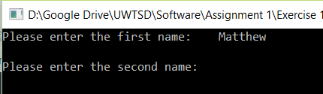
Program correctly accepted value.

B1.3.2 Accept Second Name (Array of type Char)
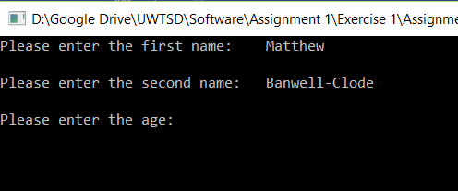
Program correctly accepted value

B1.3.3 Accept Age (Integer)
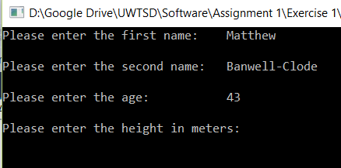
Program correctly accepted value
B1.3.4 Accept height (float)
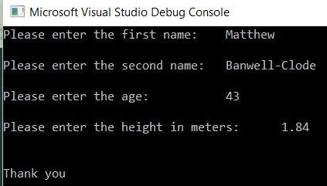
Program correctly accepted value

B1.3.5 Display Results
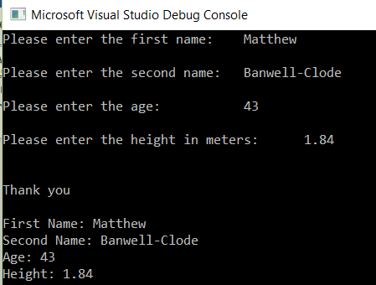
Program correctly displayed results

B1.3.6 Impossible Values
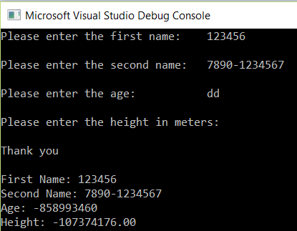
Program fails due to input type error

Exercise B2
B2.1 Identify the problem
- User enters circle radius
- Store radius to variable of type FLOAT
- User enters triangle height value
- Store triangle height to variable of type FLOAT
- User enters triangle base value
- Store triangle base to variable of type FLOAT
- Calculate circle area = (radius X radius) x pi
- Store circle area to variable of type FLOAT
- Calculate triangle area = (base X height)/2
- Store triangle area to variable of type FLOAT
- Check that triangle radius is not bigger than circle area if true display error message
- ELSE calculate area difference = circle area – triangle area
- Store difference to variable of type FLOAT
- Display Circle area
- Display triangle area
- Display area difference

B2.2 Program Listing
#include <stdio.h> //use the standard library features

void main()
{
float Pi = 3.1415;//declare a float variable to hold the value of PI
float tri_Base = 0;//float variable to hold the value of the base of the triangle
float tri_height = 0;//float variable to hold the height value of the triangle
float Circle_Rad = 0;//float variable to hold the value of the radius of the circle
float Circle_Area =0, Tri_Area=0, RemainingArea=0;//two floats to hold the area of each shape

printf("Enter the circle radius: ");
scanf("%f", &Circle_Rad);//store the circle radius
printf("\nEnter the triangle height:");
scanf("%f", &tri_height);//store the triangel height
printf("\nEnter the triangle base: ");
scanf("%f", &tri_Base);//store the triangle base

Circle_Area = (Circle_Rad*Circle_Rad)*Pi; //calculate the circle area (r2 X Pi)
Tri_Area = (tri_Base*tri_height) / 2; //calculate the triangle area (base*height /2)

if (Tri_Area > Circle_Area) //test to see if the triangle area is greater than the circle area
{
printf("\nSorry, the triangle area is greater than the circle area. The remaining area can not be calculated. Please try again......");
}
else //if the circle area is greater than the triangle area
{
RemainingArea = Circle_Area - Tri_Area; //calculate the area difference between the two shapes
printf("\n\nThe area of the circle is: %.3f", Circle_Area); //display the circle area
printf("\nThe triangle area is: %.3f", Tri_Area); //display the triangle area
printf("\nThe area within the circle would be: %.3f", RemainingArea); //display the difference

} //end of IF

} //end of program
B2.3 Testing
B2.3.1 Accept Radius Value
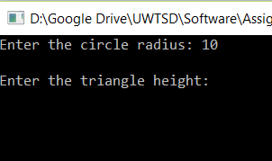
Program correctly accepted value

B2.3.2 Accept Triangle Height Value
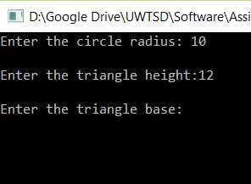
Program correctly accepted value

B2.3.3 Accept Triangle Base Value
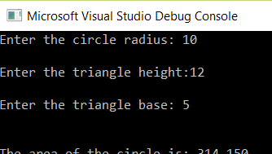
Program correctly accepted value

B2.4.4 Calculate Area Values and Display Correctly
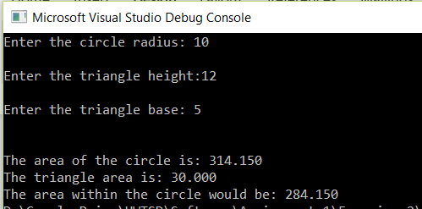
All calculations are correct and displayed correctly

B2.3.5 Display Warning when Triangle Area is Greater than Circle Area
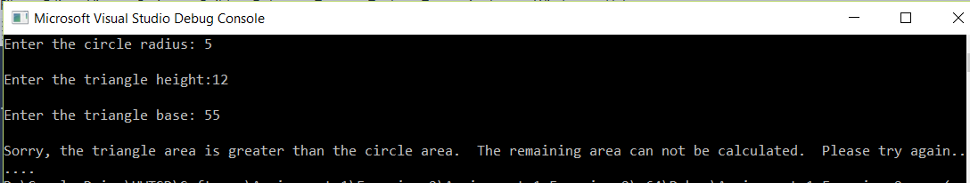
Warning displayed as expected

B2.3.6 Impossible Values
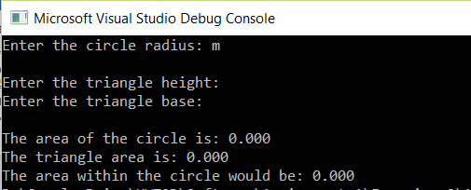
Program fails due to incorrect data type entered

Exercise B3

B3.1 Identify the problem
- Set iteration to zero
- Repeat
  - User enters product price
  - Store price to variable of array of type FLOAT
  - Calculate running total
  - Add one to iteration
- Until iteration is 5
- Calculate price including VAT
- Store VAT price to variable of type FLOAT
- Repeat
  - Print product price
  - Add one to iteration
- Until iteration is 5
- Print the net price for all products
- Print the total price including VAT

B3.2 Program Listing
#include<stdio.h> //use the standard library features

void main()
{

float ProductPrice[5]; //declare an array of 5 elements of type float
float NetPrice, VATPrice;//declare two float variables to hold the total price and the VAT inc price
int i; //declare an int to be used on the for loop

NetPrice = 0; //initialise the NET value variable
VATPrice = 0; //initialise the VAT inc variable

for (i = 0; i < 5; i++) //loop the following code for five iterations
{
printf("\nEnter the price of product %d: ", i + 1);//ask the user to enter the value
scanf("%f", &ProductPrice[i]);//store the vallue to the iteration element of the array
NetPrice = NetPrice + ProductPrice[i];//calculate the running total
} //end of loop

VATPrice = NetPrice * .2; //calculate the VAT inc price using the running total

for (i = 0; i < 5; i++) //loop the following code for five iterations
{
printf("\nProduct %d Price: %.2f", i + 1, ProductPrice[i]); //display the item num and its price
} //end of for loop

printf("\n----------------------------");
printf("\n\nNet Price : %.2f", NetPrice); //display the net price total
printf("\nTotal Price : %.2f", NetPrice + VATPrice); //display the net price total including VAT
}
B3.3 Testing
B3.3.1 Accept pricing for 5 products
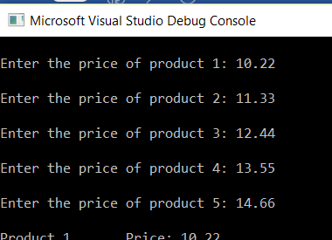
Program correctly accepted value

B3.3.2 Display pricing and calculate NET and VAT Inc. totals
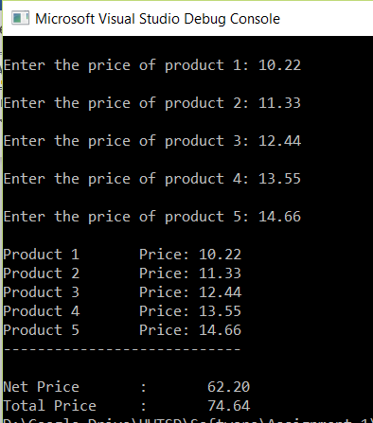
Program correctly displayed stored input, calculated the totals and then displayed as expected.

B3.3.3 Impossible Values
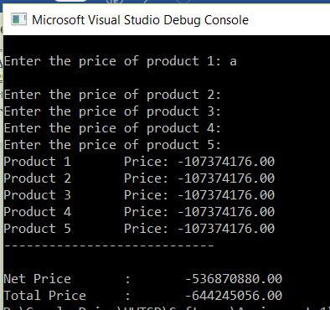
As expected the program fails due to an incorrect data type entered.

Exercise B4

B4.1 Identify the problem
- Ask user if they want to play
- Store result to variable of type CHAR
- Repeat
  - Increase game count by 1 (to type INTEGER)
  - Randomise all 3 reels
  - Store each to variable of type INTEGER
  - Display each reel value
  - If all numbers are 5
    - Add 2000 points to variable of type INTEGER
    - Display that the user has won the ‘Jackpot’
    - Display the points won
  - If two numbers are equal to 5
    - Add 100 points to variable of type INTEGER
    - Display that the user has won 100 points
  - If all the numbers are equal but not 5
    - Add 20 points to variable of type INTEGER
    - Display that the user has won 20 points
  - If there is no winning combination
    - Display that the user has won no points
    - Add ZERO to the total points to variable of type INTEGER
  - Add points won to running total of type INTEGER
  - Display running total
  - Ask if user wants to play again
  - Store to variable of type CHAR
- Until user says no to continuing

B4.2 Program Listing
#include <stdio.h> //include the standard input/output library
#include <stdlib.h> //include the standard library
#include <time.h> //include the time library (needed for randomising functions

void main()
{

int GameCount=0; //declare an integer to hold the number of plays
int low = 1; //lowest of range
int high = 5; //highest of range (Max of 5)
srand(time(NULL)); //seed randomness
int Reel1, Reel2, Reel3, i, RunningTotal = 0, Points = 0; //declare the integers
char PlayAgain; //dfeclare a char to determine continuation or end of game

printf("Do you wish to spin the wheel? y or n "); //verify that the user wants to play
scanf(" %c", &PlayAgain); //store the value

while (PlayAgain=='y') //run through the WHILE loop for as long as the user answers 'y' to continue
{
GameCount = GameCount + 1; //increase the amount of plays by 1

Reel1 = rand() % (high - low + 1) + low; //create a random number for the 1st reel
Reel2 = rand() % (high - low + 1) + low; //create a random number for the 2nd reel
Reel3 = rand() % (high - low + 1) + low; //create a random number for the 3rd reel

printf("******************\n");
printf("| %d | | %d | | %d |\n", Reel1, Reel2, Reel3); //display the reel numbers
printf("******************\n");

if (Reel1 == 5 && Reel2 == 5 && Reel3 == 5) //Test to see if all Reels are 5 (the jackpot)
{
Points = 2000; //add 200 points to the running total
printf("\n*******************************");
printf("\n******** J A C K P O T ********");
printf("\n*******************************");
printf("\n\nThats 2000 points!!");
}
else if (Reel1 == 5 && Reel2 == 5 || Reel1 == 5 && Reel3 == 5 || Reel2 == 5 && Reel3 == 5) //Test for 2 5's
{
Points = 100; //add 100 points to the game total
printf("** Two Lucky Number 5s **");
printf("\nThats 100 points");
}
else if (Reel1 == Reel2 && Reel2 == Reel3 && Reel1 !=5) //test for 3 of the same (but ignore if any numbers are 5
{
Points = 20; //add 20 points to the game total
printf("\n** Three matching numbers **");
printf("\nThats 20 points");
}

else //if none of the above criteria are met....
{
printf("Sorry - no winning combiations");
Points = 0; //set to zero to show the amount further on in program
}

RunningTotal = RunningTotal + Points; //keep a running total of the points earned by user
printf("\nYour total points are: %d", RunningTotal); //display the total points
printf("\nYou have had %d turns so far", GameCount); //display how many games the user has had

printf("\n\nDo you wish to play again? y or n: "); //ask if the user wishes to continue
scanf(" %c", &PlayAgain); //accept the users response

} //end of function

} //end of program

B4.3 Testing

B4.3.1 When user enters ‘n’ at start
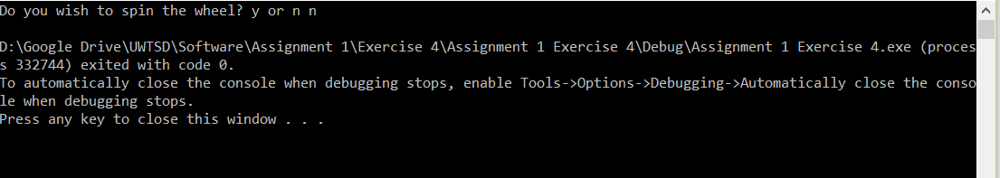
Program correctly accepted value and processed the value by ending the game

B4.3.2 When user enters ‘y’ at start
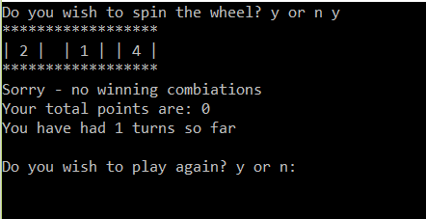
Program correctly accepted and processed the value by starting the game and ‘rolling-the-reel’

B4.3.3 When all values equal 5 (JACKPOT)
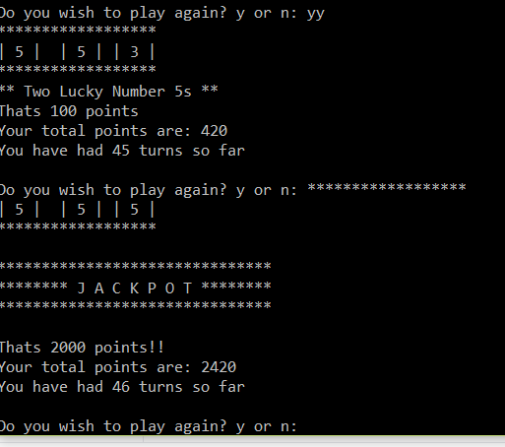
The program has acknowledged that all three ‘reels’ are of the value ‘5’ and correctly added the points to the total and displayed the event to the user.

B4.3.4 When no scoring combinations are present
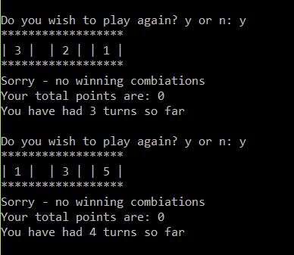
The program has correctly acknowledged that there are no winning combinations, has added no value to the winning total and the running total.

B4.3.5 When three numbers match (not 5’s though)
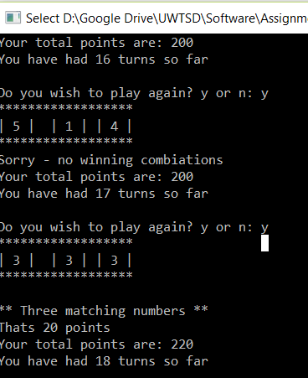
The program has acknowledged that all three ‘reels’ are the same value (but not 5) and correctly added the points to the total and displayed the event to the user.

B4.3.6 When two reels produce a ‘5’

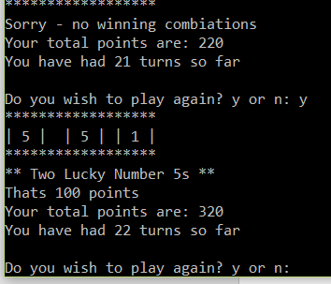
The program has acknowledged that two ‘reels’ are of the value ‘5’ and correctly added the points to the total and displayed the event to the user.

B4.3.7 As B4.3.6 but testing for two 5’s on alternate reels
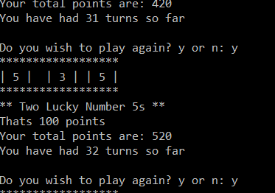
The program has acknowledged that two ‘reels’ are of the value ‘5’ and correctly added the points to the total and displayed the event to the user.

B4.3.8 Impossible values
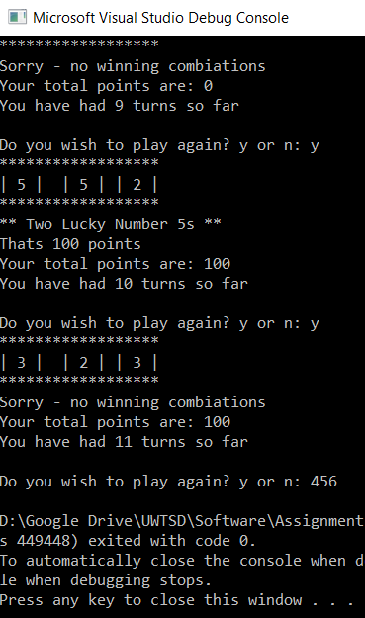
As the reply is not a ‘y’ the program finishes the game

References

[1] | S. B. A. &. S. R. Mukherjee, "Chapter 6 - Data Types," in Concepts of programming languages (Eleventh edition. Global ed.)., Swansea, Pearson, 2016, pp. 262 - 325.
[2] | M. McGrath, "Chapter 2 Storing Variable Values," in C Programming, In Easy Steps, 2014, p. 19/38.
[3] | R. Riley, "2. Handling Data," in Teach yourself C++, Hodder & Stoughton, 2005, pp. 12 - 22.

