Placement Research Report

Investigating the Impact of Shortage of Staff on the Service Quality of Hotel: A Case of the Double Tree by Hilton Bristol North

Student Name: Romeo Popescu
Student ID: 1922487

Executive Summary
To identify the underlying problems and suggest remedies, this study looks into how personnel shortages at DoubleTree by Hilton Bristol North affect the service quality. In the hotel sector, a lack of staff can result in lowered visitor satisfaction, employee burnout, and degraded service quality. To provide a thorough analysis, this research makes use of scholarly literature, particular case study observations, and reflective methodologies. The literature study emphasises the significance of efficient human resource management by highlighting the high labour intensity and turnover rates in the hospitality industry. The characteristics of service quality—reliability, responsiveness, and empathy—that are impacted by staff shortages are outlined by important models such as SERVQUAL. Staff shortages at DoubleTree by Hilton Bristol North result in longer wait times, less engagement with guests, and a general decline in service quality. High levels of stress and burnout among employees aggravate these problems and increase attrition. The detrimental effects on service quality and staff morale are demonstrated using specific instances from customer and employee testimonies. The report makes several suggestions to address these issues. Improve pay, professional growth, and work-life harmony. Implement technology solutions, cross-training, and effective staffing methods. Encourage employee appreciation initiatives, consistent feedback channels, and a positive work atmosphere. Streamline the onboarding process, provide flexible hours, and make use of temporary employment companies. Proactive personnel and operational changes are required, as shown by reflective analysis using Johns’ Model of Structured Reflection, Kolb’s Experiential Learning Cycle, and Gibbs’ Reflective Cycle. These suggestions are meant to improve service quality, lessen the negative consequences of a staff shortage, and establish a long-term working environment. DoubleTree by Hilton Bristol North must handle staff shortages through a multidimensional approach that integrates strong human resource strategies, operational efficiency, and employee engagement to maintain high service standards and guarantee guest pleasure.
Table of Contents
Executive Summary ii
Introduction 1
Background 1
Aim 1
Objectives 1
Literature Review 2
Service Quality and Customer Satisfaction 2
Impact of HR on Service Quality 2
Employee Well-being and Performance 3
COVID Impacts and Strategic Implications on Staff Shortages 3
Employment Satisfaction and Service Quality 4
Literature Gap 4
Methodology 5
Research Approach 5
Source of Data 5
Analysis Technique 5
Benefits and Limitations 6
Discussion 7
Overview 7
Location and Features 7
Functions and Amenities 8
Staffing and Operations at Double Tree 9
Financial and Staff Turnover 10
Financial Turnover 10
Staff Turnover 10
Theoretical Analysis 11
SWOT Analysis 11
Competitors Analysis 13
PEST Analysis 14
Theme Exploration 16
Key Theme 16
Critical Analysis of Staff Shortage 17
Examples and Evidence 18
Areas for Development and Improvement 19
Recommendations and Conclusions 23
Recommendations 23
Conclusion 24
Reflective Account 25
Reference 29
Appendix: Trip Advisor site of Double Tree by Hilton Bristol North 37

Introduction

Background
The hotel management industry is renowned for the quality of service provided to the guests, which influences the organisation to thrive and ensure a competitive advantage in the market. Hotels must have adequate staff to ensure quality service is delivered and maintained (Tefera, 2016). The Double Tree by Hilton Bristol North is a distinguished hotel in the UK hotel industry, marking its position with contemporary amenities, convenient location and sophisticated customer service. However, just like every other hotel in the industry, it encounters the challenge of staff shortages, which often makes it difficult to maintain its service quality and affect customer experience. Therefore, it is essential to study the relationship between staff shortage and service quality.

Aim
The paper intends to investigate how staff shortages affect hotel operations and service quality, offering findings that can be used to enhance operations and customer satisfaction. Upon completing this research, creating a considerable body of work representing autonomous research initiation, development, and production would be easier.

Objectives
- To understand the relation between service quality and staff adequacy.
- To critically appraise significant literature regarding staff shortage and how it impacts the service of hotels
- To provide recommendations to enhance service quality and mitigate the effects of personnel shortages at DoubleTree by Hilton Bristol North
This analysis will take a case study approach, concentrating on the DoubleTree by Hilton Bristol North. The paper will look at key themes such as the operational challenges caused by staff shortages, the consequences on visitor satisfaction and service performance, and potential mitigation techniques. The goal is to give practical insights and recommendations for the hotel and the larger industry through detailed analysis and critical review.

Literature Review
The global economy relies heavily on the hospitality business, which includes hotels and tourism services. In this business, service quality and client happiness are key components of success.
In particular, hotels depend more on their employees to provide great customer service experiences (Wen et al., 2020). Thus, Staff shortages are a major problem. It hurts proper service performance and results in unsatisfied visitors, ultimately creating a negative business image.

Service Quality and Customer Satisfaction
Juan Carlos Martín and Concepción Román (2017), looked at how hotels in Gran Canarias measure up in terms of service quality. Instead of just crunching numbers, the researchers investigated what people were saying online about the service quality of the hotel. They sifted through reviews and comments on popular websites. They found seven things that matter when it comes to service quality. These are like little flags that wave to tell how good a hotel is. The researchers used “fuzzy logic.” and they used some “fuzzy numbers” too. These numbers helped them to smooth out the bumps in the 5-point Likert scale As a result, the researchers were able to create an index for hotel rankings. Stakeholders can peek at this index and figure out which hotels are performing well in terms of customer service and which need more attention.
Ali et al. (2021) decided to examine customer satisfaction. They looked at how service quality affects hotels. They found that service quality is a major factor affecting the bottom line. It helps the hotels stay ahead in the industry. The key to excellent service is to understand what guests want and make sure they leave with a smile. Therefore, Service quality should not be limited to fancy sheets and fluffy pillows. It should be about keeping guests happy and satisfied.

Impact of HR on Service Quality
Dr. Osama Khassawneh and Dr. Tamara Mohammad (2018) investigated the Canadian hotel Industry. Their mission was to figure out how human resource (HR) practices affect service quality. The researchers found that the HR practices of the hotel matter a lot. HR practices are found to be key indicators of better service quality. The study was able to unearth some insights for hotel managers. They formulated a solid framework that can serve as the blueprint for connecting HR practices and service quality.

Employee Well-being and Performance
Shaniekay Codling et al. (2022) found a viable relationship between worker turnover and the business’s performance, productivity, and profitability. The hotel sector is viewed as difficult and frequently overwhelming. Employees have the challenge of upholding consumer needs while operating under unpredictable situations. Building anxiety in the industry might contribute to employee turnover as they seek better choices elsewhere, resulting in shortages. Understanding both push and pull factors, alleviating stressors, and cultivating an employee-centric culture are all critical tactics for lowering staff turnover in the hotel sector. Hotel professionals can use this information to boost retention and overall performance.

COVID Impacts and Strategic Implications on Staff Shortages
In an article by Stefan Chomka (2022), he analysed the staff shortage in the hospitality industry. He identified that despite creating nearly 300,000 new employees in the last year, the UK hospitality sector has 83% more openings than in the same period in 2019. The pandemic has had a severe impact on staffing levels. During the COVID pandemic, some workers left the business to find higher-paying positions with fewer hours elsewhere. Before Brexit, EU nationals accounted for a sizable proportion of the workforce (12% to 24%) in the UK hospitality business. Most left the nation during the lockdown (FR, 2021).
Michael Race (2021) published an article in 2021 in BBS, noting the Office for National Statistics report of job vacancies in the hospitality industry to raise record high. Several employees have been engaged in turnover since the break out of Coronavirus. From April to June 2021, the sector reported 102,000 openings, up 12.1% from the same time in 2019. The so-called “pandemic” (in which workers are instructed to remain apart by the NHS app) has exacerbated shortages. The epidemic and Brexit have accelerated the recruitment crisis, resulting in migration in a shorter timeframe (Banham, 2022). The problem is most serious in hotels, where personalised service is crucial, and personnel shortages directly impact client experiences.
Many hotels struggled during the COVID-19 outbreak due to a lack of workers. Approximately 70% of hotel employees in the USA were furloughed or laid off. A recent poll by the American Hotel & Lodging Association (AHLA) reveals that 87% of US hotels are understaffed, with 36% experiencing significant staff shortages. Housekeeping positions were significantly impacted (Mann, 2023). The pandemic-induced labour pool shift prompted some workers to choose more flexible or higher-paying professional routes, such as retail, e-commerce, or warehousing. Tobias Roelen-Blasberg (2024) navigated the impact of such a shortage and identified that reduced staffing levels could have a substantial impact on the quality of service delivered to visitors. As hotels fail to meet staffing needs, there is a greater chance of delayed service, longer wait times and an overall decrease in customer experience. Staff shortages may result in overworked employees, compromising their capacity to provide great service continuously.

Employment Satisfaction and Service Quality
Mark Lixcel Q. Lantican (2021) show that overworked personnel have high stress and job discontent, which impairs their performance and engagement with visitors. This finding is confirmed by Wagih Salama et al. (2019), who argue that employee burnout caused by staff shortages can lead to higher absenteeism and turnover, exacerbating the staffing crisis. Emily Paul (2024) identified a few issues that employees were encountering due to staff shortages. She outlined that employee morale suffers as a result of the ongoing understaffing. Operating with insufficient staff for an extended period has several negative repercussions for a company. 66% of employees believe they are experiencing burnout, which consequently increases workload and stress. 60% of people feel emotionally distant at work, which affects their engagement and general well-being. Employees describe unsociable working hours as a major difficulty that affects their work-life balance and overall satisfaction (Seo, 2022). A lack of experienced workers can result in inexperienced staff undertaking crucial roles, impacting service quality.

Literature Gap
Several kinds of literature have been identified which indicate several dimensions of service quality and its relationship with employee management. Staff shortages are crucial for the hospitality industry not only for improved service quality but also for employee well-being and performance quality. Although there is insufficient research on DoubleTree by Hilton Bristol North, insights from other hotel chains can be used. Hilton’s global service standards emphasise the significance of enough manpower to provide exceptional guest experiences. However, the COVID-19 pandemic has exacerbated staffing challenges throughout the hotel industry, including Hilton properties. This circumstance points to the need to investigate workforce constraints at DoubleTree by Hilton Bristol North, where maintaining service quality is critical to brand reputation and client retention.

Methodology

Research Approach
The study on the staff shortage within Double Tree by Hilton Bristol North is a case study-based qualitative research approach to harbour insights into the link between staff shortage and service quality in a realistic context (Bartlett, 2016). The placement research project is an empirical study devised to investigate a contemporary phenomenon of hotels’ real-world activities. This method is exclusively useful for investigating complicated issues when the context is just as essential as the phenomenon under study, such as the effects of staff shortages on service quality at the Double Tree by Hilton Bristol North (Hammarberg, 2016). In this research, both the theoretical and practical aspects of the case of the Double Tree Hotel will be evaluated. This study will also show the impacts of staff shortage on specific and will provide recommendations for strategic improvement.

Source of Data
Direct observation of hotel activities during placement will be the basic source of data for this study. The placement at the hotel helped the author to comprehend operations management and aided in learning more about management facilities. The author observed first-hand how staff shortages affect everyday operations and service delivery. This will help in creating a practical dimension to the research (Mirhosseini, 2020). Along with direct observation, interviews played an important role in acquiring data for this study. The author conducted verbal, informal and semi-structured interviews with the hotel management, staff, and customers at the DoubleTree by Hilton Bristol North. The direct interviews allowed us to identify several perspectives on the negative impact of staff shortages on the quality service delivery of Double Tree by Hilton Bristol North. Another source of data collection through observation, can be an effective strategy in creating opportunities for flexibility and developing an in-depth understanding of the issue (Monday, 2020).

Analysis Technique
This investigation report will be concluded with the help of the Reflective Writing techniques to analyse the reflection of the study. Through reflective writing, it would be easy to jot down new ideas, experiences and insights as a process of journaling. The technique comes in handy in terms of ensuring transparency and authenticity by reducing personal perception (Gibson et al., 2017). Further in the study, Netnography will be used in exploring reviews and feedback of the guests mostly from the internet, precisely from travel websites and social media. The process would help in acknowledging the existing communication of guests and other stakeholders on the Internet and understanding their demands. Netnography shows the perspective of potential and existing customer bases in terms of the relationship between staff shortage and service quality (Tavakoli, 2019). Collecting data through different sources and in various techniques will allow us to understand patterns and themes related to staffing shortages and service quality (Castleberry, 2018). Using the Triangulation method will make the study more reliable and constructive. Each finding will be discussed in several dimensions to ensure transparency and relevance of the data (Lemon, 2020). Internal reports, service quality measurements, and personnel records will work as historical contexts that help validate the interviews and observations (Morgan, 2022).

Benefits and Limitations
The major benefit of the case study method is that it can generate abundant, detailed data that provides a profound, in-depth base on the subject. Based on this specific context, the case study approach will aid in gaining a full understanding of how staff shortages affect service quality at DoubleTree by Hilton Bristol North by investigating various facets of the issue through direct observation, interviews, and document analysis (Church, 2019). One significant disadvantage is the risk of researcher bias, as the comprehensive nature of case studies might result in subjective judgments. Another limitation is the difficulty of generalising findings from a single example to a wider population, as case studies are sometimes context-dependent (Taherdoost, 2022).

Discussion

Overview
Hilton Worldwide Holdings Inc., or Hilton, is one of the world’s largest and most well-known hospitality organisations. Conrad Hilton founded the company in 1919, and it has since grown to almost 6,000 locations in 118 countries. Hilton is well-known for its dedication to providing outstanding guest experiences through a varied portfolio of brands, ranging from luxury to low-cost accommodations (Alameri, 2021). Among them, the DoubleTree by Hilton brand is notable for its friendly atmosphere, characteristic warm chocolate chip cookies at check-in, and emphasis on comfort and service.
DoubleTree by Hilton is a fast-growing brand in the Hilton family, known for its luxurious accommodations and emphasis on providing a warm and welcoming guest experience. The company manages over 600 hotels across the world, providing a combination of modern amenities and unique service components aimed at both business and leisure tourists (LHR, 2023). Each DoubleTree property attempts to provide a personalised experience by combining the dependability of a global brand with the unique character of each hotel.

Location and Features
The DoubleTree by Hilton Bristol North is strategically located between the M4 and M5 motorways, giving guests easy access to Bristol’s vibrant city core and neighbouring regions. This convenient location makes it ideal for both business and pleasure tourists (Hilton, 2024). The hotel is around 15 miles from Bristol Airport, and nearby attractions include the historic city core, the Clifton Suspension Bridge, and the lively Bristol Harbourside. Furthermore, the hotel is conveniently positioned near major business parks and convention centres, making it an excellent choice for corporate guests. The hotel is situated in Woodlands Lane, Bradley Stoke, Bristol, BS32 4JF, UK, around 8 miles from the city centre and 18 miles from Bristol Airport.
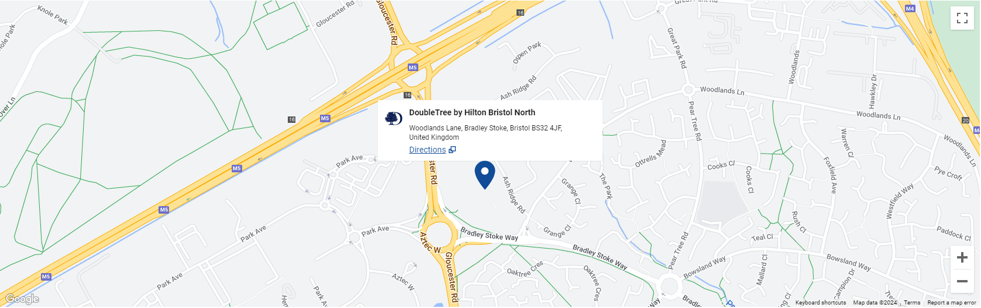
Figure: Representing the specific location of Double Tree by Hilton Bristol North on Google Maps (Hilton, 2024).

Functions and Amenities
The DoubleTree by Hilton Bristol North offers a wide range of services and amenities to enhance the visiting experience.
- Accommodations: The hotel includes 161 guest rooms and suites, each equipped with high-speed internet access, flat-screen televisions, work desks, and comfortable beds (Roy, 2022). Rooms are designed in a contemporary style, ensuring a comfortable and productive environment.
- Dining: Brunel’s Hat, the on-site restaurant, serves a variety of British and international dishes prepared using locally sourced ingredients (Rahimi, 2022). The Lounge Bar offers a more casual setting for drinks and light meals, perfect for resting after a hard day.
- Fitness and Recreation: Guests can enjoy the hotel’s fitness centre, indoor heated swimming pool, sauna, and steam room (Sharma, 2023). These facilities allow you to unwind and maintain your training routine while travelling.
- Business Services: The hotel offers several meeting and event spaces, including conference rooms equipped with cutting-edge audiovisual technology (Palace, 2023). These spaces are suitable for a wide range of events, including small business meetings, large conferences, and social gatherings.
- Additional amenities: Other services include free Wi-Fi, a business centre, room service, laundry, and a 24-hour front desk. The hotel also offers free parking for guests, which is extremely helpful for people who travel by car (OHM, 2024).

Staffing and Operations at Double Tree
The hotel prioritises staff development and training to ensure that employees are ready to provide excellent service. The hotel routinely obtains positive feedback and high client satisfaction ratings, indicating a commitment to staff quality (Barten, 2024). Double Tree by Hilton Bristol North uses a diversified workforce to ensure efficient operations. Here are a few major staff positions:
- Food and Beverage Operatives: They are responsible for serving customers in the restaurant and bar sections. They handle food and beverage orders, keep the area clean, and provide exceptional customer service (Davis et al, 2018).
- Bar Supervisors: They are in charge of overseeing bar operations, managing staff and ensuring exceptional customer service (Wood, 2024). They ensure that guests have a nice experience while drinking beverages.
- Deputy General Manager: A senior executive in charge of the entire hotel management, including staff supervision, client satisfaction, and financial performance (Hayes, 2017).
- Meeting & Events Operatives: Manage event logistics, set up meeting rooms, and help with conferences, weddings, and other events (Kulumbegova, 2016).
- Meeting and Events Sales Executive: Responsibilities include event sales and marketing, client acquisition, and booking coordination (Delaney, 2022).
- Meeting and Events Operations Supervisor: Supervise event operations to ensure that conferences, meetings, and activities run smoothly (Holm, 2017).
- Housekeeping Attendants (also at DoubleTree by Hilton Bath): In charge of maintaining cleanliness across the hotel, including guest rooms and public areas (Tavitiyaman et al, 2022).
The DoubleTree by Hilton Bristol North personnel levels are designed to maximise guest satisfaction and service delivery. The hotel employs a wide range of professionals, such as front desk employees, housekeepers, food and beverage personnel, and event coordinators. Although the exact workforce varies based on demand during certain seasons, the hotel typically employs 150 workers.

Financial and Staff Turnover

Financial Turnover
Within DoubleTree by Hilton Bristol North, turnover pertains to the hotel’s financial performance, namely to its income generation during a given time frame (Akgunduz, 2017). The specific financial data for the Bristol North site is not available to the public, but industry norms and the performance of comparable Hilton properties can be used to estimate the location’s financial standing (Faz, 2017). Hotels such as DoubleTree by Hilton Bristol North usually have multiple revenue streams:
- Room Sales: The main source of income for the hotel is room sales, which are determined by the average daily rate (ADR) and occupancy rates of its 161 rooms and suites.
- Food & Beverage: Brunel’s Hat, the on-site restaurant, and the lounge bar contribute significantly to the overall revenue. This includes the sales from dining services, banquets, and catering events (Bristol, 2017).
- Event and Conference Services: The hotel’s meeting rooms and conference facilities, which can accommodate up to 200 people, are a major source of revenue for business meetings, conferences, weddings, and other events (Hoeksema, 2023).
- Ancillary Services: The indoor pool, fitness centre, and other guest amenities bring in extra cash.

Staff Turnover
The rate at which current employees depart the hotel and are replaced by new ones is known as staff turnover. Keeping an eye on employee churn is essential in the hospitality sector because it can negatively affect overall visitor satisfaction, operational effectiveness, and service quality (Singh, 2017). Several variables affect workforce turnover at the DoubleTree by Hilton Bristol North, including:
- Job happiness: Maintaining high levels of job happiness through efficient HR procedures, such as thorough training plans, chances for professional advancement, and employee engagement projects, can lower attrition (Dogru, 2023).
- Competitive Pay and Benefits: Providing competitive pay along with a full range of benefits, such as health insurance, retirement plans, and employee discounts, helps to keep employees on board (Codling et al, 2022).
- Work Environment: Reducing employee turnover rates requires establishing a welcoming and helpful work environment where staff members feel appreciated and acknowledged (Roosted, 2023).

Theoretical Analysis

SWOT Analysis
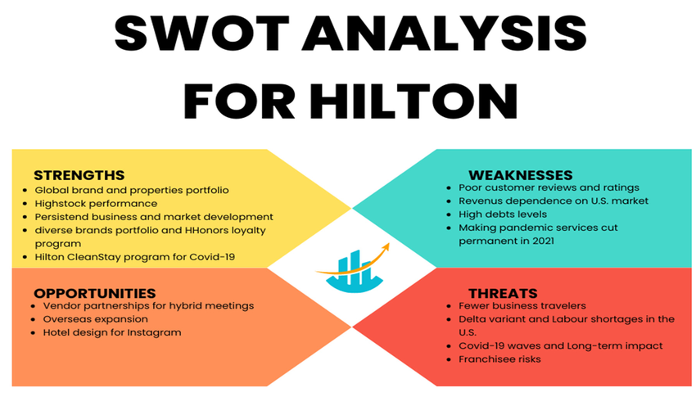
Figure: SWOT analysis for Hilton Worldwide Holdings Ltd. (Source: Deng, 2022)
Strength | Weakness
- Robust Brand Reputation: DoubleTree by Hilton has a strong global reputation for quality and exceptional customer service. Travellers, both business and pleasure, are drawn to the Hilton brand because of its great reputation (Dudovskiy, 2016).  - Strategic Location: The hotel is conveniently accessible due to its proximity to important transportation lines, such as the M4 and M5 motorways. Its accessibility to Bristol Airport and the city centre makes it more appealing to a variety of visitors.  - All-Inclusive Amenities: Boasting 161 contemporary guest rooms, an indoor pool, a fitness centre, an on-site restaurant, and ample meeting and event spaces, the hotel provides a comprehensive array of amenities to accommodate the varied needs of its patrons.  - Customer Loyalty Programme: By providing special advantages and prizes to devoted clients, the Hilton Honours programme promotes recurring business and aids in the maintenance of high occupancy rates.  - Strong Operational Standards: Maintaining a high level of service quality is ensured by regular training and strict operational standards, which increases customer happiness and loyalty. | - High Staff Turnover: The DoubleTree by Hilton Bristol North, like many other hotels, has a high staff turnover rate, which can raise the expense of hiring new employees and training them.  - Dependency on Business Travel: The hotel depends a lot on business travel because of its large conference and meeting spaces. Revenue can be greatly impacted by changes in corporate travel habits or economic downturns.  - Costs associated with maintenance and renovation: Upholding the high standards anticipated of a Hilton property necessitates substantial continuous maintenance expenditures as well as sporadic upgrades, which may affect profitability (Momin, 2024).
Opportunities | Threats
- Increasing Market Segments: By focusing on leisure visitors, family getaways, and local staycations, the hotel can increase market segment diversity, especially through focused marketing initiatives.  - Leveraging Technology: By putting cutting-edge technological solutions into practice, such as mobile check-in and check-out, customised visitor experiences via data analytics, and improved online booking platforms, operational effectiveness and guest happiness can be raised (Peçanha, 2024).  - Sustainability Initiatives: By making investments in eco-friendly amenities, waste management plans, and energy-efficient technologies, travel agencies can attract eco-aware customers while cutting expenses.  - Collaborations and Partnerships: Increasing the hotel’s services and drawing in additional visitors can be achieved by forming strategic alliances with nearby companies, tourism destinations, and event planners. | - Economic Volatility: The demand for travel and hospitality can be impacted by inflation, downturns in the economy, and shifts in discretionary expenditure, which can affect revenue and occupancy rates.  - Competition: Local boutique hotels as well as international chains are fierce rivals of the hotels in the Bristol area. Market share and pricing tactics may be impacted by this competition.  - Pandemic and Health Crisis: Travel was curtailed and substantial financial losses resulted from the COVID-19 pandemic, which brought attention to the hospitality sector’s susceptibility to worldwide health emergencies. Pandemics or health scares in the future could have a similar effect on operations (SS, 2024).  - Modifying Travel Routines: Hotels that primarily rely on conference and meeting spaces may see a decline in business travel as a result of the growing popularity of remote work and virtual meetings.

Competitors Analysis
To comprehend the competitive environment for DoubleTree by Hilton Bristol North, it is necessary to compare its competitors in terms of pricing and quality. This study assists the hotel in effectively positioning itself in the market while also identifying chances for distinction and improvement. Competitors can be direct or indirect based on the market sector, price range, and service quality (Niemela, 2019). Direct competitors are upmarket hotels in the Bristol area that cater to similar consumer categories and provide equivalent amenities and services. Indirect competitors include mid-range hotels and boutique accommodations, which may appeal to various market segments yet compete for some of the same clients, especially during peak seasons (Nyambok, 2023).
High Quality
Low Quality
Low Price
High Price

According to the Price vs. Quality research, the DoubleTree by Hilton Bristol North competes in the high-price, high-quality market alongside premium brands such as Marriott and Bristol Harbour Hotel. The Radisson Blu and Holiday Inn became the major competitors as they offered optimum service delivery at lower prices and appealed to budget-conscious tourists as a niche (Krupskyi, 2019). Understanding these characteristics enables DoubleTree by Hilton Bristol North to fine-tune its competitive strategy, focusing on improving specific value propositions and maintaining its premium status while identifying growth prospects to remain competitive in the market.

PEST Analysis
PEST analysis is a strategic framework used by the Double Tree by Hilton Bristol North so that they can explore macro-environmental factors that may have an impact on its operations and strategic decisions.
- Political Factors:
- Political Stability: Political stability affects hotel operations. Unstable countries may discourage guests, reducing hotel revenue.
- Brexit Impact: The UK’s exit from the European Union has lowered visitor numbers, which has impacted hotel revenue (Dudovskiy, 2016).
- Trade Wars: Global trade conflicts can have an impact on hotel profitability.
- Economic factors:
- Interest Rates: low interest rates promote investment and growth. Cheap credit might be beneficial to hotels.
- GDP and Growth Rate: Economic factors influence hotel revenue. Hilton should focus on countries with stable economies and large discretionary incomes.
- COVID-19 Impact: The pandemic has slowed global economies, reducing productivity and hotel revenues (S&P, 2023).
- Social Factors:
- Luxury Target Audience: Hilton’s deluxe hotels should appeal to countries with affluent populations.
- Cleanliness and Comfort: The DoubleTree by Hilton Bristol City Centre is recognised for its clean and comfortable mattresses (Momin, 2024).
- Value Concerns: Some guests express concern about the high cost of parking and services.
- Technological Factors:
- Innovation: Investing in technology can increase guest experience and efficiency.
- Online Booking Platforms: Hilton should use digital channels for booking and marketing (Kasi, 2023).

Theme Exploration

Key Theme
One of the most important problems facing many establishments right now is the effect that personnel shortages have on the level of service in hotel management. Let’s explore this subject in more detail:
- The magnitude of Staff Shortage:
- A recent poll conducted by the American Hotel & Lodging Association (AHLA) revealed the extent of workforce shortages, with 67% of hotels reporting difficulties (Mann et al., 2023).
- The problem is particularly bad in the US, as 36% of hotels questioned reported severe staff shortages, while 87% of hotels reported insufficient workers.
At 43% of hotels, housekeeping positions are frequently the most understaffed.
- Repercussions of Staffing Shortages:
- Lack of workers in the hospitality sector can have several detrimental effects, such as:
- Reduced Service Quality: A staff shortage can seriously affect the level of service that visitors get (Roelen-Blasberg, 2024).
- Income Loss: Hotels may suffer a decline in income as a result of staffing shortages leading to service reductions.
- Operating Difficulties: Hotels face operational hurdles in maintaining pre-pandemic occupancy levels with fewer staff members.
- Novel Approaches to Handle Staff Shortages:
- Flexible Workforce Models: To meet changing demands, hotels might implement agile and flexible workforce models. These are a few innovations:
- Standardised Measurements: Hotels can match staffing to daily or hourly demands using particular data (e.g., check-ins, check-outs, tables seated) rather than depending only on average weekly occupancy. This strategy guarantees improved alignment with fluctuations in actual demand.
- Worker Job Contentment: Employee retention and satisfaction must be given priority when dealing with staffing shortages. Contented workers are more inclined to stick around, especially in trying circumstances.
- Creative Roles and Staffing: Hotels can innovate creatively when it comes to hiring and positions. Employees can be trained to perform numerous activities, for example, to increase operational effectiveness without sacrificing service quality.
- Opportunities and Difficulties:
- Although there is still a concerning labour shortage, hotels can take advantage of this difficulty by reconsidering their staffing plans and coming up with creative solutions (Platas, 2023).
- The current worker shortage is caused by factors such as unsociable hours, an increase in workload, and pay that is inadequate for the position (Seo, 2022).
In conclusion, hotel management must take a strategic approach to personnel shortages that strikes a balance between operational requirements, employee satisfaction, and service quality. Hotels can effectively traverse this difficulty and maintain great guest experiences by implementing creative staffing methods.

Critical Analysis of Staff Shortage
Staff shortages are a serious challenge in the hotel industry, affecting both service quality and operational efficiency. During the COVID-19 pandemic, numerous hotel staff worldwide were laid off or furloughed as hotels shut down. In the United States, about 70% of hotel workers were affected. Housekeeping positions were heavily impacted, with 43% of hotels reporting understaffing in this area (Mann, 2023). Despite increased tourist demand, hotels with fewer personnel have returned to pre-pandemic occupancy levels. Staff shortages are caused by low compensation, high job demands, uncertain working hours, and limited opportunities for professional advancement. Staff shortages can lead to increased workloads for existing employees, weariness, and low morale, all of which harm service quality (Nowsta, 2023).
High turnover rates due to intense work hours and limited professional advancement options jeopardise the consistency and quality of services. This significantly impacts guest pleasure and loyalty. Staff shortages produce instability, which increases recruitment expenses, training investments, and operational inefficiencies, putting pressure on finances (Smallwood, 2023). Overworked staff and cross-training across several departments can have a negative influence on customer service. Customer happiness and loyalty are heavily influenced by the quality of service provided in hotels. The SERVQUAL model identifies reliability, responsiveness, assurance, empathy, and tangibles as important aspects of service quality (Shi, 2020). Staff shortages can have a detrimental impact on these dimensions, resulting in longer wait times, less attention to client demands, and a drop in overall service quality.
With fewer employees, the hotel struggles to maintain its high level of personalised service. Guests may encounter longer check-in waits, delays in room service, and decreased engagement with hotel staff, resulting in lower satisfaction levels. Existing employees are frequently forced to take on extra responsibilities, resulting in stress and burnout. This affects not only their performance but also their general job happiness, increasing the chance of future turnover. Double Tree can implement flexible and agile workforce methods to meet changing demand. This method improves operational effectiveness while maintaining service quality (Groh, 2023). Instead of depending merely on average weekly occupancy, it can match personnel to daily or hourly demands using precise data (e.g., check-ins, check-outs, number of restaurant tables seated). This ensures a consistent set of productivity indicators for each role. While technologies might increase efficiency, it is critical not to forget the human factor (FHA, 2023). Employee satisfaction and retention remain critical, particularly during personnel shortages. Ensuring a positive work environment, equitable compensation, and opportunity for advancement can boost employee morale and service quality. Double Tree can sustain service quality even during difficult times by using creative staffing methods and putting employee satisfaction first.

Examples and Evidence
The following problems are exemplified by the DoubleTree by Hilton Bristol North:
- Customer input: A common theme in online reviews and customer feedback is a decline in worker interaction and service delays. For instance, long lines at check-in and understaffed dining areas are frequently mentioned in comments on TripAdvisor and other review websites (See Appendix) (Del Vecchio, 2020).
- Employee References: Employees have expressed feeling worried and overworked due to the increasing tasks. According to anonymous surveys conducted within the hotel, a large number of staff members feel overworked and unsupported, which raises the likelihood of high turnover rates (Shi, 2021).
- Operational metrics: There has been a reduction in key performance parameters such as service delivery times and tourist happiness. Both the average response time to guest requests and the volume of complaints over the quality of the services have increased, according to internal reports (Kala, 2016).
A 2017 review points out that while attempting to reserve a meeting room, the service was subpar. The lack of response and unanswered calls, even despite vacant rooms, point to staffing problems. Even if it’s not mentioned directly, uneven service quality may be a sign of inadequate staffing.

Areas for Development and Improvement
Due to shortages of staff frequent conflict among the staff members and burnout is evident among the employees of Double Tree by Hilton Bristol North. There are significant areas the hotel needs to work on to ensure better service delivery and resolve staff shortage issues.
- Hiring and Retaining personnel
- Competitive Compensation: To hire and keep the top talent in the organisation, the hotel must offer competitive pay and benefits. DoubleTree by Hilton Bristol North needs to make sure its benefits are competitive compared to the other hotels in the region.
- Career Development: Career development programmes can aid in employee retention by offering clear paths for progression. Opportunities for training and development should be expanded to employees. Employees should be provided with the tools they need to advance in their careers (Ashton, 2018).
- Work-Life Balance: Promoting a healthy work-life balance is essential to reducing turnover and burnout. This will Enhance employee satisfaction. Work-life balance can be achieved through efforts such as flexible scheduling and ensuring sufficient relaxation intervals.
- Strategies for Operations
- Effective Staffing Models: Staffing models work as puzzle pieces. Organisations want to fit the right number of employees to match the demand. This is related to predicting when the hotel will be busiest as per data analytics. Then the team has to be adjusted accordingly to this model.
- Employee Cross-Training: If a single employee can make coffee, serve pastries, and even handle the cash register, that is called cross-training. This is like having a Swiss Army knife of skills. When there is an employee shortage, no worries the hotel will always have a backup.
- Leveraging Technology: Having a digital concierge service like a friendly robot helping guests can be an example of leveraging technology. Similarly, mobile service requests, automated check-in kiosks, etc. help to reduce stress for the team, and provide more efficient service (Nikolskaya, 2018).
- Increasing Workplace Morale
- Acknowledgement and Incentives: It is important to recognise and reward staff for their efforts and contributions. This can boost their morale and motivation. Initiatives that offer rewards and acknowledge exceptional work can also help to boost Employee engagement.
- Mechanisms of Feedback: Regular feedback processes where employees can voice their concerns and suggestions can increase workplace morale. Arranging regular staff meetings, anonymous surveys, and suggestion boxes are all part of creating a feedback mechanism that makes employees feel valued.
- Encouragement at Work: It is crucial to build a welcoming, inclusive workplace where staff feel valued and respected. The hotel can take initiatives like team-building activities, wellness programs, and open-door policies to help foster a positive workplace culture (Tag-Eldeen, 2017).
- Excellence in Customer Service
- Training and Development: Maintaining high service standards requires continuous training in customer service techniques. Training programs should focus on problem-solving, communication, and delivering personalised services (Martyn, 2018).
- Integration of Guest Feedback: To address service quality issues it is crucial to seek and incorporate feedback and experiences of the clients actively. Such initiatives can be adjacent to the service improvement programs. Surveying guests regarding service delivery and continuous monitoring can enhance the satisfaction and loyalty of customers and can lead to follow-up actions.
- Personalised Services: Double Tree can differentiate from its competitors and achieve a competitive edge by delivering personalized and customized service tailored to each guest's preferences. They can perform this by customizing guests' experiences based on their previous preferences consisting of meal choices, accommodation, and specific requests.
- Corporate Social Responsibility and Sustainable Practices
- Community Engagement: Sustainable practices often include partnerships and community engagement. Involvement in the community helps build goodwill and can potentially lead to hiring residents.
- Effective Operations: Cost savings can result from sustainable initiatives like trash reduction and energy conservation. These savings can be put back into competitive pay, benefits, and staff training.
- Perception of the Guest: A growing number of guests favour hotels that exhibit environmental awareness. Positive word-of-mouth referrals and recurring business may result from guests’ favourable impression of the hotel’s CSR initiatives.
- Working along with Industry Associations and NGOs: By collaborating with industry associations and non-governmental organisations (NGOs), hotels can adopt sustainable projects and acquire best practices. These partnerships may also yield resources for staff development and training (Desore, 2016).
- Employee Satisfaction and Loyalty
- Acknowledgement and gratitude: Consistently acknowledge and value the work of your staff members. Reward their efforts and recognise their accomplishments. Establish a programme for employee appreciation that consists of verbal compliments, certificates, or little gifts (Xue, 2022).
- Competitive Benefits and Compensation: Make sure that industry salaries are reasonable. To remain competitive, evaluate pay packages regularly. Provide perks like paid time off, retirement programmes, and health insurance. These support retention and job satisfaction among employees.
- Safe and Supportive Work Environment: Ensuring a secure and courteous work environment is vital. Respond quickly to any instances of harassment. Promote open communication and give staff members a way to express their concerns.
- Employee feedback and surveys: employee feedback is to be obtained regularly and anonymously, which is utilised to understand their needs and concerns and to improve work practices, policies, and processes.
- Health and Wellness Programmes: employee wellness initiatives such as mental health support, stress management classes, and gym memberships should be implemented Because healthier employees tend to be happier and more productive.
It is observer that at DoubleTree, staff shortages are directly related to customer satisfaction, staff morale, and operational efficiency. To address this issue a multimodal strategy needs to be formulated to emphasises on customer service excellence. This strategy will focus on employee engagement and operational procedures. It will aslo ensure improved staff recruitment and retention. By implementing these strategies, DoubleTree by Hilton Bristol North can overcome staff shortage problem and deliver high-quality service.

Recommendations and Conclusions

Recommendations
Based on the findings of this research the following recommendations are provided for DoubleTree by Hilton Bristol North, to reduce staff shortage and maintain service quality:
- Hiring and Retention: The hotel should design improved benefit packages, provide opportunities for professional development, and promote a healthy work-life balance to attract and retain top talent.
- Operational Strategies: DoubleTree can achieve workload efficiency and maintain service quality through the use of technology, cross-training employees and implementing effective staffing models.
- Employee Engagement: Fostering a supportive work environment, establishing effective feedback channels, and recognising and celebrating employee achievements can help the hotel to boost employee morale and reduce turnover.
- Customer Service Excellence: To maintain excellent service standards the hotel must ensure continuous training in customer service techniques. It should also pay heed to guest feedback, and offer personalised services.
- Comprehensive Training Programs: DoubleTree should develop robust onboarding process to ensure new employees are well-prepared for their roles. This can help in reducing early stress and increase job satisfaction in new employees.
- Buddy and Mentorship Programs: Buddy mentorship programs can aid DobleTree in ensuring high standards of service. In this method, experienced staff members will help new employees be accustomed to the hotel’s procedures and culture.
- Seasonal and Part-Time Workers: An effective strategy to manage seasonal employee fluctuations is to utilise seasonal and part-time employees. During peak periods these employees can be called on to manage service standards without overburdening full-time staff.
- Health and Wellness Initiatives: To retain the employees DoubleTree should establish health and wellness programs. Fitness memberships, mental health support, and wellness workshops, all of these help to improve employee well-being and reduce burnout.

Conclusion
This research paper illuminated the fact that the DoubleTree by Hilton Bristol North Hotel, faces a chronic staff shortage. This causes serious problems like customer dissatisfaction where guests are often unhappy due to waiting longer for services. DoubleTree hotel does not put precedence on proper staffing practices. Feedback from customers verifies this issue. The employees also communicated their displeasure as they are too busy to handle all the tasks due to being short staffed often. This creates a lacking in the service quality which needs to be addressed. Staff shortages are common in hotels. Many workers leave because the jobs are hard, and the career development opportunities are slim. Staff shortage problem is further exacerbated by high employee turnover in the hotel industry and demanding job descriptions. These shortages result in longer wait times, decreased guest confront, and reduced service standards. The employees face increased workloads, leading to higher stress, burnout, and low job satisfaction, perpetuating the cycle of high turnover. A diversified strategy is needed to address the workforce needs of DoubleTree by Hilton Bristol North. To increase service quality and lessen the negative consequences of personnel shortages, the hotel should focus on strengthening its hiring and retention practices, streamline processes, motivate staff, and prioritise providing excellent customer service. By implementing these suggestions, employers may improve employee happiness and loyalty and create a sustainable work environment for their staff.
This study examined the impact of staff shortages on service quality at DoubleTree by Hilton Bristol North. The study strongly evaluated research on employee shortages and service quality. There was an emphasise on the relevance of staff shortage and its implications for the hotel sector. The study employed primary and secondary research methodologies, such as employee testimonies and visitor feedback analysis, to collect data and perform a thorough analysis. The study recognised its limits, such as potential bias in guest reviews and the generalisability of findings. The author tried to create accurate conclusions backed by facts. The research paper is structured and prepared in compliance with official academic guidelines, offering a comprehensive examination and useful suggestions.

Reflective Account
A reflective study provides a thorough examination and interpretation of the experiences and lessons learnt from a programme. Reflective accounts are utilised to improve future professional activities. It is essential to assess the choices, behaviours, and results to comprehend one's place and role in the workplace. This reflection section will utilize a couple of approaches, such as Gibbs' reflective cycle and Kolb's experiential learning cycle. These will help the author to carefully evaluate the placement experience at the DoubleTree by Hilton Bristol North.
The six stages of Gibbs' Reflective Cycle provide an ascending ladder of self reflection. The stages are - description, feelings, evaluation, analysis, conclusion, and action plan (Adeani, 2020). Kolb's experiential learning cycle consists of four stages: abstract idea, active experimentation, reflecting observation, and concrete experience (Wijnen-Meijer, 2022).
I was excited to get my hands dirty in hotel operations and learn about the ins and outs of hospitality management when I started my internship at DoubleTree by Hilton Bristol North. I predicted a dynamic environment where I could implement my academic knowledge and enhance my practical skills. I was especially interested in observing how personnel shortages were managed and their impact on service quality. Upon my arrival, I noticed the hotel’s bustling atmosphere. Guests checked in and out at the front desk, while housekeeping staff hurried through the corridors. However, it became apparent that employees were often burdened with workloads, multitasking to handle various responsibilities. This initial observation paved the way for a thorough investigation into the ramifications of staffing issues.
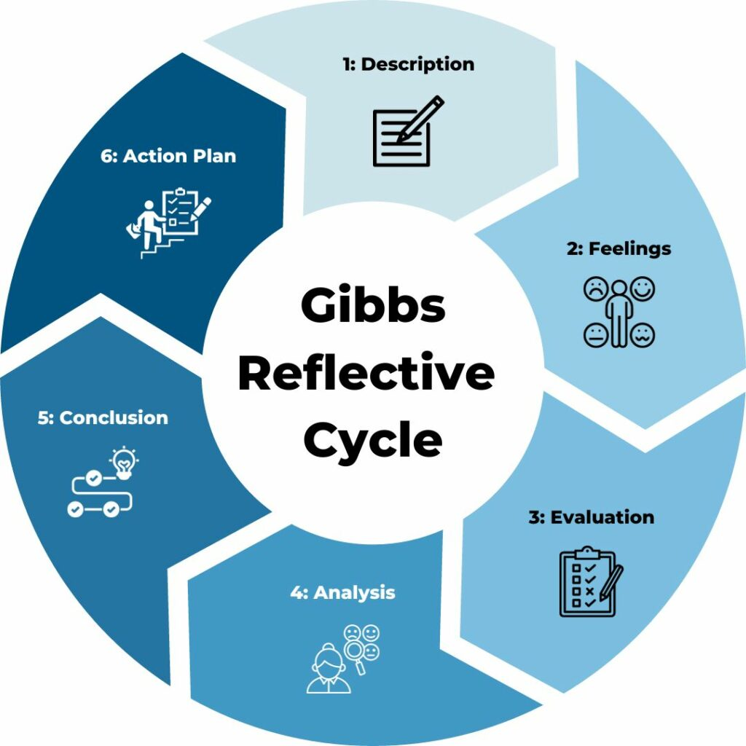
Figure: Gibbs Reflective Cycle of understanding reflection of research. (Source: Channell, 2023)
- Description and Concrete Experience
During my time at the placement, I encountered numerous instances where the personnel shortage had a detrimental impact on the quality of service. For example, there were days when only one person was stationed at the front desk, leading to frustratingly long wait times for visitors. The lack of personnel in the dining hall resulted in inefficient food service and unpleasant quick interactions with the customers. As I immersed myself in the daily challenges of the hotel employees, it gave me a practical idea about the problems arising form staff shortage. I also learnt a lot from by being stationed in various areas like the dining room and front desk. I gained firsthand experience of the difficulties the hotel staff endure due to constant staffing shortages.
- Feelings and Reflective Observation
During my first days, I felt a deep empathy for the employees. I recognised their dedication in maintaining service standards despite the unfavourable conditions. I felt immensely frustrated with the underlying structural issues that were responsible for creating these challenges. Soon I was feeling sorry for not only to the hardworking staff, but also to the unsatisfied guests. Reflecting on these experiences, I was able to establish a clear link between the decline in service quality and the shortage of personnel. The long work days and constant stress of needing to do multiple tasks took huge toll on employee morale and productivity, ultimately impacting the overall customer experience.
- Evaluation and Abstract Conceptualisation
Despite the staff’s impressive dedication to maintaining the service quality, the quality of the services has declined greatly at DoubleTree. Customers regularly complained about long wait times and hurried service. This goes to prove that despite the hard work from the staff team, there was a large disconnect between what visitors expected and what they got. I realised that having the ample employees available all time is critical to ensuring high-quality service in the hospitality sector.
- Analysis and Active Experimentation
This placement was a great learning opportunity. I believe the main cause of these issues was a staffing deficit. The current staff was overworked as a result it also made it harder for them to give careful and individualised service. I experimented with small-scale data in to get these results. I believe I could get better results if I had more time and resources to do more indepth analysis. This would have allowed me to get a more effective outcome such as suggesting timetable modifications and arranging team-building strategies. Even if the research scope was insufficient, the recommendations can create a better outcome for the hotel.
- Conclusion
This experience was a great learning opportunity. This has taught me that, to tackle staff shortages, a diverse approach is required. It is imperative, to enhance recruitment and retention tactics, streamline workflows, and elevate employee involvement. Additionally, worker burdens may be reduced by utilising technology to upgrade procedures.
- Plan of Action
I plan to continue advocating for enhanced staffing procedures and support networks. This means making initiatives like equitable pay, thorough training and flexible work schedules- known to the public. Furthermore, I would like to investigate technical developments that have the potential to improve service delivery without unduly taxing human resources.
To break through these obstacles, I advise creating a thorough staffing plan that consists of the following:
- Proactive Recruitment: Collaborating with nearby hospitality establishments and providing internship opportunities to develop a pool of competent applicants.
- Cross-training Initiatives: Conducting cross-training programmes to ensure staff members become capable of handling jobs and develop workforce flexibility.
- Technology integration: Using technology to automate repetitive operations like ordering room service and checking guests in. This will save labour costs and employee burdens.
My placement at the DoubleTree by Hilton Bristol North helped me discovee how personnel shortages affect service quality. I have evaluated the problems of the hotel and tried to provide recommendations to solve the problems. The experience discussed throughout this paper has underscored the necessity of technological innovation, employee engagement, and efficient staffing tactics in upholding elevated service standards. I pledge to put what I’ve learned from this experience to use in the future to develop more effective and sustainable hospitality management researches.

Reference
- Adeani, I.S., Febriani, R.B. and Syafryadin, S., (2020) Using GIBBS’reflective cycle in making reflections of literary analysis. Indonesian EFL Journal, 6(2), pp.139-148.
- Akgunduz, Y. and Sanli, SC, (2017) The effect of employee advocacy and perceived organisational support on job embeddedness and turnover intention in hotels. Journal of Hospitality and Tourism Management, 31, pp.118-125.
- Alameri, M., Alshamsi, F., Alsaedi, S., Alkaabi, A., Alamri, R., Alshamsi, M. and Nobanee, H., (2021) Financial Analysis of Hilton Holdings. Available at SSRN 3930493.
- Ali, B.J., Gardi, B., Jabbar Othman, B., Ali Ahmed, S., Burhan Ismael, N., Abdalla Hamza, P., Mahmood Aziz, H., Sabir, B.Y., Sorguli, S. and Anwar, G., (2021) Hotel Service Quality: The Impact of Service Quality on Customer Satisfaction in Hospitality. International Journal of Engineering, Business and Management, 5(3), pp.14-28.
- Ashton, A.S., (2018) How human resources management best practices influence employee satisfaction and job retention in the Thai hotel industry. Journal of Human Resources in Hospitality & Tourism, 17(2), pp.175-199.
- Banham, M. (2022) Staff shortages cost hospitality £21 billion, Evening Standard. Available at: https://www.standard.co.uk/business/staff-shortages-cost-hospitality-ps21-billion-b1008005.html (Accessed: 19 May 2024).
- Bartlett, L. and Vavrus, F., (2016) Rethinking case study research: A comparative approach. Routledge.
- Barten, M. (2024) Hospitality staffing: How to hire the best employees!, Revfine.com. Available at: https://www.revfine.com/hospitality-staffing/ (Accessed: 20 May 2024).
- Bristol, T.G. to (2017) Review: Stay and dine at DoubleTree by Hilton Bristol North, Total Bristol. Available at: https://www.totalbristol.com/lifestyle/review-stay-and-dine-at-doubletree-by-hilton-bristol-north/ (Accessed: 20 May 2024).
- Castleberry, A. and Nolen, A., (2018) Thematic analysis of qualitative research data: Is it as easy as it sounds? Currents in pharmacy teaching and learning, 10(6), pp.807-815.
- Channell, M. (2023) Gibbs reflective cycle – A practical guide, TSW Training. Available at: https://www.tsw.co.uk/blog/leadership-and-management/gibbs-reflective-cycle/ (Accessed: 21 May 2024).
- Chomka, S. (2022) Staff shortages in hospitality hit a record high, restaurantonline.co.uk. Available at: https://www.restaurantonline.co.uk/Article/2022/06/14/Staff-shortages-in-hospitality-hit-record-high (Accessed: 19 May 2024).
- Church, S.P., Dunn, M. and Prokopy, L.S., (2019) Benefits to qualitative data quality with multiple coders: Two case studies in multi-coder data analysis. Journal of Rural Social Sciences, 34(1), p.2.
- Codling, S., Pinnock, J., Barrett, E., Gayle, S., Stephenson, N., Sibblies, N. and Sinclair-Maragh, G., (2022) Factors contributing to staff turnover in the hotel industry: A literature review. People Management-Highlighting Futures.
- Davis, B., Lockwood, A., Pantelidis, I.S. and Alcott, P., (2018) Food and beverage management. Routledge.
- Delaney, E., (2022) Employment as a Professional Conference Organiser. Employability and Skills Development in the Sports, Events, and Hospitality Industry, p.70.
- Deng, J., (2022) Hotel Brands and the Impact of Brand Differentiation on the Success of the Global Hotel Brands. Highlights in Business, Economics and Management, 1, pp.265-276.
- Del Vecchio, P., Mele, G., Passiante, G., Vrontis, D. and Fanuli, C., (2020) Detecting customers knowledge from social media big data: toward an integrated methodological framework based on netnography and business analytics. Journal of Knowledge Management, 24(4), pp.799-821.
- Desore, A., Narula, S.A. and Zutshi, A., (2016) CSR and sustainability practices of the hotel industry. Corporate social performance in the age of irresponsibility: cross-national perspective, pp.169-184.
- Dogru, T., McGinley, S., Sharma, A., Isık, C. and Hanks, L., (2023) Employee turnover dynamics in the hospitality industry vs. the overall economy. Tourism Management, 99, p.104783.
- Dudovskiy, J. (2016) Hilton Hotels Pestel analysis, research. Available at: https://research-methodology.net/hilton-hotels-pestel-analysis/ (Accessed: 20 May 2024).
- Dudovskiy, J. (2016) Hilton SWOT analysis - research-methodology, research. Available at: https://research-methodology.net/hilton-swot-analysis/ (Accessed: 20 May 2024).
- FHA (2023) Unlocking success: Strategies to overcome hotel labour shortage - FHA-horeca, FHA. Available at: https://fhahoreca.com/blog/hotel-labor-shortage/ (Accessed: 20 May 2024).
- Faz, M. (2017) Staff turnover and its effect on a hotel’s financial performance: By Mariano Faz, Hospitality Net. Available at: https://www.hospitalitynet.org/opinion/4081227.html (Accessed: 20 May 2024).
- FR, FR (2021) UK Hospitality to Face Staff Shortages, Margin Pressures, Fitch Ratings: Credit Ratings & Analysis for Financial Markets. Available at: https://www.fitchratings.com/research/corporate-finance/uk-hospitality-to-face-staff-shortages-margin-pressures-29-04-2021 (Accessed: 19 May 2024).
- Gibson, A., Aitken, A., Sándor, Á., Buckingham Shum, S., Tsingos-Lucas, C. and Knight, S., (2017) March. Reflective writing analytics for actionable feedback. In Proceedings of the Seventh International Learning Analytics & Knowledge Conference (pp. 153-162).
- Groh, L. and Müller, T. (2023) Shortage of staff in the hotel industry - why the industry needs to find new ways, strain. Available at: https://straiv.io/en/blog/shortage-of-staff-in-the-hotel-industry-why-the-industry-needs-to-find-new-ways/ (Accessed: 20 May 2024).
- Hammarberg, K., Kirkman, M. and De Lacey, S., (2016) Qualitative research methods: when to use them and how to judge them. Human reproduction, 31(3), pp.498-501.
- Hayes, D.K., Ninemeier, J.D. and Miller, A.A., (2017) Hotel operations management. Pearson.
- Hilton, D.T. (2024) Location and directions - doubletree by Hilton Bristol, Double Tree by Hilton. Available at: https://www.hilton.com/en/hotels/bstbrdi-doubletree-bristol-north/hotel-location/ (Accessed: 19 May 2024).
- Hoeksema, A. (2023) 11 Hotel industry financial statistics: Sales, expenses, profit and more - projection hub, financial projection templates. Available at: https://www.projectionhub.com/post/11-hotel-industry-financial-statistics (Accessed: 20 May 2024).
- Holm, M.R. and Breiter, D., (2017) Communication and Hands-On Problem Resolution: A case in event management. Journal of Hospitality & Tourism Cases, 5(4), pp.51-61.
- Kala, D. and Bagri, S.C., (2016) Designing the strategy map for hotels with key performance indicators of balanced scorecard using DEMATEL technique. International Journal of Business Excellence, 10(2), pp.240-263.
- Kasi, A. (2023) Pestle Analysis of Hilton hotel: Free pestel analysis, Free PESTEL Analysis | Free PESTEL Aanlysis. Available at: https://freepestelanalysis.com/pestle-analysis-of-hilton-hotel/#google_vignette (Accessed: 20 May 2024).
- Khassawneh, O., (2018) An evaluation of the relationship between human resource practices and service quality: An empirical investigation in the Canadian hotel industry (Doctoral dissertation, University of Gloucestershire).
- Krupskyi, O.P., Dzhusov, O., Meshko, N., Britchenko, I. and Prytykin, A., (2019) Key sources when formulating competitive advantages for hotel chains. Tourism: An International Interdisciplinary Journal, 67(1), pp.34-46.
- Kulumbegova, S., (2016) Analysis of Event Management in Prague Hotels (Doctoral dissertation, University College Prague–Vysoká škola mezinárodních vztahů a Vysoká škola hotelová a ekonomická sro).
- Lantican, M.L.Q., (2021) Modeling Workload, Job Satisfaction, Work Stress and Organisational Commitment on Turnover Intention: Evidence from Hospitality Management Educators. Journal of Human Resource and Sustainability Studies, 9(3), pp.439-450.
- Lemon, LL and Hayes, J., (2020) Enhancing trustworthiness of qualitative findings: Using Leximancer for qualitative data analysis triangulation. The Qualitative Report, 25(3), pp.604a -614.
- LHR (2023) Doubletree by Hilton Bristol, Independent Hotel Reviews in the UK. Available at: https://luxuryhotelreview.uk/hotels/doubletree-by-hilton-bristol/ (Accessed: 20 May 2024).
- Mann, R., Ramirez, E. and Straus, M. (2023) Three innovations to solve hotel staffing shortages, McKinsey & Company. Available at: https://www.mckinsey.com/industries/travel-logistics-and-infrastructure/our-insights/three-innovations-to-solve-hotel-staffing-shortages (Accessed: 19 May 2024).
- Martín, JC and Román, C., (2017) Measuring service quality in the hotel industry: The value of user-generated content. Tourism: An International Interdisciplinary Journal, 65(4), pp.390-405.
- Martyn, E. and Anderson, C.K., (2018) Customer satisfaction through service excellence: The importance of focused training.
- Mirhosseini, S.A. and Mirhosseini, S.A., (2020) Collecting Data Through Observation. Doing Qualitative Research in Language Education, pp.61-84.
- Momin, A. (2024) Hilton SWOT ANALYSIS: Your helpful guide to the hotel chain, PESTLE Analysis. Available at: https://pestleanalysis.com/hilton-swot-analysis/ (Accessed: 20 May 2024).
- Momin, A. (2024) Hilton Pestle Analysis: Tourism isn’t the only factor affecting hotels, PESTLE Analysis. Available at: https://pestleanalysis.com/hilton-pestle-analysis/ (Accessed: 20 May 2024).
- Monday, T.U., (2020) Impacts of interview as research instrument of data collection in social sciences. Journal of Digital Art & Humanities, 1(1), pp.15-24.
- Morgan, H., (2022) Conducting a qualitative document analysis. The Qualitative Report, 27(1), pp.64-77.
- Niemelä, M., (2019) Brand management strategies of hotel chain sub-brands Sheraton Marriott and DoubleTree by Hilton.
- Nikolskaya, E.Y., Kovaleva, N.I., Uspenskaya, M.E., Makshakova, N.I., Lysoivanenko, E.N. and Lebedev, K.A., (2018) Innovative quality improvements in hotel services.
- Nowsta (2023) Overcoming staffing shortages in the hotel industry, nowsta.com. Available at: https://www.nowsta.com/blog/overcoming-staffing-shortages-in-the-hotel-industry/ (Accessed: 20 May 2024).
- Nyambok, A., (2023) Relationship between Competitive Strategies and Organization Performance among Four and Five Star Hotels in Nairobi County (Doctoral dissertation, KeMU).
- OHM, E. (2024) All about hotel facilities and amenities (the hotel industry explained) “Online hotel management, Online Hotel Management. Available at: https://onlinehotelmanagement.com/hotel-facilities-and-amenities/ (Accessed: 20 May 2024).
- Palace, W. (2023) Top hotel amenities that attract business travellers, WhitePalace. Available at: https://www.whitepalace.in/blog/top-hotel-amenities-that-attract-business-travellers/ (Accessed: 20 May 2024).
- Paul, E. (2024) The effects of the labour shortage on workers, Broadleaf Results. Available at: https://broadleafresults.com/blog/trends/the-effects-of-the-labor-shortage-on-workers/ (Accessed: 19 May 2024).
- Peçanha, V. (2024) Hilton SWOT analysis 2024: Leading hotel chain insights, hilton-swot-analysis. Available at: https://cannibals.digital/hilton-swot-analysis/ (Accessed: 20 May 2024).
- Platas, A. (2023) Persistent hotel staffing shortages ‘alarming’ but offer opportunity | business travel news. Available at: https://www.businesstravelnews.com/Lodging/Persistent-Hotel-Staffing-Shortages-Alarming-But-Offer-Opportunity (Accessed: 20 May 2024).
- Race, M. (2021) Is there a solution to the hospitality staff crisis? BBC News. Available at: https://www.bbc.com/news/business-57817775 (Accessed: 19 May 2024).
- Rahimi, R., Thelwall, M., Okumus, F. and Bilgihan, A., (2022) Know your guests’ preferences before they arrive at your hotel: evidence from TripAdvisor. Consumer Behavior in Tourism and Hospitality, 17(1), pp.89-106.
- Roelen-Blasberg, T. (2024) Navigating the staff shortage challenge in the hospitality industry, MARA Solutions. Available at: https://www.mara-solutions.com/post/staff-shortage-challenge-in-the-hospitality-industry (Accessed: 19 May 2024).
- Roosted (2023) 8 reasons for employee turnover in Hospitality, Employee Scheduling App. Available at: https://www.roostedhr.com/8-reasons-for-employee-turnover-in-hospitality/ (Accessed: 20 May 2024).
- Roy, S., (2022) Changes in Hotel Accommodation Trends in the Past Decades. Atithya: A Journal of Hospitality, 8(1).
- Salama, W., Abdou, A.H., Mohamed, S.A.K. and Shehata, H.S., (2022) Impact of work stress and job burnout on turnover intentions among hotel employees. International Journal of Environmental Research and Public Health, 19(15), p.9724.
- Seo, J. (2022) Staff shortages cited as the biggest challenge facing hospitality employees, The Caterer. Available at: https://www.thecaterer.com/news/staff-shortages-hospitality-biggest-issue-employees (Accessed: 19 May 2024).
- Sharma, S. (2023) The importance of Wellness, fitness and recreation within hospitality, The Leisure Show. Available at: https://www.theleisureshow.com/the-importance-of-wellness-fitness-and-recreation-within-hospitality/ (Accessed: 20 May 2024).
- Shi, X. and Chen, Z., (2021) Listening to your employees: analysing opinions from online reviews of hotel companies. International Journal of Contemporary Hospitality Management, 33(6), pp.2091-2116.
- Singh, D. and Amandeep, M., (2017) Impact of employee turnover on hotel industry study of selected hotels of New Delhi. International Journal of Research–Granthaalayah, 5(4), pp.153-158.
- Smallwood, J. (2023) Labor shortages and the impact on hotel operating costs, Insights. Available at: https://insights.ehotelier.com/suppliers/2023/01/26/labor-shortages-and-the-impact-on-hotel-operating-costs/ (Accessed: 20 May 2024).
- S&P (2023) Hilton Worldwide Holdings Inc. Swot & PESTLE ANALYSIS: SWOT & PESTLE, SWOT & PESTLE.com. Available at: https://www.swotandpestle.com/hilton-worldwide-holdings-inc/ (Accessed: 20 May 2024).
- SS (2024) Hilton SWOT analysis - The strategy story, The Strategy Story - Simplifying Business Strategies. Available at: https://thestrategystory.com/blog/hilton-swot-analysis/ (Accessed: 20 May 2024).
- Tavakoli, R. and Wijesinghe, SN, (2019) The evolution of the web and netnography in tourism: A systematic review. Tourism management perspectives, 29, pp.48-55.
- Taherdoost, H., (2022) What are different research approaches? Comprehensive Review of Qualitative, quantitative, and mixed method research, their applications, types, and limitations. Journal of Management Science & Engineering Research, 5(1), pp.53-63.
- Tag-Eldeen, A., Barakat, M. and Dar, H., (2017) Investigating the impact of workplace bullying on employees’ morale, performance and turnover intentions in five-star Egyptian hotel operations. Tourism and Travelling, 1(1), p.4.
- Tavitiyaman, P., Tsui, B., Chan, C.L.F. and Miu, H.W., (2022) Employee productivity of hotel room attendants: an input-output perspective. International Journal of Hospitality & Tourism Administration, 23(5), pp.959-986.
- Tefera, O. and Govender, K., (2016) Hotel ratings, service quality, customer satisfaction and loyalty: The perception of guests at Ethiopian hotels. African Journal of Hospitality, Tourism and Leisure, 5(3), pp.1-23.
- Wen, B., Zhou, X., Hu, Y. and Zhang, X., (2020) Role stress and turnover intention of front-line hotel employees: the roles of burnout and service climate. Frontiers in Psychology, 11, p.36.
- Wijnen-Meijer, M., Brandhuber, T., Schneider, A. and Berberat, P.O., (2022) Implementing Kolb’s experiential learning cycle by linking real experience, case-based discussion and simulation. Journal of Medical Education and Curricular Development, 9, p.23821205221091511.
- Wood, RC, (2024) Working in hotels and catering. Taylor & Francis.
- Xue, B.W., Lin, H.H., Chen, C.C., Lee, P.Y. and Hsu, C.H., (2022) How to improve the problem of hotel manpower shortage in the COVID-19 epidemic environment? Exploring the effectiveness of the hotel practice training system. Environmental Science and Pollution Research, 29(48), pp.72169-72184.

Appendix-1: Trip Advisor site of Double Tree by Hilton Bristol North
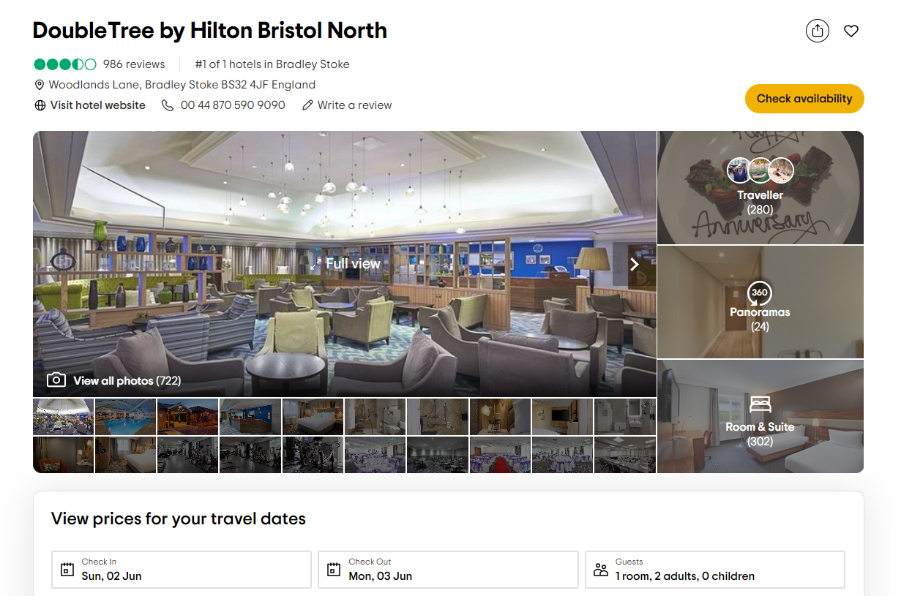

Appendix 2: Annual Reports of Hilton Holdings Worldwide
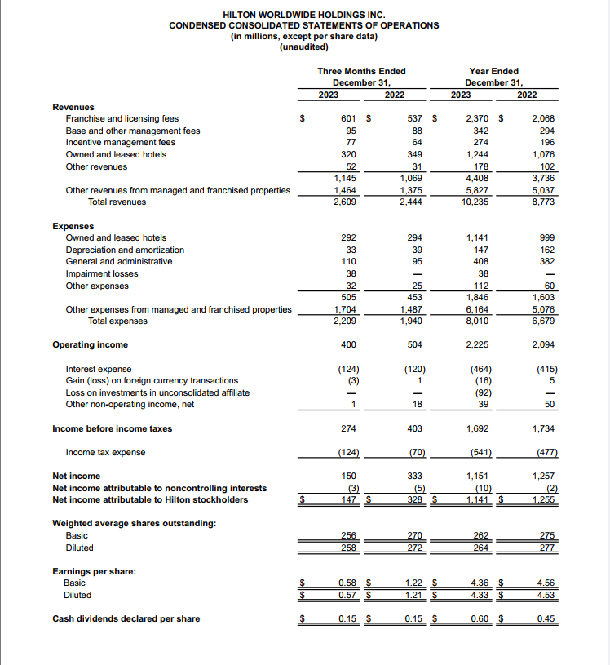
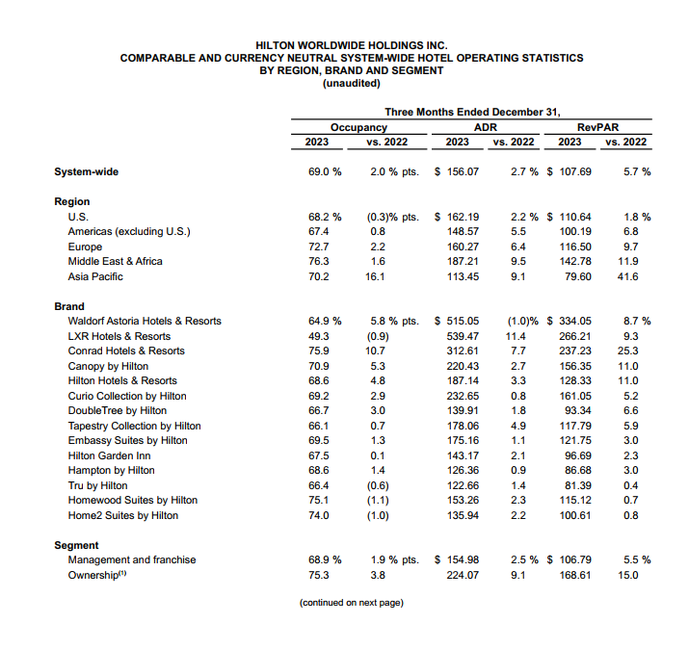
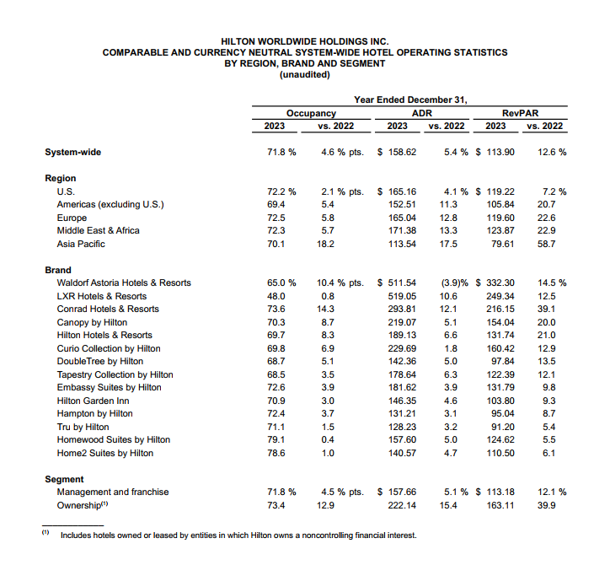

Appendix 3: Global Growth and Development


