Salem Cubed: A Proposal of a Minecraft Re-imagining of 17th Century Salem, Massachusetts

For my project, I propose to construct 17th century Salem in the popular game of Minecraft. Naturally, this will present a unique way of representing history through its settings and environments, and of blending modern and immersive technologies with history. In my proposal, I will petition this project under a theoretical framework, in which it should stand as an insightful, and beneficial way to draw new audiences into engaging with the archaeological record. With the support of my build, I argue that gaming as a medium can be revolutionary in the development of ‘historical empathy’ and education.
Modern technologies, in the numerous forms that it may take, can be utilised in such a way to broaden an audience’s understanding of a historical period or event, for which there is great precedent already. The digital age was, and is, a swiftly accelerating force, whereby the invention and repurposing of technologies allows for academic innovation, and not just toward, or with the focus of a strictly academic audience. Younger generations who have grown up around technology, and have therefore always been familiar, are uniquely positioned to connect with this project – it is hoped this interactive experience can be a means of diversifying education in a manner that could appeal to a younger, and digitally-aware audience, of whom may also have difficulty in engaging with more traditional formats of education.
Historical scholarship therefore, must adapt to these evolutions, and take advantage of any technologies with the potential to further the discipline. While these innovations are undeniable in their reshaping of our worlds, digital means of education are still not wholly positively received. Any negative reception it may have, is consciously tackled with each digital approach to historical education; this project also, will aim to enforce the strengths of digital media in education, and combat misconceptions of gaming mediums. The American Historical Association defines digital history as ‘scholarship that is either produced using computational tools and methods or presented using digital technologies’ – addressing the need to define a then emerging phenomenon demonstrated an embrace of technology within the discipline on behalf of historical institutions, and a forethought toward the approaching digital evolutions. Digital publications may use entirely separate methodologies, and practices to that of print publications, as there are many properties that separate digital works to print. Those that engage with technology for their work likely recognise and support the new ways in which it can ‘connect the professional work of expert historical scholarship with the ways in which wider publics memorialize, represent, and engage history.’
Historically informed games can be understood, or described as ‘spaces [that] include different temporalities, topographies and emotions’, of which are communicated to the audience through ‘multisensorial installations’. The precedent for this project is expansive, and bleeds past just Minecraft, but further still into the digital field. It is worth mentioning MBD, a non-profit digital creative company that specialises in immersive storytelling as a tool for historical education, and has done since 1997, at the very precipice of the digital revolution. Across the nearly thirty years the company has been in operation, they have employed 3D animation and game engine technology in the creation of online experiences for global consumption. MBD’s projects are primarily virtual reality, requiring the use of a headset for the full immersion of the user. Their overarching objective throughout their projects is akin to my own with the Minecraft reimagining of Salem; they aim to breathe life back into history. Some notable projects that they have released include ‘Steel Town Tales,’ which ‘[uncovers] the rich history of steel production in Corby’, combining virtual reality, innovative storytelling, and heritage, as well as ‘Mayflower Reflections’; a VR film that follows the boat’s voyage and its ‘contemporary parallels to modern migration’. There are many other examples of historical storytelling within the gaming industry also, such as the Assassin’s Creed franchise, wherein the user plays as a character navigating a past world.
Studies have examined the impact of games like Assassin’s Creed on students, and its capability to promote independent constructions of meaning. Gilbert’s study published in 2019 explored the extent of which video games can influence a student’s understanding, and empathetical response to history, using the Assassin’s Creed franchise as the focal representation. Carried out within a qualitative interview format, the results – derived from 14 male students, all belonging to one school – reflected a ‘sense of immediate access to history that contrasted with school-based learning, a sense of human connection to people in the past, and increased perception of multiple perspectives in history’. The franchise itself can be foremost understood as science-fiction, wherein the respective playable character can access ancestral memories within a machine; through this, they can ‘transport’ themselves into the past, and override, or inhabit the consciousness of their ancestor. In this world of reconstructed memories, the fictional narrative is intertwined with real historical events, locations, and persons, fostering a sense of empathy, and personal connection toward history. Upon interviewing these 14 students, certain facts became evident to Gilbert: firstly, Assassin’s Creed III was capable, and certainly had, influenced perceptions and opinions of historical events.
With regard to Salem Cubed then, it would be prudent of me to seriously consider this fact. The way in which I present this colonial society and its innerworkings, will have a profound effect on the audience’s perception of not only Salem, but colonial New England, and Puritanism, too. The challenge that I, or any respective game developer faces, is one of objectivity. Is there a way in which I can present the subject matter free of personal, subjective influence? Pointing to games like Assassin’s Creed, as well as Minecraft: Education Edition as precedent, I would argue this can be done successfully, through an overarching consciousness of remaining objective, and collaboration with a test group, to ensure that Salem Cubed does not appear, or act as a political tool intended to communicate either negative, or positive sentiment toward Puritanism.
Minecraft has made available a form of downloadable content that works in conjunction with their base game, known as Minecraft: Education Edition, henceforth referred to as M:EE. According to their website, it is described, and marketed as ‘game-based learning’ that ‘prepares students for the future, building future-ready skills like creativity, problem solving, and systems thinking, and nurturing a passion for play.’ Within the audience aims they have featured on their home page – to ‘explore real world issues in immersive, and imaginative worlds’, and ‘build empathy’ – parallels can be drawn between M:EE and Salem Cubed. My project will also explore real world issues through the construction and showcasing of a historic settlement pivotal to the development and success of early America. The Minecraft world will encourage imagination of the players, in that it is intended to allow players to confront realities of history in a first-person format, and develop a refreshed, and personal comprehension of Salem living during the 17th century. Additionally, I aim to target, and build upon the audience’s empathetical response to history, in such a way that connects them to the environment and events. It can be argued that much of history is emotionally inaccessible – that is to say, the recording, and thusly teaching of history in mainstream education looks at important events, and exceptional people that have affected great change. The lives of ‘ordinary’ civilians, situated and contextualised in their respective environments, are not prioritised, and therefore the idea that people of the past were emotional, individual beings, as opposed to a representative of the collective, is difficult to imagine. People become vague when observed on a macro-scale, and Salem Cubed aims to directly confront this issue.
To describe in further detail what exactly the project will entail, I will begin by introducing the architecture that will be featured. Architecture can be regarded as an imperative facet of any reconstruction of Salem, as it constitutes a major part of the portrayal of Salem. In fact, it has been remarked upon that Salem boasts America’s most impressive architecture, especially when one considers its historical import; for these reasons, its buildings have achieved considerable status. The earliest buildings to exist in Salem, and New England as a whole, are referred to as First Period, and were erected during the 17th century, and Salem is especial for its ‘largest and richest extant collections’ of these First Period houses. From the beginnings of the settlement in 1626 when the pilgrims first arrived, considerable development had been undertaken with regards to the nature of Salem’s architecture – their initial crude, wooden shelters, humble in size and affordance, had been replaced by the mid-century by much larger, and more appropriate residences for permanent habit. Specifically, these buildings were compartmentalised into two rooms, and two stories, featuring an end chimney, as well as larger two-story houses of the same sort, boasting four rooms and a central chimney. Other sources however, claim First Period houses were usually characterised by a one-room interior. 17th century houses have been described as having a ‘natural, direct appearance’, and being ‘box-like in their construction’, typically featuring the prominent central chimney, an overhang at the front, as well as a lean-to in the rear. Additionally, the exterior was finished with unpainted clapboard, and was not extravagant or boastful in its decoration. Doors were of board-and-batten, and were often not symmetrical in their alignment to the house’s structure – this could also be said of the windows, of which were diamond-paned casement, and were hinged to the sides.
Fig. 1 First Period house elements, Historic Salem inc
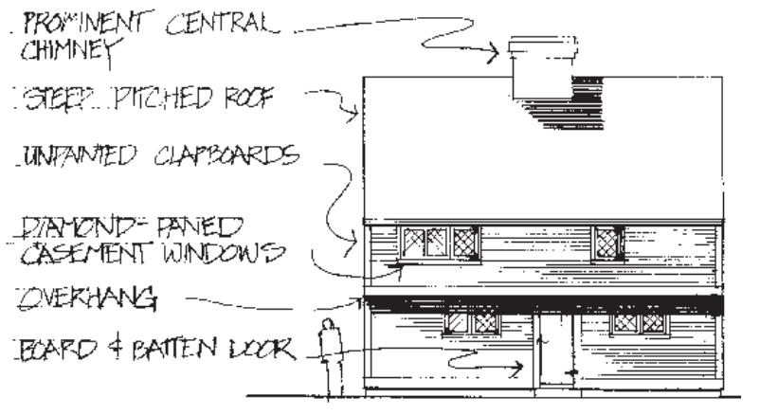
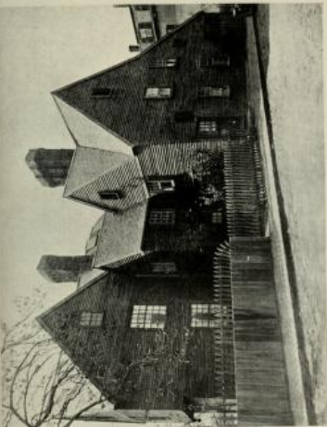
These houses had steep-pitched roofs supported by expertly crafted timber framing. Upper floor overhangs can be observed in many of Salem’s residences, as can be seen above in Fig 1. This is a characteristic look for 17th century colonial houses, and is apparent amongst some of the well-known historic houses. The town’s architecture was subject to adaptation in accordance with changing stylistic preference, and growing financial resource, all of which afforded domiciliary expansion and evolution. First Period houses such as the House of Seven Gables, which can be observed as one of the better-known early dwellings of Salem, due to Nathaniel Hawthorne’s The House of Seven Gables, were not erected in their final form; expansions were common to meet the growing needs of enlarging families and populations. Thatch roofs were prominent among homes until the 1660’s, however in the 1630’s a formal order was issued by the Governor Dudley, wherein he firmly discouraged against the use of thatch in residential buildings due to its flammable nature, thereby successive construction employed mainly shingles, or in some instances tile. Although this order was revoked in 1636, it accomplished the curbing the popularisation of thatch, and encouraged the use of more robust material – thatch roofs did still appear, however mostly for outbuildings. This serves as a great000 example of how I can contextualise Salem Cubed within its respective history; I must consider the movement toward shingle roof housing in the mid-to-late 17th century, and reflect that in the population of houses that will be built. Outhouses will be built also, and will be of a thatch roof, so as to indicate the construction knowledge and technique the pilgrims brought with them from England, and of course, communicate the fact that thatch was less present in the construction of residences.
Many of the houses in colonial Salem are well-known, and thusly contribute considerably to the town’s tourism industry. Therefore, some such houses that must be represented in Salem Cubed are the House of Green Gables, John Ward House, Narbonne House, Jonathan Corwin House, and others. The House of Green Gables (pictured left), erected in 1668 by John Turner, a wealthy merchant, is arguably one of the more globally recognised, and notorious examples, due to Nathaniel Hawthorne’s novel. It has been described as ‘one of the finest surviving 17th-century buildings in New England’. It originally boasted a one-acre plot, a kitchen garden, an outhouse, and well. The house was located on Brown Street, and stood opposite the jail that housed the persecuted during the Witch Trials. Though Salem Cubed is representative of the 17th century, and the festering hatred for paganism and the oppression against women that preceded the trials, it will be designed before the infamous events of the trial. During the mid-17th century, this jail was still employed for the captivity of criminals, but Salem Cubed will not allude to its significance in the Witch Trials. I intend to discuss my choice to represent the time before the trials further on. House of the Green Gables is characterised by the extreme pitch of its roof, that is to say, it strikes the onlooker as incredibly, and intentionally steep. It had a prominent central chimney, and a batten door and diamond casement windows both arranged in an asymmetrical manner.
To translate these houses appropriately in Minecraft, certain allowances must be made. For instance, board and batten doors are not available in the game, and there is not a wood block that is accurately representative of the clapboard, or shingle. Therefore, aesthetics must be prioritised to remain as close to the original historic appearances.

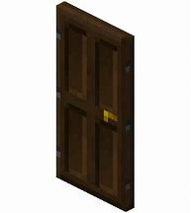
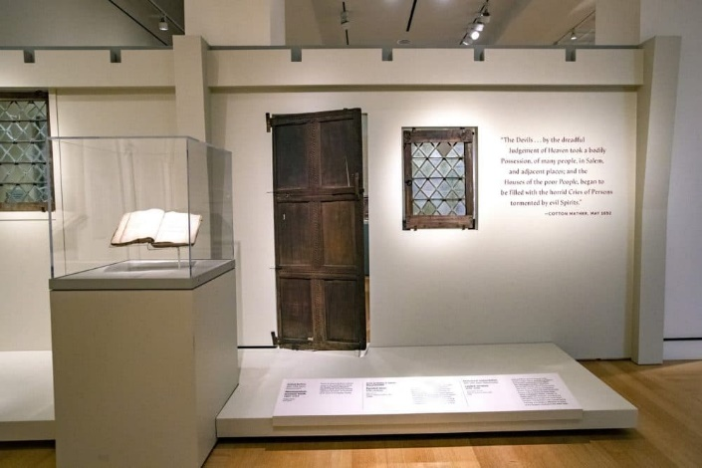
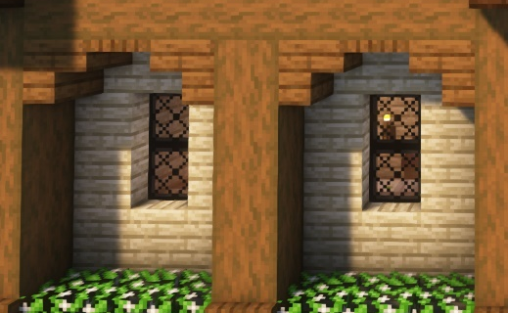
Pictured above is a display of original architectural features found in Salem; displays such as these aid in my selection of Minecraft blocks and objects, as a direct comparison can be made. The stylistic features of the door are most reminiscent of a ‘dark oak door’ (fig. 4) as one can notice the board and batten design, despite the difference in number of sections. The colour is similar also, and will appear cohesive to the wider colonial setting. For the windows, it is necessary to download a ‘mod’ for the replication of the diamond casement. Essentially, mods are add-ons that can be designed by Minecraft themselves, and made available for purchase on the game, as well as individual creators, through certain websites that allow a player to download, and thereby customise their gaming experience. A mod called ‘Medieval Windows’, made available by an individual on the website ‘Curseforge’, allows players to expand the selection of windows within their game upon download, with designs styled after diamond casement windows. In consideration of this, I acknowledge the necessity of implementing mods into Salem Cubed, and therefore must finish the project on an appropriate computer, of which responds capably to the running of these downloads. With regards to the clapboard and shingle, dark oak presents itself as the most viable, and appropriate choice, as Salem’s First Period houses were often noticeably dark in colour, which must be represented to the best of my ability and resource. While I would use dark oak in the construction of the exterior façade, the shingles are best represented by polished black stone steps or slabs. Using block form would create an unnatural and unproportionate appearance, thus the roofs will be constructed with steps and slabs, which allow for a steeper pitch, and a shingle-like impression.


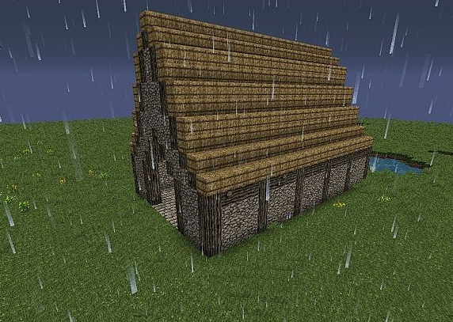
The imitation of the thatch roof can be achieved using hay-bale blocks. Thatched roofs will feature in the town’s outhouses primarily, although there is opportunity to build thatched residential houses, to further adhere to historic realism; these houses were not non-existent after all. Mods will improve the aesthetic value of the block, as it is possible for one to apply a filter of sorts, that transforms and stylises base-game blocks in various fashions. For the visual effect of Salem Cubed, the application of one of these mods would prove advantageous, as they work to realise the creator’s respective theme, which for Salem Cubed, would be dark, gloomy, and closer to realism.
It is equally important for the proper communication of Salem’s culture, to represent its industry, with specific mention to cod-fishing and rum production. Cod is remarked as having ‘influenced the course of American history more than any other marine fish’, and is observed as one of the most lucrative products of trade in New England. Its abundance in Atlantic waters, and lasting nature when salted and dried appropriately, set it apart from other fish, and therefore quickly became a large enterprise within colonial settlements such as Salem. The cod was the first product to be shipped out of Massachusetts, establishing itself as a pivotal foodstuff for the pilgrims, and by extension, early American history. When Puritan settlers first arrived in Salem, they assumed control of a local fishing settlement, and by 1640, there were considerable numbers of fishing establishments set up around the northwestern shore of Massachusetts Bay. Salem Cubed will recognise the thriving cod-fishing industry of the time with the inclusion of ports, along which will be fishing vessels loaded with barrels, fishing rods, bait, and other such necessary items. Additionally, I believe the presentation of Salem’s industry carries with it some gravity, and therefore it is preferred that the audience be able to access this information in a striking, and thoughtful way. Specifically, I would include a market area in the public grounds, wherein different stalls advertise their product to the user as they stroll through. One such stand may be selling cod, and be appropriately equipped with cod, and salt. For aesthetic value, the stall can be crowded by loaded barrels to indicate an excess of fresh fish to be sold, and I will dot the surrounding floor with redstone, which can appear, and be used as a trail of blood.
Salem also partook in international trade using their open-water fleets that could temper long durations at sea, and the carrying of heavy loads. Salem was notorious for their merchant fleets, and they had established communications with ports around the globe, including Russia, South America, Mauritius, India, China, and many others. Some of the products the merchants of Salem regularly traded for, were coffee, pepper, tea, Indian cotton, and other exotic fabrics and linens. This is to say, Salem’s remarkable place as a trading power on the world stage will be a central point to Salem Cubed, and will be illustrated as such. Merchant ships should be built, in addition to smaller, and more basic fishing vessels, to indicate to the player something of their role within world trade at the time. Products such as ivory, and teas will feature also in the market stall segment, wherein the player can observe the various origins the many items boast, and consider its implications for the town, and their ability to trade resource. Due to the younger target audience of Salem Cubed, I will not carry the expectation that the player should always, and without fail, be able to ascertain what is being communicated in every feature of the experience, and I therefore will include respective signs, and posters, that accurately label the products and their origin. Through the collaboration of player inquisitiveness, and accessible information within the world, Salem Cubed should play as a thought-provoking, and revealing experience, accessible to a younger audience, on various levels of intelligence and interaction.
Salem Cubed is not intended as a classic three-dimensional video game, wherein the player follows a narrative and explores, and achieves to that effect – it will instead be designed as a singular, unorthodox form of media that allows for each player to personalise their experience within it. Players can access Salem Cubed upon downloading the world file to their base game, on whichever platform that may be. This action should not be considered overly complicated for younger children, as the Salem Cubed website, which will exist to communicate the objectives, and nature of the gameplay, as well as to provide access to the game itself, will aid in the navigation and download. Once the user has downloaded Salem Cubed, and is thusly ready to begin playing, they will enter into the world with no direct quest or task set before them; they will consequently need to explore their surroundings, and familiarise themselves. Due to the game’s educational content, it is not intended as a fast-paced, or ‘action-packed’ game of entertainment, rather as a medium of accessing history in a relatively rethought, and refreshed manner. The player will have the opportunity to explore the interiors of houses, and glean information about the inhabitants and their way of life that may be discovered through epistemological data found in studies, or diary entries, or simply through the format in which the house is presented. Furthermore, they are free to navigate the landscape and engage with it similarly to how a Salem citizen might have done – the waterways can be fished, the livestock can be herded, or culled, the crops can be harvested.
The experience of Salem Cubed is admittedly rather wide, and open-ended, and that has its own purpose. Some may feel aimless, or non-committal about simply exploring, so I believe it important to enable the player to access the game however they feel comfortable, and in whichever manner interests them most. While some players may prefer to simply observe the environment, and consider its wider historical context, others might feel drawn to the idea of collaborating online with peers, experiencing Salem through role-play, wherein interactivity and shrugging the title of spectator off, and assuming an active role within that history, enables them to better connect. Children, of course, have varied educational needs and preferences, of which I believe non-traditional forms of teaching, such as Salem Cubed can respond to.

BIBLIOGRAPHY
Manz, Stefan, and Paul Long. 2024. ‘Internment, Immersive Technology and Historical Empathy: Natal’s Fort Napier Camp (1914–1919) as a Virtual Reality Experience’, Immigrants & Minorities (Informa UK Limited): 1–28 https://doi.org/10.1080/02619288.2024.2402047
Schmidt, Benjamin. 2015. ‘Guidelines for the Professional Evaluation of Digital Scholarship by Historians’ (American Historical Association), p. 1 https://www.historians.org/wp-content/uploads/2024/05/Guidelines-on-Digital-Scholarship-9.30.2015-1.pdf
‘Steel Town Tales’. 2014. MBD https://www.mbd.limited/mbd-projects/steel-town-tales
‘How Minecraft Impacts Learning’, Education.Minecraft.Net <https://education.minecraft.net/en-us/discover/impact> [accessed 12 January 2025]
‘John Ward House < Essex Coastal Scenic Byway’, Essex Coastal Scenic Byway <https://coastalbyway.org/communities/salem/john-ward-house/> [accessed 12 January 2025]
‘Mayflower Reflections a VR Film’, MBD <https://www.mbd.limited/mbd-projects/mayflower-reflections> [accessed 12 January 2025]
Gilbert, Lisa, ‘“Assassin’s Creed Reminds Us That History Is Human Experience”: Students’ Senses of Empathy While Playing a Narrative Video Game’, Theory & Research in Social Education, 47.1 (2019), pp. 108–37, doi:10.1080/00933104.2018.1560713
Cousins, Frank, and Phil M. Riley, The Colonial Architecture of Salem (Dover Publications, 2011)
‘MFR 41(11), 1979 | Scientific Publications Office’ <https://spo.nmfs.noaa.gov/marine-fisheries-review/mfr-4111-1979> [accessed 19 December 2024]
Moss14, ‘Medieval Windows’, Curseforge, 2023 https://www.curseforge.com/minecraft/texture-packs/medieval-windows
Tolles, Bryant Franklin, and Carolyn K. Tolles, Architecture in Salem: An Illustrated Guide (Essex Institute with the cooperation of Historic Salem, 1983)
Leavenworth, William. B, ‘The Changing Landscape of Maritime Resources in Seventeenth Century New England’, International Journal of Maritime History, 2008
National Park Service, ‘Architecture in Salem: A Guide to Four Centuries of Design’, U.S Department of the Interior, [n.d.], https://www.npshistory.com/publications/sama/brochures/salem-architecture.pdf [accessed 12 December 2024]

Schmidt, Benjamin. 2015. ‘Guidelines for the Professional Evaluation of Digital Scholarship by Historians’ (American Historical Association), p. 1
Schmidt, Benjamin. 2015. ‘Guidelines for the Professional Evaluation of Digital Scholarship by Historians’ (American Historical Association), p. 2
Manz, Stefan, and Paul Long. 2024. ‘Internment, Immersive Technology and Historical Empathy: Natal’s Fort Napier Camp (1914–1919) as a Virtual Reality Experience’, Immigrants & Minorities (Informa UK Limited) p.1
‘Steel Town Tales’, MBD, 2014 <https://www.mbd.limited/mbd-projects/steel-town-tales> [accessed 8 December 2024].
‘Mayflower Reflections a VR Film’, MBD <https://www.mbd.limited/mbd-projects/mayflower-reflections> [accessed 12 January 2025].
Lisa Gilbert, ‘“Assassin’s Creed Reminds Us That History Is Human Experience”: Students’ Senses of Empathy While Playing a Narrative Video Game’, Theory & Research in Social Education, 47.1 (2019), pp. 108–37, doi:10.1080/00933104.2018.1560713.
Lisa Gilbert, ‘“Assassin’s Creed Reminds Us That History Is Human Experience”: Students’ Senses of Empathy While Playing a Narrative Video Game’, Theory & Research in Social Education, 47.1 (2019), pp. 108–37 (p. 108), doi:10.1080/00933104.2018.1560713.
‘How Minecraft Impacts Learning’, Education.Minecraft.Net https://education.minecraft.net/en-us/discover/impact [accessed 8 January 2024].
Ibid.
Bryant Franklin Tolles and Carolyn K. Tolles, Architecture in Salem: An Illustrated Guide (Essex Institute with the cooperation of Historic Salem, 1983), p. xvi.
Ibid.
National Park Service, ‘Architecture in Salem: A Guide to Four Centuries of Design’, U.S Department of the Interior, [n.d.], https://www.npshistory.com/publications/sama/brochures/salem-architecture.pdf [accessed 12 December 2024]
Bryant Franklin Tolles and Carolyn K. Tolles, Architecture in Salem: An Illustrated Guide (Essex Institute with the cooperation of Historic Salem, 1983), p.xvi
National Park Service, ‘Architecture in Salem: A Guide to Four Centuries of Design’, U.S Department of the Interior, [n.d.], https://www.npshistory.com/publications/sama/brochures/salem-architecture.pdf [accessed 12 December 2024]
“For the prevention whereof in our new towne, intended this somer to bee builded, wee haue ordered that noe man shall build his chimney with wood, nor cover his house with thatch, which was readily assented vnto, for that diverse other howses haue beene burned since our arrival”
Frank Cousins and Phil M. Riley, The Colonial Architecture of Salem (Dover Publications, 2011), pp. 4–5.
‘John Ward House < Essex Coastal Scenic Byway’, Essex Coastal Scenic Byway https://coastalbyway.org/communities/salem/john-ward-house/ [accessed 10 December 2024].
Ibid.
Moss14, ‘Medieval Windows’, Curseforge, 2023 <https://www.curseforge.com/minecraft/texture-packs/medieval-windows>.
John J. Ryan, ‘The Cod Family and Its Utilization’, Marine Fisheries Review, 1979, p. 25 <https://spo.nmfs.noaa.gov/sites/default/files/pdf-content/mfr41112.pdf> [accessed 11 December 2024].
William B. Leavenworth, ‘The Changing Landscape of Maritime Resources in Seventeenth Century New England’, International Journal of Maritime History, 2008, p. 35
National Park Service, ‘Architecture in Salem: A Guide to Four Centuries of Design’, U.S Department of the Interior, [n.d.], https://www.npshistory.com/publications/sama/brochures/salem-architecture.pdf [accessed 12 December 2024]

