Rachael Rice 145610
rrice.145610@student.uwtsd.ac.uk
Date: 11/05/19
Classification: Private
Client Name: Geoff Haden
Client contact email: geoff@5cwmdonkindrive.com / geoff@dylanthomasbirthplace.com
Dylan thomas birthplace

Executive Summary
This report has been constructed for the Dylan Thomas Birthplace for the purpose of investigating the market for potential growth for the number of school visits to the Dylan Thomas Birthplace. It will include the aims and objectives, research methods, an analysis of the findings, a SWOT analysis, a conclusion and strategic recommendations. Questionnaires and interviews were used for primary research and a content analysis was completed for secondary research.
From the primary research findings it is shown that the educational aspect is important when choosing a location as the school trip as it is preferred that the trip fits in with the theme or topic. A location is prefer to have fencing or perimeters for a special needs primary school. Price is important for schools when booking a trip as the school will have to pay for any child that cannot pay as they cannot exclude any child. A school would prefer to go to a location that has their own risk assessment that can be sent to the head teacher as this saves time for the school on paperwork. If the children come back from a school trip and they want to talk about it to their teachers, friends or parents, this makes it a successful school trip as primary school children are encouraged to discuss to build their skills. The trip is ideally planned for all weathers, so an indoor location is ideal as the trip can go ahead whatever the weather. Head teachers are usually interested in going somewhere new on a school trip as long as it does fit in with the theme/topic. From the results it was evident that not many schools knew where the Dylan Thomas Birthplace is, which would make it difficult for them to book a trip there; for the schools that knew where it was they did not know what was offered there. A school visit provider receives between 5-7 school visits per week and it is there second biggest draw of numbers for the business.
From the content analysis it is evident that all the websites follow the same structure but they have big differences which could be the difference in schools booking a trip or not. Website 1 had a video of a previous school visit along with different sections on the website to look at, depending on the age group visiting. There was a separate section for teachers to look at which was in more depth, and there was a variety of options of things to do there. On website 2 there was a video of a previous school visit but it did not play, the website was unorganised when clicking on different links which could make booking a visit difficult as it is hard to navigate around the page. All three websites had contact details and opening times as well as information of what would take place during the trip.
There are many strengths of the Dylan Thomas Birthplace, the tours are exciting and enthusiastic, the price is cheap considering a visitor can stay there for as long as they like to ask any questions they may have about Dylan Thomas. The Dylan Thomas Birthplace is poorly marketed when compared to competitors as some schools did not know where it was, or what was offered there. Getting the Dylan Thomas Birthplace to have a closer working relationship with the schools would be an opportunity as it as something that will help with their curriculum learning. There are already a handful of competitors within the Swansea area that the Dylan Thomas Birthplace will have to try and keep up with as to not lose any business in the school visit department.
Some recommendations for the Dylan Thomas Birthplace would be to have a better marketing strategy as if schools know where it is and what is offered the number of visits would possibly improve. By putting all the information regarding school visits in one place it would make it easier for a head teacher to book, such as details about the visit, opening times and prices.

Table of Contents
1. Executive Summary 1
2. Acknowledgements 3
3. Introduction 3
4. Aims and Objectives 3
5. Methodology 3
6. Primary Research Findings 4
7. Secondary Research Findings 5
8. SWOT 6
9. Conclusion 6
10. Strategic Recommendations 7
11.Appendices 8
11.1 Appendix 1 8
11.2 Appendix 2 10
11.3 Appendix 3 11
11.4 Appendix 4 12
11.5 Appendix 5 13
11.6 Appendix 6 14
12. Bibliography 14

Acknowledgements
The consultant would like to thank Geoff Haden of the Dylan Thomas Birthplace who allowed this project to go ahead, and also provided the information of current school visits when needed. A thank you to all who completed the questionnaire, and although they would like to remain anonymous, a thank you to both the head teacher and the school visit provider for allowing the interviews to take place; without them this project would not be able to be completed.

Introduction
This report has been constructed for the Dylan Thomas Birthplace for the purpose of investigating the market for growth in the number of school visits that take place there. Questionnaires and interviews were undertaken for the research section of this project. The Dylan Thomas Birthplace has been reconstructed to look like it did when Dylan Thomas himself lived there. As Curriculum Cymreig is now undertaken by schools there are more Welsh based topics discussed more in classrooms, Dylan Thomas will now be discussed more frequently. There are many topics and themes in which Dylan Thomas would fit into both primary and secondary teaching in Wales; history, English and culture as a small number of topics. For this project, it will be focused on primary schools only. This report will include the aims and objectives from the previous PID report, the choice of research methods that the consultant had undertaken, an analysis on the findings from the research, a SWOT analysis, a conclusion and strategic recommendations that have been put together in hopes of achieving the growth in the number of school visits to the Dylan Thomas Birthplace.

Aims and Objectives
The aim of this project is to investigate the market potential growth for improving the number of school visits to the Dylan Thomas Birthplace and from the research undertaken, provide strategic recommendations on how to improve the number of school visits. The objectives for this project is to audit current school visit activity, to research the educational visits market in Swansea and to then make strategic recommendations for developing this market segment. The aims and objectives have been the same since the previous PID document and that is to keep consistency in what the consultant has been doing through their project.

Methodology
Both quantitative and qualitative data has been used for this research project. For primary research, questionnaires(appendix 1) were sent out to 63 primary schools in the Swansea area via email as the consultant thought this was the best approach due to the high volume of schools it needed to be sent to. There was an option at the end of the questionnaire to leave contact details if any head teacher had further questions or if they wanted to go through the questionnaire in more depth. The questionnaires were sent out three days prior to the Easter holidays; on critical reflection this was extremely bad timing on the consultants behalf.
As the consultant only received a handful of responses to the questionnaire, it was then decided the consultant would undertake two interviews; one with the head teacher of an autistic and special needs unit primary school(appendix 2) and one with a school visit provider (appendix 3).
For secondary research there was a content analysis conducted on three websites including the Dylan Thomas Birthplace website regarding school visits. This was conducted for comparison to see what is out there on these websites and what could be done to increase the potential growth in school visits to the Dylan Thomas Birthplace.

Primary Research Findings
The first question asked on both the interview and questionnaire was ‘what makes a good location for a school trip’. Both questionnaires came back with the educational and events aspects. The educational aspect is obviously due to needing the trip to fit in with the curriculum to justify going on the trip. Although there are some trips that schools go on as a treat at the end of term which is just to play around and have fun, head teachers prefer there to be an educational aspect on most of the trips that they go on. Events can also be important to schools especially if they are repeat visitors to the venue as it adds variety to the trips. Having an event on during a school trip could be more useful to the topic or theme that the children are learning about which will help with the children building their curriculum skills. From the interview it is shown that from a special needs school point of view it is important that the location has fencing and there are perimeters. There are certain places that the children would not be able to go to, such as indoor play areas as they have more than one entrance and exit. From a mainstream primary school point of view, they would more than likely choose somewhere that has their own risk assessment available as this can be sent via email to the head teacher. Another factor mentioned in both questionnaire and interview was price. Interviewee 1 said that price is a factor to consider as schools cannot exclude children from trips, if they ask for parental contribution and they do not pay, the school will then pay for these children to go. Having a cheaper location to go to means that if the school has to pay for a handful of children it should not dent the schools budget by a lot.
The next question was what they think as head teachers makes a successful school trip. On questionnaire 1(appendix 4), the answer given was that the trip was enjoyable and it reaches the educational objectives that were set out before the trip had taken place. The questionnaire answer also said that the trip being accessible to pupils in wheelchairs makes a trip successful and this is so no child feels excluded from doing something. From the interview, it is understood that if the children want to talk about the trip to their fellow classmates, their teachers or their parents that also makes it a successful trip; and this is because at primary school age the children are encouraged to talk about what they see and how they feel. Interviewee 1 also says that having a learning focus for the trip will make the trip stand out as being successful as it makes the head teachers feel that they made a good decision with the trip and it is building on the children’s skills. A main point that was found in both the questionnaires and interviews is that the children come back safely, this is an obvious point but it is also something that the schools look for when planning trips.
Interviewee 1 stated that a school trip ideally needs to be accessible throughout the year so going somewhere indoors such as Techniquest, is ideal with the bad weather that is predominant in Wales. Interviewee 1 also said that the trips need to be interactive so the children have something to do , rather than just something to see. It is better for the children that they have something to do such as dress up or for example in St Fagans they have a Victorian classroom sketch where the children can get involved. As a school for disabled children, playgrounds are preferred as the children can be outside enjoying the fresh air, the children also like going on various modes of transport such as trains as people mainly use cars nowadays so they like doing something they have not done before or maybe for a long period of time.
Interview question 4 was as a school, is there any interest in going somewhere else for a school visit. Interviewee 1 answered on behalf of a mainstream primary school and said that they are usually always interested in going somewhere new, as long as it fits in with the topic or theme. However, as a disabled school, a class of more abled students and teachers would go to the location first to see if there are disabled changing facilities and disabled access; if there is not any then as a school it would not be possible to go.
Another question that was asked on both questionnaire and interview was if they had heard of the Dylan Thomas Birthplace. Questionnaire 1 said that they did not know about the Dylan Thomas birthplace but as a school they are looking to develop how the school promotes the pupils’ understanding of the heritage and culture of Wales and in particular Swansea. Interviewee 1 said that they have heard of Dylan Thomas Birthplace but that is due to going to university in Swansea. From a schools perspective curriculum Cymreig is focusing on Welsh history, geography and culture. Dylan Thomas would be on the curriculum now for history, culture or English and now there may be a need/want to go on a school visit there.
From a second interview with a school visit provider, it can be seen that they have been 5-7 visits per week. School visits are the businesses biggest draw of numbers after the events that are held there. The provider says that they do not market themselves to the schools, however they do promote their exhibitions and the learning page is prominent on their website. The provider said that their most frequent visit is primary schools and this is because of the wide range of activities that are offered there, such as storytelling or classes being taught by pirates. After a phone call with another school visit provider, it is shown that at around this time of year they are very quiet, however September- December they have one school visit in every day.

Secondary Research Findings
For secondary research a content analysis was done for the Dylan Thomas Birthplace website along with two other school visit providers websites. On the Dylan Thomas Birthplace website there are details about what happens during a visit and the choice of topics that are available, this is helpful to the teachers as they can plan their day with ease. There is a video of a previous school visit and this can assist both teachers and parents as they can see what happens there during the school visit. The dates on the website are two months out of date, they are still saying March. This shows that the website is not kept up to date, some schools may be pedantic about this when booking a visit. On the school visit section of the website the pricing is not there. This is not a big issue, however having the pricing on the school link would make it easier to view instead of having to search for it elsewhere on the website.
Website 1 has different sections for the different age groups that can visit there. This can be helpful for both teachers and pupils to look at, which will enable them to see what day they may prefer to visit on. There is a video on the website of a previous school visit which again is helpful to see what the children will be attending. There are a variety of workshops held, this can cater to a larger audience as there could be more topics or themes covered. There are different web links that show the different activities offered and this is helpful as it will make looking for things to do there easier. There is a specific page for teachers on the website which again can make planning a trip easier.
On website 2, there is a video that does not play. This is not bad, however it does not give a good impression if a teacher would like to view what happens there, if they have not been there before. The website is also unorganised when trying to click on different links to go elsewhere on the website, a teacher may have a difficult time trying to see if this trip would be suitable as it is hard to get around the website.
On all three websites there are explanations of what can happen during a school visit, alongside opening times and contact details. Although the content of the visits is the most important thing to the teachers and pupils, the website may be the first place a school looks before booking a trip.

SWOT
As can be seen in the SWOT analysis table (appendix 6) there are many strengths of the Dylan Thomas Birthplace. The client has more than sufficient knowledge of Dylan Thomas that it make the tours exciting and enthusiastic as visitors know what they are being told is coming from the heart; the passion the client has for the business makes it exciting to be there as a visitor. The tours are interactive which makes the visits more enjoyable and it is learning whilst having fun which is something that schools look for before booking their visits. All areas of the house are available to go into and get into the mind-set of how Dylan Thomas lived, for all ages this is something incredible as it gets the mind into a creative mode. The price for a tour without a time limit is a strong point for the Dylan Thomas Birthplace as visitors can spend as long as they want, finding out about how Dylan Thomas lived and how he spent his days.
Weaknesses of the Dylan Thomas Birthplace is that it is poorly marketed when put alongside the competitors, although fixing something small like the website is not on the top of the to-do-list it should be thought of, as it could be the first place people look before booking a tour. Not many schools know about the attraction even though it is not far from the city centre and walking distance from a handful of schools; for the schools that know where it is, they do not know what is offered there. Not knowing what is offered somewhere makes it hard to book a visit to go there.
An obvious opportunity would be to get an increase in more school visits. It would be good as a business if more people knew about it as to be able to spread what they know, whether it be via social media or word of mouth. Another opportunity would be that the Dylan Thomas Birthplace has a closer working relationship with schools, so there are more frequent visits to learn about the different topics that are offered there and also receiving repeat visits annually from schools.
Threats for the Dylan Thomas Birthplace are the competitors, there are already a handful of places that offer school visits in the historical education theme, going through the smaller details with a fine toothcomb and doing things to stand out against the competitors is what will take a small business further.

Conclusion
The main aim of this report is to investigate the market potential for improving the number of school visits to the Dylan Thomas Birthplace. By using questionnaires and interviews to determine whether there is space in the market for primary schools to go on school visits to new places and whether schools know about the Dylan Thomas Birthplace. To conclude this, it can be seen that the Dylan Thomas Birthplace is not known about and some primary schools are looking into promoting history and culture in Swansea more, and a visit to the Dylan Thomas Birthplace would be a good opportunity. It can also be seen that price point for school trips is something that is hugely considered before booking, and having a cheaper price could secure a place more visits. Having a school trip that is focused on a theme or topic and makes the children want to discuss their day afterwards to their fellow classmates, teachers or parents makes it successful as key stage 2 children are encouraged to discuss as to build their curriculum skills. A school trip that is indoors or has an indoor area is ideal as the trip can go ahead whatever the weather. The school visit being interactive is something that head teachers look for as it gives the children something to do, rather than just something to look at; again building their skills such as communication. From interviewing the school visit provider it can be found that they are receiving between 5-7 school visits per week in term time and that school visits are the second biggest draw of numbers that they receive.
The secondary research findings show that there could be something that the schools may look at before booking the trips. By comparing the school visit section on all three websites it gives more understanding on a small step change as a way to receive more school visits. Although there are similarities between the three websites, there are also big differences.

Strategic Recommendations
There are some strategic recommendations that can be made that could improve the number of school visits to the Dylan Thomas Birthplace and these have been constructed from the findings. Firstly the website could be updated to put all of the school visit information in the same place, so what is offered there along with the pricing and then contact details. The more information in one place regarding school visits can result in making an easier booking for the head teacher, and then potentially more bookings.
Another recommendation would be to keep the website updated regularly with dates and information, however if this is not possible then to remove and avoid using dates as it shows that the website is not looked at often and when it is there are still dates on there that are two months behind. Marketing more to schools is another recommendation as if the schools do not know where the Dylan Thomas Birthplace is, or what is offered there, there are doubts that they will go there for a school trip. Schools like to go somewhere that they have been before, so going somewhere new will be very different for them so it ideally needs to go as smooth as possible from the booking process to the actual visit. Although it says on the website what is offered in the school visits it can have more detail next to it, and this would give more of a clear idea to someone who is booking a trip of what their day will consist of. For a school visit, making the visit fun and interactive is very important to them, so if it can say on the website what actually happens during the subsection of the tour they choose to go on, it could assist in securing more bookings. Having more pictures on the website it could make the website more attractive to the children as well as the teachers that will be attending the visit, or if they are looking for somewhere to attend it could make it more exciting and the children may request to go on a visit themselves. The final recommendation is to follow as many primary schools as possible on social media, so many businesses now keep people updated through social media, as well as schools keeping parents updated via social media. Following more schools on social media and posting updates they can see what is happening at the Dylan Thomas Birthplace and they may be more interested in having a more in depth look.

11.Appendices

11.1 Appendix 1

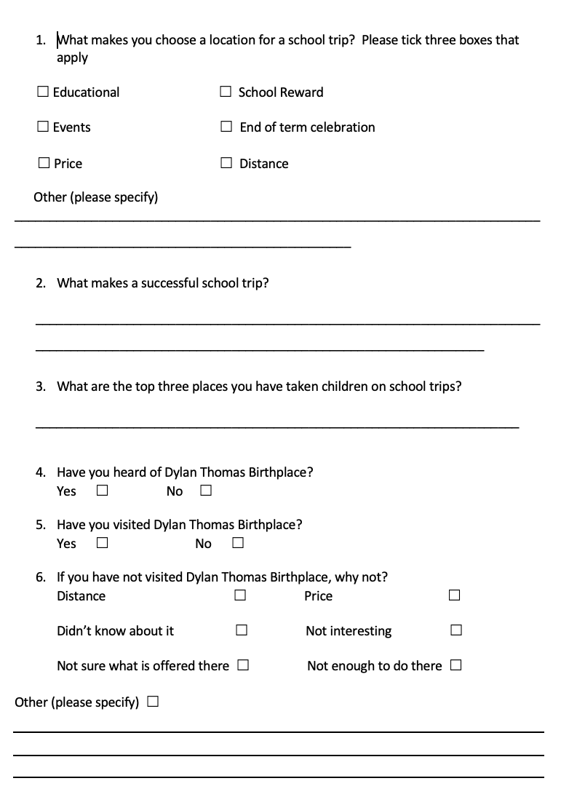

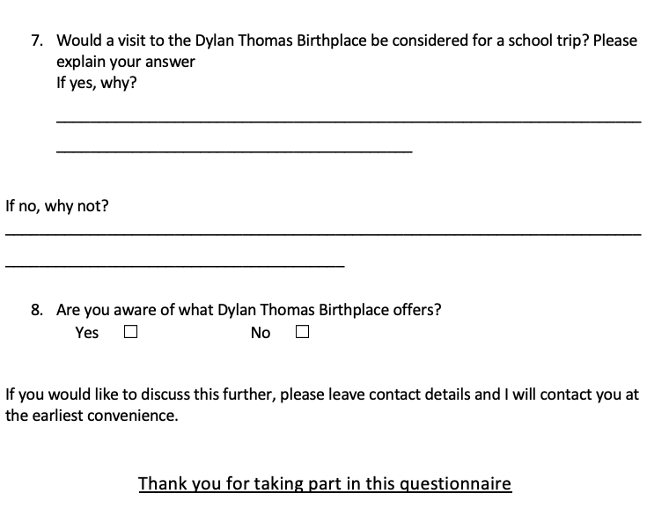

11.2 Appendix 2
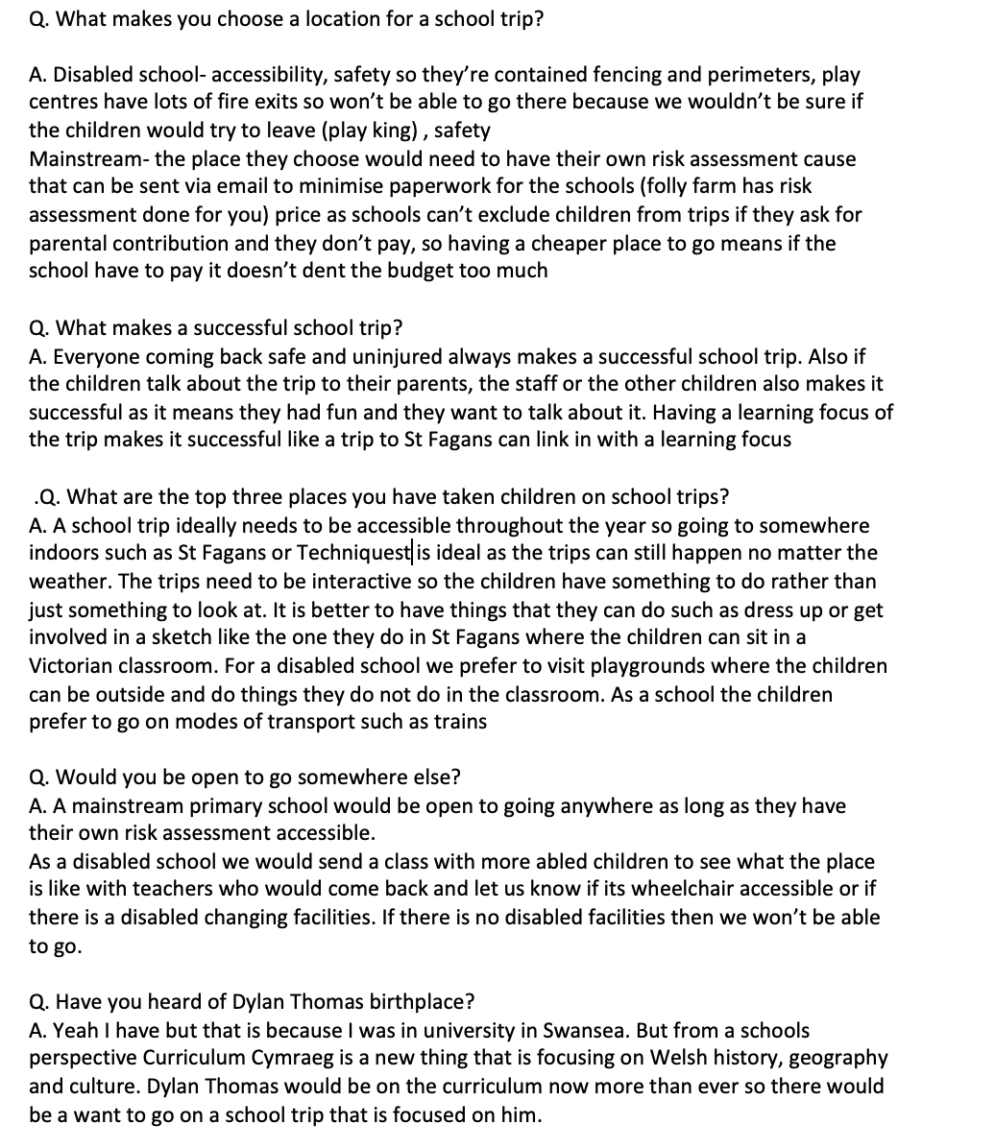

11.3 Appendix 3

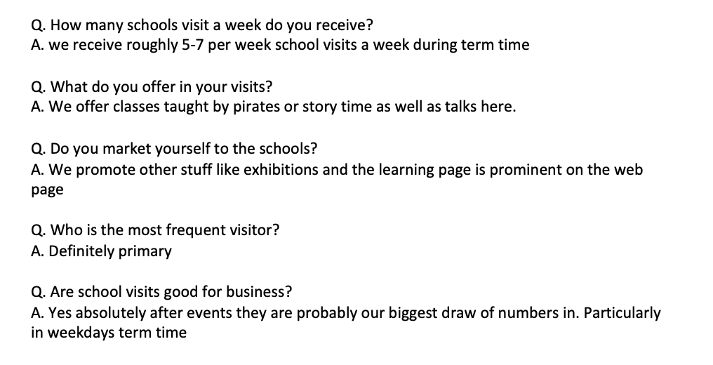

11.4 Appendix 4
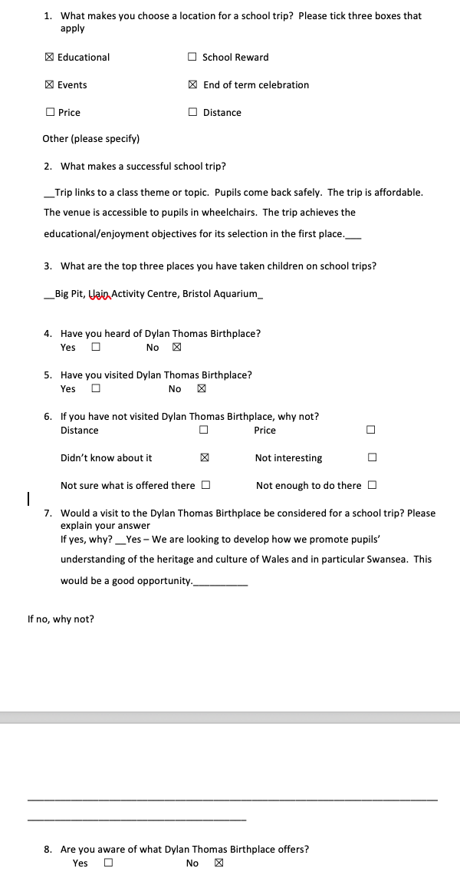

11.5 Appendix 5
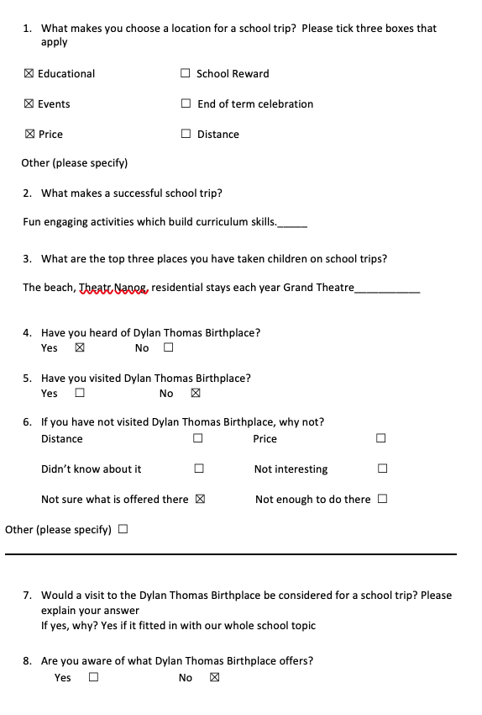

Appendix 6
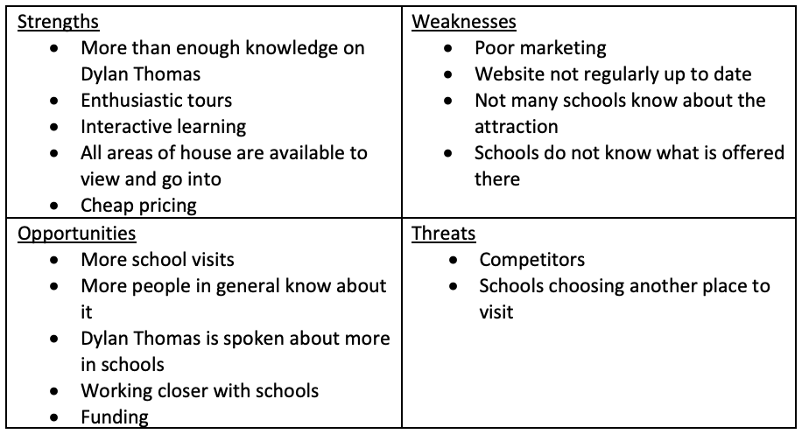

Bibliography

Dylan Thomas Birthplace. Available online at https://www.dylanthomasbirthplace.com/guidedtours . Accessed 8th May 2019.

1940s Swansea Bay. Available online at http://www.1940sswanseabay.co.uk/ . Accessed 8th May 2019.

Developing the Curriculum Cymreig. Available online at https://learning.gov.wales/docs/learningwales/publications/130424-developing-the-curriculum-cymreig-en.pdf . Accessed 8th May 2019.

National Waterfront Museum: Swansea. Available online at https://museum.wales/swansea/learning/ . Accessed 8th May 2019.

