

Hospitality & Tourism Management
BA International Hotel Management

Portfolio 4 components (Component 1, 2, and 3)

Student Name:
Nicoleta Cornelia Mocanu
Student ID:
2220990
Tutor's Name:
Giulia Chifari

Foreign Languages and Cultural Awareness- BMIH5003

Introduction
Component 1: Professional Reflection (page 2.)
- Scenario Description
- Analysis of Cultural Misunderstanding
- Reflective Skills Development
Component 2: Training Plan (page 3.)
- Introduction
- Objectives of the Training Plan
- Key Components of the Training Plan
- Implementation Strategy
- Evaluation and Feedback
Component 3: Student Self-Reflection (page 5.)
- Introduction to Self-Reflection Model
- Initial Understanding of Cultural Awareness
- Insights Gained from Experience
- Importance of the Experience
Conclusion
References
Introduction
The portfolio delves into the culturally aware world of hospitality. It strikes a professional note reflecting from first-hand experiences, provides detailed training plans on cultural competence as well self-analysis cases using Gibbs' Reflective Cycle. By doing so, we hope these pieces can help readers realize how important is cultural sensitivity for service quality improvement and customer happiness. . ghj
Component 1. - Professional Reflection
1.1 Scenario Description
An example of a scenario during breakfast service in a large hotel restaurant. As an F&B worker, I encounter a guest with different cultural affinities. The guest, who does not speak English, attempts to order a traditional breakfast special, not on our menu, from their culture. Because of their unknown accent and terms that I don't understand, I bring them something completely different mistakenly leading to confusion and dissatisfaction.
1.2 Analysis of Cultural Misinterpretation
The less developed ability to understand other people, especially as it relates to languages or diverse cultural dietary habits, is the main reason for such misunderstandings between people. Cultures deeply affect how we talk and what we expect from speech, according to Hofstede et al. (2010). But if service providers are not also attuned properly to figurative meanings (Hofstede, Hofstede, and Minkov, 2010), misinterpretations can easily ensue. Also, as Trompenaars and Woolliams (2003) points out, understanding and adapting to different cultural contexts is significant in avoiding service catastrophes in hospitality.
1.3 Reflective Skills Development
To avoid similar misunderstandings in the future, it is essential to develop cultural sensitivity. This includes improving linguistic skills, especially in widely used international languages, and undergoing cultural sensitivity training (Earley and Ang, 2003). Intent questions can ensure they get the service they need, by letting the guest explain their needs explicitly and comprehensively without feeling embarrassed. Regular team talks on cultural awareness, including practical experience-based exercises (Schneider & Barsoux, 2017), shall better equip staff to tackle these situations.
Going from reflective skills development into the curriculum of hospitality education, it is also very important to systematize cultural sensitivity training throughout. As stressed by Gundersen and Adler (2008), getting a full understanding of cultural diversity is not simply about picking up on visual markers of culture but also recognizes the underlying values, beliefs and behaviours that inform people's expectations as well as behaviour. This comprehensive approach means that members of the F&B team are not just responsive but also pre-emptive in their service.
Moreover, technology-enhanced instruction also has an important role to play in cultural training. Multimedia tools that allow for simulations of real-life situations or apps used to teach basic greetings and phrases in several languages at once can assist staff not only in learning the techniques they need muscle memory of these skills when using them out (Deresky, 2017). These tools offer an immersive and interactive experience which may lack traditional forms of learning, making the learning process both enjoyable and much more effective.
Moreover, cultural aptitude or participation in local communities could assist personnel in expanding their cultural understanding. This relationship has the potential to materialize theoretical notions into tangible experiences and foster the cultural fluency of personnel (Hampden-Turner & Trompenaars , 2020). Hospitality operators can ensure continuous learning and adaptation, which are essential for survival in the globalized service industry , by implementing these strategies.
Component 2. - Training Plan
Our hotel experienced a cultural misunderstanding in the breakfast service. Therefore, an all-encompassing training program for cultural competence is essential for our staff if they are to raise their level and reduce this sort of occurrence in future. This workbook is intended to give employees the skills they need to deal with cultural clashes effectively. By doing so it shall maintain a high standard of service and lift guest satisfaction.
2.2 Objectives of the Training Plan
- The goals for this training are:
- To increase cultural sensitivity in all employees.
- To improve language abilities which will serve a varied clientele.
- To help staff at our hotel realize and respect the dietary practices of different cultures so that they can better serve guests from diverse backgrounds.
- To develop better skills for solving problems which arise in culturally mixed situations.
2.3 Key Components of the Training Plan
Cultural Sensitivity Workshops: These are interactive sessions in which case studies and role-play provide a window onto the sorts of situations staff may face.
Language Skills Development: Beginning courses in common international languages French, Spanish and Mandarin.
Dietary Habits Training School: Staff should be given comprehensive information on global dietary habits and restrictions so that they can better accommodate diverse needs of guests.
Feedback Channels: A method should be set up whereby guests can give staff feedback on their experiences at the hotel about their cultural competence.
2.4 Implementation Strategy
The training will be introduced in stages, beginning with frontline personnel who come into contact most often with guests. Each module of training will take place, spread out over a series of workshops so that staff can both learn and absorb materials presented without being swamped. The training sessions will be required, and fitted in to inform work schedules all shifts so all staff can take part without hotel operations suffering.
2.5 Evaluation and Feedback
Following training, staff performance will be checked through both observation and by guest feedback. Therefore, frequent changes need to be scheduled when needed so that current abilities may be maintained and upgraded. Also, a means of gathering data on the training process is to be given to both staff and guests recommending improvements for constant improvement.
As part of the evaluation process, it is recommended that a formal evaluation framework such as Kirkpatrick's Four Levels of Training Evaluation be applied. This approach assesses training effectiveness on four levels: reaction, learning, behaviour, and results. It provides a comprehensive review that considers how well training has been received, the degree of new knowledge or skills acquired, to what extent learned abilities are applied in real life situations and guest satisfaction as a result (Kirkpatrick and Kirkpatrick, 2006).
Component 3. - Student Self-Reflection
3.1 Introduction to Self-Reflection Model
In this contemplation of self-reflection, I will use Gibbs' Reflective Cycle Model, a method that insists on examining experiences, step by step. There is identification with the situation and sympathizing with feelings. Evaluation comes after this immediate response. Analysis is done to make sense of it. Conclusion is drawn. What else could have been done in this situation? Finally, action planning for future events takes place based on what has just been learned in this round.
This way suits my job in the hospitality industry and enabled me to investigate my comprehension and development of cultural discernment.
3.2 Initial Understanding of Cultural Awareness
When the question of 'cultural awareness came up first, my knowledge was very thin. Aware of this I learned that it was a must for the hospitality industry, mainly because of foreigners 'guests and staff. But my perspective of culture was largely confined to using politeness customs and uttering the most elementary greetings in each foreign language influence is a citation from Maheshkar and Sharma (2018), where they discuss those very fundamental cultural phenomena needed for commerce.
3.3 Insights Gained from Experience
The real learning began after I saw such a cultural misunderstanding occur between an associate and guest at the time of my internship, an episode akin to Christiansen et al., (2020) where business dealings were profoundly altered by cultural nuances. This incident showed the depth of cultural complexity and need for deep competence, not mere superficial awareness. Training sessions and practical engagements described in works by Schneider and Barsoux (2017) provided an array of frameworks that allowed me to delve deeper into cultural dimensions. In this way, I went from simple acceptance of otherness to active participation with changing practices and customs.
3.4 Importance of the Experience
This experience was crucial. It was my first real insight into transforming theoretical knowledge into practical application. The conclusion that must be drawn is that cultural intelligence is a priority for hotel management. This sector is known worldwide because of its service excellence and customer satisfaction. In conclusion Trompenaars and Woolliams (2003) perfectly express that in any global industry--and especially in the hospitality industry where customer contact is constant--being able to travel happily down culturally integrated paths is indeed a necessary condition for achieving. success
The deep significance of this experience is also related to ethical factors in cultural intelligence: An acquaintance with local customs can only improve the quality of your services and cement respect among different ethnic groups who are customers. That ethical intercultural interactions are the cornerstone of creating design enriching environments where every person feels at home was observed by Thomas and Peterson (2 0 1 7). In my subsequent contacts with customers, I developed further this ethical view and made a big effort to treat everyone equitably. It was received with warm approval by those customers who made me feel responsible for their satisfaction.









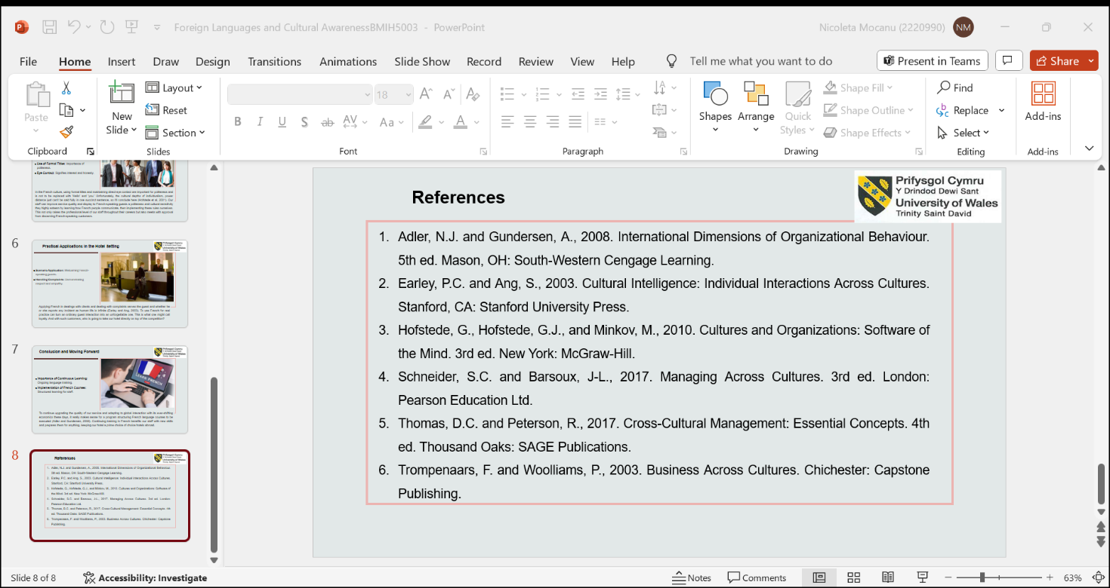
Conclusion
In conclusion, the portfolio illustrates the critical inspiration that comes from cultural intelligence in the hospitality business. By drawing on personal experience, by putting into operation a strategically thought-out training timetable turning some deep internal thoughts towards oneself, and by summarizing the news at hand, the need for continuous learning and to make adjustments as necessary is repeatedly emphasized. These programs do not only improve service delivery, but they also create a warm and accepting environment where cultural diversity is both praised and respected.

References:
- Adler, N.J. and Gundersen, A., 2008. International Dimensions of Organizational Behaviour. 5th ed. Mason, OH: South-Western Cengage Learning.
- Bhagat, R.S. and Steers, R.M., eds., 2009. Cambridge Handbook of Culture, Organizations, and Work. Cambridge: Cambridge University Press.
- Christiansen, B., Branch, J.D. and Karmowska, J., 2020. Cultural Factors and Performance in 21st Century Businesses. Hershey: IGI Global.
- Deresky, H., 2017. International Management: Managing Across Borders and Cultures: Text and Cases. 9th ed. Harlow: Pearson Education Ltd.
- Earley, P.C. and Ang, S., 2003. Cultural Intelligence: Individual Interactions Across Cultures. Stanford, CA: Stanford University Press.
- Hampden-Turner, C. and Trompenaars, F., 2020. Riding the Waves of Culture. 4th ed. London: John Murray Press.
- Hofstede, G., Hofstede, G.J., and Minkov, M., 2010. Cultures and Organizations: Software of the Mind. 3rd ed. New York: McGraw-Hill.
- Kirkpatrick, D.L. and Kirkpatrick, J.D., 2006. Evaluating Training Programs: The Four Levels. 3rd ed. San Francisco: Berrett-Koehler Publishers.
- Maheshkar, C. and Sharma, V., 2018. Handbook of Research on Cross-Cultural Business Education. Hershey: IGI Global.
- Schneider, S.C. and Barsoux, J-L., 2017. Managing Across Cultures. 3rd ed. London: Pearson Education Ltd.
- Thomas, D.C. and Peterson, R., 2017. Cross-Cultural Management: Essential Concepts. 4th ed. Thousand Oaks: SAGE Publications.
- Trompenaars, F. and Trompenaars, A., 2003. Riding the Waves of Culture: Understanding Cultural Diversity in Business. 3rd ed. London: Nicholas Brealey Publishing.
- Trompenaars, F. and Woolliams, P., 2003. Business Across Cultures. Chichester: Capstone Publishing.
- Trompenaars, F. and Woolliams, P., 2003. Managing Across Cultures. London: Nicholas Brealey Publishing.
- Woolliams, P. and Trompenaars, F., 2003. Business Across Cultures. Chichester: Capstone Publishing.

