
\

Student name: Maria Blachut
Student ID: 2337025
Module name: Changemakers: Building your Personal Brand for Sustainable Employment
Module code: BMHP5015_LON
Lecturer name: Caroline Salami

Table Of Contents
INTRODUCTION 3
Reflection on UNIT 1 3
Personal Branding 3
Ambition 4
Boundaryless Skills 5
Reflection on Unit 2 6
Networking 7
Comfort Zone 7
Diversity 8
REFLECTION ON UNIT 3 9
Influencing Tools 9
Serendipity 10
Stretch Goals 11
Reflection on Unit 4 12
Work-life Balance 12
Mentoring 14
Antifragile Thinking 15
Conclusion 17
References 17

INTRODUCTION
The Changemakers: Building Your Brand for Sustainable Employment course offered me meaningful insights into both personal and professional development over the duration of the programme. It focused on four central themes: personal branding, global awareness, opportunities, and the wellbeing. Each of these areas contributed to a broader understanding of how individuals can navigate an increasingly dynamic and competitive job market. In particular, the emphasis on adaptability and lifelong learning highlighted the importance of remaining flexible in response to evolving workplace demands (Johri, 2025).

Reflection on UNIT 1

Personal Branding
During the Changemakers: Building Your Brand for Sustainable Employment course, I explored the concept of personal branding and its importance in shaping professional identity (Calvo-Lorenzo, 2016). I developed an understanding that personal branding is not only about self-promotion but also about communicating a clear, authentic, and consistent message about my values, skills, and experiences. Through lectures and practical activities, I realised that my online presence, particularly on professional platforms, plays a significant role in how I am perceived by employers. I also recognised the importance of aligning my personal values with my professional goals to create a credible and trustworthy brand.
This learning can be linked to Personal Branding Theory, which emphasises the strategic presentation of self to differentiate oneself in a competitive labour market (Montoya and Vandehey, 2002). Furthermore, I developed an understanding of self-awareness as a foundation of effective personal branding. This aligns with the Johari Window model, which highlights how increasing self-awareness through feedback can enhance personal development (McLeod, 2023).
In the health and social care sector, developing a strong personal brand is important for demonstrating professionalism, trustworthiness, and a commitment to person-centred care, which helps build confidence among service users, colleagues, and employers.

Figure 1. Forum activity on Personal Branding

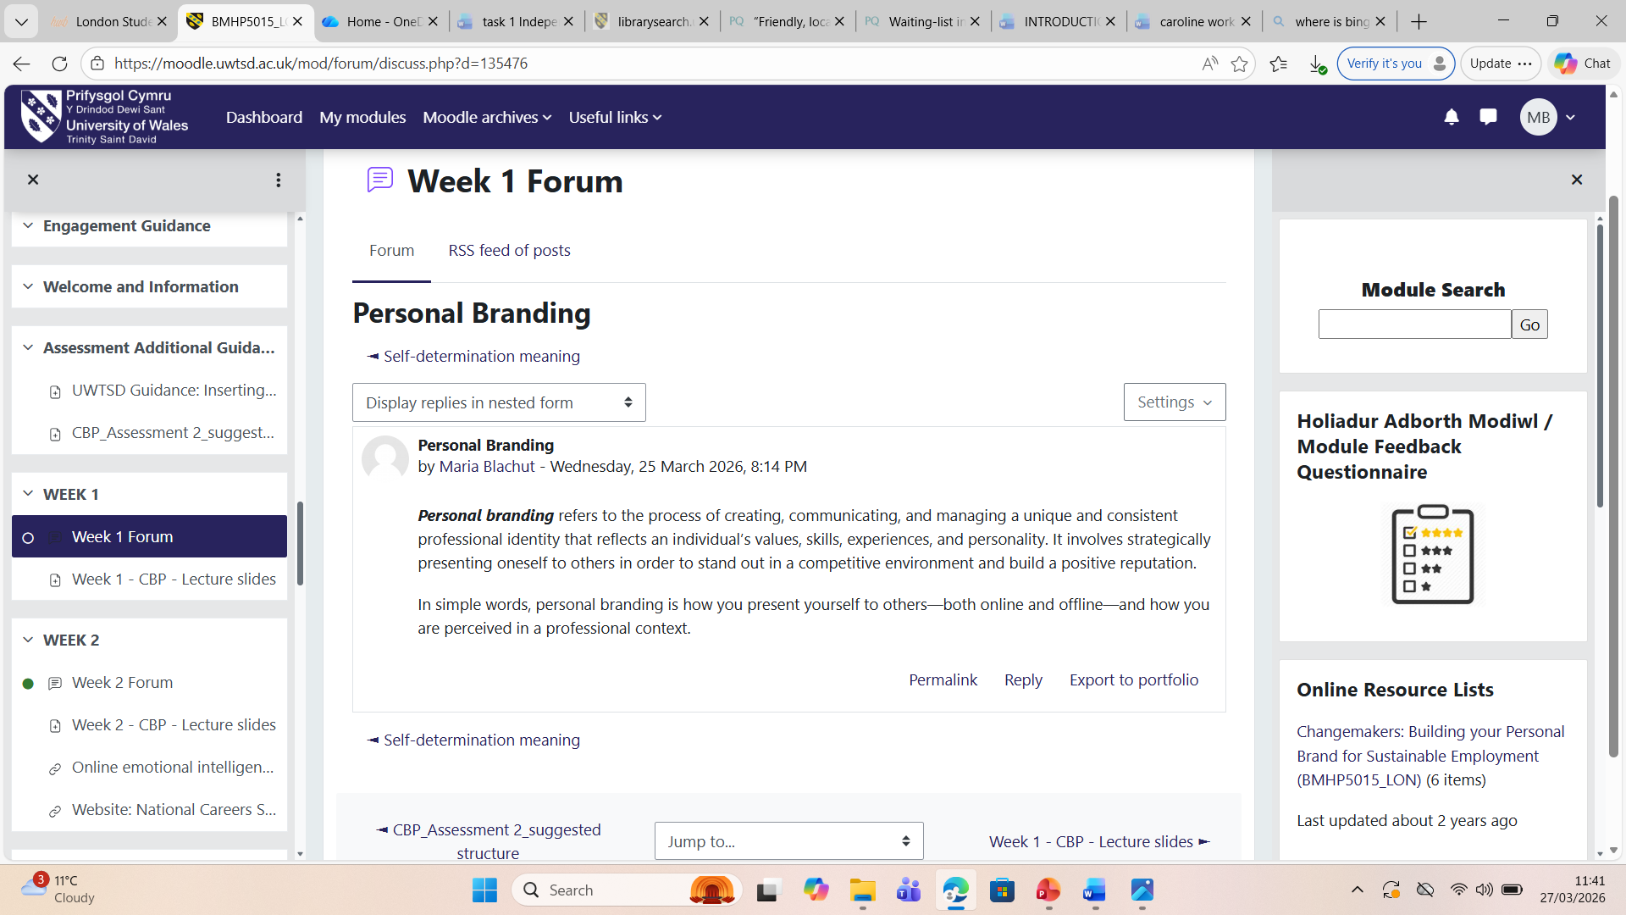

Ambition
During the course, I explored the concept of ambition and its role in personal and professional development. I developed an understanding that ambition involves setting clear goals and maintaining motivation to achieve long-term success (Mostajeran et al, 2025). I realised that ambition is not only about having high aspirations but also about being resilient and adaptable when facing challenges. Through lectures and activities, I recognised the importance of goal setting and self-discipline in sustaining progress. This learning can be linked to Goal-Setting Theory, which suggests that specific and challenging goals enhance performance (Locke and Latham, 2002). Overall, I now view ambition as a key driver of continuous growth and career advancement.
In a health and social care setting, ambition is essential for driving continuous improvement in practice, enabling professionals to set high standards for patient care, develop their skills, and contribute to better health and wellbeing outcomes for service users.

Figure 2. Forum activity on Ambition

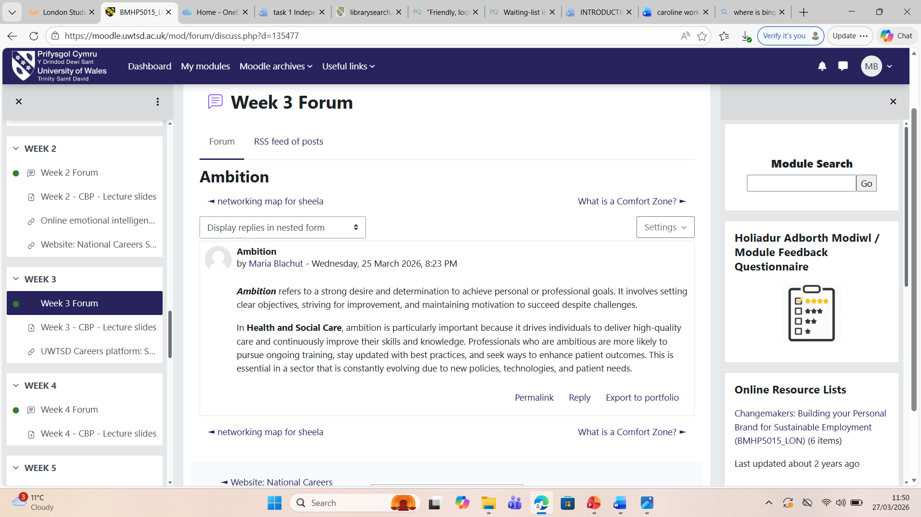

Boundaryless Skills
Furthermore, I explored the concept of boundaryless skills and their importance in a rapidly changing labour market (Haldorai, Pillai and Makawa, 2019). I developed an understanding that boundaryless skills, such as adaptability, communication, and problem-solving, enable individuals to move across different roles and organisations. I realised that traditional linear career paths are becoming less common, and individuals must continuously update their skills to remain competitive. Through lectures and activities, I learned the value of lifelong learning and flexibility in career development. This learning can be linked to Boundaryless Career Theory, which emphasises mobility and self-directed career management (Arthur and Rousseau, 1996).
In the health and social care sector, boundaryless skills are essential for working across different roles and settings, enabling professionals to adapt to changing service needs, collaborate effectively within multidisciplinary teams, and maintain high-quality, person-centred care.

Figure 3. Forum activity on boundaryless skills
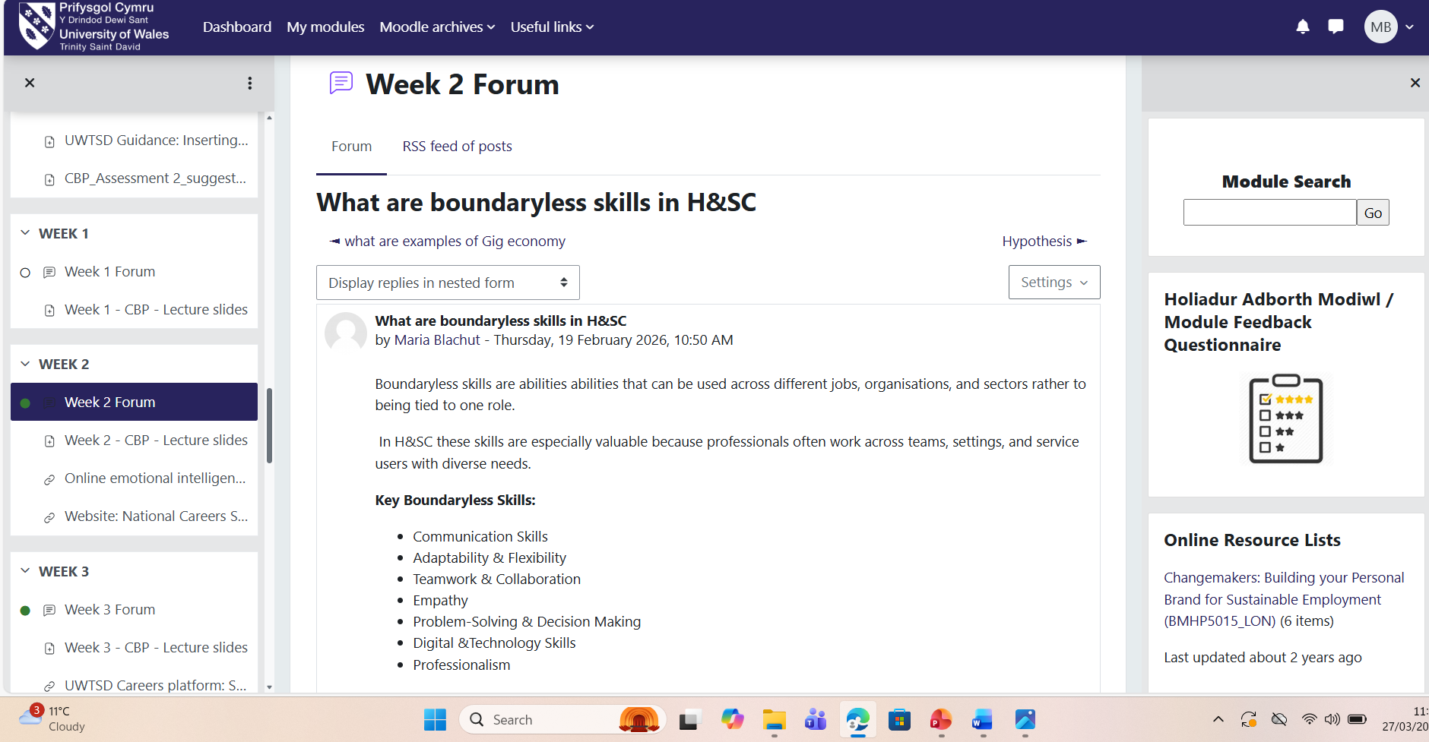

Reflection on Unit 2

Networking
During the Changemakers: Building Your Brand for Sustainable Employment course, I explored networking as an important professional development skill. I developed an understanding that networking is not just about meeting people, but about building meaningful, mutually beneficial relationships that support career growth. I learned that engaging with others both in person and online can increase visibility, create opportunities, and support knowledge sharing. This learning aligns with Granovetter’s (1973) theory of the “strength of weak ties,” which highlights how even less frequent connections can provide valuable information and opportunities. Overall, I now view networking as a purposeful and ongoing professional strategy.
In the health and social care sector, effective networking is essential for building collaborative relationships with multidisciplinary teams, enabling the sharing of knowledge, improving patient care, and creating opportunities for professional development across different services.
Figure 4. Forum activity on networking
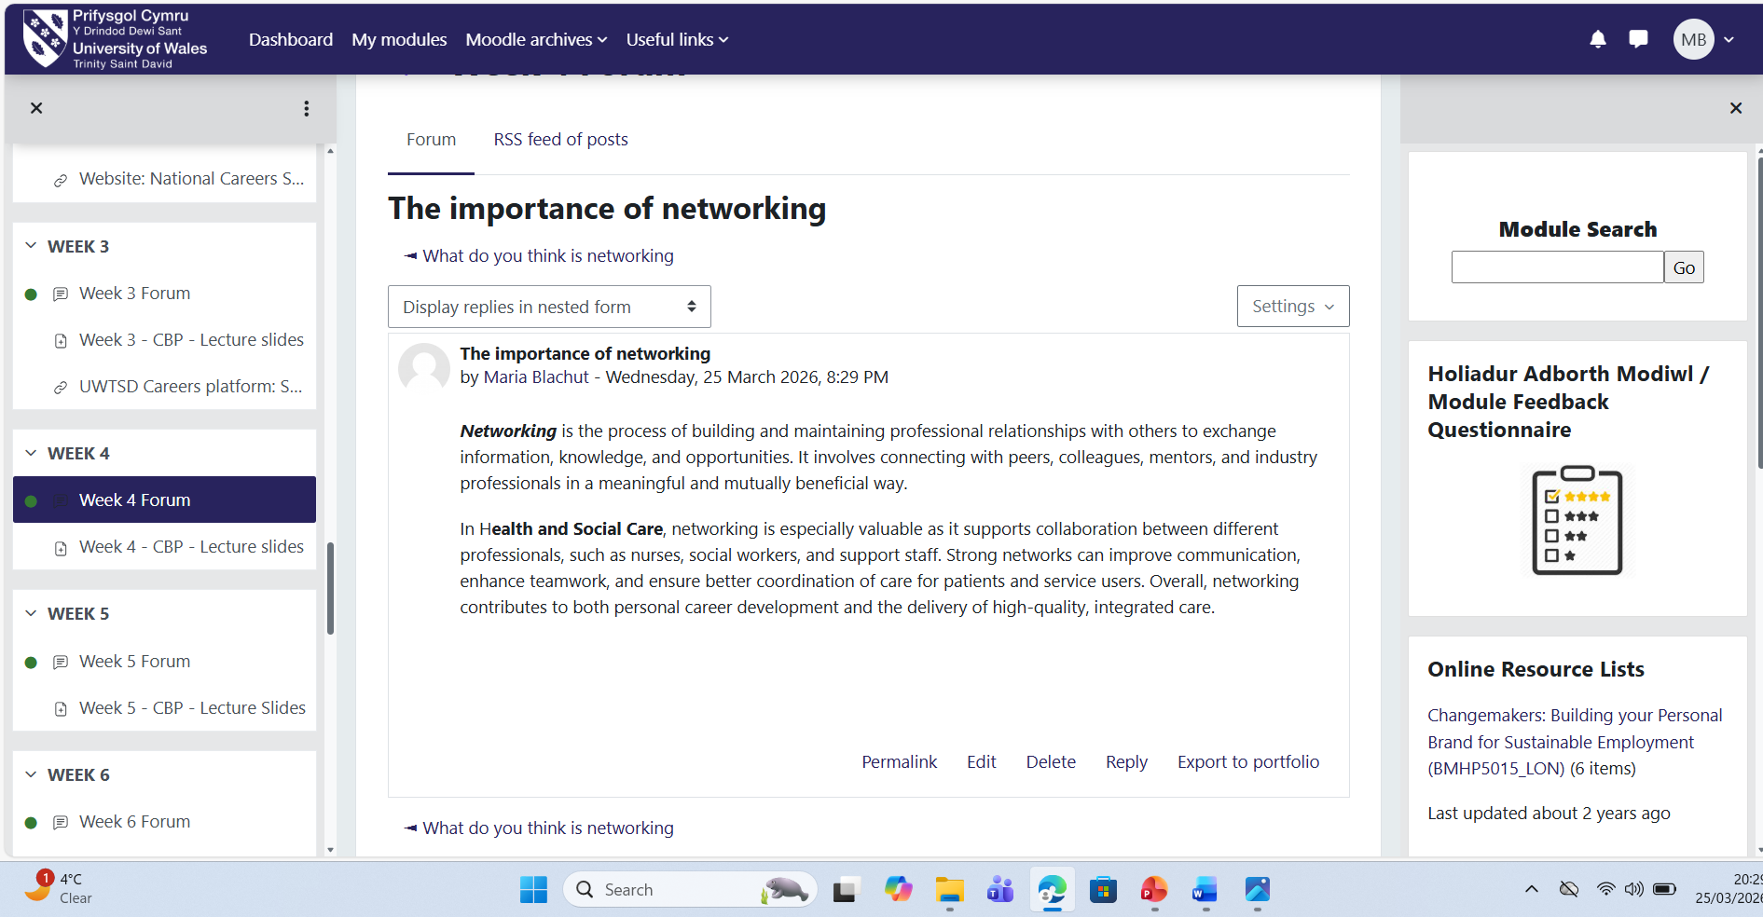

Comfort Zone
Moreover, I learned the concept of the comfort zone and its impact on personal and professional growth. I developed an understanding that remaining within familiar routines can limit opportunities for learning and development. I realised that stepping outside my comfort zone requires courage and self-awareness, but it also fosters resilience, creativity, and adaptability. I challenged myself to engage in unfamiliar tasks and reflect on the outcomes, which enhanced my confidence in handling new situations. This learning aligns with the Yerkes-Dodson Law, which suggests that moderate levels of stress or challenge can improve performance (Yerkes and Dodson, 1908), and with Growth Mindset Theory, which emphasises embracing challenges to develop abilities (Dweck, 2017). Overall, I now recognise that consciously stepping beyond my comfort zone is essential for continuous personal and career development.
In a health and social care setting, stepping outside one’s comfort zone is essential for adapting to complex patient needs, developing new clinical and interpersonal skills, and maintaining high standards of care in dynamic and often challenging environments.
Figure 5. Forum activity on comfort zone
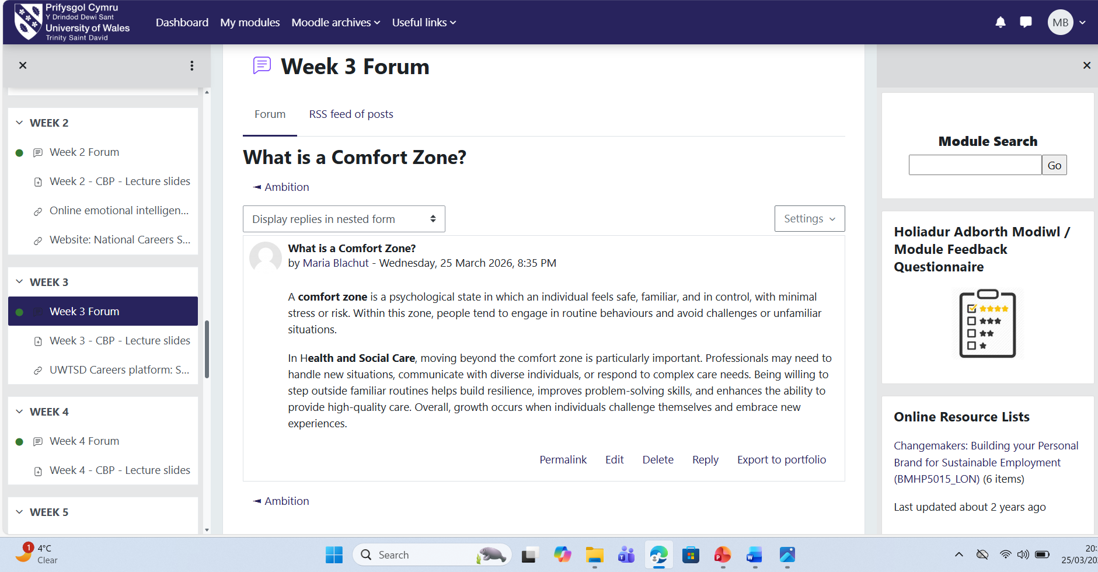

Diversity

During my learning and experiences, I explored the concept of diversity and its importance in personal and professional development. I developed an understanding that diversity involves more than recognising differences in culture, gender, or background; it also means actively valuing and using these differences to promote inclusion, collaboration, and innovation (Cox, 1993). I realised that working in diverse environments helps me challenge assumptions, reduce bias, and develop greater cultural awareness, empathy, and respect for others. This links to Shore et al.’s (2011) work on inclusion, which emphasises creating environments where individuals feel valued, supported, and able to contribute fully. Through reflection and group activities, I recognised that diverse perspectives strengthen teamwork, communication, and decision-making. Overall, I now appreciate that embracing diversity is essential for ethical practice, professional growth, and sustained career development in a competitive job market.
In the health and social care sector, embracing diversity is essential for delivering culturally competent, person-centred care, as it enables professionals to understand and respond effectively to the varied needs, backgrounds, and experiences of service users.

Figure 6. Forum activity on diversity
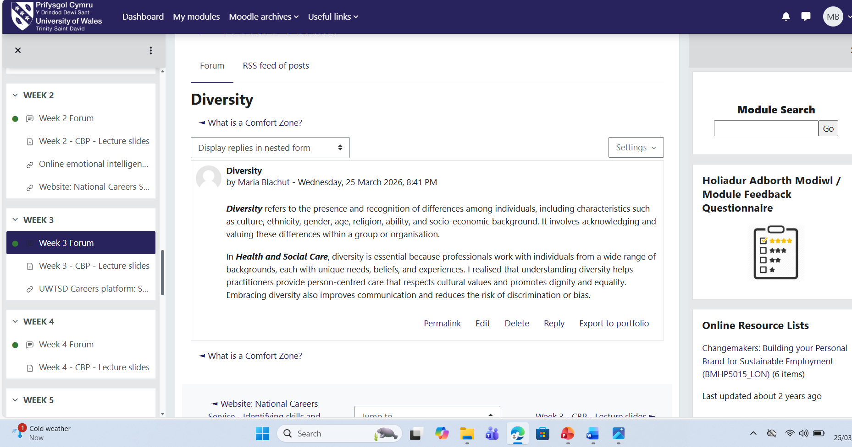

REFLECTION ON UNIT 3

Influencing Tools
During the course, I explored the concept of influencing tools and their importance in professional practice (Ferguson, Wakeling & Bowie, 2014). I developed an understanding that influencing tools are strategies used to guide and persuade others in a positive and ethical way. I realised that effective influence is not about control, but about building trust, credibility, and strong relationships. Through lectures and practical activities, I learned how skills such as active listening, clear communication, and emotional intelligence can enhance my ability to influence others. I also recognised the importance of adapting my communication style to suit different audiences and situations.
This learning can be linked to Cialdini’s (2001) Pinciples of Influence, including reciprocity, authority, and social proof, which explain how individuals are persuaded. In health and social care, these tools are essential for teamwork, advocating for patients, and supporting decision-making.

Figure 7. Forum activity on influencing tools
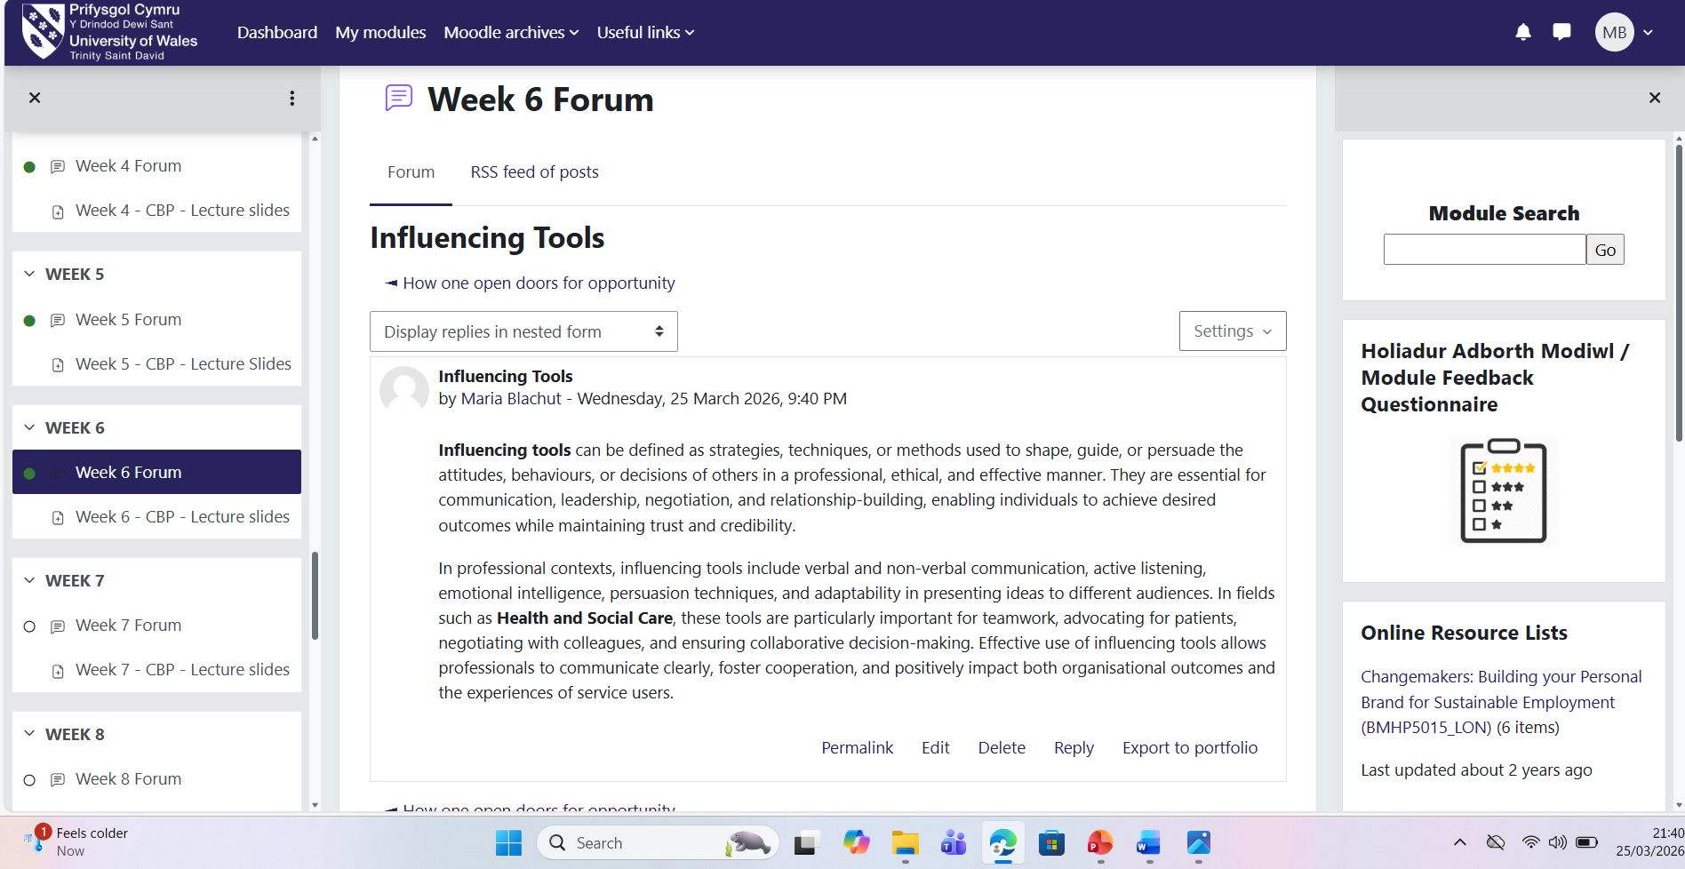

Serendipity
Additionally, I explored the concept of serendipity and its relevance to personal and professional development (Busch, 2024). I developed an understanding that not all career opportunities are planned, and being open-minded can lead to beneficial experiences. I realised that engaging in networking, trying new activities, and stepping outside my comfort zone can increase the likelihood of encountering unexpected opportunities. Through all activities, I recognised the importance of curiosity, adaptability, and a proactive attitude in making the most of such moments.
This learning can be linked to the concept of Planned Happenstance Theory, which suggests that individuals can create and benefit from chance events through their actions and behaviours (Krumboltz, 2009).
In the health and social care sector, embracing serendipity can lead to unexpected learning opportunities, new roles, or collaborative experiences that enhance professional development and improve the quality of care provided to service users.

Figure 8. Forum activity on serendipity
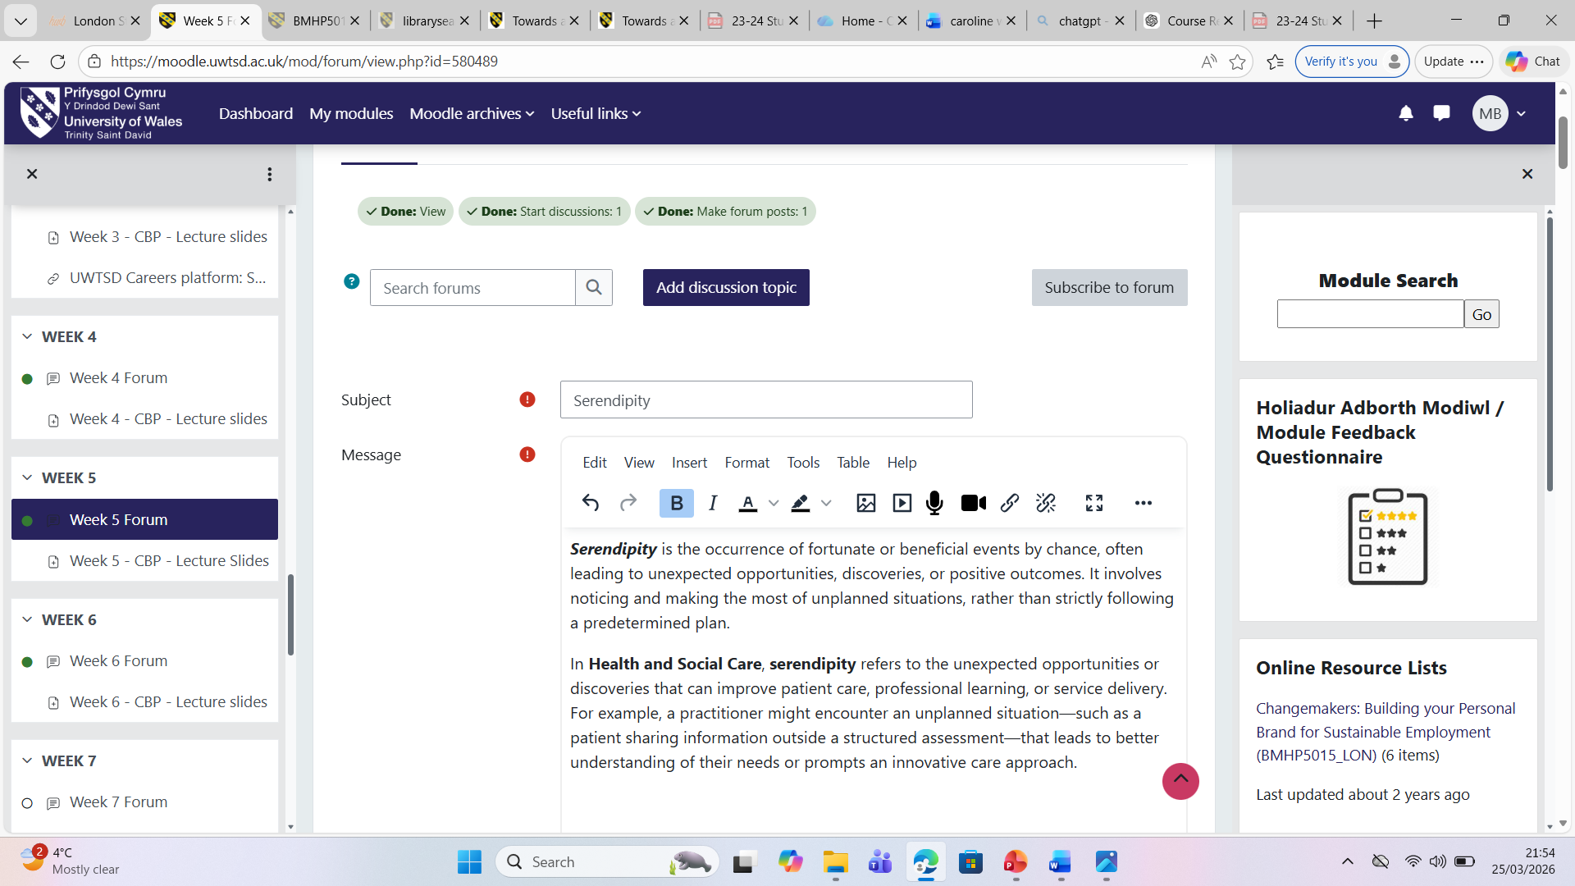

Stretch Goals
I also explored the concept of stretch goals and their role in personal and professional development. I developed an understanding that setting ambitious targets encourages me to step beyond my comfort zone, build resilience, and enhance problem-solving abilities. I realised that while stretch goals can feel intimidating, they promote continuous learning and increase confidence once achieved. Through lectures and activities, I recognised the importance of balancing ambition with realistic planning, monitoring progress, and reflecting on outcomes.
This learning aligns with Locke and Latham’s (2002) Goal-Setting Theory, which suggests that specific, challenging goals lead to higher performance than easy or vague goals.
In the health and social care sector, setting stretch goals can support professionals in developing advanced skills, improving patient care practices, and striving for higher standards while maintaining safe and effective service delivery.

Figure 9. Forum activity on stretch goals
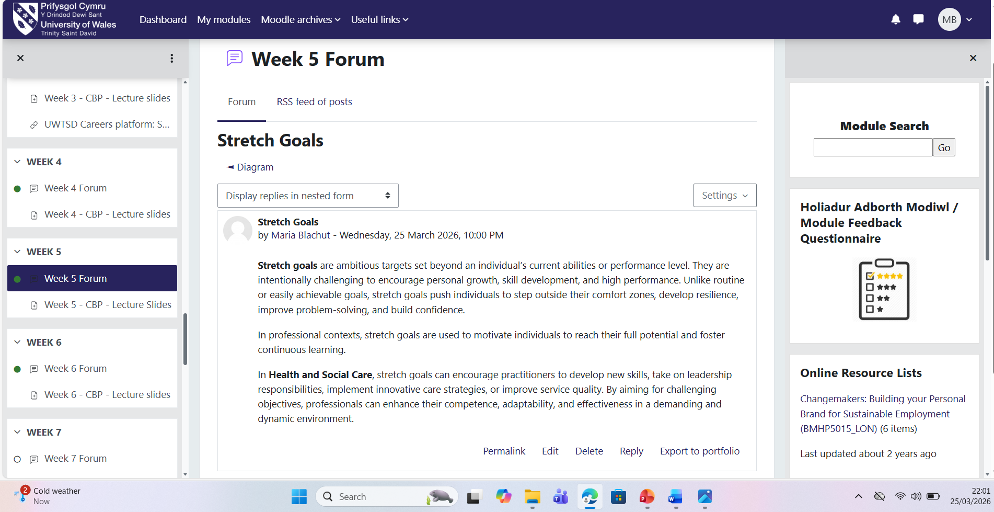

Reflection on Unit 4

Work-life Balance
During the Changemakers: Building Your Brand for Sustainable Employment course, I explored the concept of work-life balance and its importance in maintaining both personal wellbeing and long-term professional success (Gragnano, Simbula and Miglioretti, 2020). I developed an understanding that achieving a healthy work-life balance is not simply about dividing time equally between work and personal life, but about managing priorities in a way that supports overall wellbeing and productivity.
Through lectures and practical activities, I also became more aware of how overcommitment and poor boundaries can lead to stress and burnout, negatively impacting both personal and professional performance.
Additionally, I realised the importance of aligning my work habits with my personal values and wellbeing needs. This has encouraged me to adopt more sustainable practices, such as prioritising tasks, taking breaks, and ensuring time for rest and personal interests, in order to maintain a healthier and more balanced lifestyle.
Work–life balance can be effectively explained using Albert Bandura’s Social Cognitive Theory, which emphasises the interaction between personal factors, behaviour, and environment.
In a health and social care setting, maintaining a healthy work-life balance is essential for preventing burnout, supporting staff wellbeing, and ensuring professionals can consistently deliver safe, compassionate, and high-quality care to service users.

Figure 10. Forum activity on work-life balance

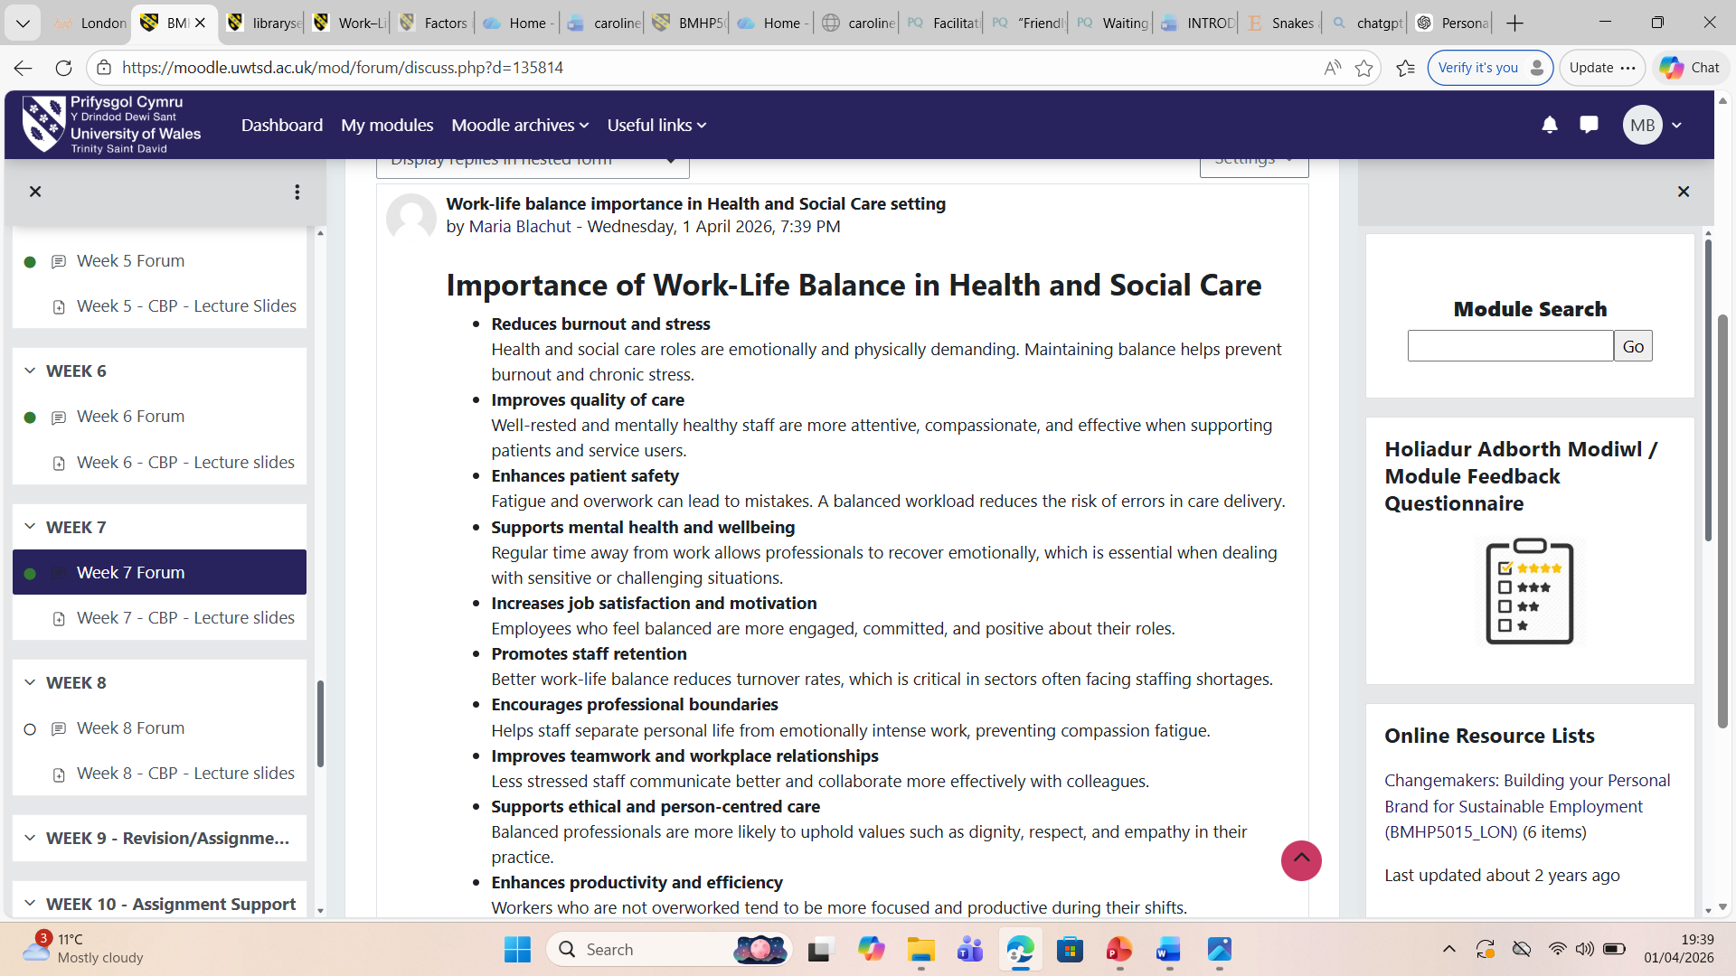

Mentoring
During my learning, I developed an understanding of the importance of mentoring and its role in supporting professional growth (Nabi et al, 2024). I realised that mentoring is not only about receiving guidance but also about developing confidence, skills, and knowledge through the support of more experienced colleagues. Through observation and interaction, I recognised that having a mentor provides valuable feedback and encouragement, which can improve job performance and help identify areas for development.
This experience can be linked to David A. Kolb’s Experiential Learning Theory, which highlights learning as a continuous cycle. For example, engaging with a mentor provides a concrete experience, where I am actively involved in learning within the workplace. Reflecting on the advice and feedback given represents reflective observation, allowing me to think critically about my actions and performance. Applying this feedback in practice demonstrates active experimentation, where I test new approaches and improve my skills. Finally, this leads to abstract conceptualisation, where I develop a deeper understanding of professional practice.
In a health and social care setting, mentoring plays a vital role in supporting continuous professional development by enabling less experienced staff to learn from senior practitioners, reflect on practice, and apply feedback to improve the quality and safety of patient care.

Figure 11. Forum activity on mentoring
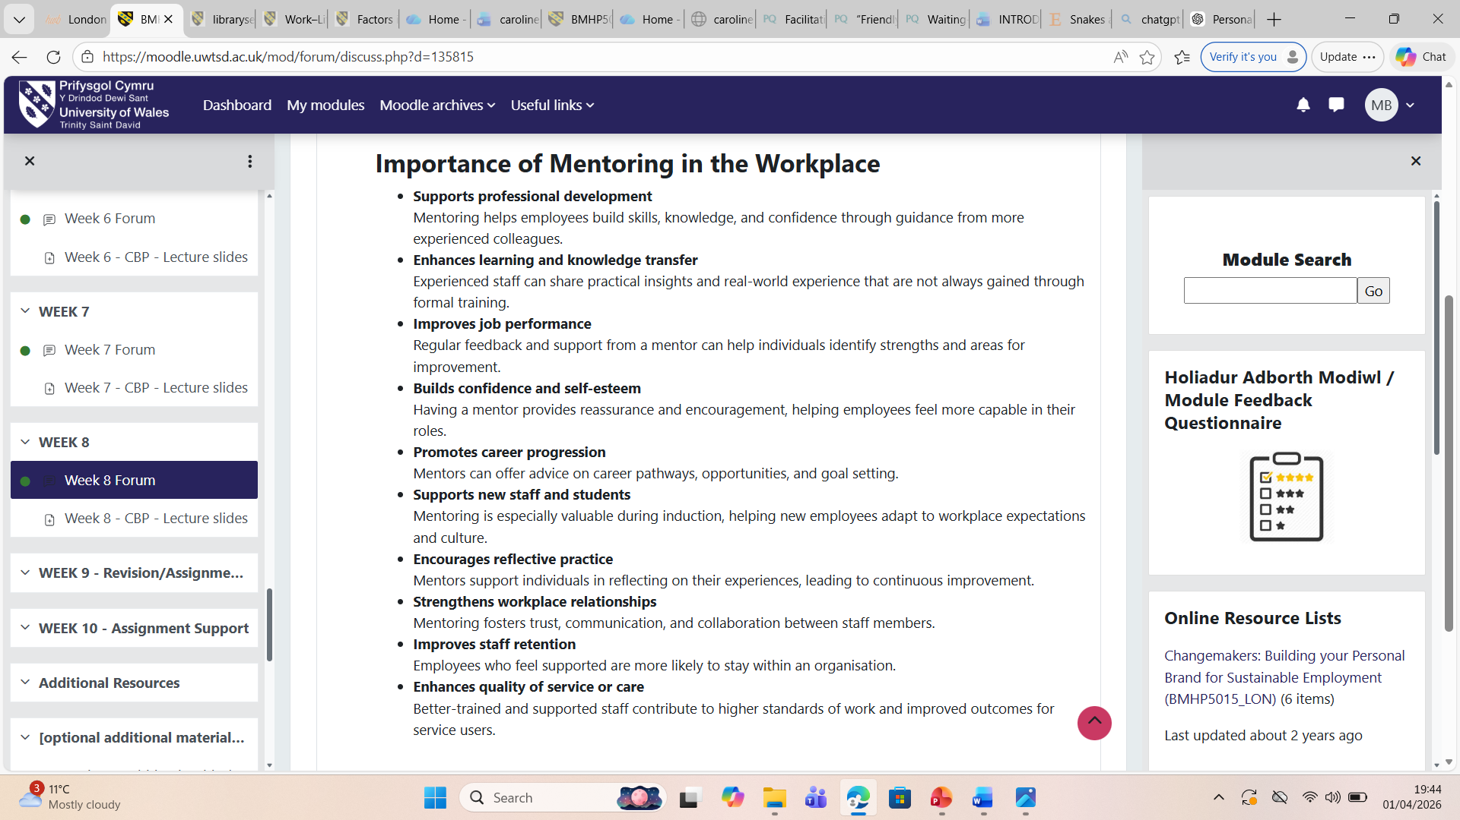

Antifragile Thinking
During my learning and experiences, I explored the concept of antifragile thinking, which encourages individuals and systems not only to withstand challenges but to grow stronger because of them (Smith, 2024). I realised that adopting an antifragile mindset involves embracing uncertainty, learning from failure, and viewing setbacks as opportunities for development rather than threats.
This links closely to David A. Kolb’s Experiential Learning Theory, which describes learning as a continuous cycle of experience, reflection, conceptualisation, and experimentation. Facing difficult situations provides concrete experience, while reflecting on outcomes develops reflective observation. Applying lessons in future situations demonstrates active experimentation, and integrating insights into professional understanding represents abstract conceptualisation. Overall, I now appreciate that challenges are essential to learning, resilience, and continuous personal and professional growth.
In a health and social care setting, adopting an antifragile mindset enables professionals to learn from challenges and adverse situations, using reflection and experience to strengthen practice, improve problem-solving, and enhance the quality and resilience of patient care.

Figure 12. Forum activity on antifragile thinking
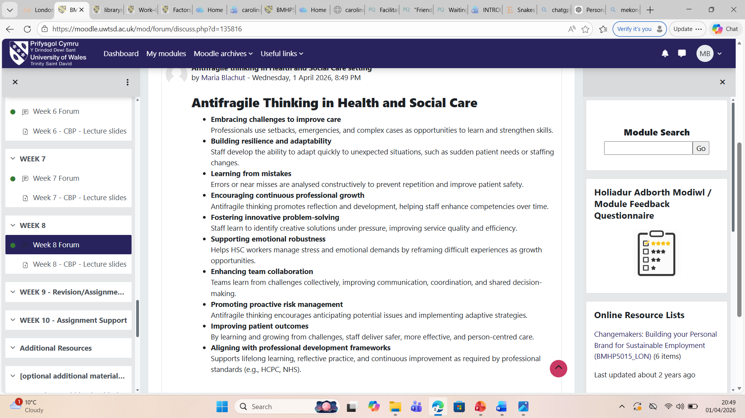

Conclusion
Overall, the topics covered throughout this course have supported my personal and professional development by strengthening my understanding of key employability concepts such as personal branding, ambition, networking, diversity, resilience, and work–life balance. I have learned how these areas contribute to success in both education and the workplace, particularly within a competitive and changing labour market. I also gained insight into relevant theories, including Bandura’s Social Cognitive Theory, Kolb’s Experiential Learning Theory, and Goal-Setting Theory, which help explain how learning and behaviour are developed over time. In addition, I now recognise the importance of transferable skills, reflective practice, and lifelong learning in continuous improvement. Within health and social care, these ideas are especially important for promoting safe, ethical, and person-centred practice. Overall, I feel better prepared to apply these concepts in future academic and professional contexts to support my ongoing development and career progression.

References

Arthur, M.B. and Rousseau, D.M. (1996) The boundaryless career: A new employment principle for a new organizational era. Oxford: Oxford University Press.
Busch, C. (2024) ‘Towards a theory of serendipity: A systematic review and conceptualization’, Journal of Management Studies, 61(3), pp. 1110–1151. Available at: https://doi.org/10.1111/joms.12890 (Accessed: 1 April 2026).
Calvo-Lorenzo, M. (2016) ‘Personal branding’, Journal of Animal Science, 94, pp. 93–93. Available at: https://doi.org/10.2527/jam2016-0195 (Accessed: 1 April 2026).
Cialdini, R.B. (2001) Influence: Science and practice. 4th edn. Boston: Allyn & Bacon.
Cox, T. (1993) Cultural diversity in organizations: Theory, research and practice. San Francisco: Berrett-Koehler.
Dweck, C.S. (2017) Mindset: Changing the way you think to fulfil your potential. Updated edn. London: Robinson.
Ferguson, J., Wakeling, J. and Bowie, P. (2014) ‘Factors influencing the effectiveness of multisource feedback in improving the professional practice of medical doctors: A systematic review’, BMC Medical Education, 14(1). Available at: https://doi.org/10.1186/1472-6920-14-76 (Accessed: 1 April 2026).
Granovetter, M.S. (1973) ‘The strength of weak ties’, American Journal of Sociology, 78(6), pp. 1360–1380.
Gragnano, A., Simbula, S. and Miglioretti, M. (2020) ‘Work–Life balance: Weighing the importance of work–family and work–health balance’, International Journal of Environmental Research and Public Health, 17(3), p. 907. Available at: https://doi.org/10.3390/ijerph17030907 (Accessed: 1 April 2026).
Haldorai, K., Pillai, S.G. and Makawa, A.T. (2019) ‘Factors influencing the choice of boundaryless careers – a PLS approach’, International Journal of Business and Globalisation, 22(2), pp. 188–205. Available at: https://doi.org/10.1504/IJBG.2019.098733 (Accessed: 1 April 2026).
Johri, A. (2025) ‘A qualitative field study of computing professionals’ dispositions for lifelong learning in the workplace’, ACM Transactions on Computing Education, 25(4). Available at: https://doi.org/10.1145/3749994 (Accessed: 1 April 2026).
Krumboltz, J.D. (2009) ‘The happenstance learning theory’, Journal of Career Assessment, 17(2), pp. 135–154.
Latham, G.P. and Pinder, C.C. (2005) ‘Work motivation theory and research at the dawn of the twenty-first century’, Annual Review of Psychology, 56, pp. 485–516.
Locke, E.A. and Latham, G.P. (2002) ‘Building a practically useful theory of goal setting and task motivation: A 35-year odyssey’, American Psychologist, 57(9), pp. 705–717.
McLeod, S. (2023) ‘Johari Window’. Available at: https://www.simplypsychology.org/johari-window.html (Accessed: 24 March 2026).
Montoya, P. and Vandehey, T. (2002) The personal branding phenomenon: Realize greater influence, explosive income growth and rapid career advancement by applying the branding techniques of Michael, Martha and Oprah. Santa Ana, CA: Personal Branding Press.
Mostajeran, Z., Kazemi, M., Alimirzaie, M. and Asanjarani, F. (2025) ‘Career aspirations: A structural equation model analyzing the role of academic vitality and academic self-regulation’, International Journal of Adolescence and Youth, 30(1). Available at: https://doi.org/10.1080/02673843.2025.2559814 (Accessed: 1 April 2026).
Nabi, G., Walmsley, A., Mir, M. and Osman, S. (2024) ‘The impact of mentoring in higher education on student career development: A systematic review and research agenda’, Studies in Higher Education, [online] Available at: https://www.tandfonline.com/doi/abs/10.1080/03075079.2024.2354894 (Accessed: 1 April 2026).
Kolb, D.A. (1984) Experiential Learning: Experience as the Source of Learning and Development. Englewood Cliffs, NJ: Prentice Hall.
Ragins, B.R. and Kram, K.E. (2023) The handbook of mentoring at work: Theory, research, and practice. Thousand Oaks, CA: Sage.
Shore, L.M., Randel, A.E., Chung, B.G., Dean, M.A., Ehrhart, K.H. and Singh, G. (2011) ‘Inclusion and diversity in work groups: A review and model for future research’, Journal of Management, 37(4), pp. 1262–1289.
Smith, J.A. (2024) ‘When resilience is not enough: Theoretical development and validation of the antifragility at work scale’, Personality and Individual Differences, 231, p. 112818.
Yerkes, R.M. and Dodson, J.D. (1908) ‘The relation of strength of stimulus to rapidity of habit-formation’, Journal of Comparative Neurology and Psychology, 18(5), pp. 459–482.

