Cover page

Name: Alina Roxana Capitanescu
Student Number: 1715249
Module Title: Business Skills for the Hotel Industry
Assignment Title: Business Skills for International Hotel Industry
Module Lecturer’s Name: Dale Clarke

Introduction
As part of this report I will explore the legal legislative risk that managers and employees need to consider in the hotel industry. I will touch on subjects such as liability, data protection, health and safety, food hygiene, risk management, licensing, including key provisions within Hotel Proprietors Act 1956.The UK’s hospitality sector remains as dynamic and fast paced as ever. The industry is no stranger to some of the hottest subjects in UK employment law and faces a countless number of challenges which show no sign of reducing in the future. Hotels are subject to a large number of roles and laws, that affect the building or the services provided. Internationally hotels must adapt to the laws and regulations of each country and that could be slightly different within the European Union. Legislative risk is the potential that legislation or regulations by the government could destroy companies and industries with only one shock waves sent. All the legislations mentioned above will keep any manager out of trouble.
Data protection
The hospitality industry is one of the most vulnerable sectors in the world when it comes to data privacy. When it comes to the hotel section, data protection is an essential aspect, since it includes managing information in various fields: economic . data such as bank accounts and credit or debit cards, financial (financial profits accounts, investments and bank transactions, balance of results and profits and losses) and personal (purchases at the hotel, tastes and likings of the client, details about the trip, companions).
The General Data Protection Regulation (GDPR) is a regulation of the European Union (EU) that came into effect on May 25, 2018. It presents significant controls and restrictions on how businesses, including hotels, may use, manage and share an individual’s personal data.
There are three main types of data collected by hospitality operators: personal data, preference data and transaction data. Personal data includes guests basic information including name, date of birth and contact information. Preference data is tracked by hotels to understand what guests like the most, including room type, late check-out requests and more.
Finally, transaction data is collected through a point of sale, reservation system or payment-enabled service and may include credit card information or bank numbers.
All companies and organizations that operate in the EU or that provide or plan to offer goods or services to constituencies in the European Union are required to comply fully with the General Data Protection Regulation.
The Regulation applies to all travel agencies, Airbnb, tour operators, restaurants, inns, hotels, motels, bed-and-breakfasts, clubs, automobile rental agencies, aggregators and other travel and hospitality groups that operate in Europe.
General Data Protection Regulation is intended to stop the misuse of an individual’s personal information and to protect the individual’s rights by limiting how that information is used. The GDPR allows the consumers to take control by forcing companies to become transparent in how they collect, store and share their customers’ personal data information. All data about persons in the EU are covered under the GDPR. This includes both guests and employees. Hotels should file what personal data they hold, where it came from and with whom it is shared.
The GDPR requires that all personal data is kept safe and secure. To meet these legal obligations, hotels need to review and consider a wide range of systems, internal policies and contracts with vendors as part of their GDPR compliance. In addition to staff contracts and guest forms, this could also include Wi-Fi policies, CCTV policies and agreements about payment transactions.“Personal data” is any data about an identifiable person. For example, if the customer would be complaining to the police that your team has been revealed any personal information of the customer of his/ her documents, they would be able to get you the court.
A person can be identified by their name, email address, phone number, IP address, reservation number, or any information that allows them to be uniquely identified. In contrast to the old data protection laws, the GDPR defines “personal data” as any information that identifies or could potentially identify an individual. Hotels must also be aware that they are often guardians of sensitive personal information from the guests or members of staff. When a guest checks in with reception, a hotel may ask for travel documents or copies of ID, or if the guest has any dietary requirements.
This data could be sensitive personal data if it reveals ethnicity, race or religion. In such situations, rules about protecting that data will apply. Information relating to sexuality, biometric data, health or political beliefs are also seen as sensitive personal data, and this could apply to information held about hotel staff as well.

Health and safety/ Risk assessment
Risk assessment is an important step in protecting the employees and the employers. It helps you to focus on the risk that really matter in the workplace. The ones with the potential to cause real harm in many instances, straight forward measures can control risks. For example: ensuring spillages are cleaned up, so people do not slip or cupboards drawers are kept closed to ensure people do not trip. For most, that means simple cheap and effective measures to ensure that the workers are protected. (Morgan and Kuch,2015)
So, health and safety and risk assessment it’s suitable and sufficient analysis of all work stations provided by users and operators.

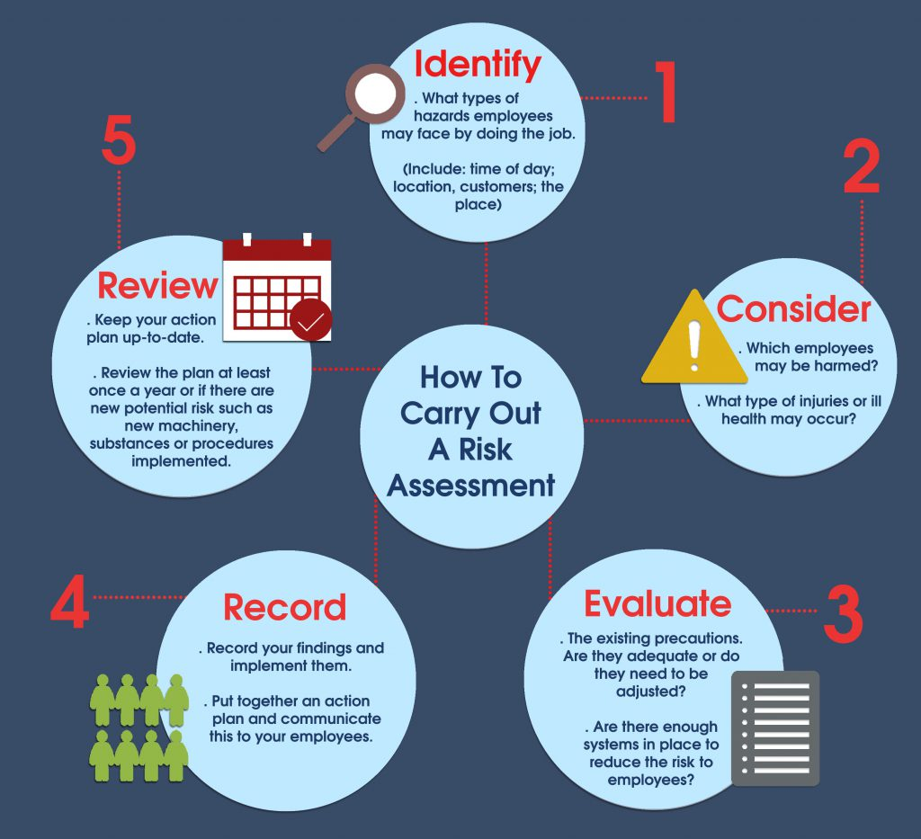

Health and safety
Health and safety is an important consideration for any workplace as it’s a high priority to keep both workers and guests safe. There are also some of the causes that are related to health and safety and these are termed as the hazards.
The most prominent and common hazards which are involved within the hospitality industry are the lifting and pushing along with the slips, falls and trips, which happens when slipping on the wet floors. In addition, occupational violence, risks with the cutting equipment and dangers related to the hot surfaces and substances are all attached with the health and safety measures (Kapuścińskiand Richards 2016).

Food Hygiene
There are also some of the consequences those are related to the food hygiene which includes the negligence in some of the sectors like cleaning, cross contamination, including the key disposal along with the cooking and chilling at the same place. The cooking and chilling include the phenomenon such as freezing and thawing.
The food hygiene is very important for the customers because foods and beverages are one of the important parts for the hospitality industry of the UK and it attracts a huge range of customers within a limited period (Adams,A 2016).

The Hotel Proprietors Act
There are some of the key provisions within the Hotel Proprietors Act 1956, where it is defined that Hotel is one of the establishments which is held out by the proprietors in offering foods and drinks if so required and sleeping accommodation and other privileges without special contract to any travellers It can be understood that under the Hotel Proprietors. Act 1956, the proprietor in any of such circumstances are liable in making good for any loss or damage to the property of the guests even though it happened due to the least fault of the proprietor or by any workers of that hotel.
Conclusion/ Recommendation
It can be concluded that the employability skills are much important for the workers to get themselves employed within the hospitality industry of the UK and these are also important for the employees who are working within the organization. On the other hand, legal and legislative risks are also described in the study which includes some of the key risks and provisions within the hospitality industry.
The risk assessment must be reviewed occasionally by operators or manager to reduce the risk or identify further hazards. The risk assessment has to be done for every single facility/ object that has been introduced in the hotel. All of the member of staff has to report any incident incident that is happening, otherwise they person injured would be able to claim or get you to the court within the next 5 years.

References:
Adam, A(1995) Food safety the formal solution for the hotel and catering industry? British Food Journal,97,(4),pp.19-, 23.
Kapuściński, G. and Richards, B., 2016. News framing effects on destination risk perception. Tourism Management, 57, pp.234-244.
Berlohniq, A., 1980. Special Event Risk Assessment Manual. Dada Point, CA: Event Risk Management, p. 259.
F. M., Monachello, M. L., and Baun, T. (1996). Human Resource Management in the Hospitality Industry. New York: J. Willey & Sons.
Sanders, T. A. B. (1999). Food production and food safety. British Marketing Journal, 318, pp. 1689-1693
Lugosi, P. And Jameson, S., 2017. Challenges in hospitality management education: Perspectives from the United Kingdom. Journal of hospitality and tourism management, 31, pp.163-172
Ariza-Montes, A., Arjona-Fuentes, J.M., Law, R. And Han, H., 2017. Incidence of workplace bullying among hospitality employees. International Journal of Contemporary Hospitality Management, 29(4), pp.1116-1132

