Assignment 1:
Task 2: Report


Name: Zaeem
Student No.: 1902036
Course: Applied Computing (Web Development)
Module: Internet Technology and Security
Date: 22/11/2019
Table of Contents
Content Page Number
- Introduction 3
2. Requirements 5
3. Implementation 12
3.1. Screenshots 12
3.2. Validation 15
4. Evaluation 17
5. References 19

1. Introduction
In this report, I will be discussing about a project that I have recently done. The project is about creating a website using the code of HTML and CSS. When creating the website, the program Visual Studio had to be used in order to type the HTML code and CSS code. Before I begin with my project. I will like to explain what CSS is and what HTML is.
CSS
CSS refers to cascading style sheet that lets the user to move designs from one web page on the user's website to another web page without any difficulty, simply by connecting the CSS on every web page. Saving all of the user design requirements in a folder lets users to modify the user's whole website design through modifying the user's CSS and also not needing to modify each single web page produced by the user that might create other problems. The CSS allows the user to change and make rules on how the user wants a text to look like, even if it's length, font, colour, or some other choices the user wants to change. [1]
Web pages will load faster because less code will be used to keep users interested. Once the user changes one of the web pages, it will be straightforward as the user could simply extend it with the other web pages as well, the larger the website, the more time it will allow the user and the quicker the website will be. This allows the user content into a user-friendly GUI, which basically tells the user to select the necessary information by a list and afterwards it will apply the HTML code to a user-friendly CSS, allowing the user to change or create this file in detail. [1]
HTML
The language where web pages are created will be the hypertext mark-up language also known as HTML. HTML includes of elements named tags which create a web page's content. It will be intended to change the presentation of text and images in internet browsers. I used HTML in my website to develop the size of every table and the website itself. The HTML includes meta tagging which allows user access details on web pages. HTML has been shown to arrange the website's physical elements between each web page's header, body and footer. The navigation bar was also developed in HTML, that can be used to switch from one page to another. Connecting a style sheet towards a website will be a great way to avoid the amount of HTML coding needed. The colour scheme, fonts and page layout which changes the appearance of an HTML website that has been included in my style sheet. [1]
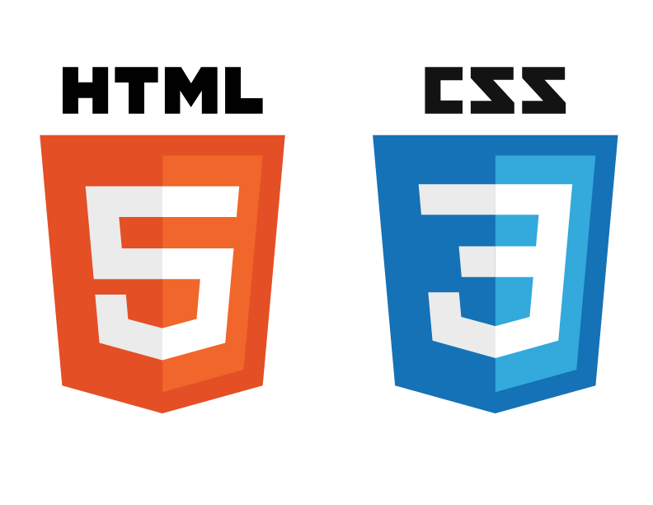

Image of HTML and CSS [2]

2. Requirements
I will explain in this report that my developed website meets the requirements and satisfies the objective, operating web layout, overall design, web usability and ease of use as these are the key points to be addressed in this report. [1]
I have created a website which consists of 6 pages titled Home, Avengers, Avengers Age of Ultron, Avengers Infinity War, Avengers Endgame and References as this contain information of Marvel Avengers series.
The overall style of the house includes an image from the internet and a simple background colour as the header and the navigation bar are at the top within the web page. The web pages will be called by the name of their specific navigation name so that users will see which page they access. I have selected an image and a background colour which goes well with the colour theme and is an eye-catching theme for the public. The target market for this particular website is targeted at teenagers or adults aged 16 to 40 who are interested in Marvel and Avengers. [1]
The size of the font and the layout have been made easy to read and I have ensured that there will be a difference between a heading, the main title underneath the navigation bar and the actual navigation bar content. I ensured that the text on the website content wasn't too small or too large, so users were able to see the difference between a heading and some information text. It will also be compatible, when the user goes on a particular page, it will not affect its style, and this will maintain its selected style during the whole website. Every link can be seen on each web page, as they will only show up at the top of the website in the navigation bar. The navigation bar would direct the user throughout the website. [1]
Home Page
The homepage includes a company logo image and a background picture as this will show the website theme. This will be more of a website introductory page. The cause behind this is that the title would show which page is being displayed and the content provides a formality to occur for anyone who might want to look at these movies. [1]
This also contains multiple icons leading to a new page to display different information about each movie to the public. However, with the user to install the Marvel app on Apple and Android, this will include two separate pages. In the home page, the website's aim is simple. Through adding a navigation bar feature, a logo image, pictures from the movie and their social media websites, I followed the basic specifications on the web page. [1]
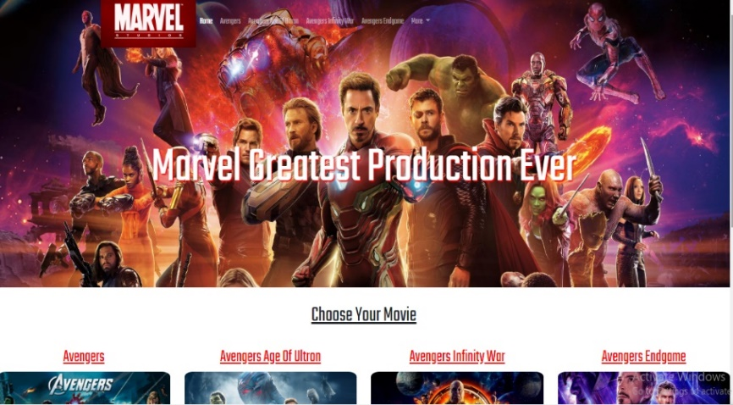

Navigation
The website's central navigation bar is noticeable because it is above the fold and at the middle of the view of the user. Since the navigation bar is a set of buttons representing web page names, the user will be advised that this is how to surf the website. It will also have visual animations such as the colour-changing links when the user hovers the mouse over it, showing that even the navigation bar will be interacted with and that every button can be clicked. Based on the website the user is on, the navigation bar will often change, the chosen page will be white to suit the web page layout and style. As there are eight pages at the top of the webpage, the amount of buttons is appropriate, so there must be a minimum of eight buttons on the navigation bar. Links will be also compatible and easily identifiable as the buttons will respond to the mouse of the user as it displays that this is a link. [1]
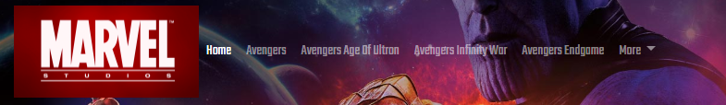

Avengers Page
The Avengers page shows a YouTube video towards the specific movie and the web page includes the story of the specific movie. “I have met the simple requirements in the web page by adding a navigation bar system, a picture of the logo” [1], pictures from the movie, a YouTube video towards the movie, information about the movie and their social media links.
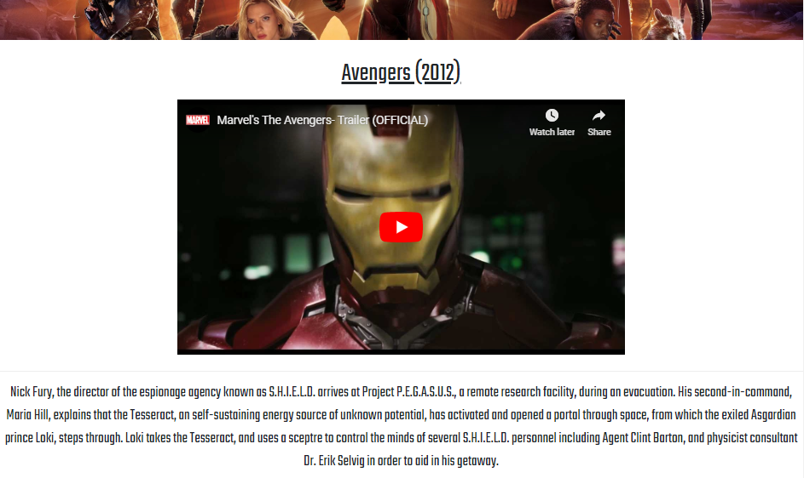

Avengers Age of Ultron Page
The Avengers Age of Ultron page shows a YouTube video towards the specific movie and the web page includes the story of the specific movie. “I have met the simple requirements in the web page by adding a navigation bar system, a picture of the logo” [1], pictures from the movie, a YouTube video towards the movie, information about the movie and their social media links.
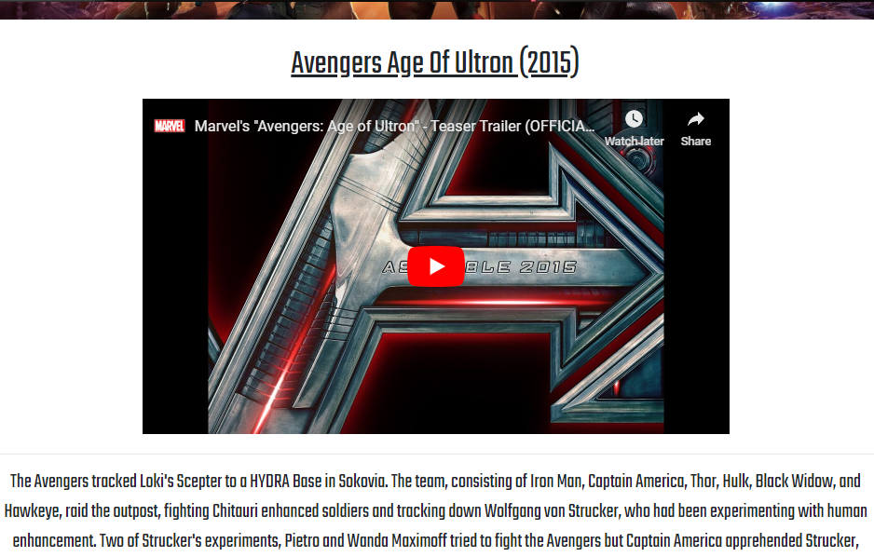

Avengers Infinity War Page
The Avengers Infinity War page shows a YouTube video towards the specific movie and the web page includes the story of the specific movie. “I have met the simple requirements in the web page by adding a navigation bar system, a picture of the logo” [1], pictures from the movie, a YouTube video towards the movie, information about the movie and their social media links.
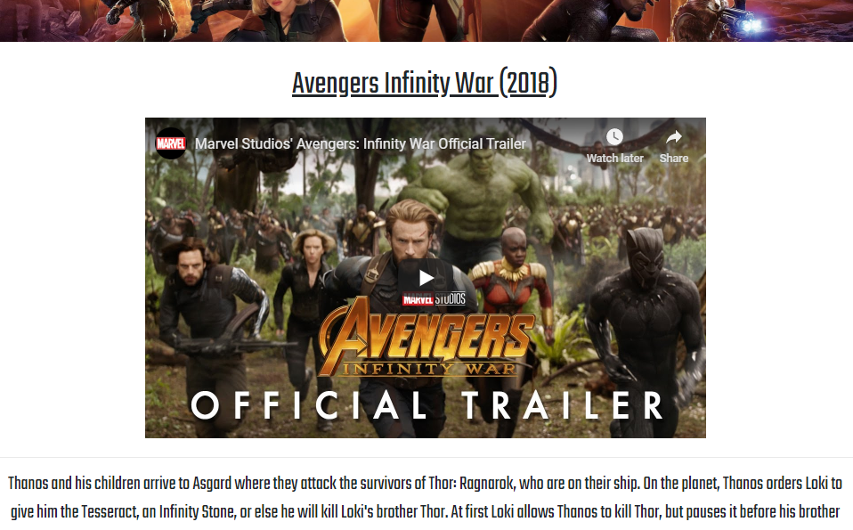

Avengers Endgame Page
The Avengers Endgame page shows a YouTube video towards the specific movie and the web page includes the story of the specific movie. “I have met the simple requirements in the web page by adding a navigation bar system, a picture of the logo” [1], pictures from the movie, a YouTube video towards the movie, information about the movie and their social media links.
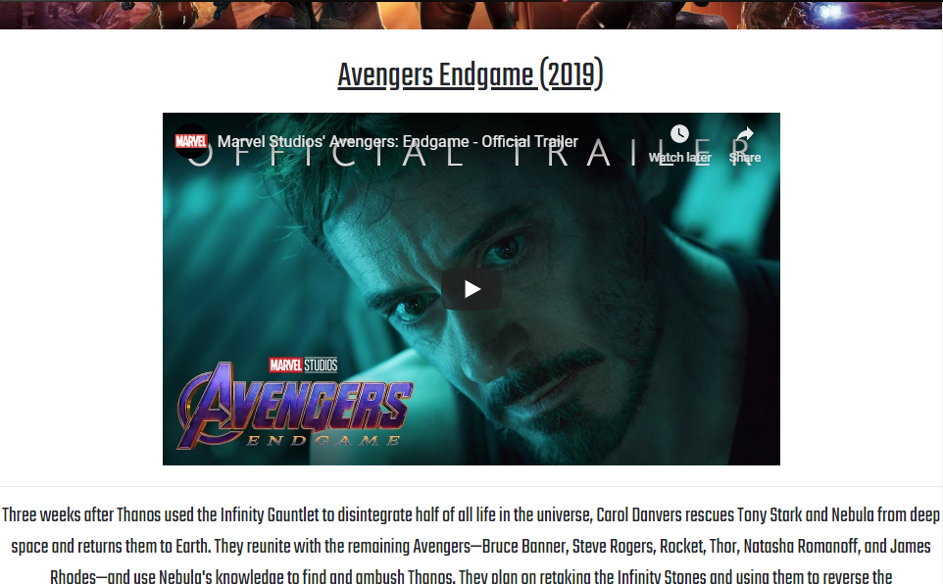

References Page
The references page shows the links from every image and every information that has been used on every webpage. “I have met the simple requirements in the web page by adding a navigation bar system, a picture of the logo” [1], pictures from the movie, information from each webpage and their social media links.
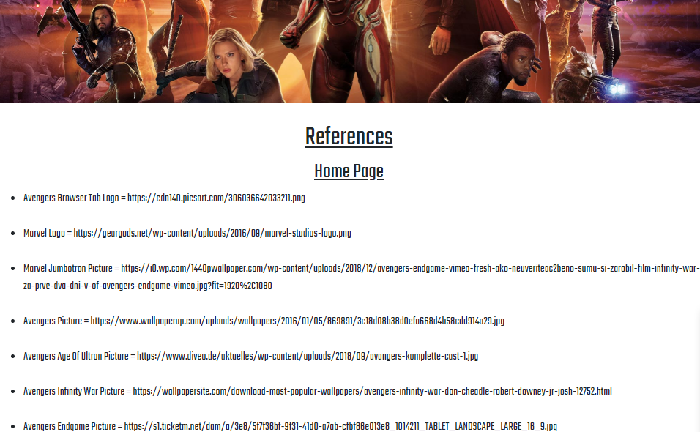

Purpose and Target Audience
My website's aim was for people that like the Marvel's Avengers series. The website would be a helpful process on how the series began and how it was ended. This is mostly done on every avenger page through an entertaining video. Instead of playing on a game console, it's appealing for people to learn about the Avengers, it will provide the user reading the website with explanations and advantages for a selection. I might not think it does a good job of that mainly because of the website layout compared to other top company websites that wouldn't compete with them. Furthermore, in my view, the aim of being helpful and useful to people who would like to know about the Avengers series is successful. The video on each avenger web page I personally think aims to achieve each of these topic as it is an interesting, popular and highly-presented video (courtesy of YouTube) that would make people think about the Avengers. The aim is ideal for a certain targeted audience as the target audience is aimed for teens and adults from 16-40 years of age. I would like to ensure they find out about the Marvel's Avengers series on the right website. [1]
Possible Website Improvements
I could add the social media logos as this allows viewers to know about social media accounts on my created website. [1]
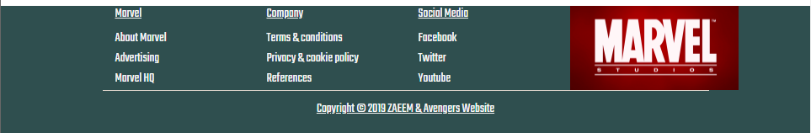
Before
After




I adjusted the font style on my website but it didn't fit my website's design, so I switched it back to the previous design. [1]
After
Before
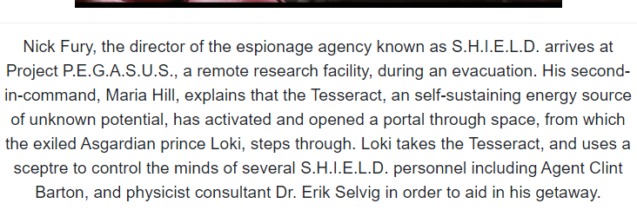
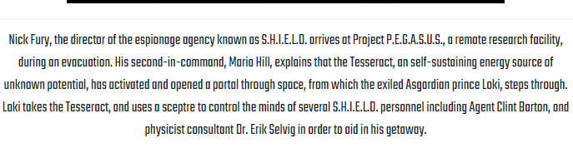

I adjusted the font size on my website but it didn't fit my website design, so I switched it back to the previous design. [1]
Before
After

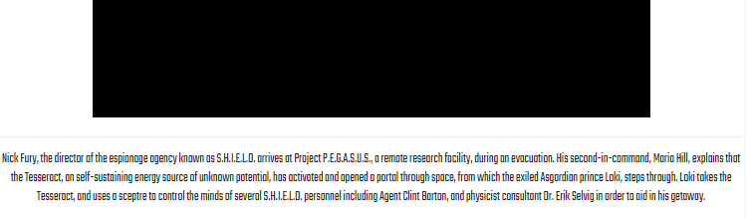

3. Implementation
3.1. Screenshots
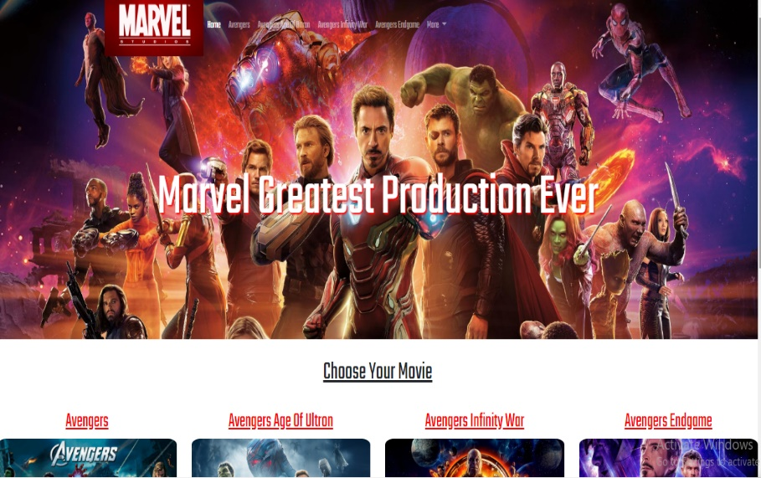
Home Page
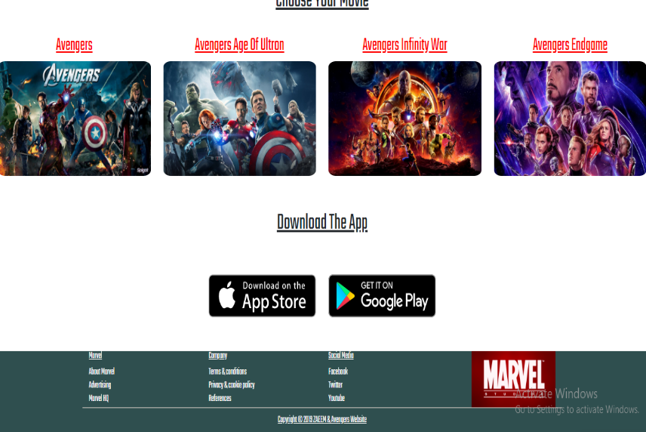

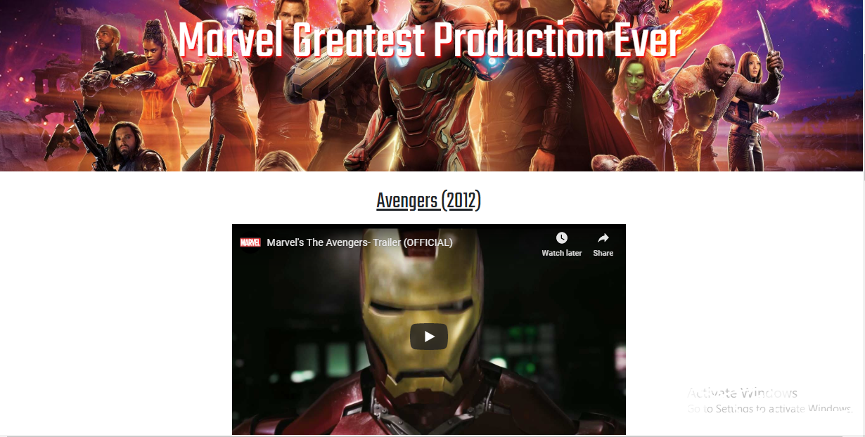
Avengers Page
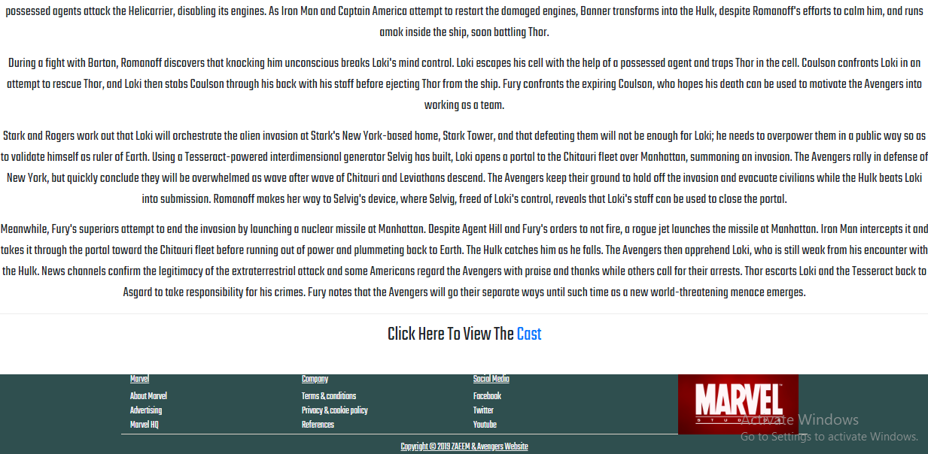
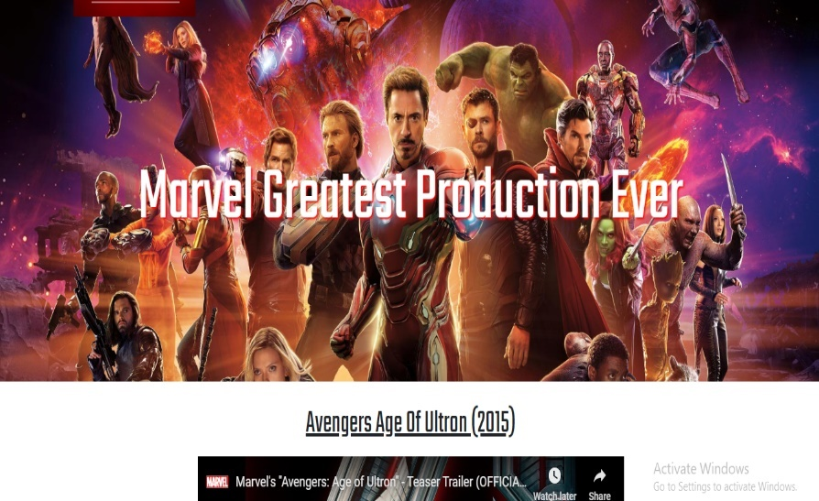
Avengers Age Of Ultron Page
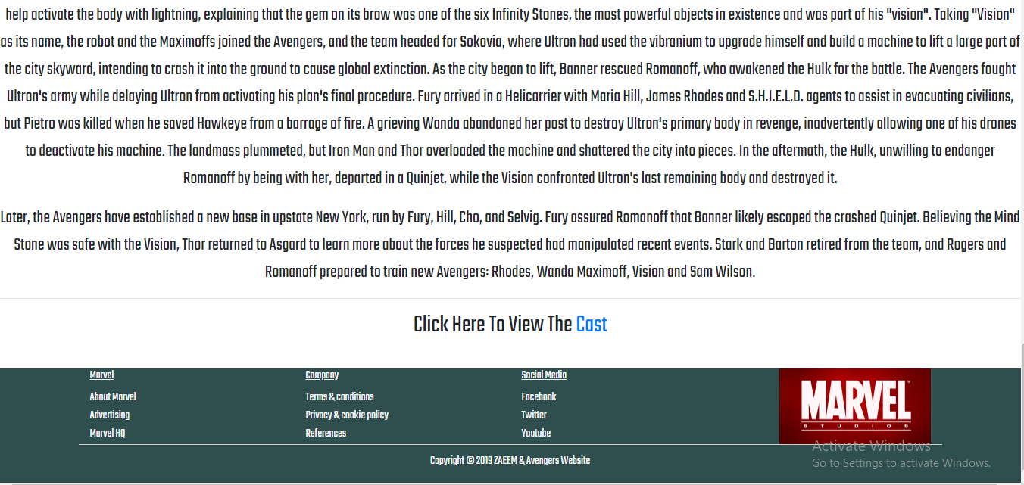

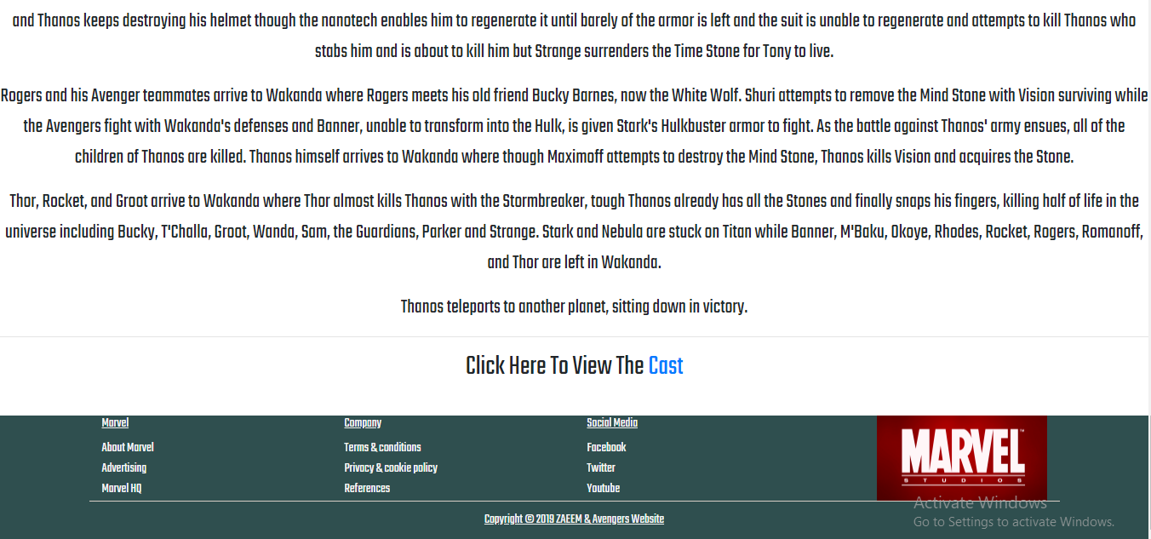
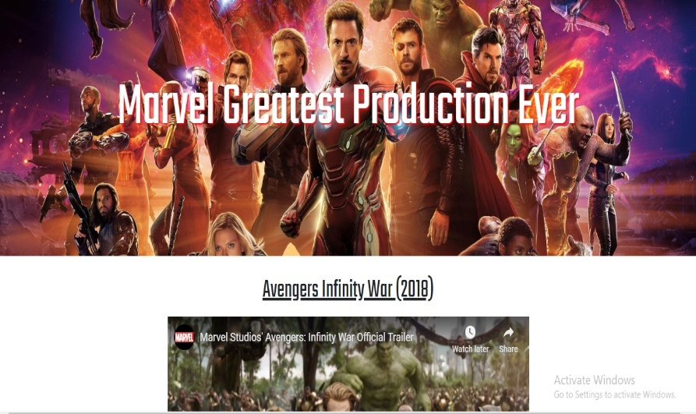
Avengers Infinity War Page

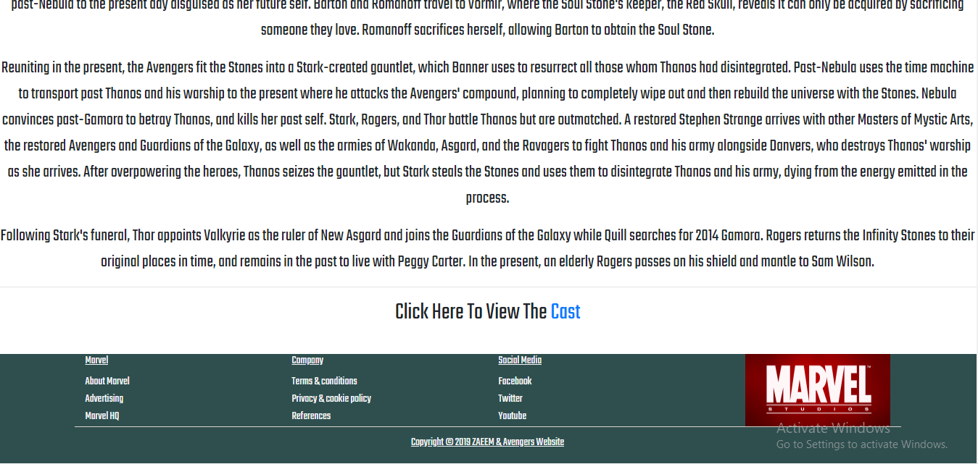
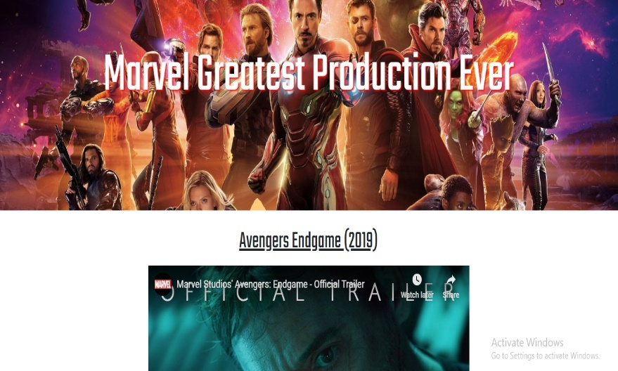
Avengers Endgame Page

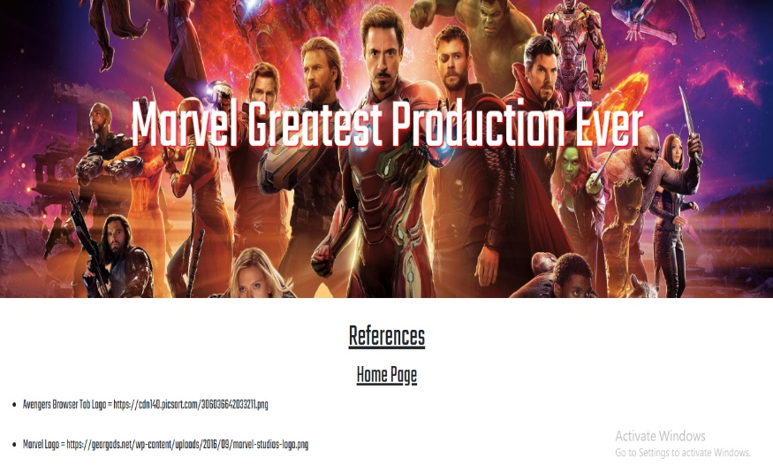
References Page
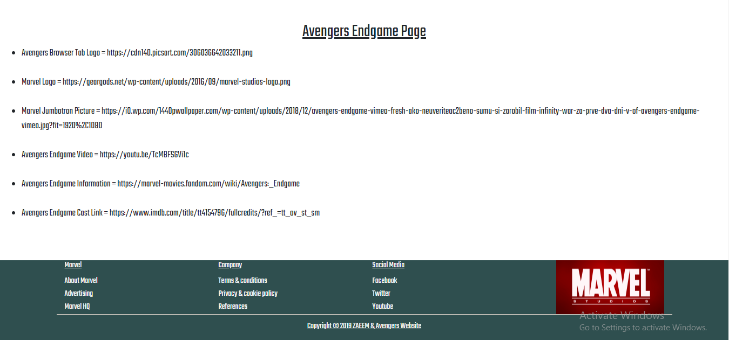

Screenshots from the created website [3] [4] [5] [6] [7] [8]
3.2. Validation
After I have typed my HTML code and CSS code on my created website, I had to verify that the HTML code and CSS code had no errors by using an online validation tool.
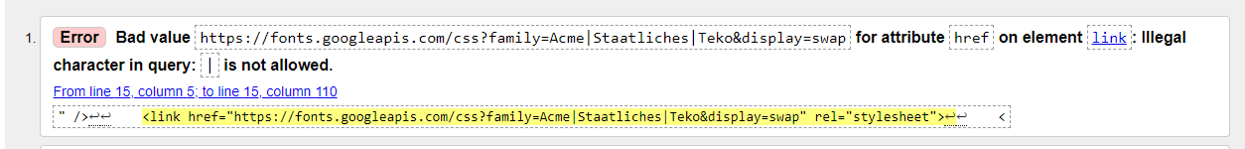
Home Page

The first error that was showing on the home page was that the symbol ‘|’ is not allowed when typing a HTML code. To fix this error, I have removed the symbol on the HTML code. After this, the error was not showing again.
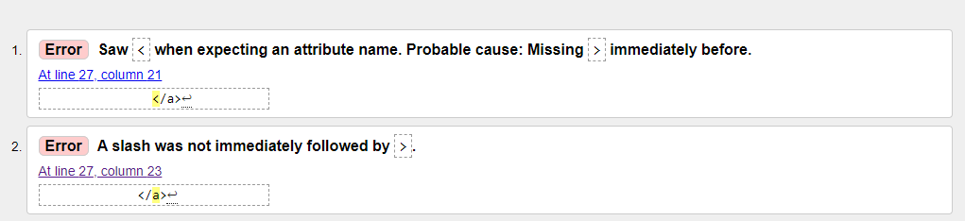

The second error that was showing on the home page was that the symbol ‘>’ was not typed in the HTML code. To fix this error, I have added the symbol on the HTML code. After this, both of these errors were not showing again.
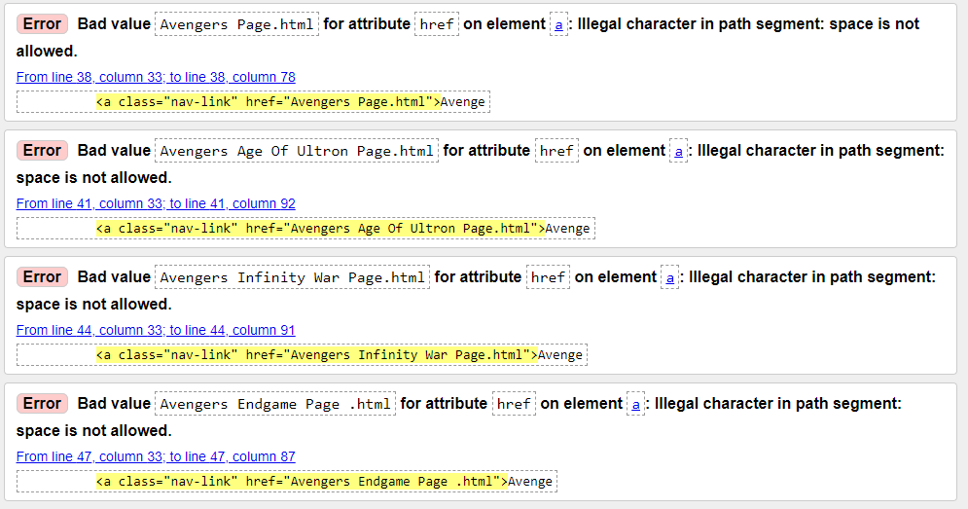

The third error that was showing on the home page was that the spaces is not allowed when typing a HTML code. To fix this error, I have removed the spaces on the HTML code. After this, these errors were not showing again.
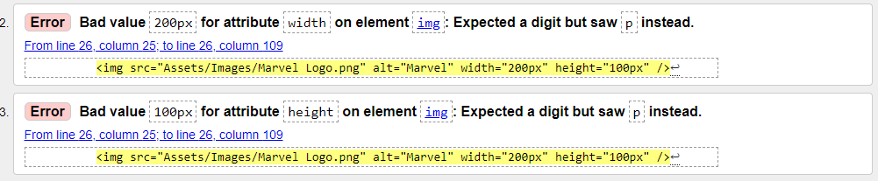

The next error that was showing on the home page was that the letters ‘px’ is not allowed when typing a HTML code. To fix this error, I have removed the letters on the HTML code. After this, these errors were not showing again.
There were some minor errors on the HTML code but I will not go in detail with those errors. The meaning of this is that if any errors are shown when validating the HTML code, it will be known as bad practice.

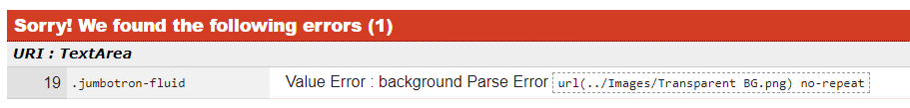
CSS

The first error that was showing on the CSS code was that there was incorrect number of symbols entered on one line of code. The symbol “ ‘ “ was entered more than once. To fix this error, I have removed the correct amount of symbols on the CSS code as only one symbol will be showing at the start and end. After this, the error was not showing again.
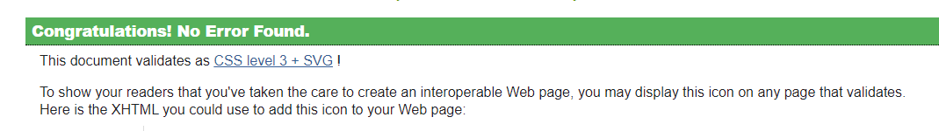

4. Evaluation
In conclusion, the website meets the simple requirements and satisfies the needs of those who want to learn about the Avengers. I think it achieved its objective. This website will have room for improvements because it must be fully accessible to disabled people and visually impaired people. This will also increase the viewers through which the page can be used, because if the disabled users don’t access it quickly, then you are leaving out a large audience group. Now that I've learned much more about developing HTML and CSS for any potential websites. Overall, I am happy on what I made, since it meets most the simple requirements and also, the aim that I originally thought about. I will say that the colour scheme would be the most important element of this website as this is the only element that remains relevant from the beginning of the design to the final product. [9]
Visual Studio
The programming software that I used to create this website “was an open source procedural programming software known as” [10] Visual Studio. Visual Studio is a powerful and object-oriented type-safe software this helps developers to create a variety of reliable applications running on the. NET Framework. The user of the computer can use Visual Studio “to create Windows Client Applications, Web Services, Database Applications, and much more.” [10] Visual Studio includes an interactive application editor, simple user interface developers, embedded debugger and several other tools to enable the development of C # or C++ language-based applications and the. NET Framework. [10]


Image of Visual Studio Logo [11]

Now I'm going to discuss how my website can be for disabled people to use it.
How my website aids user access to information?
Poor Eyesight
I could make the size of the text very big as this will allow my webpage available to users with poor eyesight, and therefore it makes it possible for “users with poor eyesight to read and understand my work.” [9] It's a really significant element because if users were able to read or understand the website then my website will not be very successful because the audience will not be able seeing what my website is saying. Also, for every task, I organised my work into small paragraphs. This will make it much easier for people who have poor vision to understand my work. [9]
Dyslexic Users
My website would be appropriate for users with dyslexia and issues with reading. This was because I was using large headings for all my task names to make it easy to read, and I also was using clear language which most users, such as people with dyslexia, know and browse essentially. [9]

5. References

Bibliography

[1] | Zaeem, "Unit 28 - Assignment 2," Zaeem, Swansea, 2018.
[2] | B. Morelli, "25 HTML & CSS Tutorials," 19 March 2018. [Online]. Available: https://codeburst.io/25-html-css-tutorials-6a864f387185. [Accessed 22 November 2019].
[3] | Zaeem, "Index Page," 21 November 2019. [Online]. Available: From the Zipped File. [Accessed 22 November 2019].
[4] | Zaeem, "Avengers Page," 21 November 2019. [Online]. Available: From the Zipped File. [Accessed 22 November 2019].
[5] | Zaeem, "Avengers Age of Ultron Page," 21 November 2019. [Online]. Available: From the Zipped File. [Accessed 22 November 2019].
[6] | Zaeem, "Avengers Infinity War Page," 21 November 2019. [Online]. Available: From the Zipped File. [Accessed 22 November 2019].
[7] | Zaeem, "Avengers Endgame Page," 21 November 2019. [Online]. Available: From the Zipped File. [Accessed 22 November 2019].
[8] | Zaeem, "References Page," 21 November 2019. [Online]. Available: From the Zipped File. [Accessed 22 November 2019].
[9] | Zaeem, "Unit 20 - Assignment 2," Swansea, 2019.
[10] | Zaeem, "Unit 14 - Assignment 4," Swansea, 2018.
[11] | N/A, "1024px-Visual_Studio_2017_Logo.svg.png (1024×1024)," N/A N/A N/A. [Online]. Available: https://upload.wikimedia.org/wikipedia/commons/thumb/c/cd/Visual_Studio_2017_Logo.svg/1024px-Visual_Studio_2017_Logo.svg.png. [Accessed 24 November 2019].

marking criteria and Student FEEDBACK

This section details the extent to which the assessment criteria are demonstrated by you, which in turn determines your mark. The marks available for each category of skill are shown. Lecturers will use the space provided to comment on the achievement of the task(s), including those areas in which you have performed well and areas that would benefit from development/improvement.

Common Assessment Criteria Applied (Assignment 1) | Marks available | Marks  awarded
1. Engagement with Literature Skills

Unfortunately the submitted work does not really address the research elements of the assignment brief and generally, demonstrates poor engagement with essential reading and little evidence of wider reading of literature sources. Please ensure that you read the assignment brief carefully in future and verify anything that is unclear with your lecturer. Expand the scope of references to further improve your research work. (Grade mark: 20.00%) | 25 | 5
2. Knowledge and Understanding Skills

Demonstrates a good understanding of the standards used to design and implement a website with a generally good understanding of the validation results. There is, however, room for improvement. Some things to note: ensure that your HTML tags are properly closed and nested. Avoid using obsolete (not in use any more, having been replaced by something newer and better) HTML and CSS. You have used a few HTML tags that are either obsolete or are not valid HTML tags e.g. the <center> tag is obsolete and <font> is not a known HTML tag. The evaluation of the website is basic and again does not really address the requirements of the assignment brief. (Grade mark: 55.00%) | 20 | 11
3. Cognitive and Intellectual Skills

4. Practical Application Skills

A very good attempt featuring a simple website with well-thought-out content. Please note the comments above. Some additional comments include: Avoid text heavy content, especially for content that is supposed to be entertaining to users and if you do need to display a lot of informative, text content, use appropriate styles. For example, avoid having very long horizontal lines of text as users find this tiring to read. This is one of the reasons magazines and newspapers use columns for text content. Make use of the grid columns to split up content. Also, do not use centred and bold font styles for long blocks of text. This styles are generally used for emphasis, i.e. draw the user's attention to some content, and are more appropriate for headings or portions of text within a block of text that you want to draw the user's attention to. I would also have liked to see some more variation between your pages and use of some additional concepts to further demonstrate your understanding of the skills e.g. use of columns to split up content instead of single-column layouts, instead of linking your contact link to an external source, create a contact page with a contact form. (Grade mark: 62.00%) | 50 | 31
5. Transferable Skills for Life and Professional Practice

The report is of a good standard but ensure that you are documenting what has been asked for in the assignment brief. A lot of the sections of your report were for things were not asked for and unfortunately do not really count. See your report for additional suggested improvements. (Grade mark: 60.00%) | 5 | 3

Assignment Mark (Assessment marks are subject to ratification at the Exam Board. These comments and marks are to give feedback on module work and are for guidance only until they are confirmed. ) | Late Submission Penalties (tick if appropriate) |  | 50%
 | Up to 1 week late (40% Max) |  | 50%
 | Over 1 week late (0%) |  | 50%

