

Marketing Management Of Chanel

Name :- Harsimran Kaur Hira
Student Id :- 2218345
Course :- MBA Banking and Finance
Module name :- Marketing Management
Module Code:- LCMB7001
Lecturer Name :- Tushara Balendran

Table of Contents
Introduction 2
1. External Influencing drivers 2
2. Porter’s 5 Forces Analysis 4
3. SWOT Analysis 6
4. STP 7
5. Marketing Mix 7
6. Conclusion 8
7. Recommendation Based on the Ansoff matrix 9
References 10

Introduction
Marketing management has a vital role in an organisation as it can assist in recognizing the opportunities and threats for the organisation. It allows companies to gain a competitive edge which can attract customers and enhance the sales of the products. In this assignment the organisation which is selected is Chanel and the product which is selected is hair products. The internal and external environment of Chanel is analysed and the marketing strategies are also been evaluated in this assignment.

1. External Influencing drivers
PESTLE Analysis
PESTLE analysis is a tool which assists the organisation in evaluating the external environment such as political, environmental, economic, social, legal and technological which has a negative and positive impact on the organisation (Christodoulou and Cullinane, 2019).
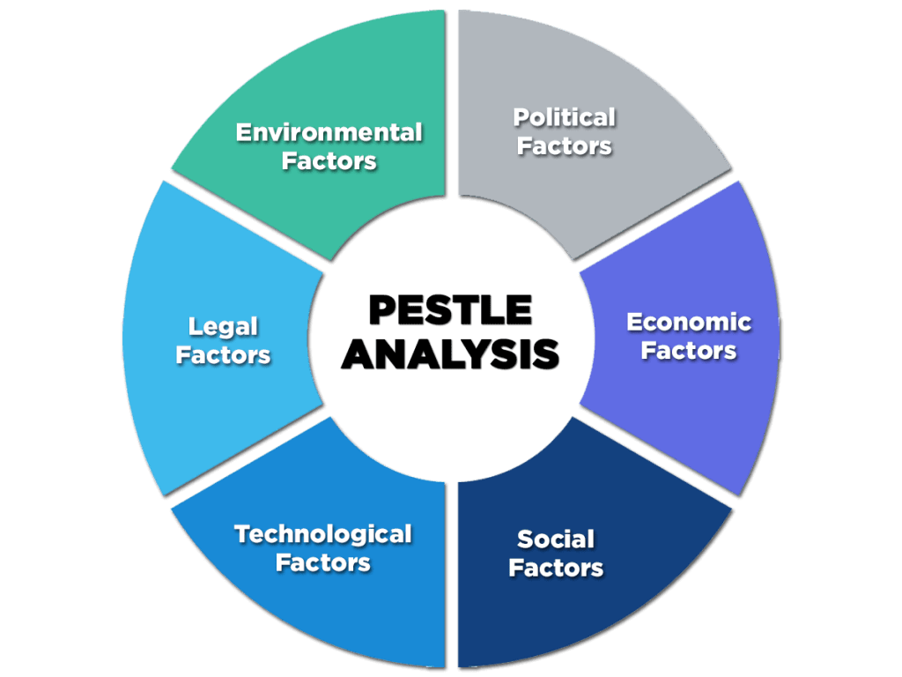
Figure 1: PESTLE Analysis
(Source: Enterslice.com, 2020)
Political
Due to the Russia and Ukraine war Chanel has stopped its sales of products in Russia following EU sanctions on Russia (Bbc.com, 2022). Due to Brexit, the logistic cost for the raw materials and products of the beauty brand in the UK has doubled (Britishbeautycouncil.com, 2021). This factor is unfavourable for Chanel as it can increase the cost of the company. The workforce and customer base are also affected due to Brexit.
Economical
The inflation rate of the UK has increased by 10.7% (Ons.gov.uk, 2022). The GDP rate of the UK is increased by 0.5% (Ons.gov.uk, 2022). The inflation rate of the UK is unfavourable for Chanel as the sales of Chanel can be reduced which can affect the profitability rate and performance. The people of the UK are finding difficulty in maintaining their daily expenses thus the sales of luxury products of Chanel can be affected.
Social
In UK, the personal care and beauty market is expected to grow by 2.17% (Statista, 2022). Thus, this social factor is favourable for Chanel as there is an opportunity for Chanel to enhance its business in future. In UK, the population density is 281 per KM square (U.K. Population, 2023). This factor is favourable for Chanel as the sales of products can be increased which can help to enhance the profitability.
Technological
In the UK, Beauty brands use several technologies such as augmented reality and artificial intelligence which can help customers in engaging in this competitive market (Bbc.com, 2019). The factor is favourable for Chanel as these technologies can provide virtual try-on apps which can help the customers to make buying decisions. AI technology can provide smart skincare tools which can analyse skin and hair quality and suggest products.
Environmental
UK government has targeted to bring greenhouse gas to net zero by 2050 (Gov.uk, 2019). This factor is also favourable for the company Chanel as the company has to use sustainable business measures which can enhance the brand image and reputation. It has been identified that 70% of waste which is generated for the beauty brand is from packaging (Kitenest.co.uk, 2022). Thus, Chanel has to make the packaging pollution free which supports the environment of the UK.
Legal
The employment laws in the UK such as Employment Right Act 1996 hold the rights for the employees such as paternity leave, unfair dismissal, dismissal and many more (Croner.co.uk, 2020). This factor is favourable for Chanel as the organisation can attract employees which can enhance the productivity of the organisation. The EU court battle has been lost by Chanel over the Huawei logo affects the brand value of Chanel (Bbc.com, 2021).

2. Porter’s 5 Forces Analysis
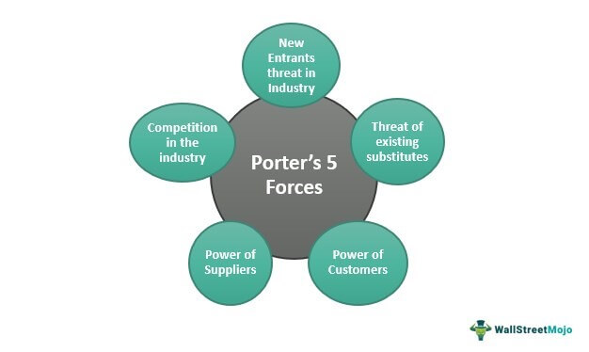
Figure 2: Porter’s Five Forces
(Source: Wallstreetmojo.com, 2022)
According to Isabelle et al. (2020), Porter’s 5 Forces Analysis has the ability to understand the attractiveness of the organisation and analyse and identify the five competitive forces which assist the organisation in determining its strength and weaknesses.
The threat of new entry
The hair product of Chanel is famous and differentiable worldwide and the products are costly and become a symbol of status. Channel operates its business in 70 countries and employs 28,000 people and Channel is also a world leader in creating, manufacturing and developing fashion accessories (Futurefitbusiness.org, 2021). Thus, the threat of a new entry for Chanel is low due to the high brand value of its products.
Buyer’s Power
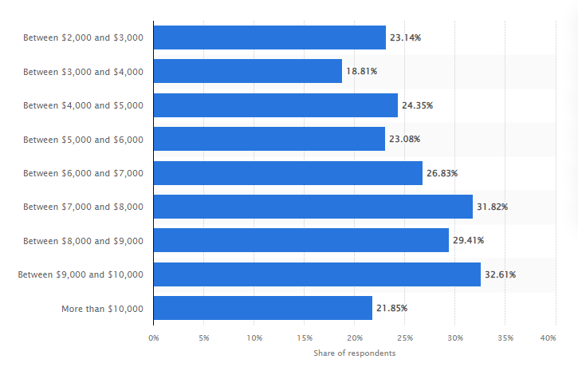
Figure 3: Share of People who buys products of Chanel
(Source: Statista, 2022)
From the above graph, it has been identified that the income of the 32.61% of people who buy Chanel products is between 9000 to 10,000 dollars (Statista, 2022). The buyer power for Chanel products is high as customers have several local and international hair brands in the market and they can easily switch to substitute brands
The threat of substitutes
The threat of substitutes for Chanel is medium as hair care products are becoming common and several local brands are getting introduced every year. However, Chanel holds global luxury brand value that helps this company to maintain a unique position in the market. There are more luxury brands which sell premium hair products such as Gucci, Prada, Armani, Estee Lauder and many more (Craft.co, 2023).
Competitor's Power
The competitors' power is high for Chanel as there are several competitors such as LVMH, Christian Dior, Gucci and many more. The competition in this brand to create brand equity is more. Thus, Chanel has to maintain the quality and value of its products.
Suppliers' Power
Chanel has a number of suppliers and partners and it has full control over the entire supply chain. The suppliers of Chanel include Panaglass investment corp, Premes SA DE CV, Impex and many more (Exportgenius.in, 2021). Thus, the bargaining power of the supplier is low.

3. SWOT Analysis

Strengths | Weaknesses
- In 2022, the brand revenue of Chanel is 15.3 billion dollars (Statista.com, 2022).  - Brand loyalty and awareness are high.  - Channel has 20,000 employees which assist in enhancing the brand value and image (Zippia.co, 2022). | - After the loss of its founder, Chanel faces several losses (Businessoffashion.com, 2019).  - The sales of Chanel are affected by Covid-19 (Ft.com, 2020).
Opportunities | Threats
- Chanel has the opportunity of online sales.  - Channel has to work on an online presence as this can enhance profits and sales (Businessoffashion.com, 2022). | - There are several competitors in the market for Chanel such as Gucci, Armani, Prada and many more (Craft.co, 2023).  - The profitability of Chanel has been reduced due to Covid 19.
Table 1: SWOT Analysis
(Source: Businessoffashion.com, 2022)
Advantages and Disadvantages of SWOT
The competitive position of the company can be evaluated and strategic planning can be developed by the framework which is known as SWOT analysis. The advantages of SWOT are that it has multilevel analysis, cost-effectiveness, and simplicity (Smallbusiness.chron.com, 2019). Valuable information can be gained through the SWOT analysis such as about the competition and regulations of the government regarding the product. The SWOT analysis is a cost-effective method as non-technical skills and training are required to perform this method. On the other hand, there are several limitations of SWOT analysis which are lack of clarity, too many opinions, and then lack of prioritisation. Also, the analysis is subjective which news a lot of time.

4. STP
Segmentation
Chanel uses demographic segmentation strategy based on income and age. The targeted customers are premium customers belonging to the adult age group. The demographic segmentation of Chanel describes the gender, age group and status of the customers which buy the hair products of Chanel. The hair products of Chanel target both genders and the age group is 20-80 years (440industries.com, 2022). However, the main target market of Chanel is women. People whose net income is between 9000 and 10,000 dollars are the main customers of Chanel (Statista.com, 2022).
Targeting
Segmented marketing has been used by Chanel as it divides the target market into groups and by segmenting the market Channel can target to enhance the sales and marketing strategies. Chanel uses a niche market target strategy as the brand targets only luxury customers for its product. However segmented marketing has some cons such as this strategy can lead to high marketing expenses and focuses on limited production. The distribution and promotion expenditures can be increased as the separate programme has been used for various market segments.
Positioning
Chanel uses a product positioning strategy as it targets to create benefits for the customers by aligning the features of the products with the needs of the customers. The product position strategy is used as it can provide benefits such as differentiation from the competition, understanding the customer challenges, and justifying the pricing strategies (Brandmasteracademy.com, 2020).

5. Marketing Mix
According to Sudari et al. (2019), the Four Ps which are product, promotion, place and price are the vital elements which determine the process of marketing a product and contribute to customer satisfaction. This marketing strategy has the ability to understand the requirements of the customers and find ways to solve the problems of the public perception of the products.
Place
Chanel sold high-class products and it has stores in high-end localities such as airports and five-star luxury hotels. For instance, in the high-traffic Chinese airport, Chanel operates its store (Forbes.com, 2020). Chanel sold its products in various locations such as New York, Paris, London, Milan and many more. This can enhance the profitability and performance of the organisation.
Price
The main target of the Channel is to focus on the quality of the product and excellence. Chanel also targets to invest in innovation, people and research & development which enhance the value of the product. Thus, Chanel uses the premium pricing strategy as the products of Chanel are known for their design, uniqueness and quality. The premium pricing strategy has several benefits such as high-profit margins and enhancing brand perception and value (Profitwell.com, 2020). Also, Chanel targets high-class people and the customer base Chanel is high due to its great image and popularity.
Product
Chanel has various types of premium hair styling and caring products such as conditioners, Shampoo and many more which assists in meaning the style throughout the day (Johnlewis.com, 2023). Also, the Chanel styling aids include hair mist which assists in creating a big volume in the hair. The hair products of Chanel contain UV filters and heat protection which protect the hair from harmful UV rays.
Promotion
Chanel uses digital marketing campaigns and ads to promote its products (Digitalagencynetwork.com, 2023). Digital marketing includes social media marketing which has the ability to attract a wide number of customers.

6. Conclusion
It has been concluded that marketing management can help to attract potential customers which can enhance the profitability of the organisation. It has been identified that the technological, social and legal external factors are favourable for Chanel. Also, the threat of substitutes and competitors is high for Chanel. The segmented marketing and product positioning strategy has been used by Chanel as it can enhance its brand performance and profitability. The premium pricing strategy is used by Chanel and digital marketing is adopted by Chanel to promote its product.

7. Recommendation Based on the Ansoff matrix
The Ansoff matrix assists marketers to recognize the opportunities to market the products through which the business enhances its revenues (Smartinsights.com, 2021).
Product development strategy
Chanel has to modify its hair products by using several strategies such as creating new products, changing ideas, enhancing product value and finding new markets (Indeed.com, 2021). The development of the product can enhance the brand value and reputation.
Market Penetration Strategy
Chanel can see the market penetration strategies such as changing the pricing strategy, identifying the requirement of the new product and growing the business in new areas. This can help Chanel as it achieves insight into how the customers view the product and service.
Diversification strategy
Chanel can use the conglomerate diversification strategy as it targets to introduce new products which have no relation to the existing products of the business (Bstrategyhub.com, 2022). This strategy can provide high growth and return on investment due to the new revenue stream.
Market development strategy
An organisation can use several market development strategies to enhance its business such as establishing growth goals, reaching development opportunities and developing an effective market plan (Indeed.com, 2021). This stage can help Chanel to enhance the performance of the brand.

References
440industries.com, (2022), Chanel Target Market – Audience & Demographic Segmentation, Available at: https://440industries.com/chanel-target-market-audience-demographic-segmentation/#:~:text=The%20Chanel%20target%20market%20includes,Chanel%20target%20market%20is%20women. [Accessed on: 02-01-2023]
Bbc.com, (2019), Five tech trends shaping the beauty industry, Available at: https://www.bbc.com/news/business-48369970, [Accessed on: 02-01-2023]
Bbc.com, (2021), Chanel loses EU court battle over Huawei logo, Available at: https://www.bbc.com/news/business-56833244, [Accessed on: 02-01-2023]
Bbc.com, (2022), Ukraine war: Chanel restricts sales of goods to Russians abroad, Available at: https://www.bbc.com/news/business-61005607, [Accessed on: 02-01-2023]
Brandmasteracademy.com, (2020), 10 Powerful Advantages Of Brand Positioning, Available at: https://brandmasteracademy.com/advantages-of-brand-positioning/, [Accessed on: 02-01-2023]
Britishbeautycouncil.com, (2021), How is Brexit affecting the British beauty industry? Available at: https://britishbeautycouncil.com/how-is-brexit-affecting-the-british-beauty-industry/, [Accessed on: 02-01-2023]
Bstrategyhub.com, (2022), What is a diversification strategy, its types, and why is it important? Available at: https://bstrategyhub.com/what-is-a-diversification-strategy-its-types-and-why-is-it-important/, [Accessed on: 02-01-2023]
Businessoffashion.com, (2019), Chanel Faces Biggest Challenge Since the Loss of Its Founder, Available at: https://www.businessoffashion.com/articles/news-analysis/chanel-faces-biggest-challenge-since-the-loss-of-its-founder-karl-lagerfeld/, [Accessed on: 02-01-2023]
Businessoffashion.com, (2022), Does Chanel’s Stance on E-Commerce Make Sense? Available at: https://www.businessoffashion.com/briefings/luxury/does-chanels-stance-on-e-commerce-make-sense/, [Accessed on: 02-01-2023]
Christodoulou, A., and Cullinane, K. (2019). Identifying the Main Opportunities and Challenges from the Implementation of a Port Energy Management System: A SWOT/PESTLE Analysis. Sustainability, 11(21), p6046.
Craft.co, (2023), CHANEL competitors and similar companies, Available at: https://craft.co/chanel/competitors, [Accessed on: 02-01-2023]
Croner.co.uk, (2020), A Comprehensive List of Employment Legislation in the UK, Available at: https://croner.co.uk/resources/employment-law/legislation-list/, [Accessed on: 02-01-2023]
Digitalagencynetwork.com, (2023), Chanel Ads & Digital Marketing Campaigns, Available at: https://digitalagencynetwork.com/brands/chanel/, [Accessed on: 02-01-2023]
Enterslice.com, (2020), Pestle Analysis: A Mechanism for Analysis of Businesses, Available at: https://enterslice.com/learning/pestle-analysis-a-mechanism-for-analysis-of-businesses/, [Accessed on: 02-01-2023]
Exportgenius.in, (2021), List of Chanel Exporters in the World, Available at: https://www.exportgenius.in/global-exporters-of-chanel, [Accessed on: 02-01-2023]
Forbes.com, (2020), Eight Luxury Stores Including Chanel And Gucci Open At High-Traffic Chinese Airports, Available at: https://www.forbes.com/sites/kevinrozario/2020/11/01/eight-luxury-stores-including-chanel-and-gucci-open-at-high-traffic-chinese-airports/?sh=2922316478a3, [Accessed on: 02-01-2023]
Ft.com, (2020), Chanel forecasts ‘difficult’ two years for luxury amid Covid-19, Available at: https://www.ft.com/content/e6d2bbf2-135d-4ee6-aa75-200c349fced7, [Accessed on: 02-01-2023]
Futurefitbusiness.org, (2021), CHANEL, Available at: https://futurefitbusiness.org/development-council/chanel/, [Accessed on: 02-01-2023]
Gov.uk, (2019), UK becomes first major economy to pass net zero emissions law, Available at: https://www.gov.uk/government/news/uk-becomes-first-major-economy-to-pass-net-zero-emissions-law, [Accessed on: 02-01-2023]
Indeed.com, (2021), What Is a Market Development Strategy? (Definition, Tips and Example), Available at:https://www.indeed.com/career-advice/career-development/market-development-strategy-example, [Accessed on: 02-01-2023]
Indeed.com, (2021), What Is Product Development Strategy? Available at:https://www.indeed.com/career-advice/career-development/product-development-strategy, [Accessed on: 02-01-2023]
Isabelle, D., Horak, K., McKinnon, S., and Palumbo, C. (2020). Is Porter’s Five Forces Framework Still Relevant? A study of the capital/labour intensity continuum via mining and IT industries. Technology Innovation Management Review, 10(6), 28–41. https://doi.org/10.22215/timreview/1366
Johnlewis.com, (2023), CHANEL Hair Styling, Available at:https://www.johnlewis.com/browse/beauty/hair-care/hair-styling/chanel/_/N-7nndZ1z0u27h, [Accessed on: 02-01-2023]
Kitenest.co.uk, (2022), How do cosmetics impact the environment? Available at:https://kitenest.co.uk/blogs/news/how-do-cosmetics-impact-the-environment, [Accessed on: 02-01-2023]
Ons.gov.uk, (2022), Consumer price inflation, UK: November 2022, Available at:https://www.ons.gov.uk/economy/inflationandpriceindices/bulletins/consumerpriceinflation/november2022, [Accessed on: 02-01-2022]
Ons.gov.uk, (2022), Gross Domestic Product (GDP), Available at:https://www.ons.gov.uk/economy/grossdomesticproductgdp, [Accessed on: 02-01-2023]
Profitwell.com, (2020), What is Premium Pricing Strategy & Is It The Best Choice for SaaS, Available at:https://www.profitwell.com/recur/all/premium-pricing, [Accessed on: 02-01-2023]
Qualtrics.com, (2023), Market segmentation: Definition, types, benefits, & best practice, Available at:https://www.qualtrics.com/au/experience-management/brand/what-is-market-segmentation/, [Accessed on: 02-01-2023]
Smallbusiness.chron.com, (2019), Advantages & Disadvantages of SWOT Analysis, Available at:https://smallbusiness.chron.com/advantages-amp-disadvantages-swot-analysis-41398.html, [Accessed on: 02-01-2023]
Smartinsights.com, (2021), The Ansoff Model, Available at:https://www.smartinsights.com/marketing-planning/create-a-marketing-plan/ansoff-model/, [Accessed on: 02-01-2023]
Statista. (2022). Beauty & Personal Care - UK | Statista Market Forecast. Retrieved January 1, 2023, from https://www.statista.com/outlook/cmo/beauty-personal-care/united-kingdom
Statista.com, (2022), American who owned Chanel fashion or accessories 2018, by income, Available at: https://www.statista.com/statistics/251698/affluent-americans-who-own-chanel-brand-apparel-accessories-footware/, [Accessed on: 02-01-2023]
Statista.com, (2022), American who owned Chanel fashion or accessories 2018, by income, Available at: https://www.statista.com/statistics/251698/affluent-americans-who-own-chanel-brand-apparel-accessories-footware/, [Accessed on: 02-01-2023]
Statista.com, (2022), Global brand value of Chanel from 2017 to 2022, Available at: https://www.statista.com/statistics/1010860/chanel-brand-value-worldwide/, [Accessed on: 02-01-2023]
Sudari, S., Tarofder, A., Khatibi, A., and Tham, J. (2019). Measuring the critical effect of marketing mix on customer loyalty through customer satisfaction in food and beverage products. Management Science Letters, 9(9), 1385-1396.
U.K. Population. (2023). worldometers.info. Retrieved January 1, 2022, from https://www.worldometers.info/world-population/uk-population/
Wallstreetmojo.com, (2022), What Are The Porter’s 5 Forces? Available at: https://www.wallstreetmojo.com/porters-five-forces/, [Accessed on: 02-01-2023]
Zippia.co, (2022), WORKING AT CHANEL Available at: https://www.zippia.com/chanel-careers-18801/, [Accessed on: 02-01-2023]

