Component 1- Portfolio
CERTHE Computing Skills for the Workplace
Software Solutions for Business
ACCA4025_LON
KWAME ASSA-AGYEI- Lecturer
Ima David -2321435
03/05/2024

Table of Contents
Task 1 E-Commerce software solutions 3
1.1 Shopify 3
1.2 WooCommerce 4
Task 2a Mind-map software applications. 5
2.1 Mind Meister 5
2.2 Lucidchart 5
Task 2b - mind map software application 7
Task 3A Office Applications 7
3.1 Microsoft Word 7
3.2 MS PowerPoint 10
3.3 MS Excel 11
Task 3b Test some business-related features of Office Applications 14
3b.1 Mail Merge 14
3b.2 Pivot Table creation 16
Task 4a- Communication Tools 19
4a.1 Email 19
4a.2 Zoom 21
Collaboration Tools 22
Task 4b Practical use of Communication and Collaboration applications 24
4b.1 Email 24
4b.2 Collaboration tool- MS Team 25
Conclusion 26
References 27

Abstract
This portfolio examines the vital software solutions essential for modern business operations. It delves into e-Commerce website software solutions, highlighting their role in enhancing business scalability and customer engagement. Additionally, it includes a mind-map that outlines the spectrum of contemporary software applications, reflecting their integration and utility in business processes. The analysis extends to office applications and their evolved business-related features that support complex data management, analytics, and collaborative project execution. Furthermore, the portfolio evaluates key communication and collaboration tools such as Microsoft Teams, Slack, and Zoom, emphasizing their impact on modern work environments by facilitating efficient and effective communication and collaboration across dispersed teams, and also some print screens to prove practical use of some of the tools. This comprehensive exploration underscores the technologies' pivotal roles in optimizing operations and driving business innovation.

Introduction
This portfolio commences with an exploration of the pivotal software solutions that define and support modern business operations. It delves into the intricacies of e-Commerce website software solutions, crucial for enhancing transaction efficiency and customer engagement in digital marketplaces. Additionally, the portfolio presents a mind-map that provides a strategic overview of contemporary software applications, reflecting their roles and interconnections in facilitating diverse business activities. The examination extends to detailed analyses of advanced Office Applications, focusing on their business-centric features that empower data management, collaborative project execution, and analytical capabilities. Further, this portfolio reviews essential communication and collaboration applications such as Microsoft Teams, Slack, and Zoom, which are integral in reshaping communication norms and collaboration structures in today’s global business environment. This introduction sets the stage for a deeper understanding of how these software solutions collectively drive efficiency, innovation, and competitive advantage in the contemporary business landscape.

Task 1 E-Commerce software solutions
1.1 Shopify is known for having an easy-to-use design that makes setting up and running an online store simple enough that people who are not tech-savvy can do it. It boasts a wide range of professional styles and an app store that offers a plethora of extra features, including store customization and more (Ballard, 2017). These extra features cover marketing, SEO, and inventory management. Shopify's robust sales tools facilitate sales across various channels, including Amazon, Facebook, Instagram, and real point-of-sale (POS) systems. It also comes with abandoned cart recovery to help increase the number of sales. The platform works with more than 100 payment providers, including Shopify Payments, which means there are no transaction fees, and the platform automatically converts currencies to make international sales easier. Built-in email marketing and SEO tools assist businesses in gaining online visibility and maintaining customer interest. Additionally, it provides a wealth of data and reporting tools to monitor store performance and customer behaviour (Dushnitsky et al., 2021). All stores get free SSL certificates and are PCI-compliant to keep payment information safe. This makes it perfect for e-commerce startups and companies that want to grow quickly. Its unique selling points are Shopify POS, which allows online and offline sales, and scalability, which means it can grow with business from a small startup to a large enterprise without the need to switch platforms. This makes it an e-commerce platform that caters to a wide range of different types and sizes of businesses.

Its limitations include reliance on third-party apps for advanced features, which can increase costs, less design flexibility compared to fully customisable platforms, and additional transaction fees if not using Shopify Payment (Noronha et al., 2022).

1.2 WooCommerce
According to (Ravensbergen, 2015). WooCommerce is an open-source e-commerce plugin for WordPress that allows one to make changes through themes and extensions. It also has flexible product management tools and supports many payment and shipping options, which makes it a great choice for businesses that want an e-commerce solution that can grow with them. WooCommerce is designed to help WordPress users, small to medium-sized businesses, and entrepreneurs add e-commerce to their websites without having to switch platforms. It also works well for businesses that need more customisation options but don't have any technical knowledge. Its unique selling points are that it works well with WordPress, can be customised in a lot of ways, and has active community support (Dehghani et al, 2019).
However, WooCommerce does have limitations, including potential performance issues with large-scale stores, reliance on third-party plugins for certain advanced features which can lead to compatibility issues and increased costs, and a steeper learning curve for users unfamiliar with WordPress or e-commerce platforms in general. Despite these limitations, WooCommerce is favoured by organizations in search of a scalable and adaptable electronic commerce solution tightly integrated with the WordPress ecosystem (Reuland, 2020).

Task 2a Mind-map software applications.
Mind mapping is the method of structuring information, understand, and show knowledge visually in a way that is both hierarchical and linked, some example of mind-mapping softwares are Mind Meister and Lucidchart.
2.1 Mind Meister is a visual method, to arrange and show data in a way that is both hierarchical and linked, usually around a main idea or theme. It involves drawing a tree-like structure with branches going off from the main subject. Each branch represents a linked idea or subtopic These branches can grow into more sub-branches, keywords, or visual elements, making it possible to show complicated ideas or data in a way that is organised and easy to understand (Tra, 2023). Mind mapping helps in creative thinking and in an unstructured way by letting one explore and find links between different ideas. Mind maps help people remember things by organising information physically. They make it easier to understand and remember important points than traditional note-taking methods that are written in a straight line (Sehrawat, 2021). Mind mapping can help with many business tasks, such as increasing imagination, streamlining tasks, and communicating more clearly. It makes strategic planning easier by giving a way to see goals, targets, and action plans. Mind maps are also useful for managing projects, fixing problems, and making decisions. It helps businesses streamline their processes, encourage new ideas, and reach their goals more quickly (Aimoldina, 2023).

2.2 Lucidchart
Durrant et al, (2022). Explains that Lucidchart is a cloud-based diagramming software that empowers users to create, collaborate on, and share a wide range of diagrams and visual representations. With its intuitive interface and extensive library of shapes, templates, and customizable elements, Lucidchart enables users to efficiently visualize complex ideas, processes, and systems. From flowcharts and mind maps to org charts and network diagrams, Lucidchart offers versatile tools for diagramming across various domains and industries. The implementation of real-time collaboration functionalities enables multiple users to concurrently edit the same diagram, thereby promoting corporation and augmenting productivity. (Yigitbas et al, 2021). Users can leave comments, give tasks, and keep track of changes, which makes it easy for teams to express themselves and work together. Lucidchart seamlessly integrating with widely used collaboration and productivity tools including Jira, Google Drive, Microsoft Office, and Slack, users are granted the ability to seamlessly incorporate diagrams into project management, presentations, and document. Additionally, Lucidchart offers advanced features like data linking, enabling users to import and visualize data dynamically from external sources such as Google Sheets and Excel. Overall, Lucidchart provides a comprehensive solution for visualizing ideas, communicating concepts, and streamlining processes across various business operations (Aschhwanden-Grenfelt, 2017).
Benefits of Lucidchart in Business Operations:
Improved Communication: Lucidchart enhances communication by providing a visual depiction of concepts and ideas that facilitates the comprehension of intricate information by teams.
Enhanced Collaboration: Real-time collaboration features enable teams to work together on diagrams, fostering teamwork and improving productivity.
Versatile Functionality: With a wide range of diagram types and customizable elements, Lucidchart supports various business needs, from project planning to process documentation.
Seamless Integration: Integration with popular productivity and collaboration tools allows users to embed diagrams directly into documents, presentations, and project management platforms, streamlining workflow.
Data Visualization: Advanced features like data linking enable users to import and visualize data dynamically, providing insights and facilitating data-driven decision-making (Shabeen et al, 2022).
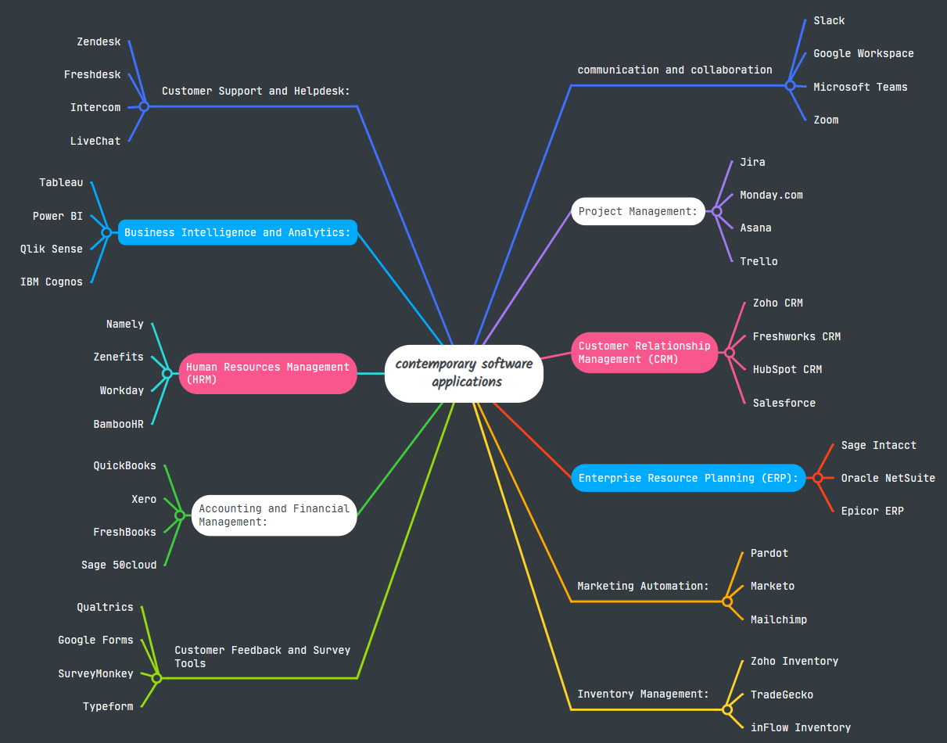
Task 2b - mind map software application

Task 3A Office Applications
3.1 Microsoft Word is a software for word processing created by Microsoft. It is a component of the Microsoft office suite and is utilised for document creation, editing, formatting, and printing. Due to its inception in the 1980s, Word has evolved significantly, incorporating a wide range of tools that facilitate complex document creation, elaborate formatting, graphic design, and collaborative editing features (Mohamed et al, 2015).

Major features
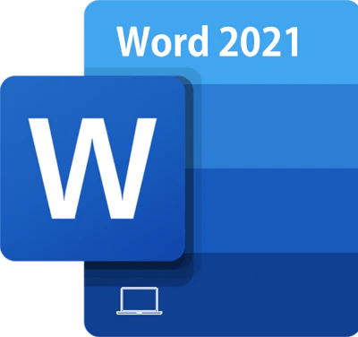
Text Editing and Formatting: MS Word provides comprehensive tools for basic and advanced text formatting. Users can adjust fonts, sizes, colours, and styles. The software also supports paragraph alignment, line spacing, and text direction.
Templates and Design Tools: Word has many templates for papers like resumes, letters, and reports that are already made. It also includes tools for creating and customizing designs, such as borders, watermarks, and page colours.
Collaboration Tools: Recent versions of Word integrate seamlessly with Microsoft OneDrive and SharePoint, allowing multiple users to work on a document simultaneously. The software supports real-time co-authoring, comments, and tracking changes.
Integration with Other Office Apps: Word integrates well with other Microsoft Office applications like Excel, PowerPoint, and Outlook. This allows for easy insertion of data like spreadsheets, presentations slides, and email content into documents.
Accessibility Features: The software includes features like Read Aloud, Text Spacing, and an Accessibility Checker, which helps ensure that documents are accessible to individuals with disabilities.
Advanced Imaging and Multimedia Features: Users can add and style pictures, shapes, SmartArt, charts, and even videos to papers to make them look better.
Mail Merge: This feature is great for making many letters, packages, labels, or emails that all look the same but have different sets of information (Morgado, 2017).
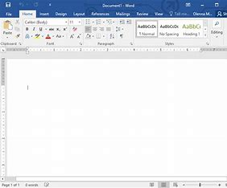
Security Features: Word provides options to protect documents with passwords, restrict editing, and manage permissions, which is critical for confidential materials.
Benefits:
User-Friendly Interface:
The Ribbon interface, introduced in Word 2007, organizes functions into logical groups, making it easy to find features. The interface is intuitive, even for beginners.
Versatility and Compatibility: Word files (.doc and .docx formats) are universally recognized. Documents can be opened and edited in various software on different operating systems, including mobile platforms.
Comprehensive Help and Support: Microsoft offers extensive help resources, including online forums, tutorials, and in-app assistance, aiding users in maximizing the software’s potential.
Regular Updates and Enhancements: Being part of the Microsoft ecosystem, Word benefits from regular updates that improve functionality, security, and user experience.
Limitations
Cost: Unlike free alternatives like Google Docs or OpenOffice, MS Word is typically part of a paid package, especially the most up-to-date versions that come with Office 365 subscriptions.
Performance Issues: Word can be resource-intensive, especially when dealing with very large documents or documents that include multiple high-resolution images and other multimedia elements.
Complex Features Can Be Overwhelming: While its wide array of features is a strength, it can also be overwhelming for users who need a simple word processor. Some advanced features have a steep learning curve.
Over-dependence on the Cloud: The latest versions emphasize cloud integration, which is beneficial for collaboration but can be a limitation when there is limited or no internet access (McGee et al, 2002).

3.2 MS PowerPoint
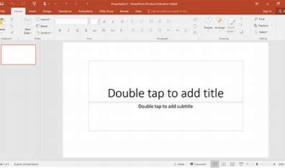

According to Rutledge et al, (2004). PowerPoint is a cornerstone of the Microsoft Office suite, it is a widely acclaimed presentation software designed to facilitate the creation of visually appealing and informative presentations. It boasts a comprehensive set of features including a robust slide creation and management system that allows users to easily add, delete, and rearrange slides; a vast selection of templates and themes that provide a professional aesthetic with options for customization; and extensive text and font choices, including effects like shadows and reflections to enhance visual appeal. PowerPoint also excels in multimedia integration, enabling the insertion of images, videos, audio clips, and charts, alongside advanced graphic tools such as SmartArt for creating complex diagrams effortlessly. The software offers rich animations and transition effects to keep audiences engaged, as well as real-time collaboration tools let different users make changes at the same time and track revisions. The Presenter View is particularly beneficial for speakers, displaying a timer, forthcoming slides, and notes privately, while only the current slide is visible to the audience. Additionally, PowerPoint supports exporting presentations in various formats, including PDF and video, and includes interactive elements like hyperlinks and action buttons, making it ideal for educational and training settings (Foulkes, 2020). Despite its many advantages, PowerPoint does have limitations, including the potential for overuse of templates and visual effects which can lead to clichéd or overly complex presentations that detract from the main content. Moreover, as part of the paid Microsoft Office suite, it may be less accessible for those on a budget, compared to free alternatives like Google Slides (Negrino, 2014). Performance can also be an issue with large presentations on less powerful hardware. Furthermore, the effectiveness of a PowerPoint presentation heavily relies on the user’s design and storytelling skills, as poor design can lead to disengagement and miscommunication. Overall, Microsoft PowerPoint remains a vital tool for creating dynamic presentations in various professional and educational environments, celebrated for its versatility, user-friendliness, and integration capabilities (Marcovitz and David, 2012).

3.3 MS Excel

According to Held et al, (2019). Microsoft Excel a vital component of the Microsoft Office suite, it is an indispensable tool for data management, analysis, and visualization, offering an extensive range of features to cater to diverse user needs. At its core, Excel operates on a grid-based interface, where users input data, formulas, and functions into individual cells to perform calculations and manipulations. Its flexibility lies in its vast array of functions and formulas, encompassing mathematical, statistical, logical, and text operations, providing users with the capability to tackle complex analytical tasks with precision. Furthermore, Excel's PivotTables are a standout feature, allowing users to summarize and analyse large datasets efficiently by dynamically reorganizing and summarizing data based on various criteria. This feature alone is invaluable for professionals across industries who rely on data-driven decision-making. Excel also boasts an extensive suite of charting and graphing tools, offering a diverse range of visualization options such as bar graphs, pie charts, histograms, and scatter plots, enabling users to present data in a visually compelling and easily understandable format. These visualization tools not only enhance the presentation of data but also aid in identifying trends, patterns, and outliers, thereby facilitating insightful analysis.
Moreover, (Jacobson, (2007) emphasized that Excel offers advanced analytical tools like the Data Analysis Toolpak and Solver, which extend its capabilities to include sophisticated statistical and engineering analyses. The Data Analysis Toolpak provides a wide range of statistical functions and data analysis tools, including regression analysis, correlation, and hypothesis testing, empowering users to derive meaningful insights from their data. Similarly, the Solver add-in enables users to solve complex optimization problems, linear programming, and what-if analyses, further enhancing Excel's utility in decision support and modelling scenarios. Additionally, Excel supports automation through macros and Visual Basic for Applications (VBA) scripting, allowing users to streamline repetitive tasks, create custom functions, and develop powerful data processing workflows. This automation capability significantly enhances productivity and efficiency, especially for users dealing with large volumes of data or complex calculations on a regular basis (Shmueli et al, 2011).
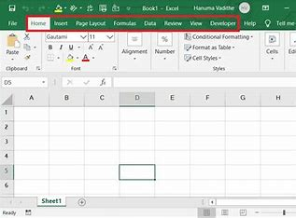
Despite its many strengths, Excel does have its limitations. One of the most notable limitations is the potential for errors, particularly with manual data entry and formula construction. Small mistakes in data entry or formula creation can lead to significant errors in analysis, highlighting the importance of thorough validation and error-checking procedures. Moreover, Excel may experience performance issues when dealing with very large datasets or complex calculations, especially on older hardware or under heavy computational loads. This can result in sluggish performance or even crashes, impacting productivity and workflow. Additionally, security risks associated with macros pose concerns, as malicious macros can potentially compromise data integrity and system security if not properly managed and secured. In spite of these limitations, Excel's versatility, ease of use, and widespread acceptance make it an indispensable tool for professionals across industries, from finance and accounting to marketing, research, and beyond. Its ability to handle complex data analysis tasks, generate insightful visualizations, and support collaborative workflows makes it an essential asset for anyone working with data in today's digital age (Kolluri et al, 2016).

3.4 MS Access
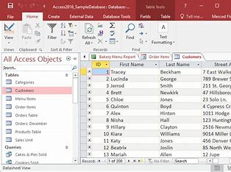

Microsoft Access, a database management system (DBMS) included in the Microsoft Office suite, is a powerful tool for storing, managing, and analysing data. At its core, Access allows users to create and manipulate databases consisting of tables, queries, forms, reports, and macros. Tables serve as the foundation of a database, where data is stored in rows and columns. Users can define relationships between tables to establish connections and ensure data integrity. Queries enable users to retrieve, filter, and analyze data based on specific criteria, facilitating efficient data retrieval and analysis. Forms provide a user-friendly interface for entering and viewing data, while reports allow for the creation of professional-looking documents summarizing and presenting data in various formats. Macros automate repetitive tasks and streamline workflows, enhancing productivity and efficiency. Moreover, Access integrates seamlessly with other Microsoft Office applications, allowing for the import and export of data between different programs. This interoperability ensures data consistency and facilitates collaboration across different departments and teams within an organization (Balter, 2004).
One of the major benefits of Microsoft Access is its ease of use and accessibility. With its intuitive graphical user interface (GUI), users can quickly design and create databases without the need for extensive programming knowledge. Templates and wizards further simplify the process, providing pre-built solutions for common database needs such as inventory management, customer tracking, and project tracking. Additionally, Access offers robust security features, allowing users to control access to data at the table, query, form, and report levels. Password protection, user-level security, and encryption options ensure data confidentiality and integrity, protecting sensitive information from unauthorized access or tampering. Another advantage of Access is its scalability, allowing databases to grow and evolve alongside the needs of the organization. Users can easily add new tables, queries, forms, and reports as their data requirements change, ensuring that Access remains a flexible and adaptable solution over time (Lambert and Frye, 2018)
However, despite its many strengths, Microsoft Access does have limitations that users should be aware of. One limitation is its performance with large datasets or complex queries. Access may struggle to handle very large volumes of data or perform complex calculations efficiently, leading to slow performance or even crashes in some cases. Additionally, Access is primarily designed for single-user or small team environments and may not be suitable for large-scale enterprise applications with thousands of concurrent users. Its file-based architecture can also pose challenges for multi-user environments, as simultaneous access to the database file can lead to data corruption or integrity issues if not managed properly. Furthermore, Access lacks some of the advanced features and scalability options found in enterprise-level database management systems like Microsoft SQL Server or Oracle Database. Users with complex database requirements or large-scale deployments may find Access lacking in terms of performance, scalability, and advanced functionality (Foulkes, 2020).

Task 3b Testing some business-related features of Office Applications
3b.1 Mail Merge
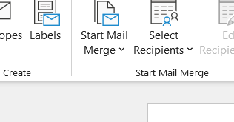
Starting the mail merge wizard in Microsoft word
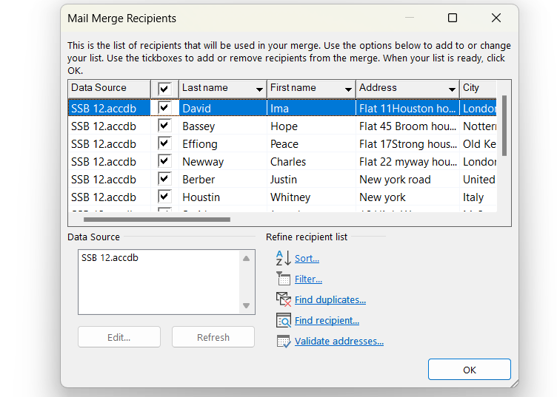

Filtering fields in the list
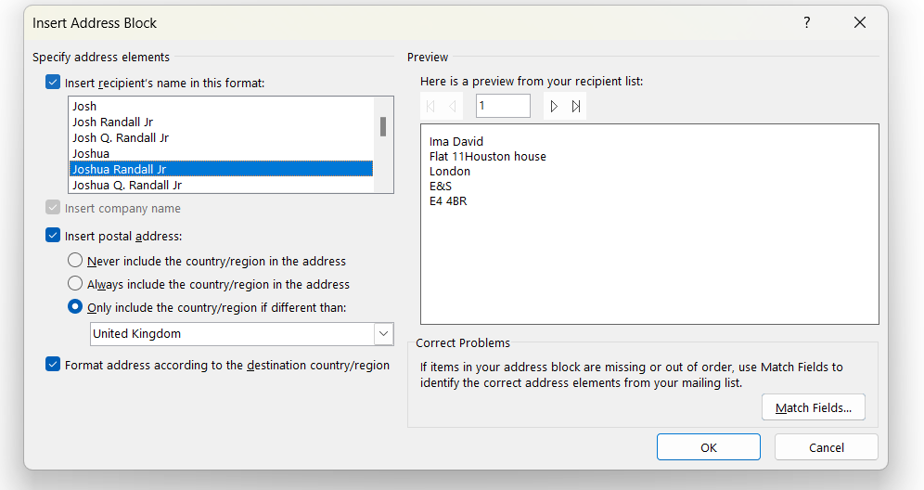
Selecting the default address block

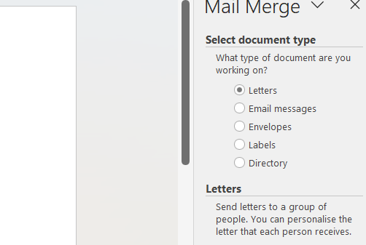
Choosing the document type for the mail merge

Creating a table to store data for Mail merge
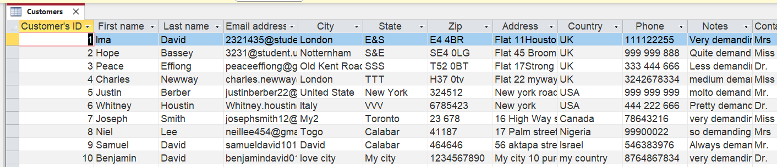


selecting the starting document for the mail merge

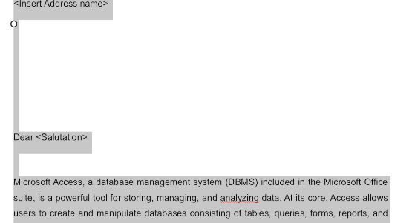
Writing the letter and inserting merge fields.

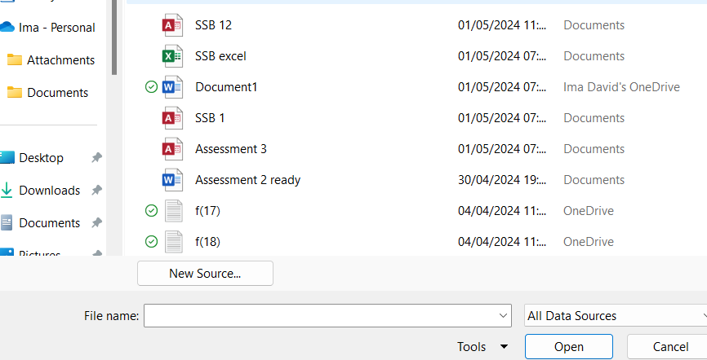
Selecting recipients from the access database

Organising recipient’s address
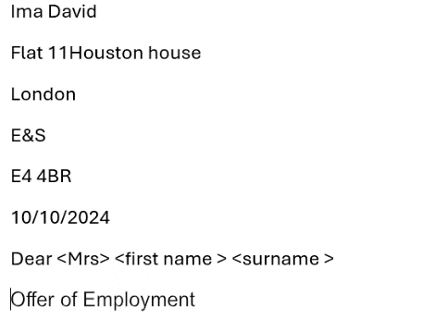

Completing the merge, send, and saving the documents.
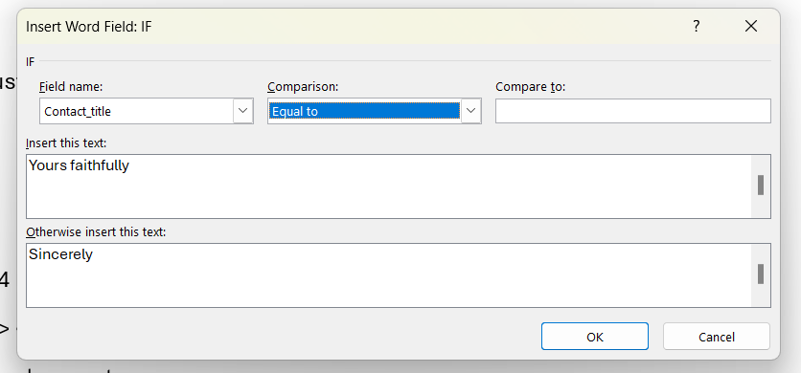

3b.2 Pivot Table creation
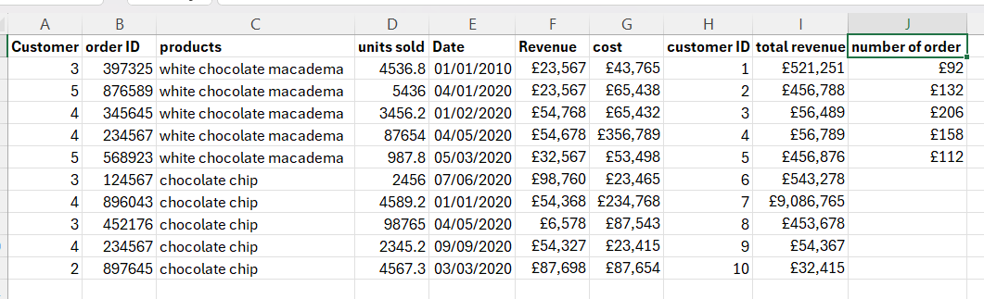
Example dataset with clear headings

Creating a new pivot table and designing the pivot table by arranging fields
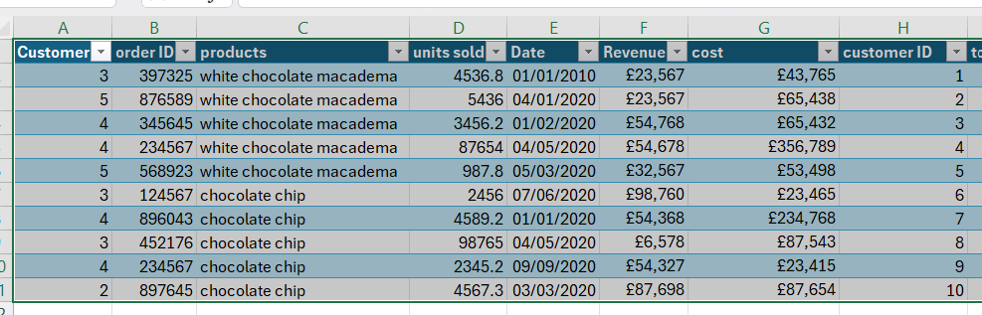
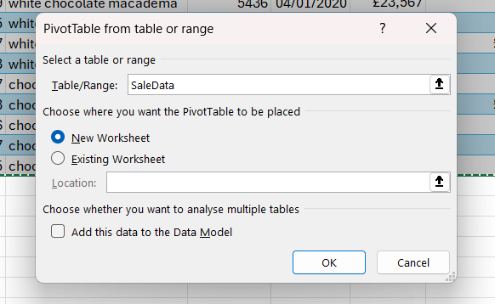

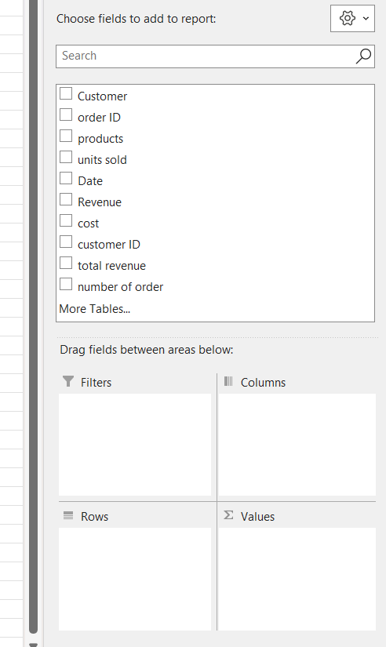

A new worksheet
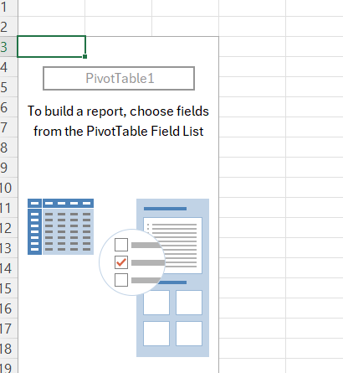
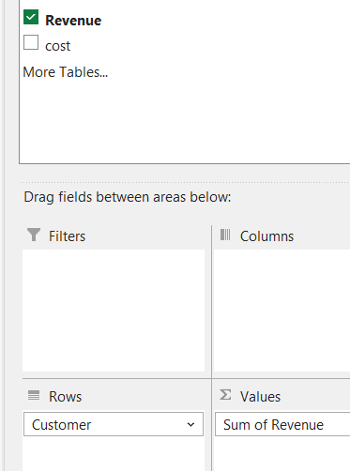

Dragging revenue to value for calculation

Dragging customer ID into row
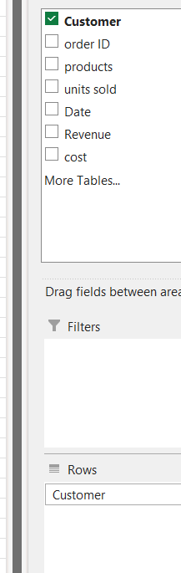

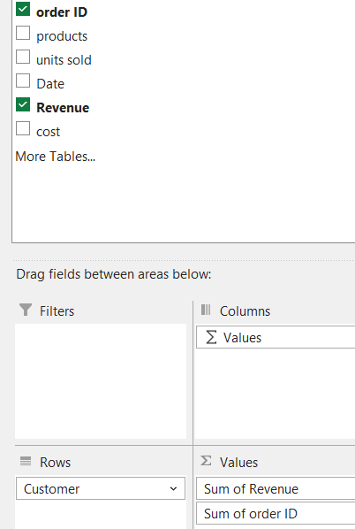

Dragging the order ID for account

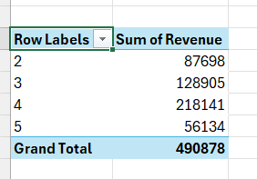

Finalizing and presenting results

- To know which customer, drive the most revenue is by clicking into the column and right click and sort from largest to smallest.
- The list can also be custom sort to change position of costumer for whatsoever reason, by right clicking and choose the option to move or change position.
- The list can also be filtered to see revenue of a few costumer’
- Total percentage of revenue contributed by a costumer can be gotten by dragging revenue unto value and right clicking on any row to select the percentage option and the costumer with the most revenue will be highlighted and more other functions.

Task 4a- Communication Tools
4a.1 Email is a cornerstone of modern communication in business, facilitates quick and convenient messaging, file sharing, and scheduling through its array of features and functionalities. Users can send and receive text-based messages, attach files, manage contacts, and organize their inbox with folders and filters. It is widely adopted and understood, and serves as a primary means of communication for internal and external correspondence including discussions with colleagues, clients, and partners, as well as marketing endeavours. Its asynchronous nature allows for flexibility in response times, while integration with calendars enables scheduling directly from the inbox (Gloor, 2016). However, email faces challenges such as overload, lack of real-time interaction, susceptibility to spam and security risks, and limited collaboration capabilities. Security measures like encryption, spam filters, and virus scanning mitigate some risks, and integration with other systems like calendars, task management tools, and file storage platforms enhances its utility. Despite its weaknesses, email remains an essential tool for communication and collaboration in modern business, especially when complemented by appropriate security measures and integration capabilities (Sumecki et al, 2011).

Summary of it features
- Instant Messaging: Send and receive messages instantly
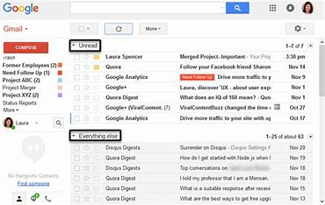

- Attachment: share files, documents, and media easily.
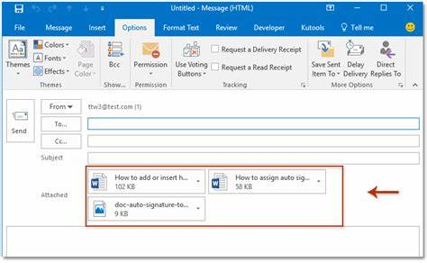

- Organization: Manage emails effectively with filters.
- Integration: Integrate with calendars and other productivity tools.
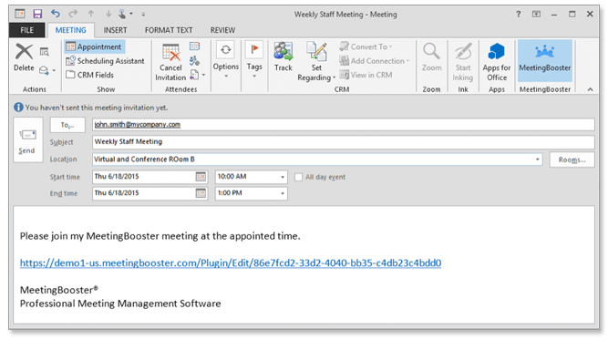

- Security: Ensure data security with encryption and spam filters.
- Mobile Access: Access emails on smartphones and tablets
- Customization: Customize settings and layouts as needed (Lambert et al, 2018).


4a.2 Zoom, a versatile communication tool widely used in modern business, offers high-quality video conferencing, screen sharing, chat, and collaboration capabilities. Users can join meetings from various devices, share screens, exchange messages, and manage participants with ease. Its integration with calendar apps like Google Calendar and Microsoft Outlook simplifies scheduling, while features like recording, virtual backgrounds, and polls enhance engagement and productivity. Notwithstanding of its strengths in ease of use, reliability, and scalability, Zoom has faced security concerns and limited collaboration features. However, its security measures like meeting passwords, waiting rooms, and end-to-end encryption mitigate risks, and integration with collaboration tools and productivity suites enhances its utility. Zoom remains a popular choice for virtual communication and collaboration, serving businesses, educational institutions, healthcare providers, and more, across industries and geographical boundaries (Nadezhda, 2020).

Summary of Zoom features
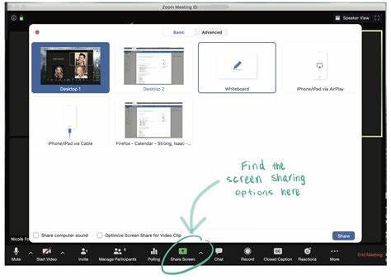
Video Conferencing: Hold high-quality video conferences with many people.
Screen sharing lets one show papers, slideshows, or apps to other people.
Chat feature: Send and receive text messages with other meeting attendees.
Virtual Backgrounds: one can change his background with virtual backgrounds to make it look better or protect your privacy.
Recording and Playback: one can record conversations to look back on and play back later. Can store the recordings locally or in the cloud.
Alliance with Calendar Apps: Easy connection with calendar apps like Microsoft Outlook and Google Calendar for setting up meetings.
Participant Management: Take care of meeting participants by muting and unmuting them, removing them, or letting them in from the waiting rooms.
Polls and Q&A: Use interactive features like polls and Q&A events to get people interested.
Security Features: Meeting passwords, waiting rooms, and end-to-end encryption are just a few of the security features that can be used to keep meetings private and safe.
Large Meeting Support: Hold large meetings with up to a thousand people, like workshops, conferences, and other online events (Sevilla, 2020).

Collaboration Tools
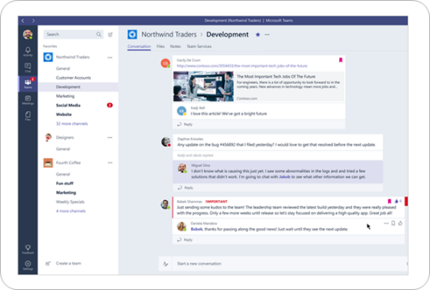

4a.3 Microsoft Teams stands out as a tool for communication that can meet a lot of different needs for businesses. Its multifaceted features include seamless chat functionalities, facilitating both individual and group conversations enriched with emojis and GIFs. The integrated meeting capabilities empower users to schedule, join, and conduct video conferences effortlessly, complete with screen sharing and recording functionalities to enhance collaboration and document discussion outcomes. Teams' channel organization system provides an effective means of structuring conversations and collaboration around specific projects or topics, ensuring clarity and focus within teams. Moreover, the platform facilitates seamless file sharing and collaboration within channels, leveraging Microsoft Office Online for real-time document editing and review. Its deep integration with Office 365 applications further streamlines workflows, enabling users to access, edit, and share files directly within the Teams interface (Purba and Sanga, 2021). Teams has a large ecosystem of third-party apps and integrations that give organisations more freedom and flexibility to make their workspace fit their specific needs and tastes. Whether for small teams or large enterprises, Teams scales effectively, accommodating diverse organizational structures and requirements. However, users may encounter a learning curve, especially those unfamiliar with Office 365 applications, and the platform's resource-intensive nature may require adequate bandwidth and computing power. Nevertheless, Teams prioritizes security and compliance, offering robust encryption, multi-factor authentication, and adherence to industry regulations such as General Data Protection Regulation GDPR
In conclusion, Microsoft Teams becomes a central location for effective and cooperative teamwork, increasing efficiency and making it easier for businesses across all industries to communicate with each other (Ilag, 2018).

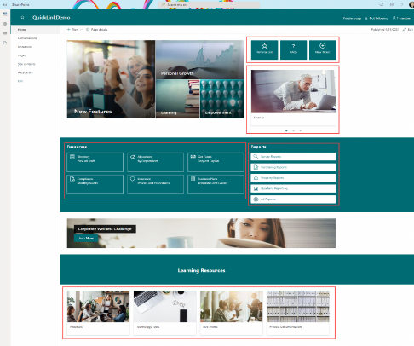
4a.4 SharePoint Perran et al, (2013). Stated that SharePoint is an all-encompassing platform that provides an extensive array of functionalities and features that are specifically designed to facilitate document administration, foster collaboration, and automate business processes. Its robust document management capabilities enable users to store, organize, and collaborate a wide range of materials, such as presentations, spreadsheets, documents, and more. In addition, SharePoint
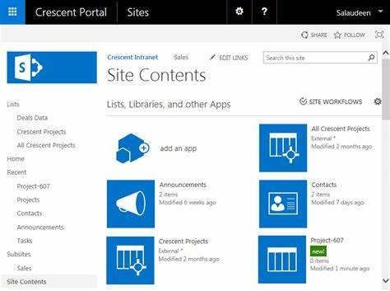
enables team collaboration by providing a centralised location for communication, information sharing, and project coordination via the establishment of team sites and collaboration spaces. Its content management features, such as version control, metadata tagging, and content approval workflows, ensure the accuracy, integrity, and security of content across the organization. Furthermore, SharePoint empowers users to streamline business processes and automate workflows, enhancing efficiency and productivity. Its integration with Office 365 applications like Word, Excel, and Outlook offers a seamless user experience, allowing users to access and collaborate on files directly within SharePoint sites. While SharePoint may present a learning curve and complexity for some users, particularly those new to document management systems or without dedicated IT resources, its extensive customization options, security measures, and compliance with industry regulations make it a powerful tool for organizations of all sizes and industries. Overall, SharePoint serves as a versatile platform for managing documents, facilitating collaboration, and driving business productivity through automation and integration capabilities (Fox, 2010).

Task 4b Practical use of Communication and Collaboration applications
4b.1 Email
Screenshot of the Gmail inbox, showing the list of emails and navigation sidebar.
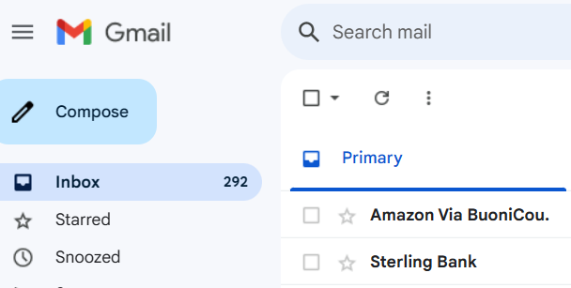


Screenshot demonstrating formatting options in Gmail, including bold, italics, and font colour.
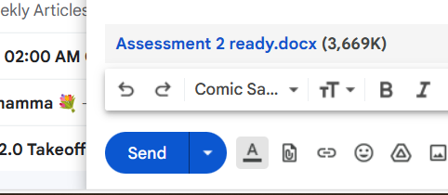

Screenshot of attaching a file to an email in Gmail, ready to be sent to the recipient.

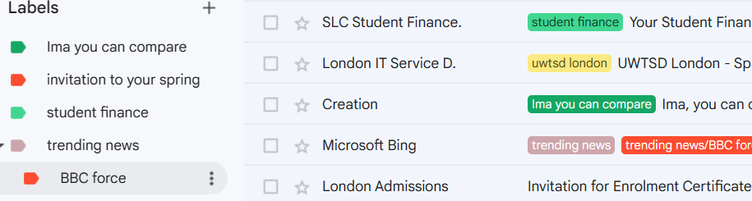
Screenshot showing the creation of a new label in Gmail and moving emails into it for organization.

Screenshot of using the search bar in Gmail to find specific emails or conversations.
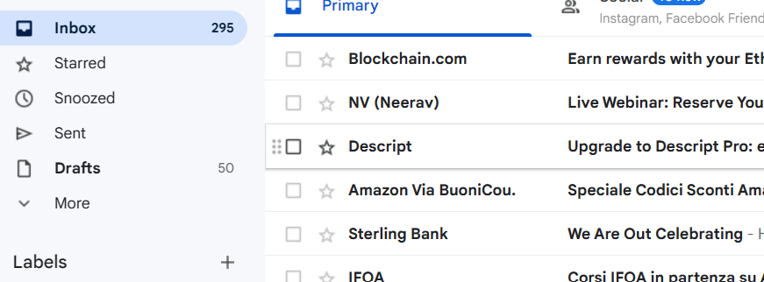

4b.2 Collaboration tool- MS Team
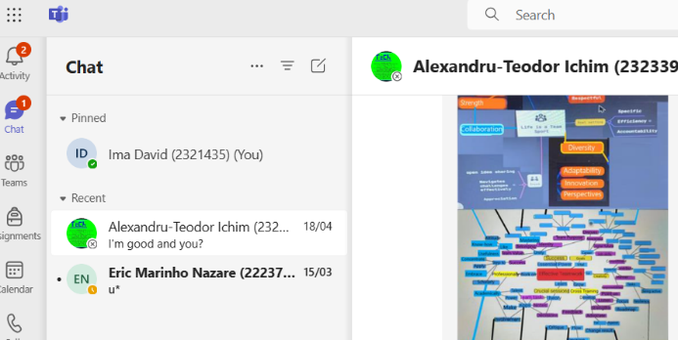
Demonstrates the messaging capabilities of Teams, highlighting the ability to send formatted messages and share files directly within a chat.

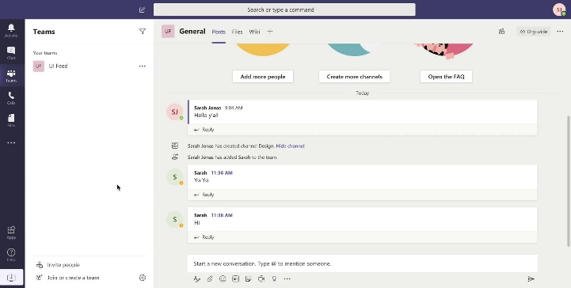
Illustrates the organizational capabilities of Teams, detailing how users can set up dedicated spaces for collaboration on various topics or projects.

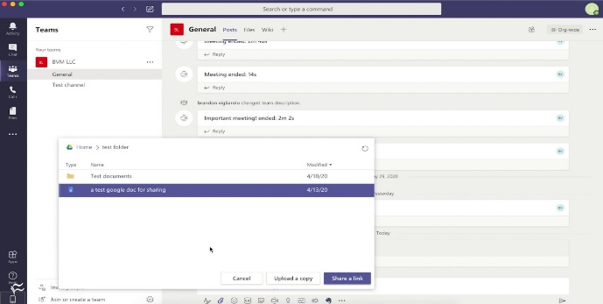

Highlights the seamless integration of Office 365 within Teams, enabling real-time document collaboration.

Conclusion
In conclusion, Component 1 of the portfolio meticulously examines the diverse software solutions crucial for modern business operations, including e-Commerce website software that enhances customer experiences and supports business scalability. It features a mind-map of contemporary software applications, illustrating the interconnectedness and strategic importance of these tools in improving operational efficiency and competitive advantage. The detailed analysis of office applications and their business-related features highlights their evolution from simple productivity tools into comprehensive suites that integrate advanced functionalities like real-time collaboration and cloud-based storage, which are indispensable in modern enterprises. Additionally, the portfolio explores several contemporary communication and collaboration applications such as Slack, Microsoft Teams, and Zoom, underscoring their pivotal role in enabling a connected, productive workplace by facilitating seamless communication and collaboration across geographically dispersed teams. This integration of diverse software solutions is emphasized as a strategic imperative for enhancing business efficiency, driving innovation, and maintaining a competitive edge in a rapidly evolving digital landscape, thereby equipping professionals and organizations with the insights needed to make informed technological choices to future-proof their business models.

References
[1] A. Perran, S. Perran, J. Mason, L. Rogers and A. Rehmani. A. Perran, S. Perran, J. Mason, L. Rogers and A. Rehmani. Beginning SharePoint 2013 Building Business Solutions eBook and SharePoint-Videos. Com Bundle Beginning SharePoint 2013 Building Business Solutions eBook and SharePoint-Videos. Com Bundle 2013.
[2] S. Fox. S. Fox. Beginning SharePoint 2010 Development Beginning SharePoint 2010 Development 2010.
[3] L. S. L. Purba. L. S. L. Purba. Microsoft teams 365 and online learning: The student’s perception. Microsoft teams 365 and online learning: The student’s perception. 1313(2), pp. 130-136. pp. 130-136. 2021.
[4] B. N. Ilag. B. N. Ilag. Introducing microsoft teams. Introducing microsoft teams. 365365pp. 1-2. pp. 1-2. 2018.
[5] G. Sevilla. G. Sevilla. Zoom vs. microsoft teams vs. google meet: Which top videoconferencing app is best. Zoom vs. microsoft teams vs. google meet: Which top videoconferencing app is best. 2020.
[6] G. Nadezhda. G. Nadezhda. Zoom technology as an effective tool for distance learning in teaching english to medical students. Zoom technology as an effective tool for distance learning in teaching english to medical students. 66(5), pp. 457-460. pp. 457-460. 2020.
[7] D. Sumecki, M. Chipulu and U. Ojiako. D. Sumecki, M. Chipulu and U. Ojiako. Email overload: Exploring the moderating role of the perception of email as a ‘business critical’tool. Email overload: Exploring the moderating role of the perception of email as a ‘business critical’tool. Int.J.Inf.Manage. Int.J.Inf.Manage. 3131(5), pp. 407-414. pp. 407-414. 2011.
[8] P. A. Gloor. P. A. Gloor. What email reveals about your organization. What email reveals about your organization. 5757(2), pp. 8. pp. 8. 2016.
[9] L. Foulkes. L. Foulkes. Learn Microsoft Office 2019: A Comprehensive Guide to Getting Started with Word, PowerPoint, Excel, Access, and Outlook Learn Microsoft Office 2019: A Comprehensive Guide to Getting Started with Word, PowerPoint, Excel, Access, and Outlook 2020.
[10] J. Lambert and C. Frye. J. Lambert and C. Frye. Microsoft Office 2019 Step by Step Microsoft Office 2019 Step by Step 2018.
[11] B. Held, B. Moriarty and T. Richardson. B. Held, B. Moriarty and T. Richardson. Microsoft Excel Functions and Formulas with Excel 2019/Office 365 Microsoft Excel Functions and Formulas with Excel 2019/Office 365 2019.
[12] R. Jacobson. R. Jacobson. Microsoft Office Excel 2007 Visual Basic for Applications Step by Step Microsoft Office Excel 2007 Visual Basic for Applications Step by Step 2007.
[13] G. Shmueli, N. R. Patel and P. C. Bruce. G. Shmueli, N. R. Patel and P. C. Bruce. Data Mining for Business Intelligence: Concepts, Techniques, and Applications in Microsoft Office Excel with XLMiner Data Mining for Business Intelligence: Concepts, Techniques, and Applications in Microsoft Office Excel with XLMiner 2011.
[14] B. Kolluri, M. J. Panik and R. N. Singamsetti. B. Kolluri, M. J. Panik and R. N. Singamsetti. Introduction to Quantitative Methods in Business: With Applications using Microsoft Office Excel Introduction to Quantitative Methods in Business: With Applications using Microsoft Office Excel 2016.
[15] D. M. Marcovitz. D. M. Marcovitz. Powerful Powerpoint for Educators: Using Visual Basic for Applications to make Powerpoint Interactive Powerful Powerpoint for Educators: Using Visual Basic for Applications to make Powerpoint Interactive 2012.
[16] T. Negrino. T. Negrino. Microsoft Office for IPad: An Essential Guide to Microsoft Word, Excel, PowerPoint, and OneDrive Microsoft Office for IPad: An Essential Guide to Microsoft Word, Excel, PowerPoint, and OneDrive 2014.
[17] L. Foulkes. L. Foulkes. Learn Microsoft Office 2019: A Comprehensive Guide to Getting Started with Word, PowerPoint, Excel, Access, and Outlook Learn Microsoft Office 2019: A Comprehensive Guide to Getting Started with Word, PowerPoint, Excel, Access, and Outlook 2020.
[18] P. Rutledge, J. Grey and T. Mucciolo. P. Rutledge, J. Grey and T. Mucciolo. Special Edition using Microsoft Office PowerPoint 2003 Special Edition using Microsoft Office PowerPoint 2003 2004.
[19] T. McGee and P. Ericsson. T. McGee and P. Ericsson. The politics of the program: MS word as the invisible grammarian. The politics of the program: MS word as the invisible grammarian. 1919(4), pp. 453-470. pp. 453-470. 2002.
[20] F. Morgado. F. Morgado. Microsoft Word Secrets: The Why and how of Getting Word to do what You Want Microsoft Word Secrets: The Why and how of Getting Word to do what You Want 2017.
[21] M. A. Mohamed, O. G. Altrafi, M. O. Ismail and M. O. Elobied. M. A. Mohamed, O. G. Altrafi, M. O. Ismail and M. O. Elobied. A novel method to protect content of microsoft word document using cryptography and steganography. A novel method to protect content of microsoft word document using cryptography and steganography. 77(4), pp. 292. pp. 292. 2015.
[22] S. R. Shabeen and K. A. Krishnan. S. R. Shabeen and K. A. Krishnan. Application of lean manufacturing using value stream mapping (VSM) in precast component manufacturing: A case study. Application of lean manufacturing using value stream mapping (VSM) in precast component manufacturing: A case study. 6565pp. 1105-1111. pp. 1105-1111. 2022.
[23] S. Aschwanden-Granfelt. S. Aschwanden-Granfelt. Process flow documentation: A flowchart guide for micro & small business. Process flow documentation: A flowchart guide for micro & small business. ; ; 2017.
[24] E. Yigitbas, S. Gorissen, N. Weidmann and G. Engels. E. Yigitbas, S. Gorissen, N. Weidmann and G. Engels. Collaborative software modeling in virtual reality. Collaborative software modeling in virtual reality. Presented at 2021 ACM/IEEE 24th International Conference on Model Driven Engineering Languages and Systems (MODELS). Presented at 2021 ACM/IEEE 24th International Conference on Model Driven Engineering Languages and Systems (MODELS). 2021, .
[25] L. J. Durrant, A. N. Vadher, M. Sarač, D. Başoğlu and J. Teller. L. J. Durrant, A. N. Vadher, M. Sarač, D. Başoğlu and J. Teller. Using organigraphs to map disaster risk management governance in the field of cultural heritage. Using organigraphs to map disaster risk management governance in the field of cultural heritage. 1414(2), pp. 1002. pp. 1002. 2022.
[26] R. Sehrawat. R. Sehrawat. Exploring mindmeister as an effective mind mapping tool for online classes to enhance critical thinking skills in learners at K-12 level. Exploring mindmeister as an effective mind mapping tool for online classes to enhance critical thinking skills in learners at K-12 level. Presented at The 4th International Conference on Education 2021. Presented at The 4th International Conference on Education 2021. 2021, .
[27] A. A. Aimoldina. A. A. Aimoldina. Digital mind maps (DMM) in developing students’ critical thinking within the course of business communication. Digital mind maps (DMM) in developing students’ critical thinking within the course of business communication. 109109(1), pp. 24-32. pp. 24-32. 2023.
[28] U. Tra. U. Tra. Development of an E-commerce web application for sunrob robotics inc. Development of an E-commerce web application for sunrob robotics inc. 2023.
[29] P. Rauland. P. Rauland. Mastering WooCommerce 4: Build Complete E-Commerce Websites with WordPress and WooCommerce from Scratch Mastering WooCommerce 4: Build Complete E-Commerce Websites with WordPress and WooCommerce from Scratch 2020.
[30] R. Ravensbergen. R. Ravensbergen. Building E-Commerce Solutions with WooCommerce Building E-Commerce Solutions with WooCommerce 2015.
[31] J. T. P. Noronha, S. M. Khan, S. Sebastian and S. M. N. Mustafa. J. T. P. Noronha, S. M. Khan, S. Sebastian and S. M. N. Mustafa. A study on the E-commerce trends using data analysis. A study on the E-commerce trends using data analysis. Presented at 2022 3rd International Conference on Innovations in Computer Science & Software Engineering (ICONICS). Presented at 2022 3rd International Conference on Innovations in Computer Science & Software Engineering (ICONICS). 2022, .
[32] G. Dushnitsky and B. K. Stroube. G. Dushnitsky and B. K. Stroube. Low-code entrepreneurship: Shopify and the alternative path to growth. Low-code entrepreneurship: Shopify and the alternative path to growth. 1616pp. e00251. pp. e00251. 2021.
[33] G. Ballard. G. Ballard. The Definitive Guide to Shopify Themes: Master the Design Skills to Build World-Class Ecommerce Sites the Definitive Guide to Shopify Themes: Master the Design Skills to Build World-Class Ecommerce Sites 2017.

