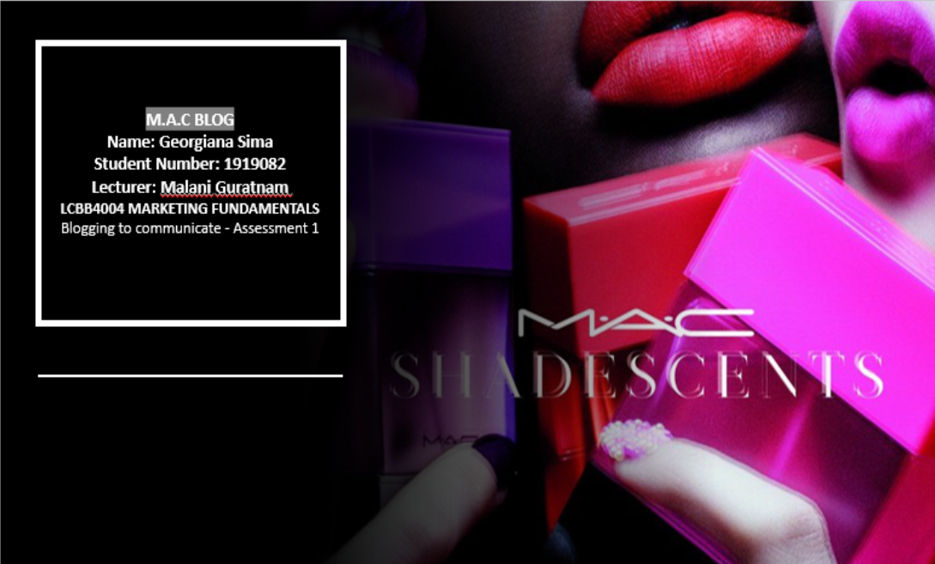
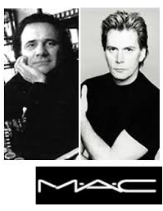
Bringing something new
MAC approached the market in a new different way having its products packed in a new stylish way using small black pots instead of the classic compacts. While all the top brands of that time were focused on skin care, MAC decide to identify itself in colours, having makeup artists instead of the sale agents in their stores. One of the most popular choice was a red matte lipstick, after Madonna wore it in an editorial and next she has been seen wearing a MAC t-shirt, details that boosts the company popularity even more.
Makeup Art Cosmetics-MAC has been born in Toronto, Canada. The fathers founders were Frank Toscan ( photographer and makeup artist) along side Frank Angelo (beauty salon owner). At that time they were both upset with the lack of makeup products who could be used for photography sessions, so they have decided to create a product of their own. They start creating their products in their home kitchen and sale them afterwards to makeup artists, models, photographers and colleagues using Frank Angelo salon. Not long after this, fashion editors have become interested in their products, so in time their popularity growth and they have decided to open MAC store in March 1984 in a shopping center from Toronto.
Founders of MAC
The History of MAC Cosmetics
Charitable Organisations
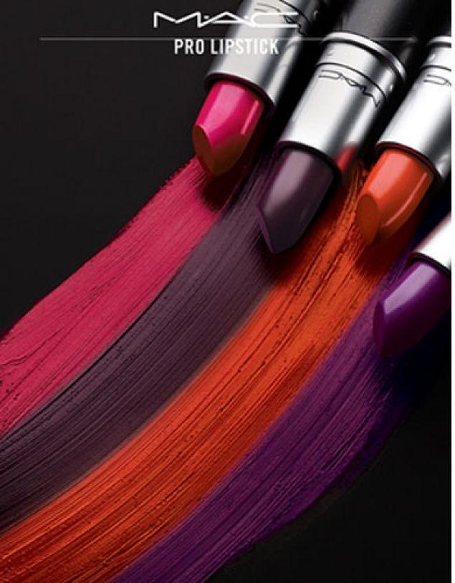
In 1994 MAC Aids found has been created, the company choosing to fight against the spread of HIV and SIDA, which was taking over the world. Until today they have raised over 340 millions dollars with the campaign Viva Glam having along side brand ambassadors like Lady Gaga, Pamela Anderson and Niki Minaj.
MAC is the world leader in makeup thanks to the artistic and technique expertise, we celebrate diversity and individuality being here for all kind of genders, all ages and all races. We are community who takes proud of our professional makeup artists, who creates trends in fashion week all over the globe.
WHO WE ARE AND WHAT M.A.C MEANS?
MAC Products
MAC’s Mantra “all ages, all races, al sexes” is the fundamental principle of the brand that comprise diversity and inclusion. It has become known that the brand caters and celebrate for diversity within the human rase and to ensure that each individual is catered for MAC is constantly adjusting and adding to their vast shade range. As population merge, ethnicities are being blended, creating a need for the company to evolve as human kind do.

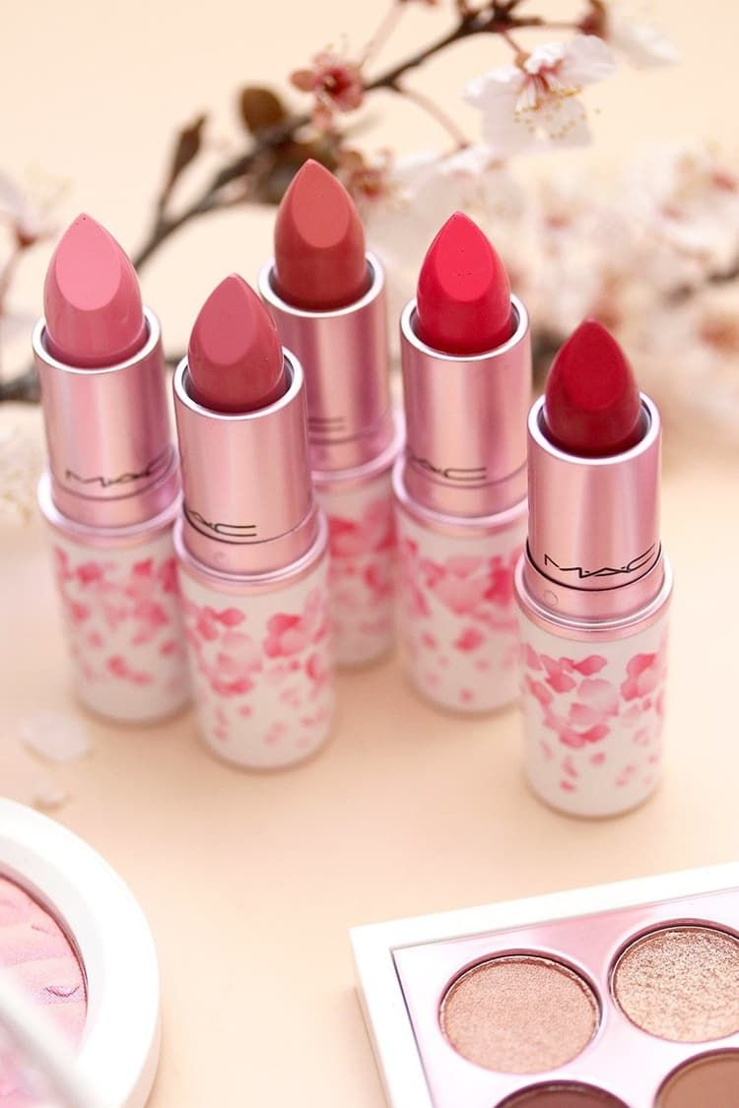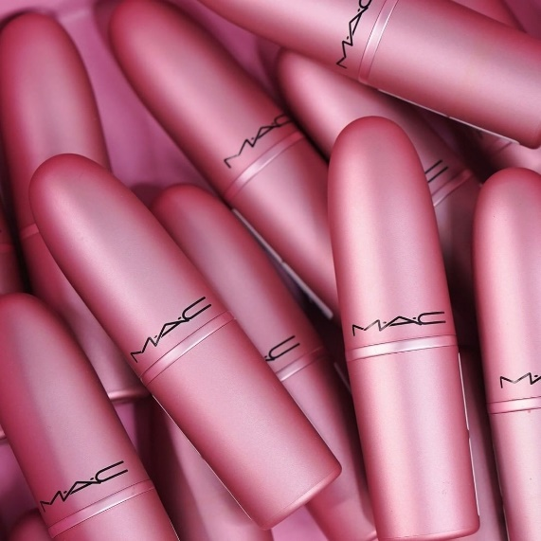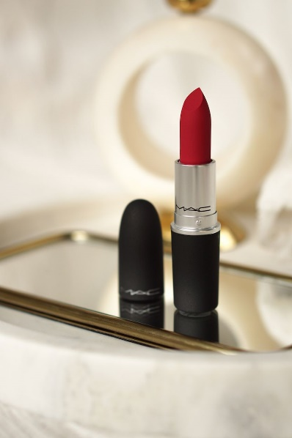

STUDIO FIX FLUID SPF 15 Foundation
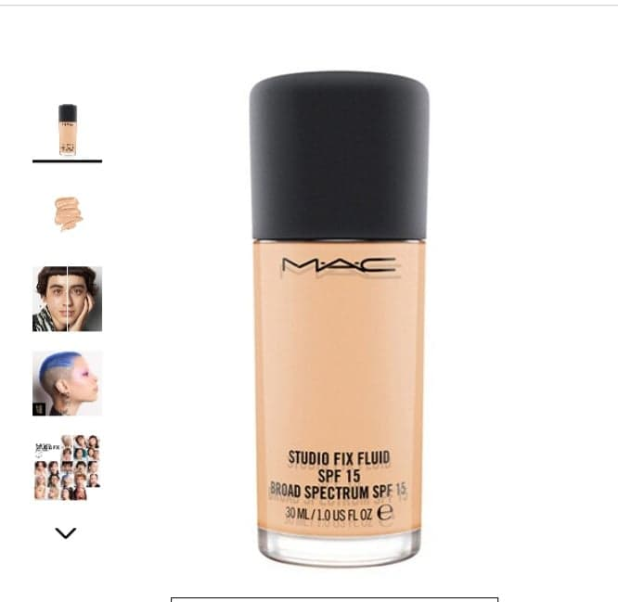
A modern shine foundation that provides the users a matte finish with a medium to full buildable coverage that promise to last for 24h.

Matte Lipstick
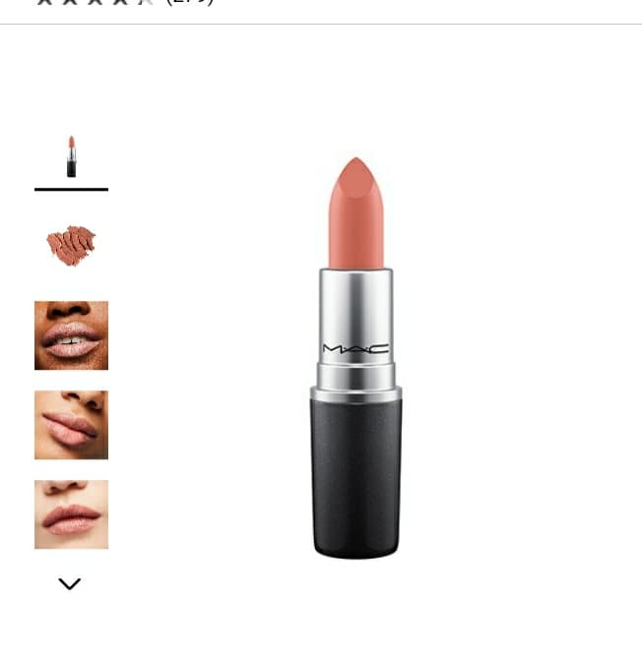
Creamy rich formula with intensive colour pay off in a no shine matte finish.
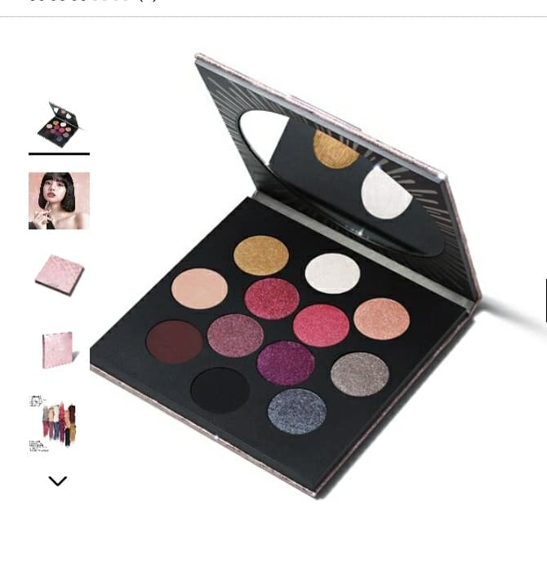
Pricing
A limited edition holiday pallete aglow with twelve neutral pink, purple and blue-green eyeshadows in a range of Matte Frost and Lustre finishes.
Rocket to fame eyeshadow pallet
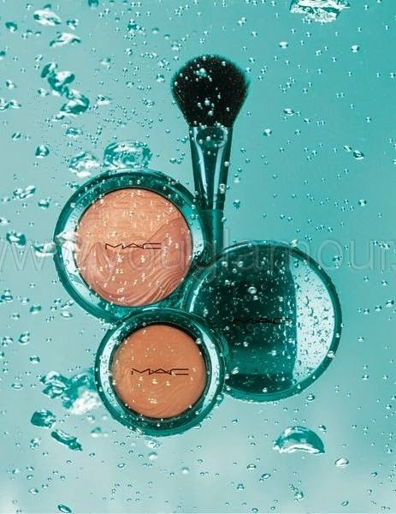MAC collaboration with famous names from the pop culture like Rihanna, Lorde,  Broke Shields has enhanced MAC relevance and the quality of the products has cemented MAC as a top makeup company. MAC its classic and iconic with a strong brand power and people are willing to pay astronomical figures so they can stay attached to this high profile brand name. MAC has a portfolio of high premium goods and adopted a premium pricing strategy with his product price a bit higher than its competitors. Mac also follow product line pricing sometimes having promotions and sales offering complementary products and other incentives.
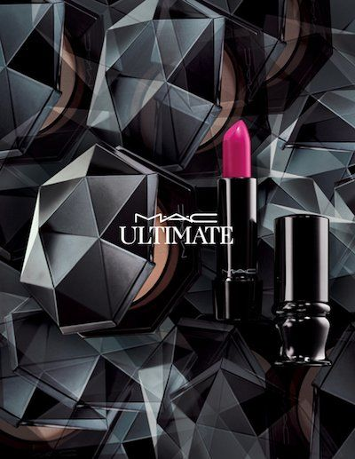
- Lipsticks/Lip pencil ranges from 7.75£ up to 19£
- Foundation starting 20£ up to 35£
- Eyeshadow starting 9.5£ up to 39£
- Mascara starting 12£ up to 22£
- Eyeliner 16£ to 20£
- Pallets starting 14£ up to 68£

MAC also offer makeup services when you can book an appointment or you can chat with a makeup artist every day of the week.
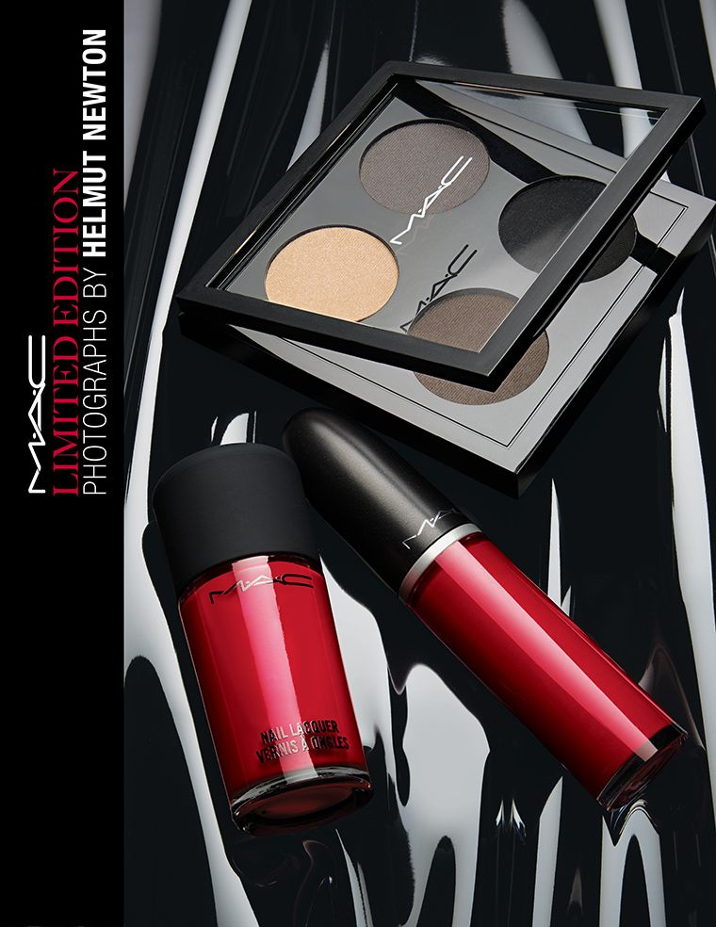
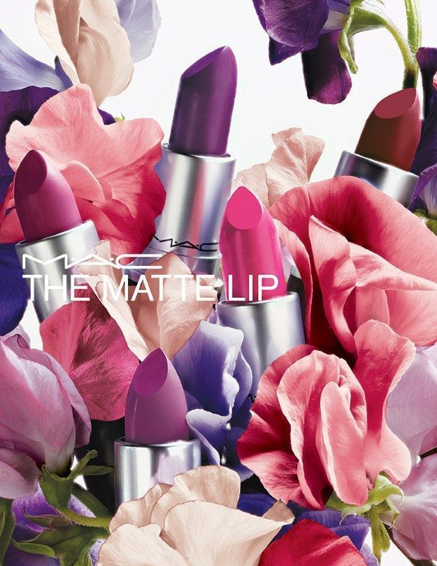
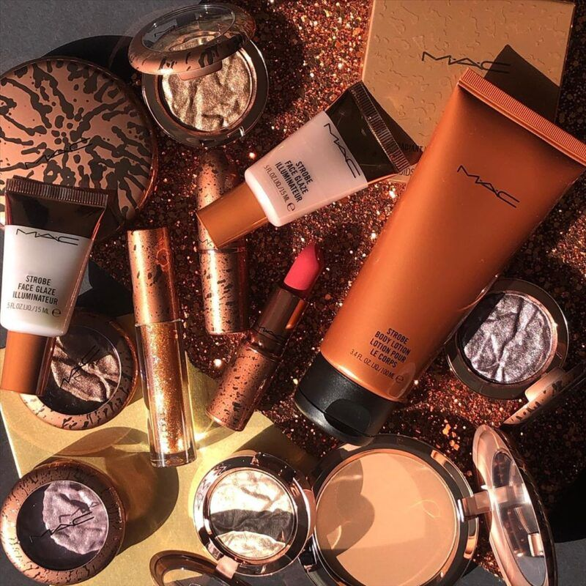
MAC’s Location and Distribution
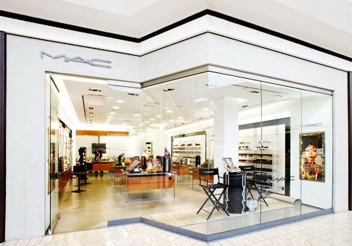
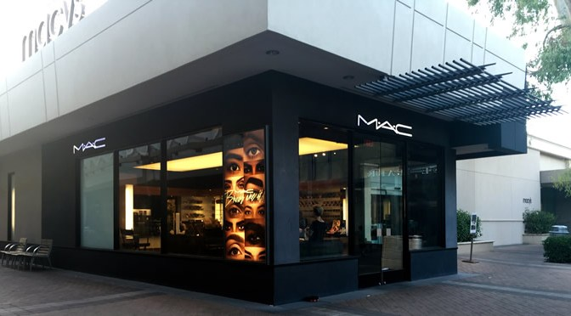
Make-up Art Cosmetic (MAC) has been created in Toronto, Canada 30 years ago and has been grown popularity in the traditional world of mouth endorsement from photographers, journalists, models and makeup artists around the world. Since 1994, MAC is part of the Estee Lauder Companies and it is sold around the world in over 120 countries. It has an army of 19.000 makeup artists. The company does not offers its products via unauthorized retailers or independent boutiques, they can be purchased only by MAC stores and its authorized dealers, it has excellent support staff that provides lessons and consultations services that can be booked via phone or company website.
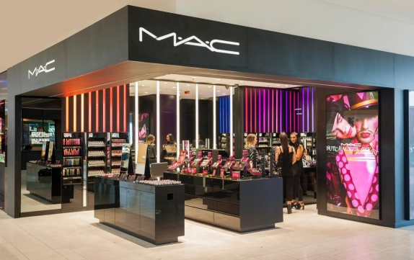
The purpose of advertising is more than simply to create customer value, it must communicate that value by engaging the targeted customers. MAC is managing to keep that relationship engaging a wide targeted audience through the slogan “All ages, all sexes, all races” that proves how much the company is giving credit to the customers. The company is being grateful and gives back to the community using its charitable trust donating all the earnings of Viva Glam Lipstick.
The brand has boosted its popularity by collaborating with famous personalities like Mariah Carrey, Rihanna, Nicki Minaj, Ellie Goulding and Selena Gomez. Knowing how important is to be up-to-date, MAC advertised its products by promoting them on social media platform such as Facebook, Instagram, Twitter, Youtube and Pinterest.
Advertising and Promotions
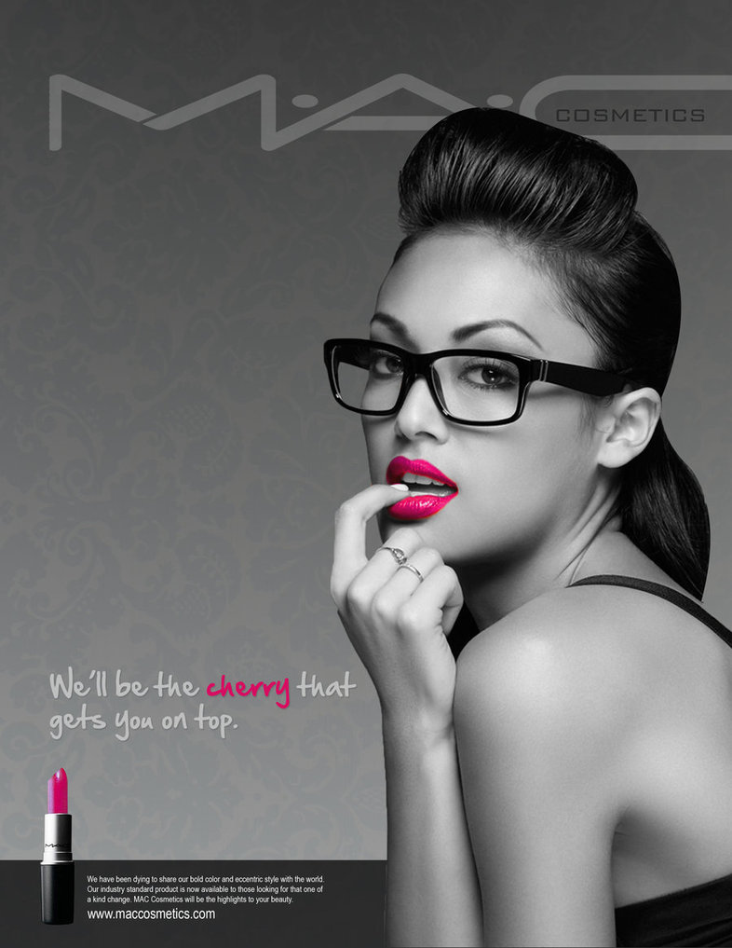
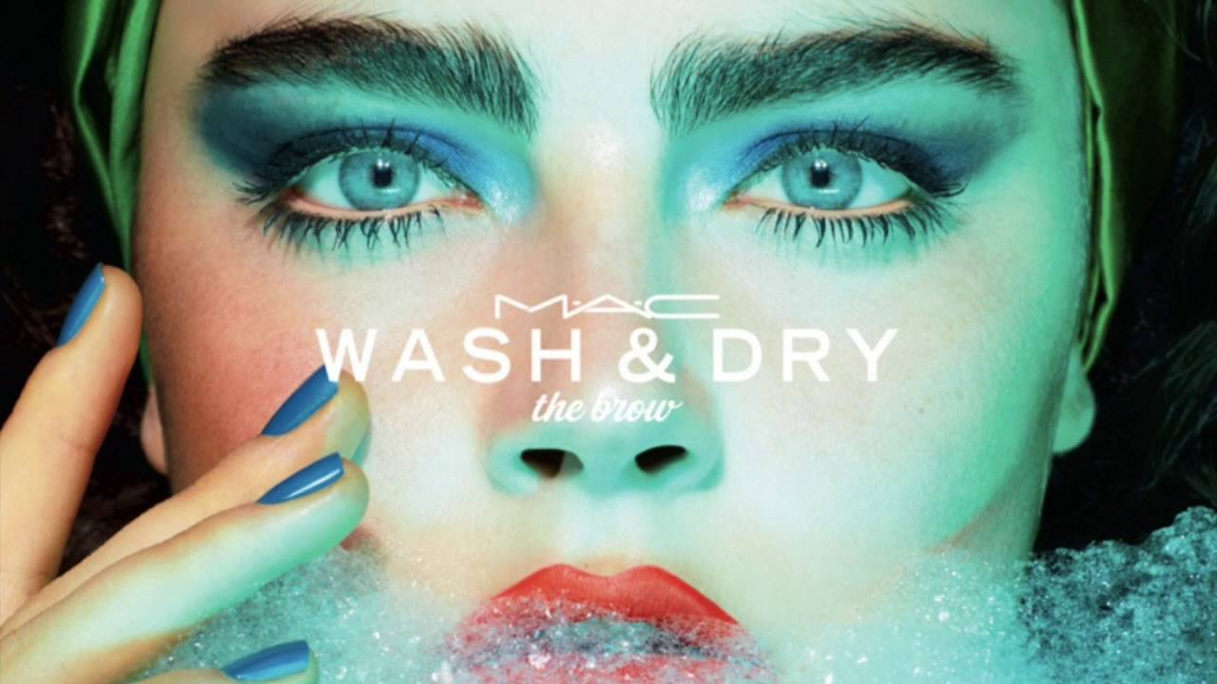
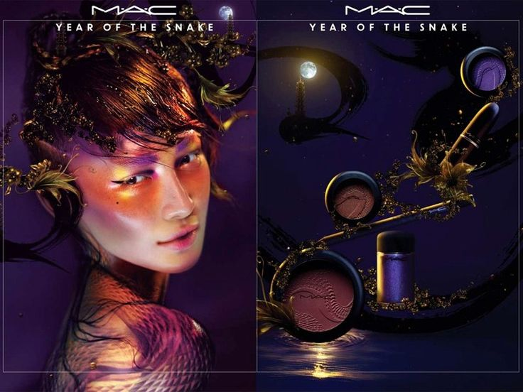
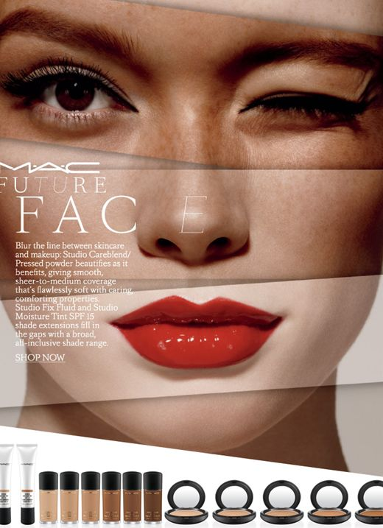
References
History of company
MAC Cosmetics - Official Site. n.d. Our Story. [online] Available at: <https://www.maccosmetics.co.uk/our-story> [Accessed 18 December 2020].

Elcompanies.com. n.d. M·A·C. [online] Available at: <https://www.elcompanies.com/en/our-
brands/mac> [Accessed 20 December 2020].
MAC PRODUCTS
HICKMAN, J., 2019. Is The Beauty Industry Really As Diverse As It Should Be? Let's Check In. [online] Well+Good. Available at: <https://www.wellandgood.com/diversity-in-the-beauty-industry/?fbclid=IwAR2eCG5w6umHyCSSuGq7lTN10DaZsWcyTgrli_zmV_fzS_I9HJTcQDZXw10> [Accessed 21 December 2020].
PRICING
Elcompanies.com. n.d. M·A·C. [online] Available at: <https://www.elcompanies.com/en/our-brands/mac> [Accessed 21 December 2020].

ADVERTISING

Kotler, P. and Armstrong, G., 2017. Principles Of Marketing, Global Edition. Harlow, United Kingdom: Pearson Education, Limited, pp.452.

