NAME: JAYDIP RAMANI
STUDENT NUMBER: 2131580
LECTURER: TUSHARA BALENDRAN
COURSE: MBA GENERAL MANAGEMENT
MODULE CODE: LCMB7001
MODULE NAME: MARKETING MANAGEMENT
ASSIGNMENT 2
ASSINGMENT TITLE: MARKETING ANALYSIS OF UNILIVER
Executive Summary
The study is focused on studying the external and the internal market analysis of Unilever using various marketing tools. The STP analysis of the company has also been provided to show the strategies of segmentation followed by the market. Additionally, the study has helped in analysing the marketing mix of Unilever as well.

Table of Contents
1. Introduction 5
2. PESTEL Analysis of the Unilever Group in the UK 5
2.1. Political and Legal 6
2.2. Economic Factors 6
2.3. Social Factors 7
2.4. Technological Factors 7
2.5. Environmental Factors 7
3. Porter’s Five Forces 8
3.1. Rivalry 8
3.2. Threat of New Entrants 8
3.3. Bargaining Power of the Buyers 9
3.4. Threat of Substitutes 9
3.5. Bargaining Power of Suppliers 9
4. SWOT Analysis 9
4.1. SWOT Analysis for Unilever Group 10
4.2. Advantages and Disadvantages of SWOT Analysis 11
5. Segmentation Targeting and Positioning 12
5.1. Segmentation 12
5.2. Targeting 12
5.3. Positioning 12
6. The Marketing Mix 12
6.1. Product 13
6.2. Price 13
6.3. Place 13
6.4. Promotion 13
7. Conclusion and Recommendations 14
8. References 16

1. Introduction
The present UK market in the consumer sector is highly competitive. Thus, it is the utmost need of the hour for all consumer companies to focus on increasing their competitive advantage. For the study mentioned, Unilever has been chosen. Unilever is headquartered in London and hence the British political regime is of utmost importance to the company (Unilever, 2022). A thorough external and internal market analysis has been presented in the study to show the state of the company in the country.

2. PESTEL Analysis of the Unilever Group in the UK
PESTEL analysis refers to the study of the various key factors that help in influencing the various key factors that can affect the growth of the organization (Abdullah et al., 2022). The main factors under consideration in PESTEL analysis are mainly Political and legal, , Economic, Social , Technological and Environmental factors.
The image below has helped in depicting the factors of the PESTEL analysis. With the help of PESTEL analysis, the decision-making system of the company can be improved to a great extent as well.
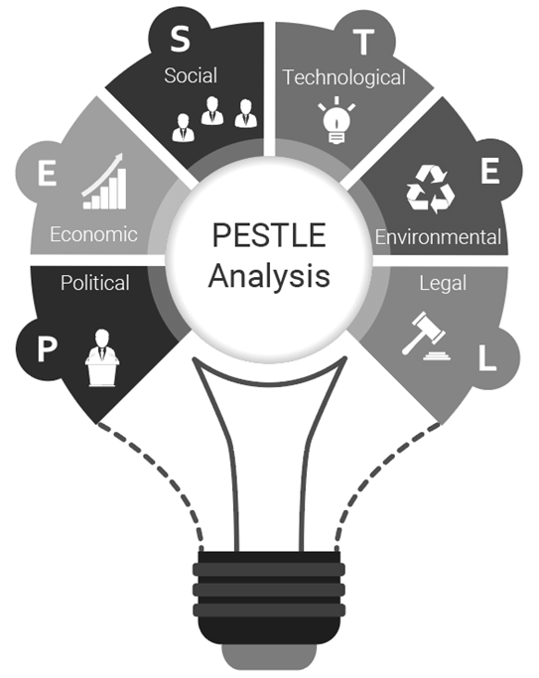
Figure 1: Factors of PESTEL Analysis
(Source: AKMAN, 2020)

2.1. Political and Legal
The ongoing political uncertainty in the country due to Brexit can be described as a major turning point for all the companies in the UK (Turnpenny and Hussein, 2021). However, the maintenance of good political relationships with the USA and other commonwealth countries is very sustainable for the growth of the company in terms of import and export operations. Considering the legal factors, it can be mentioned that the introduction of the trade bill and the UK version of GDPR may help Unilever to compete with international companies in the UK market. Considering the legal factors, it can be mentioned that the implementation of the “Employment Act, of 1996” and the “Consumer Rights Act, 2015” are very strict in the country (Devenney, 2018). Thus, the company needs to reserve the rights of the employees and the consumers under these laws.

2.2. Economic Factors
The UK has been observed 6TH largest GDP in the world (Bloomberg, 2022), The nominal GDP of the UK to reach 2.64 trillion USD in 2020 (Ons.gov.uk, 2020). Thus, it can be mentioned that this had a positive impact on the mentioned company. However, simultaneously, a fall in the GDP of the country by 9.76% in the year 2020 during the pandemic caused a setback to the growth of the company (Statista.com, 2021). Thus, the net revenue of the company faced a slight fall in the economy due to the pandemic.
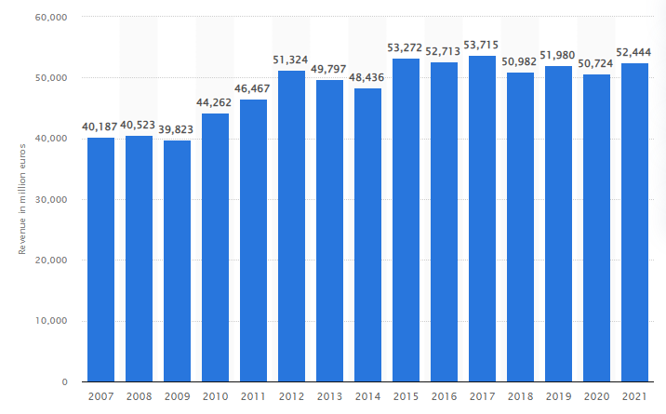
Figure 2: Revenue condition of Unilever
(Source: Statista.com, 2022)

2.3. Social Factors
Taking into consideration the social factors, it has been observed that the total population of the UK comprise different demographic and diverse cultures (Worldometers.info, 2021). The pandemic changed the purchasing power and behaviour of customers. Furthermore, the literacy rate of the country is quite high, at nearly 99% (Una.org.uk, 2020). The delivery of products through online channels helped the company to sustain itself during lockdown Hence, it can be said that the changes in social factors of the UK may require further investment to channelise their sales via online platforms for the growth of the company to a great extent. Moreover, the prospect of hiring educated and skilled employees for the country also increases, thus increasing the chances of productivity for the country.

2.4. Technological Factors
The UK is one of the most developed countries in the world in terms of technology. Considering this fact, technology transfer between different countries, companies, and societies has not that complex regulation, that encourages to the adoption of new and innovative technologies. This aspect has helped companies to adopt new technology in production, logistics, sales and marketing, and other operations to achieve efficiency. For example, Unilever adopts satellite imaging and artificial intelligence (AI) for monitoring the process of land conversion and deforestation. Additionally, the technical advancement of the company has also helped them adopt blockchain technology in its digital supply chain (Techtarget.com, 2022).

2.5. Environmental Factors
Consumers are also concerned about the sustainability and preservation of natural resources. From the SDGs adaptation of the UN, it has been observed that companies have focused on the same issue as well. As of 2019, the UK has focused on reducing carbon emissions by 2.9% and being carbon-free by 2050 (Carbonbrief.org, 2020). Unilever’s sustainability Reports have shown that the distribution centres and warehouses of the mentioned company make up nearly 2% of the greenhouse gas footprint (Unilever.com, 2022). Hence, it can be mentioned that they have focused on the development of the environment as well.

3. Porter’s Five Forces
Porter’s five force model is focused on analysing the weaknesses and strengths of the company based on the external environment (Juliana and Nyoman, 2019). With the implementation of this tool, the profitability and competitiveness of a particular sector can be identified in a better manner. The image below has helped in representing the five force model.
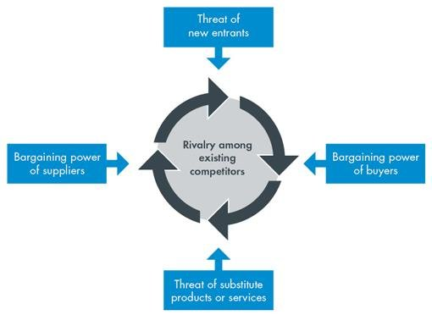
Figure 3: Porter’s Five Force Model
(Source: Chetty, 2020)

3.1. Rivalry
Competitive rivalry can be said to be a major force hampering the growth of a company. In the case of Unilever, it can be mentioned that the number of competitors that the company has is huge due to the presence of several companies in the industry. A recent report has stated that the major competitors of the company in the UK are international brands such as Colgate-Palmolive and Procter & Gamble (Craft. co, 2022). Thus, overall, it can be said that the force of competitive rivalry is high for Unilever.

3.2. Threat of New Entrants
Due to its diverse brand name and awareness, Unilever is seen competing with major and established firms. In the case of the mentioned company, it can be stated that the consumers have high brand loyalty as well. Thus, it can be stated that the switching cost of the company is quite low and the establishment of a brand name as high as that of Unilever is quite difficult. Hence, it can be stated that the threat of new entrants is low for Unilever.

3.3. Bargaining Power of the Buyers
The business of any company is highly dependent on the response of the customers to the products sold by that company (Bashir and Farooq, 2019). In the case of Unilever, consumers have been observed to have access to high-quality information about the products sold by the company. It has been observed that consumers in the present day compare products before they buy them. Thus, it can be mentioned that in the case of Unilever, the customer base of the company is diverse yet the pricing strategy plays a major role in deciding the customer's choice. Thus, it can be stated that the bargaining power of the buyers is high.

3.4. Threat of Substitutes
The increased availability of substitute products plays a major role in maintaining the strength of these firms (Wood et al., 2021). The diverse product segmentation portrayed by the company plays a major role in avoiding the growth of substitute products. Thus, it can be said that this is a weak point for the company and does not affect its growth.

3.5. Bargaining Power of Suppliers
The bargaining power of the suppliers can be considered to be a moderate force. This is mainly attributed to the firm size of the mentioned company. Because the company's supplier base is diverse. However, studies have stated that suppliers play a major role in keeping a balance between the supply and demand curves (Li et al., 2022). Thus, the diverse supplier base of the company plays a significant role for Unilever.

4. SWOT Analysis
SWOT is an acronym for Strengths, Weaknesses, Opportunities, and Threats that a company faces in its business operations. With the help of a SWOT analysis, the internal strengths and weaknesses of a company are determined. External opportunities and threats to the companies are also identified (Krasodomska et al., 2021). The image below helps in illustrating the SWOT analysis.
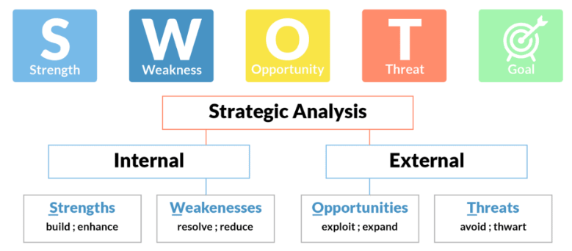
Figure 4: SWOT Analysis
(Source: Inspired by Businessmodelanalyst.com, 2022)

4.1. SWOT Analysis for Unilever Group
Strengths | Weaknesses
- Huge global footprint due to its vast presence in nearly 190 countries (Unilever.com, 2022)  - Broad product segmentation and brand portfolio  - Combines the process of global thinking with local execution  - Flexible pricing strategy (Cheng, 2021)  - Wide distribution channels  - Huge brand loyalty of the consumers  - Ability to tune in with the changing customer preferences | - High competitive rivalry  - Products sold by the company are common and are available from various other sellers at different prices.  - Natural alternatives to the product sold by the company are also possible.
Opportunities | Threats
- Proliferation and globalization of the local markets provide a greater opportunity for the company.  - The introduction of the healthcare range by the company has paved the way for an increase in its customer base of the company (Unilever.com, 2022).  - A well-developed sustainability plan shows a well-developed corporate social responsibility thus attracting customers. | - The global economic crisis has hampered the revenue growth of the company  - Shrinking income level of the global consumer base.
Table 1: SWOT Analysis
(Source: Created by the author)

4.2. Advantages and Disadvantages of SWOT Analysis
The advantages of SWOT analysis are as follows:
- Helps in providing a better understanding of the business
- Points out the weaknesses and thus helps in developing strategies to strengthen them
- Helps in deterring threats to the business
- Makes the decision-making policy better for the company
- Helps a company to capitalize on the opportunities identified, thus allowing future growth (Malki et al., 2020).
- Developing business goals based on the strengths and opportunities to create a strong competitive presence.
The disadvantages of SWOT analysis are as follows:
- The SWOT analysis can oversimplify the extent of weaknesses and strengths
- The lack of hierarchy in the SWOT analysis in terms of which action needs attention first is confusing for the company.

5. Segmentation Targeting and Positioning

5.1. Segmentation
In a market, segmentation is referred to as the process of identifying niche customers and focusing on increasing the profitability of the company (Cortez et al., 2021). In the case of the mentioned company, it can be mentioned that the market of Unilever is segmented depending on the four major principles of segmentation: Geographical, behavioural, psychographic, and demographic. It has been observed that Unilever has made its global presence eminent by following demographic segmentation as a core principle and choosing countries with huge populations such as India.

5.2. Targeting
The products manufactured by Unilever target a diverse age group right from children to adults. The mentioned company has over 400+ brands that have become famous household names (Unilever.com, 2022). In the case of the mentioned company, it has been observed that every household has at least one product of the mentioned company since they have focused on manufacturing items of daily needs. Thus, it can be mentioned that the target market of the company is based on product segmentation.

5.3. Positioning
The mentioned company is dependent on competitive positioning since they deal in products that have a threat of substitution. Thus, the mentioned company has focused on investing in advertising the products. Thus, in this manner, they have ensured customer loyalty and thus occupy a good position in the market.

6. The Marketing Mix
The 4P of marketing helps in reflecting the various combination of the businesses that are important for capturing the target market. The image below has helped in illustrating the elements of the marketing mix.
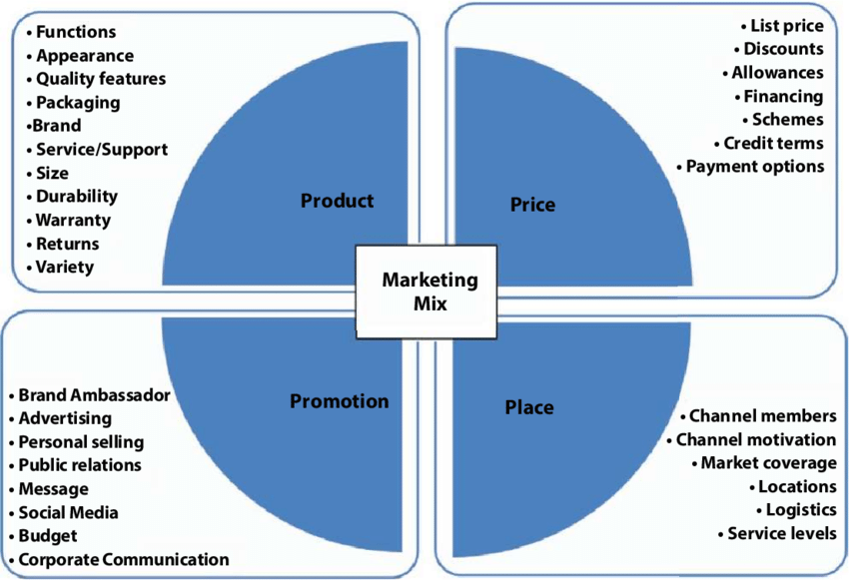
Figure 5: 4P of Marketing
(Source: Maity et al., 2020)

6.1. Product
Unilever has been observed to have a huge variety of products such as food, home care, personal care, and refreshments. Product diversification helps in increasing the customer base of the company.

6.2. Price
Unilever has been observed to follow both "premium pricing strategies" and "product bundle pricing strategy". This is done by the company to reach their target customers as well as implicate the premium quality of the products (Wood et al., 2021).

6.3. Place
Unilever chose stores, kiosks, and retail stores for selling their product. Thus, it has helped them in reaching the target customers in a better manner.

6.4. Promotion
The promotional strategy followed by the company to promote the products is through the process of advertising or sales promotion or direct marketing.

7. Conclusion and Recommendations
Conclusion
From the above discussion, it can be concluded that the implementation of the various marketing tools by Unilever has helped show that the company is quite competent. The external elements and the internal elements have helped in analysing the strengths and weaknesses of the company thus facilitating better decision-making. Thus, these factors help the marketing manager in developing new strategies for increasing the market return.
Recommendations
Unilever, being one of the major FMCG organizations needs to implement recommendation measures to improve its weaknesses. Thus, it can be mentioned that the implementation of the Ansoff matrix can be considered to be the best tool for identifying the various marketing strategies (Oshilalu and Baldie, 2021). The image below illustrates the ANSOFF matrix.
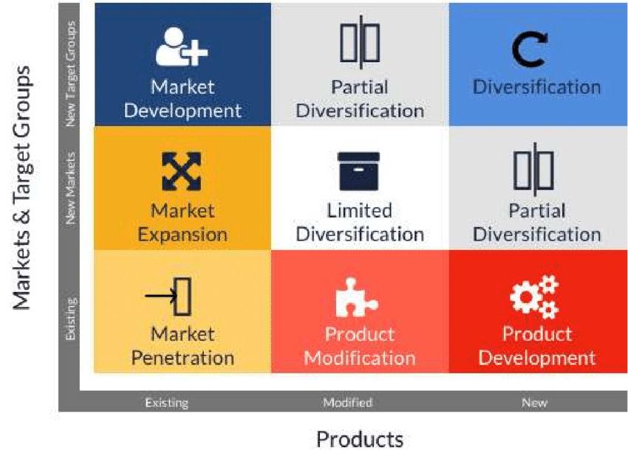
Figure 5: Modified ANSOFF Matrix
(Source: Ramadas et al., 2019)
With the help of this matrix, the market penetration can be increased while focusing on creativity and innovation would help in increasing the product range of the company as well. Furthermore, greater diversification and better market development can be achieved as well.
A further increased presence of online sales platforms may help the company to penetrate the new market. Unilever should encourage CSR and also use them as part of news or promotion to make its consumers aware of its programs.
For market development and expansion, With the help of digital platforms, the company can offer more personalisation in product making as per consumer demands. It allows product modification as per consumer conditions. Unilever may go with partnerships with different dentists, nutritionists, and beauty experts to spread more awareness of its product line. They can start a subscription-based delivery of personal care, and nutrition sections and may also provide a free consultation with experts to choose the right product as per consumer situations.
More transparency in the supply chain , productions and ingredients may also increase the trust of consumers in the brand.

8. References
Abdullah, M.F., Zainol, Z., Thian, S.Y., Ab Ghani, N.H., Mat Jusoh, A., Mat Amin, M.Z. and Mohamad, N.A., 2022. Big Data in Criteria Selection and Identification in Managing Flood Disaster Events Based on Macro Domain PESTEL Analysis: Case Study of Malaysia Adaptation Index. Big Data and Cognitive Computing, 6(1), p.25.
AKMAN, M.K., 2020. Defence Management and PESTLE analysis. Ante Portas-Security Studies, 1(14), pp.93-102.
Bashir, M. and Farooq, R., 2019. The synergetic effect of knowledge management and business model innovation on firm competence: A systematic review. International Journal of Innovation Science.
Businessmodelanalyst.com, 2022. SWOT Analysis: Everything need to know. [Online] Available at: https://businessmodelanalyst.com/swot-analysis-everything-need-to-know/ [Accessed on 19 08 2022]
Carbonbrief.org, 2020. Analysis: UK’s CO2 emissions have fallen 29% over the past decade. [Online] Available at: https://www.carbonbrief.org/analysis-uks-co2-emissions-have-fallen-29-per-cent-over-the-past-decade [Accessed on 19 August 2022]
Cheng, Y., 2021, February. Analysis of the Opportunities and Challenges of Unilever’s Differentiated Competition by Using SWOT and PEST. In 6th International Conference on Economics, Management, Law and Education (EMLE 2020) (pp. 280-284). Atlantis Press.
Chetty, M., 2020. Implementing an alternate payment method in the South African minibus taxi industry: A Business Venture Proposal.
Cortez, R.M., Clarke, A.H. and Freytag, P.V., 2021. B2B market segmentation: A systematic review and research agenda. Journal of Business Research, 126, pp.415-428.
Craft.co, 2022. Unilever competitors and similar companies. Available at: https://craft.co/unilever/competitors [Accessed on 19 August 2022]
Devenney, J. 2018. The legacy of the Cameron-Clegg coalition programme of reform of the law on the supply of goods, digital content and services to consumers. Journal of Business Law, 6, 485-511. [Online] Available at: http://centaur.reading.ac.uk/73357/3/DEVENNEY-CAMERON_CLEGG_%2526_SUPPLY%20OF%20GOOD%20ETC.pdf [Accessed on 19 08 2022]
Juliana, J.P.E. and Nyoman, Y.N., 2019. Factors influencing competitiveness of small and medium industry of Bali: Porter’s five forces analysis. Russian Journal of Agricultural and Socio-Economic Sciences, 89(5), pp.45-54.
Krasodomska, J., Simnett, R. and Street, D.L., 2021. Extended external reporting assurance: Current practices and challenges. Journal of International Financial Management & Accounting, 32(1), pp.104-142.
Li, J., Ho, M.S., Xie, C. and Stern, N., 2022. China's flexibility challenge in achieving carbon neutrality by 2060. Renewable and Sustainable Energy Reviews, 158, p.112112.
Maity, S., Singha, K., Pandit, P., and Ray, A. 2020. Circular Economy in Fashion and Textile From Waste. 10.1002/9781119620532.ch11.
Malki, B., Uman, T. and Pittino, D., 2020. The entrepreneurial financing of the immigrant entrepreneurs: a literature review. Small Business Economics, pp.1-29.
Ons.gov.uk, 2020. GDP monthly estimate, UK: September 2020. [Online] Available at: https://www.ons.gov.uk/economy/grossdomesticproductgdp/bulletins/gdpmonthlyestimateuk/september2020 [Accessed on 19 August 2022]
Oshilalu, A.Z. and Baldie, Y.C., 2021. Critical strategic analysis forecast of the oil and gas business unit of General Electric Company: A conceptual review. Research Journal of Business and Economic Management, 4(1), pp.1-12.
Ramadas, S., Kumara T M, K., Kumar, A., and Perumal, A. 2019. How to Win Markets? The Need for Strategic Planning, Implementation and Control.
Statista.com, 2021. United Kingdom: Real gross domestic product (GDP) growth rate from 2015 to 2025. [Online] Available at: https://www.statista.com/statistics/263613/gross-domestic-product-gdp-growth-rate-in-the-united-kingdom/ [Accessed on 29 August 2022]
Statista.com, 2022. Revenue of Unilever Group worldwide from 2007 to 2021. [Online] Available at: https://www.statista.com/statistics/269190/global-revenue-of-the-unilever-group-since-2007/ [Accessed on 29 August 2022]
Techtarget.com, 2022. Unilever pursues supply chain sustainability with blockchain. [Online] Available at: https://www.techtarget.com/searchsap/news/252515342/Unilever-pursues-supply-chain-sustainability-with-blockchain#:~:text=Unilever%20has%20used%20technology%20such,specifically%20address%20supply%20chain%20issues. [Accessed on 28 August 2022]
Turnpenny, A. and Hussein, S., 2021. Migrant home care workers in the UK: A scoping review of outcomes and sustainability and implications in the context of brexit. Journal of international migration and integration, pp.1-20.
Una.org.uk, 2020. INTERNATIONAL LITERACY DAY. [Online] Available at: https://una.org.uk/international-literacy-day-factsheet#:~:text=In%20the%20UK%20the%20literacy,struggle%20to%20read%20and%20write. [Accessed on 22 August 2022]
Unilever.com, 2022. Decarbonising our business. [Online] Available at: https://www.unilever.com/planet-and-society/climate-action/decarbonising-our-business/ [Accessed on 19 08 2022]
Unilever.com, 2022. Health & wellbeing. [Online] Available at: https://www.unilever.com/news/topics/health-wellbeing/ [Accessed on 21 August 2022]
Unilever.com, 2022. Unilever at a glance. [Online] Available at: https://www.unilever.com/our-company/at-a-glance/ [Accessed on 1 September 2022]
Wood, B., Williams, O., Nagarajan, V. and Sacks, G., 2021. Market strategies used by processed food manufacturers to increase and consolidate their power: a systematic review and document analysis. Globalization and health, 17(1), pp.1-23.
Wood, B., Williams, O., Nagarajan, V. and Sacks, G., 2021. Market strategies used by processed food manufacturers to increase and consolidate their power: a systematic review and document analysis. Globalization and health, 17(1), pp.1-23.
Worldometers.info, 2021. U.K. Population (LIVE). [Online] Available at: https://www.worldometers.info/world-population/uk-population/#:~:text=The%20current%20population%20of%20the,year%20according%20to%20UN%20data. [Accessed on 18 August 2022]

