Name: Hannah Bernadette Graham
Module Title: The Philosophy and Practice of Social Research
Module Code: ECGE7004Q
Student Number: 1302881

The Perception of Reasonable Adjustments in the Workplace by Non-Disabled Employers and Disabled Employees.

Introduction

The focus of this research proposal will be to present a cohesive collection of data in relation to reasonable adjustments in the work place, and the perception of its effectiveness. The objective will be to promote awareness in the way reasonable adjustments are perceived by non-disabled employers compared to disabled employees, with the aim to stimulate change. To justify the need for this research and explain how this research will be undertaken; a thorough examination of multiple sections will follow. Firstly, the Introduction will provide a logical rationale for this proposal, while intending to capture the aims and objectives, clearly drawing upon current laws in place to protect disabled employees (Equality Act 2010). Reference to current statistics, such as reports by Scope (2018) and the Trade Union of Congress (2018), will be consulted to better understand the current percentage of disabled people in the UK who are in employment, compared to those who are not in employment, and whether these figures are impacted due to discrimination against disabled workers. The following section will focus on Methodology and will aim to critically evaluate the chosen research paradigm and research design, drawing upon experts in relevant subjects such as John W. Creswell (b. unknown), Vicki L. Plano Clark (b. unknown) and Martyn Denscombe (b. 1949). The key concepts of pragmatism as a research paradigm will also be explored and debated, with input from pragmatists such as Charles Sanders Peirce (1839-1914), William James (1842-1910) and John Dewey (1859-1952) and more current sources such as Abbas Tashakkori (b. unknown) and Charles Teddlie (b. unknown). Additionally, a section on measurement process will follow providing insight and justification to the research tools chosen, with the aim to clarify why these tools were chosen using sources such as Keith F. Punch (b. unknown) and David L. Morgan (b. unknown). Moving on, data analysis will be studied, with emphasis on how the data will be analyzed and why, as well as acknowledgement of any limitations that may be encountered in the logistics of data collection, and how they may impact the validity of the data. A summary of ethical considerations will then be provided, before addressing budgeting, timeline and dissemination. Finally, concluding the need for this study to be carried out and the positive outcomes of engaging with this research.

To define a disabled person under current law, the person must have ‘a mental or physical impairment … [and] the impairment has a substantial and long-term adverse effect on [their] ability to carry out normal day-to-day activities’ (Equality Act 2010). With the introduction of the Equality Act 2010, disability is now classed as a protected characteristic, thus making it unlawful for an employer to directly or indirectly discriminate against a disabled employee. It is also worth noting that Section 20 (Equality Act 2010) is dedicated to adjustments for disabled people, including a legible and coherent breakdown of reasonable adjustments, directly followed by Section 21 (Equality Act 2010) Failure to Comply. Despite the existence of established laws, intended to simplify, streamline and replace previous laws (Disability Discrimination Act 1995, Equal Pay Act 1970) the perception of disability by disabled persons versus non-disabled persons still differs dramatically. According to The Disability Perception Gap policy report (Dixon, et al., 2018, p. 6) only one in five non-disabled people believe there are elevated levels of prejudice towards disabled people, however one in three disabled people believe they face prejudice. With this report, using data collected by the British Social Attitudes Survey 34 (2017) funded by Scope, it is clear that there is a variance in perception depending on the individuals’ standpoint. Within this study when asked ‘How much prejudice do you think there is in Britain against disabled people in general?’ (Dixon, et al., 2018, p. 5) the results showed a substantial difference of 10% between disabled respondents and non-disabled respondents beliefs. Many rationalizations, such as personal experiences and lack of association with disabled persons, could contribute towards these discrepancies, but it must be taken into account that without having first hand experience of a disability, there may be multiple subconscious preconceptions towards disabled people or a lack of awareness of the injustices disabled people face. While according to the recent report People with Disabilities in Employment (House of Commons Library, 2019), the most recent unemployment rates for people with disabilities was 7.3%, with 43.3% of disabled people economically inactive, 52.6% disabled people are in employment, resulting in a 28.9% disability employment gap. Logically, not all disabled people of working age are able to work. However, if we look at this figure paralleled to the public’s perception of disabled people, the comparison presents more queries as to why this figure is so high.

As quantified in the Public Perceptions of Disabled People produced by the Office for Disability Issues (Staniland, 2009, p. 27), 38% of participants believe that disabled people are less productive than non-disabled people, with 76% believing that disabled people need to be cared for some or all of the time. With a sample size of 1877 participants, this equals to around four in ten people, and over three quarters, respectively. This information brings forth multiple questions regarding disabled people in employment. It is likely that out of these participants at least some were in a position of managing, supervising or recruiting employees. Does this attitude translate to the work place? With research undertaken in reports such as The Disability Pay Gap (Longhi, 2017) and the Disability Employment and Pay Gaps (Trade Unions Congress (TUC) 2018), it is evident that there is a distinct difference in wages received by disabled employees compared to non-disabled employees, varying between 7% to 40% depending on the disability. While these figures can be partially explained with issues such as part time employment, there are also findings that those employees that are in jobs, such as management or as directors, are less likely to also be disabled. Yet there are a higher number of disabled workers in occupations such as customer service and sales. These figures could suggest that disabled workers are not being given full access to the job market, and are therefore missing opportunities for promotion and career development. With this in mind, the Equality Act 2010 is intended to protect disabled workers from this type of discrimination, with reasonable adjustments offering a solution to impediments that may arise from hiring a disabled person.

Methodology

While many high quality studies have been completed on reasonable adjustments, such as The implementation of equality legislation: the case of disabled graduates and reasonable adjustments (William, 2016), and Disabled people’s experiences of accessing reasonable adjustments in hospital: a qualitative study (Read et al. 2018), the majority of these studies are carried out using qualitative research methods. The applications of these methods make sense, especially when used within social research. Qualitative research puts emphasis on words rather than quantifiable results, however it does not provide the researcher the opportunity to gain a wider look at the situation from different vantage points, in this case, the employer and the employees. To expand on this theory further, and to gain a deeper and fuller understanding of the perception of reasonable adjustments by disabled employees and non-disabled employers, pragmatism will be adopted as the research paradigm, thus using a mixed methods research design. There is much perplexity surrounding the origins of pragmatism, with the three main founding philosophers disagreeing on even the preliminary stance of pragmatism. According to Tallisse and Aikin (2008, p.5) pragmatism originated in the United States in the late 1800s and is often credited to Peirce (1839-1914), before growing in popularity in the mid twentieth century through the work of James (1842-1910) and Dewey (1859-1914). Falling in popularity after world war two, later being revitalized by Rorty (1931-2007). The key differences in Pierce and James’ views on pragmatism stem from a dispute surrounding the pragmatic maxim, specifically the concept of truth. Later, Dewey and James were in agreement that ‘the pragmatic method is primarily a method of settling metaphysical disputes that otherwise might be interminable’ (James, 2013 p. 21). The impact of the issues resulting from disagreements between philosophers on the pragmatic maxim is summed up succinctly in Pragmatism Endures (Misak and Talisse, 2019) where their conclusion states:

‘The pragmatic maxim is itself a kind of indictment against the power that labels can exert over our intellect. Rather, pragmatism has always been a series of disputes among a certain stripe of empiricist philosophers about truth, meaning, enquiry and values’.

Nevertheless, taking into consideration the importance that there may be particular benefits in examining each philosopher’s viewpoints in depth, it must be taken into account that pragmatism is not dedicated to a single system of philosophy. Therefore it is more important to not get subjugated by the question of authenticity surrounding pragmatism. This is supported in Pragmatism Old and New (Haak, 2004) when stating that:

‘It is easy to get hung up on the question of which variants qualify as authentic pragmatism; but probably it is better – potentially more fruitful, and appropriately forward-looking – to ask, rather, what we can borrow from the riches of the classical pragmatist tradition’.

Justification can also be drawn from other writers such as Tashakkori and Teddlie (2002, p. 713) who define pragmatism as a

‘… deconstructive paradigm that debunks concepts such as “truth” and “reality” and focuses instead on “what works” as the truth regarding the research questions under investigation. Pragmatism rejects the either/or choices associated with the paradigm wars, advocates for the use of mixed methods in research, and acknowledges that the values of the researcher play a large role in interpretation of results’.

In light of examining two groups of research participants, a mixed method approach will provide the researcher with the ability to collect and integrate two sets of data, one quantitative and one qualitative, to gain a better understanding of the situation. An early definition of mixing methods can be seen from Greene, Caracelli, and Graham (1989). They describe the fundamental theory of mixed methods as:

‘… those that include at least one quantitative method (designed to collect numbers) and one qualitative method (design to collect words), where neither type of method is inherently linked to any particular inquiry paradigm.’

In the current field of social research, it is noteworthy to refer to the definition provided by Tashakkori and Teddlie (2002, p. ix) that ‘mixed methods research has evolved to the point where it is a separate methodological orientation with its own worldview, vocabulary, and techniques’. Nevertheless, this research will be carried out under the umbrella of pragmatism. Justification for this can be evident in Creswell’s explanation of current mixed method practice when he states:
‘Many mixed methods scholars today have moved beyond questions of mixing paradigms to the search for a single paradigm as a foundation for mixed methods. For some, this foundation is pragmatism’ (Creswell, Plano Clark, 2008, p. 27).

Using a quantitative technique will allow the researcher to gather numerical data concerning the non-disabled employer’s response. Contrastingly, the disabled employees will be approached with a qualitative technique, with the aim to gather a more in depth look at their perception and application of reasonable adjustments in the work place. Consequently, using a mixed methods approach will enable the collected data to not just be cross-validated, but will also improve the researcher’s standpoint of a single problem with the strength of various aspects (Bryman, 2016, p. 32), in this case to discover whether there is a gap in the perception of reasonable adjustments in the work place, despite the legal obligations to protect disabled workers. As a result of the epistemological nature of pragmatism, the methods that will be applied will be chosen by the researcher with the aim to solve the problem, with the objective to promote change. Utilising the freedom of a mixed methods approach, as previously mentioned, the research will be carried out using both qualitative and quantitative methods. The framework behind this mixed method approach will follow a triangulation design. Cited in the Encyclopedia of Research Design (Salkind, 2010, p. 1537) Denzin (b. 1941) identified four different types of triangulation: Data Triangulation, Investigator Triangulation, Theory Triangulation and Methodological Triangulation. Working under the framework of methodological triangulation, a minimum of two different methods will be engaged to study a single phenomenon (Salkind, 2010, p. 1537). With multiple designs of triangulation available to researchers, concurrent/convergent triangulation design is arguably one of the most familiar (Creswell, Plano Clark, 2008, p. 183), and also the most suitable for the chosen line of enquiry. Qualitative and quantitative data will be collected with equal importance, analysed separately, then compared and merged. The Data Analysis section will explain this further. Choosing this design provides the researcher with the opportunity to examine reasonable adjustments from multiple vantage points, consequently minimizing the weaknesses of using a single method for each set of participants. Despite their equal importance, to simplify the application of the concurrent/convergence model, each method will be broken down into quantitative and qualitative. Firstly, the quantitative research will consist of using a research method that will be used to gather descriptive statistics, as opposed to numerical, from a non-disabled employer’s perception of reasonable adjustments at work. The respondents for this research will be residents of the United Kingdom, excluding Northern Ireland where the Equality Act 2010 does not apply. A sample size of 385 will be the aim for this research; this includes a confidence level of 95% and a margin of error of 5%. This number was generated using a population number of 32.75 million, the current number of the population who are of working age and in employment according to the Office for National Statistics (Labour Force Survey, 2019). To achieve the desired sample size the number of surveys sent out will be higher to give flexibility to circumstances beyond the researchers control, such as respondent withdrawal. Quantitative data collection will be applied due to the sample size, with the aim to produce a generalization of non-disabled employers perceptions of whether reasonable adjustments are effective within the UK. Moreover, it would be unrealistic to produce valuable qualitative data with such a large sample size in a short time frame. Respondents in this research will only be eligible if they are employed in a position that includes hiring, recruiting or managing employees, of working age, do not identify as a disabled person, and are currently residing in the UK. Respondents will not be required to disclose their age, gender, or specific job title as the Equality Act 2010 does not require these characteristics in its application.

The qualitative research will be applied to gather data from the disabled employees in the form of a semi-structured focus group. Eligibility of participants will use the same demographic principals as the quantitative research. Participants must also be employed in the UK, be of working age, adhere to the Equality Act 2010’s definition of a disabled person, and have requested or received reasonable adjustments within their employment. Participants in this focus group will also not be required to disclose their specific age, gender, job title or disability.

Measurement Processes
As explained in the previous sections, this study will be examined through the lens of quantitative and qualitative data, with both playing an equal role. This section will aim to justify the data collection tools chosen. In relation to the quantitative aspect of the research design, quantitative research has three key points:

- It conceptualises reality in terms of variables;
- Measures these variables;
- Studies relationships between these variables; (Punch, 2014, p. 206)

These key points, when applied in the right way, result in quantifiable strength. In contrast, qualitative research is naturalistic. This is not to say that quantitative research cannot be naturalistic (Punch, 2014, p. 118), much like qualitative data is related strongly to words, quantitative data is related to numbers, neither are bound to these axioms. Qualitative data:
‘… attempts to capture data … through a process of deep attentiveness, of empathetic understanding and of suspending or ‘bracketing’ preconceptions about the topics under discussion’ (Punch, 2014, p. 119).

Evidently, where qualitative data lacks strengths, such as measuring quantities, quantitative data exceeds, and vice versa.

To carry out the quantitative side of the research, an online survey will be used. A survey is summed up using four key characteristics (Denscombe, 2014, p. 7 and 8). Firstly, empirical research; a survey pursues the needed information from the appropriate sources, instead of relying on theories and concepts. Secondly, at a specific point in time; surveys provide current data and are rarely used to gather data for longitudinal studies. Thirdly, wide and inclusive coverage; a survey is an appropriate tool to gather data from a wider population to gain sufficient data to apply a generalisation to a larger demographic. Lastly, detailed scrutiny; although detailed scrutiny may be better applied to a smaller demographic, a survey provides the researcher with the opportunity to emphasise the issue being researched and focus on what information is needed. Subsequently, the importance of choosing which type of survey presents itself. With an increasing number of surveys in the twentieth century ‘each has strengths and weaknesses, allowing it do things other modes cannot do’ (Dillman et al. 2009, p. 495). Given the sensitive nature of this research, where the non-disabled employers may not want to give their true feelings, an indirect contact survey can increase the likelihood of honest and open answers, rather than the feeling of social pressure and morality that could impose upon direct contact. Although there are multiple indirect ways to contact participants, such as postal surveys and email surveys, Sue and Ritter (2011, p. xvi), call attention to ‘the advent of free and easy-to-use survey software [that] has rendered e-mail questionnaires an unappealing choice for most purposes’. Web-based questionnaire surveys pose a proficient resolution in the digital-centered twentieth century. This would be undertaken using a survey web host such as Survey Monkey. Not only is this choice more efficient in cost, design and environmental responsibility, it also provides a scope of participants that can be targeted through pre-determined eligibility. Furthermore, the website offers anonymous responses, enabling the survey host to act as a gatekeeper, assuring confidentiality to the participants. Although there is no opportunity for the researcher to gather oral consent, there is the option to add a digital consent form at the start of the survey, thus giving the researcher the opportunity to obtain digital consent (Appendix A). This consent form will contain everything that would be on a paper-based consent, and will follow onto an introduction explaining the basis of the research. For the ease of the participants, radio buttons will be used to answer questions, allowing respondents to choose one answer for each question. Participants will also have the option to skip any question they do not want to answer, or to not submit the survey at all. The questions asked in the survey will be made up of closed questions (Appendix B), enabling the collection of quantitative data analysis.

Moving onto the qualitative aspect of this study, a single semi-structured focus group, where the researcher acts as the facilitator, will be conducted to gather disabled employees perceptions and experiences around reasonable adjustments in the work place. Although one to one interviews are a well-accepted choice for qualitative research, the desired data will be better collected through group discussion with the researcher acting as a facilitator rather than moderator, and a ‘well-facilitated group interaction can assist in bringing to the surface aspects of a situation that might not otherwise be exposed’ (Punch, 2014, p. 147). However, there are possible downsides to consider when conducting a focus group such as:

‘Group culture may interfere with individual expression, the group may be dominated by one person, the group format makes it difficult to research sensitive topics, “groupthink” is a possible outcome, and the requirements for the interviewer skills are greater because of group dynamics’ (Fontana and Frey, 1994, p. 365).

To address these issues, ethical consideration will be of high importance in the planning stage. The focus group will be conducted following a semi-structured format, with the recommended sample size of 6-8 participants (Creswell, 2014, p. 190) and the recommended time of 90 minutes covering 10-12 questions (Lavrakas, 2008, p. 288). The questions asked will be open ended giving the participants the opportunity to discuss the subject, as the researcher will facilitate rather than moderate the discussion. To reach eligible prospective research participants, a union such as Unite the Union that already works with disabled workers will be contacted to act as a gatekeeper, providing safe and ethical access to the potential participants (Lavrakas, 2008, p. 299). (Appendix C) For the safety of both the researcher and the participants, the focus group will be held in a rented room at the University of Wales Trinity Saint David, Carmarthen campus, and will be documented using audio recording equipment. Participants will be provided with a concise and easy to read introduction letter explaining the research being undertaken and their participation, along with a consent form, including their right to withdraw from the study at any time. (Appendix D and E)

Data Analysis

To justify the analysis of the data collected, it must remain separated into quantitative and qualitative research as data will be analysed separately, and each adhere to different scrutiny. In relation to questionnaire data, using Survey Monkey as a host provides the researcher with the option of using their in-house data analysis. Considering the triangulation design of the research and the need to analyse two sets of data before merging, this provides a time efficient solution. The data collected will be instantly available, and presented using a customizable chart, in this case a simple bar graph. Not receiving enough respondents is the main issue that may be encountered in the logistical collection of data. Having taken this into account, adjusting the number of participants accordingly will aim to eradicate this concern.
In the analysis of qualitative data it is important to identify and understand the researcher’s bias. One of the most read articles on this subject is Verification Strategies for Establishing Reliability and Validity in Qualitative Research (Morse et al., 2002), which argues ‘that qualitative researchers should reclaim responsibility for reliability and validity by implementing verification strategies integral and self-correcting during the conduct of inquiry itself.’ This protects the execution of objectivity during qualitative research, and gives the responsibility of validity and reliability to the researcher. However;

‘the rigor of qualitative research is particularly vulnerable when it lacks some of the devices that have been employed in quantitative research to ensure that what is produced is not just well-composed rhetoric of a well-meaning, but biased, researcher’s opinion’ (Thirsk and Clark, 2017).

This poses the question of whether how much bias, or even should bias, be a contributing factor to the findings of qualitative research? During qualitative research, the researcher is essential in all aspects of the study, so to detach their own morality would not be possible. The critical issue is not the whether the researcher has bias, but rather if the researcher has produced data that is transparent and reliable (Galdas, 2017). With this in mind, the researcher identifying their bias, in this case wanting to stimulate change and improve the quality of reasonable adjustments for disabled workers, is crucial in the validity of this research. By employing a mixed methods design, the researcher cannot impose their bias on the quantitative data, but instead will have be trusted not to produce a final report encompassing their views, but instead the honest findings of the research. To analyse the data from the focus group, the researcher will employ a thematic/coding analysis. This framework of analysis enables the researcher to identify the themes brought up in the focus group after the fact, rather than identifying the themes first. Firstly, the raw data will first be transcribed from the researchers audio recording of the focus group. Once transcribed, the researcher will employ a cutting and sorting method to identify themes. To achieve this, numerous readings of the transcript will take place before identifying important quotes. These quotes will be colour coded and highlighted. Each quote will be marked to identify them to each participant. In keeping with protecting their anonymity, a number system will be used to recognize each participant in all steps of the analysis. After all quotes have been highlighted, the researcher will cut them out and separate them into piles, before naming each pile, thus identifying the themes (Ryan and Bernard, 2005). Lastly, the researcher will write up a ‘compelling narrative about the data’ (Bryman, 2016, p. 588). Although, transcribing and identifying the themes of the raw data are important, writing up the findings are crucial to the credibility and understanding of the research once released for consumption.

Once analysed separately, results from the non-disabled employers and disabled employees will then be compared and contrasted. Working on the assumption that these findings will be corresponding in complimentary manner, non-corroboration of data is an anticipated risk. To mitigate this risk, non-corroboration of data will not be regarded as a setback but as a chance to undertake further research in the subject matter or dispel any preconceptions the researcher may have prior to the data collection (Denscombe, 2014, p. 157).
This data will create a merged cohesive report measuring the perception of reasonable adjustments in the workplace from two different vantage points, thus creating a more accurate depiction on the perception of reasonable adjustments by both non-disabled employers and disabled employees.

Ethical Considerations

In social research, ethics are of high priority and research must be carried out using a ‘variety of moral, legal, and safety considerations’ (Denscombe, 2014, p. 305), therefore ethical approval will be obtained before collecting any data. All data collection performed during this study will adhere to the British Sociological Association’s (BSA 2017) Statement of Ethical Practice and the University of Wales Trinity Saint David (UWTSD) Research Ethics & Integrity Code of Practice (2017) guidelines. Additionally, the General Data Protection Regulation (GDPR) (2018) will be adhered to where applicable. Each choice of method presents its own ethical considerations. Firstly, quantitative data will be collected using a web-based questionnaire. As explained in the GDPR (2018) ‘…‘personal data’ meaning any information relating to an identifiable person who can be directly or indirectly identified in particular by reference to an identifier’. However, as surveys are customizable, the creator can add many features that also protect the participants, thus protecting themselves. Firstly, respondents can remain anonymous, as there is the option to not collect IP addresses, rendering research respondents untraceable. Although there is no opportunity for the researcher to gather oral consent, there is the option to add a digital consent form at the start of the survey, thus giving the researcher the opportunity to obtain digital consent. This consent form will contain everything that would be on a paper-based consent form. Participants should always be aware of their right to withdraw or their right to not answer any specific questions. This can be obtained by providing the respondent with an option to skip on every question, or the choice to not submit the survey. However, any submitted responses would not be reversed, this will be explained to participants in the digital consent form. Moving onto the qualitative aspect of this research, a single semi structured focus group will take place. To expand on what has previously been discussed under measurement process, data protection will be of the upmost importance. All data will remain on the researcher’s password protected work laptop with a clear audit trail until the data is no longer needed after data analysis has been conducted, at which point it will be permanently destroyed. Although these ethical considerations are addressed during the planning phase, ethical issues can present themselves at any time during qualitative research. With this in mind, ethical issues will continue to be examined in all phases of the research process (Creswell, 2014, p. 56) and any changes will be documented within the reflection process.
The ethical guidelines being adhered to in this research aim ‘to protect the rights and welfare of participants and minimize the risk of physical and mental discomfort, harm and danger from research procedures, [and] protect the welfare of researchers’ (UWTSD, 2017) with the objective to ‘enhance the quality and integrity of research’ (UWTSD, 2017).

Timeline, Budget and Dissemination

This research will be undertaken within the timeline of an academic year. An academic year will provide enough time for the researcher to submit the research proposal, gain ethical approval, contact a gatekeeper and recruit respondents/participants, carry out the data collection in the form a questionnaire and a focus group, perform data analysis, and finally, report the findings of this research.
Budget is an important item to consider as the researcher is resourcing the project. Although many steps have been taken to be cost efficient, the budget still needs to be recorded to confirm the capability. This can be done by breaking down funds needed for all aspects of the research project such as what equipment will be used and web host costs.

Finally dissemination is an imperative consideration in any research. The study will be undertaken with the target audience in mind. To achieve the objective of stimulating change, the final report of data collected will be shared amongst trade unions and disability charities within the UK. These organisations will be given the freedom to share this information as they wish. Respondents and participants will also be given the option to request the findings, be given details on who will be given access to the final report and how it will be shared.

Conclusion

The originality of this research will provide a contemporary review of reasonable adjustments in the workplace from a pragmatist mixed methods point of view. Not only will this research demonstrate the perception and experience of reasonable adjustments by disabled employees, it will also provide the vantage point of the non-disabled employer. Combining these two elements will build upon current knowledge in this field by providing a multifaceted analysis of the same phenomenon. The positive outcomes of engaging in this study will aim to provide a new perspective on reasonable adjustments in the workplace and an insight into its effectiveness, thus giving a platform to build upon current legislation and methods currently used to provide reasonable adjustments to disabled employees.

Reference List

British Sociological Association (2017) BSA Statement of Ethical Practice Available at: https://www.britsoc.co.uk/media/24310/bsa_statement_of_ethical_practice.pdf (Accessed: 25th November 2019)

Bryman, A. (2016) Social Research Methods Oxford: Oxford University Press

Creswell, J. W. (2014) Research Design Qualitative, Quantitative, & Mixed Methods Approaches United States of America: SAGE Publications

Creswell, J., Plano Clark, V. (2008) The Mixed Methods Reader California: SAGE Publications

Denscombe, M. (2014) The Good Research Guide For small-scale social research projects London: Open University Press

Dillman, D.A., Smyth, J.D., Christian, L.M. (2009) Internet, Mail, and Mixed –mode Surveys: The Tailored Design Method Hoboken: Wiley

Disability Discrimination Act 1995 Available at: http://www.legislation.gov.uk/ukpga/1995/50/contents (Accessed: 14th November 2019)

Dixon, S. et al. Scope (2018) The Disability Perception Gap Available at: https://www.scope.org.uk/campaigns/disability-perception-gap/ (Accessed: 15th November 2019)
Equality Act 2010, c 2. Available at: http://www.legislation.gov.uk/ukpga/2010/15/contents (Accessed: 14th November 2019)
Equal Pay Act 1970 (repealed) Available at: http://www.legislation.gov.uk/ukpga/1970/41/contents (Accessed: 15th November 2019)

Fontana, A. and Frey, J. (1994) Interviewing The Art of Science United States of America: SAGE Publications

Galdas, P. (2017). ‘Revisiting Bias in Qualitative Research: Reflections on Its Relationship With Funding and Impact.’ International Journal of Qualitative Methods. Available at: https://journals.sagepub.com/doi/full/10.1177/1609406917748992#articleCitationDownloadContainer

General Data Protection Regulation (GDPR) (2018). General Data Protection Regulation (GDPR) Available at: https://gdpr-info.eu/ (Accessed: 20 November 2019)

Greene, J., Caracelli, V., Graham, W. (1989) ‘Toward a Conceptual Framework for Mixed-Method’, Educational and Evaluation and Policy Analysis, 11(3), pp. 255-274 Available at: http://citeseerx.ist.psu.edu/viewdoc/download?doi=10.1.1.1004.4570&rep=rep1&type=pdf

Haack, Susan. (2004) ‘Pragmatism, Old and New’ Contemporary Pragmatism. 1. Available at: https://www.researchgate.net/publication/263303152_Pragmatism_Old_and_New_2004 (Accessed on: 20th November 2019)

House of Commons (2019) People with disabilities in employment (7540) Available at: https://researchbriefings.parliament.uk/ResearchBriefing/Summary/CBP-7540#fullreport (Accessed: 18th November 2019)

James, W. (2013) Pragmatism A New Name For Some Old Ways Of Thinking Worcestershire: Read Books LTD

Lavrakas, P. (2008) Encyclopedia of Survey Research Methods United States of America: SAGE Publications

Longhi, S. Equality and Human Rights Commission. (2017) The Disability Pay Gap Available at:
https://www.equalityhumanrights.com/en/publication-download/research-report-107-disability-pay-gap (Accessed on: 16th November 2019)

Misak, C., Talisse, R. (2019) ‘Pragmatism Endures’ Aeon Available at: https://aeon.co/essays/pragmatism-is-one-of-the-most-successful-idioms-in-philosophy (Accessed: 20th November 2019)

Morgan, D. (1996) Focus Groups as Qualitative Research (Second Edition) United States of America: SAGE Publications

Morse, J., Barrett, M., Mayan, M., Olson, K., Spiers, J. (2002) ‘Verification Strategies for Establishing Reliability and Validity in Qualitative Research’, International Journal of Qualitative Methods, 13-22, Available at: https://journals.sagepud.com/doi/10.1177/160940690200100202
NatCen (2017) British Social Attitudes 34 Available at: https://www.bsa.natcen.ac.uk/media/39196/bsa34_full-report_fin.pdf (Accessed on: 15th November 2019)

Office for National Statistics (2009) Labour market overview, UK: November 2019 Estimates of employment, unemployment, economic inactivity and other employment related statistics for the UK. Available at:
https://www.ons.gov.uk/employmentandlabourmarket/peopleinwork/employmentandemployeetypes/bulletins/uklabourmarket/november2019 (Accessed 23rd November 2019)

Punch, K. (2014) Introduction to Social Research Quantitative and Qualitative Approaches California: SAGE Publications

Read, S., Heslop P., Turner, S., Mason-Angelow, V., Tilbury, N., Miles, C., Hatton, C. (2018) ‘Disabled people’s experiences of accessing reasonable adjustments in hospital: a qualitative study’ BMC Health Services Research 18.1 Available at: https://bmchealthservres.biomedcentral.com/track/pdf/10.1186/s12913-018-3757-7 (Accessed: 17th November 2019)

Ryan, G. W., Bernard, H. R. (2005) Techniques to Identify Themes in Qualitative Data Available at: https://pdfs.semanticscholar.org/a31e/c3652f3f1b6df31423883a1fc7fbf8509ce4.pdf (Accessed: 2nd December 2019)

Salkind, N. (2010) Encyclopedia of Research Design California: SAGE

Staniland, L. Office for Disability Issues. (2009) Public Perceptions of Disabled People Available at: https://assets.publishing.service.gov.uk/government/uploads/system/uploads/attachment_data/file/325989/ppdp.pdf (Accessed on: 16th November 2019)

Sue, M., Ritter, L. (2011) Conducting Online Surveys California: SAGE Publications

Survey Monkey (2019) We’re more than survey software Available at: https://www.surveymonkey.com/ (Accessed: 27th November 2019)

Talisse, R. and Aikin, S. (2008) Pragmatism A Guide for the Perplexed London: Continuum

Tashakkori, A., Teddlie, C. (2002) Handbook of Mixed Methods in Social & Behavioral Research California: SAGE Publications

Thirsk, L. M., Clark, A. M. (2017) ‘Using Qualitative Research for Complex Interventions: The contributions of hermeneutics.’ International Journal of Qualitative Methods, 16, Available at: https://journals.sagepub.com/doi/pdf/10.1177/1609406917721068

Trade Unions Congress (TUC) (2018) Disability Employment and Payments Gaps 2018 Available at:
https://www.tuc.org.uk/sites/default/files/Disabilityemploymentandpaygaps.pdf (Accessed on: 17th November 2019)

Unite The Union (2019) Who We Are and What We Stand For Available at: https://unitetheunion.org/who-we-are/ (Accessed: 25th November 2019)

University of Wales Trinity Saint David (2017) Research Ethics & Integrity Code of Practice Available at: https://www.uwtsd.ac.uk/media/uwtsd-website/content-assets/documents/research/research-ethics-integrity-code-practice.pdf (Accessed: 21st November 2019)

William, Laura (2016) ‘The implementation of equality legislation: the case of disabled graduates and reasonable adjustments’ Industrial Relations Journal 47 Available at: https://www.researchgate.net/publication/304065298_The_implementation_of_equality_legislation_the_case_of_disabled_graduates_and_reasonable_adjustments_Reasonable_adjustments_and_the_implementation_gap/citation/download (Accessed: 17th November 2019)

Appendices

Appendix A:
Sample of Digital Consent Form

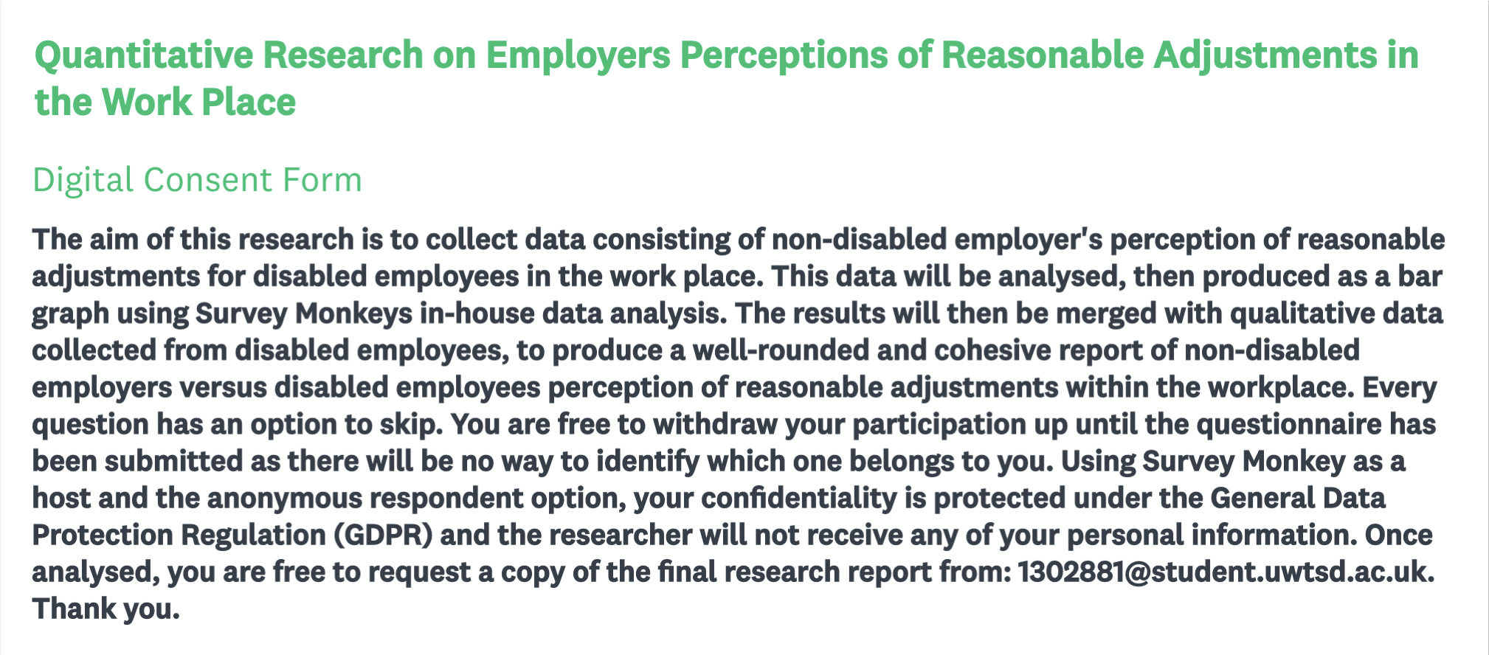
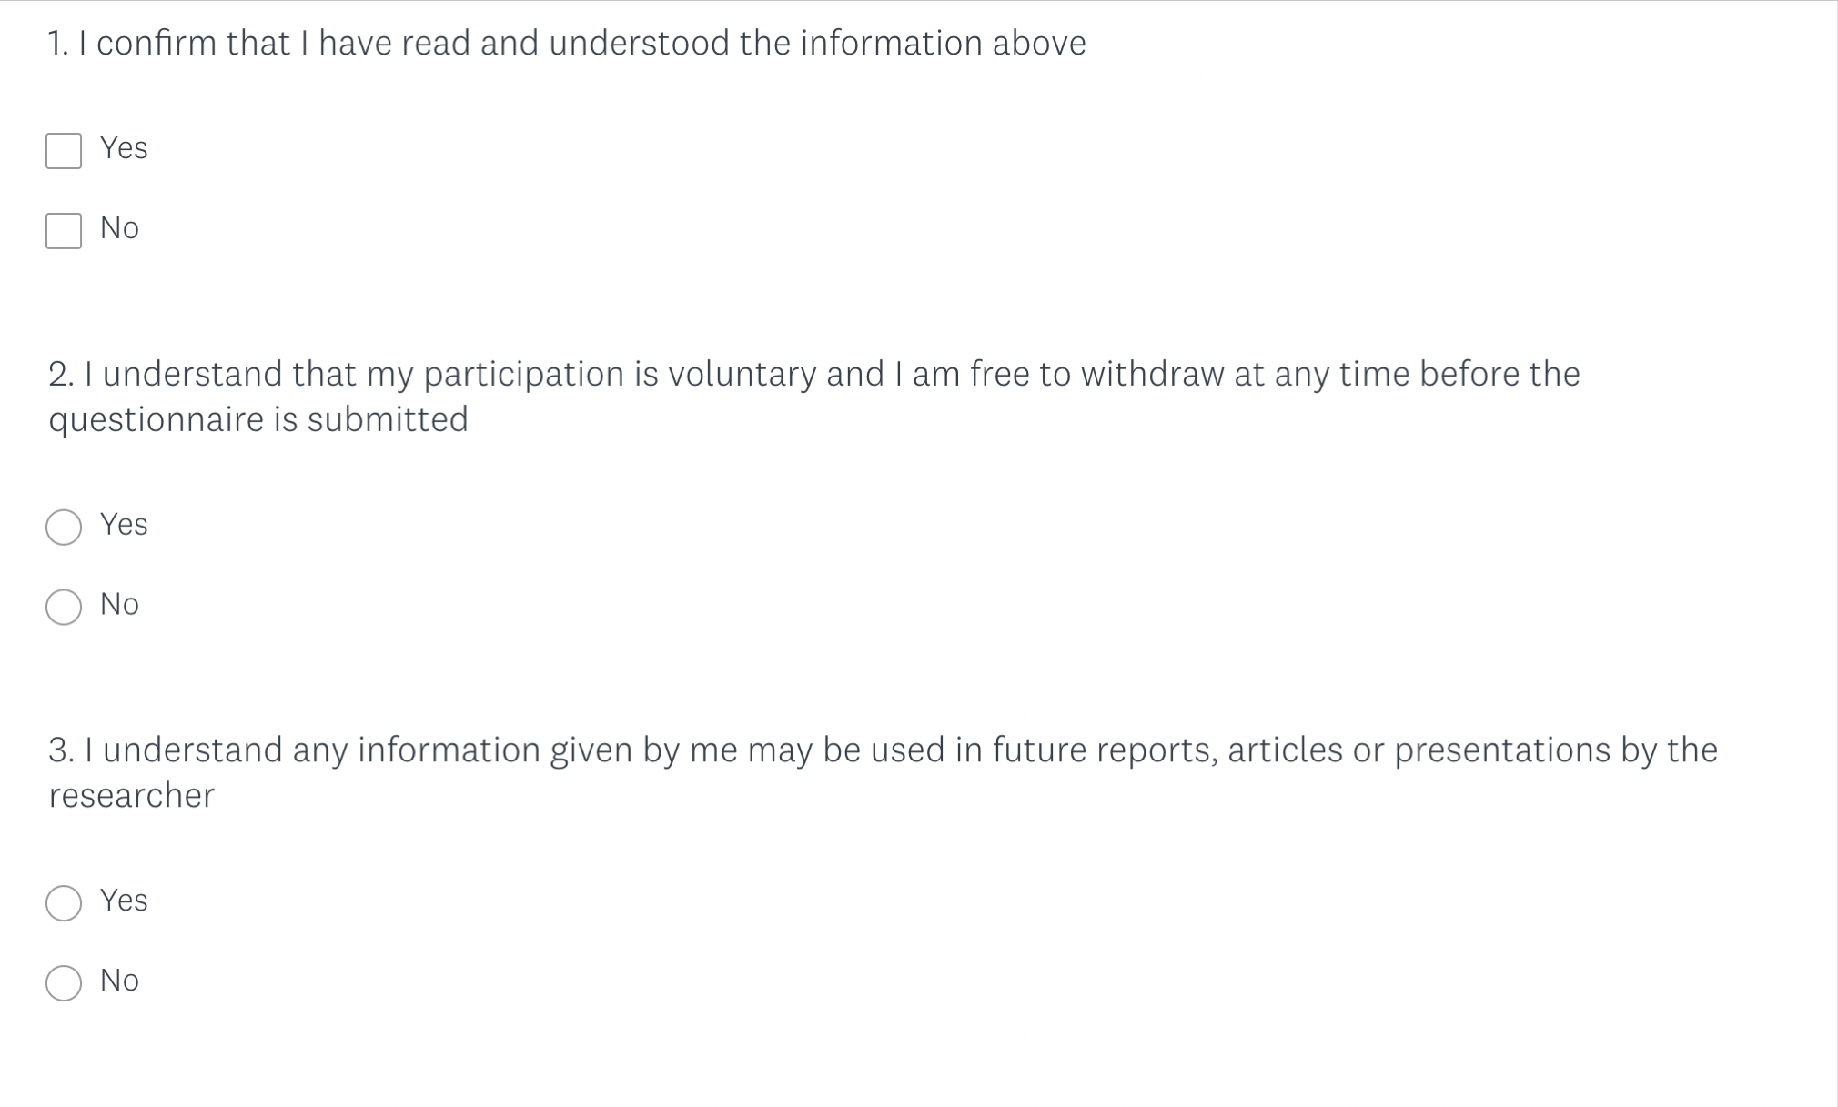
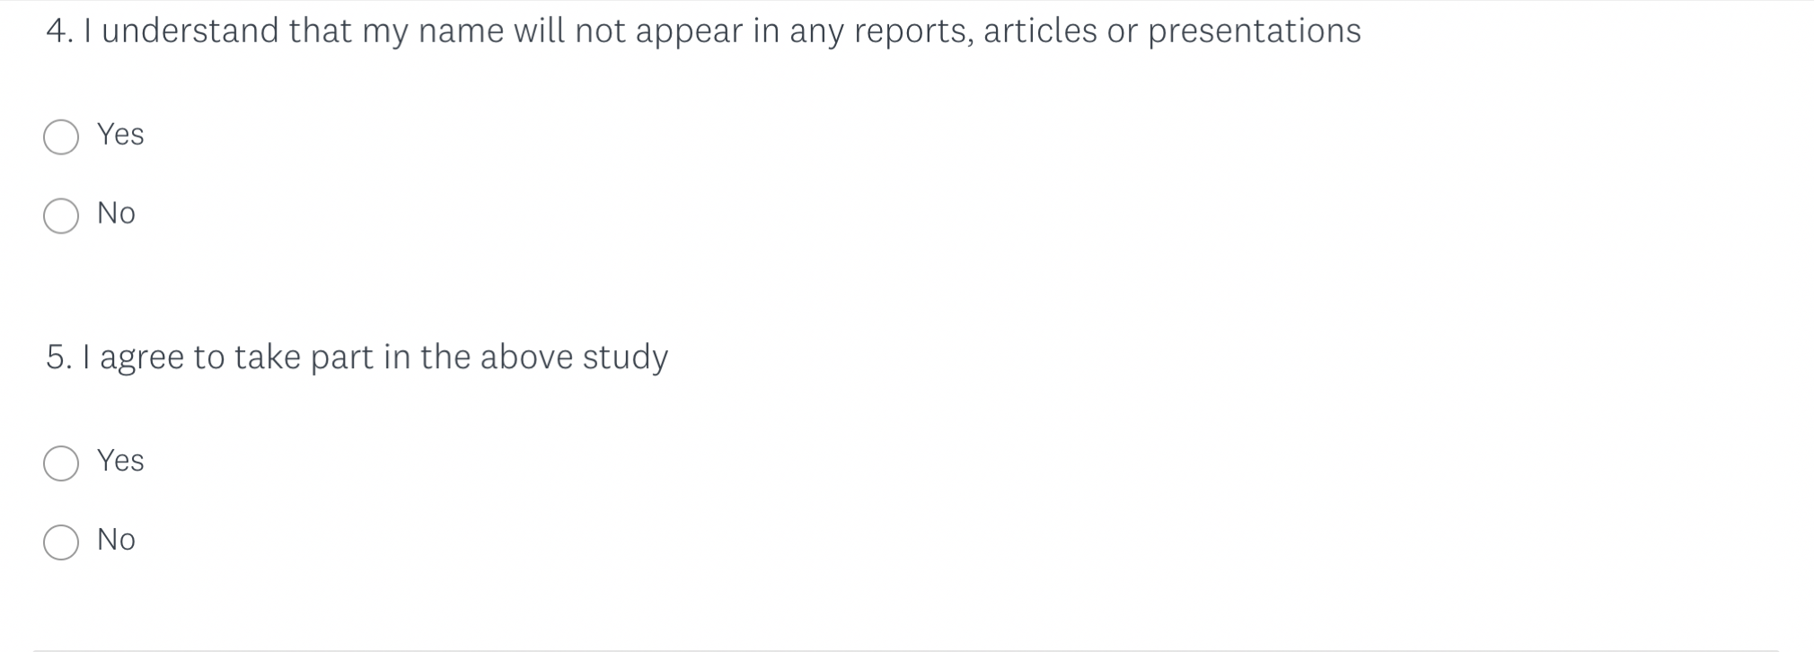

Appendix B:
Sample of Online Questionnaire Questions
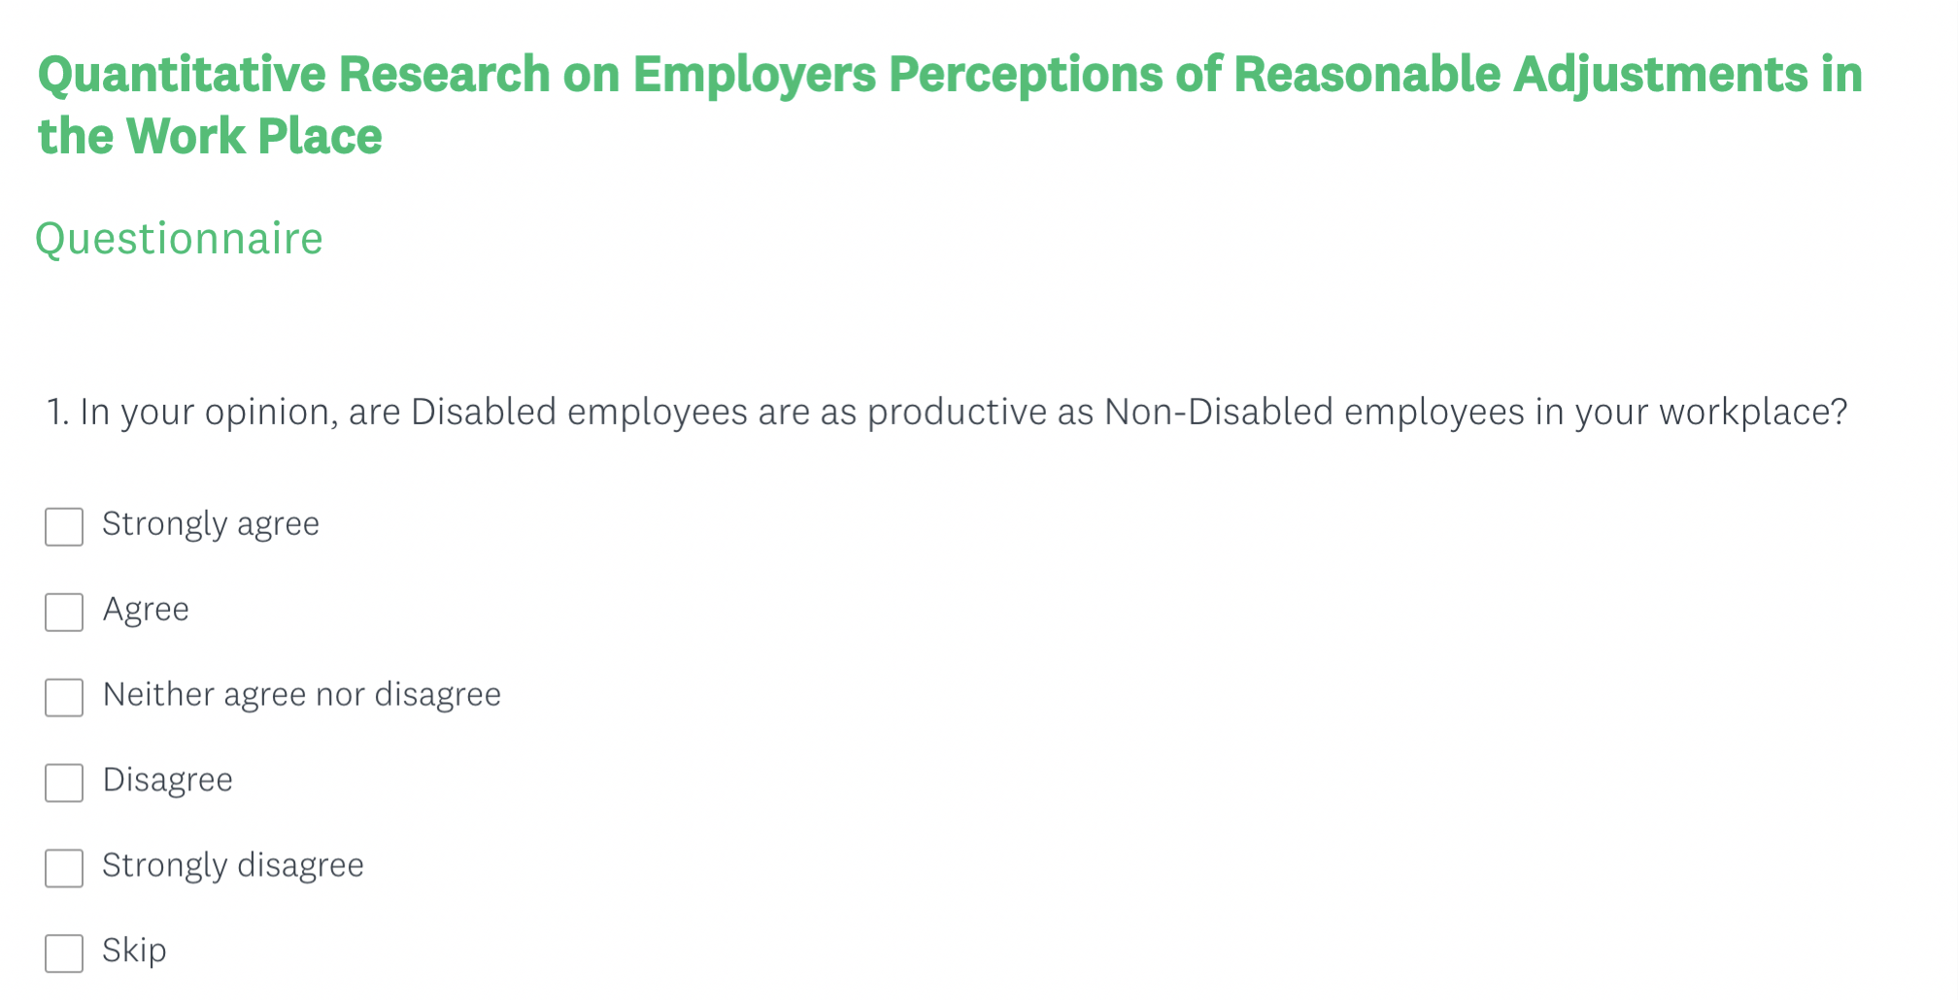
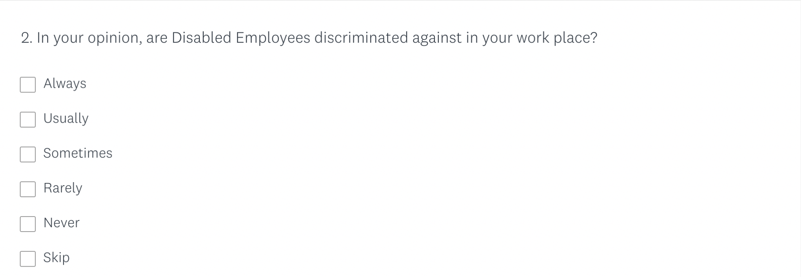
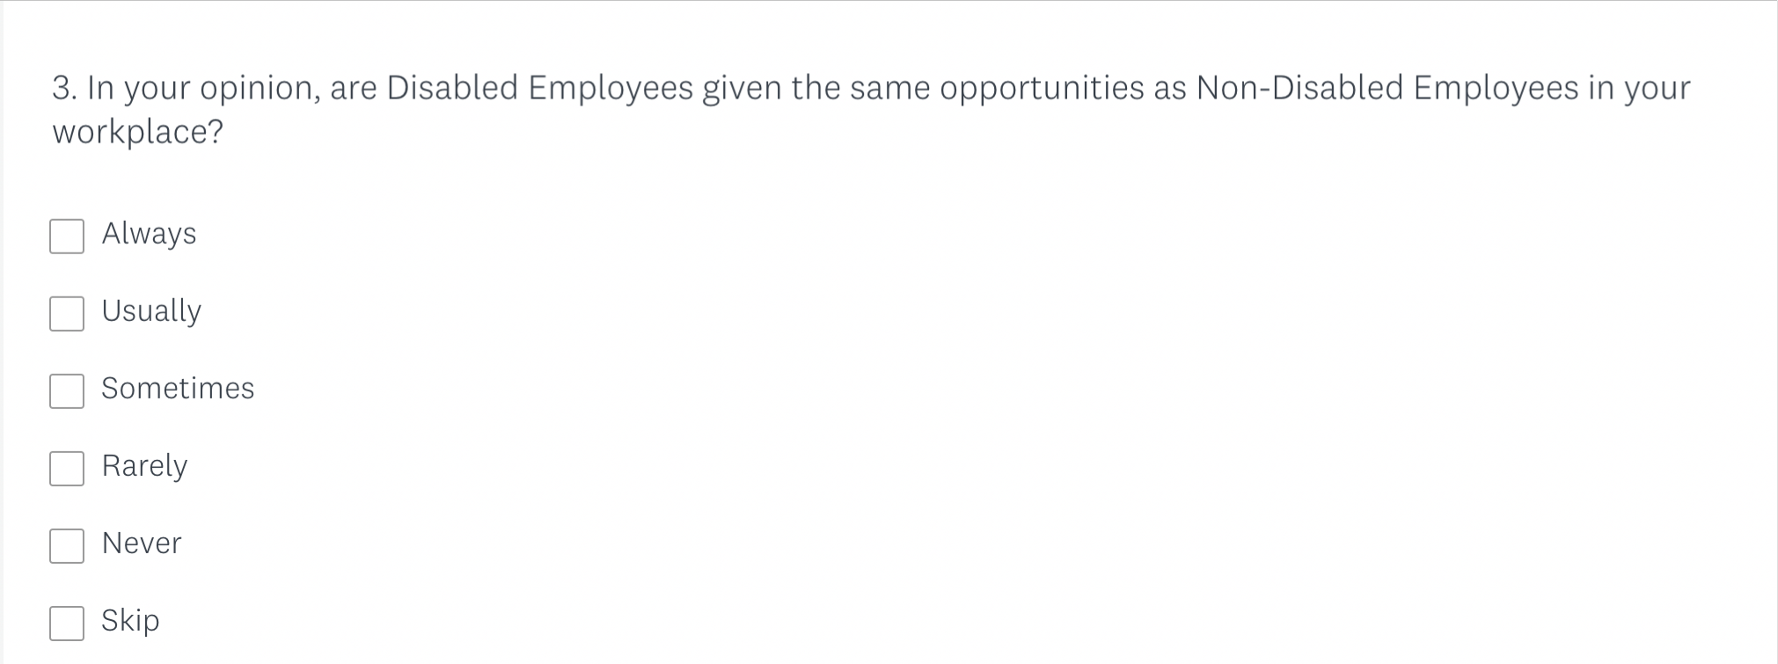
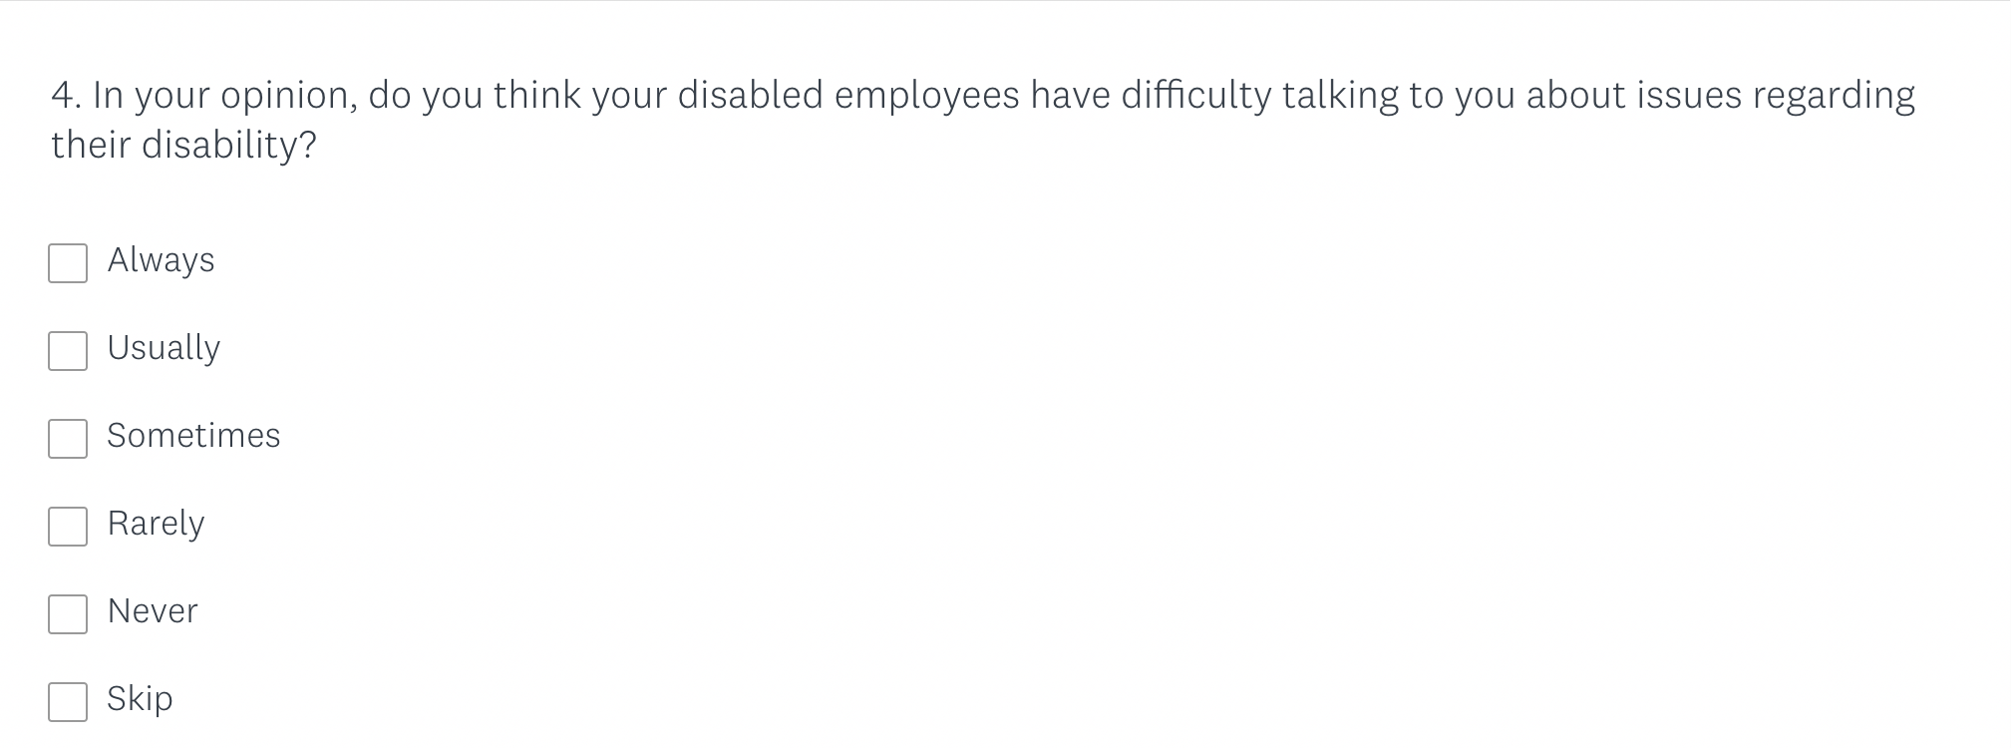
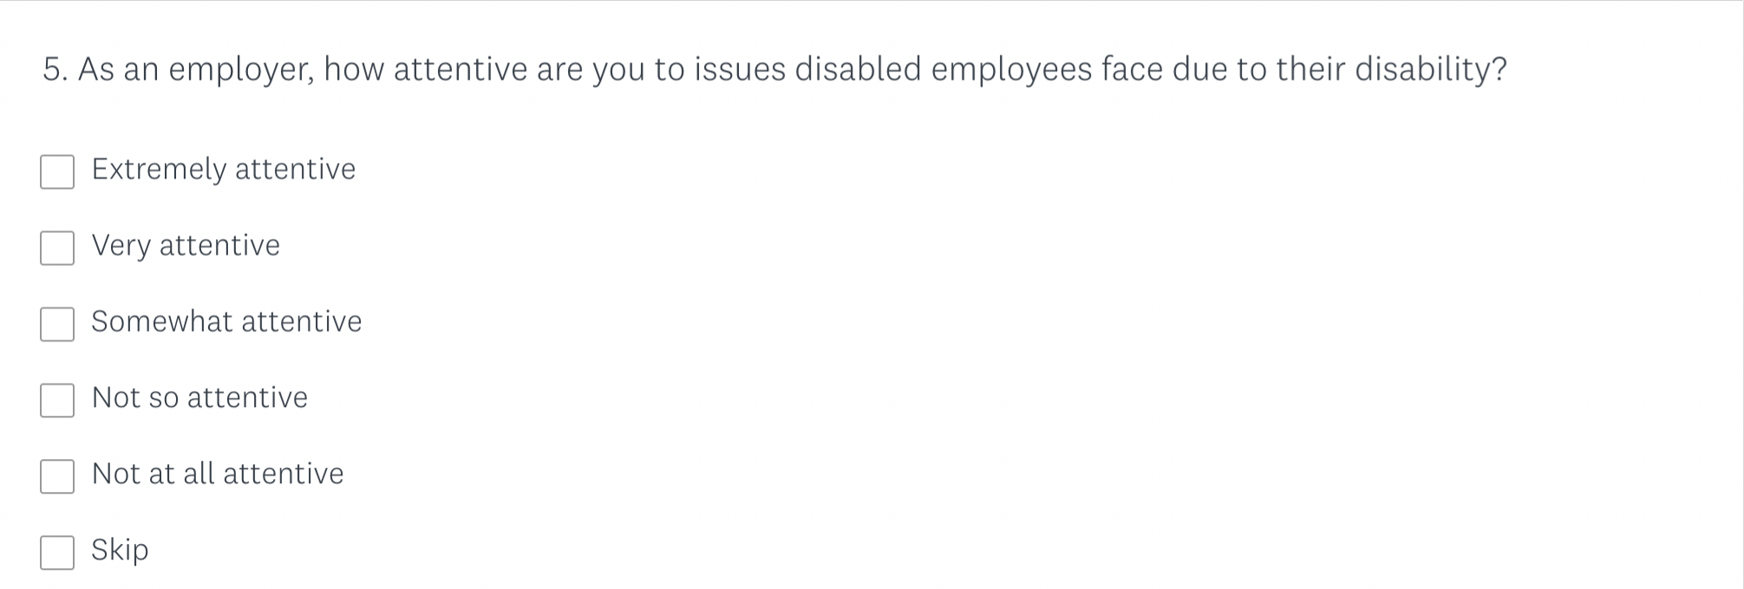
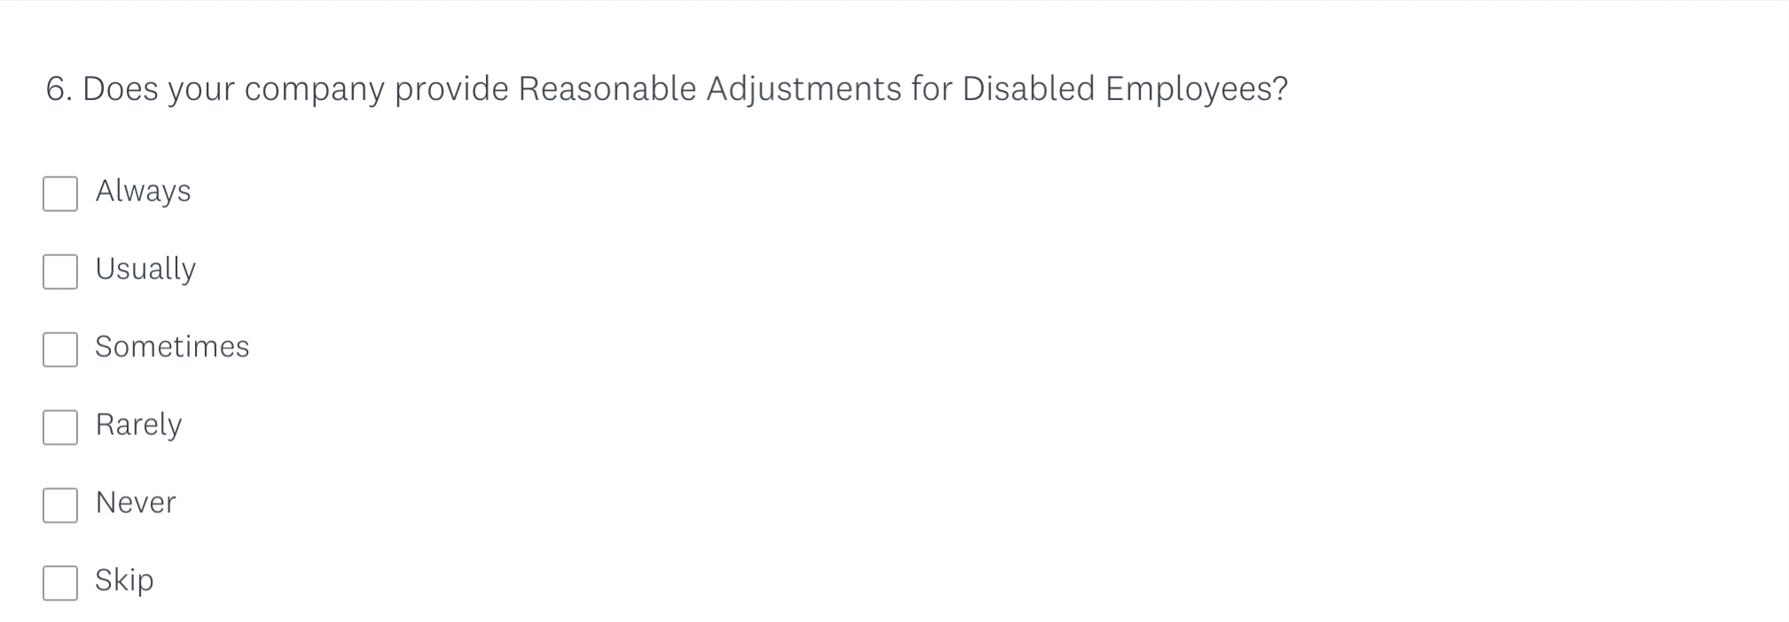

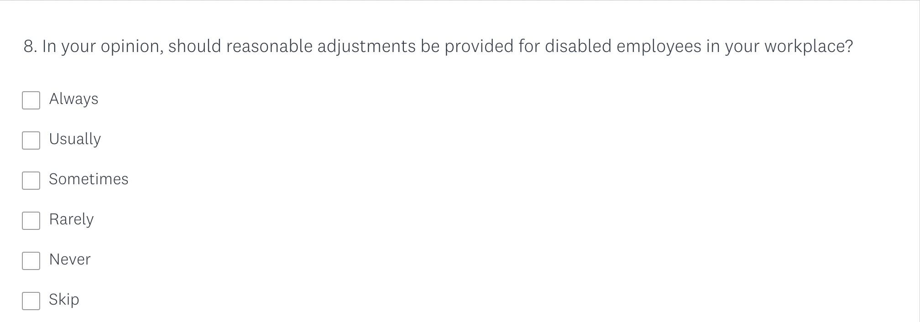
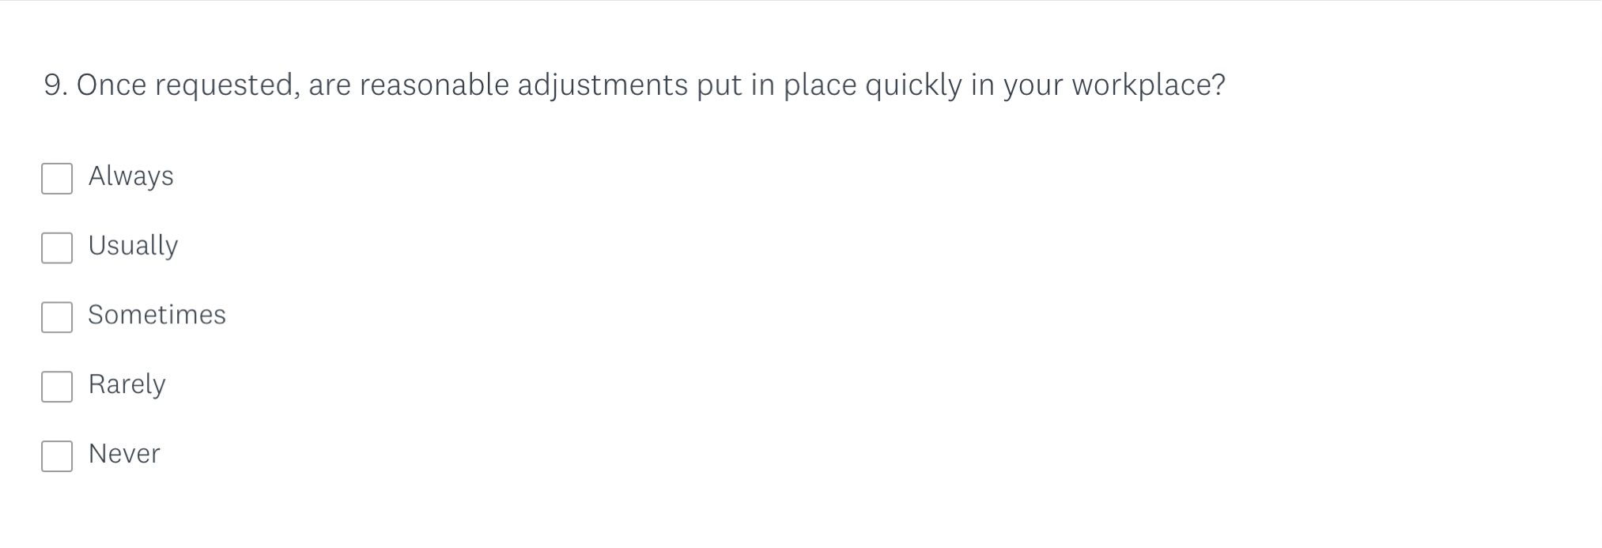
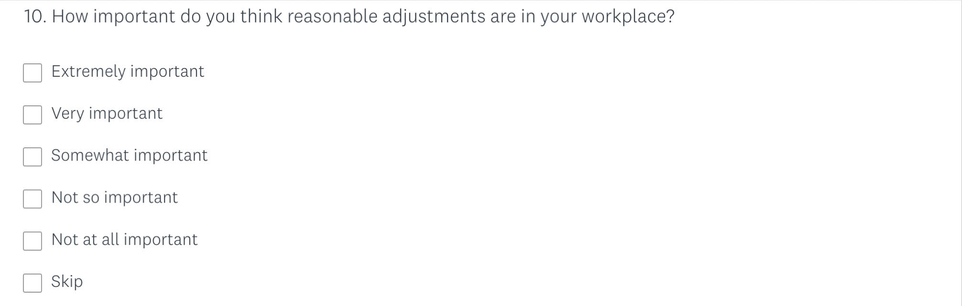
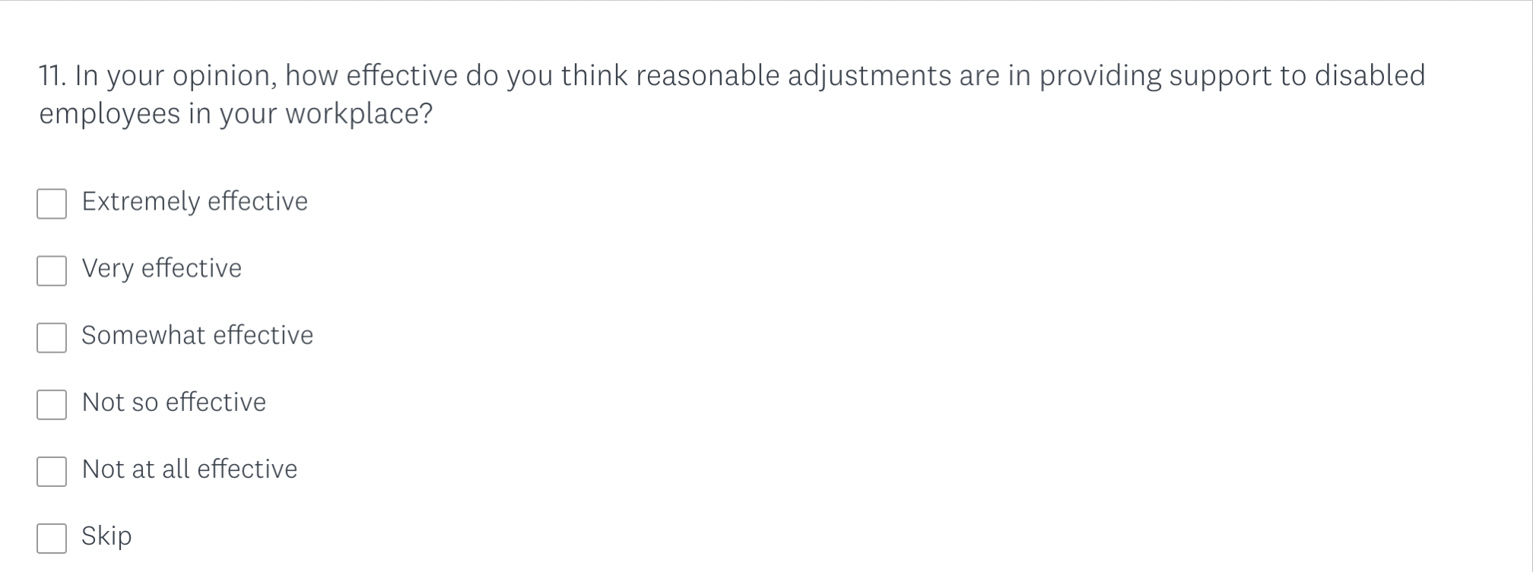

Appendix C:
Letter to Gatekeeper

Unite House
128 Theobalds Road
Holborn, London
WC1X 8TN

20th September 2019

Dear whomever this may concern,

I am a first year MA Equity and Diversity student at the University of Wales Trinity Saint David and as part of my studies I am required to conduct a research project. I have identified a need for research into reasonable adjustments in the workplace and I am writing to ask if it would be possible to recruit participants for this study from your organisation. This study will include the perception and experience of reasonable adjustments in by disabled employees, and the perception of reasonable adjustments by non-disabled employers. I am approaching your organisation, as I am aware of the successful work you do with disabled workers, and the trust they place in you.

I have prepared a description of the study and what is involved in it for potential participants, and I will attach a copy for you to read. Ideally, I would like to begin data collection in November 2019.

I would anticipate that the project would take no more than 90 minutes, and I would have a quiet place on my University’s premises to conduct the study.

Many thanks for taking the time to read this and I hope to hear from you soon.
Yours faithfully,

Hannah Graham
1302881@student.uwtsd.ac.uk

Appendix D:
Letter of Introduction to Participant

 | Participant Identification Number: | 1
 | PARTICIPANT INFORMATION SHEET
Project Title:
The Perception of Reasonable Adjustments in the Workplace by Non-Disabled Employers and Disabled Employees.

Dear Participant:

My name is Hannah Graham and I am student studying MA Equity and Diversity at the University of Wales Trinity Saint David.

I would like to invite you to participate in my research project. This project aims to present a cohesive collection of data in relation to reasonable adjustments in the work place, and the perception of its effectiveness. The objective will be to promote awareness in how non-disabled employers perceive reasonable adjustments compared to disabled employees, with the aim to stimulate change.

Through your participation in the focus group, I hope to discover more on how you perceive reasonable adjustments and experiences you have had requesting or receiving reasonable adjustments in the workplace.

All questionnaires will be kept strictly confidential to the researchers involved and at NO time will personal data be released to the general public. This gives you a chance to express your views confidentially and anonymously and still be able to make a difference. Your participation in this study is completely voluntary so you can withdraw at any stage.

The focus group should take no longer than 90 minutes to complete and will consist of 6-8 participants. You will not be required to share any personal characteristics with other participants or the research, and will be identified as a number through the data collection and data analysis process.

After careful and precise analysis of the data obtained from this focus group, I will be happy to provide you with a copy of the findings at your request. The results of this questionnaire will hopefully enhance the understanding of reasonable adjustments within the workplace and will be stored on the researchers personal password protected laptop. The focus group will be recorded using audio recording. There will be a clear audit trail while the research is on going, but once analysed the raw data will be destroyed. The results of the research will be shared with disability charities within the UK, and trade unions that work with disabled workers. Once shared, these organisations will have the freedom to share the final report as they wish.

We thank you in advance for your time and participation. If any questions do arise, feel free to contact me at your convenience.

NAME & ADDRESS OF RESEARCHER
Hannah Graham
5 Old Oak Lane
Carmarthen
Carmarthenshire
SA31 1NY

Appendix E:
Participant Consent Form
 | Participant Identification Number: | 1
 | PARTICIPATION CONSENT FORM
Project Title: The Perception of Reasonable Adjustments in the Workplace by Non-Disabled Employers and Disabled Employees.

Name of Researcher: Hannah Graham

Please initial box

1 | I confirm that I have read and understand the information sheet dated for the above study. I have had the opportunity to consider the information, ask questions and have had these answered satisfactorily.
2 | I understand that my participation is voluntary and that I am free to withdraw at any time, without giving any reason.
3 | I understand that any information given by me may be used in future reports, articles or presentations by the research team.
4 | I understand that my name will not appear in any reports, articles or presentations.
5 | I agree to take part in the above study.
Name of Participant |  |  |  | Signature
Researcher |  | Hannah Graham |  | Signature  H. Graham

You may decline to participate in this study. You may end your participation in this study at any time. If you decide to remain anonymous, maintaining your anonymity will be a priority and every practical precaution will be taken to disguise your identity. If you prefer anonymity, there will not be any identifying information on audiotapes or transcripts of this or any interview. No-one will hear any audiotapes or see any transcripts without your prior consent. All materials generated from this or any interview will remain confidential.

When completed please return in the envelope provided (if applicable). One copy will be given to the participant and the original to be kept on the file of the research team at:

NAME & ADDRESS OF RESEARCHER

Hannah Graham
5 Old Oak Lane,
Carmarthen
Carmarthenshire
Wales
SA31 1NY

