University of Wales Trinity Saint David

Wales Institute of Science & Art

Sustainability Challenges
in Industry

Automotive Materials & Sustainability
ACHA6012

John Forster
2004393

03/2024

Contents
- – Introduction…………………………………………………………………………………………………………………3
- – Environmental Impact……………………………………………………………………………………………...4-6
- – Sustainable Practices & Legislation…………………………………………………………………………..7-9
  - – Sustainable Practices & UN Sustainability Goals………………………………………………………7-8
  - – Hybrid Propulsion……………………………………………………………………………………………………….8
  - – Sustainable Fuel………………………………………………………………………………………………………….9
- – Sustainability & Technological Challenges…………………………………………………………….10-12
  - – Formula 1……………………………………………………………………………………………..……………………10
  - – Extreme E, Lithium-ion Batteries & Switch to Hydrogen………………………..……………..10-12
- – Future Outlook………………………………………………………………………………………………..……13-14
- – Conclusion……………………………………………………………………..………………………………………….15
- – Appendix………………………………………………………………………………………………………………16-20
8.0 – References……………………………………………………………………………………………………………21-23

Tables & Figures
Figure 1: 2019 Formula 1 Carbon Footprint Breakdown (Formula One Group, 2019) 4
Figure 2: Formula One 2020 Carbon Footprint Breakdown (Formula One Group, 2020) 5
Figure 3: FIA Carbon Footprint Analysis 2019 - 2022 (Fédération Internationale de l'Automobile, 2023) 6
Figure 4: Carbon Dioxide Emissions produced by the aviation industry 1940 to 2018 (Ritchie, 2020) 7
Figure 5: United Nations Sustainable Development Goals (United Nations, 2024) 8
Figure 6: Mercedes AMG Petronas F1 Team Aims (Mercedes AMG Petronas Formula One Team, 2023) 9
Figure 7: Landscape Destruction due to Lithium Mining (Tedesco, 2023) 12
Figure 8: Sustainable Fuel Plan; present day to future for FIA Categories (Fédération Internationale de l'Automobile, 2023) 14
Figure 9: Williams Racing Biodiversity Plan and relating UN Sustainability Goals (Williams Grand Prix Engineering, 2023) 15
Figure 10: McLaren Racing Project Carbon footprint, removal and social contribution (McLaren Racing, 2023). 17
Figure 11: Article 1 Section 1.20 of the 2009 Formula One Technical Regulations (Fédération Internationale de l'Automobile, 2009) 17
Figure 12: McLaren Estimated CO2 emissions reduction - Supply Chain (McLaren Racing, 2023) 18
Figure 13: Mercedes AMG Petronas F1 Team Carbon Footprint (Mercedes AMG Petronas Formula One Team, 2023) 18
Figure 14: McLaren Estimated CO2 emissions reduction – Business Travel (McLaren Racing, 2023) 19
Figure 15: McLaren Estimated CO2 emissions reduction – Logistics (McLaren Racing, 2023) 20
Figure 16: McLaren Estimated CO2 emissions reduction – Facilities (McLaren Racing, 2023) 21

- – Introduction
The main objective of this report is to evaluate the impact of current and possible future legislation regarding sustainability in the motorsport sector. This report will also assess the operation of alternative fuels and powertrains in the motorsport sector and how this can reduce the overall environmental impact.
So that these objectives are achieved this report is sub divided into sections: the environmental impact that motorsport has. This will include the carbon footprint of different categories of racing in the motorsport sector including the actual racing series itself as well as the environmental impact of spectators at each event as well as transport logistics.
Another objective is what sustainable practices and legislation that has been implemented or planned to be implemented regarding the motorsport sector and evaluating the effectiveness of each sustainable practice. This report will also outline how/if these sustainable practices meet with the United Nations sustainable development goals.
The third objective is regarding the challenges related to improving the sustainability of the motorsport sector and how these challenges could be addressed.
The final objective is regarding the potential outlook of the motorsport sector. This will include potential strategies that could be implemented in the future to improve the sector’s sustainable development.

2.0 – Environmental Impact
Overall, motorsport in general has a negative impact on the environment as most circuits have inadequate transport accessibility as well as using a large quantity of non-renewable fuel. This is most noticeable with Formula 1 as Formula 1 is a global championship with multiple teams and with races in Europe, North and South America, Asia and Australia all lasting no more than two hours. Therefore, the carbon footprint produced by this championship is large, as of 2019 it was estimated that 256,551 tonnes of carbon dioxide (C02) were emitted into the atmosphere (Formula One Group, 2019). The full breakdown of Formula One’s 2019 carbon footprint can be seen in the chart below:
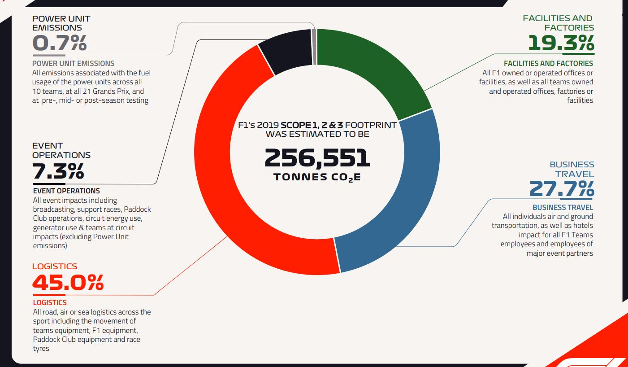
Logistics is shown to be the greatest cause of Formula One’s carbon dioxide emissions being at 45 percent (as of 2019). This is primarily due to transportation of all equipment and tyres for all ten teams as well as all the required equipment needed to set up the hospitality and fan areas at each race weekend having to be transported over numerous countries usually only with a few days between events. This means that the equipment will have to be transported as fast as possible to ensure that the following event can be run. This, however, has the negative impact on the environment by increasing the amount pollutants into the atmosphere. Progress was made in 2020 as the total estimated carbon dioxide emissions decreased from 256,551 tonnes to 155,104 tonnes a decrease of emissions by an estimated 39.54% (shown below in figure 2). Despite this, these emission figures are skewed in 2020 as the championship only ran from June until December rather than from February to December because of the COVID-19 pandemic limiting travel between countries, which also meant the championship mainly stayed in Europe and therefore meant that emissions would be much lower than predicted.
Figure 1: 2019 Formula 1 Carbon Footprint Breakdown (Formula One Group, 2019)
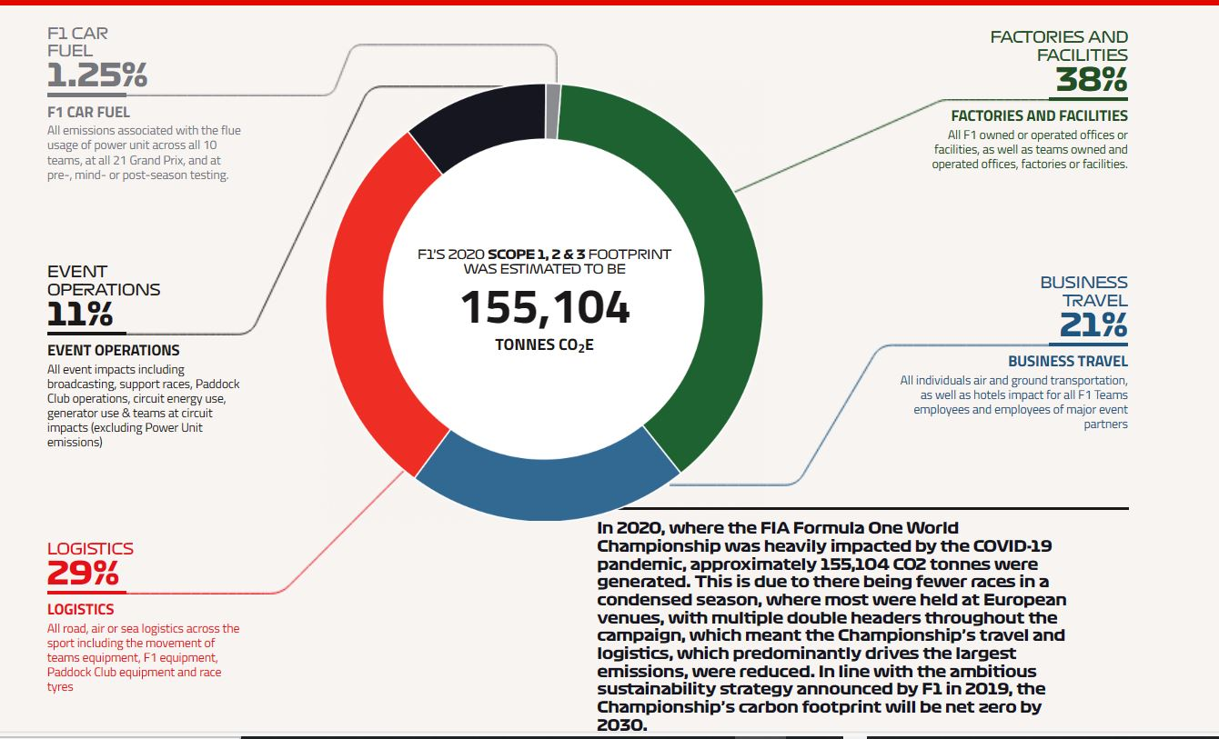
The COVID-19 pandemic and the shortened and more condensed season also explains why logistics and business travel percentages have decreased by 16% and 6.7% respectively (shown between figure 1 and figure 2).
Figure 2: Formula One 2020 Carbon Footprint Breakdown (Formula One Group, 2020)

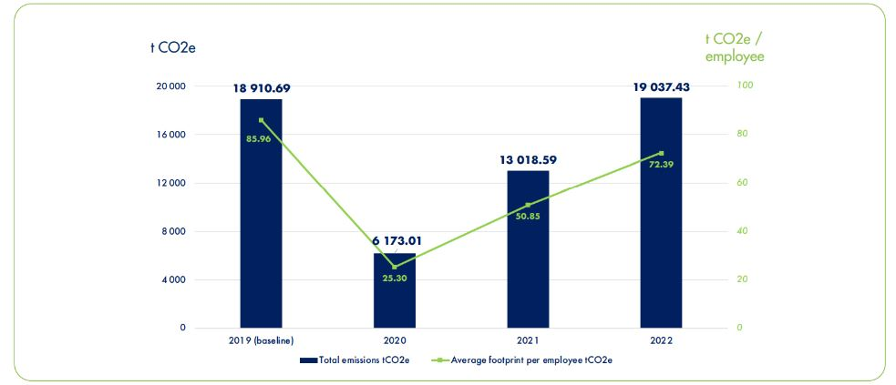
Another organisation that monitors its carbon footprint is the governing body for all major 4-wheel motorsport series; the Fédération Internationale de l'Automobile (FIA). The FIA have reported their carbon footprint every year from 2019 until 2022 as shown in figure 3 below.
Figure 3: FIA Carbon Footprint Analysis 2019 - 2022 (Fédération Internationale de l'Automobile, 2023)
Figure 3 shows the total emissions produced in tonnes by the FIA between 2019 and 2022. The graph also shows the average carbon footprint per employee in tonnes during the same period. The COVID-19 pandemic also is evident in figure 3 as the carbon footprint for both the FIA as a whole and the average per employee both plummet by 67.36% and 70.57% before gradually rising to pre-covid levels in 2022. Despite that the carbon footprint per employee remains less than 2019 levels 72.39 tonnes of CO2 compared to 85.96 tonnes of CO2. This therefore shows that the FIA are making improvements in reducing their overall environmental impact. The reason why the total carbon footprint increases by 0.7% is due to the number of FIA personnel increasing by 16% between 2019 and 2022, therefore allowing the carbon footprint per employee to be lower than 2019. (Fédération Internationale de l'Automobile, 2023).

Despite this, the motorsport industry is not as big of an emissions polluter as the aviation industry as the aviation industry as of 2018 produced over 1 billion tonnes of carbon dioxide (Ritchie, 2020) (as shown in figure 4) compared to just over 275,000 tonnes of carbon dioxide produced by Formula one and the FIA only 1 year later in 2019. 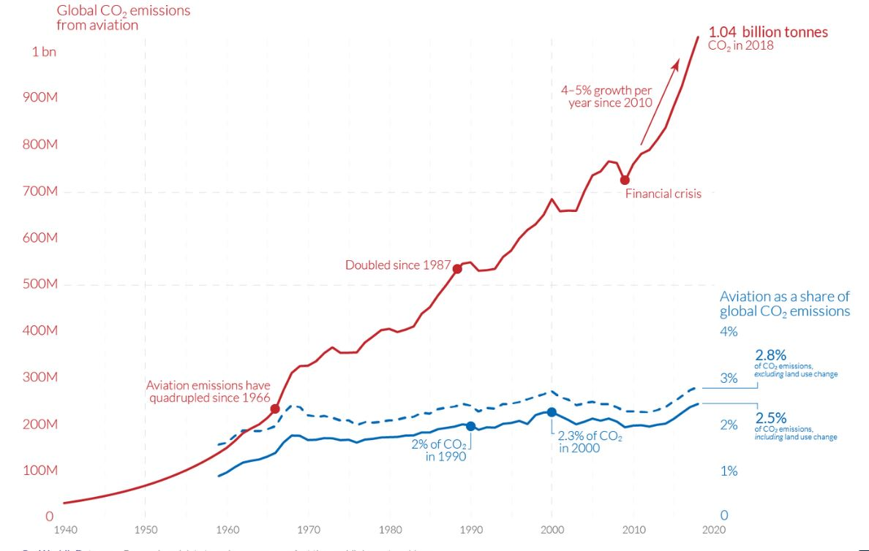
Figure 4: Carbon Dioxide Emissions produced by the aviation industry 1940 to 2018 (Ritchie, 2020)
However, it must be noted that these carbon dioxide emissions will also include all aviation emissions produced transporting Formula one, FIA and other motorsport personnel and equipment to events.

3.0 – Sustainable Practices and Legislation
3.1 – Sustainable Practices & UN Sustainability Goals

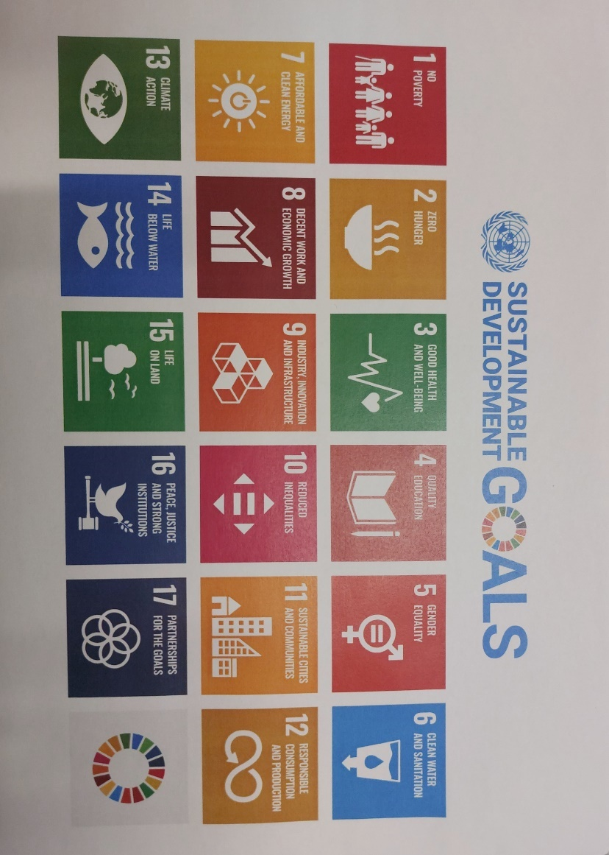
Numerous organisations aim to implement sustainable practices. These practices can relate to the United Nations Sustainable Development Goals. The United Nations Sustainable Development Goals are 17 development goals that are meant to be adopted by all 193 United Nations (UN) member states (United Nations, 2024) as well as major companies, businesses and motorsport teams such as Mercedes AMG Petronas F1 team and Williams Racing. These United Nations Sustainable Development Goals are:
Figure 5: United Nations Sustainable Development Goals (United Nations, 2024)

Since 2020 Formula One has pledged to be carbon net zero by 2030 (Formula One Group, 2020). Carbon net zero means that whatever carbon emissions are produced the same amount will be removed from the atmosphere (offset or cancelled out), therefore meaning that no additional emissions are added to the atmosphere (National Grid ESO, 2023) (National Grid, 2023). This pledge has also been met by the Mercedes Formula 1 Team which plan to reduce their carbon emissions by reducing their emissions produced from their supply chain (Mercedes AMG Petronas Formula One Team, 2023). This is so that the team follows UN Sustainable Development Goal 13 regarding taking action against climate change. The team have also pledged to be more responsible with resources and have committed to producing more renewable energy at their factories in Brackley (United Kingdom) and Brixworth (United Kingdom) as well as removing single use plastics from regular use. These aims are to adhere to goal 7 and 12 respectively of the UN Sustainable Development Goals as shown in figure 5. As well as this, the Mercedes F1 Team will also be supporting the local environment by protecting the local habitat. This will be done by redeveloping their campus at Brackley to accommodate for greater habitat biodiversity. All these aims are shown in figure 6.
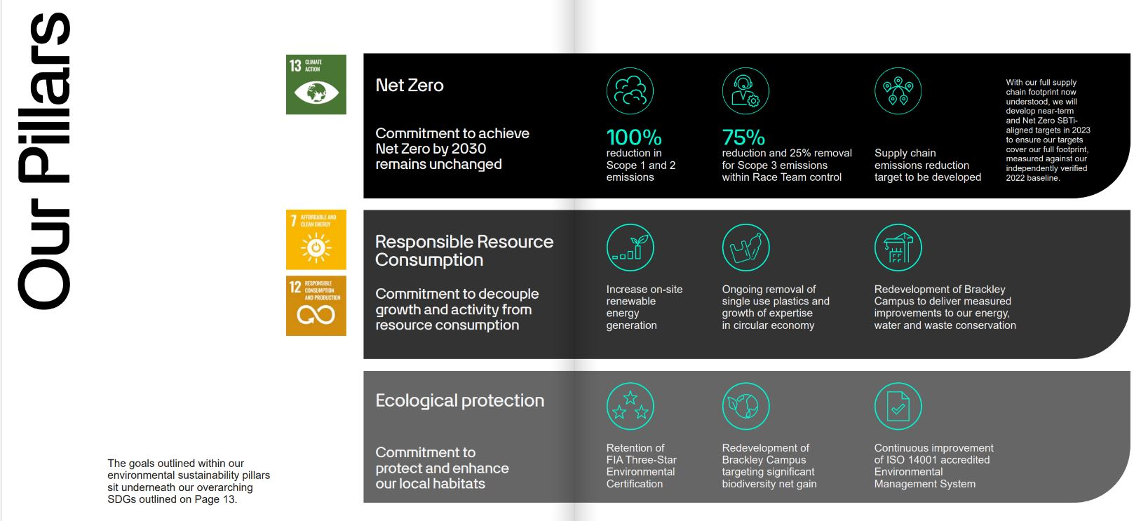
Figure 6: Mercedes AMG Petronas F1 Team Aims (Mercedes AMG Petronas Formula One Team, 2023)

3.2 – Hybrid Propulsion

In 2009 Formula One and the FIA implemented a new rule change where the teams had the option to design a kinetic energy recovery system (KERS) to their powertrain (Collantine, 2009) (Fédération Internationale de l'Automobile, 2009). See appendix for section of technical regs. This was the first step that Formula One made towards hybrid propulsion as KERS (soft hybrid) harnesses kinetic energy usually lost under braking and converts that energy to either chemical energy stored in a battery or potential energy stored in a flywheel. That energy is then available to the driver to be redeployed when the driver chooses (Collantine, 2009). However, this was not mandatory for all teams to use until 2014 where the full hybrid powertrains were made mandatory in Formula One (Fédération Internationale de l'Automobile, 2011). This will help improve sustainability in Formula One as apart of the 2014 rule change also implemented that internal combustion engines must be downsized from a 2.4 litre V8 to 1.6 litre V6 turbo hybrid (Fédération Internationale de l'Automobile, 2011). The implementation of a full hybrid system will result in less fuel needed to be used in a session and therefore resulting in fewer emissions through pollutants out of the tailpipe. Furthermore, downsizing of the engine will result in fewer emissions as this also requires less fuel to run as the fuel efficiency is increased and therefore resulting in lower emissions (Namar, Jahanian, Shafaghat, & Nikzadfar, 2021).
3.3 – Sustainable Fuel

In 2022 Formula 1 switched from high octane race fuel (between 95 & 102 octane) to E10 87 octane fuel (Kristensen, 2022). This switch was implemented so that there will be no extra added carbon dioxide added to the atmosphere. This more sustainable fuel does produce carbon dioxide however, this is being offset by the process of making the fuel (Miller, 2021). As of 2022 it was expected that the E10 fuel would achieve greenhouse gas emissions by 65% (Miller, 2021). The switch to E10 fuels in Formula 1 is a step in the right direction however, with the fuel being E10 that means there is 10% ethanol and 90% fossil fuel (gasoline/petrol) used. This means that the cars are still being predominantly run on fossil fuels so further work is needed to make this more sustainable as E10 is essentially a stepping stone to a more sustainable fuel.

A potential next step for synthetic fuels used in Formula 1 is to create fuel using captured carbon dioxide and hydrogen from water. This is what is being undertaken by Zero Petroleum: official partner of Stake F1 Team Kick Sauber (Zero Petroleum, 2024). Zero Petroleum is an energy company that produces synthetic, non-biological fuels without using fossil fuels in the process of making the fuel (Zero Petroleum, 2024). This is an upgrade on the standard currently used E10 fuel as the carbon used to make this fuel is captured carbon from the atmosphere which improves the sustainability of this fuel. There however, concerns about the sustainability of the water used to get the hydrogen to create this fuel as the company have not disclosed what type of water is used to create the hydrogen. Despite this the fuel is completely fossil fuel free and is a drop in solution to replace the current E10 fuel (Zero Petroleum, 2024).

It is not just Formula 1 that is mandating sustainable fuels produced by Aramco (Saudi Arabian fuel and lubricants company) to be used. FIA Formula 2 and FIA Formula 3 also mandate that the fuel used must be 55% sustainable with the plan to be 100% sustainable by 2027 using captured carbon dioxide (Straw, 2023). A positive of this switch is that this new fuel and subsequent new variants will all be drop in fuels meaning that no modifications will be needed to be made to the cars to accommodate for this fuel change (Straw, 2023). This is being conducted first in Formula 2 and Formula 3 so that there will be more knowledge and a more seamless transition when this fuel is expected to be used in Formula 1 by 2026 (Straw, 2023).

4.0 – Sustainability & Technological Challenges
4.1 – Formula 1
A major challenge regarding sustainability in motorsport in general is ensuring that spectators at motorsport events act sustainably. This can be solved by providing sustainable transport to the event or by implementing incentives to make people think about how they get to circuits. This is being utilised in Formula 1 as the race organisers for the Dutch Grand Prix at Zandvoort Circuit have made it possible for fans to use shareable bicycles and mopeds to travel to the circuit (Dutch GP B.V., 2023). Even though this is a good initiative it is only useable for fans from the area near the circuit, it is not viable for fans having to travel long distances to circuit. Another problem that works against this initiative is that circuits are usually located away from people so that residents are not affected by noise pollution however this can make sustainable transport to the circuit challenging for spectators. A way that could be implemented to improve this would be to build charging points that use non fossil fuel produced electricity and reduce the entry price for all spectators travelling by either electric or plug-in hybrid cars.

Another challenge presenting itself in Formula 1 regarding sustainability is that due to each team having their own fuel and lubricants supplier it means there is no set structure for all fuel companies to follow to improve carbon emissions. Conversely however, with each team having their own fuel supplier it allows the different fuel companies to create their own new ways to create their own fuel blends that improve emissions be that using captured carbon dioxide from the atmosphere as Zero Petroleum are doing (Zero Petroleum, 2024) or something new.

However, with Formula 1 being global championship this provides massive technological challenges in terms of transporting components around the world through each team’s supply chains. To improve this each team have redesigned their shipping containers to allow for more fuel-efficient aircraft to be used (Global Sustainable Sport, 2023). However, no matter how fuel-efficient the aircraft is the aircraft will still be using fossil fuels as non-fossil fuel powered aircraft currently does not have the capacity to travel long distances.

4.2 – Extreme E, Lithium-ion Batteries & Switch to Hydrogen

However, unlike Formula 1 one series of racing has tried to be sustainable since its inception: Extreme E. Extreme E is currently an all-electric offroad rally racing series that travel to various locations around the world that have been affected by climate change (Kew, 2021). Extreme E instead of transporting all equipment and cars by plane; it is all transported by ship to each race event (Extreme E, 2021). The ship is not electric yet but does run on low sulphur diesel which is currently the most sustainable shipping fuel that can be used to reduce carbon dioxide emissions (Extreme E, 2021). Furthermore, Extreme E has what they call a legacy programme. This is a project led by Extreme E’s climate scientists where work is conducted to help environments against climate change at the locations near to where the race event happens (Extreme E, 2022). For example, in before the 2022 Saudi Arabia Dessert XPrix the legacy programme helped with beach management so that the habitat of sea turtles did not get washed away due to the hardening of the sand on the beach caused by nearby cement dust from factories whilst also cleaning the beach of plastic (Extreme E, 2022).

Despite the legacy programmes at each race event there is still an issue with the current generation of Extreme E car: the lithium-ion batteries. Lithium-ion batteries are known to be bad for the environment as to mine lithium it requires to exposed to the environment when mined therefore, destroying the local environment (shown in figure 7) around where it is mined causing potentially problematic side effects such as water pollution and increased carbon dioxide emissions (Tedesco, 2023). This could potentially lead to water cycle issues including acid rain. (Tedesco, 2023).

Figure 7: Landscape Destruction due to Lithium Mining (Tedesco, 2023)

This issue is not just regarding Extreme E but the whole electric car market as most electric cars made use lithium-ion batteries due to the batteries being lighter than lead-acid. It is also an issue that is unlikely to be resolved soon as there is major economic interest in lithium mined from Australia, China and Chile as the market is worth approximately $8 Billion (Tedesco, 2023). However, Extreme E is set to switch from using lithium-ion batteries and move to more sustainable hydrogen fuel cells in their 2025 rebrand to Extreme H. Hydrogen fuel cells are more sustainable than lithium-ion batteries as the hydrogen can be created using non-drinkable water.

5.0 – Future Outlook
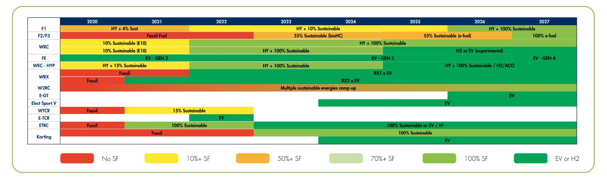
All FIA affiliated racing categories currently have a run plan from 2020 to 2027 regarding increasing sustainability in terms of fuel/powertrains. (shown in figure 8).
Figure 8: Sustainable Fuel Plan; present day to future for FIA Categories (Fédération Internationale de l'Automobile, 2023)
Formula 1 currently seems to follow this plan as currently the E10 fuel is used in line with what was expected by the FIA. After 2027 Formula 1 is set to become carbon net zero by 2030 (Formula One Group, 2020). Also, in 2022 the World Rally Championship (WRC) became the first championship to switch to 100% sustainable fuel allowing for a reduction of carbon dioxide emissions by 94% (well to wheel) (Fédération Internationale de l'Automobile, 2023).

In 2026 Formula 1 and the FIA are planning to implement a major rule change regarding the hybrid power unit introduced in 2014. The new power unit will no longer be run using fossil fuel and the electrical power output from the motor generator unit – kinetic (MGU-K) (what KERS evolved into in 2014) is expected to be almost tripled from 120 kW to 350 kW (Kanal, 2022). This will allow the cars to maintain the current levels of brake horsepower (bhp) while increasing fuel efficiency leading to lower carbon dioxide emissions (Kanal, 2022). Furthermore, the recycling of the batteries is becoming mandatory as well as the recycling of cobalt from the MGU-K (Kanal, 2022). This cobalt could then theoretically be used in another MGU-K or battery.

An area where motorsport teams could improve their sustainability would be to follow a similar path to what Extreme E currently do. This could mean enforcing motorsport teams to invest money in creating a more environmentally friendly ecosystem around their headquarters. This ecosystem would then need to be regularly monitored so that well maintained and does not get polluted. This task is being explored by Williams Racing as they are planting flowers around their base where possible (Williams Grand Prix Engineering, 2023). See figure 9 below for flowchart of their biodiversity plan.
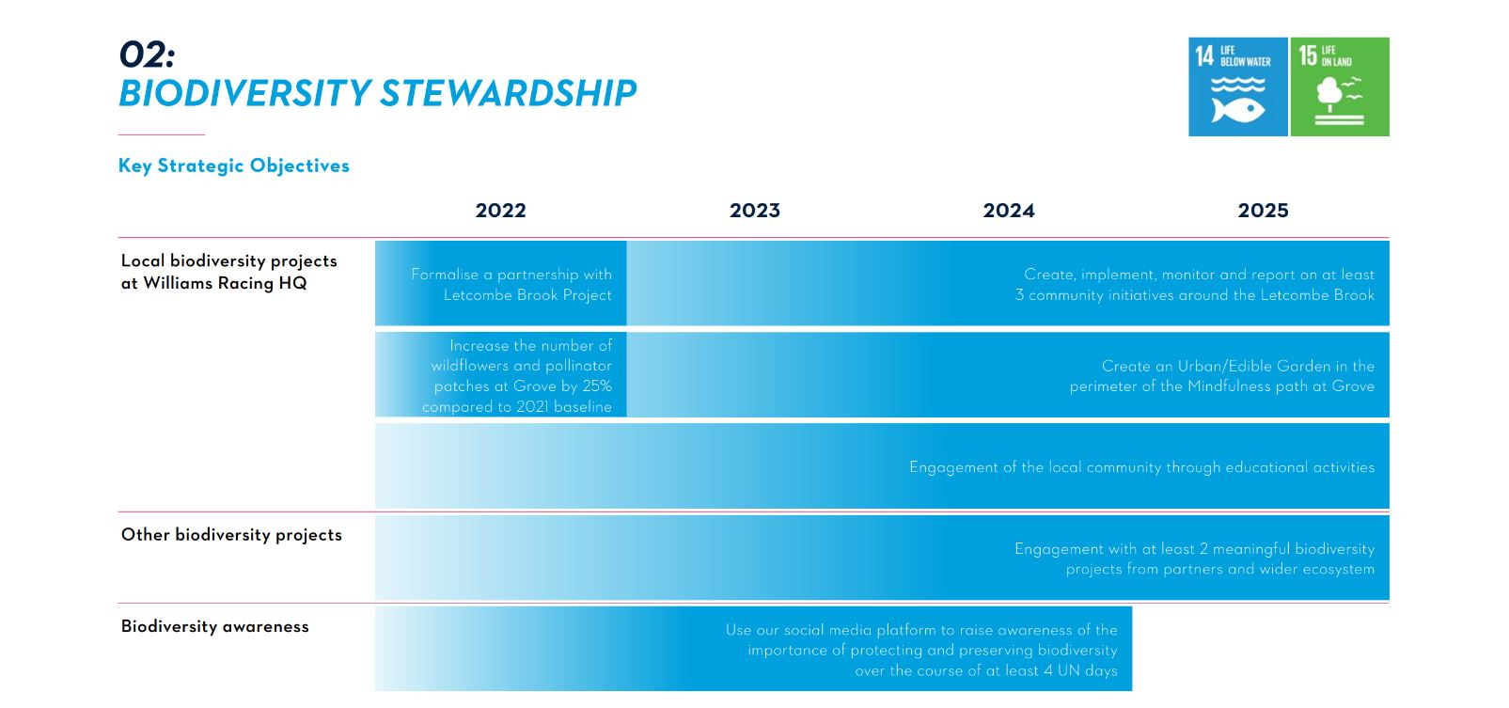
Figure 9: Williams Racing Biodiversity Plan and relating UN Sustainability Goals (Williams Grand Prix Engineering, 2023)

6.0 – Conclusion
Overall, the motorsport sector is moving for more sustainable motorsport. This is shown by the ambition of Formula 1 to be carbon net zero by 2030 and using 100% sustainable fuel by 2026. It can also be seen by Extreme E legacy programme and their switch to hydrogen fuel cells as a part of their rebrand to Extreme H. However, further work can still be made to make motorsport more sustainable in terms of transportation of components and people to race events. Despite this, the progress that is currently being made is making the first steps towards greater sustainability.

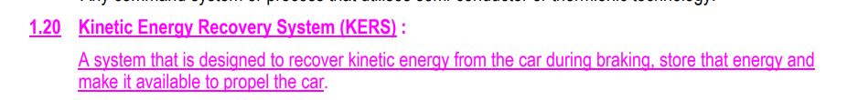
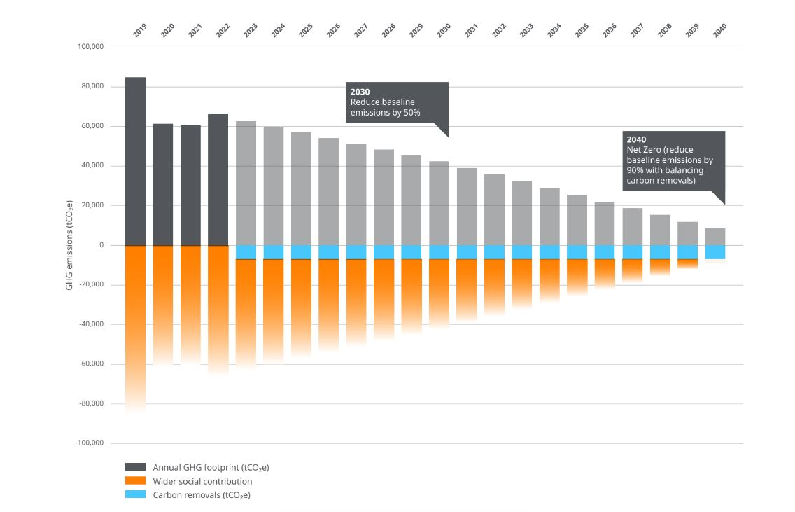
7.0 – Appendix
Figure 10: McLaren Racing Project Carbon footprint, removal and social contribution (McLaren Racing, 2023).
Figure 11: Article 1 Section 1.20 of the 2009 Formula One Technical Regulations (Fédération Internationale de l'Automobile, 2009)

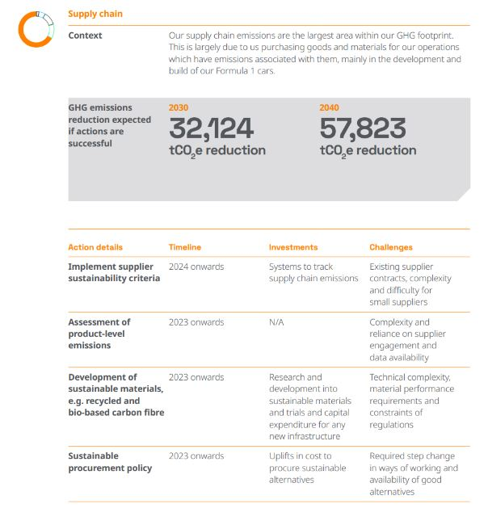
Figure 12: McLaren Estimated CO2 emissions reduction - Supply Chain (McLaren Racing, 2023)

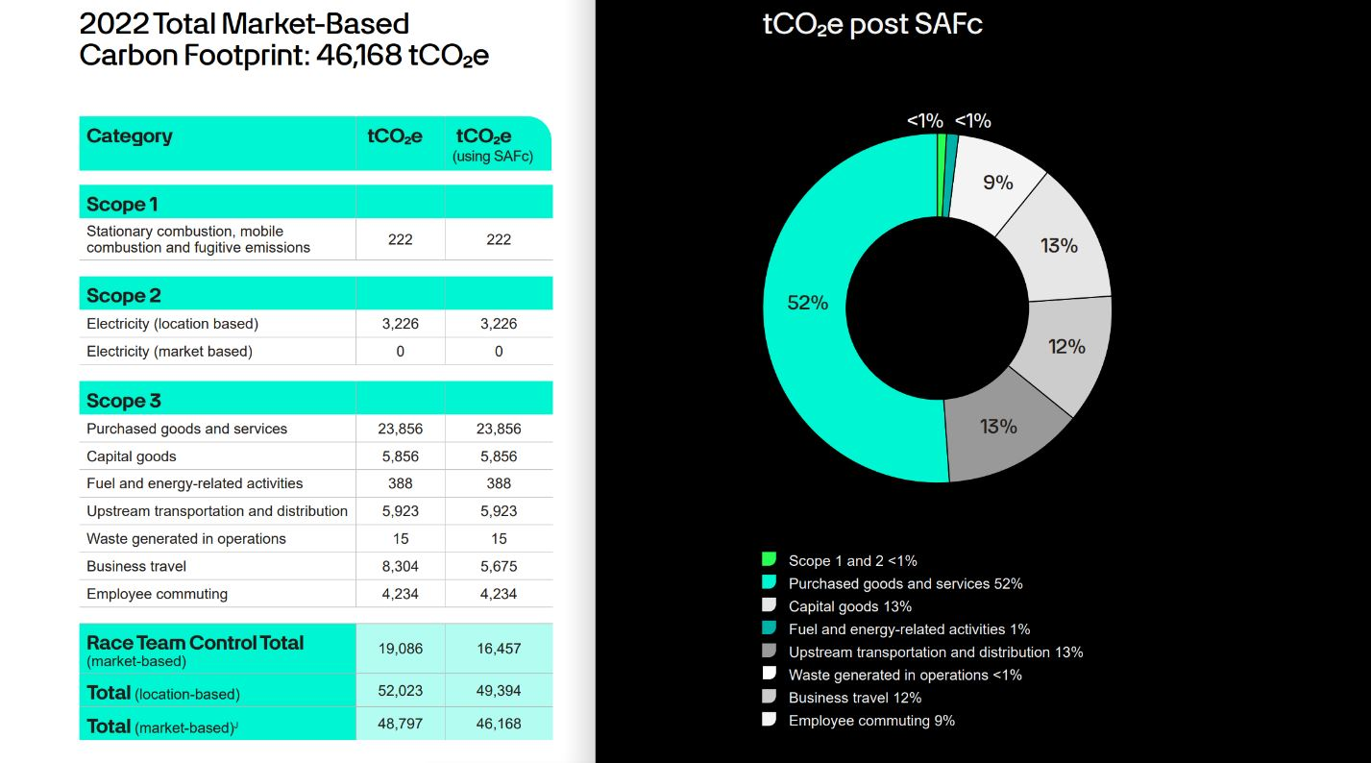
Figure 13: Mercedes AMG Petronas F1 Team Carbon Footprint (Mercedes AMG Petronas Formula One Team, 2023)

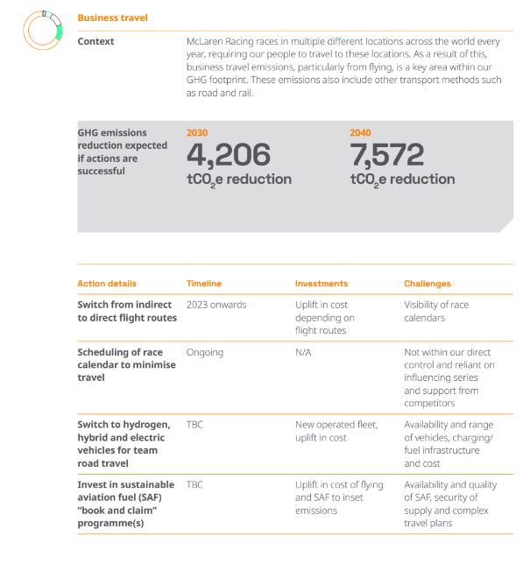
Figure 14: McLaren Estimated CO2 emissions reduction – Business Travel (McLaren Racing, 2023)

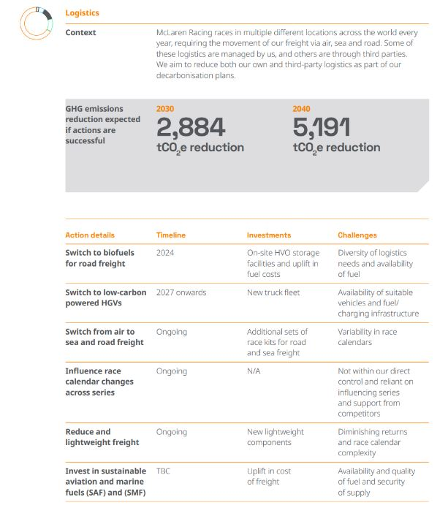
Figure 15: McLaren Estimated CO2 emissions reduction – Logistics (McLaren Racing, 2023)

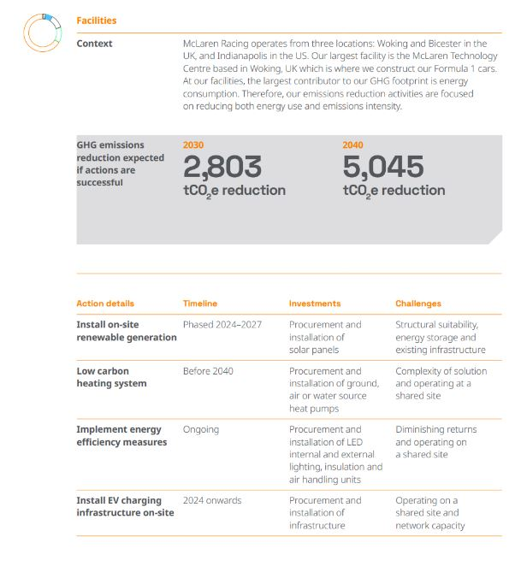
Figure 16: McLaren Estimated CO2 emissions reduction – Facilities (McLaren Racing, 2023)

8.0 - References
Collantine, K. (2009, January 11). KERS explained: how a mechanical Kinetic Energy Recovery System works. Retrieved March 15, 2024, from KERS explained: how a mechanical Kinetic Energy Recovery System works: https://www.racefans.net/2009/01/11/kers-explained-how-a-mechanical-kinetic-energy-recovery-system-works/
Dutch GP B.V. (2023). USE SHARED TRANSPORT TO GET TO CIRCUIT ZANDVOORT. Retrieved March 16, 2024, from USE SHARED TRANSPORT TO GET TO CIRCUIT ZANDVOORT: https://dutchgp.com/en/transport/shared-transport/#
Extreme E. (2021). St. Helena. Retrieved March 16, 2024, from https://www.extreme-e.com/en/the-ship
Extreme E. (2022). Legacy Projects. Retrieved March 16, 2024, from Dessert: https://www.extreme-e.com/en/legacy-projects/saudi-arabia
Extreme E. (2022). Sustainability. Retrieved March 16, 2024, from Sustainability: https://www.extreme-e.com/en/sustainability
Fédération Internationale de l'Automobile. (2009). 2009 FORMULA ONE TECHNICAL REGULATIONS. Retrieved March 15, 2024, from https://argent.fia.com/web/fia-public.nsf/7C4F8D883039AF6AC125757D00369C58/$FILE/1-2009_F1_TECHNICAL_REGULATIONS_Showing-Alterations_17-03-2009.pdf
Fédération Internationale de l'Automobile. (2011). 2014 FORMULA ONE TECHNICAL REGULATIONS . Retrieved March 15, 2024
Fédération Internationale de l'Automobile. (2023). FIA Environmental Report 2023. Fédération Internationale de l'Automobile. Retrieved March 13, 2024, from https://www.environmentalreport.fia.com/wp-content/uploads/2023/06/FIA__ENVIRONMENTAL_REPORT__2023.pdf
Formula One Group. (2019, November). F1 Sustainability Strategy. Retrieved March 13, 2024, from F1 Sustainability Strategy: https://corp.formula1.com/wp-content/uploads/2019/11/Environmental-sustainability-Corp-website-vFINAL.pdf
Formula One Group. (2020, December). Sustainability. Retrieved March 13, 2024, from https://corp.formula1.com/sustainability/
Global Sustainable Sport. (2023, April 6). How sustainable is motorsport? Retrieved March 16, 2024, from How sustainable is motorsport?: https://www.globalsustainablesport.com/how-sustainable-is-motorsport/
Kanal, S. (2022, August 16). More efficient, less fuel, and carbon net zero – 7 things you need to know about the 2026 F1 engine regulations. Retrieved march 16, 2024, from More efficient, less fuel, and carbon net zero – 7 things you need to know about the 2026 F1 engine regulations: https://www.formula1.com/en/latest/article.more-efficient-less-fuel-and-carbon-net-zero-7-things-you-need-to-know-about.ZhtzvU3cPCv8QO7jtFxQR.html
Kew, M. (2021, March 22). What is Extreme E? Car, calendar, drivers, how to watch and more. Retrieved March 16, 2024, from What is Extreme E? Car, calendar, drivers, how to watch and more: https://www.autosport.com/extreme-e/news/what-is-extreme-e-car-calendar-drivers-how-to-watch-and-more/5745149/
Kristensen, S. (2022, February 22). What You Need To Know About Formula 1 Fuel. Retrieved March 15, 2024, from https://motorsportexplained.com/f1-fuel/#:~:text=Up%20until%20the%20end%20of%202021%2C%20Formula%201,fuel%2C%20which%20will%20have%20a%2010%25%20ethanol%20content.
McLaren Racing. (2023). McLaren Racing Climate Transition Action Plan September 2023. Retrieved March 16, 2024
Mercedes AMG Petronas Formula One Team. (2023). Sustainablility Report 2023. Retrieved March 14, 2024
Miller, C. (2021, October 5). Formula 1 Is Creating a 100% Sustainable Fuel to Keep Internal Combustion Alive. Retrieved March 15, 2024, from https://www.caranddriver.com/news/a37872650/formula-1-auto-racing-sustainable-fuel/
Namar, M. M., Jahanian, O., Shafaghat, R., & Nikzadfar, K. (2021). Engine Downsizing; Global Approach to Reduce Emissions: A World-Wide Review. Retrieved March 15, 2024, from https://www.researchgate.net/publication/357209871_Engine_Downsizing_Global_Approach_to_Reduce_Emissions_A_World-Wide_Review
National Grid. (2023, February 23). What is net zero? Retrieved March 14, 2024, from https://www.nationalgrid.com/stories/energy-explained/what-is-net-zero
National Grid ESO. (2023). What is net zero and zero carbon? Retrieved March 14, 2024, from What is net zero? : https://www.nationalgrideso.com/future-energy/our-progress-towards-net-zero/net-zero-explained/what-net-zero-and-zero-carbon#:~:text=Net%20zero%20means%20that%20any,than%20the%20amount%20taken%20away.
Ritchie, H. (2020, October 22). Climate change and flying: what share of global CO2 emissions come from aviation? Retrieved March 14, 2024, from https://ourworldindata.org/co2-emissions-from-aviation
Straw, E. (2023, March 3). WHY F2/F3’S NEW SUSTAINABLE FUEL IS ‘MORE EXTREME’ THAN F1’S. Retrieved March 15, 2024, from WHY F2/F3’S NEW SUSTAINABLE FUEL IS ‘MORE EXTREME’ THAN F1’S: https://www.the-race.com/formula-1/why-f2-f3s-new-sustainable-fuel-is-more-extreme-than-f1s/#:~:text=F2%20and%20F3%20will%20use%20fuel%20containing%2055%25,with%20carbon%20captured%20from%20the%20atmosphere%20in%202027.
Tedesco, M. (2023, January 18). The Paradox of Lithium. Retrieved March 16, 2024, from https://news.climate.columbia.edu/2023/01/18/the-paradox-of-lithium/
United Nations. (2024). Member States. Retrieved March 14, 2024, from Member States: https://www.un.org/en/about-us/member-states
United Nations. (2024). Sustainable Development Goals. Retrieved March 14, 2024, from https://www.un.org/sustainabledevelopment/news/communications-material/
Williams Grand Prix Engineering. (2023). Sustainability Strategy. Retrieved March 16, 2024
Zero Petroleum. (2024, February 29). Zero Petroleum Named Official Partner of Stake F1® Team Kick Sauber . Retrieved March 15, 2024, from Zero Petroleum Named Official Partner of Stake F1® Team Kick Sauber : https://www.zero.co/news-media/zero-petroleum-named-official-partner-of-stake-f1-team-kick-sauber

