Developing Innovation & Creativity for Business Advantage

Maria Carmen Dumitrache

Executive Summary

Innovation is indeed necessary for the development of a business organisation. The innovation strategies which are discussed in this report are used by firms for the development of their products and services which later on attracts people to buy stuff from them (Wellings et al., 2021). From this report, it can be concluded that Tesla is the most innovative company in the world currently and its applications of innovation strategies are a perfect example of how innovation and creativity can develop a business organisation. It has been discussed in the report that innovation refers to unique and unusual practices which can transform an old organisation or form a new company that can redefine the trends in a new era of technology. Tesla is the leading brand that deals in electric vehicles and it has redefined the future of the automobile industry due to the innovative practices which are applied to the company by its innovative leader, Mr Elon Musk. In this report, it has been observed that Tesla almost applies all the innovative strategies to its products and services which makes it a very innovative company and makes it a billion-dollar firm. The main goal and objective of the firm are to bring sustainable transport in the popular demand worldwide and introduce new technology which will be used while running on Tesla.

Table of Contents

1.0 Introduction 4
2.0- Main Findings 5
2.1- Overview of the innovation opportunity in Tesla 5
2.2- Type of Innovation used by Tesla 6
2.3- The Creativity Thinking Process in Tesla 8
2.4- Models of Innovation 8
2.4.1 – Open and Closed Innovation is a method 8
2.4.3 – 4P’s to Innovation 11
2.5 – Assessment of the Effectiveness in Tesla 13
2.5.1- Barriers and Risks 16
2.6 – Leadership & Management in Tesla 16
References 20

1.0 Introduction
The scope of this report is to outline and to understand how important innovation is and
creativity for a business success, the report was righted by student Maria Carmen Dumitrache for the lecturer Brynach Hefferman using website, books journals article, which helped to accumulate information ,how to applied different models and to think more deeply about what innovation and creativity can help the future technology in Tesla Organization. The starting date of the report 10 01 2022 ending date 25 03 2022.
Innovation and creativity are some of the most important aspects of the organisation and contributes to the development of a business in general. Lack of creativity is boring and doesn’t give birth to new ideas (Dorsz and Lewandowski, 2021). In this report, an overview of the innovation opportunity and its types will be discussed. Furthermore, the applications of the creative thinking process, models of innovation, assessment of effectiveness, leadership and management are discussed with the reference company being taken as Tesla.
Tesla is the biggest dealer in electric cars in the world. Tesla is one of the biggest companies in the world and was founded in 2003. Later, Elon Musk joined Tesla and became the largest shareholder and CEO of the company. The organisation generated annual revenue of $31.54 billion and has employed 70,757 employees at the firm (Tesla, 2022).

2.0- Main Findings
The advantages of the development of innovation and creativity in a business organisation with understanding are discussed in this section. After analysing tesla organization using Six Thinking Hats method it shows that tesla used green hats this is mean that they demonstrate innovation and creativity with important growing creating electric cars and they look forward for the future with new ideas and more important to put in application the creativity.

2.1- Overview of the innovation opportunity in Tesla
An opportunity refers to the realisation of the need for change and having a creative idea which both can give birth to innovation in an organisation. These opportunities factors are evaluated below in the context of Tesla:
- Idea: The founders of Tesla established the firm because they had an idea where they wanted people to have a better experience with electric vehicles than the vehicles which run on gasoline. They believed electric vehicles can be more fun to drive and encourage a sustainable environment as well (Brzezinska and Bryant, 2021).
- Market Need: The need for change in an industry and starting a new revolution of products in an era is what a market need. Co-founders of Tesla identified the need for change in the automotive industry and hence brought a revolutionary product of electric cars which are sustainable in the market (Farrow et al., 2021).
- Competition: Tesla is the leading brand in electric vehicles. There are some companies like Haundayi that provide electric cars but Tesla is the only brand with multiple electric vehicles (Dik et al., 2022).
- Building the innovative team: Tesla is one of the revolutionary companies that provide extremely unique and unusual products to its customers. Hence, CEO Elon Musk has built a team full of innovative and creative minds (Villiers, 2019).

2.2- Type of Innovation used by Tesla


Figure 2.1 Innovation Matrix (Villiers, 2019)
- Breakthrough Innovation: Breakthrough innovation refers to a type of innovation that is revolutionary and which defines a change of the new era. Tesla uses this type of innovation as the products are revolutionary. No company has provided so many varied products of electric vehicles as Tesla have (Jeon et al., 2021).

Advantages: This type of innovation contributes in bringing a new change in the business environment. Something which has never been created or invented before.
Limitations: This type of innovation is extremely risky and the person investing on a company which is going through this process has a chance of losing all their money and this is one of the drawbacks of this process.
- Sustaining Innovation: Sustaining Innovation refers to a type of innovation where the company needs to perform better expand its innovative ideas onto its products constantly and keep producing varied and unique products. Tesla has manufactured trucks by the name Tesla-Semi which are supposed to save millions of dollars of truck owners which they spend on fuels (Marres, 2020).

Advantages: This type of innovation helps in evolving existing products in the organisation.
Limitations: This type of innovation is risky as well as the target audience might reject the newly introduced product.
- Basic Research: Basic Research is one of the significant types of innovation as before the research there would not be any growth for the innovation. If the co-founders of Tesla wouldn't have researched electronic vehicles and got tired of driving vehicles that run on gasoline then there wouldn't have been the birth of the innovative and revolutionary ideas (Kostic, 2019).
Advantages: This sort of innovation helps in providing a basic structure for the change of the organisation or forming a new company.
Limitations: Sometimes, basic research is not enough and the co-founders of the organisation might foresee different outcomes for the future.
- Disruptive Innovation: When organisations receive feedback from their employees and work on it then that is referred to as disruptive innovation. The CFO of Tesla is an Indian born and he suggested Elon musk introduce Tesla in India for the diversification of the company and now Elon Musk is working on it (Hopkins and Schwanen, 2018).
Advantages: This type of innovation contributes to maintaining a healthy work culture as well as it helps in letting innovative ideas flow in the organisation.
Limitations: Every time, this process might not work as sometimes employees can give wrong feedback as well.
The above analysation of different innovation strategies suggests that Tesla uses all four innovation matrix strategies.

2.3- The Creativity Thinking Process in Tesla
- At an individual level: The CEO of Tesla, Mr Elon Musk promotes listening to music during working hours as some people work better when listening to music while working (Kostic, 2019).
- At a team level Tesla follows a centralisation based organisational culture. Elon Musk promotes healthy and open communication among his subordinates and so does other team leaders. Hence, creative and innovative ideas are provided by employees including interns at Tesla (Lutsey et al., 2018).
- At the organisational level: Elon Musk believes in time management and therefore he has reduced the sizes of the meetings. The company culture of Tesla is unique. Employees are not confined by rules and regulations over there and everyone believes in a flexible mindset and that's why creativity flows at their office (LaMonaca and Ryan, 2022).
- At the industry level: The main challenge for Tesla motors is to dominate the car market, which is mainly dominated by companies like Ford, Mercedes, etc. Hence, Tesco with its innovative ideas attracting more and more targeted customers which will not only shift to electric vehicles but also help in redefining the future of automotive industries and encourage a sustainable environment as well (Lutsey et al., 2018).

2.4- Models of Innovation
The Models of Innovation used by Tesla.

2.4.1 – Open and Closed Innovation is a method
When companies use internal as well as external paths it is termed as open innovation. Tesla has collaborated with major shareholders and companies for innovative strategies. Open innovation occurs when a business pursues both internal and external avenues. Tesla has developed creative tactics in collaboration with significant shareholders and businesses.
For example, Tesla has partnered with Lotus, Panasonic, Toyota and the US government (Johnson, 2020).
Advantages: This strategy of innovation helps in bringing support from different entities for the innovative plan.
Limitations: A company cannot always rely on different entities for the process of innovation due to varied opinions and hence it is one of the drawbacks of open Innovation.
Closed innovation refers to when a company innovate and develop new products and services on its own and not by depending on other shareholders and partners. This strategy is mainly used by inventors, scientists etc. Tesla Motors’ co-founders are the biggest inventors of the world. Initially, Tesla used closed innovation by inventing and developing innovative vehicles through its unique technology (Bučko, 2018).
Advantages: They will be no interference from the outside world during the development of a new and innovative product.
Limitations: An organisation sometimes needs a different entity to support and invest into their innovative ideas and hence, closed innovation might not work on the companies with less resources.

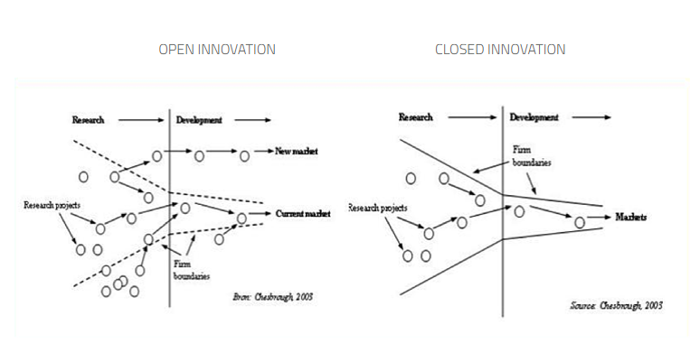 Figure 2.2 open vs closed innovation (Cole, 2018)

2.4.2 – The Innovation Process
There are different stages in organisational innovation and those are described below:
- Generating Creative Ideas: Generating creative ideas is the first stage of the innovation process. Determining what the organisation actually want to do is the first step of innovating the organisation. When co-founders of Tesla motors came up with the idea of inventing unique electric vehicles, they knew they had to implement it in real life. The process of innovation begins with the generation of novel ideas. Identifying the organization's true mission is the first step toward innovation. (Perkins, G., and Murmann, 2018).
- Reviewing the Creative Ideas: The second step of the innovation process is to review the ideas and analyse what type of resources will be needed in developing the product. Elon Musk invested in Tesla when he was the owner of Paypal (Bučko, 2018).
.
- Development: The third step of the innovation process is bringing the creative ideas into reality and beginning the process of innovating the organisation practically. Tesla released its first car in 2008 by the name Roadster. The development of this car took almost five years (Cole, 2018).
- Commercialization: This step helps in targeted customers being aware of the product so they look into it and get attracted to the product. In 2016, Elon Musk introduced a “secret master plan” where he was going to release Model-3, a low-priced car which was a great marketing strategy (Tesla, 2022).

2.4.3 – 4P’s to Innovation
The 4ps of innovation are developed by Tidd and Bessant in 2005. They are described below with a deeper understanding:
- Product Innovation: Product innovation refers to the products and services a firm offers to its customer. The innovation of the products is necessary because the kind of product an organisation has to offer tells a lot about the firm. Tesla’s products are known for bringing revolution and redefining the new age era of the automobile industry (Kim, 2020. Tesla's Model Y is one of its most well-known vehicles. It is a mid-size SUV with seating for up to seven passengers. This vehicle is built to operate in the rain, snow, and mud. Product innovation refers to the items and services offered by a firm to its clients. Product innovation is crucial because the kind of product an organisation offers reveals a great deal about the organisation.
Advantages: Product innovation contributes in bring a change in the business environment.
Disadvantages: This innovation may not work on the service sectors.



Source: (Tesla, 2022)
- Process Innovation: Process innovation refers to the change in the process of manufacturing and developing the products. Tesla is the most innovative company in the world has recently announced that they are releasing Roadster 2.0 which is the second and most advanced version of their first model to be ever manufactured and hence Tesla keeps exploring and experimenting with their innovation strategies (Holmes et al., 2020).
Advantages: This innovation bring changes in the methods practiced in the organisation.
Disadvantages: Not every member of the organisation might be comfortable with changes in the process of changes.
- Position Innovation: Position innovation refers to change in the way they choose to introduce their products to its customer. Tesla has always targeted upper-class people who can afford to buy their cars. But recently, they have introduced cars that are affordable for middle and working-class people as well (Cooke, 2020).
Advantages: This innovation method benefits in attracting appropriate customers for the organisation.
Disadvantages: This innovation method might not reach out to people who are not appropriate for the product because there is a chance of them getting attracted to the product as well.
- Paradigm Innovation: This innovation strategy is more about people’s understanding of the organisation. Tesla has created a buzz among the people with its unique and innovative products. Tesla is the first organisation to manufacture vehicles that do not need gasoline to run on the road. They encourage people to increase the quality of their lives and shift to a sustainable living style as well.
Advantages: This innovation method helps in creating a right image of the company in people’s minds.
Disadvantages: This tactic might form a wrong image of the company which it is not in people’s mind.
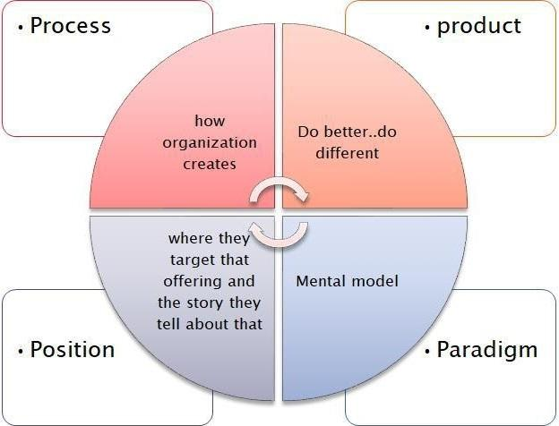
Figure 2.3 4ps of innovation (Johnson, 2020)

2.5 – Assessment of the Effectiveness in Tesla
Force field analysis is practised in any firm to determine what factors of innovation attract people and what factors push people away. This model includes five stages which are described below:
- Stage 1- Examine your Goal and purpose for change: The goal of the co-founders of Tesla was to invent electric vehicles which are as fun as regular vehicles to drive but are also good for the environment.
Advantages: This method assists in reviewing factors for the changes in the business environment.
Disadvantages: This method may or may not provide accurate result.
- Stage 2- Figuring out the force for the change: The second stage of the model consists of the need which drives an organisation towards innovation and change. Those factors can be internal or external. For example, Internal factors for Tesla can be a need to gain profit from the products and a need for a sustainable environment while selling cars. The external factors can be a need for the members of Tesla to redefine the era of the automobile industry and change trends in the business environment (Kostic, 2019).
Advantages: This stage helps in identifying the factors that are affecting the business environment.
Disadvantages: The identification of the change factors can be negative such as government interference etc.
- Stage 3- Figuring out the forces against the change: The third stage of this model would be the identification of factors and forces which are against the change in the organisation and the business environment in general. For Tesla, these factors can be rules and regulations by the government or threats of developing and investing in the unique and unusual products in the market which no one knows how it works (Jeon et al., 2021).
Advantages: This can identify negative outcomes of the changes which can help the members of the company to foresee the future and practice changes accordingly.
Disadvantages: This can identify and predict incorrect factors affecting change.
- Stage 4- Allotting Scores: The fourth step of this model is to allot scores. This represents the forces that are weak and strong. These scores examine the factors which affect the organisation negatively and positively due to the implementation of innovation. Hence, this a necessary stage of this model.
Advantages: This can identify weak and stronger points of changes properly.
Disadvantages: This might identify wrong weak points.
- Stage 5- Analyzation and Application: The fifth step of this model is the analysation and application of the model. It is up to the organisation if they want to go through with the change or not after analyzing this model.
Advantages: This is the final stage and it shows the final outcome of this model.
Disadvantages: The outcomes can be negative and the organisation might decline the forces of change.
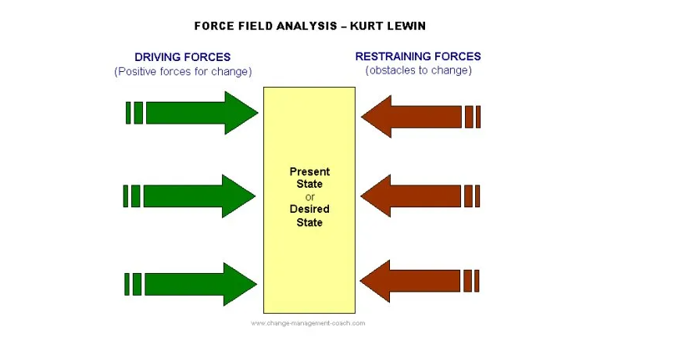
Figure 2.4 Force Feild Analysis (Marres 2020)

2.5.1- Barriers and Risks
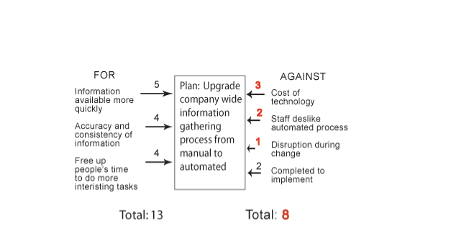
Figure 2.5 Risks of Force Field Analysis (Villiers, 2019).
There are certain barriers and risks which comes with taking the road of innovation. The above figure perfectly describes the pros and cons of change and innovation with the reference of Force Feild Analysis. Tesla’s innovation strategy is very risky but it has worked in the past. The cost of resources is extremely expensive and there are some other competitors as well which have started manufacturing Electric Vehicles.

2.6 – Leadership & Management in Tesla
The leadership style of Elon Musk is very unique and innovative just like his ideas. He has been seen sleeping near the production line which tells that he always checks up on his subordinates and their working process which is what makes him a very innovative and visionary leader. Tesla follows a function-based hierarchy that lets every member of the company have open communication with their leaders. Elon Musk always promotes a healthy work culture in his company where everyone is free to let their opinions be heard, which later on let creative ideas in the workplace flow constantly (Marres, 2020). Elon Musk’s leadership style is transformational which means he believes in creating new trends not following the old ones and that's what makes him a very innovative and inspiring leader (Villiers, 2019).
3.0- Conclusion
This report outlines the significance of innovation and creativity in an organisation and how it affects the development of the organisation. This report reviews the meaning and types of innovation and its applications of it in Tesla with a deeper understanding and also discusses the creative thinking process of Tesla. The models of innovation have been outlined in this report with a piece of deep knowledge and how it is practised in Tesla. The leadership and management of Tesla play a very crucial role in the innovation process of the company.

REFLECTION
Question 1
Innovation plays a great role in managing the factors of business and leading the business towards acquiring the business advantage. Innovation is mixture of invention and creativity. The main aim of the reflection is to demonstrate the aspect of innovation in the business and the requirement of innovation in business advantage. The reflection is the answer to the question that whether the innovation concept provided Tesla with a business advantage or not. The reflection is based on the prospects of innovation and the innovations of the Tesla. The reflection is about the Concept of innovation along with the concept of creativity. (Edwards, 2018). Innovation is a vast field and a very important aspect of a business. The firm Tesla is based on the aspects of innovation. Innovation is a major factor which leads the firm towards business expansion and becomes a deciding factor for the organization. Innovation help Tesla to achieve success and become an expert in the sector of science and technologies. The innovation involves the process of innovating new technologies and adapting the creativity level. Lack of innovation and creativity can have a major impact in the organization. It is basically the change an alteration which I am seeking in life, and which can make the flow of life easy. Innovation arises from the need of the society. It is an approach which includes two bases which are problem seeking and solution seeking (Kahn, 2018.
The tesla is known for its innovation whereas the Elon Musk is one of the biggest innovator and entrepreneur of the world. The firm is known for its automobile technology and dream to go to mars.

Creativity is the most important aspect of the innovation. Creativity is something which makes the normal thing unique and help the business organization in gaining the competitive advantage. Tesla makes sure that any innovation in the space technology or the automobile technology is filled with creativity. Creativity is a great aspect which attracts the customers and make the normal things look different. The main motive behind seeking the creativity is to develop a new framework and generate and recognize better ideas to demonstrate a better understanding of the environment (Popp, 2019). A creative mind not only seeks for problem but also seek for solution of the problem by saving time and cost too and solving the need. The best example of innovative organization is Tesla. The organization which leads by an example of innovation and creativity is involved in the innovative organization. The main motive of the organization is to solve the need, generate a new idea, seek the service, and use new and advance technology (Liubai and Milnaric, 2019). The generation of the idea of innovation can be done from any place at any time. There is no limit to that idea. Tesla is an organization which motivates the other firms to innovate new ideas and implement them to enhance the technological factor of the world. The main motivation of the generation of ideas in Tesla is through physics, principles of learning, teaching (Ojan et al., 2019.
The reflection set an understanding about the importance and need of innovation and concluded that the innovation is a major factor and leads Tesla towards the business advantage.

Question 2.

Innovation and creativity play a very important role for each person professional or daily living and is important to improve the knowledge about how you can see different aspects in different ways in the organization. For that I choose this module to evaluate my understanding, what innovation and creativity means and how important it is to put in application the new ideas .The module innovation and creativity for business advantage was very interesting and I heaved the opportunity to have Davina Evans lecture which helped me to develop my knowledge about what innovation and creativity means and how important is to see more deeply different thinks in different ways , using different models exercise and give me the opportunity to have my own opinion about what is mean innovation and creativity , and how I can develop and applied the new ideas . For me the exercise was very important in my understanding because when I practice the theory I can develop and understand better what the concept of the module means. Without exercise and just theory can be conduct at missing information about how I can apply the theory or how to use different models to understand which type or how we can use the innovation and creativity professional. To help me understand better the module innovation and creativity I done a report using tesla organization and after analyzing the process used, and how the innovation and creativity help tesla to be one of the most innovative and creative company in the world creating new technology and electric cars .

References
- Alawamleh, M., Ismail, L.B., Aladwan, K. and Saleh, A. (2018). The influence of open/closed innovation on employees’ performance. International Journal of Organizational Analysis.
- Brzezinska, D., and Bryant, P. (2022). Performance-Based Analysis in Evaluation of Safety in Car Parks under Electric Vehicle Fire Conditions. Energies, 15(2), 649.
- Bučko, A. (2018) Protecting Reputation in Crisis: Case Study of Strategic Reputational Risk Management at Tesla
- Chen, J., Yin, X. and Mei, L. (2018.) Holistic innovation: an emerging innovation paradigm. International Journal of Innovation Studies, 2(1), pp.1-13.
- Chakrtvarti, A. (2021). Elon Musk’s mail to Tesla employees about listening to music at work proves he is a cool boss. https://www.indiatoday.in/technology/news/story/elon-musk-s-mail-to-tesla-employees-about-listening-to-music-at-work-proves-he-is-a-cool-boss-1878954-2021-11-20
- Cole, K. (2018). Leadership and Management: Theory and Practice. Cengage AU. Cooke, P. (2020). Gigafactory logistics in space and time: Tesla’s fourth Gigafactory and its rivals. Sustainability, 12(5), 2044
- Connelly, M. (2020). Force Field Analysis - Kurt Lewin. Available at: https://www.change-management-coach.com/force-field-analysis.html
- Dik, A., Omer, S., and Boukhanouf, R. (2022). Electric Vehicles: V2G for Rapid, Safe, and Green EV Penetration. Energies, 15(3), 803.
- Dorsz, A., and Lewandowski, M. (2021). Analysis of Fire Hazards Associated with the Operation of Electric Vehicles in Enclosed Structures. Energies, 15(1), 11.
- Dnb. (2022). Tesla, Inc. https://www.dnb.com/business-directory/company-profiles.tesla_inc.e337e93c824d992066152d1a14d8d8e8.html.
- Edwards-Schachter, M. (2018.) The nature and variety of innovation. International Journal of Innovation Studies, 2(2), pp.65-79.
- Farrow, R., Ferguson, R., Weller, M., Pitt, R., Sanzgiri, J., and Habib, M. (2021). Assessment and Recognition of MOOCs: The State of the Art. Journal of Innovation in Polytechnic Education, 3(1), 15-26
- Geniusrevive.com/en/the-six-thinking-hats-as-a-tool-for-creativity-and-innovation/https://
- Johnson, J. (2020). The Innovation Trigger: An Idea Begins. Available at: https://www.bmc.com/blogs/hype-cycle-innovation-trigger/
- Kahn, K.B. (2018.) Understanding innovation. Business Horizons, 61(3), pp.453-460.
- Kostic, M. (2019). 4 Ps of Innovation’ - Emagazin - Innovation management consulting
- Ljubaj, I. and Mlinarić, T.J. (2019). The Possibility of Utilising Maximum Capacity of the Double-Track Railway By Using Innovative Traffic Organisation. Transportation Research Procedia, 40, pp.346-353.
- Miodrag Kostic - profitable new ideas Balkans southeast Europe Romania Bulgaria Hungary Croatia Slovenia Belgrade Serbia. Available at: https://www.veza.biz/eng/4Pinnovation.html
- Karamitsios, A. (2020). Open Innovation in EVs: A Case Study of Tesla Motors. https://www.diva-portal.org/smash/get/diva2:635929/FULLTEXT01.pdf.
- Kim, H. (2020). Analysis of how Tesla Creating Core Innovation Capability. Available at: file:///C:/Users/HOME/Downloads/JournalAnalysisofhowTeslaCreatingCoreInnovationCapability.pdf
- LaMonaca, S., and Ryan, L. (2022). The state of play in electric vehicle charging services–A review of infrastructure provision, players, and policies. Renewable and Sustainable Energy Reviews, 154, 111733.
- Lutsey, N., Grant, M., Wappelhorst, S., and Zhou, H. (2018). Power play: How governments are spurring the electric vehicle industry. White Paper.
- Marres, N. (2020). What if nothing happens? Street trials of intelligent cars as experiments in participation. In TechnoScienceSociety (pp. 111-130). Springer, Cham.
- Perkins, G., and Murmann, J. P. (2018). What does the success of Tesla mean for the future dynamics in the global automobile sector? Management and Organization Review, 14(3), 471-480.
- Oe, H. and Vo Son, A. (2020). A Conceptualisation of innovative organisation of an ICT company: A focus on the impact of ‘innovative milieu’. Journal of Business School, 3(1), pp.23-36.
- Popp, D. (2019). Environmental policy and innovation: a decade of research.
- Qian, J.Y., Chen, M.R., Liu, X.L. and Jin, Z.J. (2019). A numerical investigation of the flow of nanofluids through a micro-Tesla valve. Journal of Zhejiang University-SCIENCE A, 20(1), pp.50-60.
- Russell, M.G. and Smorodinskaya, N.V. (2018.) Leveraging complexity for ecosystemic innovation. Technological Forecasting and Social Change, 136, pp.114-131.Tesla (2022). About Tesla. TESLA. Available at: https://www.tesla.com/about.
- Wellings, J., Greenwood, D., and Coles, S. R. (2021). Understanding the Future Impacts of Electric Vehicles—An Analysis of Multiple Factors That Influence the Market. Vehicles, 3(4), 851-871.

