How to create a new Teams meeting
- Open Teams App 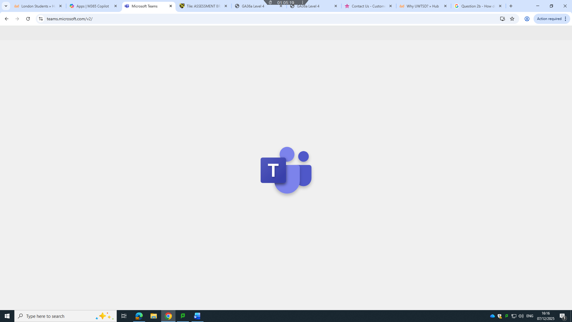
- Choose Calendar 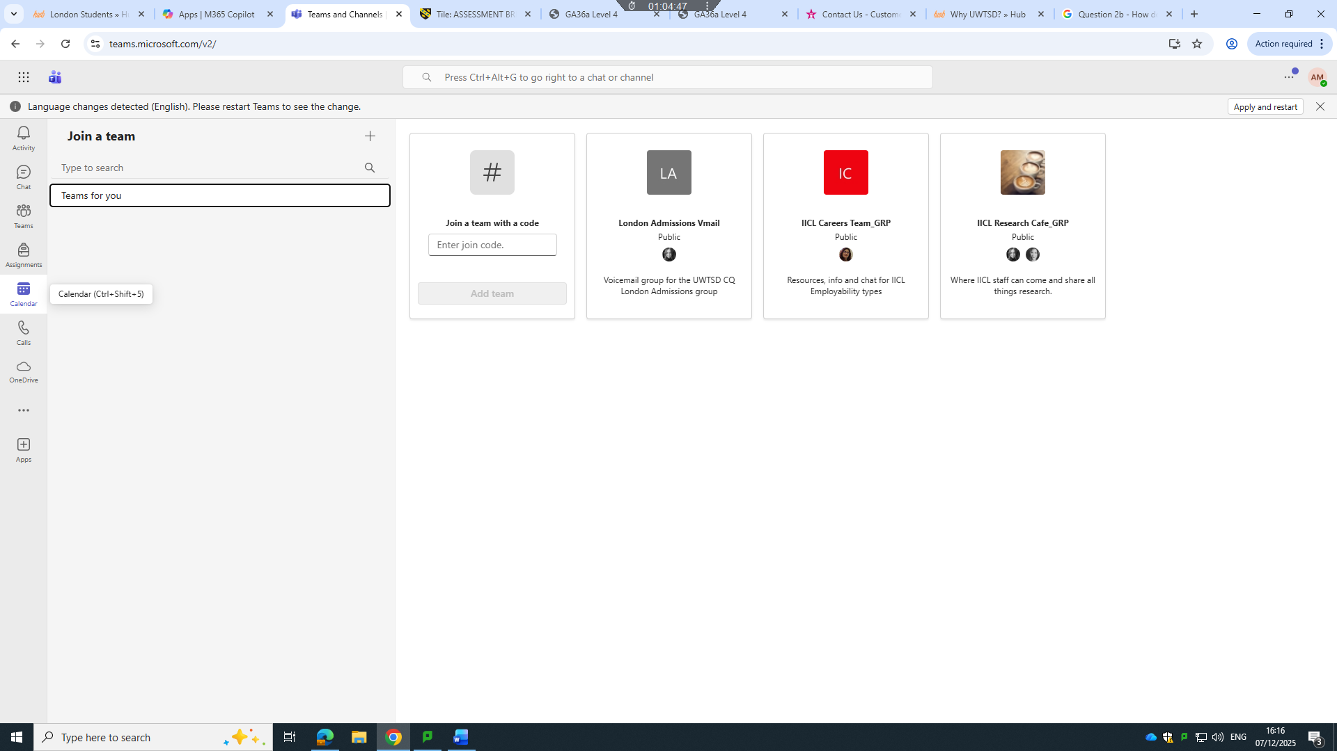
- From Calendar create new Events 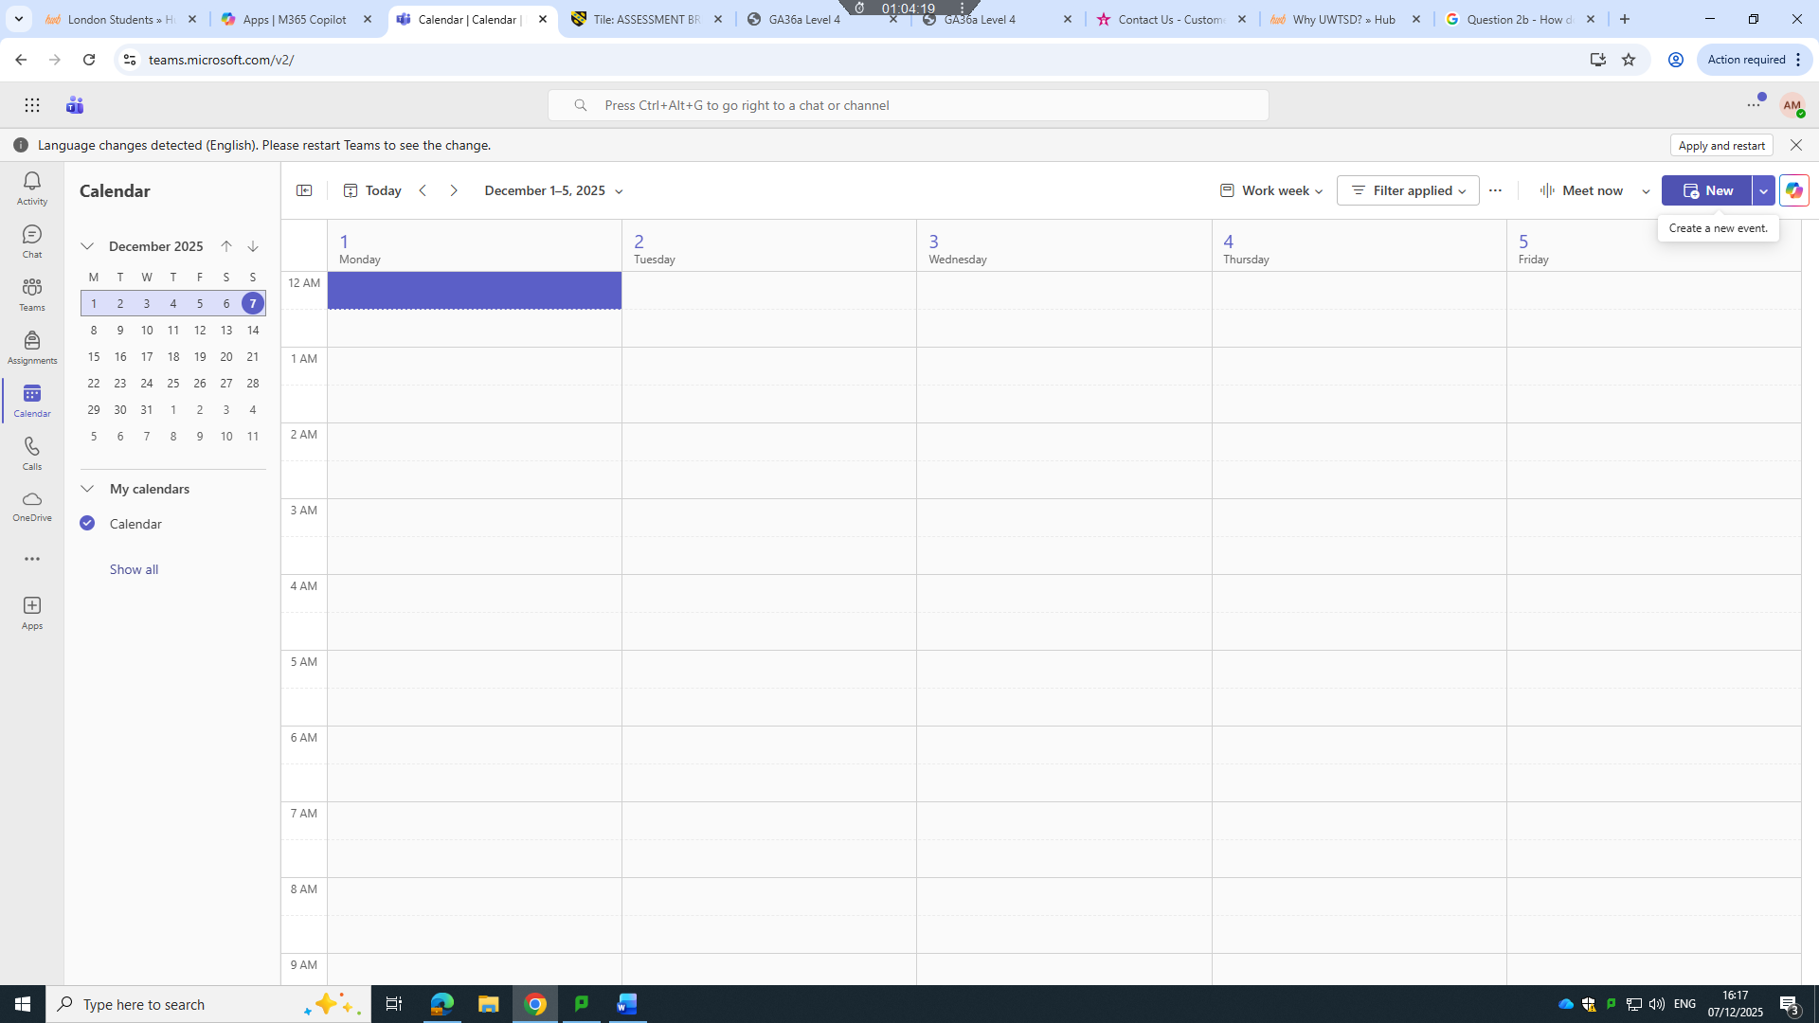
- Add topic such as School meeting 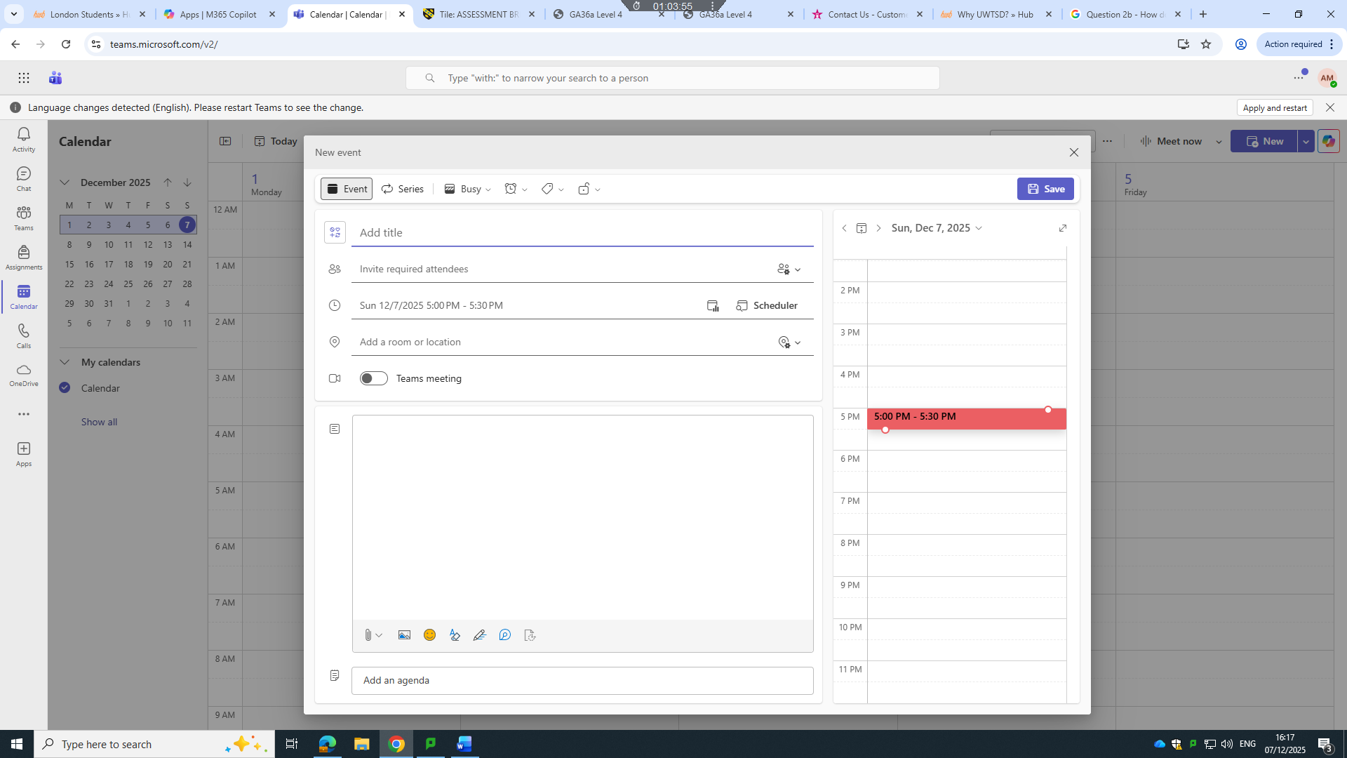
- Schedule time and place as shown on Screen
- Save and we are done

