Programme: BA Business and Management

Module: Internship & Volunteerism

Module Code: BMSP6003

Lecturer: Jess Shore

Assignment title: Critical Appraisal

Student: George Parker

Submission Deadline: 30th March 2020

- Executive Summary

This post-placement report details the entirety of the internship and personal development process retrospectively through the first person showing how the placement provider works and how this provider fits into the bar & restaurant market. Following are my thoughts regarding the business I am apart of and what responsibilities where assigned to me during this internship then are a look at my thoughts surrounding the arrangement, required resources and travel to and from the placement location. Next beings a critical reflection of myself and the process beginning with a reflection on the Gantt chart which supported me through the process by helping me to manage myself by looking at the positives and negatives of the chart. The report then details the skills which I developed on a week-by-week basis and how this was done and through what means this then flows into a comparison between my pre and post placement skills audits with an analysis of the success of the skill development. To conclude this, report my final thoughts and comments are detailed through a conclusive stamen and followed by the future recommendations that I would wish to follow in the future for this assignment.

- 1.0 – Introduction

Within this assignment there will be a critical appraisal of my work placement. This will be done by first disusing the location of my internship and what I thought of this place and what my responsibilities were whilst I was there. Also, I will reflect upon each considered factor leading up to the placement such as the arrangement of the placement and the resources required before I was able to begin the placement.

Following this I will use the Gantt chart that I created as a means of reference to critically reflect upon my time during my internship by analysing my own actions in a critical sense on a week by week basis.

The next stage of this critical appraisal will be to critically assess the Gantt chart that I created for personal development during my internship for its positives which allowed me to achieve my goals during my internship and the negative factors that caused issues and complications my own self-development that could be approved on if another opportunity arose in the future for further self-development.

The next stage of the critical appraisal will be to compare and contrast between both my pre-placement skills assessment and my post-placement skills assessment to identify if set goals and targets for development were met and if so how where they done and what effect did these have on my own persona development.

Then once this has been completed I shale then conclude on the level of success that my internship provided by reflecting upon what I was able to learn and how these will have a benefit on myself in the future in regards to my future self as well as how the skills which I have been able to learn have increased my ability to work in the future at a higher standard and increasing my chances of receiving employment opportunities.

Finally, once these steps are completed there will be recommendations made in regard to how the process of this critical appraisal has been conducted and whether it has been a success or a failure and how this success can be continued or this failure can be changed. There will also be an insight into the entire internship process and how this process was done with further recommendations being made that could increase the levels of success for reaching personal development goals.

- 2.0 - Main Findings

- 2.1 - Placement Provider

For my work placement I worked at Diablos, a cocktail bar and restaurant within Carmarthen has a focused on providing a high quality of service through a well trained series of watering and bar staff that deliver an excellent of food for their customers during the day. Unlike most restaurants Diablos has the ability to seamlessly transition between this daytime casual restaurant atmosphere and bustling hight life atmosphere, this is done by providing an excellent level of cocktail service though an expansive menu with cocktail staff which are competent enough to fulfil any order no matter the level of complexity within the drinks ordered (Diablo's Nott Square, 2019), (Ritchie, 1999).

- 2.1.1 - My thoughts of the placement location

The main reason for choosing Diablos as the location for my placement was that I had previously been there many times as a customer and was highly impressed with the high quality of all drinks, food and service. I wished to know how this was accomplished and wanted to learn from the staff and management as they seemed to have various skill sets that can be highly transferable into my own working life once I enter the world of employment once I finish university. Once I began my placement I was surprised by the levels of preparation that went into each and every aspect of the business which gave me a lot to consider and helped me to remember that everything takes time when wanting something to work and become successful. The area of Diablos which I found the most interesting was the cocktail aspect as it became apparent very quickly that this areas was the highest pressure area as it required both great memory, communication and service skills to be capable of doing this job well all whilst working into the early hours of the morning with few breaks and being surrounded by intoxicated customers. My thoughts in regard to all of these factors were that this environment world be a challenging work environment however it could be one of the most beneficial if done correctly (Beesley, 2020).

- 2.1.2 - My responsibilities within my placement

During my placement I worked in a managerial capacity with a range of responsibilities that I had to ensure were completed to an acceptable standard. One of the initial responsibilities given to me was to order and manage the levels of stocks for the bar such as the volume of alcohol spare within the bar and the quantity of ice in storage ahead of the weekend where ice was as important as spirts due to it being required in every drink before it can be served. Another responsibility which I was given was to organise shift rotas and staffing levels for the bars on the weekends to ensure that the business was adequately staffed to support the demand of customers without having too many members of staff working that would mean some would not have jobs to do and result in an inefficient bar.an additional responsibility given to myself was calculating the nightly profit at the end of a shift which taught me how to manage money and correctly work out the amount of money made per night. I felt that these were some of my most insightful roles during the placement which taught me the most on how to deal with people and accommodate their needs as much as possible (Responsibility at work, 2010), (Boella & Pannett, 2010).

- 2.1.3 - The arrangement of the placement

The enquiry in regards to if a work placement at Diablos would be possible was made at the beginning of the summer by sending an email to the company and over the following weeks of emailing back and fourth a plan for a work placement was finalized on the 30th of September. The agreed upon plan was to do twenty shifts on both Friday and Saturday nights beginning on the 4th of October and ending on the 7th of December. The shifts agreed would be the same as other managers which means beginning the shift at 4pm and then ending at 3am. My first thoughts once this was agreed upon was that the length of shift was rather lengthy and that I would have trouble with the physical demands of the job as well as working at late hours when prior to this I had never experienced working night shifts. Once I began my shifts the first weekend was the most difficult as my body was un-acclimatised to working at these hours however following the first weekend it became easier over time, working with interesting individuals in a generally friendly environment mean that time felt as if passed much quicker especially during busy periods of work (Fanthome, 2017), (Andrews, 2009).

- 2.1.4 - The Resources required prior to the placement

The required resources prior to beginning my placement was black jeans and a matching black collard shit. I was expected to provide and in turn Diablos would provide the accompanying braces and apron which could be taken off premises however they would be my responsibility to return for every shift and if forgotten it would be required that I would go home and get them, thankfully this didn’t occur. In junction with this the placement also provided all staff members with food whist on shift meaning that it wasn’t necessary for myself to bring food with me or have to leave at anytime to go and get a meal. This was a great convenience allowing all staff to receive a hot meal for no cost which increased moral and gave everyone a positive attitude whilst working. Another provision from the placement was that there was full access to physical resources related to my duties such as a computer area, telephone, pens and paper all located in a quiet office area allowing for myself and other management level staff to do work in relative peace (Best, 2010).

- 2.1.5 - The travel to and from the placement location

Travel to Diablos was not an issue as the placement location is a 25-minute walk from my home which can be done relatively quickly without many issues however at the end of a shift 3 in the morning this can be a more hazardous journey. This is considering that to save money most night I would have to walk this journey and they walk home can contain intoxicated individuals who aren’t friendly and are often uncomfortable to be around. This aspect of the placement may have been my least favourite aspect as every weekend it was unavoidable and something that I did not look forward to however I deal with it by walking with other workers from Diablos as far as possible to decrease the risks to myself and the other staff members by moving as a unite.

- 2.2 - A critical reflection of my Gantt chart

For my personal development I created a Gantt chart with four levels each representing a different level of development required based on my pre-placement audit and skills assessments. This began with the skills requiring a high amount of development becoming my primary development skills, such as supporting long life learning which were colour coded with dark orange. These skills were developed on a one by one basis as much as possible however due to some events beyond my control such as Halloween this was not the case with some skills. The skills of which I felt had development prior to the placement and as a result only needed a medium amount of development such as self-reflective analysis. These became my secondary development skills and were represented with the colour yellow, due to my feeling that these skills required less of a focus I felt comfortable in allowing the development of these skills to overlap allowing myself to develop multiple skills at a single time. Below and represented by the colour green where my low priority or tertiary skills, due to my feeling that I already had a high level of development with these skills as well as there only being two of them I placed their development over an entire month each as it seemed simple to develop them in the background and instead focusing on my primary development skills. The final level of skill development were my ongoing skills which I chose to develop over the entirety of the placement these skills were made up of my chosen SMART goals such as verbal communication through the Welsh language which could be developed much easier by day to day development through actions such as conversations with customers and are represented by the colour blue (Appendices – 5.0), (Clark, Polakov & Trabold, 2013).

- 2.2.1 - Positive aspects of the Gantt chart created

By looking at my Gantt chart I can see that there are many positives, the most pronounced being they layout and order given to my chart. This allows for my chart be read and understood simply by myself as well as others, the lay out of the chart is clear and concise containing only necessary data for my personal development plan. The colour coding of the chart makes it simpler to read which skills will be developed at which times and how long this development period will last (Appendices – 5.0).

- 2.2.2 - Negative aspects of the Gantt chart created

The Gantt chart that I created dose have areas of which are not ideal, this includes not a adequate level of colour being used on the majority of the graph with colour only being used in one section of the chart. If further colour was added across the entirety of the chart, I believe this would increase the aesthetic appeal of the chart and possible increase the ease of understanding when viewing the chart (Appendices – 5.0).

- 2.2.3 - Changes that would be made in the future

If the opportunity presented itself to re-create this Gantt chart for another attempt at increasing my development I would being by first spending more time and effort on it, ensuring that the chart is entirely colour coded and in junction to this I would split the graph from one graph containing all the information within a close space into four different graphs. Each of these charts would be responsible for a different level of personal development from primary, secondary, tertiary and SMART goals. I feel that this would allow for the charts to pe focused on in different amounts in accordance with their importance as a result increasing my personal development (Appendices – 4.0), (What is a Gantt Chart?, 2020), (Scott, 2014).

- 2.3 - A critical assessment of the skills which I developed a week by week basis using my Gantt chart for refence

The first primary skill which I decided to develop whilst at diablos was consideration of the entire system when solving problems for this skill two weeks was dedicated towards its development, this was done by ordering stock whilst being mindful of what was needed against the budget given for produce. Following this critiquing a range of information sources was developed, this was done by questing product prices and searching for cheaper alternatives to reduce costs to the business the next skill chosen for development was the connection between environmental, social and economical this was done by consider the impacts such as poor weather as rain and flooding can have on a customers desire to go out for a meal and the effect that this can have on staff and the business. supporting long-life learning was the penultimate primarily developed skill which was done via the recognition that there is always more to learn either from those around you or from researching a topic, this came to fruition through creating off-menu items for customers by asking other members of staff what was needed within the drink. My final priority skill was being effective facilitator, this was completed by helping other members of staff to reach their goals such as learning new drinks and techniques for expanding their own skill set. I feel that for each of these skills I was able to give myself a responsible amount of time for their development as well as this I feel I was able to learn something that represented each area of my primary development goals as a result I fell that this segment was adequately completed (Appendices – 5.0), (Watson & Reissner, 2020).
My Secondary development goals where perhaps the most complicated area to develop as the skills tended to overlap and in appearance seem random as a result of factors beyond my own control such Halloween requiring me to do different things that were planned resulting in the order seen bellow. Initially the two skills which were developed were creative problem solving and engaging through written communication, both could be developed by texting with members or staff to cover certain shifts that became short staffed. Commitment to life-long learning and cooperative working with others were developed by working with other staff to develop new dirk ideas for the bar in a co-operative manner to make the activity much more efficient and produced a better series of results in they end. Following this all of my remaining secondary skills overlapped requiring me to work towards multiple thing simultaneously, these skills included being an effective listener, awareness of future changes towards sustainability, adapting proactively rather than reactively, leading social, economic and environmental change, speaking openly about my values, self-reflective analysis. I feel that due to these skills having to overlap I did reduce my level of development overall although having to consider multiple aspects of development simultaneously meant I had to become better at managing my time and became an overall benefit for myself (Appendices – 5.0), (Hayes, 2004), (Kurtz, 2013).
Only having two tertiary skills allowed me to focus on each over a longer period than any other skill, both acting as a responsible citizen and having integrity driven by my own values were given an entire month each for me to work towards their development in the background to other skills. I feel that this worked well as these skills worked well in conjunction with other skills meaning it was possible to work towards other skills whilst developing these skills at the same time. For my set SMART goals these worked in the same principle way as my tertiary goals however these were considered daily across the entire internship. These skills included networking and connections, time and organizational management, verbal communication skills and communication though the welsh language. Personally the development of these skills felt the most rewarding as they had the most time to be developed it became easy to see their growth through my ability with each, this made me become more confident with my own abilities and helped me to develop other skills also by using these skills as a catalyst to work through (Appendices – 4.0 and 5.0), (O'Neill, Conzemius, Commodore & Pulsfus, 2011), (SMART Goals, 2020).
- 2.4 - A comparison of both pre-placement and post-placement skills audits

From my position at the begin of this process with my pre-placement skills audit it was clear that there were a number of areas that could be improved upon, from this skills audit it appears to show that most of my developed skills are either in the ‘gathering speed’ stage of development or they ‘well on my way’ stage. This means that prior to this personal development there are many skills which can be improved upon during my internship using my Gantt chart as a course to follow for my own development. Alongside this I also created four separate SMART goals to further increase my level of development these included attainable goals such as becoming a better networker which I could do throughout my internship on a daily basis. Both of these tools were used by myself as a self-reflective tool whilst my post-placement skills audit was done my myself and my manager at my work placement to see if development was made successfully (Maclean, 2013). From comparing both audits together I can see that it is evident I have developed myself increasing my abilities by taking part in a work placement program, from viewing my post-placement audit with my manager it can be seen I have developed myself successfully in each area and this can be supported by my post-placement review and feedback which speaks to the development made by myself during the process (Pedler, Burgoyne & Boydell, 2013). I feel that the development of these skills have helped me towards become a better person with a much clearer idea of what I need to do and how I need to conduct myself to become an effective and competent worker, hopefully following this in the future I will be able to become much more confident within my own abilities allowing me to perform better under pressure are reach goals that I set myself more efficiently going forward with my own personally development (Appendices – 1.0, 2.0 and 3.0), (Mueller, 2009), (Besic et al., 2020).

- 3.0 – Conclusions

In conclusion the internship which I did provided me with a high degree of personal benefit allowing me to work towards a range of diverse skills and allowing me to discover the limits of my own abilities and work towards raising them. The location of the placement has provided me with a great link in the local area and created a number of good friendships with those who work at Diablos which hopefully can have a benefit for myself in the future through refences or job opportunities. During this internship I have managed to develop a full range of skills each helping me in a different way as well as other skills not recoded such as working in difficult conditions such as working into the early hours of the morning teaching me to increase my own endurance allowing me to hard no matter the time to the best I can possible be at all times. In total the internship proved to become a success allowing me to work in a new area of business with conditions previously unknown to me providing excitement and enthusiasm towards working (Moore, 2020.).

- 4.0 – Recommendations

There are areas of this of my internship which could have be altered to increasing the level of personal development allowing me to further grow if the opportunity ever arose for me to repeat an internship, these changes include.

- Increasing the length of the internship would afford me more time to focus on each individual skill’s development allowing me to generate the maximum level of value for myself. This increase would also allow me to form a stronger relationship with the staff at the internship location to develop my understanding of the business resulting in me being able to learn more areas of importance.

- A possible recommendation to another internship could be converting each development into a SMART target, these SMART targets were the most successfully developed area throughout my internship due to them being converted into as list of simple to reach tasks though the da. If this could be done for each skill the amount of skills developed in a shorter timeframe could potentially be increased further allowing for personal growth.

- Another alteration to the process which I would make would be to work during a different time of year such as Christmas to see how the business is able to function during much more difficult and demanding conditions. I feel that this would provide me with an ultimately true perspective of the industry’s demands and show what my full capabilities are during an extremely challenging time.

- References

Andrews, S. (2009). Human resource management. New Delhi: Tata McGraw-Hill.
Beesley, P. Making the most of your social work placement.
Besic, A., Carta, E., Curth, A., McGuire, D., Murphy, I., & Regan, K. et al.(2020). Skills audits.
Best, T. (2010). Low-cost marketing strategies for bars and restaurants. [Lexington, KY]: Butler Pub. Group.
Boella, M., & Pannett, A. (2010). Principles of hospitality law. Andover: South-Western Cengage Learning.
Clark, W., Polakov, W., & Trabold, F. (2013). The Gantt chart. Miami (Fla.): HardPress.
Diablo's Nott Square - Diablo's Nott Square - Restaurant - Live Music - Cocktail & Wine Bar. (2020). Retrieved 29 March 2020, from https://www.diablosnottsquare.co.uk/
Fanthome, C. (2017). Work Placements - a Survival Guide for Students. London: Macmillan Education, Limited.
Hayes, J. (2004). Interpersonal skills at work. London: Routledge.
Jossey-Bass. (2010). Responsibility at work. San Francisco, Calif.
Kurtz, F. (2013). Self development - definitions, process, methods. [Place of publication not identified]: Grin Verlag.
Maclean, R. (2013). Skills Development for Inclusive and Sustainable Growth in Developing Asia-Pacific. Dordrecht: Springer.
Moore, K. (2020). The secret art of self-development.
Mueller, J. (2009). Assessing critical skills. Columbus, Ohio: Linworth Pub.
O'Neill, J., Conzemius, A., Commodore, C., & Pulsfus, C. (2011). The Power of SMART goals. [United States]: No Publisher.
Pedler, M., Burgoyne, J., & Boydell, T. (2013). A manager's guide to self development. Maidenhead, England: McGraw-Hill Education Professional.
Ritchie, C. (1999). The Kogan Page guide to working in the hospitality industry. London: Kogan Page.
Scott, S. (2014). S.M.A.R.T. goals made simple. Los Angeles (CA): Archangel Ink.
SMART Goals: – How to Make Your Goals Achievable. (2020). Retrieved 29 March 2020, from https://www.mindtools.com/pages/article/smart-goals.htm
Watson, G., & Reissner, S. (2020). Developing skills for business leadership.
What is a Gantt Chart? Gantt Chart Software, Information, and History. (2020). Retrieved 29 March 2020, from https://www.gantt.com/

- Appendices

Appendices – 1.0

POST-PLACEMENT REVIEW AND FEEDBACK

Dear Participant

Many thanks for your involvement in the work placement. I hope that the experience was a valuable and rewarding one, whether you were a Placement Provider, Student or Placement Tutor. The University of Wales Trinity Saint David reviews the provision annually for enhancement purposes and so we would be pleased to hear your feedback on any aspect of the placement.

If you wish to participate, please use this form to record your views. I’d be grateful if you would return the form either in person, by postal mail or email to the contact details below.

Yours sincerely

Coordinator Jess Shore

Placement Coordinator

UWTSD, jessshore@uwtsd.ac.uk

Name of provider’s organisation: |  | Diablos Nott’s Square Carmarthen
Name of student: |  | George Parker
What were the positive aspects?
During the placement George showed a great level of enthusiasm and commitment to his role whilst here. He has created good relationships with me as well as many other members of staff. He has shown a high level of skill with his ability to learn new skills quickly and constantly working towards his own improvement and on many occasions, he has shown that he is capable of reaching his goals. He has demonstrated great customer service skills on a daily basis as well as being a competent barman, he has become a trusted member of the team we have here.

Were there any problems?
There have been no issues with George that have caused concern about himself and his abilities. He has the tendency to try and do many tasks at once which can cause some blunders however none which cannot be simply fixed.

Do you have any recommendations for enhancement for the future?
For George’s future personal development, I would recommend that he would slows down slightly and takes more time with each individual task instead of drying to do too much at once. If he learns to better pace himself, I feel that he would become indispensable to any workforce.

Signed: | Hayley England
Name in block capitals: | HAYLEY ENGLAND
Position (please tick one): | ☒ Placement Provider  ☐ Student  ☐ Placement Tutor |  | Date: | Dec 10, 2019
Thank you for completing this questionnaire. Please return it as soon as possible to the Placement Coordinator.
Appendices – 2.0
Pre-Placement Skills audit

Skill | Already there | Well on the way | Gathering speed | Not currently
I think about the whole system when working to solve problems and developing ways of doing things |  |  | Yes
Example: I am aware of the whole system when problems become apparent however priorities my needs personally over what is best for the system.
I have the ability to address current and future problems creatively |  | yes
Example: I feel that I am creatively minded however with more experience and further development I will be able to improve further

I am confident in assessing and critiquing a range of information sources |  |  | yes
Example: I feel that I am able to tell the difference between good and bad sources of information however I feel that this is only on a basic level and further development would be greatly beneficial.

I have a critical understanding of connections between environment, social and economic factors |  |  | yes
Example: I have a working understanding of these factors however I would require much further knowledge and experience with working with the linking factors of these points.
I am capable of engaging in self-reflection and analysis |  | Yes
Example: I can look at myself critically and reflect on where I have failed and or succeeded regarding my work and abilities.

I have a commitment to life-long learning |  | Yes
Example: I feel that learning is a continues process that never truly ends as there is always someone who knows more than you do.

I am committed to supporting and encouraging others with life-long learning |  |  | Yes
Example: I understand the need for others to learn continuously for their betterment however I am more focused on my own personal betterment so that I have an advantage over others.
I am innovative and adaptable, proactive rather than reactive |  | Yes
Example: I am able to see when issues are developing and find solutions for them as they occur and find suitable solutions for them.

I am an engaging and dynamic communicator (written) |  | Yes
Example: I am able to communicate effectively through written communication
I am an engaging and dynamic communicator (oral) |  |  | Yes
Example: this area I feel could be improved as when I am lacking confidence or understanding on a subject matter I can stutter and loose my train of thought on occasions.
I am an effective networker |  |  |  | yes
Example: I currently have little to no levels of networking in my area and need to work on this section through increasing my range of connection.

I am an effective facilitator |  |  | yes
Example: I am able to accommodate the needs of others when I am able however I tend not to go out of my way to help facilitate others.

I work well in cooperation with others |  | Yes
Example: I am able to work around others and accommodate their needs when appropriate as well as to work with people instead of above them to dictate what needs to be done.
I am a well-practiced and effective active listener |  | yes
Example: I always take the time to listen to what others tell me and try to understand why they are telling me and what they would like to happen from a conversation.

I can organize myself and manage my time effectively |  |  | Yes
Example: on some occasions I am able to plan ahead and create timeframes for the completion of work with ease and on other occasions I am frantic with my work scheduling and leave work until the latest possible time before completion

I understand how to act as a responsible citizen | yes
Example: I know the difference between right and wrong and act in the appropriate way at all times possible

I have a clear vision of forthcoming change and how to act to realise a sustainable future |  | yes
Example: I have spend a large amount of time looking into sustainability and the way that the world works and what direction it is going in so I feel confident that I am informed of that actions should be taken to create a sustainable future.

I feel competent in leading on change for social, environmental and/or economic benefit |  | Yes
Example: if a change is needed for the benefit of any of these factors I feel more than able to do so when the reasons are true and the positives are the best for the business

I feel comfortable speaking openly about my values |  | yes
Example: I am able to talk about my values and morals however I feel more comfortable in listening to other before I choose to speak to understand other points of view.
I can lead with integrity driven by my own values | yes
Example: having a high integrity to a role is at the upmost importance and applying my own values to a leading role

Appendices – 3.0

Post-Placement Skills audit

Skill | Already there | Well on the way | Gathering speed | Not currently
I think about the whole system when working to solve problems and developing ways of doing things | Yes
Example: I am aware of the whole system when problems become apparent however priorities my needs personally over what is best for the system.
I have the ability to address current and future problems creatively | yes
Example: I feel that I am creatively minded however with more experience and further development I will be able to improve further

I am confident in assessing and critiquing a range of information sources |  | yes
Example: I feel that I am able to tell the difference between good and bad sources of information however I feel that this is only on a basic level and further development would be greatly beneficial.

I have a critical understanding of connections between environment, social and economic factors | yes
Example: I have a working understanding of these factors however I would require much further knowledge and experience with working with the linking factors of these points.
I am capable of engaging in self-reflection and analysis | Yes
Example: I can look at myself critically and reflect on where I have failed and or succeeded regarding my work and abilities.

I have a commitment to life-long learning | Yes
Example: I feel that learning is a continues process that never truly ends as there is always someone who knows more than you do.

I am committed to supporting and encouraging others with life-long learning |  | Yes
Example: I understand the need for others to learn continuously for their betterment however I am more focused on my own personal betterment so that I have an advantage over others.
I am innovative and adaptable, proactive rather than reactive | Yes
Example: I am able to see when issues are developing and find solutions for them as they occur and find suitable solutions for them.

I am an engaging and dynamic communicator (written) | Yes
Example: I am able to communicate effectively through written communication
I am an engaging and dynamic communicator (oral) |  | Yes
Example: this area I feel could be improved as when I am lacking confidence or understanding on a subject matter I can stutter and loose my train of thought on occasions.
I am an effective networker |  | yes
Example: I currently have little to no levels of networking in my area and need to work on this section through increasing my range of connection.

I am an effective facilitator | yes
Example: I am able to accommodate the needs of others when I am able however I tend not to go out of my way to help facilitate others.

I work well in cooperation with others | Yes
Example: I am able to work around others and accommodate their needs when appropriate as well as to work with people instead of above them to dictate what needs to be done.
I am a well-practiced and effective active listener | yes
Example: I always take the time to listen to what others tell me and try to understand why they are telling me and what they would like to happen from a conversation.

I can organize myself and manage my time effectively | Yes
Example: on some occasions I am able to plan ahead and create timeframes for the completion of work with ease and on other occasions I am frantic with my work scheduling and leave work until the latest possible time before completion

I understand how to act as a responsible citizen | yes
Example: I know the difference between right and wrong and act in the appropriate way at all times possible

I have a clear vision of forthcoming change and how to act to realise a sustainable future | yes
Example: I have spend a large amount of time looking into sustainability and the way that the world works and what direction it is going in so I feel confident that I am informed of that actions should be taken to create a sustainable future.

I feel competent in leading on change for social, environmental and/or economic benefit | Yes
Example: if a change is needed for the benefit of any of these factors I feel more than able to do so when the reasons are true and the positives are the best for the business

I feel comfortable speaking openly about my values | yes
Example: I am able to talk about my values and morals however I feel more comfortable in listening to other before I choose to speak to understand other points of view.
I can lead with integrity driven by my own values | yes
Example: having a high integrity to a role is at the upmost importance and applying my own values to a leading role

Appendices – 4.0
SMART goals
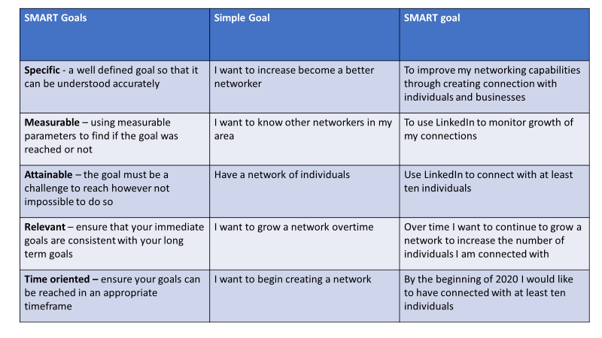
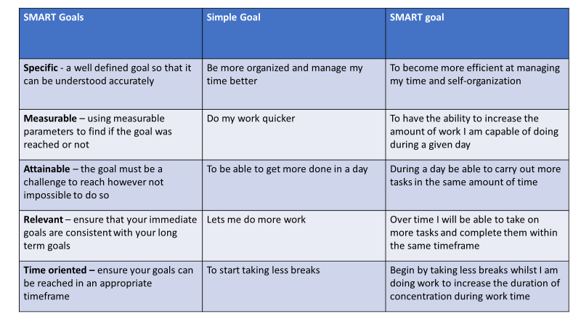
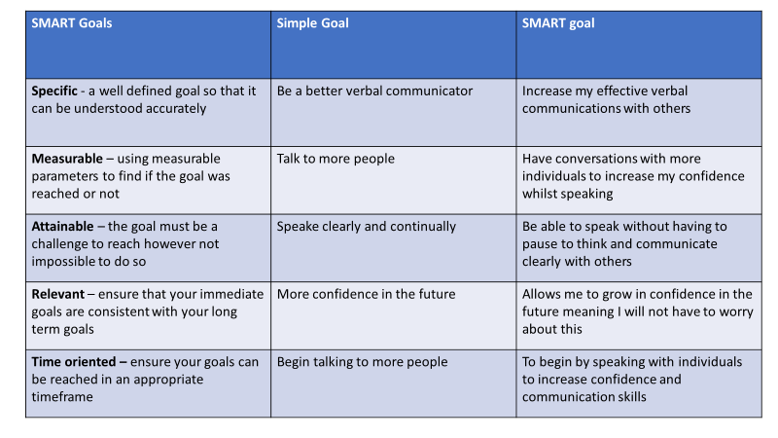
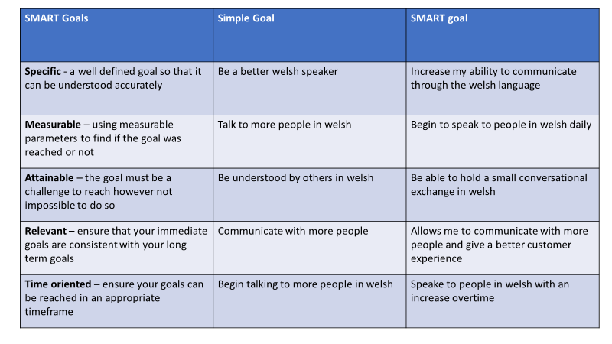

Appendices – 5.0

Gantt chart

