Assignment 2
Consuming an API In python
Harrison Stone
Uwtsd 1904085

Introduction

Introduction
Crypto is a new technology that many people have chosen to utilize due to them being able to reduce inflation on savings or investment, varying from coin to coin. Bitcoin in the last year rose to over £45,000 per coin and is now sitting at around £27,000. This variance can be capitalized on by investing when the value has significantly lowered and selling when the value has increased enough for a reasonable profit margin which can be then reinvested.

Crypto Coin Tracking API

Scope

Purpose of Creating Project
This project will aim to produce an API that can easily find coin information but also the price of the coin by using a search. This information will help the user of the program to be able to make purchase and sales decisions based on the data they receive.

Key Objectives of the Python Program
- Provide quotes for the searched cryptocurrencies.
- Allow the user to search through a list of all the coins on the API.
- Allow the user to see various price information such as current value and recent variance in price.

Possible limitations of this type of API
- May be restricted from some access on free plans as it is a new fast-growing marketplace, many people will be selling this kind of software.
- Crypto has lots of data surrounding it so navigation may be more tedious.

Crypto Coin API Report

Code Dump
from urllib import response
import requests
from requests import Session
from pprint import pprint as pp
class Crypto:
#To allow authentication with using key
def __init__(access, auth):
access.apiurl = 'https://pro-api.coinmarketcap.com'
access.headers = {'Accepts': 'application/json', 'X-CMC_PRO_API_KEY': auth,}
access.session = Session()
access.session.headers.update(access.headers)
#To display all they coins and their information
def getCoins(coins):
url = coins.apiurl + '/v1/cryptocurrency/map'
response = coins.session.get(url)
data = response.json()['data']
return data
#To get a quote for a specific coin using an coins specific symbol e.g ETH,BTC,USD,etc
def getQuote(quote, symbol):
url = quote.apiurl + '/v1/cryptocurrency/quotes/latest'
parameters = {'symbol': symbol}
response = quote.session.get(url, params=parameters)
data = response.json()['data']
return data
#To get show latest crypto update
def getLatest(latest, symbol):
url = latest.apiurl + '/v1/cryptocurrency/listings/latest'
parameters = {'symbol': symbol}
response = latest.session.get(url, params=parameters)
data = response.json()['data']
return data
key = Crypto('259810f7-006e-4619-aeb7-a1b182b48291')
pp(key.getCoins())
pp(key.getQuote('ETH'))
pp(key.getLatest('USD'))

Firstly, the API was checked to see whether it was functional by using headers to allow access with an API key. opening all the data on the API to have an initial look at the range of data available.
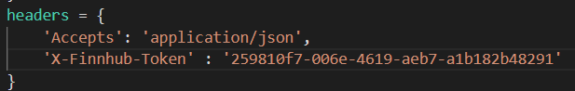
This header did not work authorizing the program and came back with an error code 1002.
I then could see that the API key was missing from the error description. After lots of big fixing attempts, I could not resolve this, so I looked through the API documentation on the site. I then noticed I had missed a comer after the API key however after changing this and numerous other headers and factors I was still unable to make it work correctly. So, I copied and pasted their start-up to ensure it worked and got a response. However, I did some research around programming and decided to change the way I was going to code it. Using a class as I realized the amount of data would be hard to code making room for more human error, I decided to take a class that would have numerous different functions which first would authenticate the user then allow them to access data within that session.
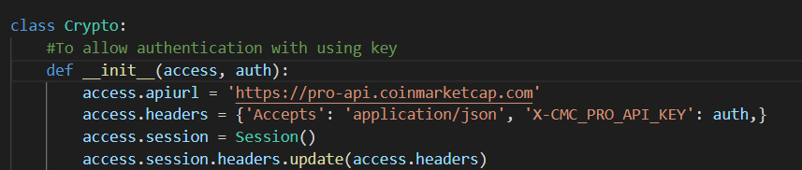
Furthermore, the next step was to create a list of all the possible coins and the documentation showed that searching by symbol was available which basically means allowing to search for abbreviations of the various coins such as BTC,ETC,USDT,etc.
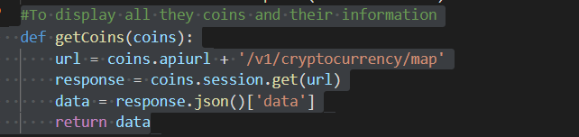
This allows the user to print the get coins function with pp(cc.getCoins()) which displays all the coins on Coin Market Caps API also displays lots of other useful information such as the abbreviation to search for more in-depth price data.
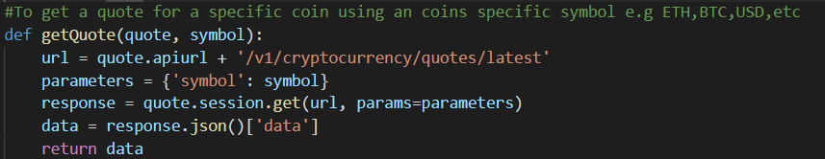
I then created a function to produce a quote on a specific coin by using its abbreviation, luckily writing this I did not encounter any bugs except typing errors.
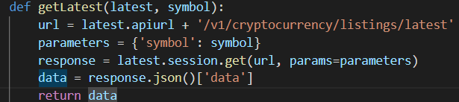
I then created a piece of code to show the latest crypto updates and information. However, I was unable to get this to work correctly.
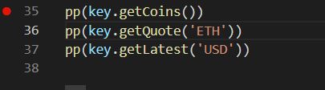
Finally, I used simple get commands to produce the functions I previously made however the getLatest still does not work.

conclusion
In conclusion, I believe the python program produces most of the data I aimed to provide the user with, however, the bugs I couldn’t resolve have limited data on new crypto updates.Although the API can still be used in order to check information, price points, and variance.

