STUDENT NAME MOHAMMED AMIR HUSSAIN CHAUDHARY STUDENT REGISTRATION NUMBER: 1711710 MODULE CODE: BMSK - 5004 GROUP NUMBER: ONE LECTURER’S NAME: PAUL RANSON MODULE NAME: MANAGING PROJECTS IN THE ORGANISATION

Executive summary
Main aim of this report is to inform my course
lecture. Defining the techniques and approach taken to develop the project in the case study, this report briefly examines each and every tools, that is required in project management. Also identifying the complications that can arise within the project. Furthermore, this report will concentrate on steering the group, and how we collaborate with each other, finally
provide a personal reflection of my own ability to supervise project’s with potential
strategy and self-improvement plan to enhance own performance.

Contents
Contents 3
1. Introduction. 6
2. Overview of the Vintners Antiques. 7
3. Steering group. 7
4. Risk associated with the project. 7
5. Tools and techniques being utilized. 9
5.1. Users stories. 9
5.2. Product project technique. 9
5.3. Gantt Chart. 10
5.4 Altering, our not implementing the above theory. 11
6. Waterfall Model. 12
7. Personal reflection. 12
8. Self-development plan. 12
9. Recommendations. 13
10. Conclusion 14
11. Reference 15

Table of Figures.
Figure 1: The approach to risk management………………………………………………. 8 Figure 2: Users Stories( micro-soft planner)…………………………………………………… 9
Figure 3: Task and Day Chart…………….………………………………………………………10
Figure 4: Gantt Chart………………………………………………………………………………11

List of tables.
Table 1: Product project technique……………………………………………………………..10
Table 1: Self-development plan…………………………………………………………………12
Table 3: Recommendations ..……………………………………………………………………13

Introduction.
The purpose of this report is to reveal to my course lecture about each and every measures that I will be performing to achieve the success of the project of moving the Vintners antique existing business from Shirly to spark hill . Defining the techniques and approach taken to develop the project in the case study, this report briefly examines each and every tools, specifying the importance of these tools when managing projects. Similarly identifying the complications that can arise within the project. The report will emphasize the techniques utilized to mitigate any issues that arise Furthermore, this report concentrates on the steering group, their responsibilities to the project and how we will collaborate with each other in future. Finally, Deliver a personal reflection report of my own capability of supervise project’s with potential strategy and self-improvement plan to enhance personal performance.

Overview of the Vintners Antiques.
Vintners Antiques is an antique shop currently trading in Shirly, selling antiques to the local community as well as nationally. Vintners Antiques currently also have a warehouse in Spark hill, where they keep all their stocks. This project will involve relocating the existing antiques business from Shirly to Spark hill. As a student, I would like to inform my tutor on the approaches that will be taken to develop the Project in this case study for Vintners antiques.

Steering group.
Working using Roberts 2012 methods. Being a project manager, I believe that you ought to organized yourselves in the steering group like this diagram. According to (Kutila, et. al. 2014) it is very vital for project managers and steering groups to Communicate with each other appropriately. The method that will be utilized is verbal communication, telecommunications and live web chats on regular bases.



Denis Vintners Doreen Vintners Suha Omer

Being a project manager I suppose that Denis Vintner Ought To take on the role as project sponsor taking all the decisions. Cooperating with me concerning any new decisions, altering or modifying any current decisions and overseeing how the project is progressing.
Doreen Vintners ought to be the commercial character who manages all the proposals about the business and its finances. She comes across as very experience, she very cautious and formal.
Omer ought to be the specialist person, who must be is in contact with me involving any requirements.
Suha ought take the responsibility of being the user, have to argue on behalf of the individuals who are going to be utilizing the building to trade from.

Risk associated with the project.
As a project manager I can understand, there are many risks involved in project management. As the projects is based on estimates and guesses, some of the most common risks in project management are as follows.
4.1 Estimating time. Managing the vintners antique project, one of the most crucial issues, that will be faced regarding executing this project is estimating the time for each stories correctly. These author claim ( Hoai, et. al. 2013 ) since every stories times are estimates and guesses, and somewhat distinct from each other’s , it’s not always possible to come up with exact time estimations.
Impact. Error in estimating time incorrectly can impact the project as well as other stories. According to Bertisen and Davis ( 2008) every stories (task) are interlinked to each other and if one stories is postponed or delayed, then the others are affected as well.
4.2 Unforeseen circumstances. As vintners Project managers and developers we can be confronted with unanticipated circumstances as we are all humans beings, for example, one of us can fall sick or unwell or even if one of the project manager couldn’t comprehend the Gantt chart accurately or even shortage of cash through progression of the project.
Impact. This matters can delay the project for an unspecified period of time as nobody has control over this forms of matters. they have to be resolved or discover alternative methods on to put the project back on track.
4.3 Suppliers Risk. Being the project managers for Vintners antique I realise that there are many risks involving the suppliers such as critical technology failure and the order is misinterpreted, misplaced, damaged, broken when delivered or receiving incorrect products from the suppliers, for example worktops or shelves that are too small or to large.
Impact. This can affect the delivery time of the product or goods. Delays in receiving goods implies that the task involved with that particular products will also be delayed. If damaged or incorrect goods received, then have to be exchanged or replaced, occurring in further delays.
Solution. As a project manager, the steps that where undertaken keeping in mind the above issues, identify every possible risks to this project, prioritize the risks, make a risk response plan, keep track of every risks identified, notify the steering group and updating them on every actions taken in regards to solving the arises issues and retaining an extra week in hand for the final project completion. According to Roberts (2011) there four key stages to demolishing a risk. Below is a diagram from his book of the four stages.
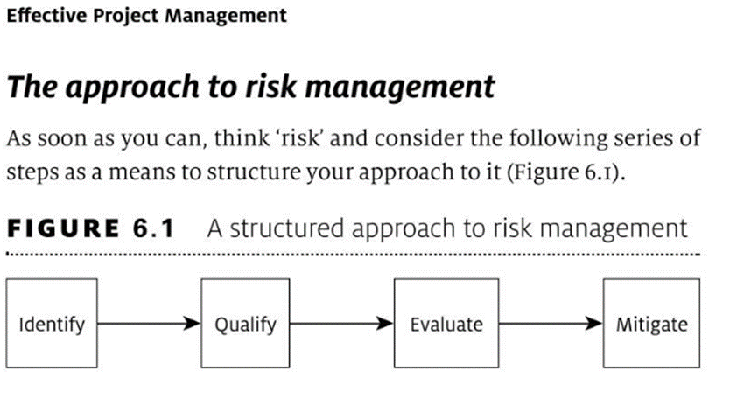
Figure 1: The approach to risk management.
(Source Roberts-2011, pp.142)

Tools and techniques being utilized.

5.1. Users stories.
To manage this project, the first tool that would be utilized is the users stories, as your aware, we’ve ( the vintners) previously agreed on which users stories that is going to be implementing in your new warehouse in spark hill. I would like to briefly describe what users stories are and how they are utilized in project management.
The main purpose of this procedure is not to find answers, but to identify the source of the problem that a project needs to solve. Users stories are brief paragraphs , which are documented on postedit notes, users stories can also be developed on a project management software called micro soft planner. According to Straker, (2009) users stories can be penned by numerous stakeholders, managers, team members or clients. This is a useful technique for communicating with stakeholders as postedit notes can be moved to were you feel appropriate, the three key stages are, Must have - Want to have - Nice to have, as all stories created by stakeholders are not equally and should not be left unmanaged, so in order to solve them they have to be prioritize in the above order so that they can be solved.

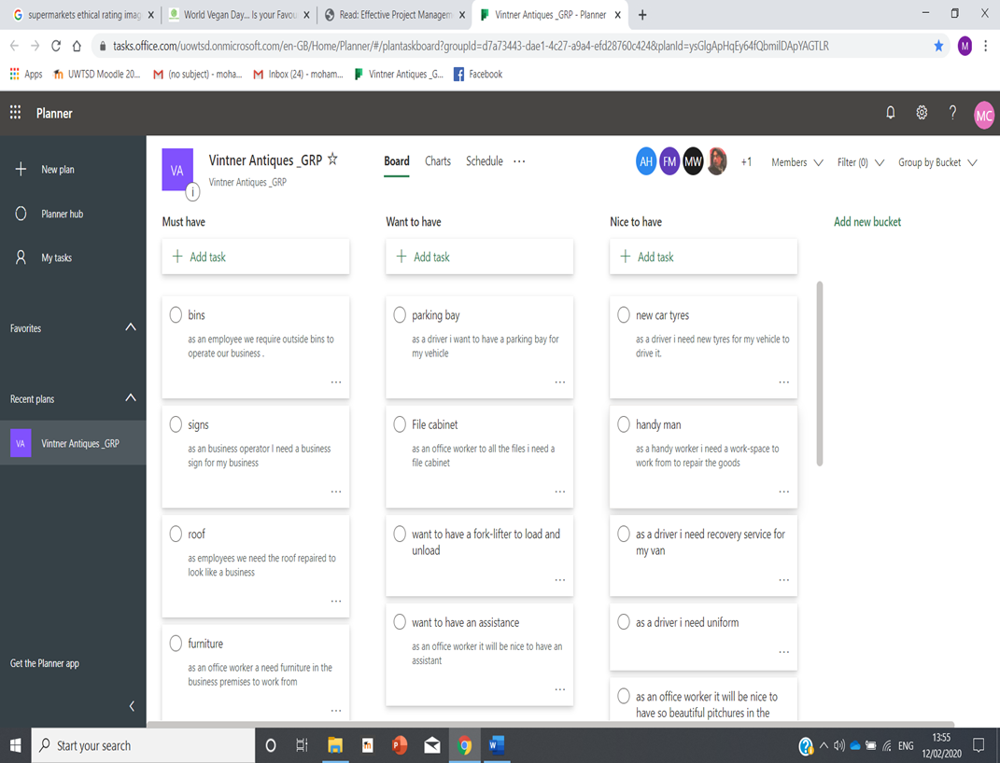
Figure 2: Users Stories (micro-soft planner)

5.2. Product project technique.
Once the stories were prioritised, then the next method is attempting to work out exactly how long each stories will take to resolve, to do this, the use of different method of Roberts called product project technique (Delphi technique) is going to be utilised to get the best gases to how complexed every stories would be and the scope of the stories to solve, this concerns negotiating with many dealers to get the best result. According to Roberts (2012) he named it wisdom of the crowd. Below is an example of how this technique works.

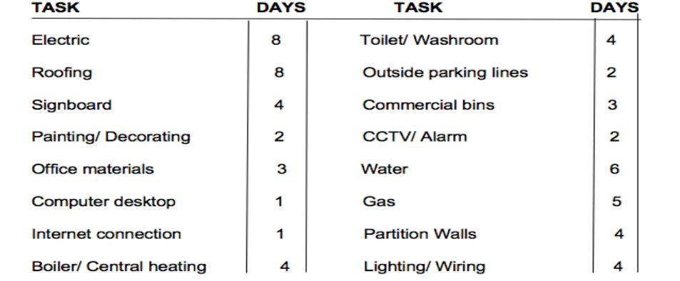
Figure 3: Task and Day Chart
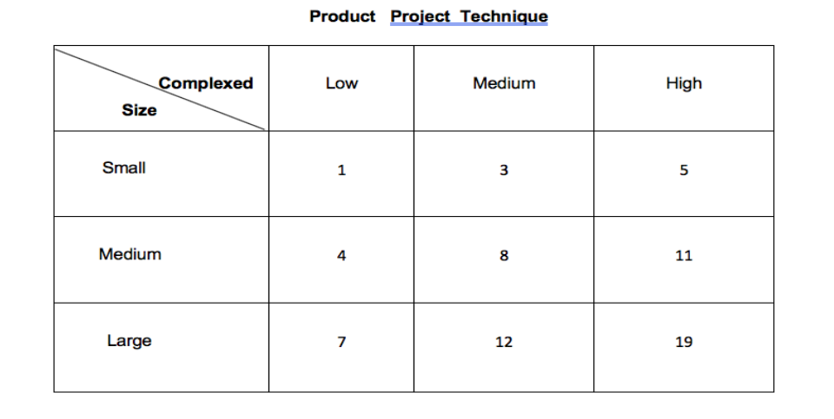

Table 1: Product project technique

5.3. Gantt Chart.
Gantt Chart is unique way of figuring out which task (stories) ought to be looked at and in what order for the task to be finished in overall project. On top of the chart there is a calendar and on the side of the chart are the tasks, each block represents the number of days it will take to complete the task and where it is poisoned indicates at what point of time this task will start in the project. According to Wilson (2003) Gantt Chart is a good way of demonstrating how the project is going to progress and monitor the progression of each tasks, for example if a task takes six days work to complete and two days’ work has been completed, then you colour two days red to show that two days’ work has been complete.

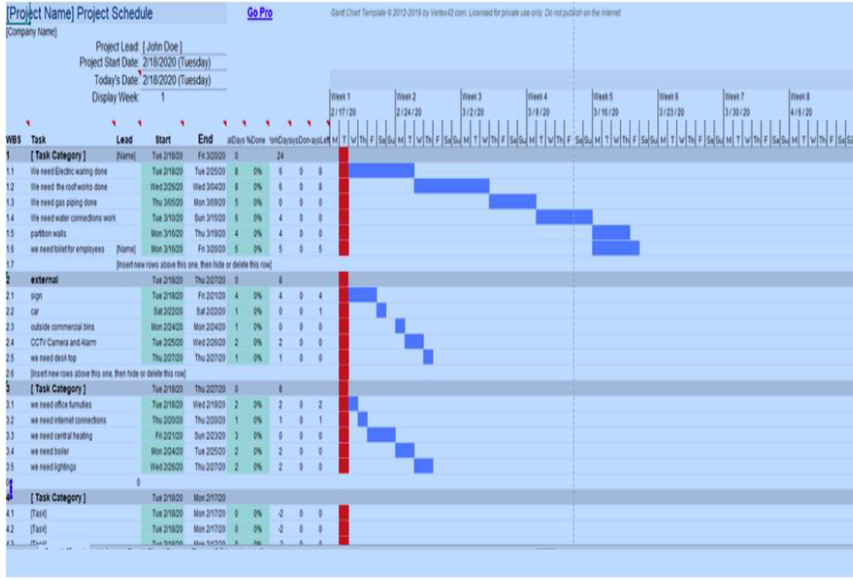
Figure 4: Gantt Chart

5.4 Altering, our not implementing the above theory.
The above tools are very vital for project management, as these tools helps to create a balance in managing a project successfully. According to Heagney (2011) once you’ve decided on final details of the project and it has been approved by the steering group you have created the Iron tringle.
At a later stage, if you choose to alter anything, for example you want to add another stories or save costs, well you can’t because the iron tringle is rigged, you’ve created as balance in your plan, Alternatively, if you choose to add another stories, then you have to at least change one of the corner, possible more. Which means either the costs will increase or will take longer to complete the project.

Waterfall Model.
This report was achieved applying the waterfall model system. The waterfall model system is a traditional model used in structure development life cycle to establish a system with a direct and progressive approach. According Sun, (2004) It is termed as waterfall because the model develops methodically from one phase to another in a downward trend (like a waterfall) through the phases of formation, Initiation, analysis, layout, construction, testing, production/completion, and maintaining.

Personal reflection.
Reflecting back on how I successfully achieve and completed the vintners antique project. The success of the project depended on the efforts and ability of every project members as well as the ability of the (myself) project manager in manage them. Consequently, as project manager the key was to concentrate on analysing all the possible risks associated with the project.
This has assist me to utilize most suitable risk managing and project monitoring strategies and process. Furthermore, my focus was mainly on collaboration skills to have effective involvement with essential stakeholders such as sponsor, commercial and the users specialist to foster my projects effects. According to Turner (2018) It can be stated that proper management of personal capability for developing tools such as Delphi technique, Users stories and Gantt chart, as this will create a pathway and help in providing resource and this will establish me as a successful project manager.

8. Self-development plan.
Self-development Strategies. Time frame

To improve myself attend Agile project management course. 5 months

Attending prince two course and read books about project management. 5 months

learning about project monitoring skills, also learn new
communicating skills to improve project management. 4 Months

Researches needs to be conducted on key factors on why projects fail. These
authors(Green, et. al. 1990) claims if you can understand why projects fail then you 4 Months
will gain vast knowledge and understanding of how to be successful in projects
management.

Table 2: Self-development plan.

9. Recommendations.

Enhance my professional skills such as leadership skills, communicating skills, task management skills, critical thinking and risk management skills etc.

To gain knowledge and understanding, it is necessary to read articles, journals and books-based on project management.

To develop my expertise on conflicts management abilities to preserve sustainability in project process. This also can be beneficial to apply effective project management strategies.

Learning the proper methods use of project management tools to assist the project.

Table 3: Recommendations

Conclusion
After completing this report it can be concluded that it is very vital to utilize appropriate project management tools and take necessary steps essential to fulfil the requirements of the project. In managing the project of moving the Vintners antiques existing business from Shirly to Spark hill. I have achieved immense experience and vast knowledge of project management and the various strategies and tools that assist in managing projects such as properly communicating with the steering group, using the Delphi techniques, the importance of Users stories and reading following the Gantt Chart correctly. This report has also assisted me in realising the obstacles that a project faces, to overcome this complications the means and associated in achieving all activities within the static time framework.

Reference

- Bertisen, J. and Davis, G.A., 2008. Bias and error in mine project capital cost estimation. The Engineering Economist, 53(2), pp.118-139.
- Green, G.P., Flora, J.L., Flora, C. and Schmidt, F.E., 1990. Local self-development strategies: National survey results. Community Development, 21(2), pp.55-73.
- Jha, K.N. and Iyer, K.C., 2007. Commitment, coordination, competence and the iron triangle. International Journal of Project Management, 25(5), pp.527-540.
- Joseph, Heagney . 2011. Fundamentals of project management. Amacom Publisher.
- Kutila, M., Jokela, M., Fruttaldo, S., Montanari, R. and Pallaro, N., 2014. Project ownership and steering committee challenges in international context. Recent Advances in Economics, Management and Development, 35.
- Le-Hoai, L., Dai Lee, Y. and Nguyen, A.T., 2013. Estimating time performance for building construction projects in Vietnam. KSCE Journal of Civil Engineering, 17(1), pp.1-8.
- Roberts, Paul. Effective project management: Identify and manage risks plan and budget keep projects under control. Kogan Page Publishers, 2011. pp 139-160.
- Roberts, P. (2012). Strategic Project Management: Creating the Conditions for Success. London: Kogan Page Publishers.pp.66-71.
- Straker, D., 2009. Rapid problem solving with post-it notes. Da Capo Lifelong Books.
- Sun, Z., 2004, December. A waterfall model for knowledge management and experience management. In Fourth International Conference on Hybrid Intelligent Systems (HIS'04) (pp. 472-475). IEEE.
- Turner, J.R., 2018. The management of the project-based organization: A personal reflection.
- Wilson, J.M., 2003. Gantt charts: A centenary appreciation. European Journal of Operational Research, 149(2), pp.430-437.
- Wysocki, R.K., 2011. Effective project management: traditional, agile, extreme. John Wiley & Sons.

