Discord Bot - API Integration

Dominik Tomasz Kania
Computing (Computer Networks and Cybersecurity)
University of Wales Trinity Saint David
Swansea, Wales
1702026@student.uwtsd.ac.uk

About
Scrappie is an open source Discord Bot coded in Python using API wrapper (discord.py) for Discord. Discord.py is a Python library that exhaustively implements Discord’s APIs in an efficient way. The purpose of this bot is to provide information about current Covid-19 statistics using 2 different APIs and display random animal facts and images on Discord server. However, Scrappie is in continuous state of development and new features, such as: music, videos and alerts are planned for the future.

Features
Scrappie offers help for commands in direct and general messages, checks user messages and replies to them if a particular word is found, and supports mentions, which allows to mention a user that is looking for help. This Bot recognizes 4 various commands across 3 different categories:
- Help command – to use this command, user needs to type “.help”. Bot responds with a list of all commands available to use.
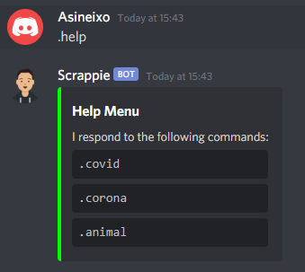
- Covid command – this command is used to show Covid-19 statistics for each country in the world. It allows user to check each country, global statistics and see the list of all countries supported. To use this command, user needs to type:
  - “.covid” – Help menu if there is no user input for subcommand.
  - “.covid [country]” – Covid-19 statistics for chosen country.
  - “.covid world” – World Covid-19 statistics.
  - “.covid countries” – List of all countries supported.
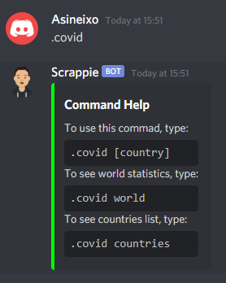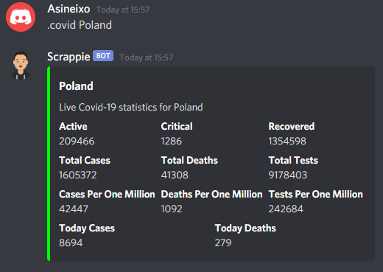
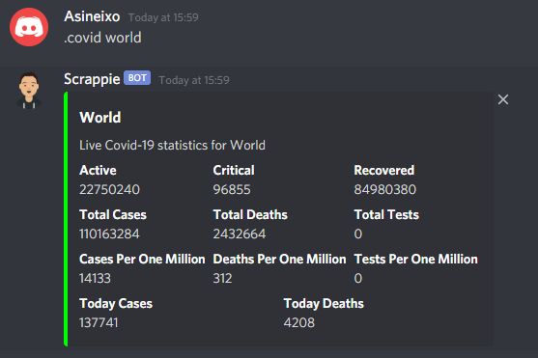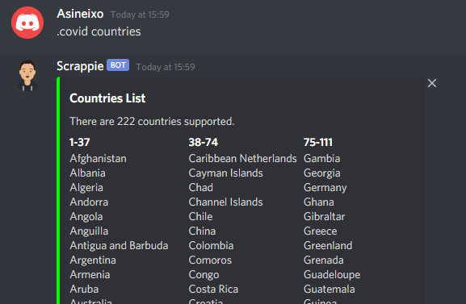

- Corona command – this command is very similar to Covid command, however it shows more statistics and adds a country flag. This command has much higher response time, due to large amount of data being sent. It also needs to be installed using “pip install corona-python” command in command prompt. To use this command, user needs to type:
  - “.corona” – Help menu if there is no user input for subcommand.
  - “.corona [country]” – Covid-19 statistics for chosen country.
  - “.corona world” – World Covid-19 statistics.
  - “.corona countries” – List of all countries supported.
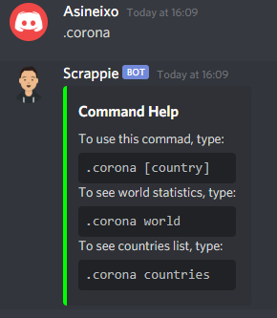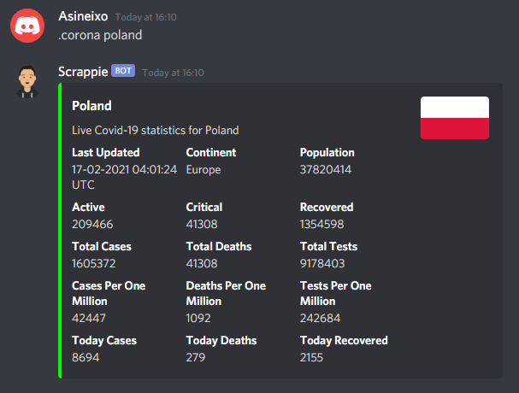
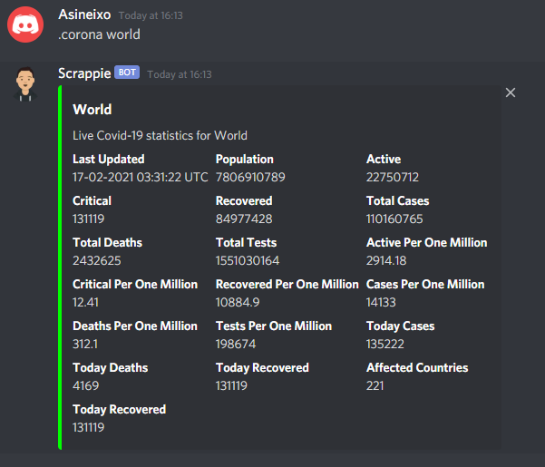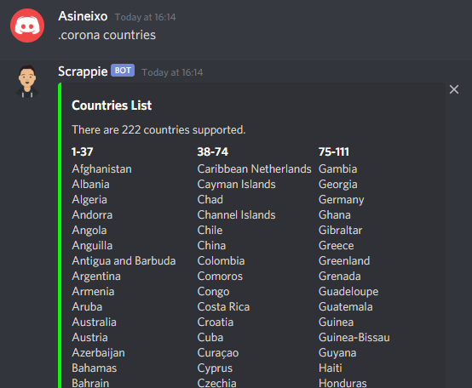

- Animal command – informative and fun, random animal facts and images are gathered from the Internet. This command was coded differently, using nested while loop to keep user in the changing menu without the need to type particular animals. User can choose between 3 different menus: main menu, animal facts and animal images. Nested while loop allows user to choose facts and images continuously, until exit option is chosen. To use this command, user need to type “.animal”. This will move user to main menu and allow him to select different options.
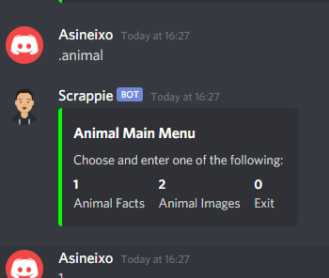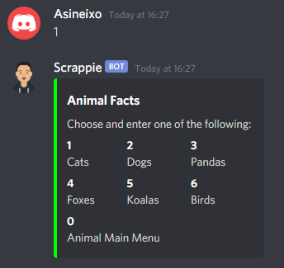
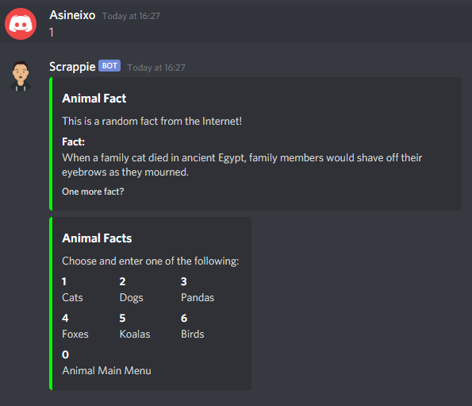
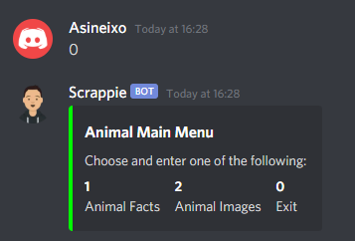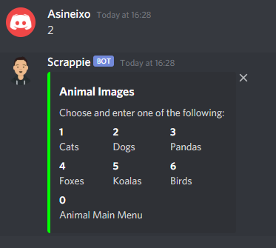
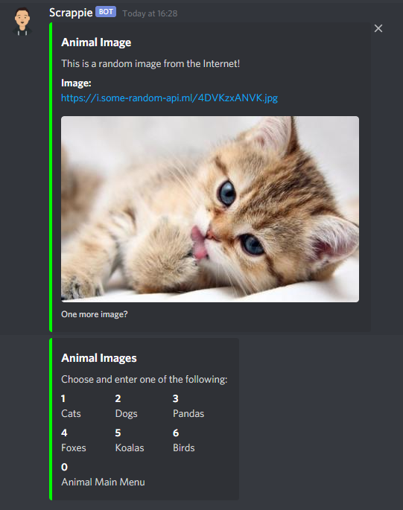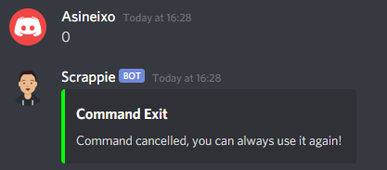
Scrappie checks all messages and helps users by mentioning them and reminding about specific commands.
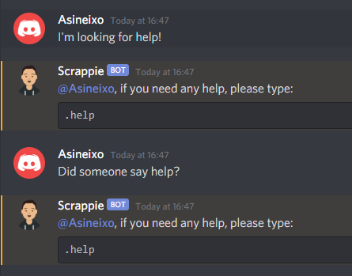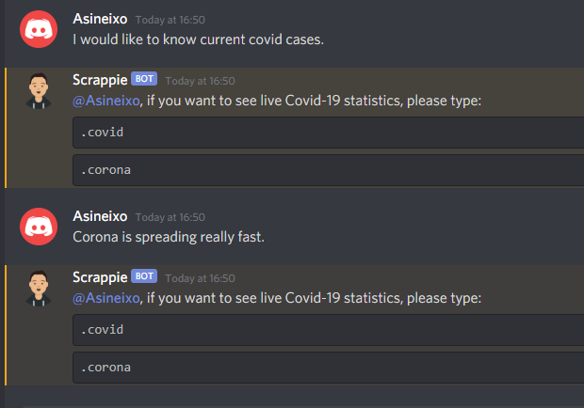
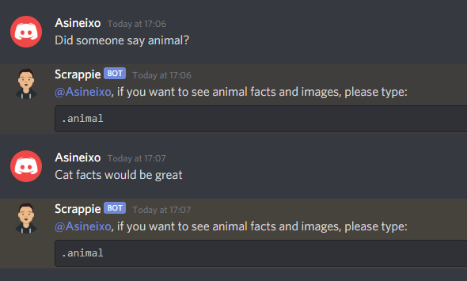
It also notifies server upon successful connection.
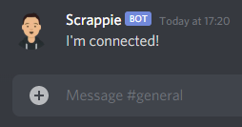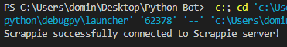

Code Snippets
Bot code can be edited, however installation guide must be followed in order to make changes. To set command prefix, command.Bot function has to be used. Prefix “.” can be changed at any time.
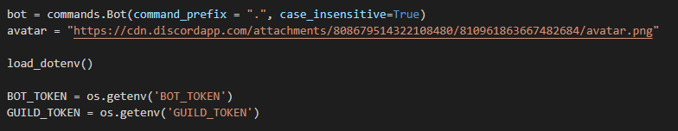
Events were set to check the status of the bot. Additional functions can be added if needed.
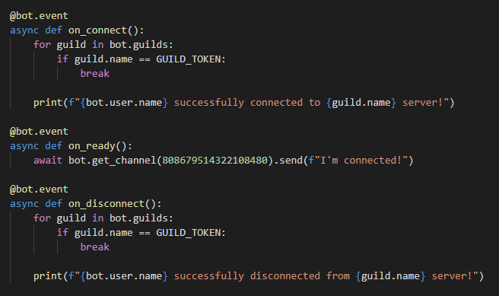
Each new member will receive a private message from the bot with information how to use it.
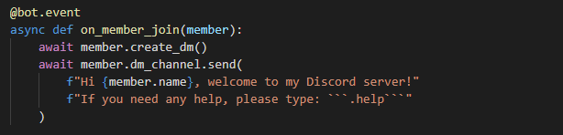

Each message is checked by the bot, and if the Bot finds a particular word, it will respond to the user.
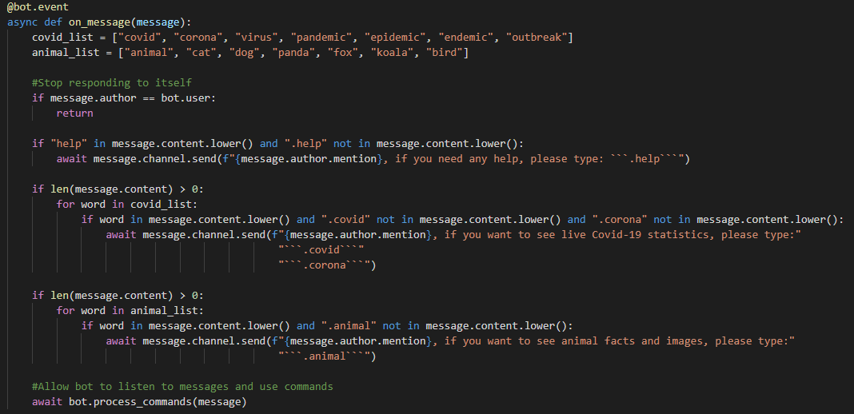
Default help command needs to be removed in order to add new Bot help command.
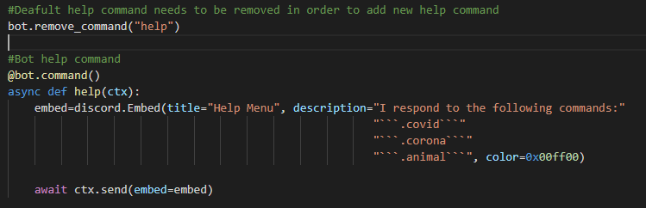
Covid and corona commands use aiohttp.Clientsession to retrieve data from external APIs.
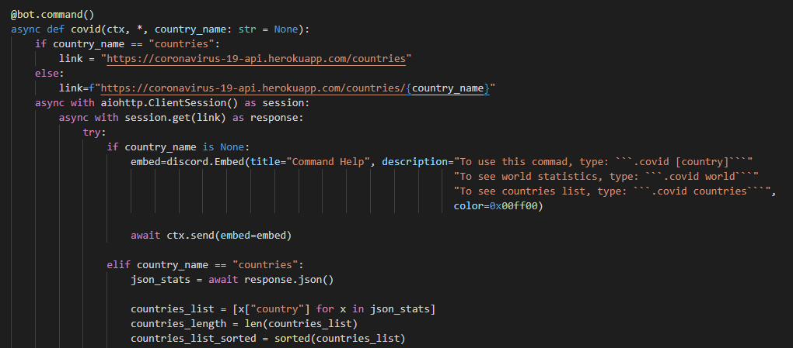
Data is divided into chunks, as Discord embed.add_field supports only 1024 characters.
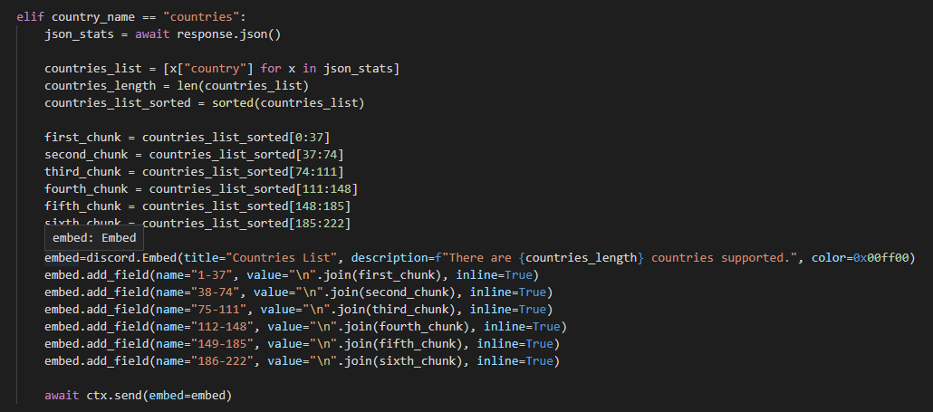
JSON data is retrieved from external API and added to embed.add_field for output.
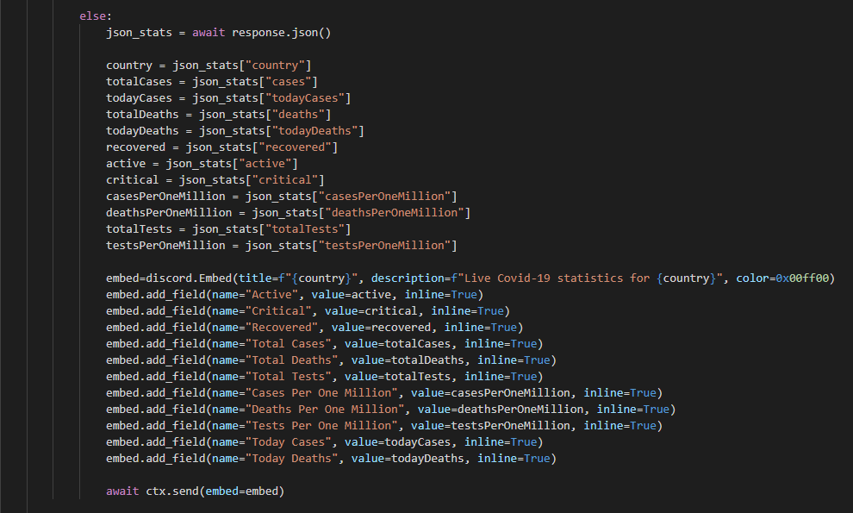
Exception is added to see any errors.
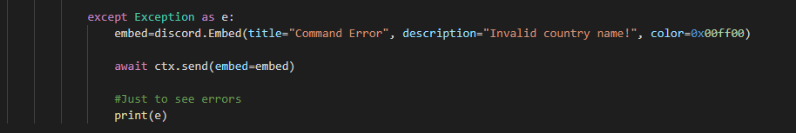

Corona command uses the same structure, however it combines 2 external APIs in one command. It is because corona API does not support countries list, it only shows statistics. Combining 2 APIs allowed to add countries list feature.
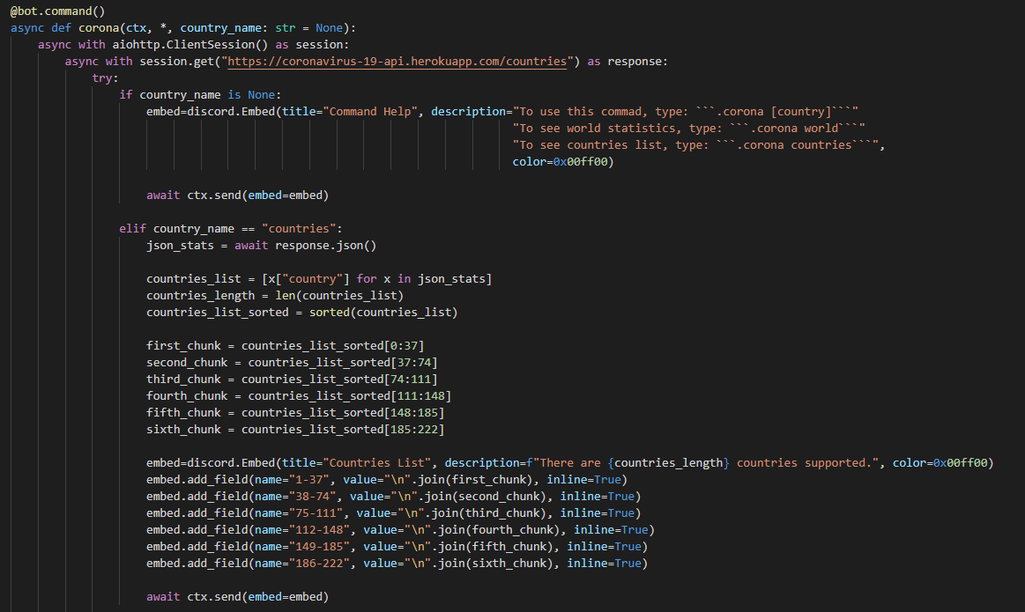
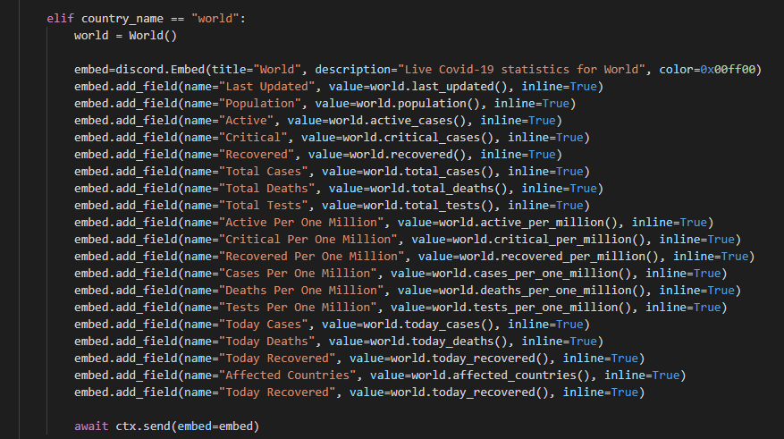
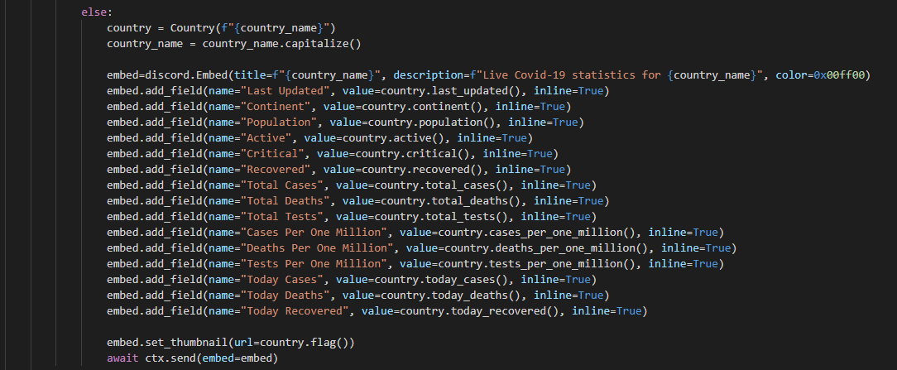
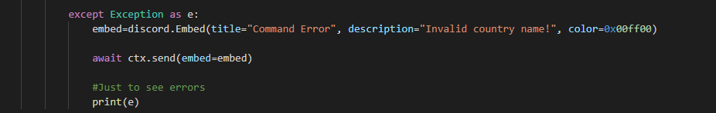
Animal command uses nested while loop to keep user in the main menu.
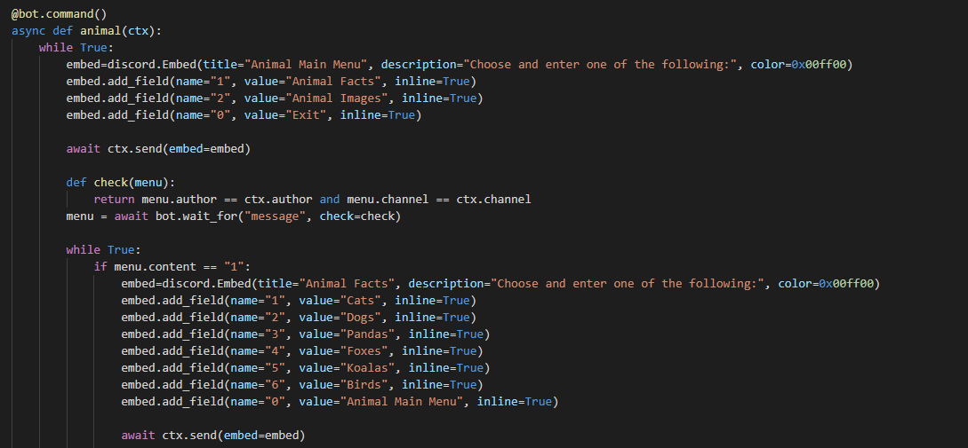

Requests are used to retrieve data from the external API.
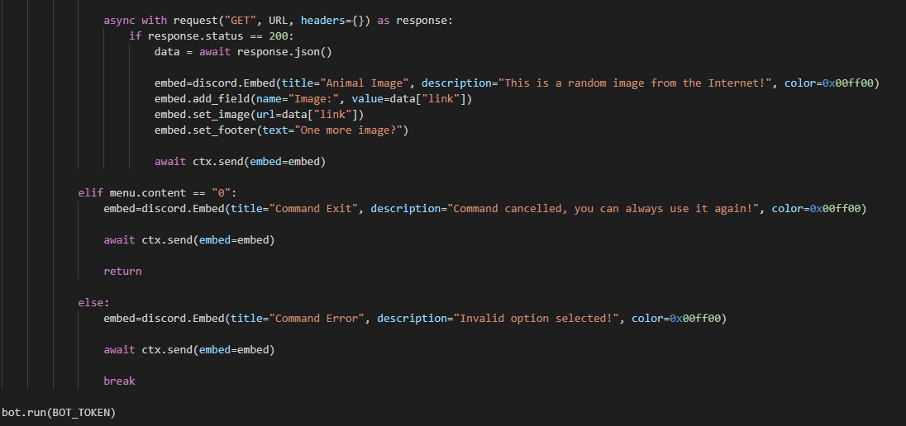
Discord Bot will not work if libraries below are not imported.
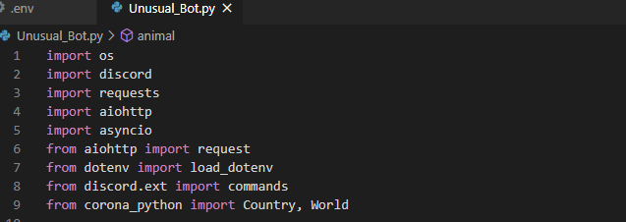
Discord Bot will not work if bot.run(BOT_TOKEN) is not added.
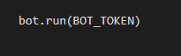
To secure Bot Token, .env file is used to hide data. If file is leaked, Bot Token must be regenerated and added to .env file. Bot Token can be kept in the main code, however if its ever leaked, anyone could add and run any code on the Bot. Running malicious code can have devastating consequences.
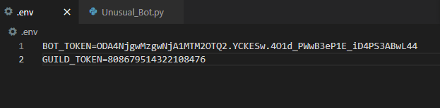

Installation
To install Scrappie Bot, download Scrappie.py file and create .env file. In .env file add Bot Token generated on Discord Developer Portal and Guild Token (Discord server ID).
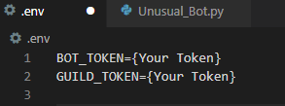
Discord requires discord.py to be installed. To do that, use pip install -U discord.py command.
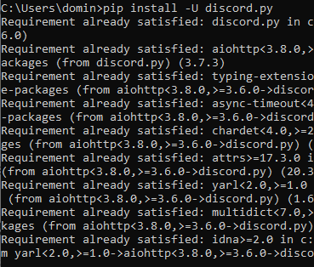
To hide Bot Token, python-dotenv needs to be installed. To do that, use pip install -U python-dotenv command.
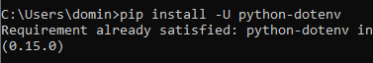
Corona API requires corona-python to be installed. To do that, use pip install corona-python command.
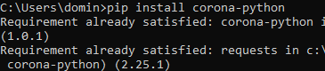

Covid and animal APIs require aiohttp in order to run. To install them, use pip install aiohttp[speedups] command.
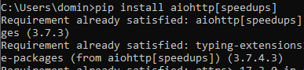
Requests have to be installed to retrieve data from external APIs. To install them, use python -m pip install requests command.


