5/27/2022
Jordan Williams
Comtinental
Project Report
MCMA5009

Contents
Introduction 2
Flow Chart 3
3
Gantt Chart 4
Specification 5
Solutions 6
Solution 1 6
Solution 2 9
Solution 3 10
Solution 4 11
Selection 11
Methodology 12
Initial Data 15
Implementation 16
Results 16
Analyse 17
Evaluation 19
Conclusion 21
Appendix 22
Progress Log 22

Introduction
Overview
I have identified that there in an issue with maintainability of a machine in my workplace. The machine identified is a CNC Milling machine called Topper Tongtai. This machine uses proximity sensors to detect when the machine is in the correct position to perform the next operation, for example the machine will not start until all sensors for fixture clamps have been activated. The issue with the proximity sensors is that the environment in a CNC machine is not suitable due to the dust from the castings and the swarf produced when machine. A mixture of dust and swarf produces a silt that can easily build up on the sensors in the machine, giving a false signal. Regular maintenance is required to repair damaged sensors and to reset false alarms. My proposal to resolve this issue is plumb new coolant lines, these will be directly on the sensors, giving them a constant flow of coolant, which will prevent any build up.
Problems and/or needs that justify the project
The excessive maintenance required to keep the machine in product justifies the need to improve the maintainability of the machine. The issue is using valuable resources while also slowing down production. These issues give the project high potential for success.
Purpose of the project
The basic purpose of the project is to reduce the amount of time that the machine need maintenance by changing features of the machine. This will have additional benefits such as giving maintenance staff more time to complete other tasks and increasing production. I also aim to increase the life of the sensors used in the machine.
Scope
The scope of the project is to improve the maintainability of the machine, reduce downtime and increase production. To meet the expectations of stakeholders in the project I will aim to achieve this without major disruption to production, stay within a reasonable budget and improve the productivity of maintenance staff.
Application
The project will be applied directly to the machine. Time has been allocated by my supervision to closely monitor the machine before and after the project is implemented.

Benefits
This project has the potential to benefit people internally within the company and externally. Internally the project will benefit maintenance staff, the machine operator, and the supervisor. It can also benefit the logistics department due to the increase in production, this increase will also benefit the customer receiving the components manufactured on the machine.

Flow Chart
Yes
Brainstorm Solutions to resolve issue with sensors
Develop Project
Can Project Be Achieved?
Identify Potential Project
Is Project Suitable?
Yes
No
No
Yes
Gather Initial Data on downtime and number of stoppages
Evaluate Potential Success
Can Project Be Successful?
No
Finalise Solution
Make All Preparations, allocate time with supervisor
Implement Project
Record New Data
Evaluate Success
Conclusion

Gantt Chart

Specification

Time | How long do you have to complete your work? The project must be implemented by 31/03/2021. The project must be completed by the 10/05/2021.
Target Market | This product will be made for all maintenance/setting employees that work on the machine. For this project to be successful the result of the project must be approved by the maintenance team.
Function | This project must reduce the total time per shift that the machine is down.
Size | The size of any new components must not obstruct the machine operator’s ability to run the machine or obstruct any other maintenance required on the machine. Due to these constraints any components must not exceed ${100mm}^{3}$
Aesthetics (looks) | There are no specific colours or theme of the project, but any changes to the machine’s aesthetics must be approved by the supervisor.
Durability | The life of proximity sensors must be longer than the current sensors if they are changed.
Materials | Any new added will need to be approved by the engineering department. New materials added must not contaminate the machine in any way.
Safety | Any changes made to the machine must not cause any potential hazards to the machine operator such as obstruction. Any new materials added must not contaminate the machine which could cause injury or sickness to anyone work around the machine.
Cost | The annual cost of my project must not exceed £1000.
Environmental Issues | Any components added to the machine must not be toxic to the machine operator or must not contaminate the products being produced. Any changes to the noise levels or light levels must also be evaluated and conform to all regulations.

Solutions

Solution 1
One possible solution considered was to replace the sensors with something more suitable. Any sensors considered use be of a similar spec of the current sensors as show below
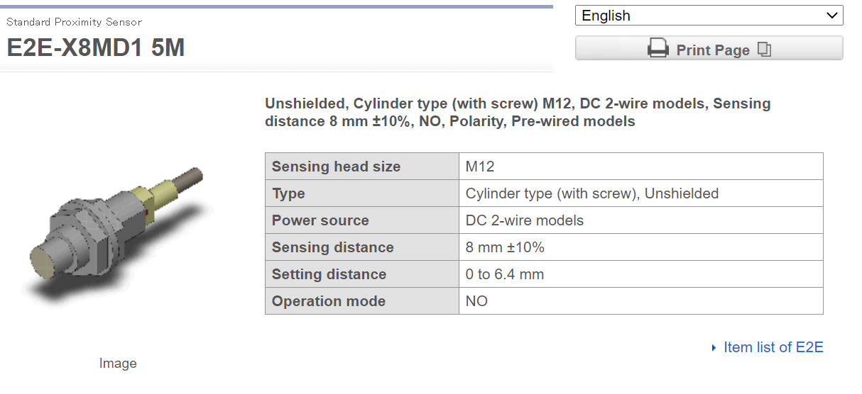

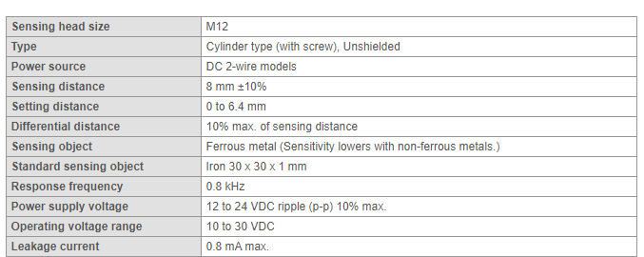

Any alternative sensors would need to meet the same setting distance of 8mm, it must also have a thread size of M12 and require the same power source. The dimensions of the alternative sensor can vairy slightly but must be of similar size. They must also be competitive with the price of current sensors which is £48.05.
Two alternatives were considered as shown below;

Alternative Sensor 1
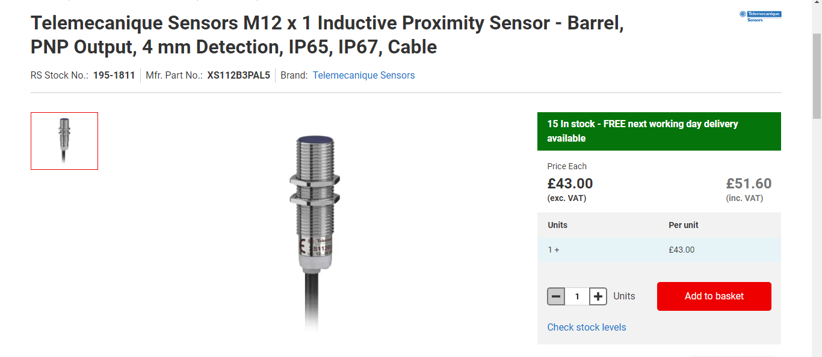
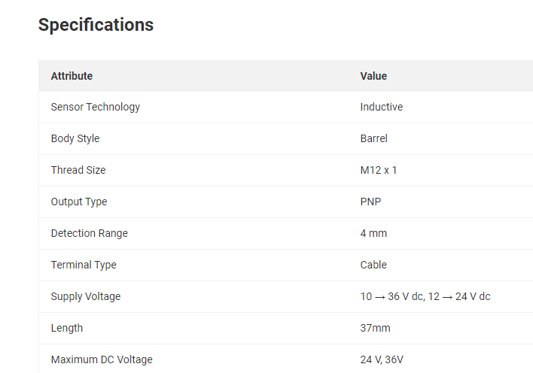

Alternative sensors 2
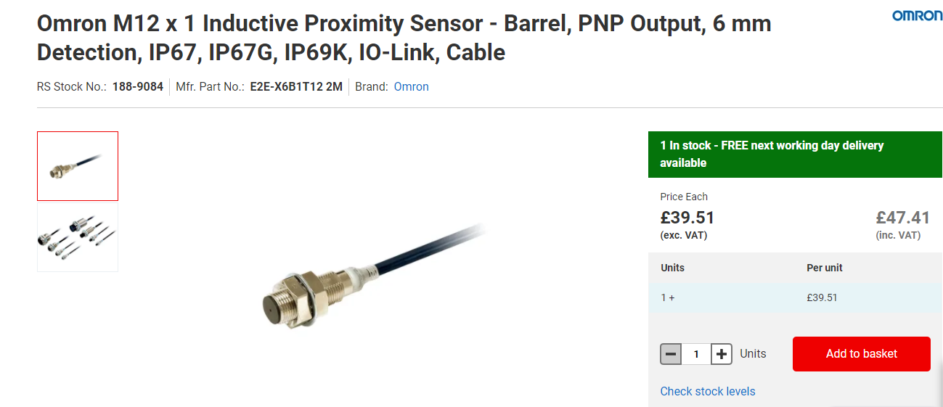
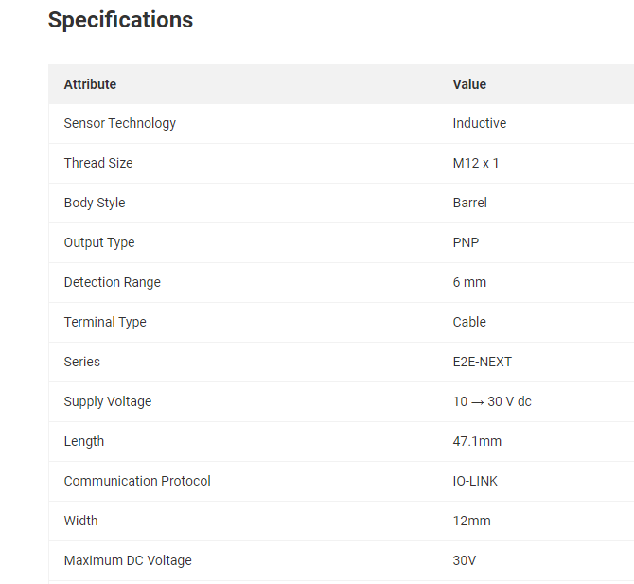

Decision matrix
Sensor | Thread Size | Power Source | Dimensions | Range | Cost
Current | M12 | 12-24 V DC | L 38.0mm  W 21.0mm | 8mm | £48.04
Alternative 1 | M12 | 10-36 V DC | L 37mm  W 12.0mm | 4mm | £51.60
Alternative 2 | M12 | 10-30 V DC | L 47.1mm  W 12.0mm | 6mm | £47.41

From evaluating this matrix it was clear that other sensors were available but would not be an improvement on the current sensors. After conducting this research, I decided that the current sensors are of a high quality and changing them would not resolve the issue.

Solution 2
Remove sensors
It was also considered to remove the sensors. This solution has the potential to eliminate the issue of false alarms caused by swarf. A drawing of the fixture showing location of sensors is below.
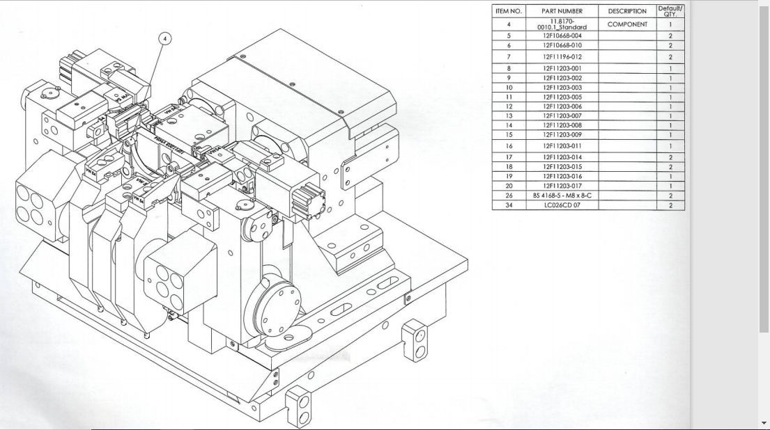
Sensors
Clamps
Two sensors are located under the blocks highlighted by the red arrows, these blocks serve as protection for the sensors but are not effective as swarf can still entre and block the sensor. The purpose of these sensors is to signal when the clamps, highlighted by the blue arrows, are down as they are in this image. If these clamps are not down actuating sensors, the machining cycle will not start. This it to prevent contact with the milling cutters and the clamps.

There is also an additional sensor on the unloading arm, this is responsible for the majority of false alarms.
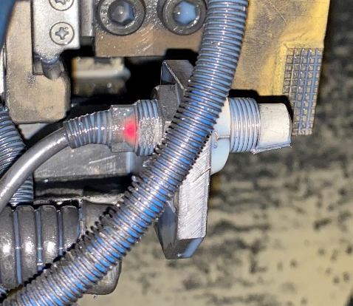
This sensor has a red light which means there is something too close, in this image there is a small piece of swarf on the left of the sensor. The machine will now lower the unloading arm when the alarm is in this state because it believes there is something below it.
Removing the sensors has the potential to completely remove the issue of false alarms. As well as its potential for high reward it also has high risk. If the clamps are not lowered and the machine cycle starts there will be a lot of damage to the milling cutters and to the fixture, there may also be damage to the machines spindle and spindle bearings. This will result in thousands of pounds in repairs and a very long period of downtime. Although this is very unlikely the potential damage must be considered.

Solution 3
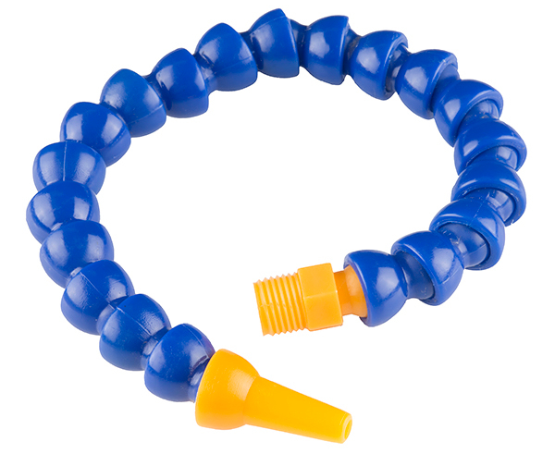
Another solution I considered was to use a coolant line to give the sensors a constant flow of coolant to wash off any swarf that lands on it. The new coolant lines would be plumbed into the existing lines, this means it could be installed easily and without a big disruption to production.
These are coolant lines being used in the machine currently. New line would be added to deliver a flow of coolant to the sensors as well as the milling cutters. These coolant lines are cheap and easy to install. They are also kept in stores so no addition components will need to be ordered. Although this solution is simple it may be very effective in preventing swarf from triggering the sensors.

Solution 4
Compressed air can be used as an alternative to coolant to prevent build up on the sensors. Instead of a coolant line a compressed air line would be fitted to the machine, the air would blow the sensor down during the machining cycle but would have to stop before the doors open for the operator to load the next cycle. This is to prevent any swarf being blown in the direction of the machine operator.

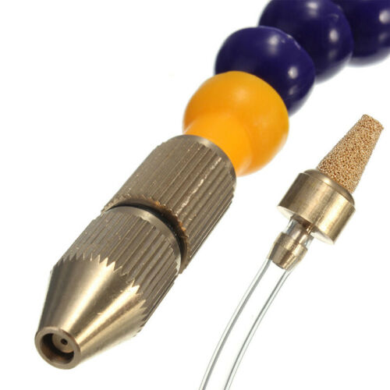
This would function in a similar way to the coolant line, but with a nozzle at the end designed for compressed air. To fit this to the machine would be far more complex that the coolant line, this is because a plc would need to be made to allow the flow of air during the machining cycle and then turn it off at the end of the cycle when the operator is loading the next part. This would require additional skill to install. Using compressed air will also be considerably more expensive than using coolant.

Selection
To decided which solution was the best I compare them against some critical points in my specification and score them out of 5 as shown in the table below.
 | Cost | Longevity | Time to implement | Potential success | Potential failure | Total
Solution 1 | 4 | 3 | 4 | 2 | 2 | 13
Solution 2 | 5 | 3 | 3 | 5 | 1 | 17
Solution 3 | 5 | 5 | 5 | 4 | 4 | 23
Solution 4 | 2 | 5 | 3 | 4 | 4 | 18

After comparing some of the core objectives of the project it was clear that solutions 3 and 4 were the most suitable. Solution 1 was not chosen as I concluded that the current sensors were of a high standard and changing them would not improve that maintainability. Solution 2 had was considered but the potential for failure was too high, the likelihood of the clamps not lowering is low but the damage that it would cause would result is thousands of pounds of repairs and downtime. This left solutions 3 and 4, they were both considered carefully as they are very similar, the deciding factors were the cost and the time it would take to implement. Having a constant steam of compressed air blowing down the sensor would cost a lot more than using the existing coolant lines. It would also require a lot of downtime to implement solution 4 which would cause too much of a disruption to production. I believe solution 3 would have the same success as solution 4 but at a lower cost and being easier to implement, this is why I chose solution 3 to further develop.

Methodology
Methodology Approach
The reason for gathering data was to get a better understanding of the current downtime of the machine. Secondary data was available as the company has SAP software, this software gave instant access to qualitative data relating to downtime, reason for downtime and what was done to resolve the issue, however it was apparent that major breakdowns were being recorded by not all minor breakdowns. This meant that this data would not give a true representation of the current issue.
This meant more data needed to be collected to give a better understanding of downtime. Due to the unreliability of the secondary data available I decided it would be more beneficial to the project to gather qualitative primary data over a two-week period.

Methods of Collecting Data
Data needed to meet a certain criteria to be eligible for the research, this made the data being gathered more reliable and more focused of the issue being targeted. The chosen criteria were that machine breakdown related to sensors would be recorded separately to other breakdowns, this was to highlight the machine stoppages being targeted. Other criteria selected was that all data would be recorded on day shift, the reason for this was to gather data when production was at the highest. Less staff work on the afternoon and night shifts, this might have given inaccurate data.
A new standard operating procedure (SOP) for machine breakdown was also produced. The new procedure was that operators needed to record the exact time of the machine stoppage on the document provided, only after the time had been recorded can the operator inform a team leader about the stoppage. When the team leader hands the machine back to the operator the team leader recorded the time and the reason for the stoppage. The document containing the results would be collected at the end of the shift and the data would be transferred to excel.
A meeting was held with all operators and team leaders before the SOP was introduced, this was to inform them that the data collection was taking place and when would be expected of them. They were informed that the data collection was taking place over a two-week period and were given a copy of the SOP.
A variable to make the data more reliable was also introduced, at least four members of staff would have to operate the machine over the two-week period.

Methods of Analysis
Before the data was analysed it was check for any anomalies. All data was put into excel and displayed in a graph format. The downtime caused by issues being highlighting was compared against all other downtime.

Evaluate and Justify Choices
The choice not to use secondary data already available was justified as it gave for more accurate results, if the secondary data was used the effectiveness of the project would not have been highlighted. The reason why the secondary data was not reliable was because the minor rests of the machine became so frequent that they were not considered a breakdown by maintenance staff, over a period they gradually stopped being recorded.
Using 4 different operators for this research was essential to give reliable data. All operators followed the SOP but each operator has a slightly different was of running the machine, this gives the research a more true representation of production.
Copy of SOP
Title:  Downtime data collection | Version Number:  1 | Effective Date:  02/02/2021 | Author:  Jordan Williams

Purpose | This SOP is to record downtime more consistently and reliably, this is necessary to give a better understanding of the current issues being highlighted.
Scope | The scope of this SOP is for all operators to be able to record downtime more accurately to give a truer representation of the current downtime and reasons for machine stoppages.
Responsibilities | Operators will have the responsibility of recording the exact time that the machine stops.  Team leaders have the responsibility of recording the nature of the stoppage and the time the machine has been handed back to production.  Team leaders also have the responsibility of collecting the downtime record at the end of the shift.
Procedures | Operators needed to record the exact time of the machine stoppage on the document provided, only after the time had been recorded can the operator inform a team leader about the stoppage.  When the team leader hands the machine back to the operator the team leader recorded the time and the reason for the stoppage. The document containing the results would be collected at the end of the shift.

Approved by: G.Griffiths | Date: 21/12/20

Copy of Data Record Sheet
Name: | Team Leader: |  | Date:
Time of Stoppage | Time Handed Back | Team Leader Name | Description

Initial Data
The information gathered over the two-week period and was condensed into these two tables.

Week 1
Date | Day | Operator | Team Leader | Downtime (minutes) | Number of stoppages
04/01/2021 | Monday | J. Davies | J. Williams | 21 | 3
05/01/2021 | Tuesday | J. Davies | J. Williams | 39 | 4
06/01/2021 | Wednesday | J. Davies | J. Williams | 16 | 3
07/01/2021 | Thursday | A. Richardson | J. Williams | 4 | 1
08/01/2021 | Friday | A. Richardson | J. Williams | 23 | 2
 |  |  | Total | 103 | 13

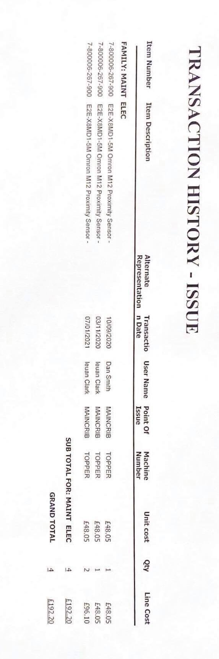
Week 2
Date | Day | Operator | Team Leader | Downtime (minutes) | number of stoppages
11/01/2021 | Monday | R. Hedges | J. Williams | 13 | 1
12/01/2021 | Tuesday | R. Hedges | J. Williams | 7 | 2
13/01/2021 | Wednesday | R. Hedges | J. Williams | 26 | 3
14/01/2021 | Thursday | A. Punton | J. Williams | 18 | 3
15/01/2021 | Friday | A. Punton | J. Williams | 29 | 3
 |  |  | Total | 93 | 12

This data shows that total downtime over a two-week period was 196 minutes with an average of 98 minutes per week. The total number stoppages were 25, this means that each stoppage takes around 8 minutes before the machine is running again. The data collection is also consistent with the methodology as four different people operated the machine over the two-week period.
The image above shows the transaction history for the proximity sensors over a nine-month period, this information shows how frequent these sensors are needing to be replaced. In this time four sensors were booked out the stored costing a total of £192.20. All four sensors were booked out to the Topper which is shown under the heading ‘Machine Number’.

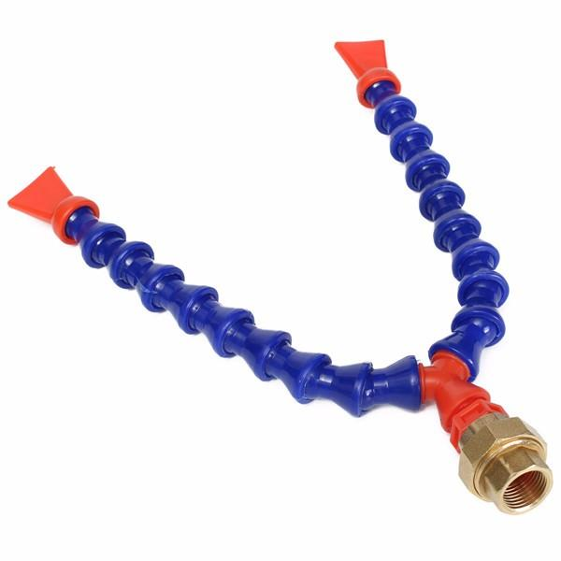
These are the coolant tubes used to direct the coolant on to the sensors. They are kept in stock so no purchases will be needed to implement the project. The current coolant line was replaced with this V-shaped line, one end will be used to deliver coolant to the sensor and the other will be used for the original purpose of delivering coolant to the milling cutter.

Implementation
Before implementing the project, a meeting was held with the engineering department, this was to ensure changes to the machine would not affect the function of the machine. As the chosen solution will not affect the operation of the machine the project was approved for a trail.
A meeting was also held with the production manager to eruption to ensure that there would be no major disruption to production. The initial data gathered showing the current stoppages was shown in the meeting along with the solution proposed. The project was then approved by the production team and a time of thirty minutes was allocated to implement the project.
The project was them implemented in the allocated time and new data was collected.

Results
To collected data post implementation the decision was made to use the exact way it was initially collected, this was to make the results of the project as consistent as possible.
Week 1
Date | Day | Operator | Team Leader | Downtime (minutes) | Number of stoppages
29/03/2021 | Monday | A. Punton | J. Williams | 9 | 1
30/03/2021 | Tuesday | A. Punton | J. Williams | 10 | 1
31/03/2021 | Wednesday | A. Punton | J. Williams | 5 | 1
01/04/2021 | Thursday | R. Hedges | J. Williams | 0 | 0
02/04/2021 | Friday | R. Hedges | J. Williams | 11 | 2
 |  |  | Total | 35 | 5

Week 2
Date | Day | Operator | Team Leader | Downtime (minutes) | number of stoppages
03/04/2021 | Monday | A. Richardson | J. Williams | 14 | 1
04/04/2021 | Tuesday | A. Richardson | J. Williams | 7 | 1
05/04/2021 | Wednesday | A. Richardson | J. Williams | 0 | 0
06/04/2021 | Thursday | J. Davies | J. Williams | 0 | 0
07/04/2021 | Friday | J. Davies | J. Williams | 20 | 2
 |  |  | Total | 41 | 4

Analyse
I collected my initial data and my results and put them into a graph to analyse.

Over the two-week period the number of stoppages has been reduced overall, however there is a two-day period where the number of stoppages was the same. The number of stoppages for pre implementation peak on Tuesday of week 1 at 4, the lowest it reached was 1, meaning that this problem as occurring at least one time per shift. After the project was implemented the number of stoppages peaked at 2, but reached 0 for 3 of the shifts.
There was not clear pattern between the days and the number of stoppages, so I decided to calculate the average stoppage per day to make the data easier to interpret. The average number of stoppages per shift was 2.5 before the project was implemented, post implementation that number reduced to 0.9, meaning the number of stoppages was reduced by 1.4 times. This gives me an overall reduction of 36% per shift.

This graph shows the minutes of downtime over the two-week period, there is an overall reduction post implementation. As the first graph has shown there is a period where the data is similar on Monday and Tuesday of week two. There are also times on the graph where the downtime post implementation exceeds the initial data.
Because there is no clear pattern in downtime, I decided to calculate the average per shift. The average minutes of downtime before that project was implemented was 19.6 minutes per shift, that number then reduced to 7.6 minutes post implementation. This meant that downtime was reduced by 12 minutes. This gives me an overall reduction of 48.98% per shift.

Evaluation
Time
My specification said that my project needed to be in place by the 31/03/2021, the project was implemented on the 26th of the same month. This means that I met with criterial although it could have been implemented earlier to allow more time. The project was also completed by the 10/05/2021 meaning this criterial was also met.
Target Market
The target of the project was help free time for all maintenance/setters so they could carry out other task without being interrupted. As the downtime and the number of stoppages has been reduced. The project was also approved by the engineering team before it was introduced, I feel because of these point that this criterion has been met.
Function
The downtime was reduced from an average of 19.6 to 7.6 minutes per shift. The number of stoppages was also reduced from 2.5 to 0.9. From this data I can conclude that the project has met the function criteria of the specification.
Size
The new components added did not obstruct the operator’s ability to run the machine. The new coolant line does not interfere with the operator of the machine in any way. It also does not obstruct any maintenance tasks that may need to be carried out as the coolant line is flexible and can be moved with ease. The new coolant line is also with the dimensions set in the specification
Aesthetics
the changes made to the machine are not visible from the loading station of the machine, to view the changes made you would need to lean into the machine or take off the side door. There were also no specific aesthetic themes set in the specification. For these reasons I believe that the project did well on aesthetics.
Durability
As the current sensors are still being used it is difficult to gauge this aspect of the specification. The sensors are lasting around 1.25 months before the project was introduced. If I have given myself more time, I would have monitored the lifetime of the sensors after the project was introduced.
Materials
The materials used for the coolant line were kept consistent with materials already being used. I used the same materials because they have proven to last a long time and do not degrade in the machine’s environment. Changing materials could introduce new oils or substances that could contaminate the coolant. Contaminated coolant can lead to a build up of bacteria which can cause rashes and dermatitis if it contacts the skin of the operator. Contaminated coolant can also lead to damage to the coolant system in the machine by blocking filters or causing strain on pumps.

Safety
The changes made to the machine do not obstruct the operator in any way, so it does not cause any potential hazards, the new coolant line is mate from materials that are not harmful to people working in the area. Any new potential materials were considered carefully to prevent any contamination, the new materials added are the same as the existing materials so there is no concern form contamination which could potentially cause injury or sickness for employees working on the machine.
Cost
The plastic coolant pipe used costs around £10.99, the coolant pipes used are also kept in house meaning no new materials were bought. This kept my project massively under budget. The amount of downtime that the project has reduced also has the potential to save lots of time and money in the future.
Environmental Issues
No hazards chemicals, oils materials have been added to the machine that could cause any issues with the function of the machine or cause any health concerns with machine operators. There has also been no changed to the noise levels of the machine, so the working environment has not changed for the machine operator. No harmful chemicals have been added to the machine or is being produced so there are no concerns relating to COSHH.

Overall, the project has done well to achieve the key points in the specification. I think the project did particularly well in function, cost, safety, materials, durability and environmental. In these areas I feel that the projected surpassed the expectations. The reduction in stoppages and downtime by using a coolant hose shows the function of the project has been successful and been done with a cheap and simple solution. It was also achieved by using materials that were in house.
The project also did well in other aspects such as aesthetics, size, and target market. The project did not incorporate a lot of aesthetics or size as existing materials were used rather than designing new components. Although the target market section of the project was achieved, I feel that it could have been improved. A reduction of 36% is good but it has not eliminated, this means that maintenance and setting staff are still having some time taken up by this issue.
If more time were allocated to data collection earlier in the project, I believe that the results would have given a truer representation of the issue. Recording the data over a four-week period would have given more accurate results than the two-week period that the data was collected over. If time management were improved, I would have also allocated time to collect data on the lifespan of the sensors before and after the implementation.

Conclusion
For this assignment I had to formulate and plan a project that will provide a solution to an identified engineering problem with regards to maintainability. I then had to conduct and plan project activities to generate outcomes which provided a solution to the identified engineering problem. As a result of this I identified a reoccurring issue with a high-volume machine, the issue was that the machine was breaking down numerous times in the shift for faults alarms. I saw this as an opportunity to improve the maintainability by reducing the number of breakdowns, maximizing efficiency and reliability of the machine.
The research question has been achieved as I evaluated three possible concepts for my engineering project, I then used a weighted matrix to compare key points, this helped me decide which project was the most suitable to further develop. After further development I evaluated four possible solutions to concept I chose. I decided to evaluate four solutions to give me a wide range of possibilities, I arrived at the conclusion that adding a coolant line to wash sensors down had the most potential. This reduced the number of stoppages by 36% and the downtime by 49%. This not only improves that maintainability of the machine by also give the machine a higher production output. It also gives skilled workers more freedom to complete other tasks without being interrupted.
Using compressed air to blow sensors sown may have been more successful than using coolant, this is because coolant can carry small pieces of dust from the castings that can pass through the filters which can cause a build up of silt on the sensor, this silt can then allow pieces of swarf to stick to the sensor and cause the issue that I have tried to eliminate. I believe this is cause of the results not being as high as I expected. I did not anticipate this in when evaluating which solution would be the most affective. Using compressed air may have given better results but the time and skills needed to fit a new compressed air line would cause too much of a disruption to production. If I were allocated time in the future, I would implement a system that uses compresses air to see if it would be more successful.
Another alternative could be to remove some of the sensors completely, when evaluating this as a possible solution I concluded that the potential to cause damage to the machine was too high. However, one of the sensors on the unloading robot could be removed without having the risk of causing damage, this sensor checks if a part is there before it Is unloaded from the machine. If the sensor were removed and a part was not present, the robot would carry out the unloading cycle with no part. Other sensors in the machine could not be removed due to their importance but removing is one could eliminate a portion of the issue.
If I were to develop this project further, I would aim to reduce the number of stoppages further by using a combination of the solutions that I evaluated. By doing this I have predicted that the issue with the sensors flagging fault alarms and be reduced further or even completely eliminated.

Appendix

Progress Log
Description | Person/People | Reason | Date | Comments
Lecture | G. Flower (Lecturer) | Information on project requirements | 09/09/2020 | Assignment brief was handed out. Potential projects must be chosen
Meeting | G. Griffiths (Supervisor) | Discuss with workplace supervisor about possible projects | 11/09/2020 | A couple of issues concerning maintainability were raised
Meeting | G. Griffiths (Supervisor) | Allocate time in work to investigate potential projects. | 18/09/2020 | Time to was given to allow further research into potential projects
Lecture | G. Flower | Feedback on potential projects | 23/09/2020 | Potential projects were proposed to lecturer.
Meeting | C. Davies (Production Manager) | Photographs | 02/10/2020 | A meeting with my manager was held to ask for permission to take photographs of machines/products
Meeting | G. Griffiths (Supervisor) | Discus project selection | 16/10/2020 | The selected project was proposed to supervisor to ask for approval.
Lecture | G. Flower | Progress check | 25/10/2020 | Progress check with tutor on project planning
Meeting | P. Richards (Engineer) | Discus selected solution | 05/11/2020 | Chosen solution was approved by engineering department
Lecture | G. Flower | Introductions | 14/11/2020 | Lecture to discuss writing a project brief and specification
Meeting | D. Hughes (Quality Engineer) | Data collection | 22/11/2020 | Data on machine downtime and scrap was collected from quality department
Lecture | G. Flower | Writing methodology | 03/12/2020 | Lecture on what to include in methodology and to check progress
Meeting | Team leaders and machine operators | New SOP | 10/12/2020 | All machine operators and team leader were made aware of data collection and new SOP.
Meeting | B. Gregg (Storeman) | Collect stores data | 17/12/2020 | Data on frequency of sensors being booked from stores was collected
Meeting | P. Richards (Engineering) | Fixture Drawings | 21/12/2021 | Meeting with engineering department to gather fixture drawings.
Meeting | G. Griffiths (Supervisor) | Start of data collection | 04/01/2021 | Meeting held to inform supervisor of data collection on machine stoppages
Lecture | J. Rogers | Progress check | 20/01/2021 | Lecture to discuss project progress and to discuss results section of project
Meeting | C. Davies (Production Manager) | Implementation | 11/02/2021 | A meeting was held to allocate downtime on the machine for project to be implemented
Lecture | J. Rogers | Progress check | 24/02/2021 | Check progress with lecturer and discuss data analysis
Lecture | J. Rogers | Technical Writing | 10/03/2021 | Presentation on technical writing
Lecture | J. Rogers | Conclusions and critical analysis | 17/03/2021 | Presentation on writing conclusions and how to critically evaluate project
Meeting | G. Griffiths (Supervisor) | Post implementation data collection | 25/03/2021 | Inform supervisor of data collection being carried out on shop floor
Meeting | Team leaders and machine operators | Data collection | 29/03/2021 | Inform employees of changes made to machine and that data collection will be carried out over next two weeks
Meeting | C. Davies (Production Manager) | Results | 13/04/2021 | Results were presented to production manager to show reduction in downtime

