Anthropology of Art and the Ancient Near East

This week we will be thinking about anthropological approaches to art might allow us to examine ancient artworks, representations. The main approaches covered are:
- Art as aesthetics: the science of sensuous perception, the perception of the beautiful
- Art as a form of social communication
- Technologies of enchantment
- Agency of art
I would also like you to think about itinerary of object and how ancient art might be separated (or not) from its contemporary connections in the modern world.

Case Studies
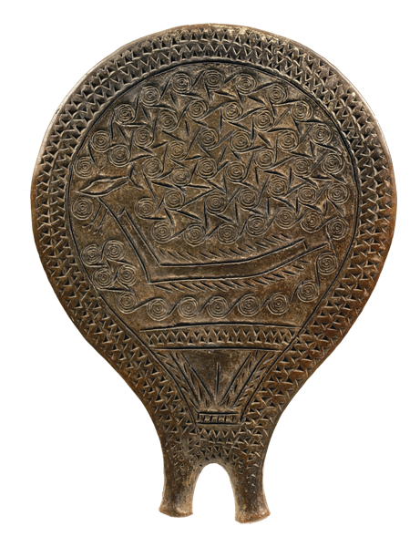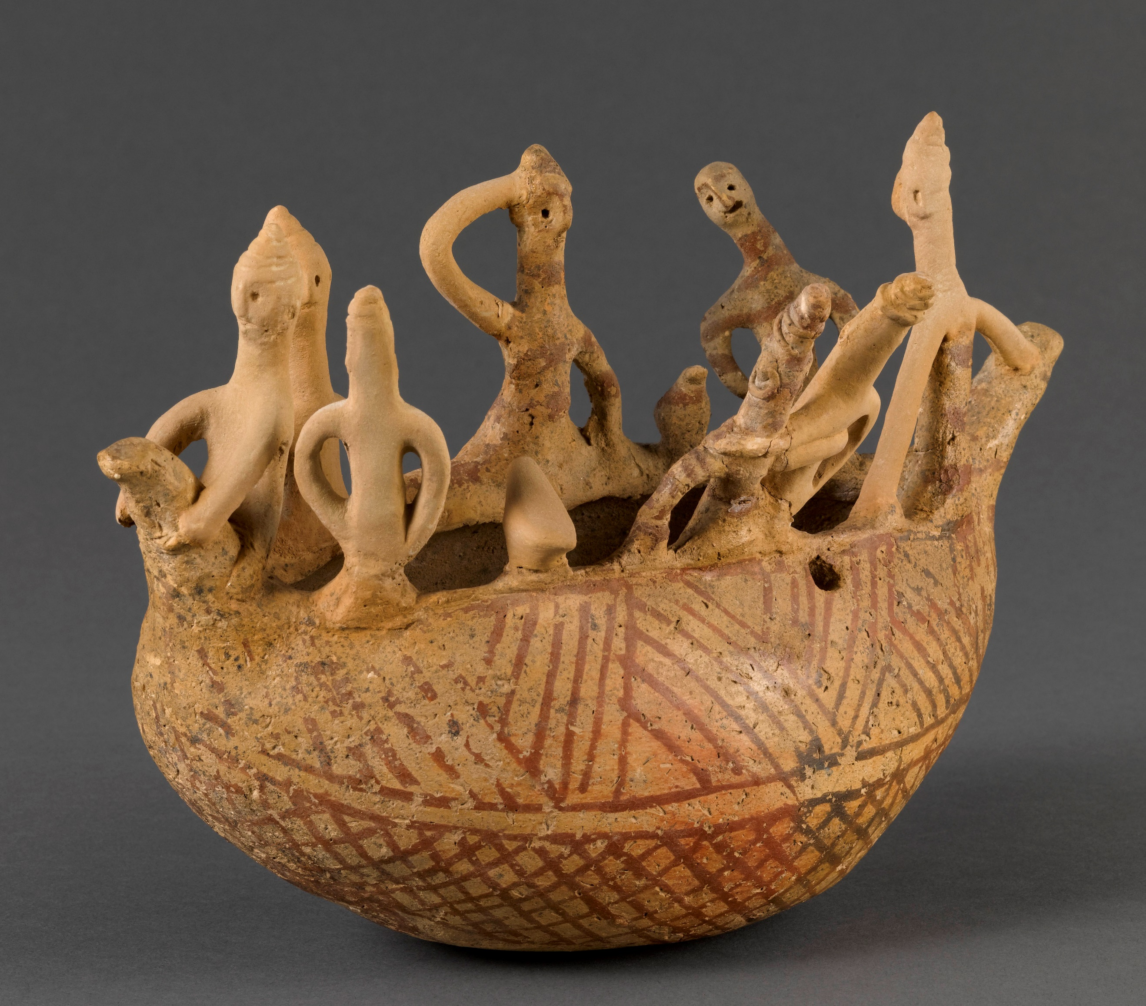
1. Bronze Age Cyclades: incised clay tray 2. Bronze Age Cyprus: clay boat model

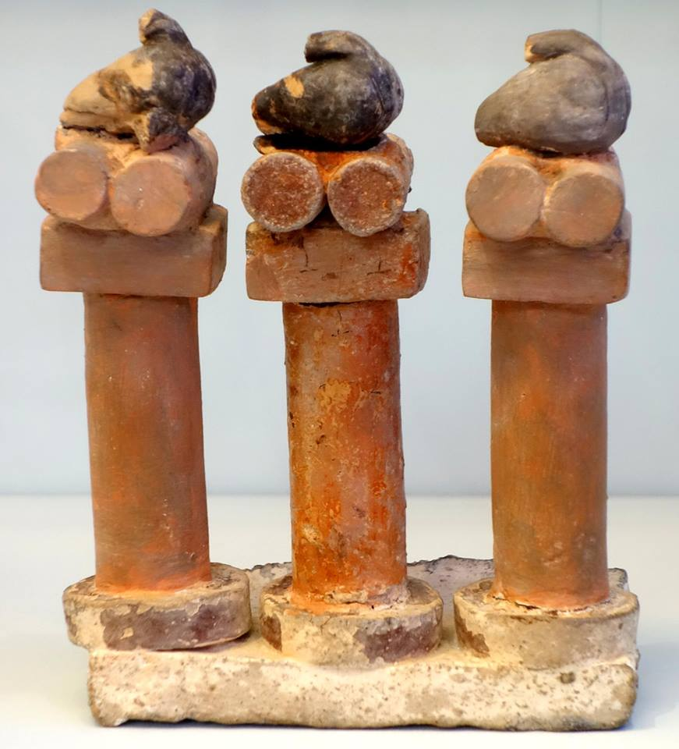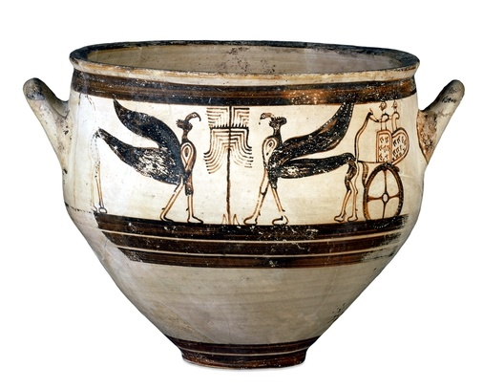
3. Bronze Age Crete: clay model 4. Bronze Age Greece: ceramic krater
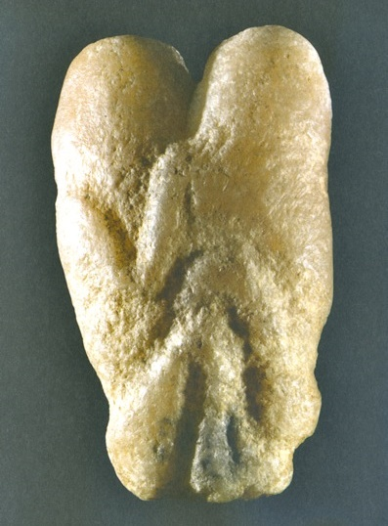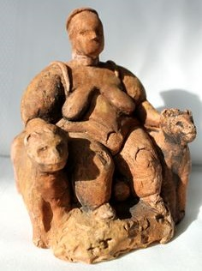
5. Near East (Natufian):stone carving 6. Neolithic clay figure, Çatal Höyük
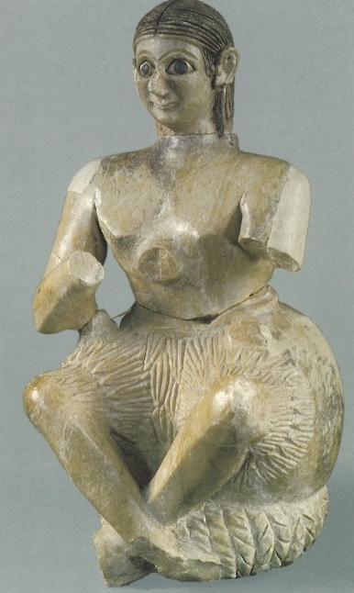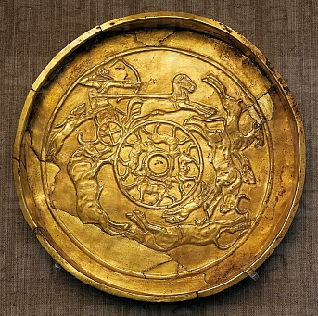
7. Bronze Age Near East: stone figure 8. Bronze Age Near East: Gold bowl
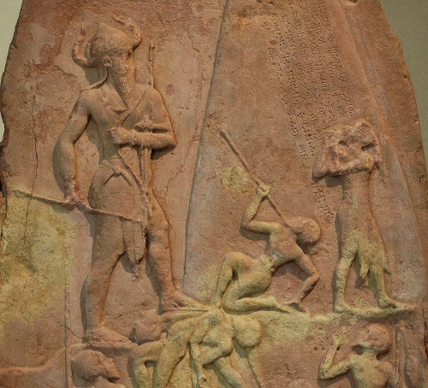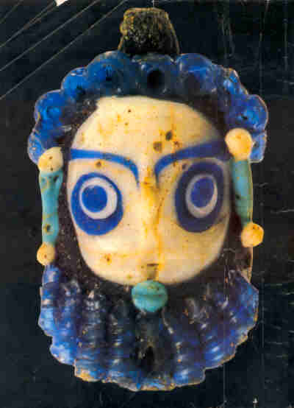
9. Bronze Age Mesopotamia: stone stela 10. Iron Age Phoenicia: glass bead

