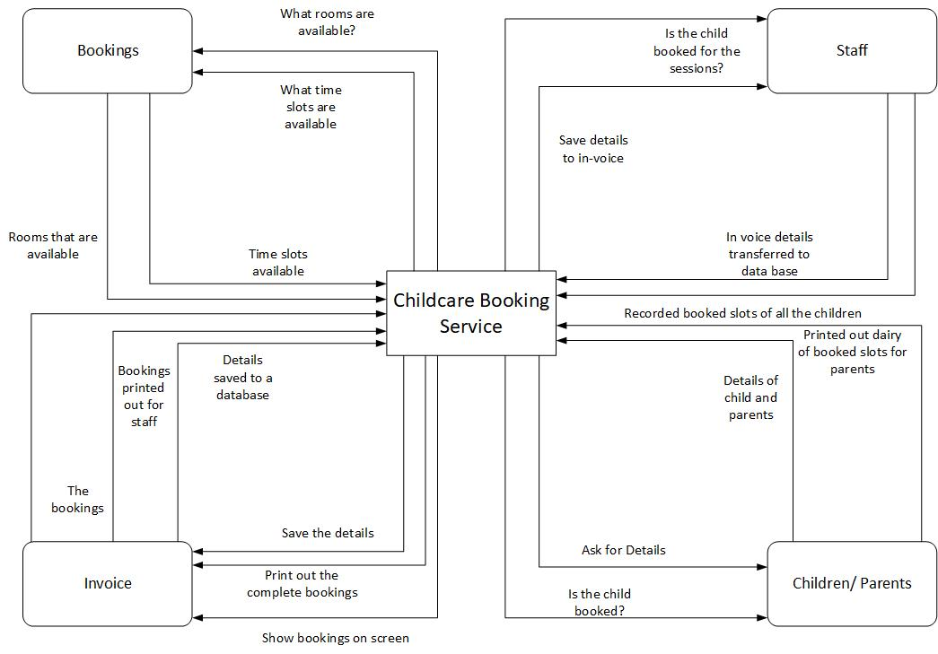
Practical test Analysis of systems requirements

DFD 0

This DFD 0 shows the data that is gathered in this task.

DFD 1
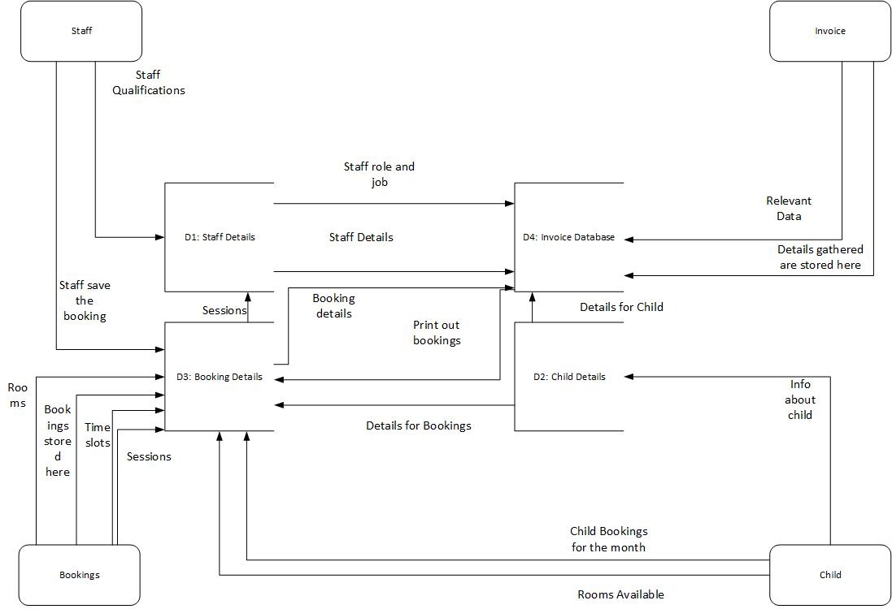

This DFD 1 shows the links that all of the database have and where the data is sent and receive.

ERD
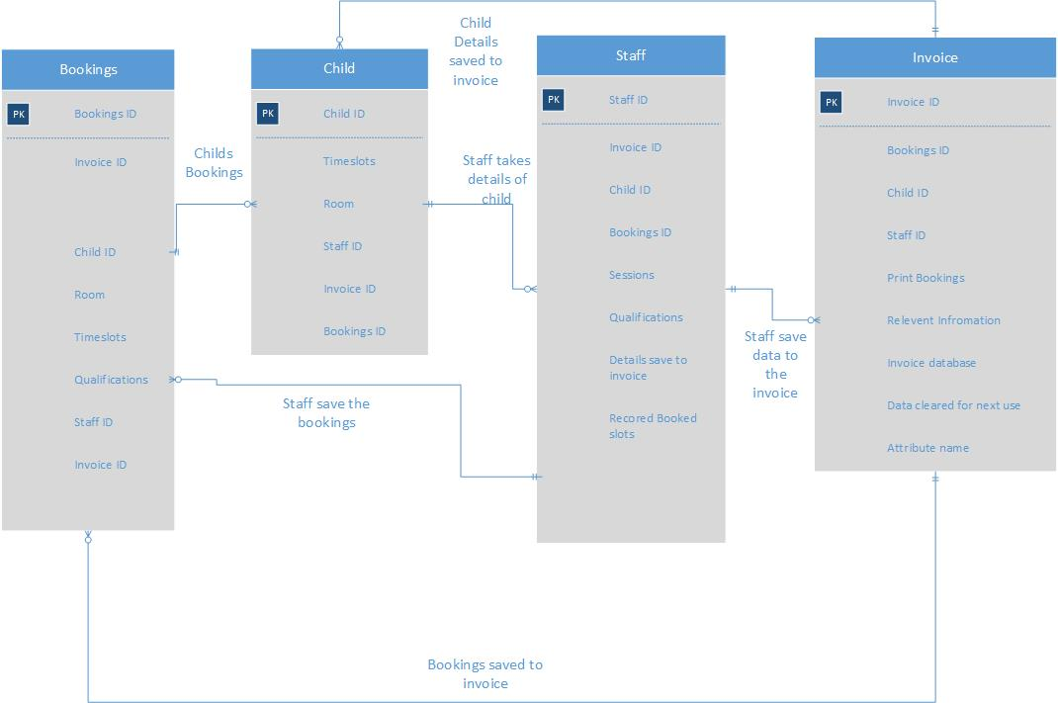

This ERD shows the relationships between the Entities and what progress goes on.

