Process Improvement Methodologies

Two leading process improvement methodologies are Six Sigma and Lean principles. This report will identify the key elements of both and show evidence of them being implemented in the workplace.
“Motorola set a product and service improvement goal in 1987 stating that there is only one ultimate goal: zero defects – in everything we do.” (Evans and Lindsay, 2014, p.4) However, Deming and Cahill (2000, p. 12), stated that “Performance and style, whatever these words mean in the minds of customers, must show constant improvement. Zero defects is not sufficient.”
“Many process improvement methodologies appear to conflict with each other or at least down play the contribution of other methodologies.” (Nave, 2002) However, “All process improvement theories and methodologies make a few of the same assumptions.” (Nave, 2002) This report will focus on two specific process improvement methodologies. Firstly, the main elements of Six Sigma process improvement initiatives. Secondly, the principles of Lean implementation, and how it can be utilised to optimise operational performance.
(Carver, 2019) The primary desire of the customer is to only pay for value, however, value is often incorrectly define by businesses. Products and services are simply an aid to meet customer’s needs. The real value is when the customer’s needs have been successfully fulfilled. Although the engineering specification of a product or service may appear perfect, if it does not satisfy a customer’s needs, the product or service has no actual value.
The main concept of the Six Sigma methodology is that by focusing on reduction of variation, solutions to process and business improvements can be devised. “Through a rigid and structured investigation methodology, the process elements are more completely understood. The assumption is the outcome of the entire process will be improved by reducing the variation of multiple elements.” (Nave, 2002)
(Nave, 2002) States that there are five pivotal steps to Six Sigma –
Define
- The process
- Ask who the customers are
- What the problems are
- Identify key characteristics
- Identify existing output conditions
Measure
- Focus on categorizing key characteristics
- Data collection
Analyse
- Collected data is analysed
- Convert raw data into information that provides insight into the process
- Insights include fundamental causes of the defects and the problems

Improve
- Solutions to the problem are developed, and changes are made to the process.
- Results of process changes are seen and the decision is made as to whether the changes are beneficial or not

Control
- If process is performing at a desired and predictable level
- The last step is sustaining the new performance

(Nave, 2002) “Re-evaluation of processes means that some elements are modified and improved, whereas others are discontinued. Focusing on the primary area of variation produces secondary effects such as improved quality.”
(Findlay, 2014) In many industries, time pressures are a dark cloud over employees heads. The balance between meeting targets and producing high quality products and services can be achieved by the implementation of six sigma. It aids in effective time management, by setting smart goals that are achievable, giving allowances to interruptions or disturbances that may occur.
Developing and sustaining a respectable rapport with customers is key to the successfulness of a business. Customer satisfaction levels will be demonstrated by the level of loyalty a customer shows. Six Sigma helps by focussing on reduction in variation, resulting in highly satisfied customers. Using tools such as Voice Of the Customer helps a business understand elements of their process which is imperative to customer satisfaction.

(Nave, 2002) Six sigma assumptions
- Data analysis can be used to produce improvements – this assumption has been tried in the workplace and proved through the evidence shown in this report
- Reduction of variation of processes equals improved organisation performances
- However, improving a business problems ‘just because’ could have a detrimental effect over all. It may decrease the ability to meet customer’s needs. The realised savings could work out less than the cost of improvement.

(Nave, 2002) Similarly to six sigma, lean’s focus is manifested in an emphasis on flow
“Lean’s 5 essential steps
- Identify which features create value – Value is expressed in terms of how the specific product meets the customer’s needs, at a specific price, at a specific time. Specific products and services are evaluated based on whether the feature adds value or not.
- Identify the sequences of activities called the value stream – a determination is made as to whether activities that do not contribute value are necessary. An example of a necessary but non value adding activity is payroll, people need to be paid.
- Make the activities flow – once value added activities and necessary non value adding activities are identified, improvement efforts are directed towards making the activities flow (definition here). Major inhibitors of flow are work in progress, batch processing and transportation. These are classed as buffers, which slow down the tome from product/service initiation to deliveries. Buffers also tie up money that could be used elsewhere in the organisation.
- Let the customer pull product or service through the process – after waste is removed and the flow is established, efforts turn to letting the customer pull product or service through the process, in other words, encouraging a ‘process responsive’ behaviour. This means that the product or service is only provided when the customer needs it.
- Perfect the process – This process is repeated, creating a constant attempt to remove non value activity, improve flow and satisfy customer delivery needs.

Similarly to six sigma, lean produces secondary effects where quality can be improved. The production process is essentially ‘sped up’, therefore, the product spends less time in process, minimizing the chance of damage. Also, simplification of the processes results in reduction of variation.” (Nave, 2002)
Lean assumptions
- People value the visual effect of flow
- Waste is the main restriction to profitability
- Many small improvements in rapid succession are more beneficial than analytical study
- Process interaction effects will be resolved through value stream refinements
- People in operations appreciate this approach
- Lean thinking is sometimes referred to as the Toyota production system.*
- Focuses on removal of waste
- Waste is defined as “anything not necessary to produce the product or service”
- Common measure – “touch time” = the amount of time the product is actually being worked on, or touched, by the worker
Lean involves many people in the value stream. Transitioning to flow thinking causes vast changes in how people perceive their roles in the organisation and their relationships to the product. (Findlay, 2014) Employees that believe they have a say in the organisation’s process show a 20%-25% increase in productivity levels.

(Nave, 2002) Comparison of both Six sigma and Lean
They both start by addressing the product or service, and improvements are proposed. All process improvement theories and methodologies make a few of the same assumptions -
- The design of product or service is essentially correct
- The design of the product is the most economical
- Customer needs are satisfied with that design
- The current product configuration fulfils the functional requirements of the market and customer
- The management structure supports and nourishes
Despite these assumptions made, not necessarily all of them are accurate, which leads on to further investigations.
After extensive refinement of the existing processes or systems, many improvement methodologies begin to look at the product or service design
Two techniques used to establish this are quality function deployment and value management. They help connect the product or service design to customer needs.

Example of where I have used the Six Sigma and lean methodologies in the workplace
Define
Preventative maintenance is imperative to the production successfulness of the business. In order to assure the business reaches and exceeds their targets, the engineering department is involved in a “Journey to Reliability” award scheme. When a job needs to be carried out/highlighted, the details are collated and input onto SAP. The job is assigned to a specific work centre which is managed by the appropriate engineer in the casters. The major problem is that there is not enough jobs being completed, creating a large amount of jobs in backlog – which is too high to achieve the bronze award. Although the “Journey to Reliability” focuses on the bronze award, this is a secondary effect of backlog job reduction. The more serious primary effect of high amounts of backlog jobs is the increased chance of safety, environmental, quality and production impacts.
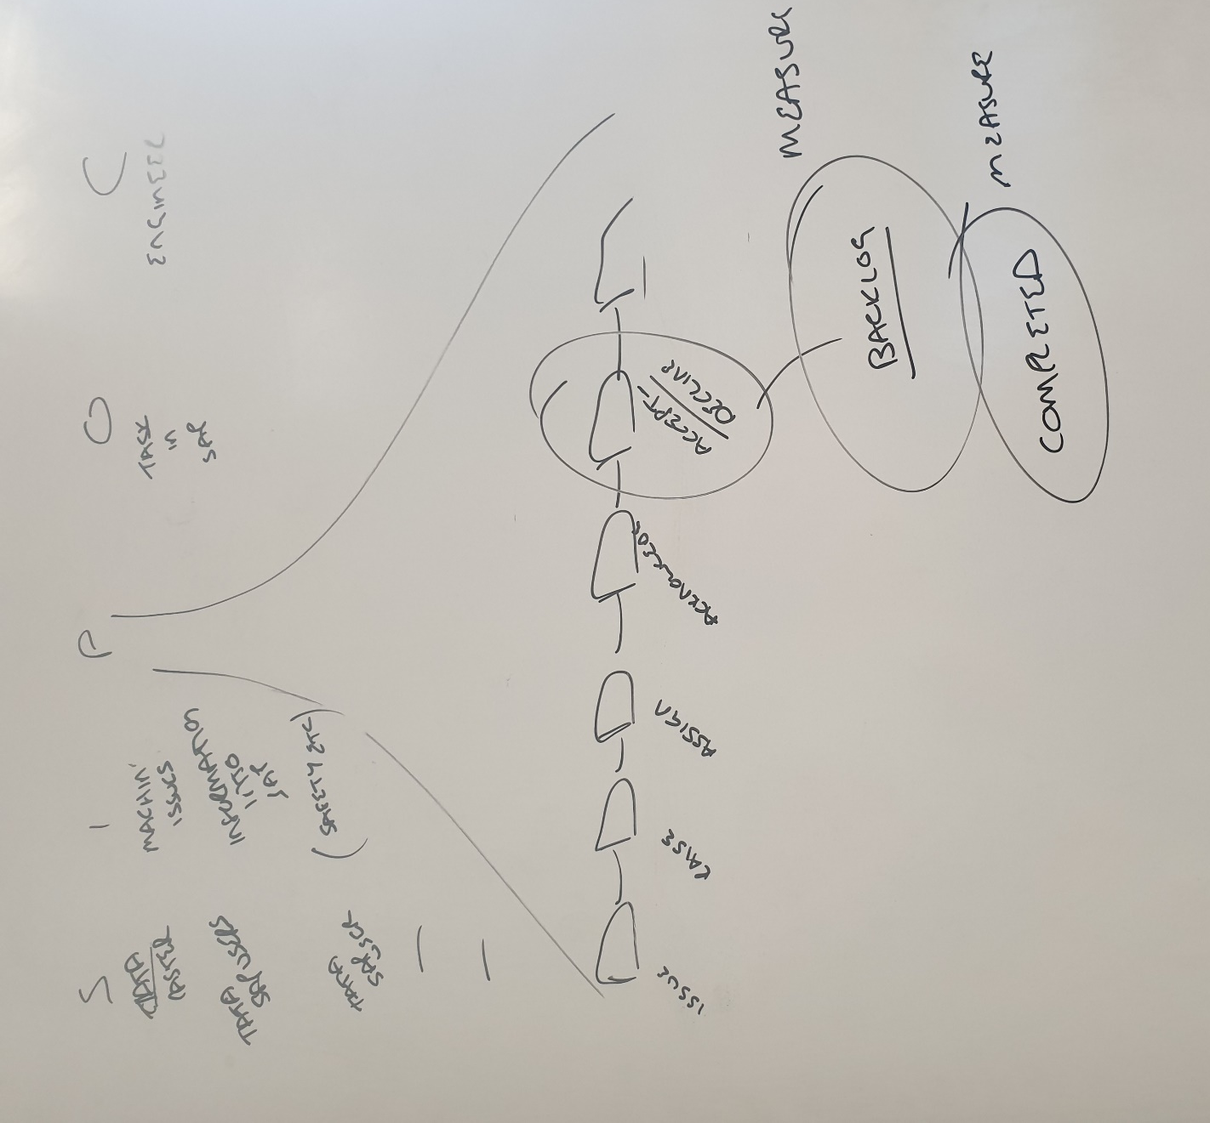

Measure
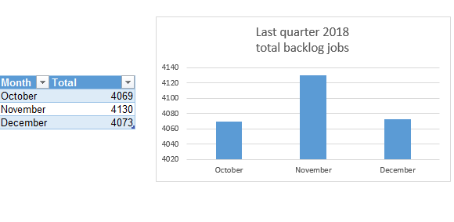
Displayed in this graph are the total number of jobs in back log during the last quarter of 2018, October, November and December.

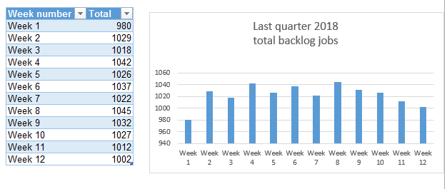

By the end of the next quarter, the goal is to reduce the total number of jobs in backlog by 10%

Analyse

12272 jobs
in backlog

(Zuppan, N.D)The Ishikawa fishbone diagram above highlights the main causes and sub-causes of the problem, 12,272 jobs in backlog.

Value Stream Mapping
(Plutora, 2019) “Value stream mapping is a lean manufacturing or lean enterprise technique used to document, analyse and improve the flow of information or materials required to produce a product or service for a customer.”
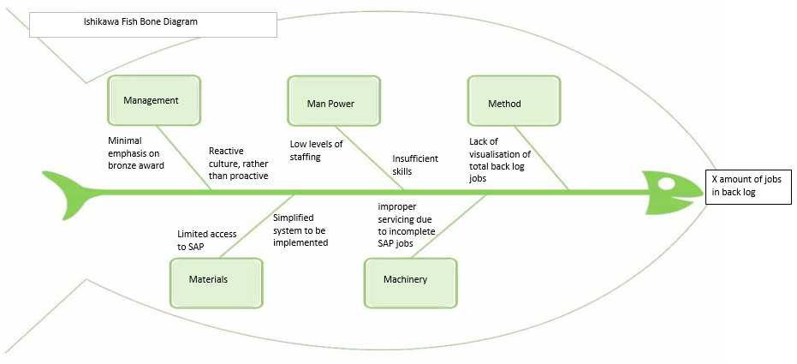
The main focus of value stream mapping in this process is to eliminate or reduce waste. (Skhmot, 2017) Two desired waste removals to be considered are wasted motion and waiting waste. These are highlighted by linking with the Ishikawa diagram, as ‘simplified system to be implemented’ and ‘visualisation of total back log jobs.’

Improve
SAP USER MAINTENANCE JOBS
As highlighted in the define stage SIPOC, the area of focus will be ‘jobs in back log’ part of the process. From the analysis above, one area requiring improvement is the need for a simplified system. Skhmot (2017) states that “waiting waste can include waiting for the computer to load a programme” In order to achieve this particular waste reduction, an automatic data retrieval tool, also known as, a script, was developed.
Every Friday, the script is now run on SAP and each individual work centre is manually located, the total number of back log jobs is noted, and input into a table, as shown below. Although the desired goal of this process is to reduce backlog jobs and achieve the bronze award, the primary effects as mentioned in the define stage will also be improved.

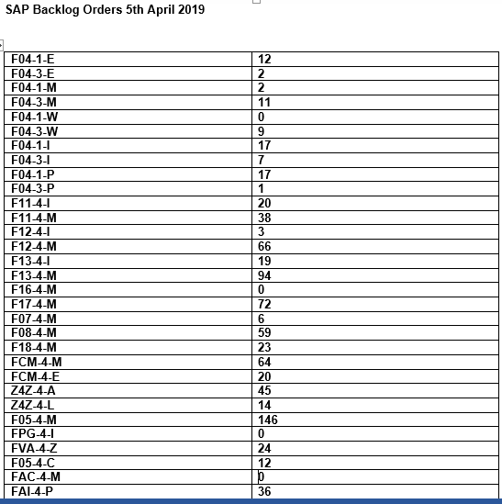

Skhmot (2017) states that “wasted motion can include walking and double entry of data.” In order to reduce this waste, the data from the table above is input into a graph, as shown below, and transferred via Bluetooth to a screen display on the engineering floor of the concast admin block. Each individual work centre’s total is displayed on the screen, along with the overall total of jobs. This visual management display emphasizes the total amount of jobs in backlog and encourages the engineers to reduce their own jobs in backlog.

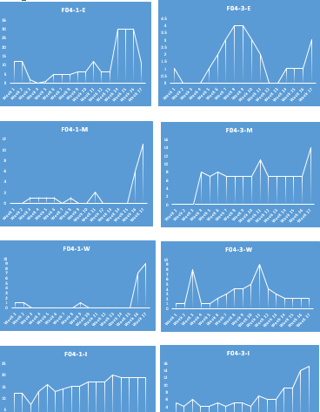

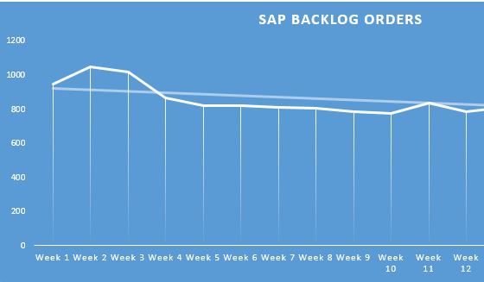
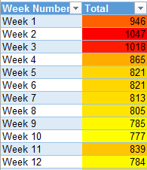

The data above shows the total amount of jobs in back log for the following quarterly period. The total of jobs is 10,321 which shows a reduction of approximately 16% which is 6% more than the original target set out.
The use of visual management boards will help (Kanbantool.com 2019) “improve communication between team members and help your team stay focused on their goals” The use of colour in this display helps identify whether the total jobs in backlog is at an acceptable level. The goal is green, which will be less than 150, which has not been achieved yet. Currently, the colour is amber, which shows desired reduction from the original red, which is too high.

Control
As proven by the 16% decrease shown by the latest quarterly data graphs, the two improvements made have been incredibly beneficial to the reduction of total jobs in back log.
The automatic data retrieval tool used to effectively identify and highlight the total number of jobs makes creating the data graphs a more simplified and faster process.
The use of a Bluetooth connection to transfer the visual data to the display screen also speeds up the process and allows the data to be accessible to the engineers involved in the ‘Journey to Reliability’ process.
As predicted, due to the emphasis on achieving the bronze award by reducing total number of jobs in backlog, the safety, environmental, quality and production concerns have also been reduced due to the increase in preventative maintenance within the casters.
With the commitment of the engineering department, and the improvements that have already been made, this process is predicted to continue betterment. Although the 16% reduction has surpassed the initial target, there is still room for refinement and progression, to eventually reduce the total jobs in back log to under 150.
Management of Change creates huge benefits as it “minimizes unplanned adverse impacts on system integrity and reliability for the business. It also maximises the productivity and efficiency of staff planning, coordinating and implementation of the changes. Finally, it provides a stable production environment.” (Lni.wa.gov, 2019)

Bibliography
Deming, W. and Cahill, K. (2000). The New Economics for Industry, Government, Education. Cambridge: MIT Press, p.12.
Evans, J. and Lindsay, W. (2014). An Introduction to Six Sigma and Process Improvement. p.4.
Kanbantool.com. (2019). Visual Management Board | Kanban Tool. [online] Available at: https://kanbantool.com/visual-management-board [Accessed 20 May 2019].
Lni.wa.gov. (2019). [online] Available at: http://www.lni.wa.gov/safety/grantspartnerships/partnerships/vpp/pdfs/vppmocbestpractices.pdf [Accessed 22 May 2019].
Carver, M. (2019). The Five Fundamental Assumptions of Six Sigma | iSixSigma. [online] iSixSigma. Available at: https://www.isixsigma.com/new-to-six-sigma/getting-started/the-five-fundamental-assumptions-of-six-sigma/ [Accessed 20 May 2019].
Nave, D. (2002). How to compare six sigma, lean and the theory of constraints.
Plutora. (2019). Learn the 10 Key Steps to Value Stream Mapping (VSM) - Plutora.com. [online] Available at: https://www.plutora.com/blog/value-stream-mapping [Accessed 17 May 2019].
Skhmot, N. (2017). The 8 Wastes of Lean. [online] The Lean Way. Available at: https://theleanway.net/The-8-Wastes-of-Lean [Accessed 15 May 2019].
Zuppann, E. (n.d.). Handbook of Product Design for Manufacturing. pp.5-1, 5-22.

