Module Code: BMSW5009
Module Title: Managing Projects in the Organisation

Project Management Blogs

Student Name: Mohammad Riazuddin Riaz
Student ID: 2326121

Table of Contents
Blog 1: Stakeholder Analysis in Project Management 1
Blog 2: Risk Management Techniques in Projects 2
Blog 3: The Iron Triangle – Balancing Time, Cost, and Quality 3
Blog 4: Corporate Social Responsibility in Project Management 4
Blog 5: Critical Self-Evaluation and Personal Development Plan 5
Bibliography 6

Blog 1: Stakeholder Analysis in Project Management
Stakeholder analysis is a project management tool that helps identify who or what is involved and their power and interests in a project. The stakeholder theory calls for thinking about the needs of all stakeholders, not just the primary beneficiaries (Riahi, 2017).
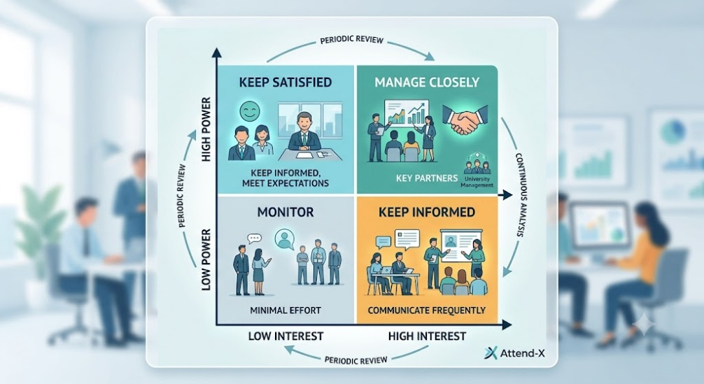
Figure 1: Stakeholder Analysis in Project Management (Author's created)
The 14 stakeholders identified in the Attend-X project included: Students, Lecturers, University Management, IT Staff, and External Sponsors. Stakeholders were categorised, and responses that matched the power-interest grid were assigned. University management was ranked as high power-high interest and needed frequent exchanges of messages via meetings, etc. Other stakeholders (parents, external universities) had low power and low interest and thus minimal involvement. This was done based on the stakeholder grid of ‘managing closely’, ‘satisfied’, ‘kept informed’ and ‘monitor’ (Zarghami and Dumrak, 2021). The stakeholder analysis has its drawbacks; stakeholders' influence can vary during a project. So, it is advisable to review stakeholder maps from time to time. This was despite this drawback, and the analysis guided communication planning and stakeholder engagement in the Attend-X project. It helped the team focus resources, communicate effectively, and keep key stakeholders engaged in the project life-cycle.

Blog 2: Risk Management Techniques in Projects
Risk management is a process of identification, assessment, and response to uncertainty that could impact a project's success. Risk management can support projects to be on time, on budget and on track with intent (Loosemore et al., 2012). In the Attend-X project, several project risks were identified: project over-scoping, lack of team coordination, disengagement of stakeholders and technical risks with QR code attendance verification. This was a huge liability to try to build an entire software application based on just a few weeks' work. To minimise this risk, the team only worked on the proposal and design phase of the project (Six Sigma, 2024).
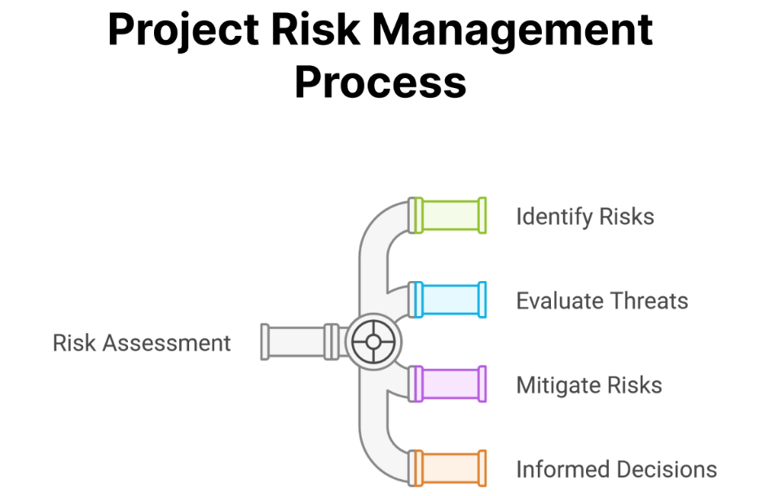
Figure 2: Risk Management Techniques in Projects (Six Sigma, 2024)
Risk registers, RAID logs and probability-impact matrices are common risk management tools. These tools are used to prioritise risks based on their likelihood and impact size. For instance, the failure of technology was deemed high-impact and low-probability, whereas communication within the team was deemed moderate in both impact and likelihood. Risk management should be an “everyday” process, not a “one-off” (Cagliano et al., 2015). Teams consider new risks and review/change responses through regular reviews. If time and resources are constrained (as in student projects), proactive risk management is more important. It helps teams predict problems, minimise risk and boost the chances of successfully reaching project objectives (Cagliano et al., 2015).

Blog 3: The Iron Triangle, Balancing Time, Cost, and Quality
The Iron Triangle, also called the Triple Constraint concept, is one of the most important concepts that is defined in project management. It says that there are three factors that all projects have to work together: time, cost, and quality (or scope). Changes to one factor will affect at least one of the others (Asana, 2025).
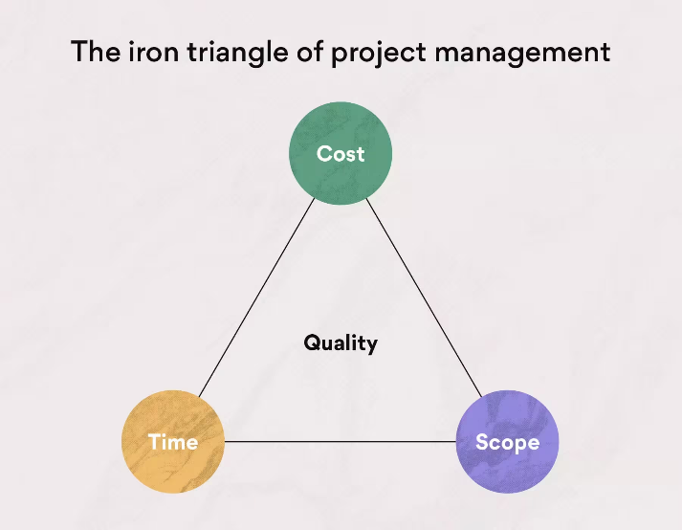
Figure 3: The Iron Triangle – Balancing Time, Cost, and Quality (Asana, 2025)
The time used for the Attend-X project was predetermined at 8 weeks. Due to this constraint, decisions were to be made on cost and scope regarding the project. There was only an outline for the project in terms of design and proposal due to a lack of resources for implementation in software and special equipment. Requirements were well-defined to ensure quality. A remotely raisable attendance system had to be easy, secure, and accurate. Quality assessment, however, was confined to assessing the concept due to project scope limitations and constraints (Bronte-Stewart, 2015). While there is some debate about whether the Iron Triangle captures the complexity of modern project environments, it is a useful construct. It has supported the team in the Attend-X project to consider trade-offs, avoid scope creep and make sensible choices (Wright and Lawlor-Wright, 2018).

Blog 4: Corporate Social Responsibility in Project Management
Corporate Social Responsibility (CSR) is the consideration of the social, ethical and environmental effects of project options. In the field of project management, CSR is not just about deliveries and cost, but also about providing the project results responsibly to the stakeholders (Griffon, 2024).
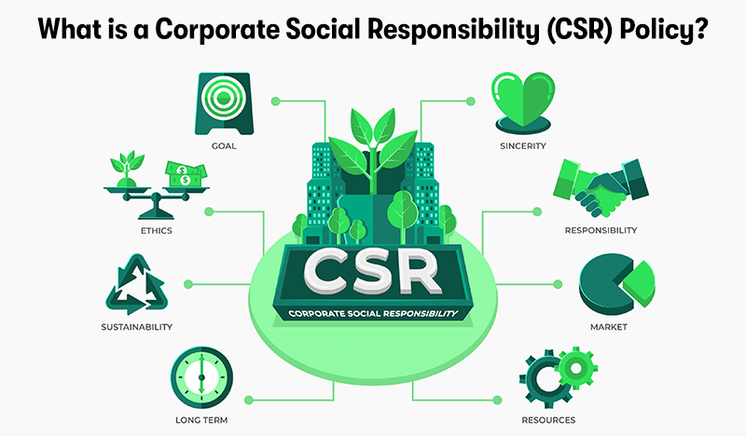
Figure 4: Corporate Social Responsibility in Project Management (Griffon, 2024)
The Attend-X project identified some points of CSR. Data Privacy, Accessibility and Digital Inclusion were significant factors as the project relied on a QR code attendance system. The proposed system needed to comply with data protection regulations and ensure that students could use it regardless of their level of digital experience. The student union was kept as a stakeholder, a reflection of good, responsible governance. The Project team ensured that students' views were taken into account in the planning and design by including end users in discussions. This strategy aligns with a perspective that argues project success should apply ethical and stakeholder aspects as well as technical aspects (Al‐Marri et al., 2019). CSR also provides transparency, fairness and responsible decision making. Attend-X called for candour about the limitations of the project and the security of the data collected. The overall goal was to ensure that the team could develop a solution that added value but also used social responsibility principles in the planning to protect the interests of the stakeholders.

Blog 5: Critical Self-Evaluation and Personal Development Plan
This module in project management has enhanced my knowledge of project management concepts and tools. Before this module, I knew very little about working in a team and on a deadline. Now I understand more about stakeholder analysis, risk management, Iron Triangle.
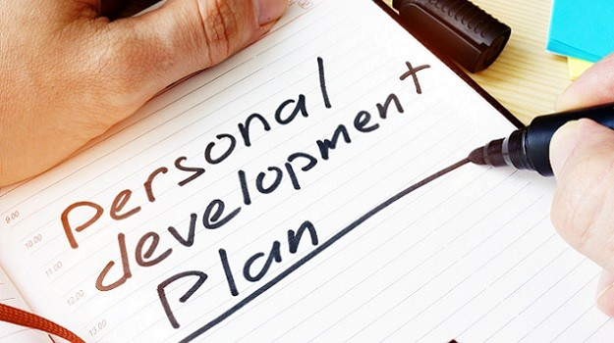
Figure 5: Personal Development Plan (Rogers, 2021)
One of my skills was to participate in stakeholder identification and classification in the Attend-X project. Made an active contribution to discussions and bound the project, excluding software development. This decision has kept this project real and achievable. But I saw some ways to do better. I do not have lots of experience in applying risk tools to real projects, and my knowledge of risk management is still mainly theoretical. I sometimes struggled with time management when I had several assignments and project tasks to complete. To improve my skills, I will read more literature on project management, especially risk and scheduling. I also plan to learn how to use the project management programme like Trello and Asana to build Gantt charts and Risk Registers. Also, I will pursue project management experience as part of an internship, as a volunteer or by working. These activities will enhance my professional competencies and prepare me for future career possibilities upon graduation.

Bibliography
Al‐Marri, M., Pinnington, A.H., Karatas‐Ozkan, M. and Nicolopoulou, K. (2019). The management of corporate social responsibility through projects: a more economically developed country perspective. Business Strategy & Development, 2(4), pp.358-371.
Asana (2025). The Project Management Triangle: What It Is and How to Use It.Asana. Available at: https://asana.com/resources/project-management-triangle.
Bronte-Stewart, M. (2015). Beyond the iron triangle: Evaluating aspects of success and failure using a project status model. Computing & Information Systems, 19(2), pp.19-36.
Cagliano, A.C., Grimaldi, S. and Rafele, C. (2015). Choosing project risk management techniques. A theoretical framework. Journal of Risk Research, 18(2), pp.232-248.
Griffon, P. (2024). What Is A Corporate Social Responsibility Policy? Purple Griffon. Available at: https://purplegriffon.com/blog/what-is-a-corporate-social-responsibility-policy.
Loosemore, M., Raftery, J., Reilly, C. and Higgon, D. (2012). Risk management in projects. Routledge.
Riahi, Y. (2017). Project stakeholders: Analysis and management processes. International Journal of Economics and Management Studies, 4(3), pp.39-45.
Rogers, C. (2021). The Importance of a Personal Development Plan.Engineering & Technology Jobs. Available at: https://engineering-jobs.theiet.org/article/the-importance-of-a-personal-development-plan.
Six Sigma (2024). Project Risk Management: Strategies, Tools, and Best Practices. SixSigma.us. Available at: https://www.6sigma.us/six-sigma-in-focus/project-risk-management/.
Wright, A. and Lawlor-Wright, T. (2018). Project success and quality: balancing the iron triangle. Routledge.
Zarghami, S.A. and Dumrak, J. (2021). Reimaging stakeholder analysis in project management: network theory and fuzzy logic applications. Engineering, Construction and Architectural Management, 28(9), pp.2426-2447.

