

BA(Hons) Business Management

Component 2 Individual Report

Student Name: George Andreeas Geamanu
Student Number: 2440439
Course Name: Data Handling & Business Intelligence, LCBB5014

Introduction
Business Intelligence (BI) when integrated with data management and statistical analysis and visualisation methods, helps organisations gain insights into trends, customer behaviour and consequently optimise operations, and gain a competitive edge (Månsson and Waniurska, 2026). In the film and entertainment sector, digital platforms collect a lot of data including ratings, views, likes, and fan engagement. By analysing this data, production companies, streaming services, and marketers can gain insights into the viewers' preferences, which can be used to create strategies to enhance the viewers’ satisfaction and commercial performance (Provost and Fawcett, 2013). This report examines the Letterbox Movie Classification Data Set, which contains 10,000 movies with data on the average rating, run time, genres, original language, number of watches, number of likes, number of fans and number of ratings. Data was cleaned, prepared, described, analysed and visualised using Microsoft Excel and inferential statistical analyses were conducted using IBM SPSS Statistics, including an independent-samples t-test, Pearson correlation and multiple linear regression. These analytical techniques help to determine relationships among variables related to audience involvement and film ratings and aid in evidence-based decision-making (Hair et al., 2019).
Data Cleaning and Preparation
Data cleaning involves detecting and removing errors from a data set in order to improve the quality of data (Rahm and Do, 2000). Using Microsoft Excel, the first step of the data cleaning process involved confirming the completeness of the data by identifying missing and duplicate values for the different variables including Average Rating, Runtime, Genres, Original Language, Watches, Likes, Fans and Total Ratings. No missing or duplicate variables were found to exist in the data set. The data set was also formatted as a table and categorical variables were standardised to ensure consistency and ease subsequent analysis. The Genres variable had several genres listed in brackets and in quotation marks. Using Excel’s Find and Replace feature, the variable was cleaned to include only the first and listed main genre title to enable easy frequency analysis and visualisation of genre distributions. The original language variable was also checked for unrealistic for inconsistent naming, for instance, English and ENGLISH and it was confirmed that no unrealistic values existed for numerical variables like Average rating and run time. These data processing procedures enhanced the consistency, reliability, usability and effective analysis in Excel and SPSS. Data cleaning and preprocessing is a critical phase in business intelligence process, as the quality of the output of the analysis is directly dependent on the quality of the data (Kimball and Ross, 2013; Månsson and Waniurska, 2026).
Figure 1 and 2 below show screenshots of the dataset before and after cleaning and preparation in Excel.
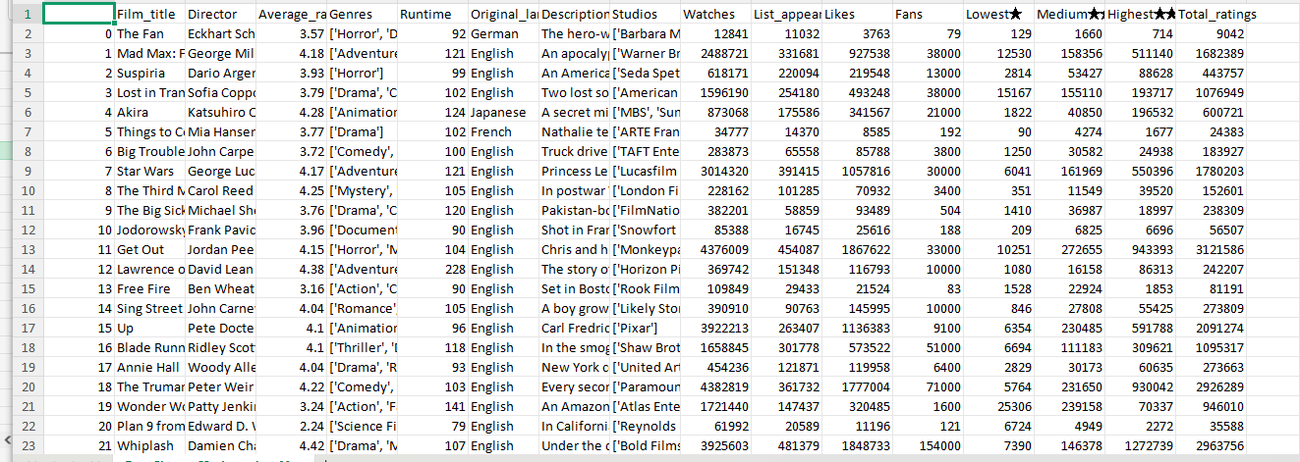
Figure 1: Before data cleaning and preparation
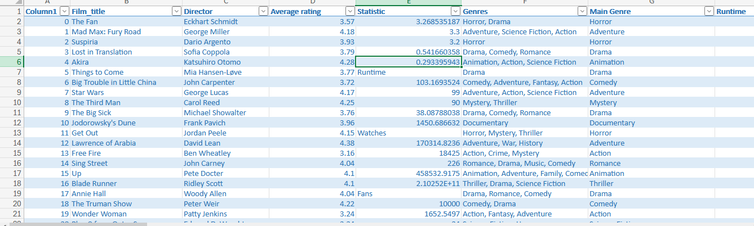
Figure 2: After data cleaning and preparation
Descriptive Statistics and Summary
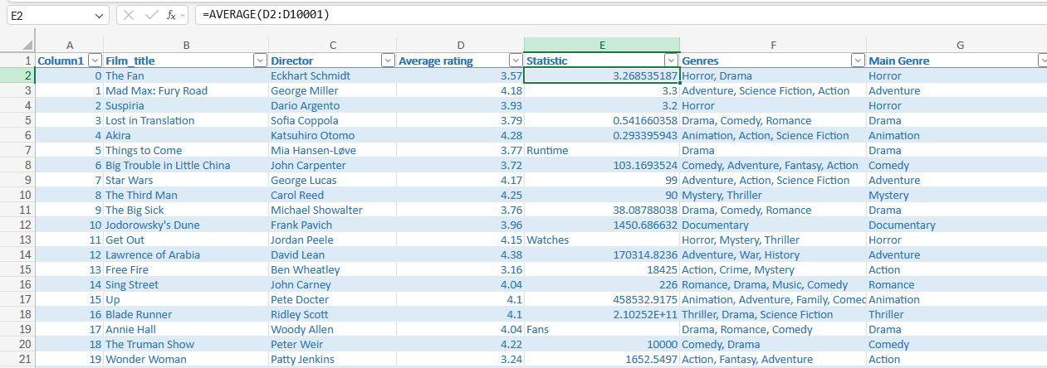
Figure 3: Descriptive statistics using Excel formula
Descriptive Statistics
 | N | Minimum | Maximum | Mean | Std. Deviation
Watches | 10000 | 2 | 5195503 | 170314.82 | 458532.917
Likes | 10000 | 0 | 2730813 | 43734.79 | 151531.431
Fans | 10000 | 0 | 326000 | 1652.55 | 9368.258
Total_ratings | 10000 | 0 | 4091037 | 106392.30 | 294734.320
Valid N (listwise) | 10000
Figure 4: SPSS descriptive statistics output
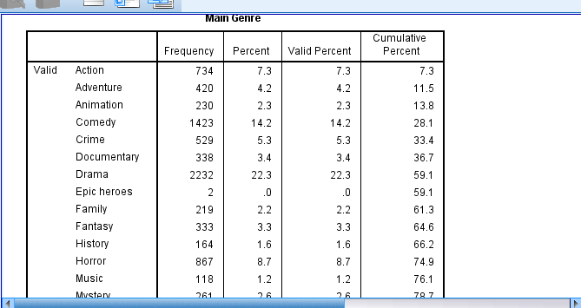
Figure 5: Main Genre Frequency table
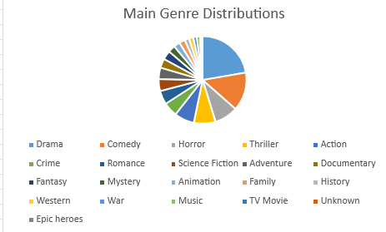
Figure 6: Main Genre Distributions (pie chart)
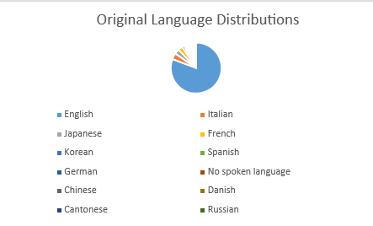
Figure 7: Original Language Distribution (pie chart)
As shown in the above screenshots, descriptive statistics of the dataset were both performed in SPSS and using Excel functions. According to Field (2024), descriptive statistics enable researchers to learn about the central tendency, variation and distribution of the data and identify patterns that could be used to inform business decisions. Descriptive analytics is the first step in business intelligence as it converts raw data into informative summaries to aid organisations in making strategic decisions and planning (Sharda et al., 2014). Descriptive statistics from SPSS showed that the average number of watches was 170,314.82 views/watches with a standard deviation of SD = 458,532.92 (Figure 3 and 4). The high standard deviation around the mean highlights the variability in the numbers of people who view films. The mean of 106,392.30 and standard deviation of 294,734.32 for the total ratings variable indicates significant variations in audience engagement across different movie types and genres.
Frequency tables and visualisations for categorical variables were created using Excel. The results for the Main Genre frequency distribution revealed that Drama was the most prevalent genre in the sample followed by Comedy, Horror, Thriller or Action (Figure 6). This distribution indicates that drama films are most prevalent genre in the film content available, consistent with the overall trend of the global film industry. Likewise, the Original Language distribution revealed that English-language make up the largest share of the data set, consistent with the many English-language films in the market (Figure 7). Average Rating Box Plot illustrates that the median rating lies at approximately 3.0 and the middle 50% of the ratings are concentrated within a relatively narrow interquaritile range. The box plot therefore shows that most films in the data set received moderately similar ratings.

Trend Analysis and Visualisation
Figure 6: Main Genre Distributions (pie chart)
Figure 7: Original Language Distribution (pie chart)

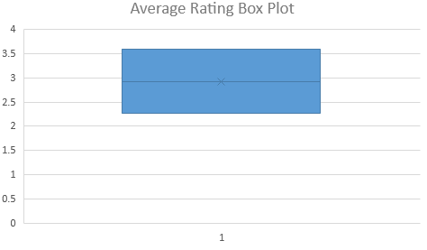
Figure 8: Box Plot of Average Rating
Group Statistics
 | English vs Non-English | N | Mean | Std. Deviation | Std. Error Mean
Average_rating | English | 8074 | 3.21 | .524 | .006
Average_rating | Non-English | 1926 | 3.51 | .461 | .011
Figure 9: SPSS Group Statistics for English and Non-English Genres
Trend analysis plays a vital role in business intelligence as it helps organisations detect the recurring trend in their past data and apply the insights to enhance strategic planning and operational performance (Chen, Chiang and Storey, 2012). Within the film and entertainment industry, knowing how audiences behave and what they like and dislike helps producers, streaming platforms, and distributors to decide on content plans, marketing strategies, and resource allocation (Davenport and Harris, 2017). As can be seen from the visualisation of the Main Genre distribution (Figure 6), Drama is the most common genre in the dataset, being followed by Comedy, Horror, Thriller and Action. On the other hand, History, War, Western and TV Movie are the least common film genres in the data set. However, it is important to note that the chart shows the number of films or representation of films in each genre in the dataset rather than indicating the number of watches or popularity. Nonetheless, if this trend is confirmed in a wide variety of datasets, it can help production companies focus more on genres that have high commercial value and resonate with a larger audience. From a business intelligence standpoint, this data can help production studios and streaming services pinpoint dominant market segments and help them understand the potential opportunities for diversification into other less saturated genres.
The Original Language distribution (Figure 7) and SPSS Group Statistics output show that English-language films are the most prevalent genres in the dataset, which potentially demonstrates their dominance in the international film market. The significant proportion of non-English films in the dataset does indicate that there is a growing audience interest in international films, however, this has been enhanced by the rise in global streaming platforms that provide multilingual films and subtitles (Lobato, 2020). This means that media companies can increase the reach of their audience by implementing localisation initiatives such as translating subtitles and using multilingual marketing.
The box plot of average rating (figure 8) suggests that the audience ratings are fairly evenly distributed across all films despite the diverse genres and languages presented in the Letterbox Movie Classification dataset. While there is some variation, most films fall within the same range of rating values, indicating that other variables, including exposure to marketing, size of attendance and/or screen visibility, might be more important than rating in determining differences in audience engagement.
Figure 10: Independent Samples T Test Output
Statistical Analysis Using SPSS
Independent Samples Test
 |  | Levene's Test for Equality of Variances |  | t-test for Equality of Means
 |  | F | Sig. | t | df | Sig. (2-tailed) | Mean Difference | Std. Error Difference | 95% Confidence Interval of the Difference
 |  |  |  |  |  |  |  |  | Lower | Upper
Average rating | Equal variances assumed | 27.710 | .000 | -23.009 | 9998 | .000 | -.299 | .013 | -.324 | -.273
Average rating | Equal variances not assumed |  |  | -24.878 | 3219.603 | .000 | -.299 | .012 | -.323 | -.275

Correlations
 |  | Likes | Fans | Average rating | Watches | Runtime
Likes | Pearson Correlation | 1 | .799** | .290** | .951** | .129**
Likes | Sig. (2-tailed) |  | .000 | .000 | .000 | .000
Likes | N | 10000 | 10000 | 10000 | 10000 | 10000
Fans | Pearson Correlation | .799** | 1 | .251** | .671** | .088**
Fans | Sig. (2-tailed) | .000 |  | .000 | .000 | .000
Fans | N | 10000 | 10000 | 10000 | 10000 | 10000
Average_rating | Pearson Correlation | .290** | .251** | 1 | .249** | .187**
Average_rating | Sig. (2-tailed) | .000 | .000 |  | .000 | .000
Average_rating | N | 10000 | 10000 | 10000 | 10000 | 10000
Watches | Pearson Correlation | .951** | .671** | .249** | 1 | .146**
Watches | Sig. (2-tailed) | .000 | .000 | .000 |  | .000
Watches | N | 10000 | 10000 | 10000 | 10000 | 10000
Runtime | Pearson Correlation | .129** | .088** | .187** | .146** | 1
Runtime | Sig. (2-tailed) | .000 | .000 | .000 | .000
Runtime | N | 10000 | 10000 | 10000 | 10000 | 10000
**. Correlation is significant at the 0.01 level (2-tailed).
Figure 11: Pearson Correlation Matrix
Model Summary
Model | R | R Square | Adjusted R Square | Std. Error of the Estimate
1 | .342ª | .117 | .116 | .494
a. Predictors: (Constant), Likes, Runtime, Fans, Watches
Figure 12: Regression Model Summary
Inferential statistical analysis is an extension of descriptive statistics, as it allows the researcher to decide if relationships or differences observed in a dataset are statistically significant, that is, not due to chance. In business intelligence, inferential techniques allow organisations to obtain evidence that can guide and help with strategic decision-making and predictive modelling (Hair et al., 2022; Provost and Fawcett, 2013). For this task, the independent-samples t-test, Pearson correlation analysis and multiple linear regression were conducted using IBM SPSS Statistics to analyse the relationships between movie characteristics, audience engagement and average ratings.
An independent-samples t-test was employed to check whether there was a significant difference between English-language films and non-English-language films in the Average Rating. The results for group statistics showed that English-language films (n=8,074) had a mean rating of 3.21 and SD=0.524 while non-English-language films (n=1,926) had a higher mean rating of 3.51 and SD=0.461. The mean difference of approximately 0.30 rating points on the five-point scale indicates, in practical terms, a moderate difference, not a trivial one. Besides, a moderate effect-size is indicated by a moderate Cohen’s d of approximately 0.59 when using the group means and standard deviations. Therefore, besides the statistical significance due to the large sample size, the finding is practically meaningful, suggesting that higher audience ratings noticeably go to non-English films compared to English-language films in the dataset.
The Levene's test for equality of variances was statistically significant (F=27.710, p < .001), which means there are unequal variances between English and non-English films (Figure 10). Therefore, the unequal variances row has been taken into account in the interpretation of the results of the t-test as suggested by Field (2024). The analysis showed that there was a statistically significant difference in the average ratings of the English language films and the non-English language films (t(3219.603) = -24.878, p < .001). This result could be due to the growing respect for foreign films and the popularity of foreign-language films made available via the internet (Lobato, 2019).
Pearson correlation tests were then conducted to explore relationships between variables for audience engagement. The results showed a very high positive correlation between Watches and Likes (r = .951, p < .001), suggesting that films with more Watches also have more Likes, meaning that films with more positive user engagement have larger audiences. However, the sufficient high size of the correlation raises concerns about multicollinearity in the subsequent regression analysis. As such, since Likes and Watches may be measuring closely related aspects of audience engagement, the regression findings should be considered with caution.
A regression analysis results shows that involved variables Likes, Fans, Runtime, and Watches as independent variables and Average rating as the dependent variable shows that the model was statistically significant (F(4, 9995)=330.085, p < .001). The 0.117 R² value indicates that the four predictor variables (run time, watches, fans and likes) can explain the 11.7% variation in the Average rating variable (Figure 13). However, approximately 88.3% of the variation in ratings could not be explained by the four predictor variables, which indicates that despite the model’s statistical significance, its explanatory power is relatively modest and may not provide a comprehensive prediction of film ratings as there might be other factors that come into play in predicting film ratings besides engagement data.
Insights, Recommendations and Conclusion
The analysis showed that business intelligence techniques can be helpful in gaining insights into the behaviour or engagement of the audience and the characteristics and performance of films. The descriptive statistics and trend analysis show that Drama films and English-language films were the most prevalent in the dataset. Correlation and regression analyses also revealed that Likes was the strongest positive predictor of average ratings. However, the regression model explained only 11.7% of the variation in ratings, indicating that engagement metrics alone could not sufficiently explain film success. These results highlight the need to consider other factors, like production budget, cast popularity and marketing expenditure, alongside engagement metrics to assess the success of films in the film industry.

Reference List
Chen, H., Chiang, R.H.L. and Storey, V.C. (2012) ‘Business intelligence and analytics: From big data to big impact’, MIS Quarterly, 36(4), pp. 1165–1188. Available at: https://misq.umn.edu/misq/article-pdf/36/4/1165/5436/8_si_chenintroduction.pdf (Accessed: 31 July 2026).
Davenport, T.H. and Harris, J.G. (2017) Competing on analytics: Updated, with a new introduction: The new science of winning. Boston, MA: Harvard Business Review Press.
Field, A. (2024) Discovering statistics using IBM SPSS statistics. London: Sage Publications. Available at: https://vlb-content.vorarlberg.at/fhbscan1/330900091084.pdf (Accessed: 31 July 2026).
Hair, J.F., Black, W.C., Babin, B.J. and Anderson, R.E. (2019) Multivariate data analysis. Available at: https://researchdiscovery.drexel.edu/esploro/outputs/book/Multivariate-data-analysis/991019295303204721 (Accessed: 31 July 2026).
Kimball, R. and Ross, M. (2013) The data warehouse toolkit: The definitive guide to dimensional modelling. 3rd edn. Indianapolis, IN: John Wiley & Sons. Available at: https://files.isec.pt/DOCUMENTOS/SERVICOS/BIBLIO/Documentos%20de%20acesso%20remoto/The-Data-Warehouse-Toolkit-2ed_Kimball.pdf (Accessed: 31 July 2026).
Lobato, R. (2020) Netflix nations: The geography of digital distribution. New York: New York University Press. Available at: https://www.degruyterbrill.com/document/doi/10.18574/nyu/9781479882281.001.0001/html (Accessed: 31 July 2026).
Månsson, M. and Waniurska, N. (2026) Between analytics and judgment. Available at: https://lup.lub.lu.se/luur/download?func=downloadFile&recordOId=9240138&fileOId=9240144 (Accessed: 31 July 2026).
Provost, F. and Fawcett, T. (2013) Data science for business: What you need to know about data mining and data-analytic thinking. Sebastopol, CA: O’Reilly Media. Available at: https://fosterprovost.com/wp-content/uploads/2019/06/Data-Science-for-Business.pdf (Accessed: 31 July 2026).
Rahm, E. and Do, H.H. (2000) ‘Data cleaning: Problems and current approaches’, IEEE Data Engineering Bulletin, 23(4), pp. 3–13. Available at: https://cs.brown.edu/courses/cs227/archives/2017/papers/data-cleaning-IEEE.pdf#page=5 (Accessed: 31 July 2026).
Sharda, R., Delen, D., Turban, E., Aronson, J. and Liang, T. (2014) Business intelligence and analytics: Systems for decision support. Available at: https://www.academia.edu/download/110353463/BUSINESS_INTELLIGENCE_AND_ANALYTICS_RAME.pdf (Accessed: 31 July 2026).

