

Ivanka Nikolova
Student number:1904047
Community Engagement
Pure Gym as a leading Health and Fitness Provider
Tanja Nathan

Table of Contents
1.Overview
2. Introduction
3. Pestle Analysis
4. Swot Analysis
5.Customers expectations and satisfaction
6. Employes Role and Training Development
7. Description Of The Job Role Undertaken and Training Plan
8. Conclusion
9. References and Appendix1
Overview
The project will include an overview of one of the most significant Health, Wellness and Fitness Company in the UK. Identifying the current strengths and weakness, trough PESTLE and SWOT analysis. The current trends and rapid changes in the fitness industry. ” The value of the UK fitness club market has been valued at £5.1bn – a figure which is expected to grow by more than 8 per cent each year.” According to (Walker ,2018)
The vital role of the employes for company expansion and growth. The customer's satisfaction and retention.


Introduction
Pure Gym is a privately held company founded in 2009 based in Leeds. The company is a low-cost health and fitness operating in the United Kingdom. It is Britain’s largest chain of clubs with over one million members. The objective of the company is to open 300 clubs by 2020 and increase the revenue from memberships. They are currently running over 200 clubs successfully representing a growth of 15.5%(Company House 2018)

 | 2017 | 2018 | Increase in numbers | Increase in %
Members | 927,00 | 1,012,000 | 85,000 | 9,25
Gym | 192 | 222 | 30 | 15.6%
 | 2017  £ | 2018  £ | Increase in  £000 | Increase in %
Revenue | 197,998 | 226,086 | 28,082 | 14,2%
EBIDTA | 64,961 | 76,254 | 11,293 | 17.4%
*EBIDTA A company's earnings before interest, taxes, depreciation, and amortization
(Company House ,2018)

The concept of the company is to allow people to join without a contract and full access 24 hours a day. The moto of Pure Gym is to enable everyone to exercise and keep healthy at an affordable rate.
They are investing in high-quality equipment and a variety of products to exceed customers expectations. All enquires are processed online allow them to develop new exciting products to attract more customers. Pure Gym is a rapidly expanding business offering a product with a considerable demand in the current market.

PESTLE Analysis
Political
The company position could be affected by changes in the current regulation. Which is very unlikely to occur in the current political environment. There is stability in regards to investment level and business growth. The government campaign towards a healthy and active lifestyle. This movement will reflect on the number of people looking to join a fitness club and exercise.
Economical
In recent years, the whole UK market has been affected by the uncertainty of Brexit. The company does not deal with European counties and will not be changed as much. Pure Gym is offering a very competitive product that will attract a considerable part of the population.
Social
The social factors are complex of an ageing population and the demand for more equipment adapted to the needs. The current trend for the growing gym culture and body image. The ever more increase demand to exercise and be healthy due to the obesity crisis.
Technological
Powerful online presence due to the decreased customer service forces. The Pure gym is investing heavily in apps, website updates. Members benefit from easy access to several information sources. They could look into developing a platform for online supplements.

Legal
The legal regulation of European law affecting obesity. The role of the government. By introducing a tax deduction for businesses if they buy into the corporate membership scheme(Gov. Uk 2018). It is an excellent opportunity for the fitness industry and Pure Gym in general.
Environmental
They are using many energy sources due to the number of equipment. Looking into an alternative source of energy.

SWOT Analysis

Strength
Pure Gym is the largest low-cost fitness chain on the market. They have a substantial base of members. Over 1 million members on a monthly membership and a constant increase.
“ So it’s no coincidence that we hold a place in the Sunday Times 100 Best Companies to work for in the UK”(Pure Gym ,2019)
They are offering a flexible product appealing to a large number of people. There is a growth of the market and the fitness industry as a whole — the increasing impact and awareness of a healthy lifestyle — the constant interest of new investors.
Maintain a firm level of cash flow supported by the monthly memberships. Moreover, the revenue from personal trainers paid monthly as rent to the gym.
One of the main strengths of Pure Gym is the online television system connected 24 hours with relevant departments to allow safe experience.

Weakness

The low-cost membership and free cancellation police will mean a high volume of customers retention. According to findings to gain new customers is five times more costly than keeping exciting customers (Schmittlein 1996)
They will need to maintain a high level of services and updating the equipment. The club capacity and class availability too. The parking availability and the cost involved. They do not have enough people to do the inductions, and the level of customer service and support will suffer. The high turnover of Personal Trainers due to lack of product to attracting new customers. The small capacity of the changing rooms during peak hours. Trying to identify and discover products that will easily differentiate the company from the rest of the market. Keeping updated continuously with the new trends and technology on the market. High investment in new equipment and highly paid trainer for all the new classes.
Opportunity
They may look into increasing the corporate memberships as a substantial part of the club budget. The increasing number of people looking to join fitness club to maintain a healthy lifestyle.

Many high-end clubs are struggling to keep operating in the current market. Create an excellent opportunity for Pure Gym to expand. From a survey in the fitness industry of 4000, fitness professionals identify a decrease in the number of people using apps to exercise.(BBC 2018)

They do not need considerable investment in marketing in order to reach more people. Pure Gym is to explore all the social media channels to increase revenue. The energetic brand presence allows the company to be easily recognisable and trusted.
The review from Public Health regarding the benefits of regular strength and aerobic exercises is a great opportunity ( Public Health 4. July 2018)
Threads
The current changes in the legislation and policies. The constant changes and increase in prices of insurance, electricity and water. The competition in the fitness industry is rapidly increasing. They are more low-cost new gyms opening. A large number of competitors and the increased risks of a price war.
Customers Expectations
According to the customers, PureGym offers fantastic fitness facilities with enthusiastic, supportive staff.(Pure Gym, 2019).
The current level of members over a million is an indicator of customer satisfaction.

Employees working within the company
Pure Gym has an outstanding portfolio of a highly motivated workforce.
“Our story has been made possible by a fantastic team of talented and committed people, whom we trust, encourage, challenge and believe in.”(Pure Gym 2019)

They believe in investing in a training programme for the ongoing support of everyone in the company. As a result of continuous staff training and support to improve customer service will impact positively on the customer's retention strategies(Theresa Hurtley, 2004)
They will never refuse the application of a person with a disability.
We are already making progress in addressing the Gender Pay Gap. For example, since autumn 2017, three of seven of the senior leadership team in PureGym have been female.
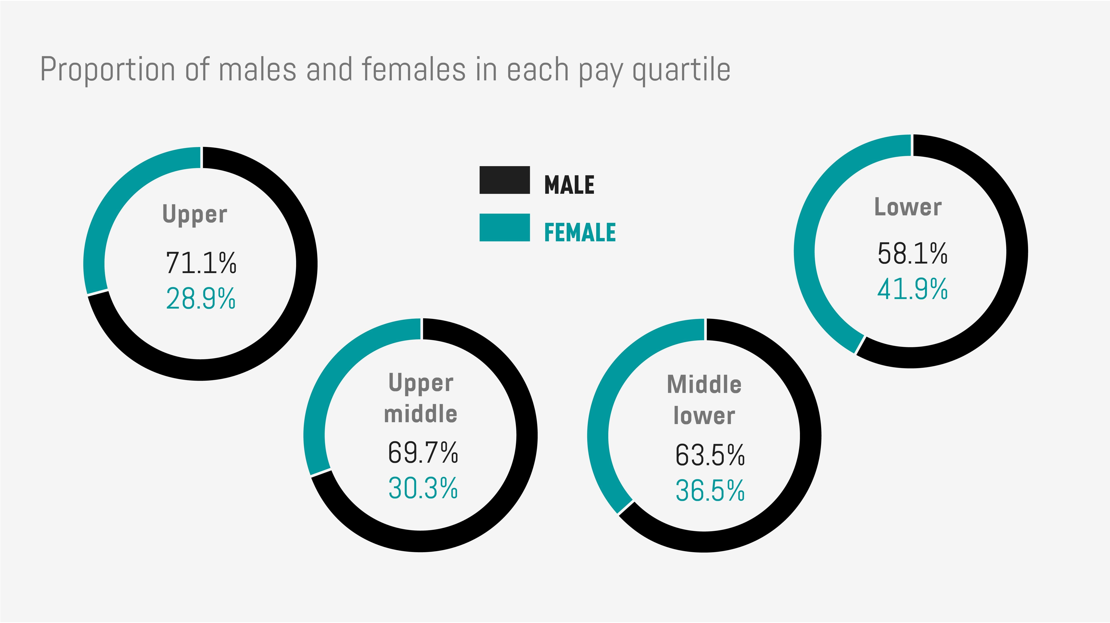
(Pure Gym 2019)
Also, other benefits such as maternity and adoption policy – that in particular support females to work at all levels of the business have been significantly enhanced to attract and retain more female colleagues within the business. (Melton and Deans, 2010)

Pure Gym has a clear pathway for a progression within the different departments:

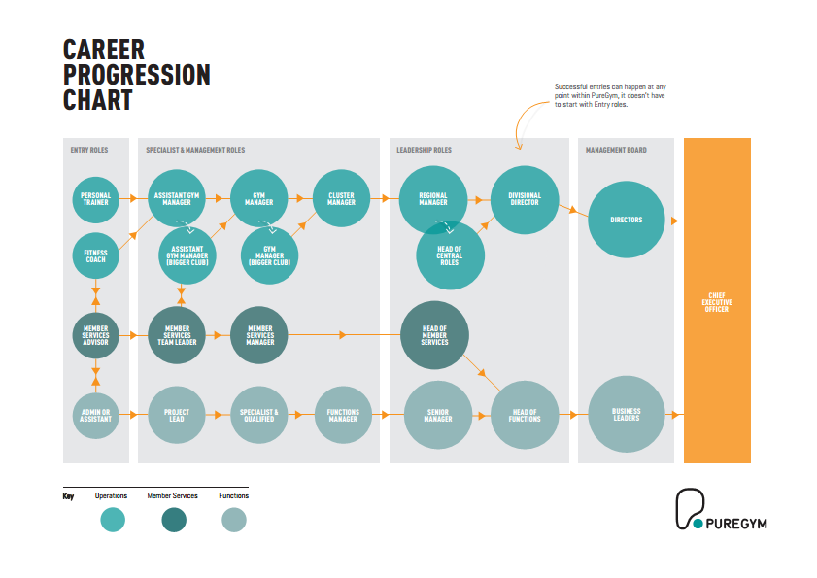
(Pure Gym 2019)

Job Role

General Manager
Working in the company as General manager running one of the busiest clubs in London near Oval Station. The club is operating since 2011 in the heart of an industrial estate. Attracting many working inside the estate and a high number of the residents. There is a university-based inside the estate attracting many of the students currently attending the campus.The club has a membership base of 3000 members on a regular monthly membership. They are currently fitness instructors and one assistant manager working in the club. And 14 personal trainers. Leading a productive and self-motivated team. “With the operating values of a
“Ethical behaviour: Doing the right thing
Relationships: Developing mutual trust and respect
Success: Operating a profitable and well-run organisation
Learning: Always growing,enquiring,and developing”(Blanchard 2019)
Part of the duty will be recruiting and training fitness instructors.
To maintain the club preparing financial statements and managing budgets and dealing with complaints and emergency up to company standards. To become familiar with all the health and safety regulation.
To complete all task by creating a long and short term marketing plan. To promote company values by offering high-value customer service. Be prepared to work flexible hours due to the nature of the business. To expect to work some evening and weekends as a majority of the customers are visiting the evening and weekends.

As a part of the responsibility is holding regular meetings with the staff offering full support and implementing a training programme. Monthly meeting in the head office and devising a full training plan:
Training name
Health and Safety Course CPD Training 2 days
Management course Level 2
Marketing Course Development Training 2 months
Leadership Course Development Training 2 Days
Customer Service Course CPD Training 2 days
Company Policy Training CPD Every six months
Training Goals
Achieving and maintain high-quality company standards
Preparing marketing plans
Skills to evaluate the needs and preparing training plans for the current employs
Moving up into the company ladder
Results
Completed and managed to achieve the following certificated
Health and Safety Certificate
Customer Service Level 2

Marketing Strategy Certificate Level2
As a part of the development plan will be undertaking ongoing CPD training programmes in the head office and online.
The role of a general manager is very crucial for the growth of the company and increase revenue. Pure Gym has a high volume of memberships, and it is essential to have healthy and reliable managers on a local level. The whole organisation and people will benefit from an effective manger.( Blanchard and Johnson 2004)

Conclusion

Pure Gym is an innovative and highly competitive company. They are continually growing brand, offering a positive customer’s experience. Despite the areas for improvement, they have positive growth for several consecutive years. After identifying the strength and weakness of the business through Pestle and Swot analysis, we can conclude the strong brand presence and the fact that the business will not be affected as much from the current economic changes in the UK. Despite all the positive factors the company is operating in a very competitive environment. They will always need to attract new customers as a vital part of business growth.

References

1.(2019) Fitness at work, Available at: https://www.gov.uk/guidance/fitness-at-work (Accessed: 1st December 2019).
2.Schmittlein, D.S. (1996) ''Customers as strategic assets'', Financial Times, (), pp. part 8.
3.Blanchard k (2010) leading at a higher level, revised edtion edn., united kingdom: pearson educations.
4.Blanchard k and johnson spencer (2004) the one minute manager , paperback edtion edn., united kingdom: harper collins publisher.
5.Company house (2019) Overview of Pure Gym, Available at: https://beta.companieshouse.gov.uk/company/06690189 (Accessed: 1st december 2019).
6.Hurley Teresa (2004) 'Managing customers', irish marketing review, 17(), pp. 23-29.
7.Jones lora (2018) 'saving pounds', bbc news, (), pp. [Online]. Available at: https://www.bbc.co.uk/news/business-44766250 (Accessed: 1st december 2019).
8. Llb reporter (2018) 'pure gym reaches 1 million mebers', london loves business, (), pp. [Online]. Available at: https://londonlovesbusiness.com/pure-gym-reaches-1-million-members-and-announces-opening-of-200th-gym-in-the-uk/ (Accessed: 2nd decmebr 2019).
9.Public Health England (2019) Major health benefits , Available at: https://www.gov.uk/government/news/major-health-benefits-from-strengthening-and-balance-activity (Accessed: 28th November 2019).
10.Pure Gym LTD (2019) Workplace, Available at: https://www.puregym.com/careers/ (Accessed: 15th November2019).
11. Walker (2018) fitness deemed, Available at: https://www.leisureopportunities.co.uk/news/Fitness-deemed-fastest-growing-business-sector-in-the-UK/338366 (Accessed: 2nd December 2019).

Appendix1:

Training Plan Template

Training Name: | Time: min | Training Type:
Leadeship Course;Managment Course;Marketing Course

Training Goals
- Improving the leadership skills
- Improving the management skills
- Improving the Marketing skills

Results
- Successfully completed leadership course
- Successfully completed management course
- Successfully completed the marketing course

Certificate Skills Covered
- Level 2 Award Certificate in Leadership
- Level 2 Award Certificate in Management
- Level 2 Award Certificate in Marketing

Time / Length | Section  Goals/Results | Description | Equipment and Material  (Room Lay) | Comments
2 days | Improving the leadership skills | Achieving better understating of leading a great team | Computers,
Ongoing | Management and marketing | Ongoing support and training due the constant changes and updates. | Computers,

