When I visit museums, heritage sites and centres, it is usually the staff and attendants that interest me more than the objects. The stuff has been, and is going to be, around for a while. These people are making a choice, reluctant or joyous, and all shades in between, to be here while I am here. I will only have this single chance to hear their stories. I’ve never been let down.

I had been to the grounds of St Fagans before, with a couple who have recently separated after sharing nearly forty years and two adult children together. The journey here had been terrible. I had cried most of the way. The bus had passed the care home that my wife lives in, and PTSD had gripped me. On top of that, the condition we don’t speak about had flared up. I was in pain and feeling sorry for myself by the time our bus arrived.

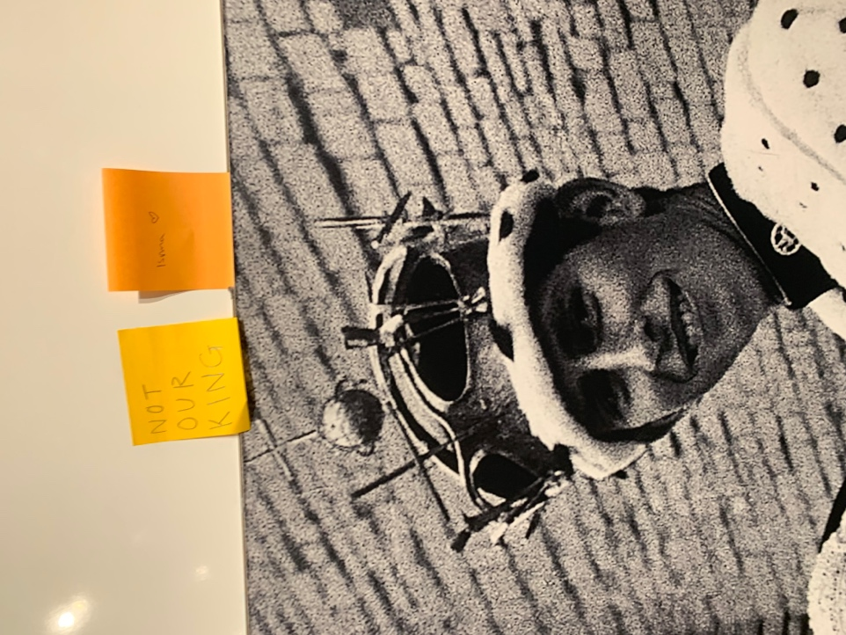
Limping into the “Wales is” space, I caught the tang of peat smoke, originating from the attendant who greeted me. I was instantly calmed and cast back to my childhood in the north of Scotland. What an evocative smell this middle-aged chap, with the happy demeanour, had about him. As interested in me as I was in him, we set about the interrogation. Quickly, it was established that both of us had known Camden Town in the 1980s. He had watched movies at the Gate cinema, where I had worked - perhaps I once tore his ticket? We had both watched blues and folk bands at the Dublin Castle pub. Our bond was cemented after we spoke of being carers. He told me he’d gone back to Camden recently and was disappointed by its gentrification. I nodded.

Moving on through the exhibition space, I took dozens of photos with my phone, without considering what was in front of me. My first wife had been an exhibition designer at the British Museum and, to be honest, I was thinking more about the layout of the exhibits and the organisation of the pathways though the space. The manufacture of, and ease of access to, the display cases.

Nevertheless, I laughed when the “NOT OUR KING” post-it note above the princely Charles’ investiture image caught my eye.

Author’s own photograph

And then. Then? I realised I was standing in front of a large black and white ariel photograph of the Aberfan disaster. Childhood memories flooded back. The silence of my parents and grandparents as the radio announcer broke the news. The tiny black and white television we owned struggled to convey the catastrophe. How it touched everybody in the kingdom.

Although I lived six hundred miles, and two nations, away I recall the newspapers seemed to struggle to print photographs large enough to convey the horror. I can still only think of Aberfan in black and white. Colour cannot be applied, even all these years later.

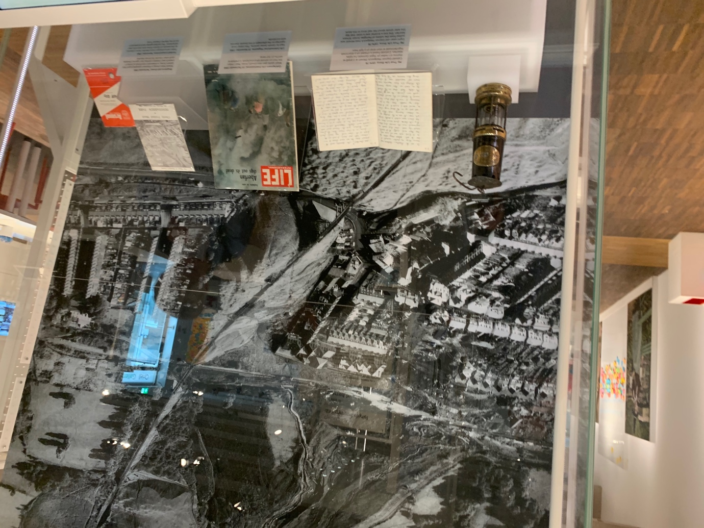
Author’s own photograph

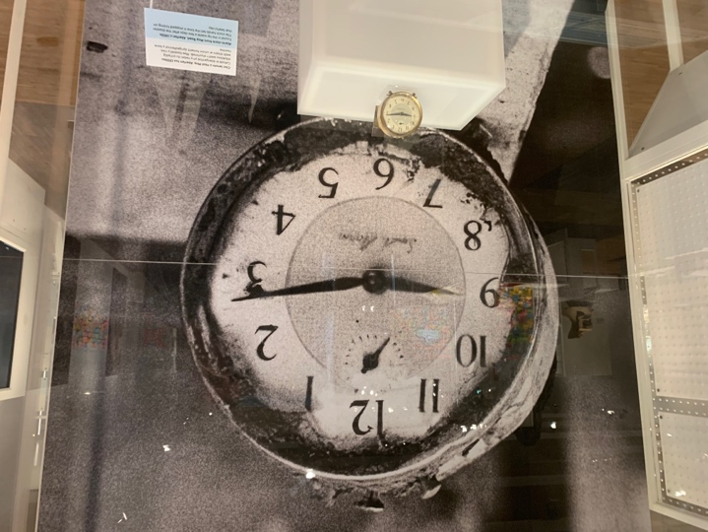
An elderly couple approached and stood beside me but did not acknowledge me. He already had tears forming in his eyes. They spoke with a precise North American accent that I’d heard before - from my two uncles who have lived in Vancouver for fifty years - but his voice had a hint of south Wales. She seemed to have no prior knowledge of what had happened that day. He had answers to every one of her questions – “But...?”, “Why was...?”, “Why would..?”, “How could..?” and “But, surely..?”.

Tears rolled down his cheeks as he answered her. Her tears only starting after her questions had stopped. I moved to the other side of the display. To the alarm clock frozen in time at the instant the world ended for so many. Blown up to enormous scale, as is fitting, but the shiny brass of the clock itself, sitting there, rescued from tip waste, unlike so many, seems so incongruous. How can anything that remains from that day be shiny? It is almost unbearable to look at.

Turning away, I was ambushed by a nondescript chest of drawers pulled from Pantglas Junior School. For so long, the only school’s name I knew in Wales.

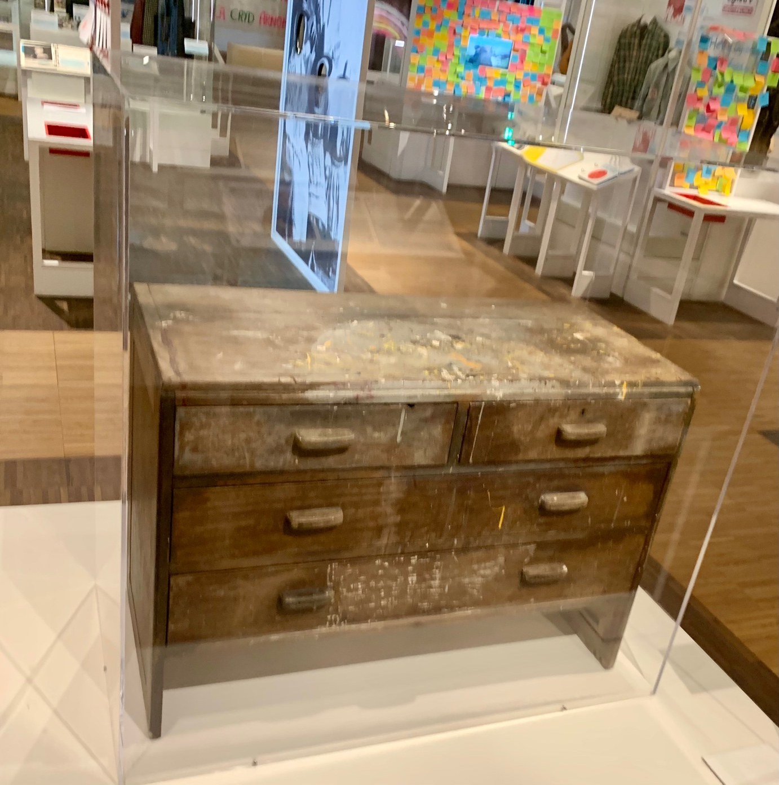

I could not stop wondering – what does it smells like? Screened by a Perspex cowl, I will never know. Yet, consider how that smell affected the museum staff who conserved it? Those who placed it there? Are attendants drawn to, or repelled by, the proximity of such a bland representation of terror?

After this, the rest of St Fagans seemed extraordinarily bright and vibrant. A potpourri of exhibitions and historic buildings. Welsh life. With a shop that peddles COAL NOT DOLE fridge magnets.

An acceptance of St Fagans visited me as I wandered. Respect for the vision, dedication, struggle; the effort that has gone into its creation and continued existence. I had needed something to stop me - jolt me out of - projecting my own concerns about Scottish nationalism, as an exile perhaps forever frozen in the 1970s. Then I witnessed that couple’s reaction to the Aberfan display.

On reflection, I have only admiration for the placement and creation of St Fagans. The part it will play in developing a future Welsh identity. If you don’t like it and think it needs to be done in another way, go ahead. St Fagans will still be here while you struggle at it.

Anticipating writing about a future field trip to Llanerchaeron, already shaping my reaction, I’d felt the need to tell a story passed on to me by my late neighbour Euros. What my visit to St Fagans brought home to me (I’ll leave the pun there) is that my neighbours have gone. Those wonderful old Welsh people who made me so welcome when I moved here twenty years ago, and who teased me and each other mercilessly. Still, they have left me fragments of their history.

Euros and Olwen - Euros skipping school as a boy and being given permission by Ponsonby at Llanerchaeron to pick flowers for his mother from the garden, hoping to avoid another skelping for truancy.

Lloyd and Nanna Thomas of Gyfeile who once farmed the fields around Tegfan, my home. The cast iron pipes that carried water from the top pond are still in the ground, perhaps to be discovered by a future archaeologist, but I will tell the story of the water wheel in the farmyard, turned by the flow of that water and powering a threshing machine.

I realised that many of the stories I want to tell are Welsh, perhaps told using Scottish words, and why not?

A slap, smack, or blow, esp. one given with the open hand [chiefly Scottish]

