

Understanding and Engaging in the Customer Experience
Student name: Anca Sultan
Student ID: 1921337
Lecturer name: Balendran Kandasemy
Executive Summary
This report has explained the customer service experience in the context of Unilever Plc. It has shown the application of marketing theories, CRM tools and models to explain the importance of service quality and customer relationships for business. Strategies and practices of Unilever Plchave been shown in the report to show the company's approach in managing customer experience and expectations. The purchase decision-making process of customers and buyers and relationships has been discussed to show factors affecting customer relationships. It has also shown the benefits and challenges of maintaining good customer relationships in an organisational context.
Table of Contents

Introduction 4
Main Body 5
Conclusion 17
Reference List 18

Introduction
Customer experience and engagement are considered for the growth of a business as it promotes loyalty and help in retaining customers for a longer period. It is crucial to offer a positive service experience to customers to continue business in future as positive experiences contribute to consistent demands for services. Many internal and external factors in a business environment affect an organisation's quality control systems and customer relationships. For instance, the covid-19 pandemic, economic crisis and Brexit are some of the external factors that affect the quality process and customer services in an organisation. Similarly, quality control, marketing strategies, Skills and the behaviour of staff are internal factors that affect customer experience.
Hence, this report will discuss customer relationship management, quality process and customer experience using theories and models in an organisational context. It will also discuss the benefits and challenges of developing good customer relationships for business. Unilever Plchas been chosen for organisational reference, as it is a popular FMCG and manufacturing organisation and it keeps innovating with customer experience offerings to maintain positive customer relationships.

Main Body
Company background
Unilever Plc is a leading British multinational company operating in the fast moving consumer good (FMCG) industry.The company offers multiple products such as food, grocery and household items.Company was established in 1929 by the merger of a British soap making company and Dutch margarine producing business (unilever.com, 2021). Currently it has more than 400 brands and it is operating in more than 190 countries. 2.5 billion Customers use Unilever products on regular basis, as company offers wide range of consumer good products (unilever.com, 2021). There are 149,000 employees working with company in different parts of world (unilever.com, 2021). Financial and market success of company indicates strong customer relationship. Hence, the company has the potential to invest in new technologies and skills to enhance customer experience by improving products and service quality with changing trends.
Unilever is world’s largest soap making company. During covind-19, pandemic company came up with initiatives to help people from all over the world by meeting their essential needs. Company donated € 100m to help people in overcoming negative influences of pandemic. Soaps and sanitizers worth value €50m donated to World Economic Forum to support global health organisations (unilever.com, 2021). Company also increased manufacturing of soaps and sanitisers for schools and offices to meet the demands of sanitising items in markets. It also donated food for people who lost their income during the pandemic. For safety of customers, company increased safety in products and packaging of products during products. Company manufactures many essential products such as baby food, cleaning products and packaged food items. Therefore, safety of employees and customers were priority during the operation.
Understanding of quality process (relating to customer service) in the workplace
Quality is considered important for building a positive image and gaining the trust and loyalty of customers. Customer services of a business significantly depend on the quality of products and services offered by the company (Santouridis and Veraki, 2017). For instance, quality in services contributes to less feedback and negative reviews. Customers also avail services repeatedly due to positive experience and greater customer satisfaction. Unilever Plc is a large business with thousands of products hence; managing quality is a big task for the company. Covid-19 pandemic has also increased the need of cleanliness, hygiene and public safety in customer experience. However, the use of technology and innovation has made it easier to monitor and test quality on different levels of operations. Regular training and development programs for employees are offered to help them in resolving customer issues quickly without any conflict. Unilever Plc has also considered customer's perspectives to develop customer services for greater service satisfaction. Hence, by anticipating customer needs and prioritising their time and attention company has gained the trust of millions of customers.
Product quality is checked in Unilever Plc before making it available for customers. This measure is useful in mitigating the risk of defects and fake products. The company has introduced product safety and quality codes to ensure quality and safety in products and services.provided by the seller. Reputation of company is based on quality of products and services, which is achieved by meeting all applicable regulations and standards in value chain. Employees are important assets in managing quality and exceeding customer expectations. Quality code of Unilever has list of must and must not for employees (unilever.com. 2021). For instance, employees must use effective measures and preventative steps to ensure great quality experience for customers. On the other hand, employee must not intentionally produce or distribute products that have negative impact on health of other staff and customers. Hence, every employee follows the quality codes during operation to mitigate risk of quality issues. Covid-19 has increased the safety and hygiene requirements in operations therefore quality has become more important to survive in market.
Another quality measure of Unilever Plc is Safety & Environmental Assurance Centre (SEAC), which measures the sustainability of product for les environmental impact of business (unilever.com, 2021). There are scientists and researchers working in these centres look after the sustainability and quality requirements in products and services. This measure is associated with operational levels and the company focuses on minimising the environmental impacts and enhancing brand reputation in market.The company has been continuously improving the process to improve the overall customer experience. Hence, effortless customer experience has made Unilever Plc a leading FMCG business in global markets. The company is emphasises improving customer experience at operational level and resolving issues permanently and immediately. Customer experience is one of the competitive advantages of Unilever Plc that has helped in surviving competition from local and global businesses.
Customer Experience at Unilever Plc
Customer experience is a subjective response of customers in case of any direct or indirect interaction with the company. It can be shaped by improving the value proposition in the offerings of the business. Service quality and practices of organisations play a crucial role in creating positive experiences for customers (Siebert et al., 2020). On the other hand, negative experiences can increase feedback and negative reviews. Hence, customers can switch to other brands for a better service experience. The customer experience at Unilever Plccan be understood by using the customer experience model.This model shows five stages that are considered by a business to enhance the overall customer experience.
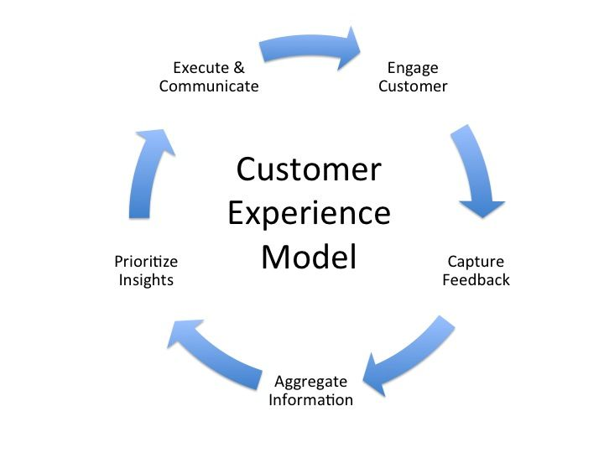
Figure 1: Customer Experience Model
(Source:Zaki and Neely, 2019)
The first stage is to engage customers where customers are attracted through marketing, innovative and quality services. Unilever Plc engages customers through its efficient and innovative customer services. A wide range of products, quality products and services and easy availability of products in markets through the website, stores and applicationfor safe services during pandemic are strategies to engage customers with business. Effective marketing and correct targeting help in attracting and engaging customers by meeting their needs. Greater engagement of the customer with business contributes to loyalty and a strong customer base. The next stage is about capturing feedback to identify weak areas that are affecting customer experience. Customers share their issues through feedback and reasons for inconvenience are identified. Hence, Unilever Plc can mitigate negative experiences by improving the areas identified. The company has a systematic approach to escalate an issue and respond to feedback for greater service quality. It emphasises reducing the efforts of customers during services to improve customer experience.
Another stage is to aggregateinformation related to market trends, customer needs and technological developments. Information is collected by performing market research, reviewing feedback and interacting with customers during services. Unilever Plc is amanufacturing business hence, collecting and analysing information is easy by using technologies such as AI and customer database. Hence, the preferences of customers are tracked and related services are suggested for a convenient and positive experience. The next stage is to prioritise the insights to make improvements in current processes and strategies. Information gathered at the previous stage is analysed to prioritise the areas and objectives for improvement in customer experience. Unilever Plc has prioritised the customer experience to maintain consistent demands and a loyal customer base. Safety and convenience in services while complying with safety guidelines related to Covid-19 is current insight for Unilever Plc. Therefore, it continuously works to bring new services and convenience for its customers as per the insights from research and feedback.
The last stage is to execute and communicate the insights in business. Innovation is a continuous process at Unilever Plc and it keeps adding new products and services in its portfolio for meeting the expectations of customers. Based on insights gathered from research, feedback and analysis new and improved services are developed, executed in business. The company has a dedicated customer support team to look after the needs of customers and addressing their queries in less time. Skilled and qualified staff interact with customers to resolve the issue at initial levels. 24/7 customer support services are available to help customers with their needs. Unilever Plc has prioritised the customer experience to attract and retain customers for competitive advantage. Discounts offers and after-sale services are available for customers to enhance the value proposition.
Buying Decision Making Process
The consumer decision-making process is a journey of the consumer during a market transaction that shows changes in decisions at different stages of the process. There are five stages of the decision-making process that help brands in influencing purchase decisions by understating customer expectations at different stages.
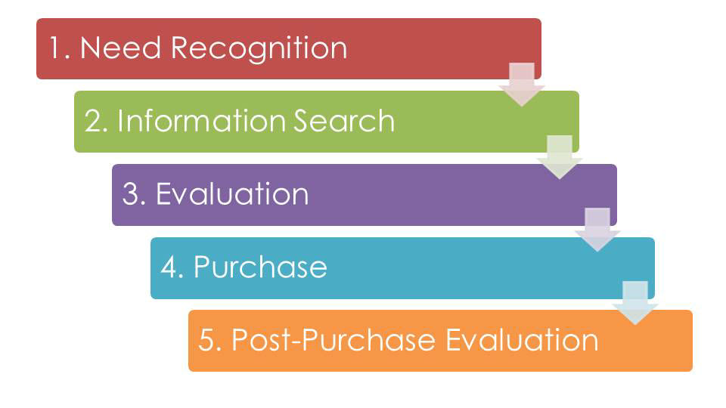
Figure 2: Consumer Decision making Process
(Source:Huang and Benyoucef, 2017)
The first stage is to identify the need for a product or service. Unilever Plc creates the need for products by marketing and promotion among target customers. New products, quality and prices are used to encourage the need for purchase. Information search is the step of exploring the options available for customers in markets. Competitors’ products, substitutes are explored to filter best-suited products as per budget and need. Hence, Unilever Plc uses retailers, TVE advertisements and social media marketing for easy search of Unilever Plc products on online and offline media platforms. Evaluation is the step where the selected product is compared with other options in terms of price, design and durability. Fairtrade practice is important to provide reliable and valid information about products to attract customers (Weissteinet al., 2017).
Next is purchase where ownership of the product is transferred to customers and the product is delivered. Sales tactics are used to turn the decision of customers into sales. Offers, discounts and saleare offered by retailers to encourage purchase of Unilever products. Lastly, feedback, return and exchange are the result of the post-purchase evaluation. Unilever Plc has easy and convenient after-sale services for customers to continue customer relationships.
Value and purpose of Customer Relationship Management (CRM)atUnilever Plc
Customer relationship managementcan be referred to as a system for managing interactions between a business and its customers. It includes various areas such as marketing, sales, technical support and customer services (Bergeron, 2004). The overall experience of a customer with a business determines the future relationship. Strong customer relationship indicates loyalty and trust of customers in business. On the other hand, weak customer relationship indicates weak brand image and low loyalty towards the brand. CRM is important for Unilever Plc to develop customer loyalty and expand the reach of business during convid-19 pandemic. Therefore, the company has introduced innovative and customised services for the convenience of customers in different countries. Unilever products are available on different e-commerce platforms such as Amazon, Tesco and Asda. Hence, customers can reach to products easily by searching brands owned by company. It shows the initiatives of the company towards customer engagement and relationship management.
CRM at Unilever Plccan be explained using the IDIC model of CRM. Peppers & Rogers Group introduced this model in 2004. This model divides CRM into two categories: analytical and operational. Analytical CRM focuses on customer insight and operational CRM emphasisesdelivering a good customer experience (Santos, 2020). Each letter in the name of the model suggests steps involved in the CRM process of business.
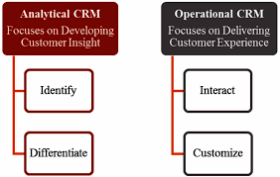
Figure 3: IDIC Model
(Source: cbusinessnewsdaily.com, 2021)
Identify - The first step is to identify the target customers and understand their needs and preferences. By understanding, the customers or leads an organisation develops can better customer relationship. This step also helps in identifying pain points that are affecting customer experience and engagement with business. Hence, Unilever Plc can identify both pains and gain points to develop strategies related to CRM as per customer segments. It can develop customised and safe online access to products and delivery services for different customer groups based on the findings of this step.
Differentiate - At this step, customers identified in the first step are segmented based on the value created by them for the businesses. Both long-term and short-term value can be considered to classify customer segments. Hence, Unilever Plc can consider time, strategies and efforts spent on different customer segments. The company has a large customer base therefore; segmentation of customer groups can be used to develop services as per the needs of customers and focus on key customer groups for greater value generation. Issues of these customer segments can also be identified easily and permanent remedies can be offered.
Interact - Successful application of the first two steps creates the base for interaction between customers and business. Hence, personalised communication and services can be developed as per the needs of customer segments (Kumar and Reinartz, 2018). Unilever Plc can easily understand the needs of customers during interactions by classifying and differentiating customer groups. These interactions can be developed into long-term relationships between businesses and customers. Interactions are also a source of information for business, as customers share their preferences with the business. Therefore, this step is crucial for building positive customer relationships.
Customise -In this step, information gathered during interactions are used to customise services and product portfolio as per customer requirements. Unilever Plc has products for customers from different income groups, cultures and age groups. For instance, customers can use the local e-commerce platforms to buy products of Unilever Plc in their local area for convenience. Products related to different cultures such as Indian, Chinese, Italian and American are produces in different locations.Therefore, customising services as per customers' needs is an effective way of developing and maintain customer relationships.
Relationship marketing
Relationship marketing is a concept based on the idea that stronger customer relationships can lead to greater demands, loyalty and promotion of the brand. It is part of CRM that is focused on long-term customer engagement and loyalty (Gummesson, 2002). Unilever Plc can use this marketing strategy to develop deeper and longer relationships with customers in this uncertain market condition. The company is using affiliate marketing, influencer marketing and referral marketing to connect with customers using multiple channels. This marketing strategy encourages the existing customer base to continue availing services in the longer run.
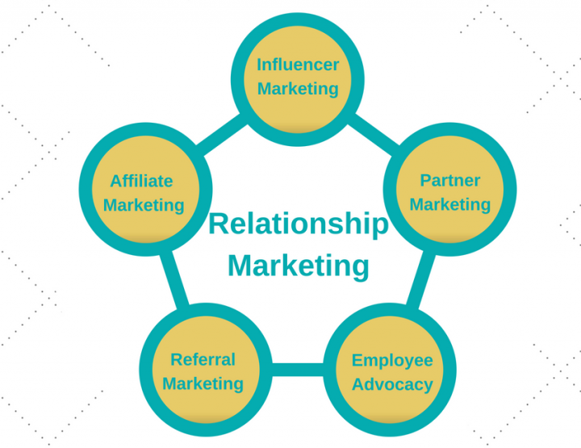
Figure 4: Relationship Marketing Strategies
(Source: Melancon, and Dalakas, 2018)
Influencer marketing is a technique in which social media influencers, celebrities and influential people are used to promote products and services of a brand among specific target customer groups. It is an effective way of targeting specific demographics such as age, gender and lifestyle.Unilever Plc also uses influencers on Instagram and YouTube to connect with customers. It is easy to influence the purchase behaviour of potential customers by using popular influencers in that market niche. Partner Marketingis done by collaborating with media houses, marketing agencies to promote a brand in the wider area (Piercy, 2016). Unilever Plc uses this technique to promote the brand in different countries by using local media partners. Employee Advocacy is a commonly used marketing technique in which employees promote the brand among family and friends or develop a strong bond with potential customers to encourage sales.
Referral marketing is generally used by new businesses or existing businesses in new locations. Businesses offer referral discounts and benefits to the customer for sharing and promoting the brand with others. Affiliate marketing is widely used by businesses for the promotion of its products. In this technique, individuals using online channels such as blogs, YouTube channels and Instagram accounts in return for rewards promote one or more products. Discounts are offered to buy a product from affiliate links. Unilever Plc is increasing its marketing budget each year to improve its marketing campaign and make it more engaging.
Unilever Plc has an effective customer service team to address customer issues at any time. It is also important to have an effective CRM tool for managing feedback and tracking communication for proper follow-ups.Unilever Plc has invested in technology for managing communication between customers and business during services, issues and queries. Hence, it is easy for staff to keep track of issues and come up with permanent solutions. Another important need is comprehensive customer-facing portals for quick access and response to customer issues (Thaichon and Ratten, 2020). For instance, customers can reach to customer services of Unilever Plc using texts messages, emails and calls. There are multiple ways to report an issue offered for the convenience of customers.
Buyer Seller Relationship
Understanding of buyer seller relationship is important to understand customer relationships. This relationship has become important during covid-19 pandemic due to increased demand for online services (Itaniet al, 2017). Four types of buyer-seller relationships exist in CRM, transactional, functional, affiliate and strategic.Transactional relationships exist for a small period and each sale is a separate transaction between the parties (Echchakoui and Ghilal, 2019). Retail sales ofUnilever Plc are transaction sales between customers and the company. Functional relationships are the long-term relationship between parties and buyer continue to purchase products from sellers. The relationship between retailers, suppliers and Unilever Plc is an example of a functional relationship. An affiliate selling relationship exists between buyer and seller when a certain amount of expertise is needed and trust is an issue between parties. Unilever Plccan use affiliate sellers to promote products among retail customers. Strategic relationships exist when both parties have significant benefits from a transaction. Partnerships and suppliers of Unilever Plc are strategic relationships of business.
Managing customer engagement and expectations At Unilever Plc
Customer engagement is the process of interaction between a brand and customer through various online and offline channels. A high level of customer engagement shows regular purchases, positive reviews and greater loyalty. Interaction between business and customer takes place using online and offline channels. Therefore, focusing on the in-store experience, navigation and interface of online tools such as websites and applications can enhance customer engagement (Goodman, 2009). Unilever Plc is a FMCG business, therefore, service experience from daily household products plays important role in the customer engagement practices of the company. It has focused on the needs of customers to develop products, services and value chain for the convenience of customers. Meeting the needs of customers and improving services at each touchpoint is the idea of Unilever Plc for engaging customers and increasing sales in post pandemic market conditions.Therefore, various online platforms for availability or products in markets and 24/7 customer support are introduced to address the needs of large customer groups.
Maslow hierarchy of needs theorycan be used to meet the needs of customers to enhance engagement.
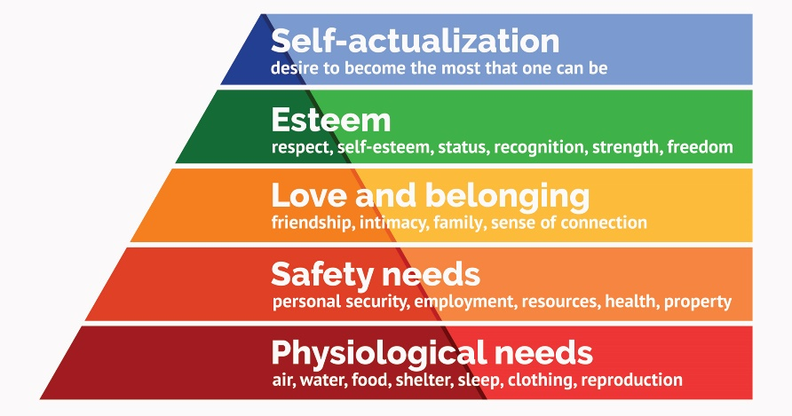
Figure 5: Maslow Hierarchy of Needs
(Source: Hopper, 2020)
There are five needs of an individual shown in the theory that can be fulfilled to encourage them to engage with products, services or any task. Unilever Plc can consider these needs of customers to develop products and services for keeping them engaged with business in the longer run. Basic needscan be fulfilled by offering quality products and services as per their needs. A large number of products for customers from different cultures, gender and age groups can meet the basic needs of people during shopping. Safety needs can be met by providing privacy and safety during delivery, signing up and payments. Compliance with the data protection act and the use of security systems can offer greater safety for customers during interactions. Covid-19 safety guidelines followed by staff and delivery partners. Hence, storing and using this information safely for business use can help in gaining the trust of customers.
Love and belonging needscan be fulfilled by quick response to queries and friendly staff. Employees can be trained to interact positively with customers. Personalised services can develop a sense of belonging in people.Esteem needs can be fulfilled by recognising the loyalty of customers by offering discounts, free services and loyalty programs. Meeting these four needs can lead to reaching the top level of hierarchy and customers can develop loyalty towards the brands (Fallatah and Syed, 2018). Self-actualisation can be achieved by considering the expectations of customers and eliminating issues related to quality, queries and purchase experience. Unilever Plc has a friendly staff and strong value chainto meet the basic and safety needs of customers. It has friendly and skilled staff to help customers with their problems. There are offers and discounts for regular customers to recognise their loyalty. Hence, the company is effectively meeting the needs of its customers to maintain positive and long-term customer relationships.
Service quality management (SQM) At Unilever Plc
SQM is a measure to compare service expectations of a customer and company’s performance in meeting those expectations.It is crucial for customer satisfaction, as quality products generate greater value for money. Unilever Plc considers SQM for maintaining brand reputation, managing costs and satisfy customer needs. Quality standardcodes and quality guidelines have been introduced for products and services available on the websites, physical stores and application. Technology is used to inspect and reduce quality issues in the digital contents of Unilever Plc. Employees are provided with training and list of quality procedure to ensure product quality.
SERVQUAL model is used business to identify quality expectations of customers and current practices of business. This model includes five areas that are considered to compare the actual quality of services from customer expectations (Gajewskaet al., 2019).
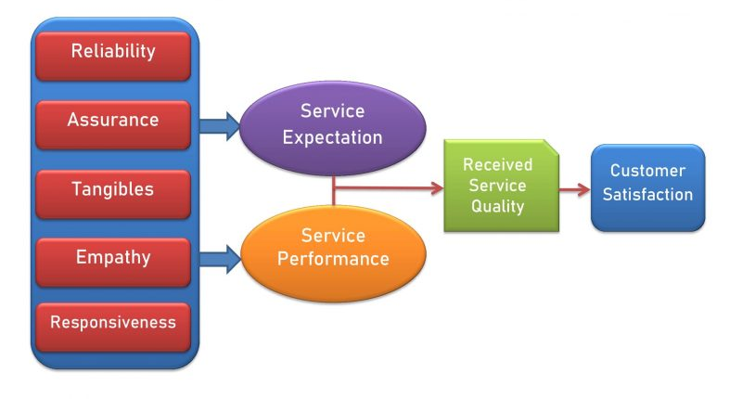
Figure 6: Servqual Model
(Source:Shi and Shang, 2020)
Reliability– Reliability indicates the ability of a brand to meet the service expectations of customers efficiently and accurately. It shows the ability of businesses to offer the quality that they promise to their customers. Unilever Plc has sufficient resources to invest in training, research and technology to improve products and service quality at each level of operations. Customers can rely on the company for quality products and services due to its strong brand name and high market value.
Assurance – This area includes skills and abilities of staff and management to convey confidence and trust of business towards quality. Therefore, the interaction between staff and customers plays important role in assuring the quality of services. Unilever Plc has trained, skilled and friendly staff to convey the policies of businesses related to service quality and customer experiences. Free customer support is available 24/7 to help customers and address their issues.
Tangibles – This area includes physical channels, facilities, equipment, communication facilities and personnel that represents the promises of the company about service quality (Afthanorhanet al., 2019). For instance, customers can analyse service quality by using the products of Unilever Plc. Similarly, the quality of products received can indicate issues in facilities. Well-behaved and friendly staff is tangible evidence of service quality for business.
Empathy – This area states about caring and personalised attention offered by a brand to its customers. Understanding customer needs and valuing small expectations of customers in the marketing and sales process shows the empathetic approach of the brand ((Steinhoff et al., 2019). Unilever Plc also prioritises the needs of all customers in its product portfolio and customer services to exceed their expectations. Issues of customers are rectified quickly to value their time and effort.
Responsiveness– Lastly, this area indicates the willingness of brands to help their customers and offer a quick response to problems.Unilever Plc is highly responsive to the trends, feedback and problem of customers. It continued operations during pandemic ensuring availability of essentials for customers. Hence, quick solutions to queries add to the service quality of Unilever Plc.
Benefits and challenges of developing and maintaining good customer relationships
Benefits
The first benefit of a good customer relationship for Unilever Plc is the strong brand name of the company. Strong customer relationships contribute to positive reviews of products and services that attract new customers. Marketing of products and services becomes easy due to the increase in popularity of the brand. Unilever Plc can use this strong brand name to enter new markets. Hence, brand name improves with the good customer relationship. Another benefit of developing a good customer relationship is customer loyalty and long-term growth. Loyalty develops with a deeper customer relationship between a brand and its customers (Bin-Nashwan and Hassan, 2017). Unilever Plc can enhance a loyal customer base for consistent demand in uncertain market conditions.
The next benefit is a competitive advantage for the brand. Consistent demands and a strong brand name are a significant competitive advantage for any business. Unilever Plc also has this competitive advantage due to good customer relationships. Customers use the company for buying products related to daily needs. Good customer relationships also contribute to an increase in sales and profitability for the business. Unilever Plc can attract new customers through effective customer services and relationship marketing hence, sales can be increased. Similarly, increased sales volume can lead to higher profits and financial freedom for the company.
Challenges
The first challenge associated with developing and maintaining customer relationships is managing skilled staff for quick response to customer issues. It is difficult to understand the needs and expectations of all customers. Therefore, staff might face issues in managing problematic customers. Another issue can be a lack of focus, as a customer of diverse needs. Similarly, different locations and cultures have different legal, financial and marketing requirements. Hence, solving too many issues in less time can be a challenge (Leppard and Molyneux, 1994). Communication is also a challenge, as it requires the active participation of all parties in the process. Regular communication and follow-up can be difficult due to heavy work pressure on staff.
Leadership support is also an issue, as it is required to help customer support staff to face critical issues. Availability of suggestions and resources to help customers in real-time is an issue for large businesses. Therefore, Unilever Plc also witnesses a long list of feedback on regular basis. Lack of clarity about objectives, responsibilities and customer support practices can affect the process of developing good customer relationships. Strong leadership and effective technology integration in the process can help in mitigating these challenges.

Conclusion
Thus, it can be concluded from the report that Unilever Plc has well-established customer relationship management to manage customer experience and expectations. The company has quality guidelines and technologies to ensure quality in services during pandemic. Buyer and seller relationships are considered for developing long-term and short-term customer relationships. The consumer purchase decision is considered to influence the buying decisions and increase sales. The service quality of a brand depends on reliability, assurance and responsiveness. Hence, focus on these areas can improve customer experience and develop deeper customer relationships. Good customer relationships can help Unilever Plc in building brand name and gaining competitive advantage However, lack of focus, diverse needs of customers and communication issues are challenges in maintain customer relationships.

Reference List
Afthanorhan, A., Awang, Z., Rashid, N., Foziah, H. and Ghazali, P., 2019. Assessing the effects of service quality on customer satisfaction. Management Science Letters, 9(1), pp.13-24.
Bergeron, B., 2004. Essentials of CRM: A guide to customer relationship management (Vol. 14). John Wiley & Sons.
Bin-Nashwan, S.A. and Hassan, H., 2017. Impact of customer relationship management (CRM) on customer satisfaction and loyalty: A systematic review. Journal of Advanced Research in Business and Management Studies, 6(1), pp.86-107.
businessnewsdaily.com. 2021. What Are CRM Models?. Available at: https://www.businessnewsdaily.com/16098-crm-models.html (Accessed: 22 July 2021).
Echchakoui, S. and Ghilal, R., 2019. How sales managers can use salespeople's perceived attributes to monitor and motivate a sales force during relationship marketing. European Research on Management and Business Economics, 25(2), pp.99-104.
Fallatah, R.H.M. and Syed, J., 2018. A critical review of Maslow’s hierarchy of needs. employee motivation in Saudi Arabia, pp.19-59.
Gajewska, T., Zimon, D., Kaczor, G. and Madzík, P., 2019. The impact of the level of customer satisfaction on the quality of e-commerce services. International Journal of Productivity and Performance Management.
Goodman, J., 2009. Strategic customer service: Managing the customer experience to increase positive word of mouth, build loyalty, and maximize profits. Amacom.
Gummesson, E., 2002. Total relationship marketing: Marketing management, relationship strategy and CRM approaches for the network economy. Total relationship marketing: marketing management, relationship strategy and CRM approaches for the network economy.
Hopper, E., 2020. Maslow’s Hierarchy of Needs Explained. ThoughtCo, ThoughtCo, 24.
Huang, Z. and Benyoucef, M., 2017. The effects of social commerce design on consumer purchase decision-making: An empirical study. Electronic Commerce Research and Applications, 25, pp.40-58.
Itani, O.S., Krush, M.T., Agnihotri, R. and Trainor, K.J., 2020. Social media and customer relationship management technologies: Influencing buyer-seller information exchanges. Industrial Marketing Management, 90, pp.264-275.
Kumar, V. and Reinartz, W., 2018. Customer relationship management. Springer-Verlag GmbH Germany, part of Springer Nature 2006, 2012, 2018.
Leppard, J. and Molyneux, L., 1994. Auditing your customer service: the foundation for success. Cengage Learning Emea.
Melancon, J.P. and Dalakas, V., 2018. Consumer social voice in the age of social media: Segmentation profiles and relationship marketing strategies. Business Horizons, 61(1), pp.157-167.
Piercy, N.F., 2016. Market-led strategic change: Transforming the process of going to market. Routledge.
Santos, F.R.D.S.B., 2020. Building the foundations for CRM strategy in a company–the case of a Tech Start‐Up (Doctoral dissertation).
Santouridis, I. and Veraki, A., 2017. Customer relationship management and customer satisfaction: the mediating role of relationship quality. Total Quality Management & Business Excellence, 28(9-10), pp.1122-1133.
Shi, Z. and Shang, H., 2020, July. A review on quality of service and servqual model. In International Conference on Human-Computer Interaction (pp. 188-204). Springer, Cham.
Siebert, A., Gopaldas, A., Lindridge, A. and Simoes, C., 2020. Customer experience journeys: loyalty loops versus involvement spirals. Journal of Marketing, 84(4), pp.45-66.
Steinhoff, L., Arli, D., Weaven, S. and Kozlenkova, I.V., 2019. Online relationship marketing. Journal of the Academy of marketing science, 47(3), pp.369-393.
Thaichon, P. and Ratten, V. eds., 2020. Transforming relationship marketing: Strategies and business models in the digital age. Routledge.
unilever.com. 2021. All brands. Available at: https://www.unilever.com/brands/ (Accessed: 24 July 2021).
unilever.com. 2021. Helping to protect lives and livelihoods from the Covid-19 pandemic. Available at: https://www.unilever.com/news/press-releases/2020/helping-to-protect-lives-and-livelihoods-from-the-covid-19-pandemic.html (Accessed: 24 July 2021).
unilever.com. 2021. Our company | Unilever. Available at: https://www.unilever.com/our-company/ (Accessed: 24 July 2021).
unilever.com. 2021. Our history & archives | Unilever, Available at: https://www.unilever.com/our-company/our-history-and-archives/ (Accessed: 24 July 2021).
unilever.com. 2021. Product safety and quality | Unilever. Available at: https://www.unilever.com/planet-and-society/responsible-business/product-safety-and-quality/ (Accessed: 24 July 2021).
warc.com. 2021. CRM to Play Key Role in Unilever's Global Marketing | WARC. Available at: https://www.warc.com/newsandopinion/news/crm-to-play-key-role-in-unilevers-global-marketing/15899 (Accessed: 24 July 2021).
Weisstein, F.L., Song, L., Andersen, P. and Zhu, Y., 2017. Examining impacts of negative reviews and purchase goals on consumer purchase decision. Journal of Retailing and Consumer Services, 39, pp.201-207.
Zaki, M. and Neely, A., 2019. Customer experience analytics: dynamic customer-centric model. In Handbook of Service Science, Volume II (pp. 207-233). Springer, Cham.

