STUDENT NAME : MIRELA ELENA IONESCU
STUDENT NUMBER : 1815193
MODULE TITLE : HOSPITALITY AND GUEST SERVICE – M4X01915
ASSIGNEMENT TITLE : Evaluative report, based on a hotel organization of your choice. In your report, you will discuss the service provided in the chosen hotel, quality management (Continuous improvement), how the hotel adapts to changing consumer preference and how these changes impact guest service management.
LECTURER NAME : DR. OLU ADEGBITE

CONTENT PAGE
INTRODUCTION
DISCUSSION
QUALITY MANAGEMENT (CONTINUOUS IMPROVMENT)
GUEST SERVICES
HOW CHANGING CONSUMER PREFERENCES IMPACTS GUEST SERVICE MANAGEMENT
CONCLUSION

INTRODUCTION
The purpose of this report is to analyze the services, the quality of the services and the determination of the management of a hotel to adapt to changing the preferences of the clients.
Guest services is the act of taking care of the customer`s needs by providing and delivering professional, helpful, high quality service and assistance before, during, and after the customer`s requirements are met. (study.com)
In this report is the analysis of the services offered by HOTEL PREDEAL COMFORT SUITES. Predeal comfort suites is the hotel that manages to meet the wishes of its customers, harmoniously combining the high quality services with the unique view that the mountains have to offer this hotel. The hotel is select, luxurious, original, thoughtful and built to delight guests with impeccable four-star service.
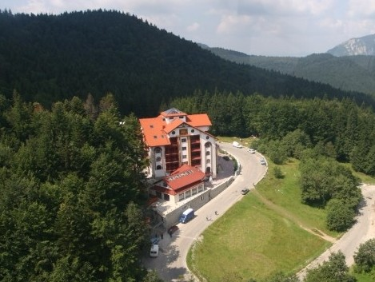

DISCUSSION
The services offered by this hotel are:
- Lebanese restaurant
- Swimming pool
- Spa and sauna
- Jacuzzi
- Free parking
- Free internet
Besides all these services, this hotel offers a relaxing massage program to its guests.
The hotel has sixteen rooms with double bed, these are suites, sixteen deluxe suites that are made up of living room and bedroom and sunflower suite where guests benefit from an exclusive treatment throughout the stay. All rooms and apartments have minibars, wi-fi, guests can call the room service anytime and many other facilities for personal needs. This hotel also has conference rooms equipped with ultra-modern equipment.

GUEST SERVICES IN HOTEL
Guestology is a term originated by Bruce Laval of The Walt Disney it means that all the organization’s employees must treat customers like guests and manage the organization from the guest’s point of view “GPOV”. (linkedin.com)
For the hotel to provide the services correctly and efficiently, it must:
- know the product - know what sells to customers
- to know the customer - he must know the preferences of the customers and what he wants from the hotel, he must know if the client has allergies or any other problems regarding the food
- to know themselves - the employees and the management of the hotel must know themselves to know what the client wants, to be friendly, sociable and to inspire confidence and must know absolutely everything about the hotel in order to be able to communicate to the clients information
- the goals of all - the departments of a hotel must communicate with each other in order for the organization to function correctly and continuously, working in a team, trusting each other most often bring goals that make the company reach the highest levels of the hospitality industry.
In order to win the trust of the customers, the front desk employees of the hotel, must follow certain criteria:
- smile - for the client to feel welcome in the hotel
- make contact eyes - for the client to feel that the employees trust the services they provide, to feel that the employees are sincere
- respect for the guests - respect is an important factor in the hotel and guests must feel respected to return to the hotel
- initiates the contact with the guests - the phones that I give to the customers are important because, the guests feel important and this is the truth.
- creates special services for guests - such as surprise parties for customers
- always end with a thank you - employees will always end discussions with clients with a thank you.
As the services are wider and more quality, the relationship between the client and the company becomes closer and the collaborations between them are very well frozen.
When the customer is satisfied he stays loyal longer, he buys more as the company introduces new products, speaks beautifully of the company and pays less attention to the other companies.

QUALITY MANAGEMENT (CONTINUOUS IMPROVEMENT)
Quality management is the act of overseeing all activities and tasks needed to maintain a desired level of excellence. This includes the determination of a quality policy, creating and implementing quality planning and assurance, and quality control and quality improvement. (investopedia.com)
In order to improve the services offered to the clients the hotel must focus on certain principles of management quality.
In order to gain the quality and the improvement of the services offered to the clients, for a correct and satisfactory distribution of the services, the management of the hotel must consider the following aspects.
Safe operation - no errors or delays regarding the distribution of services.
Receptivity - availability and willingness of employees to provide services to customers.
Capability - the competencies of all employees but especially the competence of the personnel who have contact with the clients and the operational personnel.
Practicable - the skills of the employees who know how to approach the client and how to get in touch with the client, giving him detailed details about the hotel services
Kindness - friendship, kindness, respect of the service personnel so that the clients feel satisfied with the services made available to him.
Communication - communication between hotel employees and customers is important because clients need to be aware of certain services and products and they should be listened to when there is something wrong
Trust - the hotel must awaken in its clients the trust, honesty and credibility so that they can enjoy services and return to the hotel
Security - the hotel offers the clients and employees the security, being important for the protection of both
Report - understanding the personal needs of the clients
Maintenance - maintenance of electrical, thermal installations, all the equipment that helps the operation of the hotel gives the confidence and protection of customers and employees.

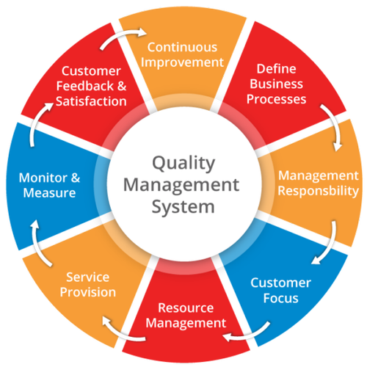
Taking all this into account, the hotel demonstrates the ability to constantly provide products and services that satisfy the clients' wishes, demonstrates that it oversees all the activities and tasks required to maintain a high quality level of desire.
When the new changes in the hotel will come into practice the management of the company must anticipate the client's behavior and wishes because these changes require a complex process.
At the beginning of the changes in the hotel, it offers its customers numerous offers to attract the customers to try the new products.
Quality management also includes quality policy determination, quality assurance, control and improvement, but also creation and implementation of planning.
Considering all the above, management quality works only if all the departments of the hotel work together to improve the processes, products, services offered to the clients and to improve the business itself.

HOW THE HOTEL ADAPTS TO CHANGING CUSTOMER PREFERENCES
How the hotel adapts to changing customer preferences is self-change, involving all departments and involving the management of the hotel to provide customers with high quality services. In order to adapt to changing customer requirements, the hotel management must communicate with the clients to listen to their wishes and dissatisfactions regarding the services offered.
By making available to the customers more facilities, the hotel adapts to changing customer preferences. These facilities consist of the clients' wishes which could be:
- spaces with commercial functions; tourist office, rent-a-car office, beauty salon inside the hotel
-sports field
- showrooms
- rooms with 3 single beds
- space for reading
- spaces for kids
-Technological advancement
- Trained highly qualified staff
Considering all this, the hotel management must also consider the hotel staff that must be trained, must have a positive attitude, always be sincere, make the client feel comfortable and collect as many goals to make the management proud and communicate with the other departments to ensure that the changes that follow will be advantageous and bring revenue to the hotel.
Technological advancement, customers don’t like to wait in queue, so now hotels tourism industries started self check-in check-out service,

HOW CHANGING CONSUMER PREFERENCES IMPACTS GUEST SERVICE MANAGEMENT
These changes in customer preferences can affect the management of the hotel services because the hotel must implement new rules and new customer needs in the hotel, it must identify the customer satisfaction regarding the services, needs and expectations of the customers.
However, the hotel must focus on the market, which tends the trends, which are being carried on at the moment, must also take care of the local and national aspects of the place.
If the hotel is not market oriented these changes can be expensive for the hotel and can generate the following:
- high level of complaints and the technology to answer would be expensive
- must maintain the expensive mechanisms in which they would invest
- customers would not evaluate the products correctly
- higher prices
- must constantly invest in product promotion activities
- performance quality difficult to achieve
- replacing old customers who would not pay more for new services
- development in new markets
In this situation there are also bad things but good things, considering that the hotel does not have as many facilities as other hotels. The hotel would enter the modern market, the management of the hotel should focus more on the needs and wishes of the customers to maintain the successful business.
In the competitive field it would have a superior performance and would be extremely successful in the "struggles" with the other competitors.

CONCLUSION
In conclusion, given that the hotel is medium in size and is a hotel that can be expanded, management may think of an extension that will allow the hotel to have more facilities and more services for customers. It is written above, the hotel must bring as many services as profitable for its customers and can benefit from the dream vision that this hotel has around. Quality management plays an important role in a business because it manages and takes care of customers and the services that the hotel provides.
New changes in customer preferences are good from my point of view because the hotel is in trend with the market and can provide customers with new and unforgettable services. For the new changes it should also take into account the company policies that all these changes can be implemented.

References
- Paul Mckinney. (2019). What Is Customer Service? - Definition, Types & Role in Marketing. Available: https://study.com/academy/lesson/what-is-customer-service-definition-types-role-in-marketing.html. accessed at 22th Nov 2019.
- Image : https://www.indiamart.com/proddetail/quality-management-system-20854925555.html.
- ADAM BARONE. (2019). Quality Management. Available: https://www.investopedia.com/terms/q/quality-management.asp. accessed at 22th Nov 2019.
- Gerard de Manresa. (2016). Guestology Is Essential for Success, Your Employees Even More. Available: https://www.linkedin.com/pulse/guestology-essential-success-taking-good-care-your-even-d-manresa. accessed at 22th Nov 2019.

