Health and lifestyle questionnaire
Skye Jones

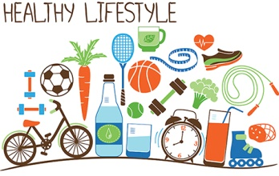
(The Lewisham Care Partnership, 2019)

Contents page
Introduction………………………………………………………………..page 3
The Individuals Collected Data…………………………………………page 4-5
BMI, Weight and diet……………………………………………….…..page 6-7
Smoking……………………………………………………………...……page 8
Drinking Alcohol…………………………………………………...….page 9-10
Maslow’s Hierarchy of Needs………………………………………..page 11-12
Conclusion…………………………………………………………....page 13-14
References……………………………………………………….……page 15-21
Appendix…………………………………………………………...…page 22-27

Introduction
The following academic report will evaluate the normal and abnormal physiology, health, nutritional and emotional needs of an individual. The informational will be obtained by a health and lifestyle questionnaire and will look at recommendations following government, public health and National Health Service (NHS) strategies. The Participant has given informed consent and their identity will be protected throughout this academic report and they will also be given a debrief form. A blank copy of the questionnaire will be included in the appendix of this report.
The report will also take into consideration Maslow’s hierarchy of needs and focus on the individual’s self-actualisation, self-esteem, love and belonging needs, safety needs and psychological needs. In order for the individual to feel truly motivated in life; all five needs must be met.

The individual’s collected data
The individual participating in the health and lifestyle questionnaire is between the age of 21-30 and is a female. The individual weighs 13 stone and 13 pounds (88.9 KG) and is five foot 6 inches tall- which makes their body max index (BMI) 30-39.9 and puts them in the obese category- however they have a healthy blood pressure of 118 over 76. The individual who participated in the questionnaire answered that they did light exercise during the week (1-3 days). The individual has quit smoking within the last year and drinks alcohol monthly. The individual has answered that they do not have any existing health problems and they only take microgynon contraception. The individual’s father has no existing health concerns but their mother suffers with depression, fibromyalgia and hypercholesterolemia. The individual does not have any known allergies. The individual never visits the opticians but regularly attends 6 month check-ups with the dentist. The participant regularly eats 5-10 fruit and vegetables a day but doesn’t follow the governments ‘healthy eating plate’. The participant usually has fast food or takeaways twice a week and mostly drinks the recommended daily intake of water a day. The participant stated that they worked as a paediatric care assistant but would like to earn a higher income. The participant feels as though they have a good work/life balance and they socialise with family and friends weekly. The participant also partakes in hobbies such as cooking and baking, walking, travelling and going to the cinema. The participant answered that they ‘sometimes’ feel they get enough sleep and generally feel in a good mood.

BMI, Weight and Diet
The individual taking part in the health and lifestyle questionnaire is over all in good health; however, they are currently classed as obese. Both the NHS (2016) and the World Health Organisation (WHO) (2019) explain that the individual is classed as obese as their BMI is 31.5 and to be a healthy weight their BMI should be between 18.5 and 24.9. Diabetes UK (2019), the NHS (2018) and the National Institute for Health and Care Excellence (NICE) (2019) all explain that it is important to have a healthy BMI because if a person is overweight or obese it can lead to health complications such as diabetes, heart disease, stroke, cancer and bone or joint problems. The UK Government have set out initiatives and strategies in order to tackle obesity as it is a growing concern for Britain. In 2016 the UK Government introduced a scheme called the healthy eating guide which clearly underlines what and how much people should eat from each of the food groups (British Nutrition Foundation, 2018). A picture of the healthy eating guide is included in the appendix of this report titled diagram 1. Ridder et al (2017) conducted a report about healthy diets and came to the conclusion that most people had a poor understanding of a healthy diet and that low social class was the biggest influence on people not adhering to a healthy diet. The Welsh Government introduced physical activity guidelines to help people understand the importance of exercise for the health of the public, the government highlighted that adults should participate in 30 minutes of exercise for at least 5 days of the week and should reduce the amount of time they spend sedentary. Weiler and stamatakis (2010) and Barker et al (2019) both agree that lack of physical exercise causes a huge strain and cost on the NHS because physical inactivity is linked to increased risk of chronic diseases such as hypertension, type 2 diabetes and obesity. In March 2016 the UK Government introduced the ‘sugar tax’. The sugar tax is an initiative that charges companies that don’t reduce the sugar content of their drinks, since it was introduced in 2016, the equivalent of 45 million kg of sugar has been reduced. Any companies that don’t reduce the sugar in their drinks will be taxed and money will go towards schools for physical exercise programmes (UK Government, 2018).

Smoking
The participant of the questionnaire stated that they had given up smoking within the last year. Centres for Disease Control and Prevention (2018), the NHS (2018) and Bupa (2019) all agree that smoking can have a detrimental effect on a person’s health; smoking can cause cancer, heart disease, stroke, COPD, fertility problems and premature births. The UK Government have introduced a number of initiatives in order to reduce rates of smoking in Britain; tobacco products are banned from being displayed in shops so that young people cannot see them and to help adults who want to quit (The Welsh Government, 2018). The Guardian (2019) reported that 57% of children who regularly smoked bought cigarettes from shops; when the display ban was introduced this dropped by 40%. The government placed a ban in 2006 so people could not smoke in public places such as pubs, clubs, public transport and shopping centres (politics.co.uk, 2019). The BBC (2019) and Tayu Lee, Glantz and Millett (2011) have both reported that although smoking numbers are declining; there is no evidence to suggest that it is due to the public smoking ban. The NHS (2019), Smokefree.gov (2019) and Action on Smoking and health (2019) all agree that quitting smoking has great benefits even from the first few weeks; firstly skin and teeth appearance will improve, taste will improve, general fitness and breathing will improve, fertility chances will increase and heart disease/stroke risks will reduce.

Drinking Alcohol
The participant stated that they only drink alcohol monthly. The NHS (2016) and drink aware (2019) both describe the dangers of drinking alcohol excessively as; cancer, stroke, heart disease, liver disease, brain damage and damage to the nervous system. Centres for Disease Control and Prevention (2018) agrees with the NHS (2016) and drink aware (2019) and also argue that drinking alcohol can also have dangerous short term effects such as; injuries from driving or cooking whilst under the influence, violence, alcohol poisoning and risky sexual behaviour. Although the participant doesn’t drink very often, when they do, they drink a lot- this is considered binge drinking. Healthline (2019) explains that binge drinking (no matter how often) can be detrimental to a person’s health- it can cause sudden death from high blood pressure or irregular heartbeat, dehydration, low blood sugar, or choking from a depressed gag reflex. Many charities have set up initiatives to help reduce the amount and how regularly people drink. Alcohol Change UK (2019) introduced ‘Dry January’in 2013; this is where people give up alcohol for the month of January and 72% are reported to still drink less ‘riskily’ 6 months after taking part. Ballard (2016) also reported that 67% of people who took part in Dry January reported a reduction in drinking alcohol 6 months after taking part. The British Liver Trust (2019) has reported that out of all the people who participated in Dry January, 76% thought more about why they drink, 70% had better general health, 71% slept better, 58% lost weight and 57% had better concentration. The UK Government (2012) reported that over half of people who drink alcohol don’t realise the dangers of excessive drinking.

Maslow’s Hierarchy of Needs
Maslow was a psychologist that created the hierarchy of needs pyramid (see diagram 2 in the appendix). Maslow wanted to research what motivated people and fulfils them in life (simplypsychology, 2018). First on the pyramid of needs is psychological which means the basic needs of food, water, sleep and warmth, second on the list is safety needs which means health, employment and stability, thirdly comes love and belonging which means family, social, romantic aspects and feeling wanted, fourth comes esteem which means the person’s own confidence levels and lastly comes self-actualisation which means a person feels they have reached their full potential in life (verywell mind, 2018). ThoughtCo. (2019) explains that the first part of the pyramid must be met in order for a person to move further up the pyramid. Lester (2013) explains that it is hard to measure a person’s self-actualisation as different people will have different opinions on what motivates them and what they consider stability and quality personal relationships. The Participant stated that they would like to earn a higher income- this means that they cannot fully reach self-actualisation until they are happy with their financial income even though they meet a lot of the other parts of Maslow’s pyramid- if a person doesn’t receive a high income they may not be able to participate in the social activities they might want to or afford simple things such as food and petrol (Lomas, 2013). The participant said that they often spend time with family and friends. This means that the participant is likely to feel wanted and accepted (ExplorePsychology, 2019).

Conclusion
In conclusion; although the participant is considered to be in overall good health, there is a few recommendations that have been made clear throughout this report. Firstly, the participant needs to lose weight and lower their BMI in order to not only reduce their risks of heart disease, diabetes and cancer but have more energy and better fitness (Harvard T.H. Chan, 2019). The participant should also make effort to be more physically active as they stated that they are only ‘lightly’ active and taking part in regular physical exercise will help the participant lose weight and reduce health risks as well as help with mental health- it is recommended that a person should have 30 minutes of exercise per day (Better Health Channel, 2018). The participant does well to mostly eat 5-10 fruit and veg every day but should consider following the governments ‘healthy eating plate’ as they will then eat the right amount from each food group per day- the eat well plate will also ensure that people eat the right portion sizes of all the food groups and gives a person all the correct nutrients they need (UK Government, 2016). The participant has done well to quit smoking within the last year but needs to keep it up as the more time passes after a person quits smoking, the bigger the benefits- the risk of heart disease reduces by 50% within 1 year of quitting and the risk of stroke is significantly reduced after 5 years (Quit Genius, 2018). The participant also doesn’t drink alcohol very often which is good but when they do drink they should ensure that it is not excessive- Drinkaware (2019) advises that a person limits the amount of alcohol drunk at one occasion, to alternate alcoholic drinks with water, don’t drink on an empty stomach and only 1 unit of alcohol should be drank per hour. If the participant follows all of these recommendations then they can reach their full health potential- reducing health risks and cutting NHS costs.

References
Action on Smoking and Health (2019) Why quit smoking? Available at: https://ash.wales/what-happens-hours-days-years-after-you-quit-smoking/ [Accessed 26th April 2019]
Alcohol Change UK (2019) What is Dry January? Available at: https://alcoholchange.org.uk/get-involved/campaigns/dry-january/about-dry-january/what-is-dry-january [Accessed 26th April 2019]
Ballard, J. (2016) Evidence that Dry January changes behaviour for good. The BMJ. [online] Available at: https://www.bmj.com/content/352/bmj.i599.full [Accessed 26th April 2019]
Barker, J. et al (2019) Physical activity of UK adults with chronic disease: cross-sectional analysis of accelerometer-measured physical activity in 96,706 UK Biobank participants. International Journal of Epidemiology. [Online] Available at: https://academic.oup.com/ije/advance-article/doi/10.1093/ije/dyy29415306120 [Accessed 23rd April 2019]
BBC News (2017) Pub smoking ban: 10 charts that show the impact. Available at: https://www.bbc.co.uk/news/health-40444460 [Accessed 24th April 2019]
Better Health Channel (2018) Physical Activity- it’s important. Available at: https://www.betterhealth.vic.gov.au/health/healthyliving/physical-activity-its-important [Accessed 27th April 2019]
British Liver Trust (2019) 4.2 million people in the UK to give up alcohol for Dry January 2019. Available at: https://www.britishlivertrust.org.uk/millions-to-do-dry-january-2019/ [Accessed 26th April 2019]
British Nutrition Foundation (2018) The eatwell guide- A revised healthy eating model. Available at: https://www.nutrition.org.uk/healthyliving/healthydiet/eatwell.html [Accessed 23rd April 2019]
Bupa (2019) Effects of smoking. Available at: https://www.bupa.co.uk/health-information/lungs-breathing/effects-of-smoking [Accessed 24th April 2019]
Centers for Disease Control and Prevention (2018) Fact Sheets- Alcohol Use and Your Health. Available at: https://www.cdc.gov/alcohol/fact-sheets/alcohol-use.html [Accessed 25th April 2019]
Centers for Disease Control and Prevention (2018) Health Effects of Cigarette Smoking. Available at: https://www.cdc.gov/tobacco/data_statistics/fact_sheets/health_effects/effects_cig_smoking/index.htm [Accessed 24th April 2019]
Diabetes.co.uk (2019) Why is BMI important? Available at: https://www.diabetes.co.uk/bmi/why-is-bmi-important.html [Accessed 23rd April 2019]
Drinkaware (2019) Binge drinking. Available at: https://www.drinkaware.co.uk/alcohol-facts/drinking-habits-and-behaviours/binge-drinking/ [Accessed 27th April 2019]
Drinkaware (2019) Health Effects of Alcohol. Available at: https://www.drinkaware.co.uk/alcohol-facts/health-effects-of-alcohol/ [Accessed 25th April 2019]
Explore Psychology (2019) Maslow’s Hierarchy of Needs. Available at: https://www.explorepsychology.com/maslows-hierarchy-of-needs/ [Accessed 27th April 2019]
Harvard T. H. Chan (2019) Healthy Weight. Available at: https://www.hsph.harvard.edu/nutritionsource/healthy-weight/ [Accessed 27th April 2019]
Healthline (2019) What Happens to Your Body When You Binge Drink. Available at: https://www.healthline.com/health-news/what-happens-to-your-body-when-you-binge-drink#1 [Accessed 25th April 2019]
Lester, D. (2013) Measuring Maslow’s Hierarchy Needs. Psychological Reports: Mental & Physical Health. [Online] 113 (1) P15-17. Available at: https://journals.sagepub.com/doi/pdf110.2466/02.20.PRO.1/3x16z1 [Accessed 27th April 2019]
Lomas, C, J. (2013) Climbing the Needs Pyramids. Sage Journals. [Online] 3 (3). Available at: https://journals.sagepub.com/doi/full/10.1177/2158244013500283#articleCitationDownloadContainer [Accessed 27th April 2019]
NICE (2019) Obesity: identification, assessment and management. Available at: https://www.nice.org.uk/guidance/cg189/ifp/chapter/Obesity-and-being-overweight [Accessed 23rd April 2019]
NHS (2016) Alcohol support. Available at: https://www.nhs.uk/live-well/alcohol-support/the-risks-of-drinking-too-much/ [Accessed 25th April 2019]
NHS (2016) What is the body mass index (BMI)? Available at: https://www.nhs.uk/common-health-questions/lifestyle/what-is-the-body-mass-index-bmi/ [Accessed 23rd April 2019]
NHS (2018) BMI healthy weight calculator. Available at: https://www.nhs.uk/live-well/healthy-weight/bmi-calculator/ [Accessed 23rd April 2019]
NHS (2018) What are the risks of smoking? Available at: https://www.nhs.uk/common-health-questions/lifestyle/what-are-the-health-risks-of-smoking/ [Accessed 24th April 2019]
NHS (2019) Smokefree. Available at: https://www.nhs.uk/smokefree/why-quit/what-happens-when-you-quit [Accessed 26th April 2019]
Politics.co.uk (2019) Smoking ban. Available at: https://www.politics.co.uk/reference/smoking-ban [Accessed 24th April 2019]
Quit Genius (2018) A Timeline of Benefits When You Quit Smoking. Available at: https://www.quitgenius.com/blog/quit-smoking-timeline [Accessed 27th April 2019]
Ridder, de, D. et al (2017) Healthy diet: Health impact, prevalence, correlates and interventions. Psychology and Health. 32 (8) P907-941. [Online] Available at: https://www.tandfonline.com/doi/full/10.1080/08870446.2017.1316849?scroll=top&needAccess=true [Accessed 23rd April 2019]
Simply Psychology (2018) Maslow’s Hierarchy of Needs. Available at: https://www.simplypsychology.org/maslow.html [Accessed 27th April 2019]
Smokefree.gov (2019) Benefits of Quitting. Available at: https://smokefree.gov/quit-smoking/why-you-should-quit/benefits-of-quitting [Accessed 26th April 2019]
Tayv Lee, T., Glantz, A, S. and Millett, C. (2011) Effect of Smoke-Free Legislation on Adult Smoking Behaviour in England in the 18 Months Following Implementation. PLos One. 6 (6). [Online] Available at: https://www.ncbi.nlm.gov/pme/articles/PMC3115957/ [Accessed 24th April 2019]
The Guardian (2019) Tobacco display ban linked to drop in children buying cigarettes in shops. Available at: https://www.theguardian.com/society/2018/sep/21/tobacco-display-ban-linkes-to-drop-in-children-buying-cigarettes-in-shops [Accessed 24th April 2019]
The Lewisham Care Partnership (2019) Healthy Lifestyle. Available at: https://www.mordenhillsurgery.co.uk/healthy-lifestyle [Accessed 22nd April 2019]
The Welsh Government (2018) Guidance on the display and pricing of tobacco products in Wales, for tobacco retailers and regulatory officers. Available at: https://gov.wales/sites/default/files/publications/2018-09/tobacco-display-ban-guidance.pdf [Accessed 24th April 2019]
ThoughtCo. (2019) Maslow’s Hierarchy of Needs Explained. Available at: https://www.thoughtco.com/maslows-hierarchy-of-needs-4582571 [Accessed 27th April 2019]
UK Government (2011) Physical activity guidelines for adults (19-64 years). Available at: https://assets.publishing.service.gov.uk/government/uploads/system/attachments_data/file/213740/dh_128145.pdf [Accessed 23rd April 2019]
UK Government (2012) Change4Life launches its first alcohol campaign. Available at: https://www.gov.uk/government/news/change4life-launches-its-first-alcohol-campaign [Accessed 27th April 2019]
UK Government (2016) New Eatwell Guide illustrates a healthy, balanced diet. Available at: https://www.gov.uk/government/news/new-eatwell-guide-illustrates-a-healthy-balanced-diet [Accessed 29th April 2019]
Very Well Mind (2018) The five levels of Maslow’s Hierarchy of Needs. Available at: https://www.verywellmind.com/what-is-maslows-hierarchy-of-needs-4136760 [Accessed 27th April 2019]
Weiler, R. and Stamatakis, E. (2010) physical activity in the UK: a unique crossroad? British Journal of Sports Medicine. 44 (13) P912-914. [Online] Available at: https://bjsm.bmj.com/content/44/13/912.info [Accessed 23rd April 2019]
World Health Organization (2019) Body mass index- BMI. Available at: www.euro.who.int/en/health-topics/disease-prevention/nutrition/a-healthy-lifestyle/body-mass-index-bmi [Accessed 23rd April 2019]

Appendix
Diagram 1
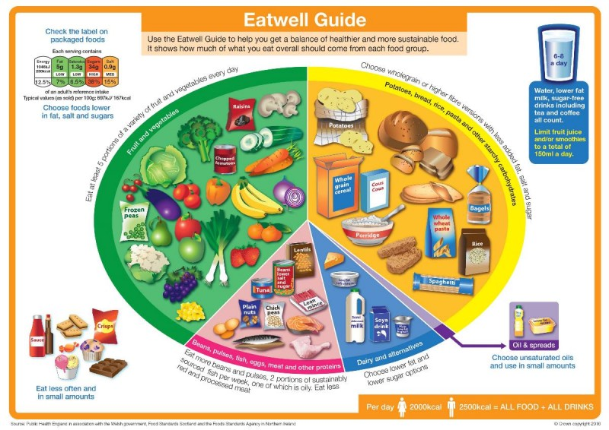
(British Nutrition Foundation, 2018)
Diagram 2
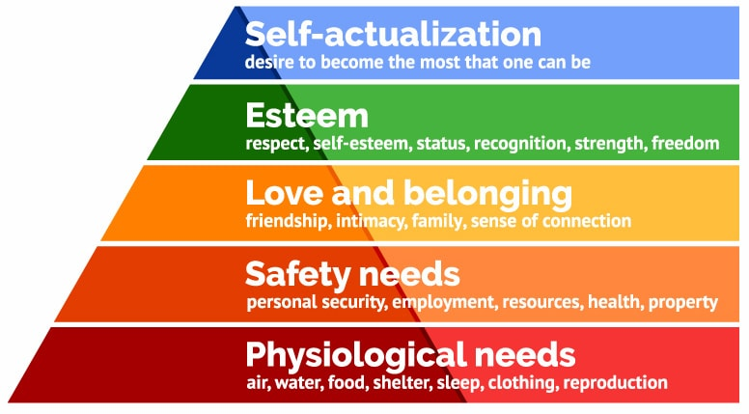
(Simply Psychology, 2018)

Blank health and lifestyle questionnaire
1. What age group are you in?
18-20 [ ] 21-30 [ ] 31-40 [ ] 41-50 [ ] 51-60 [ ] 61+ [ ]
2. What is your gender?
Female [ ] male [ ] other [ ] prefer not to say [ ]
3. How much do you weigh?
________________________________________________________________
4. What weight group are you in?
Underweight [ ] healthy weight [ ] overweight [ ] obese [ ]
5. How tall are you?
___________________________________________________
6. What is your BMI?
18.5 and under [ ] 18.5-24.9 [ ] 25-29.9 [ ] 30-39.9 [ ]
7. What is your blood pressure?
90/60 and under [ ] 120/80 [ ] 140/90 [ ] 190/100 [ ]
8. What are your activity levels?
Little to none [ ] light [ ] moderate [ ] heavy [ ]
9. Do you smoke?
Everyday [ ] socially [ ] quit within the last year [ ] quit over a year ago [ ] never smoked [ ]
10. How often do you drink alcohol?
4+ days per week [ ] 2-3 days per week [ ] once a week [ ] monthly [ ] every few months [ ] never [ ]
11. Do you have any existing health problems?
Yes [ ] no [ ]
If yes, please state below:
________________________________________________________________________________________________________________________________________________________________________________________________
12. Are you currently taking any medication?
Yes [ ] no [ ]
If yes, please state below:
________________________________________________________________________________________________________________________________________________________________________________________________
13. Does your mother or father have any existing health problems?
Yes [ ] no [ ]
If yes, please state below:
________________________________________________________________________________________________________________________________________________________________________________________________
14. Do you have any allergies?
Yes [ ] no [ ]
If yes, please state below:
________________________________________________________________________________________________________________________________________________________________________________________________
15. How often do you visit the opticians?
Once a year [ ] every 2 years [ ] every 3-5 years [ ] never [ ]
16. How often do you visit the dentist?
Every 6 months [ ] every 12 months [ ] every 2 years [ ] every 3-5 years [ ] never [ ]
17. Do you eat 5-10 fruit/veg a day?
Always [ ] most of the time [ ] sometimes [ ] never [ ]
18. Do you follow the government healthy eating plate?
Always [ ] most of the time [ ] sometimes [ ] never [ ]
19. How often do you eat fast food/takeaways?
5+ days per week [ ] 4 days per week [ ] 3 days per week [ ] 2 days per week [ ] 1 or less days per week [ ]
20. Do you drink the recommended amount of water per day?
Always [ ] most days [ ] sometimes [ ] never [ ]
21. What is your occupation?
________________________________________________________________
22. Do you experience job satisfaction?
Yes [ ] no [ ]
23. Would you like to earn a higher income?
Yes [ ] no [ ]
24. Do you feel that you achieve a good work/life balance?
Yes [ ] no [ ]
25. How often do you socialise with family and/or friends?
A few times a week [ ] weekly [ ] every few weeks [ ] monthly [ ] 6+ months [ ]
26. What are your hobbies?
________________________________________________________________________________________________________________________________
27. Do you feel like you get enough sleep?
Sometimes [ ] often [ ] almost never [ ] never [ ]
28. How would you describe your daily mood?
Very positive [ ] general good mood [ ] nervous/anxious [ ] snappy/stressed [ ] worried/depressed [ ]

