LCBB4015

Introduction to Leadership and Management

Dr Dudley Ofori

Component 2: Coursework: Essay

BA (Hons) Business Management

Marek Horvath

2438124
Contents
Introduction 2
Main Body 2
1. Definition of Leadership 2
2. Overview of Goleman’s Leadership Framework 3
3. Leadership Style 1 – Authoritative (Visionary) Leadership 4
4. Leadership Style 2 – Democratic Leadership 5
5. Leadership Style 3 – Coaching Leadership 5
6. Essential Leadership Skills for Today’s Leaders 6
Conclusion 7
References 7

Introduction
Leadership and management in business refers to how organisations carry out the process of getting things done to achieve results. The management deals with planning, organising and composing of resources while leadership deals with influencing, motivating and leading people to common objectives. Effective leadership is becoming more essential in modern organisations because of rapid technological change and global competition and workforce expectations. Daniel Goleman’s emotional intelligence leadership framework is one of the influential theories concerning leadership that describes different types of leadership styles and their impact on employee motivation and organisation performance. This essay examines the three leadership styles of Goleman, which include their strengths and weaknesses. Practical business situations illustrate when each style is most effective and advantageous. In addition, it outlines important skills leaders today need to manage complexity, support organisational growth and promote sustainable development in the current dynamic business environment.

Main Body

Definition of Leadership
Leadership refers to the ability of influencing people in an organisation to work for a common goal. It is one of the important functions of management. An individual influences a group to accomplish a goal that is for the common good. Northouse (2022) states that leadership is mostly an influence process and not a position-related process. Likewise, Robbins and Coulter (2021) define leadership as the process of motivating, directing and inspiring employees to work voluntarily towards achieving organisation objectives. As suggested by these definitions, leadership is people-centred and closely related to behaviour.
Between leadership and management, most commonly interchangeably used terms in our routine life. Management is with planning, organising and controlling resources so that there is efficiency and stability, whereas leadership sets direction, inspires people and drives change (Kotter, 2102). In order to be effective, both functions are required in an organization, but leadership is more important where a particular environment is dynamic and uncertain where employee commitment and adaptability help the organization achieve efficiency.
A good leadership positively impacts the performance of the organization as it can help make better decisions and improve employee engagement and achievement of organizational objectives (Yukl, 2020). Leaders enhance productivity and foster commitment through effectively motivating employees and ensuring individual efforts align with the goals of the organisation for its long-term success.

2. Overview of Goleman’s Leadership Framework
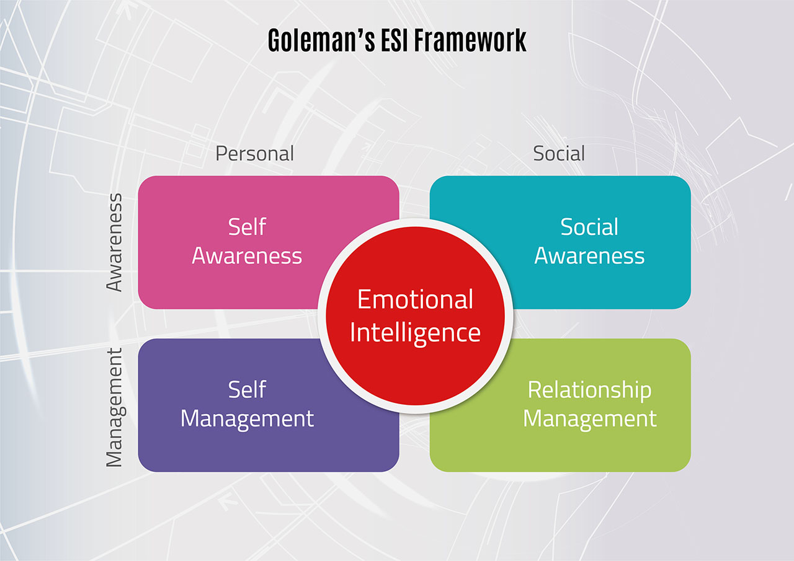
Augustin J. A. Bogdan’s perspective of the world revolves around the actions of people, and how they choose to interpret these actions. Goleman (2000) states that effective leaders are not the ones with better technical skills or cognitive ability but the ability to understand and manage emotions of themselves and of others. According to Goleman, Boyatzis and McKee (2013), emotional intelligence (EI) is made up of a set of complementary skills or competencies which include self-awareness, self-regulation, motivation, empathy and social skills that shapes leadership behaviour.
Following this idea, Goleman identified six leadership styles: coercive, authoritative, affiliative, democratic, pacesetting and coaching. Any style has a varying effect on organizational climate and employee motivation depending on its application, its timing, and so on (Goleman, 2000). Goleman underlines that there is no one best style of leadership; effective leaders adapt their style to the situation. In light of this, the essay will look at three broad leadership styles that are relevant in today’s organisation, thus allowing for a deeper insight into their characteristics, strengths, weaknesses, and application in business.

Leadership Style 1 – Authoritative (Visionary) Leadership
Authoritative, also known as visionary leadership, is when a leader communicates a vision to give clear direction to employees. Leaders who work in this way, according to Goleman (2000), can motivate employees by explaining how their work fits into the larger organisational goal. Communication is generally assertive and future-oriented, while decision-making is still leader-led with a longer-term perspective. The emotional intelligence of the head is likewise relevant here. A leader must obtain self-confidence, empathy and effective social skills to inspire trust and commitment from employees (Goleman, Boyatzis and McKee, 2013).
One notable benefit of authoritative leadership is that it helps motivate employees and keep them engaged. According to Northouse (2022), clearly communicating the purpose and direction increases the likelihood of employees’ commitment to the organisational goals. According to Yukl (2020), this type of communication enhances team alignment, improves organizational performance, and supports strategic change within organizations.
There are situations when authoritarian leadership is not very effective as a leadership style. It is not effective in case the leader lacks credibility or emotional intelligence. Workers may become resistant if the leader’s vision is unclear and unrealistic (Goleman, 2000). In addition, the overuse of this style may hamper the autonomy of personnel, more so in highly skilled teams, which favour participation and shared decision-making (Robbins and Coulter, 2021).
The authoritative leadership style is beneficial for use during change, such as restructuring or organisational strategy. The organization’s vision is important in cases of restructuring as it gives employees something concrete to look forward to. According to Kottler (2012), leaders direct peoples’ energy toward a goal and purpose.

Leadership Style 2 – Democratic Leadership
Democratic leadership is characterized by participation, collaboration and shared decision-making. As per Goleman (2000), such leaders engage with employees, allow the exchange of ideas, and value team contribution before making decisions. Interaction is two-way and open which creates trust and commitment within teams. Emotional intelligence is key to this style, where leaders show empathy, actively listen to concerns and have strong social skills that help them manage differences and maintain a constructive dialogue (Goleman et al. 2013).
One key benefit of democratic leadership is its ability to drive employee involvement and motivation. Through the participation of employees in the decision-making process, the individuals feel valued and empowered increasing their job satisfaction and commitment (Northouse, 2022). The style also enhances creativity and innovation because different perspectives help with better solutions and better organisational results (Yukl, 2020).
Democratic leadership has got many advantages but is time-consuming and less effective in emergencies. Consulting widely can delay a decision and render it less effective in a crisis (Goleman, 2000). Also, if employees do not have the necessary skills and experience, shared decision-making may lead to low-quality decisions or even confusion about responsibility( Robbins and Coulter, 2021).

Leadership Style 3 – Coaching Leadership
Coaching leadership seeks to develop the long-term capabilities of employees by identifying no recent strengths, weaknesses and supporting personal growth. Goleman (2000) states that coaching leaders spend time mentoring or giving feedback to people with their sights on learning and development and not immediate performance. Work culture which is supportive and future-oriented communication and a decision-making process that makes employees responsible for improvement. According to Goleman, Boyatzis and McKee (2013), empathy and self-awareness are essential components of emotional intelligence that allow the leader to understand individual needs and adapt directives accordingly.
Coaching leadership is advantageous because it enhances employee development and motivation, both of which are important. Training employees enhances the capabilities of organizations and also results in customer satisfaction (Northouse, 2022). According to Yukl (2020), it also fosters sustainable growth of an organisation by creating an increasingly capable and adaptable workforce.
Though having its own strengths, coaching leadership may not prove to be as effective in fast-paced or high-pressure environments where immediate results are required. Time and energy needed for coaching people can lower productivity temporarily (Goleman, 2000). As Robbins and Coulter (2021) note, this style does not work when workers do not want to learn and the leader does not have coaching skills.
Coaching leadership is particularly effective in situations aimed at developing employees, such as graduate training programmes and performance improvement. In such circumstances, a preference is given to long-term capability building instead of immediate delivery. According to Kotter (2012), this explains that there is no one effective leadership style, and one must lead according to the organizational goal or situation.

Essential Leadership Skills for Today’s Leaders
Organisations today are increasingly operating in complex and uncertain environments which are characterized by rapid technological change, a globalised competition and a diverse workforce. Consequently, leaders need a diverse set of skills to assist them in being able to respond to these challenges whilst helping the organisation grow sustainably. The ability to understand the feelings of other people therefore, requires emotional intelligence. It allows one to manage their own emotions as well. It also helps one communicate in a better way. A smart way to achieve leadership is developing high emotional intelligence, as it allows one to build trust, manage conflicts, and motivate employees(Goleman, 2000; Goleman, Boyatzis and McKee, 2013)
The ardent communication is yet another essential quality of a leader that helps him explain his plans. Communication software and tools align employees with the organization’s direction so that they know what is expected from them (Robbins and Coulter, 2021). Similarly, adaptability and flexibility have become important as it enables leaders to change their style and decision-making methods depending on the situation (Yukl, 2020).
Advanced ethical sensitivity is a decisive factor in dominant design. Ethical leadership is essential for creating trust, fairness and accountability, which help organisations to sustain themselves (Northouse, 2022). All competencies help the leader to manage the complexity and support diverse team and make sure that the organization is growing responsibility and sustainably.

Conclusion
The contemporary organization’s leadership was examined in this essay with reference to Daniel Goleman’s leadership framework based on emotional intelligence. Leadership is a process of influencing others to accomplish an organisation’s goals as a group activity. In the above discussion, three of Goleman’s leadership styles authoritative, democratic and coaching were discussed with their characteristics, pros and cons. The analysis showed that each style has its effectiveness depending on the business situation, such as organisational change, collaborative decision-making and employee development, no style of leadership is universally effective. The essay also identifies emotional intelligence, communication, and adaptability as essential leadership skills in dealing with complexity and sustainable development. In reality, today’s organisational leaders are advised to adopt a flexible and situational approach to leadership, nurture emotional intelligence, and modify leadership style according to organisational needs, workforce diversity and changing business environment to ensure long-term success.

References
Bass, B.M. and Riggio, R.E. (2006) Transformational leadership. 2nd edn. Mahwah, NJ: Lawrence Erlbaum. DOI: https://doi.org/10.4324/9781410617095 Accessed: 23 December 2025.
Burns, J.M. (1978) Leadership. New York: Harper & Row. Available at: https://archive.org/details/leadership00burn Accessed: 23 December 2025.
Clegg, S., Kornberger, M. and Pitsis, T. (2020) Managing and organizations: An introduction to theory and practice. 5th edn. London: Sage. Available at: https://uk.sagepub.com/en-gb/eur/managing-and-organizations/book256164 Accessed: 23 December 2025.
Goleman, D. (2000) ‘Leadership that gets results’, Harvard Business Review, 78(2), pp. 78–90. Available at: https://hbr.org/2000/03/leadership-that-gets-results Accessed: 23 December 2025.
Goleman, D. (2004) ‘What makes a leader?’, Harvard Business Review, 82(1), pp. 82–91.
Available at: https://hbr.org/2004/01/what-makes-a-leader Accessed: 23 December 2025.
Goleman, D., Boyatzis, R. and McKee, A. (2013) Primal leadership: Unleashing the power of emotional intelligence. 2nd edn. Boston: Harvard Business School Press. Available at: https://store.hbr.org/product/primal-leadership/10028 Accessed: 23 December 2025.
Griffin, R.W. (2022) Management. 14th edn. Boston: Cengage Learning. Available at: https://www.cengage.com/c/management-14e-griffin Accessed: 23 December 2025.
Hersey, P., Blanchard, K.H. and Johnson, D.E. (2013) Management of organizational behavior: Leading human resources. 10th edn. Harlow: Pearson Education. Available at: https://www.pearson.com/en-gb/subject-catalog/p/management-of-organizational-behavior/P200000006798 Accessed: 23 December 2025.
Kotter, J.P. (2012) Leading change. Boston: Harvard Business Review Press. Available at: https://store.hbr.org/product/leading-change/10165 Accessed: 23 December 2025.
Kotterman, J. (2006) ‘Leadership versus management: What’s the difference?’, Journal for Quality and Participation, 29(2), pp. 13–17. Available at: https://asq.org/quality-resources/articles Accessed: 23 December 2025.
Mintzberg, H. (2009) Managing. San Francisco: Berrett-Koehler. Available at: https://www.bkconnection.com/books/title/managing Accessed: 23 December 2025.
Northouse, P.G. (2022) Leadership: Theory and practice. 9th edn. Thousand Oaks, CA: Sage Publications. Available at: https://uk.sagepub.com/en-gb/eur/leadership/book273927 Accessed: 23 December 2025.
Robbins, S.P. and Coulter, M. (2021) Management. 15th edn. Harlow: Pearson Education.
Available at: https://www.pearson.com/en-gb/subject-catalog/p/management/P200000006512 Accessed: 23 December 2025.
Wren, D.A. and Bedeian, A.G. (2020) The evolution of management thought. 8th edn. Hoboken, NJ: Wiley. Available at: https://www.wiley.com/en-gb/The+Evolution+of+Management+Thought-p-9781119703643 Accessed: 23 December 2025.
Yukl, G. (2020) Leadership in organizations. 9th edn. Harlow: Pearson Education.
Available at: https://www.pearson.com/en-gb/subject-catalog/p/leadership-in-organizations/P200000006699 Accessed: 23 December 2025.

