Pfizer – The Innovative Leader in Workplace Changes
Leading and Implementing Workplace Change (BMSK6003_LON)

Student: Marius Ionut Saiz 1605685
Lecturer: Rexon Nting

Table of Contents
INTRODUCTION 3
BACKGROUND OF THE COMPANY 4
ANALYSIS 5
DEFINITION OF CHANGE 5
TYPES OF CHANGES 5
EXTERNAL AND INTERNAL ANALYSIS OF THE COMPANY 7
SWOT Analysis 7
PESTLE Analysis: 8
Force Field Analysis: 10
Burke Litwin model 12
Lewis 3 step model 15
Cultural model 17
Evaluation of the impact of organizational culture on the change management program 19
Conclusion 23
References 24

INTRODUCTION
Every organization needs some changes so that they will fulfil all the need of the customer and they will also satisfy their wants. The organization is using the different type of strategy in their organization so that they will easily achieve there goal and objective of the company. The organization need to implement some of the changes in their organization on a regular basis so that they will plan accordingly and try to cope up with these entire dynamic environments. They will also try to increase the market share of the company
The main motive of this assignment is that they will try to explain the different type of internal and external environmental factor that will affect some of the changes and they will also analyse the changes which will affect them. This report will explain the change which was applied in Pfizer. On the other hand, some of the barriers will also explain and different types of models are also explained and manage all the changes which will identify the position of the business.

BACKGROUND OF THE COMPANY
Pfizer Inc. is one of the most famous American multinational pharmaceutical corporations. The main headquarter of the company is in New York City. Its foundation was laid down by Charles Pfizer and Charles F. Erhart in the year 1849. Pfizer has nine divisions in operation which are into the production of drugs and vaccines. They also have a research division as well.
The company manages its business operations through two segments which are Pfizer Innovation Health (IH) and Pfizer Essential Health (EH). Pfizer Innovation Health's operations mainly involve developing medicines and vaccines while Pfizer Essential Health performs legacy of brands, branded generics, etc. The company has almost 92,000 employees working in the company.
Based on the latest analysis this was found that this company was one of the largest pharmaceutical companies. Based on the latest analysis the total revenue of the company in 2018 was more. This was announced that a joint merger of their client healthcare division with the UK farm. The share of the company controlled and maintained by the British company.

ANALYSIS

DEFINITION OF CHANGE
According to Van der Voet and Vermeeren, (2017), the simple meaning of change is that inventing anything new or implements something new in the organization so that organization will satisfy the need of the customer. Most of the companies are using the internal and the external factor so that they will make some changes in their organization and they will also try to implement some different type of strategy.
Alvesson and Sveningsson (2015) also state that on the regular basis the company have to change themselves inadequate planning so that they will easily understand the different change and try them will plan accordingly and try to cope up with these entire dynamic environments. They will also try to increase the market share of the company

TYPES OF CHANGES
There is mainly two types of change which the company have to mainly focus on that so that they will attract more and more customer towards them (Cameron, E. and Green, M., 2019).
- Strategic Change
- Structural Change
STRATEGIC CHANGE
In most of the organization, the strategic changes are mostly applied. This will highly affect the different type of module of an organization and they will also make many different types of strategy. The most popular example of the strategic change is that some changes we're implementing in the management style. Pfizer Inc. takes some of the steps ahead so that they will bring some of the changes in their organization. This type of changes was expected to have some negative as well as a positive effect. The performances of the company will change on the basis of changing trend in the market (Cameron, E. and Green, M., 2019).

STRUCTURAL CHANGE
Structural Change is mainly referred to some of the dynamic change which will take some course of action in the organization. The meaning of Structural Change is making some innovation in the organization (Cameron, E. and Green, M., 2019). Below is the changed organisational structure of the Pfizer.

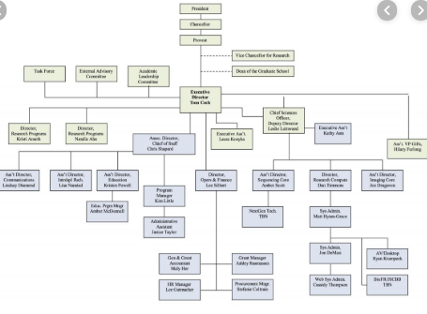

SOME OF THE IMPACT ON PFIZER INC. STRATEGY AND THERE OPERATION
Some of the changes in Pfizer Inc will change the external environment of the company and some of the operation of the business (Van der Voet and Vermeeren, 2017). The manager of the company has to implement some of the training and development programs in their organization so that employee of the organization is up to date with the new innovation. Proper training and development program will help to motivate the moral value of the employee and most of the employee will give their best in the organization which is very beneficial for the company. Due to a change in the weather condition, the demand of the customer will also change (Van der Voet and Vermeeren, 2017).

EXTERNAL AND INTERNAL ANALYSIS OF THE COMPANY

SWOT Analysis:
Let us understand the company better by using some strategic tools i.e. SWOT Analysis and PESTLE Analysis (SHTAL et al., 2018).
SWOT Analysis: SWOT Analysis is an acronym for Strength, Weakness, Opportunity and Threat. SWOT Analysis of Pfizer Inc. is as follows:
- Strengths: Pfizer is one of the leading organizations in its industry. Pfizer has numerous strengths. These strengths help in protecting market share and also help to penetrate in the market (Phadermrod et al., 2019). Some of the strength of Pfizer are as follows –
    - Strong brand name
    - Voluminous portfolio with several premium drugs.
    - Extensive focus on research and analysis.
    - Very sound financially.
- Weakness: Weakness is something which it needs to work upon. Weakness is something which does not allow the organization to achieve its goals and objectives (Bull et al., 2016). Pfizer has some weakness –
    - The negative image in public due to tax scandal
    - Unsuccessful mergers and acquisitions
    - Claims for illegal marketing methods.
- Opportunity: Pfizer has some opportunities –
    - Increasing health awareness globally.
    - Partnership with Research companies for innovation.
    - Partnership with the government.
- Threats: Pfizer has some threats –
    - Strict regulations for the pharmaceutical industry.
    - Strong competition from other pharmaceutical companies.

PESTLE Analysis:
PESTLE Analysis is an acronym for Political, Economic, Social, Technological, Legal and Environmental. It is an important framework for analyzing the impact of stated factors on an organization (Sammut et al., 2015). Let us study the analysis of Pfizer Inc. below –
- Political: Political factors affect the working of an organization. Pfizer made many political contributions. Pfizer is operating in many countries and is exposed to a different political environment. Before entering into any new market, it should analyse the political stability, level of corruption, government interference in the drug industry, etc. (Bull et al., 2016).
- If political factors change very rapidly, it becomes difficult for an organization to work in such an environment. New political parties will implement their formulated rules and regulations and if the political party loses control rapidly that signifies that there exists a need to switch to new rules and regulations on a quicker basis (Bull et al., 2016).
- Economical: Since Pfizer is a US-based company, significant changes in US taxation policy are happening. Also, Pfizer can use major economic indicators such as economy growth rate, inflation, financial markets in that economy, etc. to forecast the growth of the economy. Pfizer needs to analyse the changing economic environment. If the economic environment changes are in favour of the organization, it becomes easy for the organization to operate and to grow in that economy and vice versa (SHTAL et al., 2018).
- Social: Society's culture and ideology affect the working of an organization. The belief and the mindset of the people in society will play a major role in deciding how the organization will target its customers. Social factor such as increased awareness about health improvements provides the company with an added advantage. However, due to negative publicity and false marketing practices the reputation of the company in people's mind has reduced (SHTAL et al., 2018).
- Technology: Pfizer invests a large sum of money in technology and research and development which makes it highly advanced. Some organizations which are not tech-savvy might end up losing their market share to its competitors due to rapid enhancement in technology. Technology affects the product that the organization is offering to the public. Any change in this factor affects the industry majorly (SHTAL et al., 2018).
- Legal: In many countries, the legal system is not effective enough to safeguard the rights of an organization while in some countries it is very strict. Pfizer should always evaluate the legal framework of the area before entering into the markets of the said area. Also, noncompliance of legal framework can attract penalties like Pfizer always delays in implementing any new or change in existing legal compliance which then attracts penalties for them and creates a negative image in the society (SHTAL et al., 2018).
- Environmental: Every country has its own environmental standards and policies. Before entering into a new market, the organization should carefully analyse the environmental policy and monitor changes in the same. Any noncompliance of these policies will be then strongly opposed by the environmentalists. For example: Before entering into a new market Pfizer should analyse about the recycling policies, weather conditions, etc. If these are not appropriate the company will not be able to deliver the desired quality products and will also face strong opposition from the environmentalists (SHTAL et al., 2018).

Force Field Analysis:
This tool is useful for making decisions by analyzing the forces for and against a change. The idea behind this tool is to maintain a balance between forces that drive the change and forces that resist the change. As per this model, for a change to happen the driving force for change should be stronger than the force resisting change (Nash et al., 2019). Force Field Analysis has the following steps –
Step 1: Describe the plan for change: An organization should define their goal or the purpose of change in this step. Pfizer Inc. is a laggard in legal compliances. So it should define its need for improving its legal department in this step.
Step 2: Identify the force for change: Identify the forces that demand the change to happen. These drivers for change can be external or internal. In our case, Pfizer Inc. identifies that it needs to improve its legal department because noncompliance of the same attracts penalties and makes a negative image of the organization in the eyes of society and government (Nash et al., 2019).
Step 3: Identify forces against the change: Identify the forces that resist the change. These forces can be fear of the unknown, present structure of the organization, etc. Pfizer needs to identify the forces that resist the change and should list them on one side (Nash et al., 2019).
Step 4: Assign score: According to the degree of influence that each force exerts, every force is to be assigned a score from one to five. In our case, let’s consider the forces in favour of the change, they are legal penalties, negative marketing, etc. and favour against the change i.e. fear of the unknown, present structure, etc. Now let us assign a score to each of the forces. Scores are as follows (Nash et al., 2019)
- The score assigned to legal penalties is said five.
- The score assigned to negative marketing says four.
- The score assigned to fear of the unknown is said two.
- The score assigned to the present structure of the organization says three.
Step 5: Analyse and apply: Now that we have analysed the forces in and against the favour of the change and now that we have assigned the scores to the forces, in this step we analyse the scores and decide whether to move with the decision to change or to continue without change. In our case, if we see the score for the forces in favour as a total, it adds up to nine and the score of forces against the change adds up to 5.
Clearly, the score of the forces in favour outweighs the score of forces against. So Pfizer Inc. should proceed with the change. Pfizer can train the employees in the legal department, show the staff that change is necessary for moving ahead, employee highly skilled employees who can guide existing employees in the right direction, etc. (Nash et al., 2019)
By analyzing the SWOT Analysis, PESTLE Analysis and Force Field Analysis, we conclude that the environment is uncertain and is dynamic in nature. An organization needs to use its strength to harness the opportunities in the external environment and to minimize its weakness and threats (Sammut‐Bonnici and Galea, 2015).
Pfizer Inc. should carefully monitor the external environment and study the changes happening in the same so as to adopt those changes and to incorporate the same in their strategies. Model for change, along with the change management and leadership style (Sammut‐Bonnici and Galea, 2015).

Burke Litwin model
This model of change usually works on the basis of the cause and effect relationship. In this model, the assumption is been made that there the organisation is been divided into 12 elements which help in the determination of the change happening within the organisation (Hussain et al., 2018).
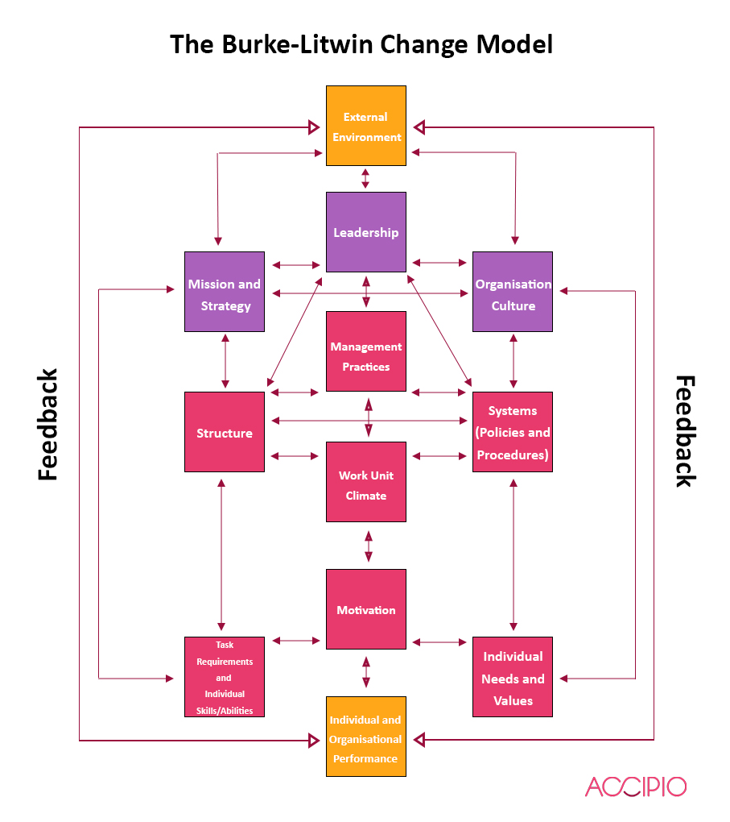
The yellow boxes represent the initial and the end process i.e. external environment and the Individual and the organisational performance of the Pfizer Inc. In the external environment, the factors representing the outside forces which can affect the Pfizer Inc.is been analysed and in the later box, the overall output of the Pfizer Inc. is been discussed (Hussain et al., 2018).
The purple blocks represent the characteristics as well as processes followed in Pfizer Inc. So a slight change in these factors affects the rest of Pfizer Inc.
The mentioned factors might get affected due to the external environment along with influencing the transactional factors which are being represented by the pink blocks (Olivier, 2018).
Leadership
This factor provides the direction and path to the rest of Pfizer Inc. and is also responsible to come up with the mission and vision for the company (Olivier, 2018).
Mission, vision and strategy
This factor helps in defining the purpose with the Pfizer Inc.is working along with the process to achieve them (Olivier, 2018).
Organisation culture
This factor consists of the norms as well as values followed in Pfizer Inc.
The pink block represents the transactional factors which represent the day to day activities that are been done in Pfizer Inc. So if there are any changes in these factors, the resulting change will only happen in these factors only if transformational factors are being changed (Olivier, 2018).
Practices of management
This factor involves the activities and behaviour of the Pfizer Inc. managers which try to align their actions with the strategies (Olivier, 2018).
Structure
This factor represents the hierarchy followed in Pfizer Inc.
Policies as well as procedures
This factor defines a mechanism which is been followed so as to provide support to the employees. These systems can be concerned about the legal aspect of the reward system (Olivier, 2018).
Working climate
This factor defines the working culture and climate of Pfizer Inc. For example, the comfort of the employees working in Pfizer Inc. or how comfortable employees feel in expressing themselves (Olivier, 2018).

Motivation
This factor works on the setting the objectives as well goals which help in inspiring and directing the employees (Giuliano and Nunn, 2017).
Requirements and abilities
This involves putting the right people at the right place at the right time. For example, some of the older employees working in Pfizer Inc. might have a problem in adapting to the advancement done in technologies (Giuliano and Nunn, 2017).
Needs and values at the individual value
All the employees working in the organisation have certain demands and expectations from the company like the salary, personal and professional life balance etc.
So in order to manage the change, the first thing is to identify the group where change is been occurred and then within the group, the factor in which the change is been analysed is been identified. The last thing is to analyse all the factors and elements which is being affected by the changed factor (Giuliano and Nunn, 2017).
Example: change in the legal working requirement of Pfizer Inc. This would result in the leader to change the management as well as leadership method which is been followed which will also result in the change in the working climate as well (Giuliano and Nunn, 2017).

Lewis 3 step model
In this model, there are three basic steps which are followed i.e. unfreezing, changing and then freezing.
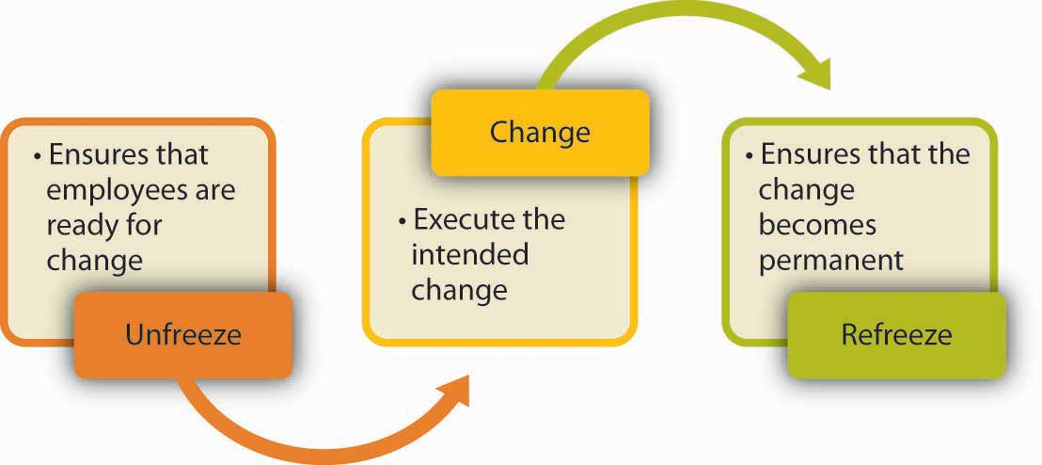
Pfizer Inc. has hired the personnel on the position of the director digital change management. The personnel on the post will have to support all the changes and developments which will take place and come up with the strategies that will help in going through the change and enable all the employee working in an organisation to adapt with the changes (Alvesson and Sveningsson, 2015).
Unfreezing
In this case, the hired manager for the digital change has to make every employee aware of the digital trends that are being trended in the pharmaceutical company. Also, he should ensure that the employee should have the proper knowledge of the change top management of Pfizer Inc. is been planning to apply (Alvesson and Sveningsson, 2015).
Also when the company decided to organise the business of the company into three types of the model i.e. business of science-based innovative medicines, a new business unit of hospital especially for the anti-infective along with the injectable sterile and the third business unit was off-patent branded along with the generic established medicine business which is been operated under the autonomy which is substantial under the Pfizer. These changes were about to be implemented by the start of the fiscal year 2019.

Changing
When this new change was being implemented, a structure was also formed which represented the evaluation done in the ongoing business of the Pfizer. So with all the changes happening in the Pfizer, the organisational structure is also been changed which also changed the capital allocation in the business. Also, the product line is been expanded, the working also changed in the company. Therefore at this stage, all the changes are being applied and the employees are expected to adapt to the new working culture along with all the changed policies and procedures due to the change and expansion in the product line (Alvesson and Sveningsson, 2015).
And when the changes concerning the digitisation id been made the employees are given the proper training so that they get accustomed to the new technologies and feel at ease in using these new technologies.
Refreezing
This step ensures that all the changes done are permanent in nature. As advancement in the technology is been discussed, the top management and the human resource department tries to train the employees so that they become tech-friendly and get accustomed to the new way of working (Alvesson and Sveningsson, 2015).
The two reasons for which the segmentation is been done as the company wanted to have the growth profile which is higher and more sustained and on the other hand, the new business structure is been applied which will also help in doing the better positioning of the brand in the market. This new structure will also help in ensuring that there is natural evolution done in the new culture of the business and business structure. Also in order to refreeze the changes done, the employee cutting is also been done and the global headcount is also been reduced which is by almost 2% and in order to this, the technique of voluntary retirement is been applied along with reducing the number of staff working.

Cultural model
Organisation culture can be explained as the bundle of norms as well as the behaviour which is been shared by all the people working in the group. So the main question arises here is that how the Pfizer can indirectly act on the culture by maintaining its effect in an effective and efficient manner? So there are four ways in which the culture is been influenced which can be described with the help of the following chart (Bejinariu et al., 2017):
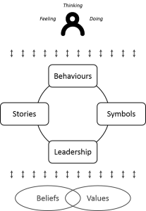
This diagram shows how culture is been influenced and it affects us. In the centre of the above diagram, there are four elements i.e. behaviour, symbol, leadership and stories.
Behaviours
Since the Pfizer is planning to reorganise its organisational structure, the work culture might also change which might also change the behaviour and the attitude of the people as the reorganising also included the employee cutting by voluntary retirement and staff removal. This might affect the work culture and environment in the Pfizer (Bejinariu et al., 2017).
Symbols
The symbol refers to the things that intentionally or unintentionally means something. This might include the client reception area and the perception or the message it is trying to give to the other people or even the how much senior management post is been occupied by the women etc. (Bejinariu et al., 2017)
Leadership
In order to get the change done in an effective and efficient manner, it is very important that this change should be accepted and adopted by the leader or the top-level management first. If the leader adapts to the change, he can motivate the employees also to come in terms with the change. In Pfizer, the business is reorganised into three new elements which also resulted in the change in the culture and work environment. So when the top management of the Pfizer adapts to the change, their employees will surely adapt to the changes (Bejinariu et al., 2017).
Stories
The stories, either implicit or explicit in nature, known to the employees also affects the work culture of the environment. So the past of the Pfizer surely helps in shaping the work environment and work culture of the Pfizer (Bejinariu et al., 2017).
Below the cycle
In the diagram, below the cycle, the values and beliefs are been put like they are underpinning the cycle of the element of the culture. It is been out of the cycle as the change management in the company do not directly depend on beliefs and values as these concepts are very fundamental in nature (Bejinariu et al., 2017).
Above the cycle
The main point of the change management is how employees working in the organisation deals with the change happening in the working culture or environment. In the case of the Pfizer Inc., since the reorganisation is been done in the workplace along with dividing the business into three elements, the success of this change highly depends on the level at which the change is been adopted by the employees. So if Pfizer wants that the distribution of the business in the 3 new business elements along with the introduction of the new technology gets successful, then it is very important than the employees working in the Pfizer should adapt to the new working culture (Bejinariu et al., 2017).

Evaluation of the impact of organizational culture on the change management program
Before analyzing the impact of organizational culture on change management program let us first understand what culture means.
A culture is a common image held by the employees of an organization. In a nutshell, it is a system of shared perception (Cameron et al., 2019). Culture is the sum of the values that shape the behaviour of the organization.
Organizational culture consists of organizational expectations, values, etc. that guide the organization's member's behaviour and is shown in the self-image of the member, working and in interaction with the outside world. Every company has a unique personality. This unique personality is nothing but its culture. It is invisible but is a powerful force that influences the behaviour of the people of the organization (Alvesson and Sveningsson, 2015).
An organization with the best strategy in the world but a culture that won’t allow it to make that strategy happen is doomed (Van der voet et al., 2017).
Change management, on the other hand, is a systematic approach to deal with the transition of the organization's goals and objectives. The purpose of change management is to implement strategies for putting change into effect, controlling change and help people adapt to it (Bortolotti et al., 2015).
The similarity between individuals and the culture of the organization decides the eminence change management (Alvesson et al., 2015).
In an organization, managers need a clear understanding of the culture prevailing in the organization so he can direct the employees accordingly and can avoid any incorrect influence on employees who are not devoted towards the goals and objectives of the organization (Bortolotti et al.,2015). It is necessary for the individual beliefs to map with organization's culture because the culture of mutual desire results in action which helps the organization to achieve common goals and objectives.
An organization will successfully accomplish implementing change management when the key values are mutual to the majority of the members. So if the management does not understand the culture that motivates and encourages the organization to achieve the common goal, organization without a doubt will face problems. New procedures will be tough to enforce if it does not match with the organization's culture.
Developing an environment where people can enjoy and value their work is crucial. In order to attain this, management should clearly communicate their expectations from the employees in an organization (Hickman et al., 2018). These expectations should be supported by the actions of the managers who on a periodical basis let people know how their work is important to the organization.

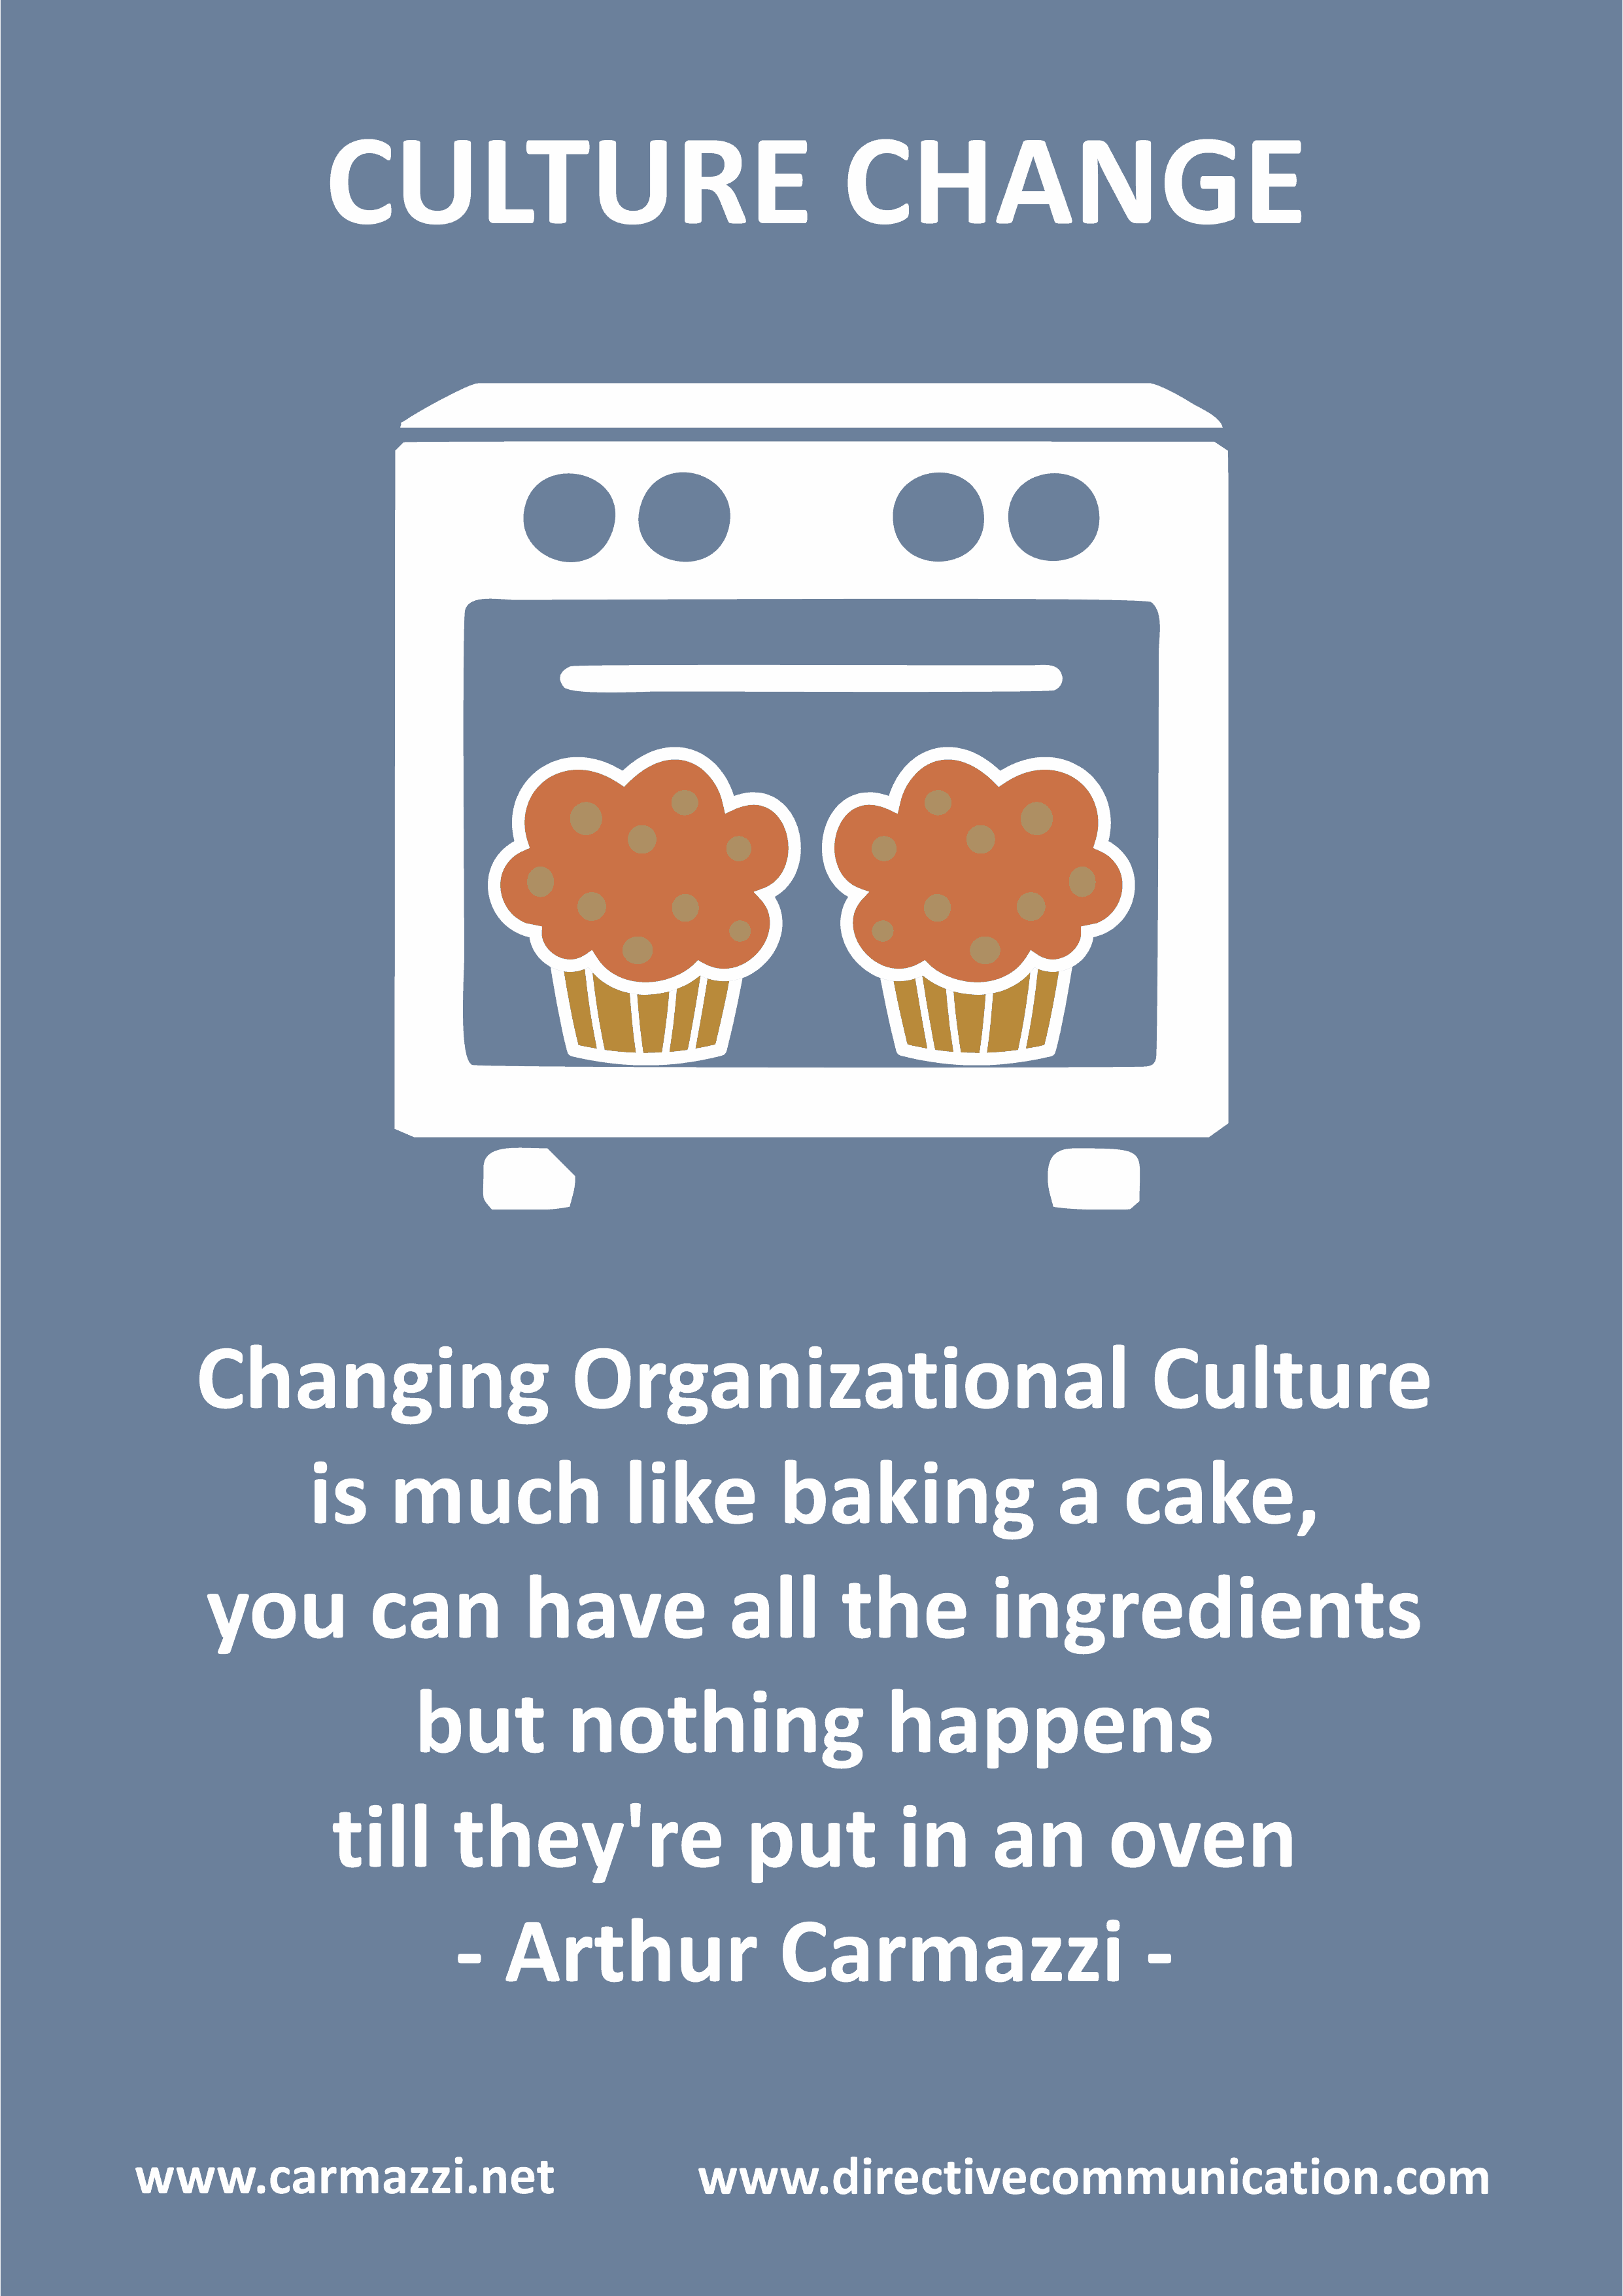

When management implements a change or plans to implement a change, there are five main points which need to be remembered while implementing any change:
- Different people respond to changes in a different manner.
- Everybody has some basic needs which they want to be fulfilled.
- Changes on a regular interval involve losses and people generally go around that.
- Anticipation need to be managed rationally
- Deal with the fear of change
The organization culture represents an attribute of object, idea or event while the change management is the outcome of specified actions. Organization culture constitutes of value, norms and rituals (Guiso et al., 2015). They impact change management by promoting a sense of belongingness that motivates the employees to participate in the change. The norm means the dress code, communication manner, work ethics, etc. They either increase the productivity of the employees or drastically reduce it. The rituals include training, rewards, punishment, promotion, etc.
The organizational culture and change management are interrelated. Every organization has a unique culture so if the management implements changes then they have to adopt the change process with the culture or they have to change the organizational culture.
Organizational culture and change are both difficult and complex. Change brings uncertainty and resistance. However, these two can work together. Resistance can be reduced with the help of organizational culture. If the change strengthens the culture then the members are most likely to welcome the change.
When it comes to doing improvement in an existing culture, some of the organizations fail to do so because –
- Focus on culture rather than behaviour: Management should try to alter how people act in an organization by deciding the behaviour that they want. Leaders should provide training on the required behaviour, and reinforce them with punishment or reward. If an organization requires its employees to be more quality-focused, then they should conduct proper training sessions and teach them the fundamental skills needed for this change. If an organization wants an innovative culture then it should recognize and celebrate something which is new.
- Lack of Investment: Change to be recognized and implementation of change needs time and investment. An organization may be required to change the structure of the organization or even a few policies prevailing in the organization. Changing organizational culture is not a small task. It takes a lot of time and persistence. But the organization sworn to change should enable people to thrive and grow.
People are comfortable with the current organizational culture. For people to consider a change, a significant event must happen.
In our case, Pfizer Inc. decided to improve its legal department because it is a laggard when it comes to legal compliances. The present culture in the company is of very relaxed and people do not comply with the legal implications as and when required or within the prescribed timeline. There exists a need for change in the organization.
The organization decides to hire highly skilled employees who are motivated enough and have the required skill sets to direct their teams towards the desired goals. Also, the organization linked the rewards and punishment directly with the performance. This increased the productivity of the legal department drastically.
Further, proper training sessions were conducted for the employees in the legal department and were provided with the latest books and periodicals to update their knowledge. Employees were motivated to attend seminars and training programs to refine their skills. Management gave proper time to understand what changes are required to be done and made a proper investment for the same.
At first, the change was opposed. Then the management made the employees realize the importance of change and motivated them to accept the change. Management helped the employees to link their values with that of the organization's goal and it was only then the change management became successful.

Conclusion
It can be said that it is one of the most challenging tasks of implementing the changes with respect to the organisation along with bringing the permanent change in the behaviour of the employees working in a company. The gist of the report says that the implementing change in the organisation, in this case Pfizer, starts with the leadership, then ensuring that the change Pfizer is trying to apply is positive in nature and it will surely benefit the employees too along with the company, then coming up with the opportunities where people can accept the change and at last trying to sustain that change.
Cultural change in the organisation can be scary for both, i.e. for the employee along with the employers or the top-level management. However, if the organisation works and moves on the right path having its sole focus on the management on the change, they can surely move towards getting successful and come with the positive change management in the company. Three models which are being discussed are the cultural change model, Lewis three-stage model and Burke Litwin model which helps in developing the entire path to do the change management in an effective and efficient manner.
Also in order to do study the change in a more prominent manner, the SWOT, as well as PESTEL analysis of the Pfizer, is been conducted followed by the field force analysis. In the last part, the evaluation is been done of the impact the organisational culture brings to change management programme of the Pfizer.

References
- Alvesson, M. and Sveningsson, S., 2015. Changing organizational culture: Cultural change work in progress. Routledge.
- Alvesson, M. and Sveningsson, S., 2015. Changing organizational culture: Cultural change work in progress. Routledge.
- Bejinariu, A.C., Jitarel, A., Sarca, I. and Mocan, A., 2017. Organizational Change Management–Concepts Definitions and Approaches Inventory. In Management Challenges in a Network Economy: Proceedings of the MakeLearn and TIIM International Conference 2017 (pp. 321-330). ToKnowPress.
- Bortolotti, T., Boscari, S. and Danese, P., 2015. Successful lean implementation: Organizational culture and soft lean practices. International Journal of Production Economics, 160, pp.182-201.
- Bull, J.W., Jobstvogt, N., Böhnke-Henrichs, A., Mascarenhas, A., Sitas, N., Baulcomb, C., Lambini, C.K., Rawlins, M., Baral, H., Zähringer, J. and Carter-Silk, E., 2016. Strengths, Weaknesses, Opportunities and Threats: A SWOT analysis of the ecosystem services framework. Ecosystem services, 17, pp.99-111.
- Cameron, E. and Green, M., 2019. Making sense of change management: A complete guide to the models, tools and techniques of organizational change. Kogan Page Publishers.
- Giuliano, P. and Nunn, N., 2017. Understanding cultural persistence and change (No. w23617). National Bureau of Economic Research.
- Guiso, L., Sapienza, P. and Zingales, L., 2015. The value of corporate culture. Journal of Financial Economics, 117(1), pp.60-76.
- Hickman, C.R. and Silva, M.A., 2018. Creating excellence: Managing corporate culture, strategy, and change in the new age. Routledge.
- Hussain, S.T., Lei, S., Akram, T., Haider, M.J., Hussain, S.H. and Ali, M., 2018. Kurt Lewin's change model: A critical review of the role of leadership and employee involvement in organizational change. Journal of Innovation & Knowledge, 3(3), pp.123-127.
- Nash, M.M., Manning, M.R. and Heiser, E.J., 2019. Applying Lewin’s Force Field Theory to facilitate SWOT analysis: an effective and efficient approach. In Preparing for High Impact Organizational Change. Edward Elgar Publishing.
- Olivier, B., 2018. Psychometric validation of an Organisational Performance Questionnaire (OPQ) based on the Burke-Litwin model. Journal of Psychology in Africa, 28(1), pp.46-51.
- Phadermrod, B., Crowder, R.M. and Wills, G.B., 2019. Importance-performance analysis based SWOT analysis. International Journal of Information Management, 44, pp.194-203.
- Sammut‐Bonnici, T. and Galea, D., 2015. PEST analysis. Wiley Encyclopedia of management, pp.1-1.
- SHTAL, T.V., BURIAK, M.M., AMIRBEKULY, Y., UKUBASSOVA, G.S., KASKIN, T.T. and TOIBOLDINOVA, Z.G., 2018. Methods of analysis of the external environment of business activities. Revista ESPACIOS, 39(12).
- Stone, K.B., 2015. Burke-Litwin Organizational Assessment Survey: Reliability and Validity. Organization Development Journal, 33(2).
- Van der Voet, J. and Vermeeren, B., 2017. Change management in hard times: Can change management mitigate the negative relationship between cutbacks and the organizational commitment and work engagement of public sector employees?. The American Review of Public Administration, 47(2), pp.230-252.

