Assignment 2

ORGANISATIONAL BEHAVIOUR

Reflective report

Module Name: Introducing the Modern Workplace
Module code: LCBB4003

Student: Marius Scorcea
Lecturer: Aparna Venkatesan

Contents
INTRODUCTION 3
MAIN BODY 3
1. Description 4
2. Feelings 4
3. Evaluation 5
4. Analysis 5
5. Conclusions 6
6. Action Plan 6
CONCLUSION 7
REFERENCES 7

INTRODUCTION

This report is a reflection over the Power Point presentation that we had as a group on 27th of November, ,,Introducing the Modern Workplace British Airways’’.
As we all probably know reflective practice is a life tool that we are using on daily basis, in my case since I open my eyes at 6 o’clock on the morning and I start thinking at all the things that I have to do during the day and at the end of day I analyses if everything went well, the way I expected or if not, why and what I should have done differently?
“Whether we focus on problematic experiences or positive ones, reflecting on them will provide us with opportunities for growth and development.”
Bassot, The reflective journal
Personal reflection or self-reflection is strong related to personal growth as without reflection we won’t be able to realize what is going on around us or to control our emotions as a response to other people actions. Reflecting will help us changing bad behaviours or thoughts that are not suitable for us. (Habbash, 2022).
In the following lines I will try to asses using Gibbs Reflective Cycle the experience I had as a student presenting in front of the class and the teacher, and as a member of a group that came together for the first time in order to deliver the Presentation.

MAIN BODY

Reflective practice at academic level is different than the reflection, thought we are having every day.
Gibb’s Reflective Cycle is making this difference through the six stages of reflection that are the corner stone of learning from experience process.
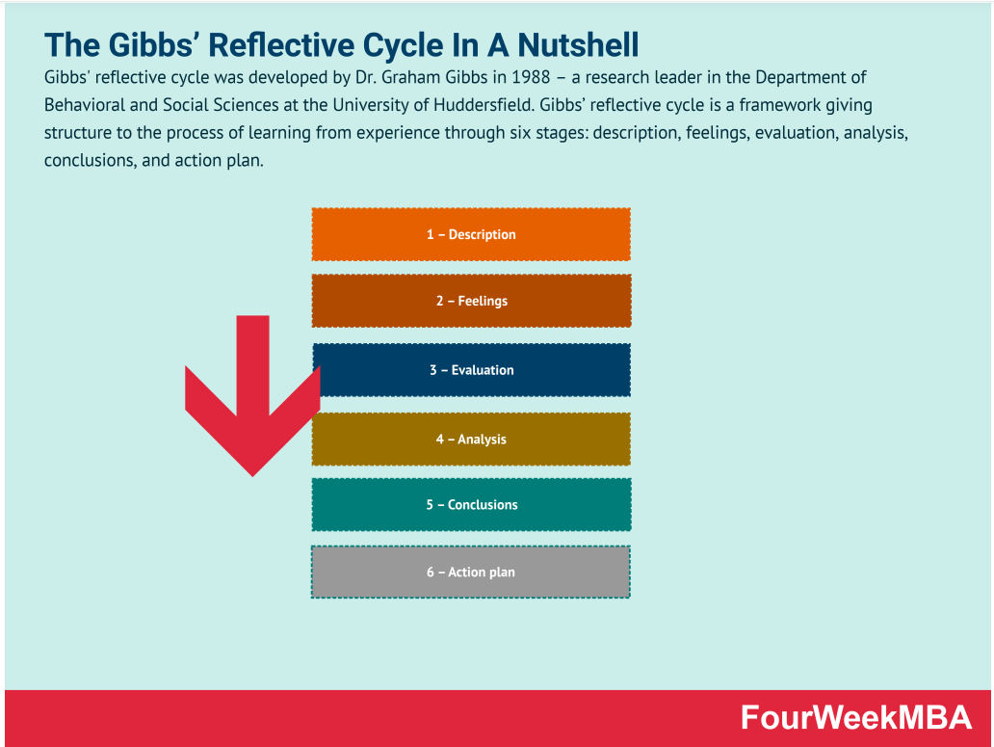
https://fourweekmba.com/gibbs-reflective-cycle/

Description
As a module task we had a group assignment, a presentation that we had to deliver at the end of November.
For this we had to form a group and divide the work according to our skills and abilities, we choose a group leader that had to upload the work on Moodle for all of us and had to make sure that the paper is uniform an according to University Standards before uploading it.

Feelings
I was pleased with the team that we formed, I worked with four wonderful ladies, I felt that everybody is committed and desire to deliver a good job even though at a moment I was a little bit frustrated regarding our group leader attitude. I felt like she is pushing us too much and there is no need to do so.

Evaluation
Assessing now the way we presenting, I think overall, we were inspired the way we divided the work. It was fair for each of us, we had to do a research on British Airways and even though we start all thinking on those 3 minutes that each needed to deliver the presentation I have to admit that some of us went over 3 minutes and affected a little bit our performance as a team.
But as a positive point, I have to say that we tried to help and encourage each other, for instance, when one of us forgot to change the slides as she was really focused on her speech, our group leader helped her by changing the slides for her, which I would say it was a good team effort.

Analysis
Analysing further what happened, I have to admit that our team coagulate well, I could identify all Belbin’s team roles among us:
- Plant and Resource Investigator roles belonged to Andreea as she was the one that came up with the idea of presenting British Airways and she provide us most of the resources.
- Coordinator and Specialist roles were fulfilled by Dana as she was the one that coordinated the team ad she gather all the materials in a final and suitable form.
- Shaper role was attributed to Primavera, through her attitude she helped us overcome any communication difficulties that appeared along the process.
- I was definitely the Monitor-Evaluators I was always focused on how to find the right way to deliver the Presentation on time and what can we use, e.g. hand notes, in order to make our life easier and relieve the pressure of the moment.
- Larisa was a Team Worker, ready to help the team to complete the work, always there if we had issues.
- The roles of Implementer and Completer I would say belonged to all of us as we, all, contributed and worked on a good strategy for the assignment and at the end of the task we made sure that we have all the materials in a final form, ready to be presented in front of our teachers and colleagues.

Conclusions
This assignment, the fact that we had to work as a group made me realise the importance of planning ahead, choosing the right people to do the job they are best at in order to avoid pressure of delivering in time and minimise unnecessary effort.
Also, contradicting is not always very bad in a team, good ideas may appear and the research is dome with more attention.

Action Plan
From this experience I have learned that speaking English is not enough in order to appear in front of people. You need confidence, a fluent speech and a good preparation.
I will definitely use hand notes instead of my phone because I felt that the colleagues which use them looks more professional and also, I think it is important to approach the team work in more scientific way, using Belbin’s team role for more efficient division or the work.
Also, I will try to communicate to the team my objections sustained by strong arguments if I feel that things can be done differently.

CONCLUSION

This assignment helped me understand at a whole new level the notion of reflection. I become aware of all Gibb’s Reflective Cycle stages and this put reflection in a different light for me.
All the people are learning from mistakes but analyzing facts, thoughts, actions is a process that is meant to help me grow professional and spiritually and to develop my work ethics.
Reflection is life changing because you start seeing the whole picture and you end up taking decisions that will have a great impact on your future.

REFERENCES

Habash, C. (2022), What is self-reflection? Why is self-reflection important?, Available at: https://thriveworks.com/blog/importance-self-reflection-improvement/, [Accessed on 01 DEC 2022]

Cuofano, G. (2022), What is Gibbs’ Reflective Cycle? The Gibbs’ Reflective Cycle In A Nutshell, Available at https://fourweekmba.com/gibbs-reflective-cycle/, [Accessed on 01 DEC 2022]

