Please add your targets from the previous assignment (Only relevant if you have completed an assignment)
Targed/Target 1 | Use the reading list to guide you to the sources that need to be read to give your work more dept
Targed/Target 2 | Read more closely the Harvard referencing guide you were given.
Targed/Target 3 | Use capital letters for the names of things, try not to scatter them over the place at random.
Targed/Target 4
Targed/Target 5

Carly Seymour – 2204585
EDCAD4010 How is outdoor play supported within schools?

Introduction

The foundation phase focus is to create a structured and supportive environment for all pupils and
encourages holistically their overall development covering all areas emotionally, physically,
cognitively and socially. This assignment is to discuss and research pupil engagement within an
outdoor area of play. It is very important especially in foundation phase that pupils feel able,
comfortable and empowered within their environment. Pupils within foundation phases are
encouraged to work to their full potential with the support of their peers and teachers. Learning
experiences within foundation phase classrooms are designed to aid children to work as part of a
group demonstrating communication, working as part of a team, and using their own innovative.
Problem solving activities and interactive workshops gets the pupils minds stimulated and keeps
them engaged within the learning environment. The School I visited created different stations at
break times to encourage outside learning using different fine motor skills and problem solving, this
also encourages independent learning and an opportunity for children to explore and discover the
surroundings within their environment. Weekly meetings with the pupils and catch-up sessions is
also key within foundation phase encouraging self-reflection and self-analysis.

Literature Review
Within foundation phase outdoor play offers a contrasting way of developing children’s holistic skills compared to an organised and indoor planned environment. Outdoor play also offers children and opportunity to carry out their learning and outdoor playtime in an unstructured way and encourages them to use their time and outdoor space freely (Gabriela Bento, Gisela Dias 2017). Outdoor space is a great way for children to improve their communication skills combined with using their free space to explore and learn. Foundation phase learning also is highly focus on team building activities encouraging children to take turns and share developing the behaviour of children in a positive light while using their outdoor environment and props.
The school I visited was based in a highly deprived area which could suggest that children had limited access to outdoor space, and not used to outdoor surroundings. During a study carried out by the American Institute for Research titled “Effects of Outdoor education programs in California” (American Institutes for Research, 2005) they focused on children who were underperforming and from disadvantaged areas. The results of the research after the programme had run reported children were much more engaged and confident in team building activities. The report also suggested that children’s self-esteem and mood were boosted, the pupils were more motivated and willing to learn and their etiquette and behaviour within a classroom environment had significantly improved.
“The knowledge base shows that exposure to natural spaces – everything from parks and open countryside to gardens and other greenspace – is good for health” (Sustainable Development Commission 2008, p. 3).
The introduction of forest school and outdoor nurseries has been a big focus within Foundation phase to encourage outdoor learning and play. This steers away from the structured educational curriculum as a whole and focuses more on children engaging in making survival crafts and building mud kitchens allowing for free play and exploring the outdoor environment (O’Brien, 2006; O’Brien and Murray, 2007). The focus of problem solving was set up with a view of looking at a constructivist and social constructivist learning method through a Forest School set up of outdoor learning enabling children to carry out experiments and discover outdoor surroundings. This constructing and direct experience approach links to Piaget’s theory suggesting children construct knowledge from direct experiences around them and Vygotsky zone of proximal development theory building on experiences and learning from them instead of taking new information in (Knight, 2016).
The Estyn report on the school I visited suggests that the use of their outdoor space is good the school has use of large playing fields and yards with stimulating outdoor areas, which are used by teachers and staff efficiently (Estyn 2014 P.10).

Methodology
The Leuven scale can be used as a significant observation tool to measure behaviour in foundation phase childhood education. It looks at the child’s development in five areas and provides and overall outlook. The areas that the Leuven scale looks at are emotional and cognitive development, interaction in a social environment, a child’s speech and language, the ability on inability to problem solve and their physical development. These areas are then split into subheadings and scored from 1-5 or by ticking if the child has displayed these behaviours depending on what observation tool you have chosen to use. This allows us to measure a child’s behaviour over a period.
Pedagogical tools are often used within an education setting to measure a child’s behaviour however there are advantages and disadvantages associated with using it as a measuring tool. As the Leuven scale is an observation-based tool this focuses entirely on the child and the learning environment surrounding them. An advantage of using the Leuven scale as an observation tool means it focuses on the child’s holistic behaviour and doesn’t allow for children to be put in the same box for every behavioural trait. The observer can look at the child’s behaviour in a reactive way and focus on the child’s individual needs (What Is the Leuven Scale and How to Use it, 2022). Additional learning needs students and non-verbal students being observed using this method however don’t fit into any category of scoring and this can be seen as a disadvantage to using this scale. As they’re observed behaviour could be different of that of a child without additional learning needs. While looking at cultural difference in the school it can also be argued that the Leuven Scale and can be argued that children with cultural differences can behave in a different manner than that mapped out on the Leuven scale this can also be seen in John Bowlby’s Attachment Theory (Ackerman, 2018).

Discussions and findings
When discussing and outlining my findings it is important to note and consider the ethical guidelines around my research. Referring to the BERA 2018 document it is important that the participants understand they have a right to withdraw from the research at any point. The document also outlines the important of consent and assent. Informed consent is the voluntary verbal agreement given to participate in research, allowing parents to sign a consent form for the willingness for their child to take part in the research and understanding the risks but not all the facts. Assent is expressing an emotional willingness to take part in the research whereby the child may be too young to consent and express emotion – will involve regularly checking in and making sure the child is still happy to proceed (BERA 2018 P15). Assent gives children a voice and allows them to make their own choices based on how they’re feeling.
It is also important that participants are aware the researcher has a duty of care to not cause any emotional turmoil and put the person before the research (BERA 2018 P25). This would involve identifying any particular risks by carrying out the research and evaluating the emotional effect it has on the participant. As seen in the Little Albert experiment (Mcleod, 2018) demonstrating a conditioning theory generalising fear with a particular item or subject, the research I’m carrying out must not be conditioned by emotion. It is also important to make the participants within my research aware that they have a right to privacy at all times, and their data will be handled confidentially and with anonymity. I will do this by changing the children’s names to child 1,2 and so on and referring to the school as School X (BERA 2018 P 27).
My observation I carried out were on 3 different children outdoors on a station making a mud cake. As the children I was observation could verbally consent I regularly checked in and made sure the children were still happy for me to observe. Referring to appendix 1 my observations on the children using the Leuven Scale of involvement were done over the course of 5,10 and 15 minutes. I have labelled these children Z, L and N for confidentiality reasons.
Child 1(Z)
Nonparticipant observation using Leuven Scale matrix
- Scored a 2 after 5 minutes this was indicating that the child was engaged in the activity seldomly making a mud cake but not listening to the instruction was also getting distracted by other children and what they were making and the noise around them.
- Scored a 4 after ten minutes the child had now become emerged in the activity listening clearly to the instructions for the mud cake and had ignored the distractions around them allowing them to focus on the task, they started singing the mud kitchen song successfully participating.
- Scored a 3 after 15 minutes the child had lost slight interest during this point although still wanted to complete the task and was becoming easily distracted by others.

Child 2(L)

- Child 2 after 5,10 and 15 minutes scored a five at each time slot. Child 2 was engaged and interested in building the mud cake throughout the activity engaging with others and listening to instructions. Child 2 sustained a good level of participation and engagement throughout the activity.

Child 3(N)

- Child 3 at 5 minutes scored a 4 indicating that from observation they were not easily distracted by others and were always involved. Child 3 asked questions around the task and showed a good level of understanding.
- Child 3 at 10 minutes scored a 5. The child is creative and showing a high level of concentration throughout the task. Energetic and enthusiastic when making our mud cake and using all available space and props around them.
- Child 3 at 15 minutes scored a 4 still maintaining a high level of concentration and a continuous willing to learn. After 15 minutes the child still wasn’t easily distracted and focused on the task.

Conclusion

To conclude it is evident outdoor play benefits children’s mental health and wellbeing alongside holistic development and social skills. I feel that outdoor learning has become a vital and invaluable tool to help children thrive and grow within a school setting as well as keeping children active.

Within School X 55% percent of the pupils had an additional learning need and I found the Leuven scale was restrictive within some areas. I couldn’t record the pupils engagement within the 5 minute sector on times as the child would become disengaged very easily and become distracted. As it was playing time there was also a lot of other children around completing various activities and this would distract the participants from the offset. I also found the weather a factor in my observation as it started to rain during the task the children become less engaged as they were jumping in the puddles and not focused on the task in hand.

If I were to carry out the observation again, I would conduct it inside with a small group of children to minimise distractions and eliminate the weather being a factor. My observation sheet I would edit to include an additional comments box allowing me to write any other notes I found relevant to the observation that I couldn’t include within the Leuven Scale boxes.

Appendix
Appendix 1
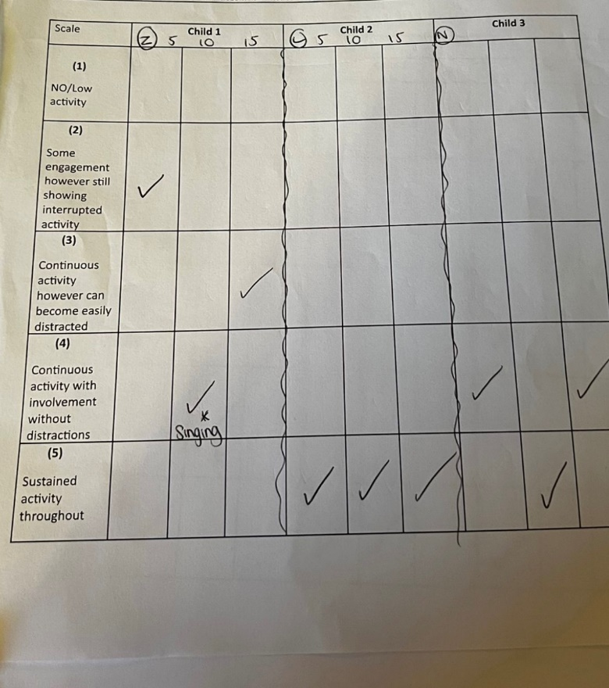

References
Ackerman, C.E., MA (2018) What is Attachment Theory? Bowlby’s 4 Stages Explained. Available at: https://positivepsychology.com/attachment-theory/ (Accessed: February 27, 2023).
American Institutes for Research (2005) Effects of Outdoor Education Programs for Children in California. Available at: http://www.seer.org/pages/research/AIROutdoorSchool2005.pdf (Accessed: February 27, 2023).
Bento & Dias, G. (2017) ‘The importance of outdoor play for young children's healthy development’, Porto Biomedical Journal, PP157-160.
British Educational Research Association [BERA] (2018) Ethical Guidelines for Educational Research, fourth edition, London. https://www.bera.ac.uk/researchers-resources/publications/ethicalguidelines-for-educational-research-2018.
Estyn Report. (2014) “A report on Cadle Primary School Middle Road Fforestfach Swansea”p7 Available at: Inspection Report Template (gov.wales) (Accessed: 27 February 2023).
Knight, S. (2016) Forest School in Practice: For All Ages. Sage
Mcleod, S. (2018) Little Albert Experiment - Simply Psychology. Available at: https://www.simplypsychology.org/little-albert.html (Accessed: February 27, 2023).
O’Brien, L., Murray, R., (2005) ‘Forest schools in England and Wales: woodland space to learn and grow’, Environmental Education, Autumn, pp. 25 – 27.
O’Brien, L., Murray, R., (2007) ‘Forest School’ in England: an evaluation of three case study settings’, Environmental Education, Spring, pp. 8 – 9.
Sustainable Development Commission (2008) Health, Place and Nature: how outdoor environments influence health and well-being: a knowledge base, http://www.sdcommission.org.uk/publications.php?id=712.
What Is the Leuven Scale and How to Use it (2022). Available at: https://learningjournals.co.uk/what-is-the-leuven-scale-and-how-to-use-it.

Professional Reflection
The Research Days allowed you to start making connections between theory and practice. Use this template to reflect on your experience as a researcher.

- Disgrifia UN o'r arsylwadau a gyflawnwyd gennyt. Beth wnest ti ei ddysgu ohono?
Describe ONE of the observations you carried out. What did you learn from it?

Alongside my one observation spoken about I also observed a group of children learning welsh. Some children picked up the welsh task very easily, others needed help. The children had emotion cubes to put up how they were feeling to show the teacher and how difficult or easy they were finding the task.

- Beth oedd yr heriau a'r cyfleoedd o fod yn sylwedydd nad oedd yn cymryd rhan (non-participant observer) yn yr ystafell ddosbarth?
What were the challenges and opportunities of being a non-participant observer in the classroom?
It allows you to observe through a window without getting involved allowing you to see the bigger picture. Non participant observation also allows you to observe from the outside and children may act more naturally. However a challenge would be if the task wasnt run to fit around your observation and also you cant ask question about why children were acting in a certain way compared with participant observation.
- Yn dy brofiad di, beth oedd manteision a chyfyngiadau'r Raddfa Leuven fel offeryn ymchwil?
In your experience, what were the benefits and limitations of the Leuven Scale as a research tool?
Easy to record and visually easy to read off. A limitation would be that the Leuven scale isnt suited to addtional learning need students as theyre behavioiur and actions do not fit into a numerical box as they can get easily distracted.
- Beth oedd prif bwyntiau dysgu i ti o ran bod yn ymchwilydd yn yr ystafell ddosbarth?
What were the main points of learning for you in terms of being a researcher in the classroom?

How the children participate within structured activited and communicate with each other. Observing their ability to work within a team aswell as and independent learner.

- Beth fyddet ti'n ei wneud yn wahanol pe bae ti'n cynnal yr ymchwil hon eto? Pam?
What would you do differently if you were to conduct this research again? Why?

I would carry the research out inside as the weather was a contributing factor towards my research results. I would also ensure it wasnt break or lunch time when carrying out the research so that the pupils I am observing are less distracted. The time of day also has a contributing factor as I felt pupil engagement was higher at the start of the day as opposed to the end when the children were tired and overworked.

- Trafoda unrhyw ddulliau eraill o ymchwil y gallet eu defnyddio yn yr ystafell ddosbarth i wella dy ymarfer. Beth yw'r pethau positif a negyddol?
Discuss any other methods of research you could use in the classroom to improve your practice. What are the positives and negatives?

