PROPOSAL
by Charu Gautam

Dissertation – Proposal
LCMB7035

Proposed research title:
The Impact of AI-Powered Digital Marketing on Consumer Buying Behaviour: A Comparative Study of Amazon Customers in the UK and India

NAME: CHARU GAUTAM
STUDENT ID: 2432997
SUPERVISOR: AMARE DESTA

Table of Contents
1.INTRODUCTION 4
2. Literature Review 7
2.1 AI-Powered Digital Marketing 7
2.2 Consumer Trust and AI Transparency 8
2.3 Privacy Concerns and Buying Behaviour 8
3. Methodology 9
3.1 Research Onion 9
3.2 Research Design 10
3.3 Sampling and Participants 10
3.4Data Collection 10
3.5 Data Analysis and Ethics 10
4. Expected Findings 11
4.1 Expected Relationship Between AI-Powered Digital Marketing and Consumer Buying Behaviour 11
4.2 Expected Role of Consumer Trust and AI Transparency 11
4.3 Expected Influence of Privacy Concerns and Cross-Country Differences 12
5. Limitations 12
5.1 Sample and Geographical Limitations 12
5.2 Data Collection and Response Bias 13
5.3 Time and Scope Constraints 13
5.4 Mitigation Strategies 13
6. Timeframe 14
7. Conclusion 15
Reference 17
Appendix 18

1.INTRODUCTION
Online marketing has been revolutionized by Artificial Intelligence (AI) to enable companies to offer customized recommendations, targeted advertisements, chatbots, and forecast shopping experiences. Amazon has become a worldwide frontrunner of AI-centered marketing tactics to enhance client interaction and acquisition choices on various markets (Vashishth et al., 2024). Though the role of AI-driven marketing as a subject of consumer-based buying behaviour received more and more academic underpinning, there is little comparative evidence of the impacts of AI-driven marketing in developed and developing economies. This paper therefore explores the consumer behaviour of Amazon consumers in the United Kingdom and India to understand how consumer trust, transparency of AI and privacy issues are relevant in the shaping of the purchasing behaviour. The proposed study will utilize primarily quantitative research to deliver viable study findings to support in the international e-commerce environment that will enable more efficient, plausible and customer-focused AI marketing initiatives (Vashishth et al., 2024).

RESEARCH AIM
To test the way in which AI-positioned digital marketing can be used to shape the consumer purchasing behaviour through comparative analysis of the Amazon users within the United Kingdom and India.

RESEARCH OBJECTIVES
1. To evaluate the effect of AI-powered digital marketing (e.g., personalised recommendations, AI chatbots, targeted advertising, and dynamic pricing) on consumer buying behaviour.
2. To examine the mediating role of consumer trust in the relationship between AI-powered digital marketing and consumer buying behaviour.
3. To investigate how privacy concerns moderate the relationship between AI-powered digital marketing and consumer trust.
4. To compare the differences in consumer responses to AI-powered digital marketing between Amazon customers in the UK and India.
5. To develop strategic recommendations for improving AI-powered digital marketing practices that enhance consumer trust while addressing privacy concerns in international e-commerce.

HYPOTHESIS
H1: AI-driven online marketing is strongly associated with a positive impact on consumer purchasing behaviour.
H2: Consumer trust has a significant positive effect on consumer buying behaviour.
H3: AI-powered digital marketing has a mediating relationship with consumer trust and consumer buying behaviour.
H4: Consumer trust is greatly impacted negatively by privacy issues.
H5: The difference between Amazon customers in the UK and India in terms of the influence of AI-powered digital marketing on consumer buying behaviour is significant.

RESEARCH QUESTION
RQ1: How does AI in digital marketing work in Amazon?
RQ2: What is the impact of AI-driven digital marketing on consumer buying behaviour?
RQ3: How does consumer trust affect buying decisions when using AI-powered marketing?
RQ4: What is the impact of privacy apprehensions on consumer confidence and purchase behaviour?
RQ5: Which are the differences between Amazon consumers in the UK as compared to India with respect to AI-powered digital marketing?

2. Literature Review

2.1 AI-Powered Digital Marketing
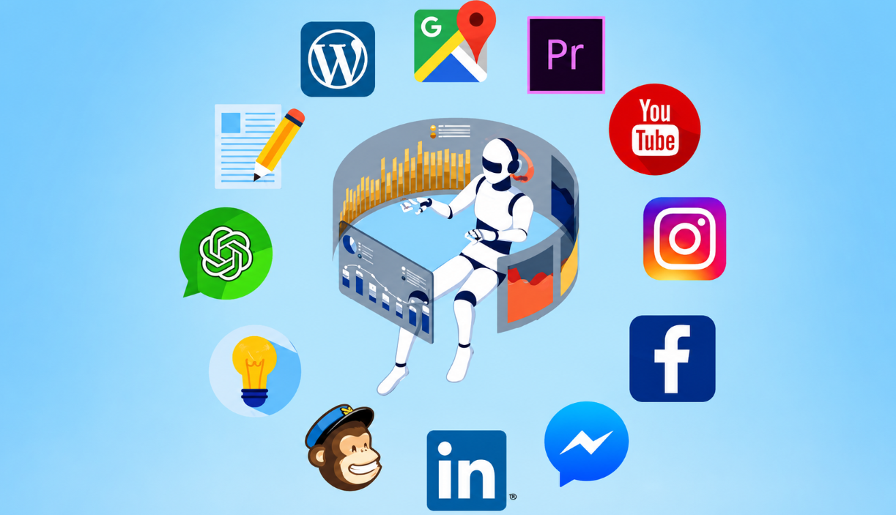
Figure1: AI-Powered Digital Marketing
Source:(Morávek and Advertising, 2025)
Through digital marketing using AI, organisations are able to offer personalised recommendations, specifically targeted advertising and automated communication to customers through the analysis of consumer inputs. It completely depends on the adoption of the technologies compared to the adoption by the consumers on the issue of interacting with AI-driven interactions and hence, these technologies ease the issue in shopping convenience and enhanced customer interaction, according to past studies (Vashishth et al., 2024).

2.2 Consumer Trust and AI Transparency
It is more or less agreed that consumer trust is a determinant of online buying behaviour. Literature suggests that clear AI recommendation engines that have a rationale behind product recommendations increase trust and perceived trustworthiness of consumers. On the other hand, less openness can decrease the level of trust and purchase intentions even after the correct recommendations have been made (Kumar, Dayal and Of, 2025).

2.3 Privacy Concerns and Buying Behaviour
As much as AI personalisation will ameliorate the shopping experience, it is an issue of privacy concern that there is tremendous data capacity gathered. Personalised recommendations could be seen by consumers as worthwhile with a corresponding concern regarding the security of information and surveillance. This poses a trade-off between convenience and privacy, which affects the choice of purchasing behaviour among consumer groups differently (Kumar, Dayal and Of, 2025).
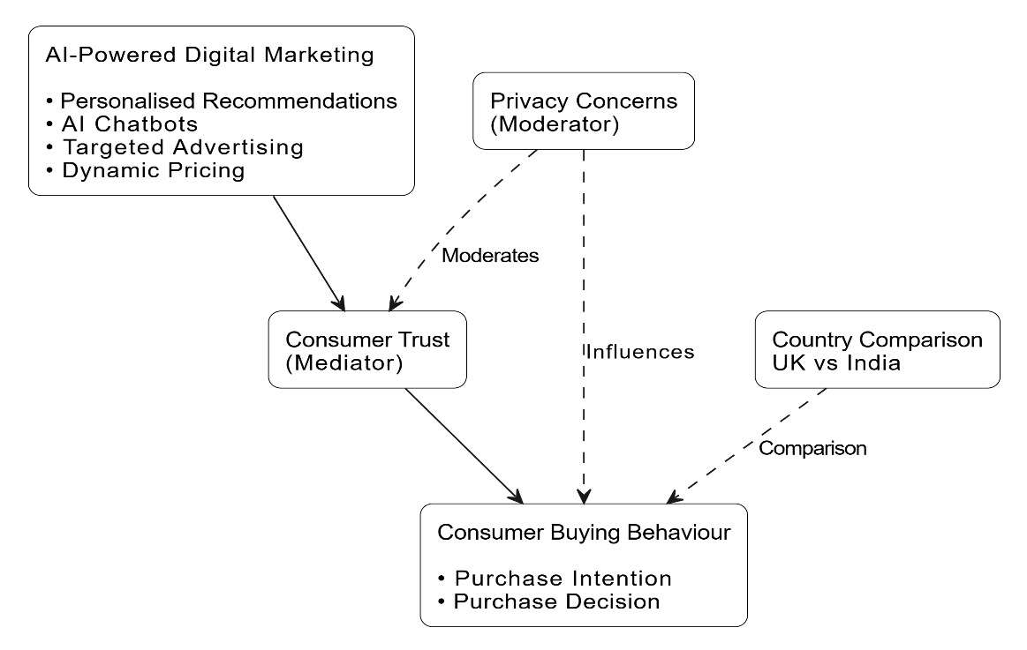
Figure 2: Conceptual Research Framework

3. Methodology

3.1 Research Onion
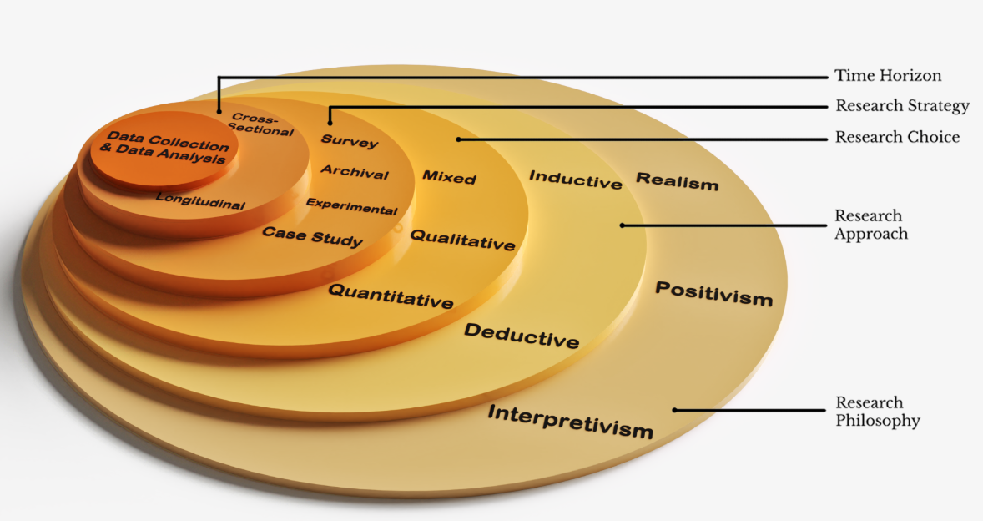
Figure 3: Research Onion
Source: (Penmypaper, 2017)
The research methodology is informed by the Research Onion framework which offers a systematic framework of choosing suitable research methods. The research philosophy used in this study is positivist, and the deductive method as well as a quantitative research strategy will be applied in order to analyse the relationship between AI-based digital marketing and consumer purchasing behaviour. A cross-sectional survey is conducted with the help of a structured questionnaire that is sent via Google Forms. The SPSS will be used to analyse data gathered on 50 Amazon customers in UK and India, as it is warranted that research design aligns with research objectives, and gets reliable statistical analysis.

3.2 Research Design
The paper is a quantitative study that considers a positivism philosophy and deductive research theorizing the relationship between AI-enabled digital marketing and the consumer buying behaviour. The investigator chooses a cross-sectional survey as it can be a method that can gather measurements of large amounts of respondents at a single time that the data can be statistically compared between Amazon customers in the United Kingdom and India (Kumar, Dayal and Of, 2025).

3.3 Sampling and Participants
The target group will comprise Amazon customers, who have made a single online purchase over the past six months. Convenience sampling will be used to recruit respondents as there is a requirement to have 50 respondents (25 customers of the United Kingdom and 25 customers of India) to make a comparison between both markets possible (Ologunebi, Taiwo and Alli, 2025).

3.4Data Collection
Primary data will be gathered using a Google Forms questionnaire consisting of 25 close ended questions (taking five points Likert-scale) Strongly Disagree (1) to Strongly Agree (5). Perceptions of AI-based personalised suggestions, consumer trust, AI transparency, buying behaviour and privacy issues will be measured in the questionnaire. The questionnaire will be sent via the social network, email and online forums of Amazon customers (Ologunebi, Taiwo and Alli, 2025).

3.5 Data Analysis and Ethics
Data collected will be analysed in SPSS, through descriptive statistics, reliability analysis, correlation and comparative analysis to answer the research objectives. To maintain ethical standards, the study will make sure that informed consent is obtained, voluntary participation, the anonymity of the respondents and confidentiality of data is maintained throughout the study (Ologunebi, Taiwo and Alli, 2025).

4. Expected Findings

4.1 Expected Relationship Between AI-Powered Digital Marketing and Consumer Buying Behaviour
This study will demonstrate that AI-based digital marketing imposes a positive impact on consumer buying behaviour in the tone that it offers consumers personalised recommendations, personalised advertising, a chatbots, as well as personalised-promotion content that will assist enhance the overall shopping experience. It is expected that consumers will feel that AI-driven marketing is more relevant and convenient, which will lead them to make more purchase decisions or choices on Amazon (Kravets et al., 2025).

4.2 Expected Role of Consumer Trust and AI Transparency
Trust in consumers is likely to become one of the key determinants of the success of AI-based digital marketing. In this case, the respondents who trust the recommendations and think of recommendation systems as transparent provided by AI are expected to declare higher purchase intentions as compared to respondents with a lesser level of trust. It also means that transparency will help increase the trust towards recommendations made by AI by reducing the lack of confidence when making a purchase (Kravets et al., 2025).

4.3 Expected Influence of Privacy Concerns and Cross-Country Differences
Matters of privacy are likely to tame the association between AI-based marketing and buying behaviour. Although the introduction of personalised marketing will probably motivate purchasing, the worries about collecting personal data might lower consumer confidence and buying intentions. In addition, there will be differences between the Amazon customers in the United Kingdom and India (Kravets et al., 2025). The sensitivity of the UK consumer to privacy and AI transparency will be greater and Indian consumers may be more sensitive to the convenience, personalisation, and promotional value. The general implication of the findings is that they are likely to provide realistic recommendations to both Amazon and other digitally driven e-commerce organisations that are in need of streamlining AI-driven companies digital marketing initiatives and strike a compromise on personalisation, transparency and consumer privacy in various foreign markets (Li, Rho and Kobsa, 2020).

5. Limitations

5.1 Sample and Geographical Limitations
The research has weaknesses in that it has a comparatively small sample, which comprises 50 participants (25 Amazon customers in the United Kingdom, and 25 Amazon customers in India). Though this sample might be suitable in an MBA dissertation, it might not accurately reflect the various attributes and buying patterns of both nationalities in Amazon. This may also result in low generalisability of the results (Li, Rho and Kobsa, 2020).

5.2 Data Collection and Response Bias
The research is based on a questionnaire which was posted online in Google Forms and applied convenience sampling. Such an approach can lead to sampling bias because the respondents are not selected randomly but rather the ones, which can be approached easily. Also self-reported information can be degraded by the social desirability issue, incorrect recall or any other respondent providing the answer that they regard as preferable instead of their behaviour drastically (Li, Rho and Kobsa, 2020).

5.3 Time and Scope Constraints
The research is in the form of cross section design that is to be carried out at a single instance in collecting data. Since the perceptions of consumers towards AI motivated digital marketing are still changing with the technological changes, long term changes in behaviour may not be reflected by the findings. Additionally, the study looks at exclusively Amazon customers which limit the applicability of the findings to other e-commerce platforms (Vij et al., 2024).

5.4 Mitigation Strategies
To alleviate these deficiencies, the questionnaires, to be employed, will consist of simple questions that are open ended, the research will be anonymous to enable the respondents to be open and the respondents will be recruited in the two countries to improve on comparative validity. Future studies can utilize a larger sample, longitudinal studies and various e-commerce sites to increase the strength and broaden the generalisability of the results (Vij et al., 2024).

6. Timeframe
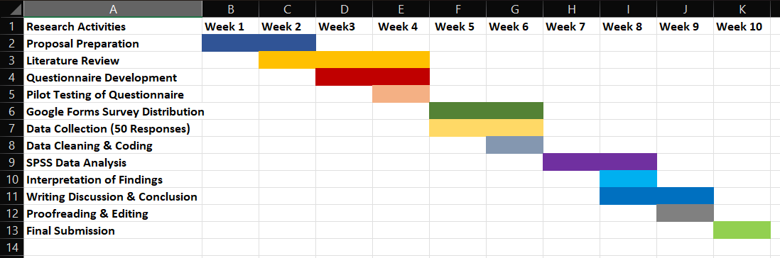
Figure 2: Gantt Chart
The Gantt chart shows a progressively ten-week timetable of achievement of the proposed research. The initial few weeks are to concentrate on perfecting the proposal, create the literature review and questionnaires to possess a sound theoretical and methodological foundation. The survey that was developed using Google Forms will be piloted out and then later will be sent to the Amazon consumers in United Kingdom and India as a way of getting the required 50 responses (Vij et al., 2024).
The research will probably take a period of ten weeks after which time, all the stages involved in the research will be adequate. The type of work to begin with in the project will be refining the research proposal, and a comprehensive review of academic works to establish the theoretical foundation of the research. To ensure the questionnaire is clear, reliable and relevant, the questionnaire will be developed in Google Forms and pilot tested before the actual data collection on a large scale (Almusaed, Almssad and Yitmen, 2025).
The online questionnaire will be conducted as primary data whereby 50 Amazon respondents (25 in the United Kingdom, 25 in India) will be administered the questionnaire. After gathering the responses, the information will be tabulated, purged and examined with the help of SPSS. The analysis of the relationship between the AI-sourced digital marketing, consumer trust, issues of privacy, and purchasing behaviour will undergo the analysis with the help of statistical methods, including descriptive statistics, reliability analysis, correlation and comparative analysis (Almusaed, Almssad and Yitmen, 2025).
The interpretations of the findings studied will also be discussed as compared to the research objectives and existing literature (Fife and Gossner, 2024) . This will be then followed by the development of discussion, conclusion and recommendations and then finally, the proofreading, formatting and final submission. The suggested time frame includes flexibility that would enable any unexpected delays in the distribution of questionnaires or data analysis and would make sure that all research actions will be done within the set timeframe. This proactive timeline depicts proper project management and provides practical guide on how a stringent and well structured MBA dissertation can be generated (Fife and Gossner, 2024).

7. Conclusion
The proposal outlines a comparative study that examines the impacts of AI-powered digital marketing to consumer buying behaviour towards Amazon in the UK and India. The research will look into how AI-based personalisation, consumer confidence, revelation of the recommendations, and privacy problem affect the purchasing strategies in the different international markets. A quantitative research design adopted has been an online questionnaire and statistical test to observe the plausible empirical evidence that may align with the aim of the research. The projected results will add to the academic knowledge and management practice by providing an awareness of effective AI-powered marketing strategies. Lastly, international e-commerce organisations will be able to implement responsible, transparent and customer-focused AI marketing with the help of the research to enhance consumer engagement and purchasing behaviour.

Reference
Almusaed, A., Almssad, A. and Yitmen, I. (2025). Developing a Research Proposal. pp.239–275. doi:https://doi.org/10.1007/978-3-031-97393-2_8
Fife, S.T. and Gossner, J. D (2024). Deductive Qualitative Analysis: Evaluating, Expanding, and Refining Theory. International Journal of Qualitative Methods, 23(1), pp.1–12. doi:https://doi.org/10.1177/16094069241244856.
Kravets, O., Uliana Korolova, Oleksandr Nosachenko, Olena Vasiltsova and Serhii Koberniuk (2025). AI-Powered Digital Marketing: Enhancing Customer Behaviour Predictions. European Journal of Sustainable Development, 14(2), pp.84–84. doi:https://doi.org/10.14207/ejsd.2025.v14n2p84 .
Kumar, A., Dayal, M. and Of (2025). AI-Powered Marketing: A Content Analysis of Bias, Transparency, And Consumer Trust. [online] doi:https://doi.org/10.5281/zenodo.15491261 .
Li, Y., Rho, E.H.R. and Kobsa, A. (2020). Cultural differences in the effects of contextual factors and privacy concerns on users’ privacy decision on social networking sites. Behaviour & Information Technology, pp.1–23. doi:https://doi.org/10.1080/0144929x.2020.1831608
Morávek, I.T. and Advertising, L.D. (2025). The AI-Powered Digital Marketing & Digital Advertising Guide. [online] Udemy. doi: https://www.udemy.com/course/ai-chatgpt-digital-marketing-guide/?srsltid=afmbooox2kenkdgkt1fmnowuse08wi6hmgwvia4aunh6ke8eor4xhcou&couponcode=25bbpmxnvd35.
Ologunebi, J., Taiwo, E.O. and Alli, K. (2025). Digital Consumer Behavior in E-commerce: A Study of Amazon and Temu’s Customer Purchase Decision-Making Processes in the UK and the USA. SSRN.
Penmypaper (2017). How to write a flawless Research Methodology. [online] Penmypaper Blog. doi: https://penmypaper.com/blog/how-to-write-a-flawless-research-methodology/.
Vashishth, T.K., Vikas, N., Sharma, K.K., Kumar, B., Chaudhary, S. and Panwar, R. (2024). Enhancing Customer Experience through AI-Enabled Content Personalization in E-Commerce Marketing. CRC Press eBooks, pp.7–32.
Vij, A., Vij, M., Maged Farouk and Kumar, P. (2024). Evaluating the Effectiveness of AI-Integrated Digital Marketing on Consumer Behavior, Brand Perception, and Sales Performance. doi:https://doi.org/10.1109/iccr61006.2024.10533049

Appendix

