Data Warehousing & Data Mining:
Data Warehousing

MODULE | Data Warehousing & Data Mining (ACCA6026)
STUDENT NAME | Pedro Gaetjens Molongua
STUDENT NUMBER | 2327143
LECTURER | Dr. Rajeev Nath
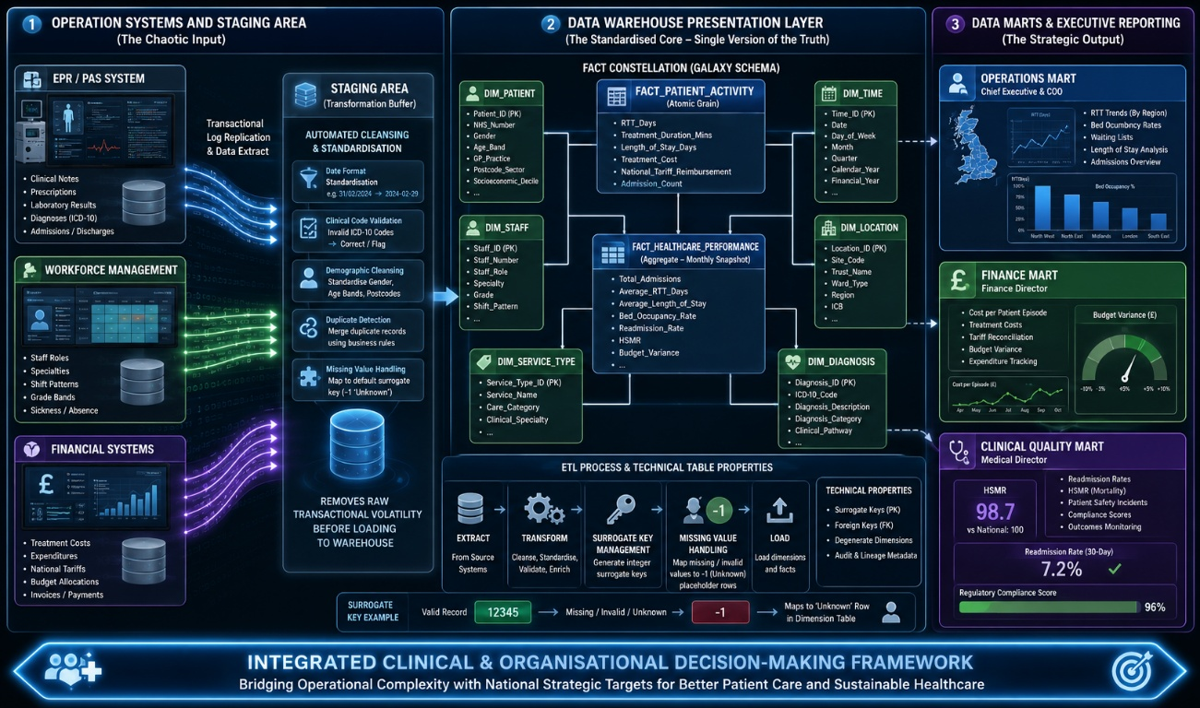
Image generated by ChatGPT
INDEX
INTRODUCTION 2
TASK 1: STRATEGIC CONSULTANT’S REPORT 2
1.1: OLTP vs. Data Warehouse 2
1.2: Data Warehouse Architecture & ETL 3
1.3: Data Marts for Management Decision-Making 4
1.4: OLTP Normalisation vs. Data Warehouse Dimensional Modelling 5
TASK 2: SCHEMA DESIGN & TECHNICAL IMPLEMENTATION PLAN 7
2.1: Source System Identification 7
2.2: Star Schema Design 7
2.3: Data Marts and Schema 10
2.4: ETL Plan 11
2.5: Data Quality & Governance 12
CONCLUSION 12
REFERENCES 12
FIGURES
Figure 1: Proposed Tiered Data Warehouse Architecture and ETL Pipeline for NHS England (Ref) 3
Figure 2: Conceptual Star Schema for NHS England Patient Activity Analytics 6
Figure 3: NHS England Multi-Fact Constellation (Galaxy Schema) 9

INTRODUCTION
NHS England manages vast amounts of operational, clinical, workforce and financial data across multiple healthcare providers. While these operational systems efficiently support day-to-day patient care, their fragmented nature limits organisation-wide analysis and strategic decision-making. This report proposes a data warehousing solution that integrates data from disparate systems into a single analytical platform. It examines the limitations of OLTP systems, outlines a layered ETL architecture, and presents a dimensional data warehouse design with supporting data marts, enabling secure, consistent, and evidence-based reporting to improve operational performance and patient outcomes.

TASK 1: STRATEGIC CONSULTANT’S REPORT

1.1: OLTP vs. Data Warehouse
NHS England’s operational systems, EPRs and PAS, are engineered for individual-level speed. They manage patient-level transactions: clinical notes, prescriptions, laboratory results, and diagnoses [1]. A clinician checking one patient’s current status works seamlessly. But ask a strategic question and the architecture collapses entirely; what is the three-year Referral-to-Treatment trend across five regions?
This is a structural, not technical, limitation. OLTP systems prioritise fast concurrent writes with normalised data, whereas data warehouses (DWs) are designed to aggregate large historical volumes for analytical processing and business intelligence [2]. The performance gap is empirically substantial: empirical evaluations demonstrate that DW query execution is up to 2,493 times faster than equivalent OLTP system when pre-aggregated analytical tables were applied [2].
The structural remedy is well-established. Kimball and Ross’s dimensional modelling, organising data into fact and dimension tables via star schema, is implemented specifically to support this analytical performance [2]. It is further reinforced that DWs remain the foundational infrastructure for analytical and organisational decision-making [1].
Critically, executing heavy analytical queries directly against active OLTP systems risks database locking and severe lag, potentially disrupting clinicians entering real-time patient notes. A DW completely separates analytical workloads from operational activity, ensuring hospital operations remain entirely uninterrupted while strategic reporting runs simultaneously.

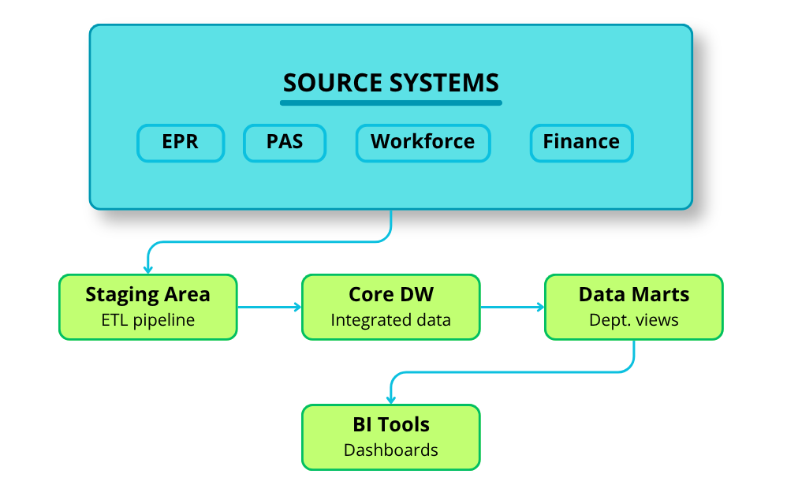
1.2: Data Warehouse Architecture & ETL
Figure 1: Proposed Tiered Data Warehouse Architecture and ETL Pipeline for NHS England (Ref)
As illustrated in Figure 1, the proposed NHS England data warehouse utilises a tiered structure-oriented architecture designed to safely transition data from decoupled operational systems into a unified analytical environment without disrupting frontline clinical pathways. The end-to-end data pipeline flows systematically from top to bottom: Source Systems (EPR, PAS, Workforce, Finance) → Staging Area → Data Warehouse Presentation Layer → Data Marts → BI/Reporting Tools. This structural progression relies on a layered data warehouse flow where source data is first staged then cleansed and converted before being loaded into warehouse and data mart layers for reporting [3]. It is also shown that healthcare warehouse should use a layered design with data source, staging, storage, and presentation layers, because clinical data is sensitive and distributed across multiple systems [4].
The Extract, Transform, Load (ETL) process is central to this architecture. In the extract phase, data is pulled from NHS operational system such as EPR, PAS, workforce databases, and finance records. This extraction should be scheduled during off-peak hours, such as 2:00 AM, so clinicians and administrative staff continue working without performance loss; where needed, transaction log replication can support near-real-time movement with minimal impact on live systems [3], [4]. In the transform phase, data is cleaned and standardised before loading. This phase mandates that data be thoroughly cleansed and converted prior to loading, utilizing automated verification workflows to maintain strict architectural consistency across the repository [3]. Typical transformation includes standardising date formats, correcting invalid codes, reconciling duplicates, and handling missing NHS numbers by applying validation rules or controlled matching logic [3]. The load phase then inserts the refined data into the presentation layer, where it is organised into subject-oriented structures and data marts for analysis [3], [4].
This design protects operational performance while improving overall data quality. The staging area acts as a physical buffer between live hospital environments and analytical reporting, ensuring raw records are never queried directly by resource-intensive dashboards [3]. Protecting clinical data across every tier is paramount, necessitating a privacy-by-design approach embedded directly within the data storage and presentation mechanics [4]. Collectively, these architectural layers support a secure, controlled and efficient warehouse architecture for NHS reporting [3], [4].

1.3: Data Marts for Management Decision-Making
Raw warehouse data, however well-structured, remains inaccessible without targeted delivery mechanisms for executive users. Data marts address this directly by functioning as departmental subsets of the core warehouse, compressing integrated data into role-specific KPIs aligned to each user’s strategic objectives [5]. In a healthcare context, the impact of this approach is empirically significant. It is demonstrated that Kimball-designed business intelligence implementation achieved an 82.10% reduction in decision-making time and a 17.93% improvement in accuracy across management processes [6], providing robust justification for structuring NHS executive access through dedicated marts rather than monolithic database queries.
For NHS England, three distinct marts align with the specific information needs of the Chief Executive, Finance Director and Medical Director. The Operations Mart serves the Chief Executive’s requirement for macro-level strategic monitoring, surfacing KPIs including three-year Referral-to-Treatment (RTT) trend analysis across five regions, bed occupancy rates, A&E waiting times, and strategic resource gap assessments. The Finance Mart addresses the Finance Director’s need for cost control and efficiency tracking, aggregating cost-per-patient-encounter metrics, departmental expenditure against allocated budgets, financial penalties arising from target breaches, and clinical negligence scheme costs. The Clinical Quality Mart supports the Medical Director’s regulatory accountability obligations, presenting hospital-standardised mortality ratios (HSMR), 30-day unplanned readmission rates, surgical site infection frequencies, and clinical audit compliance scores. Structuring marts around domain-specific KPIs ensures executives receive decision-ready intelligence rather than raw transactional data, enabling accurate and timely operational responses [5].
A critical architectural risk arises when separate marts generate conflicting figures, a scenario that would undermine board-level confidence in any strategic discussion. This is resolved through Conformed Dimensions: shared, standardised master dimensions such as Dim_Patient, Dim_Calendar and Dim_Location that remain consistent across all three marts simultaneously. Hart argues that a Kimball-integrated warehouse resolves complex inter-domain data relationships through precisely these shared structures, enforcing a single authoritative data entity across all reporting environments [7]. When the Finance Director reports cost-per-patient and the Medical Director reports readmission rates for the same patient cohort, both draw from an identical Dim_Patient and Dim_Calendar definitions, eliminating definitional discrepancies and ensuring all board reporting is grounded in consistent, trustworthy data.

1.4: OLTP Normalisation vs. Data Warehouse Dimensional Modelling
OLTP systems in NHS England are built on Third Normal Form (3NF), which eliminates data redundancy and maximises transactional integrity by decomposing data across multiple related tables. While 3NF is optimal for writing clinical records, ensuring no data is stored twice, it becomes structurally counterproductive for analytical queries. Generating cross-tabular reports requires reconstructing data through extensive multi-table joins, which is computationally expensive. This structural inefficiency results in severe operational latency; empirical evaluations demonstrate that join-heavy OLTP structures can produce query performance up to 2,493 times slower than an equivalent pre-aggregated dimensional mode [2].
Dimensional modelling resolves this by restructuring data around business processes rather than normalisation rules. A star schema places a central Fact table, recording transaction measures, surrounded by Dimension tables providing descriptive context, linked through primary and foreign key relationships. Aligning star schema construction to a knowledge base of business entities consolidates complex multi-table OLTP relationships into fewer, readily-queryable joins [8]. Hart and Kuo further demonstrate that in healthcare specifically, a Kimball-based dimensional warehouse resolves complex inter-domain clinical relationships, enabling consistent reporting across patient, location, staff, and time axes [7]. Unlike 3NF schemas that distribute these concepts across dozens of normalised tables, the dimensional model surfaces them through a single pre-joined analytical layer.

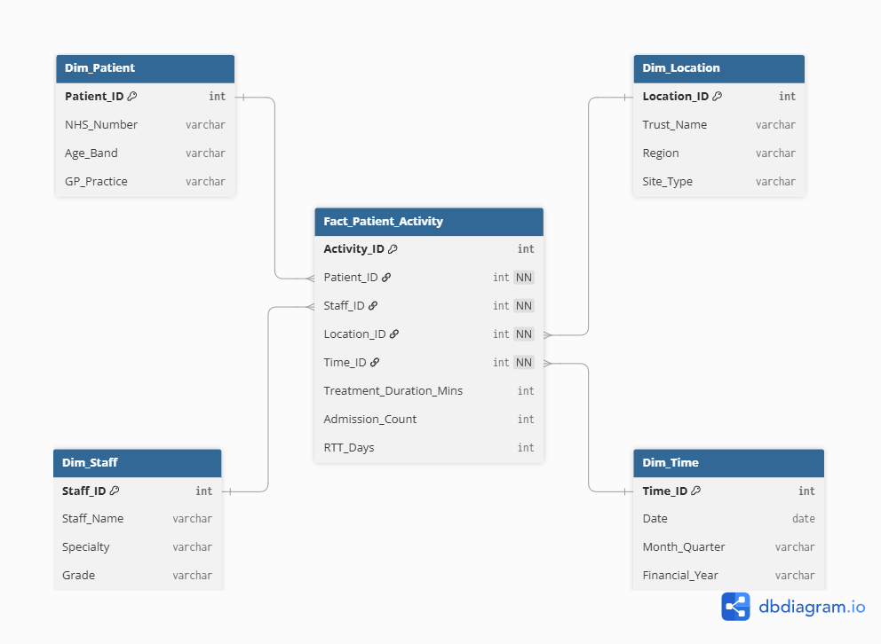
Figure 2: Conceptual Star Schema for NHS England Patient Activity Analytics

As illustrated in Figure 2, the proposed NHS star schema centres on Fact_Patient_Activity, storing measures including Treatment_Duration_Mins, Admission_Count, and RTT_Days. This conceptual schema demonstrates how dimensional modelling organises analytical data around a central business process, while additional fact tables and dimensions can be incorporated within the wider data warehouse to support executive reporting requirements. Each foreign key links to a corresponding dimension: Dim_Patient, Dim_Staff, Dim_Location, and Dim_Time, enabling complex trend analysis, such as three-year RTT performance across regions, without querying any live OLTP system. This architecture provides the IT Director with a query-optimised foundation that separates analytical processing entirely from NHS operational systems.

TASK 2: SCHEMA DESIGN & TECHNICAL IMPLEMENTATION PLAN

2.1: Source System Identification
The proposed NHS England data warehouse integrates data from multiple heterogenous operational systems to provide a unified view of healthcare performance. Internal data sources include Electronic Patient Records (EPR) and Patient Administration Systems (PAS) for patient demographic, referrals, admissions, discharges, diagnoses and clinical activity; clinical systems for treatments, diagnostic tests and outcomes; workforce management systems for staff roles, specialties, shift patterns and sickness absence; and financial systems for treatment costs, national tariffs, expenditure and budget performance. Additionally, external datasets such as Office for National Statistics (ONS) demographic data, NHS national tariffs updates and public health datasets can enrich strategic reporting by providing wider population and policy context. Integrating these heterogeneous sources through a central data warehouse creates a consistent, enterprise-wide foundation for operational and executive decision-making [1], [3], [4].

2.2: Star Schema Design
Building upon the conceptual star schema introduced in Figure 2, the proposed NHS England data warehouse expands into a multi-fact constellation (galaxy schema), illustrated in Figure 3. While Figure 2 demonstrated the principles of dimensional modelling using single fact table, the complete implementation introduces an additional aggregate fact table and metadata dimension to support both operational reporting and executive dashboards. This architecture combines an atomic transactional layer with a summary analytical layer, linked through shared conformed dimensions that ensure consistent reporting across the organisation [7].
The primary transactional table, Fact_Patient_Activity, is designed at the atomic grain, where each row represents one patient encounter, such as an admission, outpatient appointment, transfer, discharge or treatment episode. Selecting this level of granularity preserves the maximum analytical flexibility because regional and national summaries can subsequently be derived without sacrificing detail. The table contains foreign keys referencing Dim_Patient, Dim_Staff, Dim_Location, Dim_Time, and Dim_Service_Type, together with operational measures including Treatment_Duration_Mins, Length_of_Stay_Days, Treatment_Cost, National_Tariff_Reimbursement, RTT_Days, and Admission_Count. These metrics directly support operational KPIs such as Referral-to-Treatment (RTT) performance, treatment efficiency, patient throughput and financial analysis.
The surrounding dimensions provide the descriptive context required for multidimensional analysis. Dim_Patient stores master data including NHS Number, gender, age band, GP practice and anonymised postcode sector, enabling demographic and population-based reporting. Dim_Staff contains staff identifiers, clinical role, specialty, grade and shift pattern to support workforce planning and productivity analysis. Dim_Location records NHS Trust, hospital site, ward type, Integrated Care Board (ICB) and NHS region, allowing comparisons between hospitals and the five operational regions identified in the case study. Dim_Time provides calendar and financial hierarchies, including date, month, quarter, year and financial year, enabling longitudinal trend analysis and budget reporting. A dedicated metadata dimension, Dim_Service_Type, classifies clinical pathway such as emergency care, elective surgery, outpatient services and specialist treatment, allowing performance to be analysed consistently across different healthcare services.
To improve executive reporting performance, the warehouse also incorporates Fact_Healthcare_Performance, an aggregate fact table containing pre-calculated monthly performance indicators. Its grain is defined as one row per service type, location and reporting period, allowing dashboards to retrieve strategic metrics without scanning millions of transactional records. Measures include Total_Admissions, Average_RTT_Days, Average_Length_of_Stay, Bed_Occupancy_Rate, Readmission_Rate, Hospital Standardised Mortality Ratio (HSMR) and Budget_Variance. Metadata supporting warehouse governance, including Load_Timestamp, Source_System and ETL_Batch_ID, is maintained during loading to provide complete data lineage, traceability and auditability.

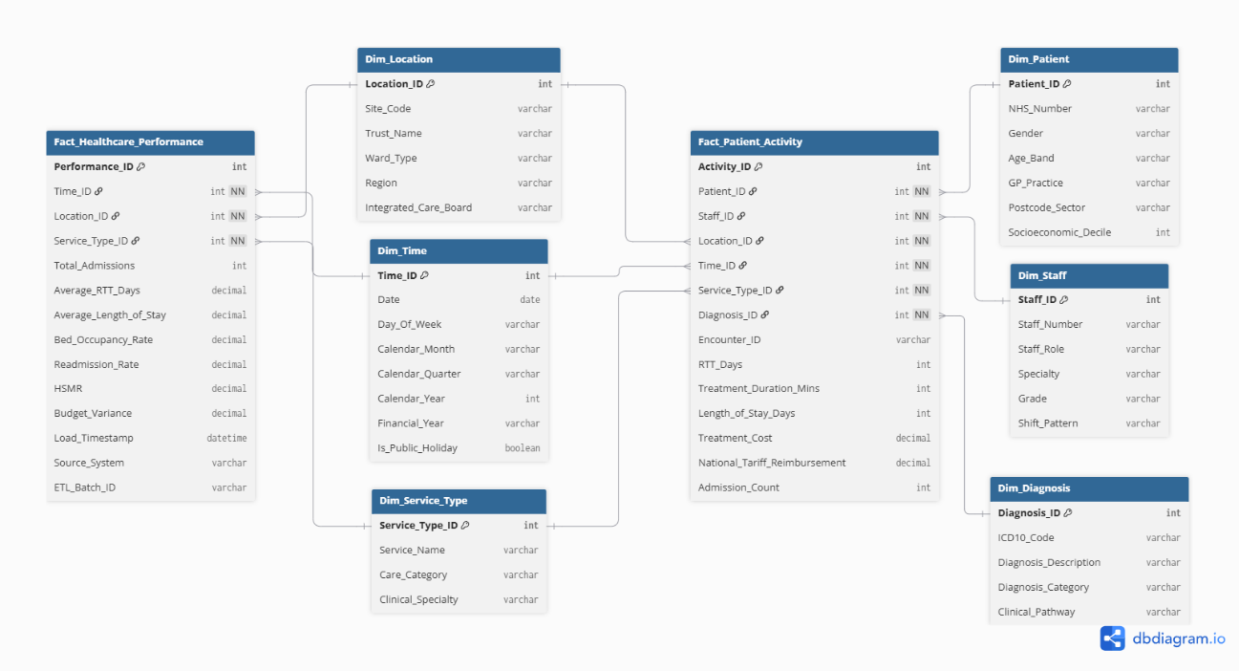
Figure 3: NHS England Multi-Fact Constellation (Galaxy Schema)
The proposed design follows Kimball’s dimensional modelling principles by combining atomic transactional facts with conformed dimensions that can be reused across multiple analytical domains. Hart and Kuo demonstrate that shared dimensions provide consistent definitions across healthcare reporting environments, eliminating discrepancies between operational and strategic analyses [7]. Likewise, the implementation of a star schema significantly reduces the complexity of analytical queries by replacing numerous OLTP joins with a small number of intuitive dimensional relationships [8]. By combining detailed clinical activity with pre-aggregated performance summaries, the proposed constellation schema provides NHS England with a scalable query-optimised platform capable of supporting operational monitoring, departmental data marts and executive decision-making simultaneously.

2.3: Data Marts and Schema
To provide decision-ready information for senior leadership, NHS England should implement dependent data marts sourced directly from the enterprise data warehouse. This top-down architecture ensures a single version of the truth, allowing each department to access validated data tailored to its operational and strategic responsibilities while maintaining enterprise-wide consistency [5], [6].
The Operations Mart follows a star-schema centred on Fact_Patient_Activity, supported by Dim_Time, Dim_Location, Dim_Patient and Dim_Service_Type. It enables the Chief Executive and operational managers to monitor patient flow, capacity utilisation and service performance. Core measures include RTT_Days, Admission_Count, Length_of_Stay_Days, and Bed_Occupancy_Rate, supporting the identification of elective care backlogs, patient flow bottlenecks and regional resource constraints.
The Finance Mart combines Fact_Patient_Activity and Fact_Healthcare_Performance with Dim_Time, Dim_Location, and Dim_Service_Type to support the Finance Director. Key measures include Treatment_Cost, National_Tariff_Reimbursement, Cost_Per_Patient_Episode and Budget_Variance, enabling expenditure monitoring, tariff reconciliation and long-term financial planning.
The Clinical Quality Mart is centred on Fact_Healthcare_Performance and incorporates Dim_Patient, Dim_Diagnosis, Dim_Location, Dim_Time and Dim_Service_Type. It supports the Medical Director by monitoring Readmission_Rate, Hospital Standardised Mortality Ratio (HSMR), patient safety incidents and other clinical quality indicators used to evaluate healthcare outcomes and regulatory compliance.
All three marts reuse the conformed dimensions Dim_Patient, Dim_Time and Dim_Location. Hart and Kuo demonstrate that shared dimensions maintain consistent business definitions across healthcare reporting environments, enabling reliable cross-functional analysis and ensuring that executive decisions are based upon a single trusted version of organisational performance [7].

2.4: ETL Plan
TARGET TABLE | SOURCE SYSTEM(S) | LOAD STRATEGY | TRANSFORMATION LOGIC
Dim_Patient | EPR, PAS | Incremental (Delta) | Validate NHS Number, standardise demographics, anonymise patient identifiers, map missing values to "Unknown".
Dim_Staff | Workforce Management | Incremental (Delta) | Standardise staff roles, specialties and NHS grade bands.
Dim_Location | PAS, NHS Trust Database | Full Refresh | Standardise NHS region names, Trust codes and ICB identifiers.
Dim_Service_Type | Clinical Systems | Full Refresh | Map local service names to standard NHS service categories.
Dim_Diagnosis | Clinical Systems | Full Refresh | Validate ICD-10 codes against the national reference dataset.
Fact_Patient_Activity | EPR, PAS, Finance | Scheduled Nightly Batch | Join clinical and financial records, calculate RTT_Days, Length_of_Stay_Days, Treatment_Cost and National_Tariff_Reimbursement.
Fact_Healthcare_Performance | Fact_Patient_Activity | Aggregation | Generate monthly KPIs including Bed_Occupancy_Rate, Readmission_Rate, HSMR and Budget_Variance.
Data is extracted from NHS operational systems into staging area, where cleansing, standardisation and validation are performed before loading into the dimensional warehouse. Incremental extraction is used for frequently changing transactional data, while periodic aggregation generates the executive performance fact table. This layered ETL approach protects operational systems while ensuring consistent, high-quality analytical data [3], [4].

2.5: Data Quality & Governance
Data quality is maintained through automated validation, duplicate detection, and metadata files including Load_Timestamp, Source_System, and ETL_Batch_ID, providing complete data lineage and auditability [4]. Ongoing warehouse operations comply with the UK GDPR, Data Protection Act 2018, and Caldicott Principles through strict Role-Based Access Control (RBAC), ensuring sensitive clinical information is accessible only to authorised personnel while executives analyse anonymised and aggregated performance data. Continuous ETL monitoring further identifies anomalies and preserves data accuracy and consistency [4].

CONCLUSION
The proposed data warehouse provides NHS England with a scalable and secure platform for integrating healthcare data into a single source of truth. By combining a layered ETL architecture, a Kimball-based galaxy schema, conformed dimensions, and dependent data marts, the solution supports consistent reporting across operational, financial, and clinical domains while protecting live transactional systems. Together with strong data governance and regulatory compliance, the architecture enables accurate, timely, and evidence-based decision-making, helping NHS England improve resource utilisation, service performance, financial management and patient care.

REFERENCES

[1] | T. Knezevic Ivanovski, S. Honap, R. Matic, S. Markovic and L. Peyrin-Biroulet, “Building a healthcare data warehouse: considerations, opportunities, and challenges,” Frontiers in Digital Health, vol. 7, p. 1691142, 2025.
[2] | D. Joiner, M. Clement, S. T. Chan, K. Pereira, A. Wong and Y. Khmelevsky, “DW vs OLTP Performance Optimization in the Cloud on PostgreSQL (A Case Study),” in 2022 IEEE International Conference on Recent Advances in Systems Science and Engineering (RASSE), 2022.
[3] | K. Jameel Merceedi, A. Adil Yazdeen, A. Kh. Ibrahim, M. Bahjat Abdulrazzaq and M. Ramiz Mahmood, “Analyses the performance of data warehouse architecture types,” Journal of Soft Computing and Data Mining, vol. 3, no. 1, pp. 45-57, 2022.
[4] | R. D. Thantilage, N.-A. Le-Khac and M.-T. Kechadi, “Healthcare data security and privacy in Data Warehouse architectures,” Informatics in Medicine Unlocked, vol. 39, p. 101270, 2023.
[5] | P. De-La-Cruz-Vdv, S. Moquillaza-Henríquez, M. Valeriano-Peña, G. L. E. Maquen-Niño, H. Vega-Huerta and I. Adrianzén-Olano, “Data Mart and key performance indicators to optimize decisions in a medical service clinic,” in 2023 18th Iberian Conference on Information Systems and Technologies (CISTI), 2023.
[6] | A. Aguilar-Chávez, J. Banda-Barrientos and M. Cabanillas-Carbonell, “Business Intelligence, Based on the Ralph Kimball Methodology, for Decision-Making in General Management,” in 2021 16th International Conference on Intelligent Systems and Knowledge Engineering (ISKE), 2021.
[7] | R. Hart and A. M.-H. Kuo, “Meeting Health Care Research Needs in a Kimball Integrated Data Warehouse,” in 2016 IEEE International Conference on Data Science and Advanced Analytics (DSAA), 2016.
[8] | N. Sanprasit, K. Jampachaisri, T. Titijaroonroj and K. Kesorn, “Intelligent approach to automated star-schema construction using a knowledge base,” Expert Systems with Applications, vol. 182, p. 115226, 2021.

