

What are the benefits of Microservices and how do they compare with other serverless architectures?
by
Daniel Rhys Newman

Supervisor: Michael Dacey
Second Marker: Kemi Ademoye

Project submitted as part of the requirements for the award of BSc (Hons) Web Development

April 2020
DECLARATION

I, Daniel Rhys Newman declare that I am the sole author of this Project; that all references cited have been consulted; that I have conducted all work of which this is a record, and that the finished work lies within the prescribed word limits.

This work has not previously been accepted as part of any other degree submission.

Signed : Daniel Rhys Newman

Date : 24/04/2020

FORM OF CONSENT

I, Daniel Rhys Newman hereby consent that my Project, submitted in candidature for the B.Sc.(Hons) Web Development) degree, if successful, may be made available for inter-library loan or photocopying (subject to the law of copyright), and that the title and abstract may be made available to outside organisations.

Signed : Daniel Rhys Newman

Date : 24/04/2020

Abstract
Serverless computing is a massive industry at the moment with the likes of Netflix, Amazon, Google and Microsoft all taking advantage of what is possible with serverless technology. Using microservices is a method of creating small serverless functions that can be run on a website, they are essentially small web services. Businesses often use services such as AWS Lambda to pay only for whichever services are run on their website. [1] As time goes on however, other methods of creating these services have changed drastically with different types of service types such as Functions as a Service, Infrastructure as a Service and Software as a Service. [2] As a result of these changes some programmers argue that microservices no longer have a place in designing serverless websites and systems and that the programming industry as a whole has created better ways of optimising services. Meanwhile other programmers would argue also that microservices still have a place in the industry as they can be useful if used in the correct scenarios. In this following report the author will discuss serverless computing, microservices and functions as a service and research them to aid in the creation of a microservice system that will be implemented. Some hypothesises will be tested to ensure the validity of research and results and conclusions will be made about the state of microservices in today’s serverless architectural environment.

Table of Contents
Abstract 3
Table of Figures 6
Chapter 1 – Introduction 8
Introduction 8
Aim 8
Objectives 8
What is in this report? 9
Chapter 2 – Literature Review 10
Background 10
Serverless Computing 11
Microservices 13
Functions as a Service 14
Conclusion of Literature Report 16
Chapter 3 – Research Methodology 18
Introduction 18
Research Overview 18
Research Process 19
Research Philosophy 19
Research Methodologies 20
Research Design 20
Conclusion 20
Chapter 4 – Design and Implementation 22
Introduction 22
Design 22
Implementation 26
Computing Teacher 26
English Teacher 33
Maths Teacher 34
Science Teacher 35
Art Teacher 36
History 37
All Teachers API 38
Conclusion 38
Chapter 5 – Testing 39
Introduction 39
Testing 39
English Teacher 39
Maths Teacher 40
Science Teacher 40
History Teacher 41
Computing Teacher 42
Art Teacher 42
Cloudwatch Statistics 43
Evaluation 44
Chapter 6 – Conclusion and Results 45
Introduction 45
Summary 45
Conclusion 45
Hypothesis 1: 45
Hypothesis 2: 46
Hypothesis 3: 47
Hypothesis 4: 48
Hypothesis 5: 48
Hypothesis 6: 49
Hypothesis 7: 49
Hypothesis 8 and 9: 50
Competition 50
Chapter 7 – Reflections 51
Introduction 51
Reflection of literature review 51
Reflection of Implementation 51
General reflection 52
References 53

Table of Figures
Figure 1 - Design - ShoppingAPI 21
Figure 2 - Design - ShoppingAPI Code 22
Figure 3 - Design - ShoppingAPI resources 22
Figure 4 - Design - ShoppingAPI Deploy 23
Figure 5 - Design - ShoppingAPI GET 23
Figure 6 - Design - ShoppingAPI POST 24
Figure 7 - Design - ShoppingAPI Error 24
Figure 8 - Design - ShoppingAPI error 2 25
Figure 9 - Implementation - ComputingTeacher Part 1 25
Figure 10 - Implementation - ComputingTeacher Part 2 26
Figure 11 - Implementation - ComputingTeacher Part 3 26
Figure 12 - Implementation - ComputingTeacher Part 4 27
Figure 13 - Implementation - ComputingTeacher Part 5 27
Figure 14 - Implementation - ComputingTeacher Part 6 28
Figure 15 - Implementation - ComputingTeacher Part 7 28
Figure 16 - Implementation - ComputingTeacher Part 8 29
Figure 17 - Implementation - ComputingTeacher Part 9 29
Figure 18 - Implementation - ComputingTeacher Part 10 29
Figure 19 - Implementation - ComputingTeacher Part 11 30
Figure 20 - Implementation - ComputingTeacher Part 12 30
Figure 21 - Implementation - ComputingTeacher Part 13 30
Figure 22 - Implementation - ComputingTeacher Part 14 31
Figure 23 - Implementation - ComputingTeacher Part 15 31
Figure 24 - Implementation - EnglishTeacher Part 1 32
Figure 25 - Implementation - EnglishTeacher Part 2 32
Figure 26 - Implementation - MathsTeacher Part 1 33
Figure 27 - Implementation - MathsTeacher Part 2 33
Figure 28 - Implementation - ScienceTeacher Part 1 34
Figure 29 - Implementation - ScienceTeacher Part 2 34
Figure 30 - Implementation - ArtTeacher Part 1 35
Figure 31 - Implementation - ArtTeacher Part 2 35
Figure 32 - Implementation - HistoryTeacher Part 1 36
Figure 33 - Implementation - HistoryTeacher Part 2 36
Figure 34 - Implementation - AllTeachers Part 1 37
Figure 35 - Implementation - AllTeachers Part 2 37
Figure 36 - Testing - EnglishTeacher GET 38
Figure 37 - Testing - EnglishTeacher POST 38
Figure 38 - Testing - MathsTeacher GET 39
Figure 39 - Testing - MathsTeacher POST 39
Figure 40 - Testing - ScienceTeahcer GET 39
Figure 41 - Testing - ScienceTeahcer POST 40
Figure 42 - Testing - HistoryTeacher GET 40
Figure 43 - Testing - HistoryTeacher POST 40
Figure 44 - Testing - ComputingTeacher GET 41
Figure 45 - Testing - ComputingTeacher POST 41
Figure 46 - Testing - ArtTeacher GET 42
Figure 47 - Testing - ArtTeacher POST 42
Figure 48 - Testing - CloudWatch 1 42
Figure 49 - Testing - CloudWatch 2 43
Figure 50 - Conclusion - Hypothesis 1 44
Figure 51 - Conclusion - Hypothesis 2 45
Figure 52 - Conclusion - Hypothesis 2 Part 2 45
Figure 53 - Conclusion - Hypothesis 3 46
Figure 54 - Conclusion - Hypothesis 5 47
Figure 55 - Conclusion - Hypothesis 7 48

Chapter 1 – Introduction

Introduction
Microservices are a technological advance in the world of serverless computing. In web design these microservices act as small features that can be called upon from the server to activate a feature. Though, not entirely serverless as the name would suggest, microservices still have a role to play in terms of keeping costs of development low and allowing them to be infinitely scalable to new server versions and in the event that high traffic putting load on the program. In short, this report will be an analysis of microservice technology drawing conclusions on its usefulness against another serverless method known as functions as a service. Some microservice systems will then be produced to demonstrate how these features work and how they come to prove the worth of microservice technology.

Aim
The aim of this dissertation is to investigate the benefits and drawbacks of Microservices for businesses’ decision and design process whilst comparing them to other types of serverless computing options. To do this the author will discuss microservices and other types of serverless options, mainly functions as a service as a general example and what effects these choices could have on the decision making process.

Objectives
Below are the author’s Objectives for this dissertation, these are the tasks that the author expects to complete by the end of the dissertation process.
The first objective is to perform a review of existing literature regarding the topics of serverless computing, microservices and functions as a service, including literature of the benefits and drawbacks and how these choices would likely effect a development process.
Secondly, the author will analyse what methods can be taken to best demonstrate and investigate the effects microservices have on development and how those benefits and drawbacks effect development and business decisions.
Next, using Amazon Web Services (AWS) Lambda the author intents to create some systems that demonstrate the possibilities of microservices and to demonstrate its benefits. AWS Lambda is a web service provider created by Amazon and is one of the most popular and widely used systems in industry. [3]
After Testing, the next objective would be to discuss how the development process for a microservice based system differs from a standard development process. As well as comparing the author’s own experiences with Microservices to the literature available for other serverless systems, this includes testing if the benefits as well as the drawbacks discussed in the literature report were accurate to the author’s own experiences with using microservices in development.
Finally, the author will evaluate their own findings, compare them to literature and evaluate their own self performance and conclude their findings in a conclusion summary for what the overall takeaway of this dissertation project is.

What is in this report?
In Chapter 2 the author will perform a literature review of existing knowledge and resources about microservices, functions as a service and about serverless computing in general. Chapter 3 (Research Methodology) will entail a look at the methods that will be carried out to achieve the results that the author is looking to get out of this report. Chapter 4 (Design and Implementation) will be a look at the design of the systems the author is looking to produce, thereafter the implementation will be shown with a look at microservices work. Chapter 5 (Testing) will be a chapter showing that the systems that have been created works as intended and demonstrates the strengths of microservices as the author is anticipating it will. In chapter 6 (Conclusion) the author will show the overall findings of the development, and what we as programmers can learn from it, and analyse how the benefits of microservices still have a place in modern day serverless technology. Chapter 7 (Reflections) will be a summary of the author’s own thoughts about their progress and work for this report, what went well and what did not and how they would improve from this in the future.

Chapter 2 – Literature Review

Background
Serverless computing, microservices and Functions as a Service (FaaS) are recent software infrastructures, these infrastructures have been gaining popularity as one of the newest and most useful infrastructures used by software developers today. Functions as a Service infrastructures are predicted to be the next step up from a previous software infrastructure known as microservices, however some argue that there is still a large need for microservices. Serverless computing removes the need for managing servers, infrastructures and operating systems and the management of those things will instead be done by the cloud server providers. Despite the name, serverless computing is not actually completely serverless, however serverless computing gets its name from removing the main development team away from the server-side development of a project. This means that a development team can create an application without thinking too much about the server-side development of the application as these features are scaled on demand by the server itself. [4]
A business using a serverless computing system would pay for their server usage rather than paying a fixed amount for the servers being used. Many companies today purchase cloud servers and many of these companies purchase more servers than they believe they are likely to exceed just in-case of sudden spikes in activity that their applications would take up, as a direct result of this, many businesses overpay for servers they don’t use for the majority of the time they are paying for them, much of the servers go to waste. Many serverless systems use a “Pay as You Use” system where a business would need to pay rates depending on how much traffic they receive so if a certain threshold is met then the cost of that day’s server would increase. Serverless systems can also be updated much quicker than older methods to new server updates. [5] Amazon Web Services AWS mention these same benefits on their website and say that with serverless computing the developer will have no server management, the program will have flexible scaling of server usage, the developer will pay for the usage of the server units rather than for the server units themselves and a tolerance to problems that the application could experience. [6]
Functions as a Service is a development concept of using serverless architectures to activate individual functions or actions quickly and independently. This will make the services within an application event driven and so functions may activate independently depending on the user’s needs. This also means that if a developer pays every time a server is used, then payment would only be needed for the execution of functions and not for times where the server is not being used, for example an event that happens on Christmas day would currently cost a business all year around, Functions as a Service means that this function will only need to be paid for the one time use as Functions as a Service is useful for scheduling code. Matt Watson describes this as a way to run one set of code if certain conditions are met. [7] With Functions as a Service, a server is split up into many different functions and when certain requirements are met then an independent function can be activated based off that. [8] Some benefits of Functions as a Service are a decrease in development time due to programmers not having to apply server logistics, Functions as a Service server usage is scalable and so applications that use functions as a service will be able to handle unexpected traffic spikes and thus it would also be cost efficient since a business will not be paying for unused servers. When it comes to the disadvantages of functions as a service, the programmers can have less control over the system since a third party is managing the server infrastructure and as a result it is very difficult to test these types of systems. [9]

Serverless Computing
David Prothero defines Serverless Architectures as a software design pattern in which an application can be hosted by a server from a third party removing the server software away from the developers. When discussing why serverless architectures are useful David Prothero says that traditionally hosting software requires managing physical servers to run it from but now the need to have physical servers has been eliminated so that developers only need to focus on the main parts of programming. David Prothero suggests that serverless systems should be used if the developer wants to have a limited number of functions or if the developer needed more than they would need to create the application differently to fit a certain criterion. Prothero adds that some systems would benefit more from migrating slowly in small parts over time. [10]

Gillian Armstrong, a cognitive technologies expert discusses in a conference about the future of serverless systems and the effects serverless systems have had on chatbot systems such as smart speakers. Amazon’s smart speakers for example, use serverless technology, if the user is not using it then no server is being used. These speakers are not boxes with many responses pre-loaded into it, these speakers use serverless technology to gather their answers intelligently by reading online definitions when the user asks for a definition or reading out current news reports from online news sources. Gillian Armstrong discusses the design of conversations users can have with smart speakers, firstly Armstrong says that users should be aware of what a chatbot can and cannot do so that there is an understanding between the user and the smart system as to what it is capable of. Gillian Armstrong’s cognitive technologies team used serverless systems when creating their own chatbot system, this was for a few reasons. Firstly, Gilliam Armstrong’s team wanted their chatbot to learn, this meant entering many commands into the system to test its responses and so a pay per use system makes more sense than to pay outright for servers to run at all hours. Many chatbot systems are created by small businesses that are trying to learn the ropes of creating chatbot systems and with serverless systems it means that they can abandon the system and start from scratch with zero drawbacks and also if no users are using the chatbot then it costs the business little money to run. Gilliam Armstrong describes using serverless as similar to purchasing a wardrobe at a store, it may not be what the buyer wanted exactly but at least they can take parts out, put new parts in and change the architecture for free, though a third party creates the architecture, the developer can change that architecture. Gilliam Armstrong adds that serverless systems do not scale by default and that some work is needed on the developers end to make sure they do performance checks to optimise their system well enough for sudden spikes in server use, Armstrong finishes the main body of his conference by adding that low uses of a serverless pay per use system results in low cost and high usage of a pay per use system means high costs so many businesses and start-ups may need to take into account that budget can be hard to predict. Finally, during Gilliam Armstrong’s question and answer segment of the conference an audience member asks if businesses would be able to implement a strategy for dealing with load increases effecting budget. Armstrong answers the question by saying that many businesses may decide to add limits to how many users can access the chatbot, for example, Gilliam Armstrong’s business limit to 50,000 users at a time so that they don’t pay more than what they are comfortable paying for. [11]

One source believes that serverless design platforms are changing the way programmers think about applications. Because of the way parts of a program can be hosted on a cloud, many programmers’ objectives are simplified as they can create simpler programs. When discussing AWS Lambda, Amazon’s own serverless system the source mentions functions as a service as an example and describes that the function aspect of the architecture is very similar to how programmers typically associate the word in other settings, typically it is a piece of code which can be called when needed but if it is not needed during the run time of an application then the system never needs to waste time going through it since it is outside of the application. [12]

Klint Finley discusses serverless computing in an article he composed about the promise of serverless computing. In said article Finley says that instead of a business having a whole warehouse dedicated to servers and running and maintaining them that a business might be better of paying for a cloud computing solution and pay only for what they use. However, Finley is quick to point out that some serverless solutions do not allow businesses to pay for exclusively only what they use and will make businesses pay for a price bracket which will determine how much the application is allowed to scale. So, a business that usually get 100 website visits a day could choose to pay for roughly that amount of usage but if their website gets an unexpected surge in usage then the price they paid may not be enough and instead most businesses will choose to pay many brackets higher when they may not even need that much on a daily basis. [13]

When discussing five advantages to a serverless architecture, Wendy Schott mentions that her first noticeable advantage was how quickly applications could be made, in some cases hours or days, especially apps that relied on third-party assets such as login systems and social media feeds as well as maps of areas. Next Schott discusses the scalability of applications. In the event of a spike in users, if the business had paid to allow their application to scale further then in a matter of days a large spike of users can naturally be scaled and adjusted for. Thirdly, lower costs of running as spending thousands on servers and server rooms is no longer required, that and the shorter development times mean that applications can be created fast and for a lower price. The next advantage is that developers can work more on the features of an application that users will enjoy, since most of the workload becomes abstract in serverless systems that means that the time not spent doing tasks that are no longer required can be used developing a better user experience. Finally, Schott describes the benefits serverless technology has on latency. Traditionally a business could have a server which deals with the number of users, and network latency and also the latency dependant on where the user is, for example a user in the UK could have a harder time connecting to server solely in the USA than someone who is local to the server. Many prominent server providers have stations in every corner of the world and so with serverless computing many users will experience much less latency as a result of their location. [14]
In an article published by Faizan Bashir, he considers the advantages and disadvantages of serverless architectures and how they work. When comparing traditional computing and serverless computing Bashir says that the responsibility of the front-end logic, back-end logic, security and databases are on the developers. In contrast to this, in serverless computing then the front-end logic is done by the developers and chunks of the back-end logic, security and the database can be done by third party services. Bashir gives some advantages to the developers involved in making a serverless system, first being reduced liability for any back-end infrastructure that is created by a developer. When discussing the benefit serverless can have on users Bashir says that users can experience faster updates and new features quicker than they could if the application was a traditional one, as well as this there is a larger chance that users will be able to use other services like Google Drive as a result of third-party functionality. In terms of negatives to serverless, Bashir mentions it being harder to test locally and a risk of being harder to recover from in the event of a third-party system going down. [15]
The Serverless industry is fairly competitive, not only is Amazon the main serverless company, but google are attempting to increase their serverless cloud business according to Tom Krazit. Google are working on their service named Google Cloud Next as well as service called Cloud Functions. The main difference between AWS and Azure over Google’s system is that payment is worked out per second of usage of functions, so whereas AWS charges for the amount of functions used, Google will be charged for every second the function runs, so depending on how complex the functions of a system are it may be beneficial to get charged less per function if its measured by time of operation rather than number of operations. [16]

Microservices
Microservices are one of the most popular architectures out there as it has been around for many years. Some claim that Functions as a Service will replace microservices in the future. Every application using microservices is made from a collection of bundles of services responsible for a single feature of the application. An example of a microservice could be an online retailer website where all functions relating to the shopping basket are its own microservice which can be activated when the shopping basket is used. The difference between this and functions as a service is that microservices would access all functions relating to that one feature, pre-emptively before it is needed. Some benefits to microservices are faster development of projects and the use of cloud application in projects, however microservices are harder to maintain and may experience communication issues due to latencies and additionally microservices may be hard to test because of the complex nature of the development architecture [17] [18]
An advantage of Microservices is that it is designed to deal with failure, for example since the application is split up into multiple services then if one fails the other services are still intact and so they can still function when another one cannot. Microservices are also an evolutionary architecture which means that it is capable of being upgraded to new uses. As time goes on, new devices and systems will be able to run the application and microservice systems are prepared for this evolution even though no one can anticipate how technology will advance exactly. [19]
One of the main purposes behind microservices is that some applications are easier to maintain when chopped up into smaller sections to work on a similar purpose and can work in conjunction with each other. One source in particular believes that microservices have five main benefits. Firstly, the independence of the developers is made more important as development teams can work on projects and applications faster than they could work on monolithic applications. Secondly, microservices work in isolation and so a microservice application is failure resistant, what this means is that a microservice application is built in a way so that if one microservice function breaks and stops working then the other microservices can still operate adequately, what this means is that if one system breaks it will not affect other microservices so that they can still operate with minimal errors making it resistant to failure. The third benefit is scalability so that many services only require a small amount of resources to run however if the service is more demanding then more resources can be scaled up to accommodate, another use for this is with servers as businesses could choose to have the server scale to traffic with a pay as you use server system. The fourth benefit is the lifecycle of the application in general as new features are more easily added to the system through a delivery pipeline so that new features can be added over time and old versions can be rolled back if needed. [20] The final benefit is how the architecture can be split along a business’ properties so that their designs across different applications can remain similar so that users are able to recognise a system made by that business. [21]
In his book “Building Microservices”, Sam Newman calls an application that does not use microservices a monolithic application and that the act of transforming a monolithic application is to change the cohesive code and making them more abstract by separating them into modules but these newly created modules will be cohesive because the functions within them are related to a particular feature. A major benefit of microservices detailed by Sam Newman is the scalability of microservice applications, this refers to the system priorities the users’ needs based off choices made by the user. For example, if the user is rushing through the website not reading most posts then the application could choose to scale to their needs by showing photos first to grab the users’ attention and accommodate their needs. Sam Newman also discusses the ease of deployment of a microservice based application as a monolithic application needs to deploy the entire application every time it is needed however a microservice based application will only need to deploy what is needed at that moment. [22] These same views are shared by Johannes Thones who also stresses the benefits of the scalability as each function of the application has a singular aim to achieve so that it the tasks are simple enough to activate when they are needed by the user. [23]

Functions as a Service
Bowei Han once discussed his experience at a local conference where the capabilities of the Functions as a Service architecture was demonstrated. Bowei described the concept of serverless computing as a cloud computing model which takes away server management decisions away from developers themselves and places those decisions with the cloud provider instead, this means that an application can be created without developers having to worry about creating or scaling a server. When discussing Functions as a Service itself Bowei Han says that Functions as a Service allows an application to execute code in response to conditions being met without using a complex infrastructure. Bowei Han compares Functions as a Service, microservices and a monolithic application by stating that a monolithic application is a collection of all functions, microservices are the next step up from that where microservices have functions bundled into groups that perform the same task and finally functions as a service which is singular functions separated to activate when each is needed. Bowei believes Functions as a Service has many advantages, such as not needing to develop or manage a server, allowing the server to automatically update and scale to the users’ needs. Another advantage Bowei mentions is being able to manage costs of running a serverless application as idle resources are not being paid for. However, Bowei does add that the debugging process could potentially be tough and that most systems using the infrastructure could be very hard to understand. It may also be an issue that because functions are not ordered into any particular groups that keeping a track of what functions exist and do not exist could become quite confusing and it may be difficult to track down particular ones when needed, the more complex a system the harder this will become as time goes by. [24]
Margaret Rouse sums up Functions as a Service as an application model where the application deploys functionalities without the developers maintaining a server which will increase development efficiency. Margaret Rouse adds that these types of serverless systems are used frequently with web applications and chatbot systems. Functions as a Service allows developers the ability to run a single piece of logic of an application, executed by external servers. Margret Rouse discusses the advantages and disadvantages of Functions as a Service, in terms of advantages Rouse mentions that less development time is spent working on server logistics, server scaling depending on certain conditions, developers only paying for server activity used rather than the right to use the server and finally a fault tolerance to avoid issues effecting other sections of the program. In terms of disadvantages, Rouse mentions that some systems may be difficult to understand when third parties manage the server externally and keeping track of all the functions included in a system can make optimisation and debugging more difficult. Another interesting disadvantage specified by Margaret Rouse is that judging how much payment will be needed when it is time to pay for the “Pay to Use” systems is entirely unpredictable since the developer may never know how much of a spike in activity their application could receive whenever traffic increases drastically, costs at the end of the month could be small or huge, this makes budgeting the system very difficult to predict. [25] This last point is actually quite concerning as it brings in to question how much a business is likely to pay if they experience a DDoS attack, this is an attack where someone creates many fake users to flood an application in the hopes to crash the application. Many businesses keep notifications to let them know if they receive sudden spikes in activity so that they can be notified early if something went viral or if they are experiencing an attack, however not all businesses do this so they could find out much later if something is happening. Typically, a DDoS attack will not last too long and so the payment rise they could experience likely would not be enough to put a start-up out of business however the effects could be substantial enough to take an unexpected chunk out of a predicted budget. If a business does not realise an attack is happening sooner than they can expect to pay more needless money as a result. [26]
In Erin Baez’s blog, Functions as a Service and serverless computing concepts in general are discussed. Baez describes Functions as a Service as a means of uploading a function onto a cloud platform to execute it when needed so that the user can use the front end sections of an application without using the server and only activating the server side aspects of the application forward when the user requires them, so if 100 users need server side functions then the server will activate 100 functions if only a few request server side functions then the server will only need to be active for those few users. When discussing the reasons why businesses choose to use Functions as a Service solutions Erin Baez believes that because it takes away the server-side platform away from the developers, it opens up a lot of opportunities such as being able to program the application in any language since the server-side logic is separate from the program itself. Baez considers benefits of Functions as a Service as being the automatic scaling of an applications server usage to deal with unexpected spikes whilst also not paying for wasted server space. Another benefit Baez mentions is the updatability of a functions as a service application as once code is completed it can be compiled and uploaded straight to the cloud. When should a business use Functions as a Service? This question is answered by Erin Baez. Baez believes that there are constraints to what Functions as a Service can and cannot do. Functions as a Service is a good solution assuming a business has functions and states that should change and be dependent on factors. Functions as a Service would not be suitable if a business’ functions are expected to last a long time as many services put hard time limits on them, as well as this Baez mentions that due to having third party involvement the business may run the risk of vendor lock ins which means that developers will have to develop to accommodate for that third parties programming interface. Erin Baez finishes his discussion by discussing the decreased costs of Functions as a Service and the increased efficiency of it as a whole and mentions that not having to run and maintain a server means that a business needs no staff to maintain them as it is all managed by the cloud provider. [27] [28]
One source discusses the criticisms and drawbacks of functions as a service and serverless architecture systems. One of these drawbacks are problems that occur due to third party Application Programming Interface (API) systems such as vendor lock-ins such as the type Erin Baez discussed. The next drawback is a lack of operational tools as developers rely on the third-party server owners to debug and test their own systems and tools. As a result of this reliance of third-party activities, debugging can be difficult if it is not a system the developer has direct or full control over. The architecture of serverless systems can be difficult to program because functions should be small and work independently and so the programmers need to optimise how many functions should be accessed at any given time. The more functions that eventually end up on the system, the harder it is for the developers to keep control of. The last drawback the source mentions is about implementation testing in serverless applications being difficult for programmers to do, Implementation Testing is the act testing modules of code after being deployed to discover problems in the code. The reason integration testing is so difficult for serverless systems is because the modules of code are much smaller than they would typically be in a monolithic architectural system. Additionally, because of third party code being invisible to the developers, some programs may experience longer testing periods where that third-party code is more complex. [29] [30]
Amazon, Google and Microsoft all use serverless computing architectures according to Mike Roberts. He says that serverless systems generally involve getting third party server providers to manage back end server logistics. When discussing functions as a service, Mike Roberts claims that developers would not need to write new server infrastructures and that functions as a service allows for functions to be queued and scheduled in order. Mike Roberts believes that the functions in a functions as a service infrastructure have time outs so that they are active for short periods of time, as so functions as a service solutions might not be suitable for functions that are expected to be active for a large period of time. [31]
Peter Sbarski discusses four main principles of serverless design. Sbarski’s first principle is to use serverless computing is for the developer to not run their own servers or anything of the sort. Code should be entirely based off of a Functions as a service architecture design. The second principle is to follow another principle known as the Single Responsibility Principle in which every function should have one purpose and do that purpose well rather than having functions that do multiple different functions. [32] The third principle is to use event driven pipelines, for example activating functions if certain conditions are met like activating a notification if the user presses a button. [33] The next principle is to create the application with user interactivity in mind through a well-designed front-end system. [34]

Conclusion of Literature Report
In conclusion to the literature surrounding this topic, programmers see strengths in microservices and functions as a service and to serverless technologies in general. Serverless computing is the general umbrella term used to refer to these technologies and is a current trend in the web development industry for creating scalable systems that are more fault tolerant than ever before. Microservices are small services that can be called by the user from the server these microservices can have many functions contained within them, whereas functions as a service development models are smaller and contain one function per call request. Both microservices and functions as a service have their unique benefits and drawbacks and even share a few where relevant. Overall it seems that though from an onlooker’s perspective there is little to no difference between the two, on further inspection they seem to be very similar looking systems with very different uses. Microservices are better suited generally for some programs and the same is true for the latter in many other scenarios. After all, programmers would not have recreated the same system to do what is essentially the same task, instead the creators of these systems must have seen a need for something that does the same thing but differently enough that made it essential. Microservices work best for projects where a task has very few functions to carry out and on the opposite end of the spectrum work well in scenarios where there are a lot of functions that need to be completed, a functions as a service system would likely be hard to control in such an environment however using a microservice for a larger job like that would likely bring costs of running up higher. It’s the cost of running that makes functions as a service reliable in larger projects, though the code and systems are far more complicated looking and hard to sort through, overall they bring down costs enough to make the trade-off worth it.

Chapter 3 – Research Methodology

Introduction
In this chapter the author will conduct an overview of the research types the author intends to use, using the research onion as a base for how that research will be carried out. The author will discuss the philosophies layer, approaches layer, strategies layer, choices layer, time horizons layer and the techniques and procedures layer. Then the author will discuss the research process, philosophies and methodology approaches that will be taken in the results of the dissertation. Finally, the author will discuss the design of the research that will be carried out and how the results will be taken from the implementation.

Research Overview
Using the research onion approach the author will create an overview of how the results will be gathered and what needs to be done to get the intended results.
The first layer of the research onion, Philosophical stances includes, Pragmatism, Constructivism, Objectivism, Interpretivism, Realism and Positivism. In this layer, the most appropriate method for the author to use is positivism. A philosophical stance is a way of gathering ideas to form an opinion or theory based on information, in other words philosophical stances is how a researcher generates their hypotheses about the research topic. [35] Using a positivism method means to create an hypothesis and ideas about the research topic based on information that is already accepted, in this case this accepted knowledge would be the types of information seen in the literature review. [36]
The second layer of the research onion, Approaches includes, Deductive and Inductive Research. In this layer, the chosen method of research is inductive. The Approach method then refers to how the researcher will think of drawing conclusions, whether the researcher decides to deduce a statement to be true if they prove the opposite to be false or if they test if something is true by testing its validity. [37] Inductive research is often qualitative research, meaning that information is usually opinionated and not measurable by numeric or any other types of values. To perform inductive research the author must use the information gathered in the previous layer and analyse it to come up with theories about how the systems should perform. [38] [39]
The third layer of the research onion, Strategies includes, Archival Research, Ethnography, Ground Theory, Action Research, Case Study, survey and experiment. In this layer, the most appropriate method for the author to use is Grounded Theory. The strategies layer refers to how the researcher will test their hypothesis and what they will do to prove or disprove what their hypothesis sets out to prove. [40] Ground theory is a research strategy performed by using the knowledge known and the theories and hypothesises created to then create scenarios where those hypotheses can be tested. [41]
The fourth layer of the research onion, Choices includes, Mono Method, Mixed Method and Multi-Method research. In this layer, the author has chosen to use Mono method as their method of choice. Qualitative and Quantitative data is important for this layer, the choices layer allows the researcher to choose to use their tests to gather either Qualitative research, Quantitative Research or both and use that research choice to form their results. [37] Mono Method research can either be Qualitative or Quantitative, however in this case the data will be qualitative as the nature of the research in this report is mostly opinion based. Mono Method in this case is the choice as the other choices in this layer focus on using both data types. [37]
The fifth layer of the research onion, Time Horizons includes, Longitudinal and Cross Sectional Research. In this layer, the chosen method of research is cross sectional. The time horizons layer defines the time frame research should take up. This does not refer to the length of research total, but instead the time per test for testing the hypothesis. [42] Cross sectional research is research that is tested from a single instance of time that means that tests can be static. The other choice in this layer refers to tests that test systems over larger periods of time. The nature of this report however would benefit by having static tests as microservices will not likely take very long to activate or use. [43]
The sixth layer of the research onion, Techniques and Procedures then is finally data collection and data analysis. Techniques and procedures do not have any other types available as everyone who reaches this step has the same final step. Data collection and analysis is the final step and is the amalgamation of all the previous steps. From the research gathered in the previous layers the author needs to come up with suitable stances for the results and what those results mean, this means interpreting the results against the hypothesis. [44]

Research Process
Research process refers to the way research is carried out and how using that research will benefit the author going forward. The research process of this dissertation was to inspect and analyse existing research performed by others interested in serverless technologies and collect this research from trustworthy sources such as books, peer reviewed journals and some website sources where necessary. The literature review would be considered the main element of research process that has been conducted by the author, it goes into detail about what serverless computing is and the benefits and drawbacks of it, and the uses, benefits and drawbacks of both microservices which are the main focus of this dissertation as well as functions as a service which is researched for the sake of better understanding the capabilities of microservices against its similar counterparts. As well as the literature review the author also created a prototype microservice, one that did not use a network as an example of how a microservice works on a smaller scale and one prototype using AWS Lambda that does use a network, though these are technically just smaller implementations they were extremely helpful to the author to create a better understanding of what a microservice is and how they can be used in actual practice. The small test implementations will be discussed more thouhoughly in chapter 4.

Research Philosophy
A research philosophy is the ability to critique and acknowledge existing research and form a set of beliefs and ideas based off that, in relation to the research onion in the author’s case refers to positivism. Based on knowledge previously discussed from other researchers, the author can assume the following hypothesises:
- Microservices run quickly, they have very little start up time to have them run.
- Many microservices can exist at any given time and only charge businesses based on the time that is used by the microservices.
- Microservices allow the programmer to cut up their program into smaller chunks which they can then use to better format their website.
- Microservices are scalable to large traffic and changes that a website is experiencing and also allow the businesses to keep using the same microservices over years of time as they can be reused elsewhere.
- Microservices allow developers to focus more on other tasks as an external server provider can handle the server side logic.
- If a microservice were to stop working or fails an attempt at running the rest of the site can still function as intended.
- As an application grows it becomes harder to understand the programs and harder to find each line of code directly linked to a microservice function.
- There is a higher chance that failures can emerge than in a monolithic system as each microservice must go through a communication stage with the server.
- Possible network issues can lead to a website being unusable, or at least make certain aspects of the website unusable.
The above hypothesises will be tested and proven or disproven where necessary in this dissertation as the author will use these hypothesises as examples depending on what the implementation and development of these microservices systems show the author about how microservices operate and whether they make a difference to the development process at all compared to what is said about other serverless systems as well as compared to standard monolithic systems.

Research Methodologies
Research methodologies are the methods in which an author chooses to use those philosophies and put them to the test. [45] To test the hypothesises that the author has identified the author must implement microservice solutions using AWS Lambda, the author will create general examples of microservices and also more in depth examples using multiple microservices to create a bigger project. Using these examples the author will analyse their personal experience using these systems and how they match up to the hypothesises as well as using a built in feature to AWS Lambda called CloudWatch which allows the author to see the logs of calls to any microservice as well as view the time those calls took to activate, the error and success rates of tests, the amount of concurrent executions that the microservice receives on average. [46] Also the author will perform many cross sectional research methods to achieve a great level of quality research results from the tests.

Research Design
The author will perform cross sectional research methods by checking how any given microservices are at any specific moment will allow the author to get an idea the both a general user’s perspective of these systems compared to what they are used to as well as the perspective of a developer testing their microservices for the first time. Though there will be some non-cross sectional elements in terms of the CloudWatch statistics, mostly the results will be cross sectional. Cross sectional statistics will be used based on existing research and comparing that research to the results of the tests produced in the development of the author’s microservice. Cross sectional research is mostly observational and this is the author’s chosen method to draw conclusions from the tests, observing and interpreting the reality of microservices against the author’s existing hypothesises. [47]

Conclusion
To conclude the methodology chapter, the author has created a literature review previously and will use that research to create hypothesises and to test the results against. In philosophy the author has chosen to draw conclusions based off existing knowledge through a positivism approach. As for approach the author will test hypothesises by proving them to be true or false through the inductive approach. The strategy chosen is to test these hypothesises by creating scenarios in which they can be tested though the grounded theory strategy. The author has chosen to use both qualitative and quantitative results so that the research covers both opinionated and factual figures in the results through the mono method approach in the choices layer of the research onion. Cross sectional results will be carried out for the Time Horizons layer as these results show what is happening at once instance of time in the cases of short tests. Then data collection and analysis will take place to come to these results. The author will do these following steps by creating microservice technologies in AWS Lambda to test the author’s hypothesises.

Chapter 4 – Design and Implementation

Introduction
In this chapter the author will design the microservices that will be created and also show some initial prototype designs. The author will then show a completed development process for microservice technologies. To do this the author will first show their created microservices and then perform an explanation on how these microservices were achieved and created. In order to demonstrate the implementation the author will provide screenshots and explain what is happening and why the microservices work the way they do.

Design
The first microservice that was produced by the author was a small look at the design was a c++ application to test the fundamental basics of how a microservice operates. This design process was a small shopping cart system where the shopping cart itself was stored in a function and the rest of the project was written in the main. Though this was not technically a microservice, it is very similar to how one appears to work. For example, when the main calls for the function it is getting the function externally and placing it into use and once it’s served its purpose it is terminated. For the purpose of showing the design of a microservice in action, the following screenshots are taken from the first test microservice that the author produced in AWS Lambda, the following screenshots are more representative of a real microservice.
Before the author can show these screenshots there are a few terms to explain which will help make understanding the project easier. These are API, GET and POST. An API is defined by the oxford English dictionary as an application programming interface which allows sets of functions and features to be set for an application and also to provide services. [48] A GET request is used to get data from a different location, in the case of the following program this will be coming from an AWS Lambda server. Then finally a POST request is where data can be sent to the AWS Lambda server, this for example can be used to give a status on students present at any given time in a classroom setting. [49]
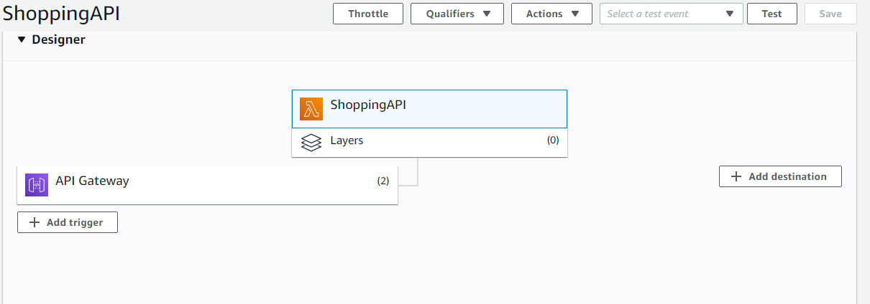
Figure 1 - Design - ShoppingAPI
Above is a screenshot of how the design of the API looks. This example is a shopping cart with an item. So the overarching API of the system is this Shopping API, in this prototype it has two gateways which refers to both the GET and POST requests within it.
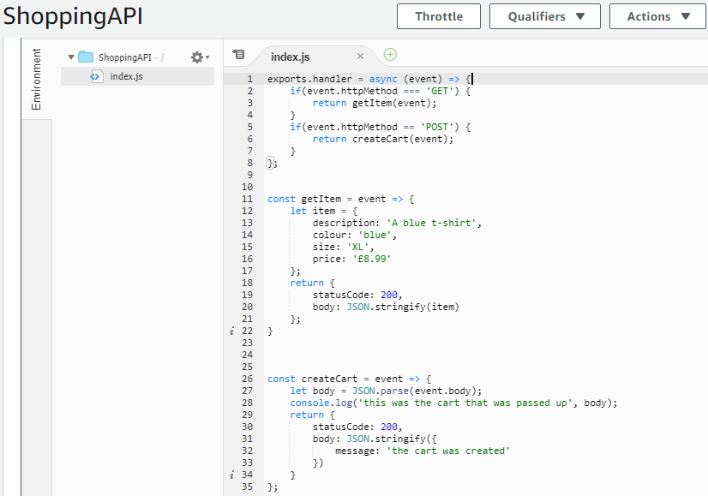
Figure 2 - Design - ShoppingAPI Code
Then the lambda code that has been produced for the prototype is implemented. The author has set GET and POST events that will be activated depending on what the API requires of it. If the API requests for a GET request it will call upon the getItem event. This event has the details of an item in it with the details for a blue t-shirt, the size of the t-shirt and the price. If the API makes a POST request then it should add the item to the cart and output “The cart was created”.

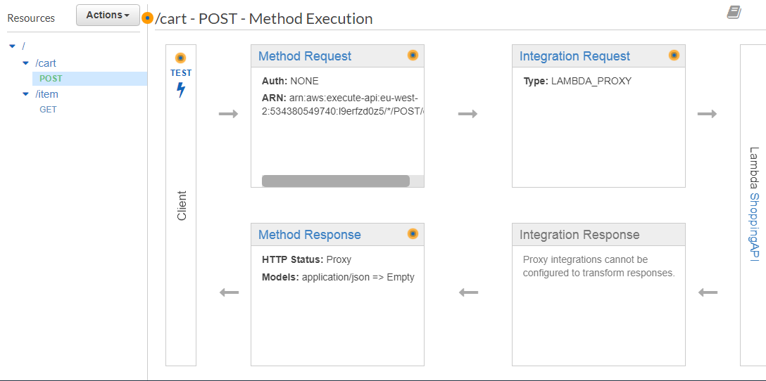
Figure 3 - Design - ShoppingAPI resources
Next we can begin to examine the API. This shopping API has two resources, cart and item. Item is the GET request and Cart is the POST request. Once the request is made it will follow along the intended path and once it picks up on the integration request section of the diagram it will go through the lambda code to decide what to do.

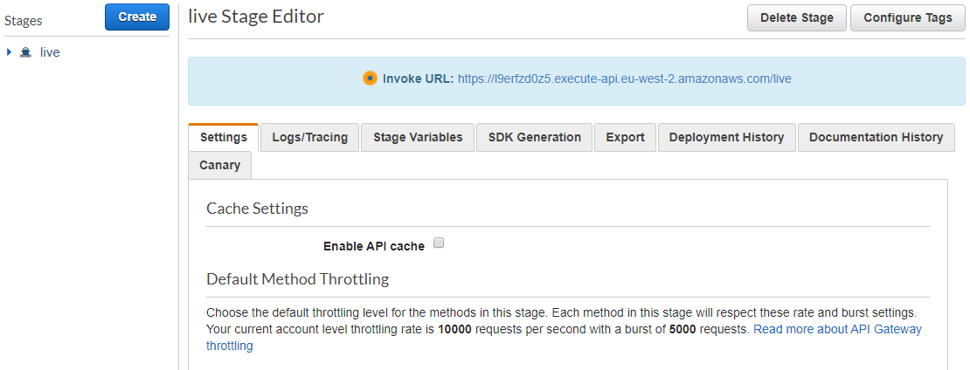
Figure 4 - Design - ShoppingAPI Deploy
Once the API is deployed the author has access to a link that will allow them to test these GET and POST requests.

Figure 5 - Design - ShoppingAPI GET
Following the link and using a forward slash and the name of the event resource the item information is gathered from the server, showing the details for a red shirt. The shirt that was entered into the lambda was blue however, so how did the shirt show as red? After the author tests the POST request this information will become clear.

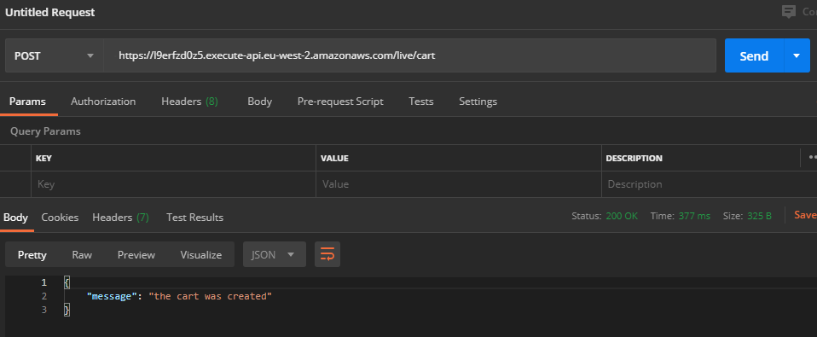
Figure 6 - Design - ShoppingAPI POST
As POST requests cannot be performed by the search engine, above the author is using a software called Postman which can run POST requests. Once the author uses the API link as well as forward slash with the POST request resource, the software comes back with a status of 200 which was set in the lambda as being an okay status as well as outputting with “the cart was created” showing that the request was successful.
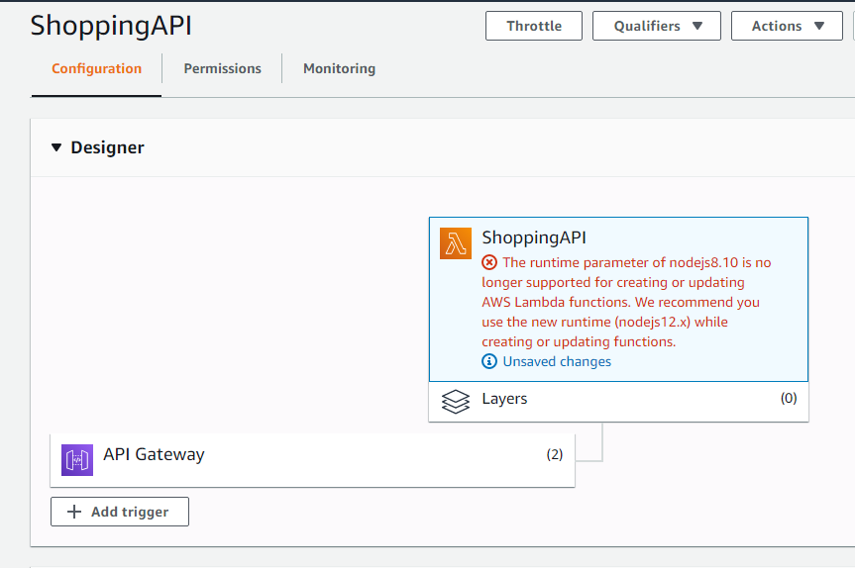
Figure 7 - Design - ShoppingAPI Error
This prototype was created by the author in September of 2019 and since then the Node.js that was used has become out of date. At the time nodejs8.10 was used however now nodejs12 and onward is the standard. As a result changes to the code will not be saved. This is exactly what was meant previously in the literature review as to how serverside logic was not in the hands of the developers, instead this needs to be changed by whoever is looking after the serverside logic. To fix this is quite simple, just update the type of nodejs that the API is using and the system will run again, this is the same as the scalability mentioned previously as when new versions of software comes out these can be updated later without the developers needing to change any details about the logic of the functions.
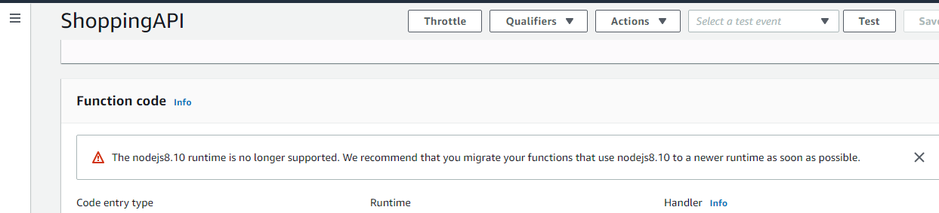
Figure 8 - Design - ShoppingAPI error 2
Above is the warning message that shows that the system needs to be updated.

Implementation
To show how these can be used multiple times the author has created many microservices that can work together when put into a school logging system. The idea of the following implementation is to show which teachers are in the school on this particular day. For the implementation chapter the lambda and API will be shown but the working GET and POST requests will be shown in the testing chapter. Before showing the rest of the teacher’s API’s and Lambda functions the author will cover the computing teachers first and explain step by step how each part was implemented, following that will be screenshots for the other teachers without the same level of explanation.

Computing Teacher
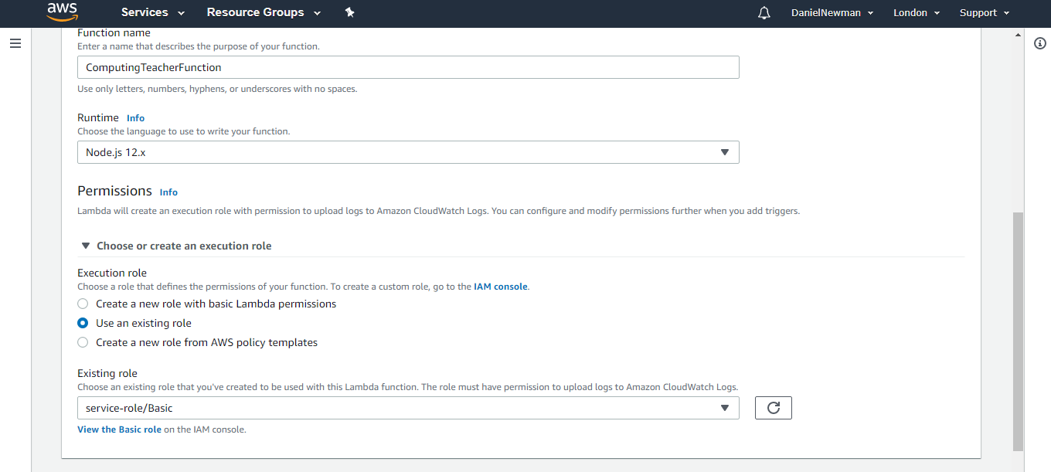
Figure 9 - Implementation - ComputingTeacher Part 1
So the first step in implementation is to create a lambda function that will allow the GETs and POSTs to work with the API that will be created later. This function will be called ComputingTeacherFunction. Before we can create the function we need to give it an execution role which changes the amount of permissions that this function can operate, in this case the author gives a basic function that allows most permissions. [50]
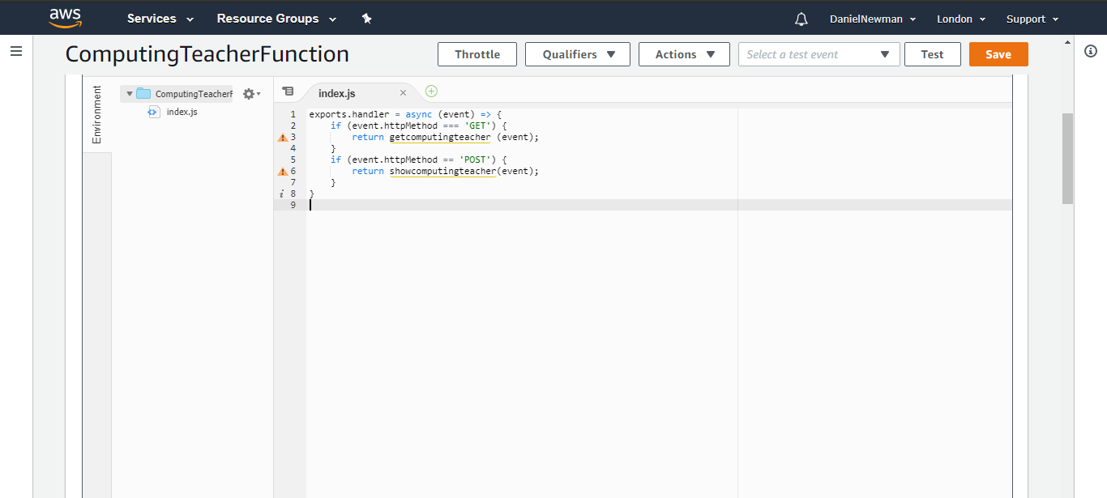
Figure 10 - Implementation - ComputingTeacher Part 2
In the lambda code editor the first few lines to create are to check if the event the code has been given is a POST or a GET, when a GET is received, the code will activate an event called getcomputerteacher. The if the code recieves a POST request then the code will activate an event called showcomputerteacher.
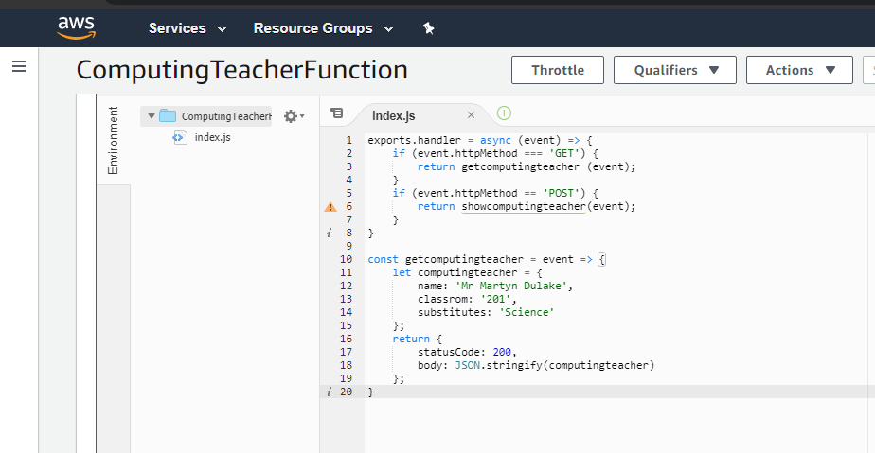
Figure 11 - Implementation - ComputingTeacher Part 3
The getcomputingteacher event is the next thing to be programmed, the program has been given the details of the teacher, in this case the name of the teacher has been set to Mr Martyn Dulake, in the classroom numbered 203, and since most teachers are able to substitute into other classes, this teacher has been given a substitute science class if the science teacher is not present. If the code runs successfully the status will be set to 200 and output the teacher details.
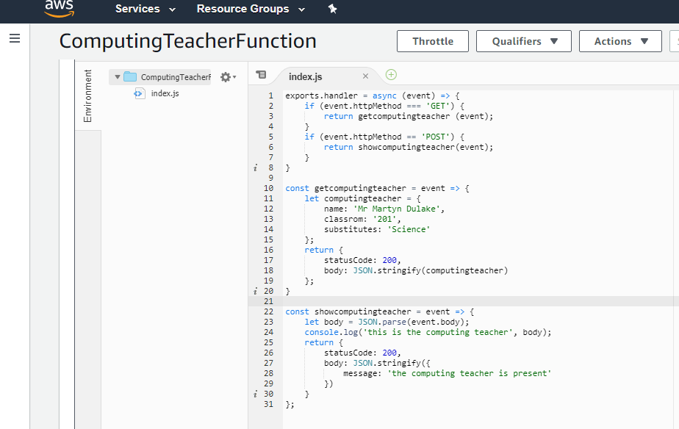
Figure 12 - Implementation - ComputingTeacher Part 4
The final piece of code in this computing teacher function is the showcomputingteacher event. Again, the status is set to 200 if successful and the program will post that the computing teacher is present, and also write to the console that the information has been parsed.
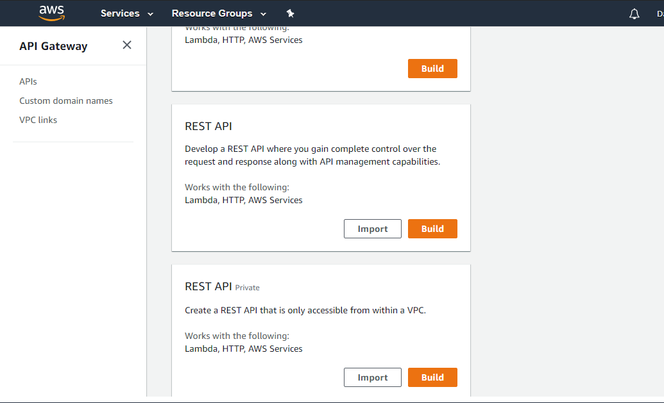
Figure 13 - Implementation - ComputingTeacher Part 5
Moving onto creating the API to use this function with, in AWS Lambda a public REST API is used in this case. The reason a REST API is used is because for this project the author needs something that is scalable so that the hypothosis can be tested. More control is given to the author to manage requests in this API type. [51]
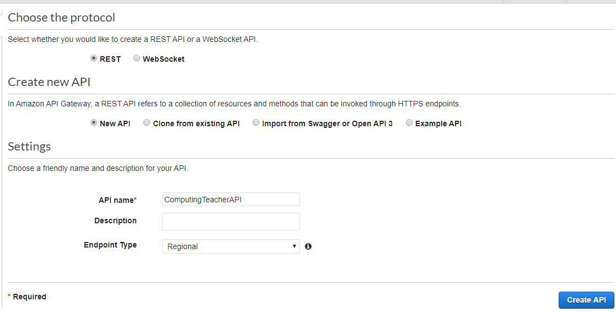
Figure 14 - Implementation - ComputingTeacher Part 6
Selecting the REST protocol, and creating a new API all that is left to do to create the API is to name it. In this example the name of the API is going to be ComputingTeacherAPI. This is following a naming convention between the other APIs created. Then click “Create API”.

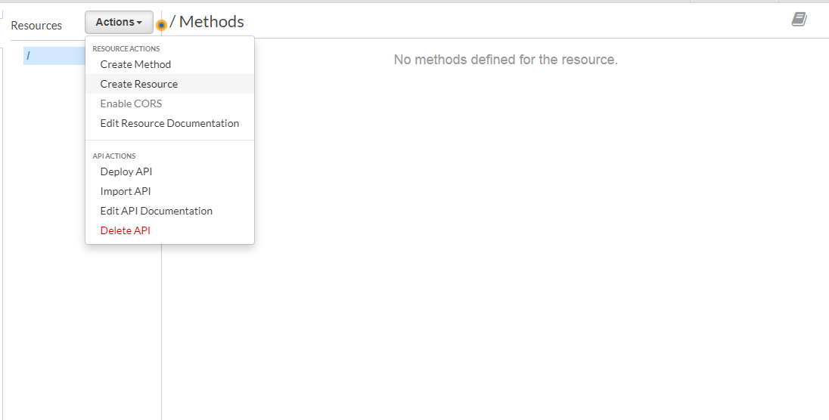
Figure 15 - Implementation - ComputingTeacher Part 7
Within the API it is empty at first. Selecting the actions drop down will show that there are a few options, the ones that will be used are creating resources, creating methods and deploy API. Resources are the separate actions that can be completed in this API, then methods are what those actions do, for example GET and POST.
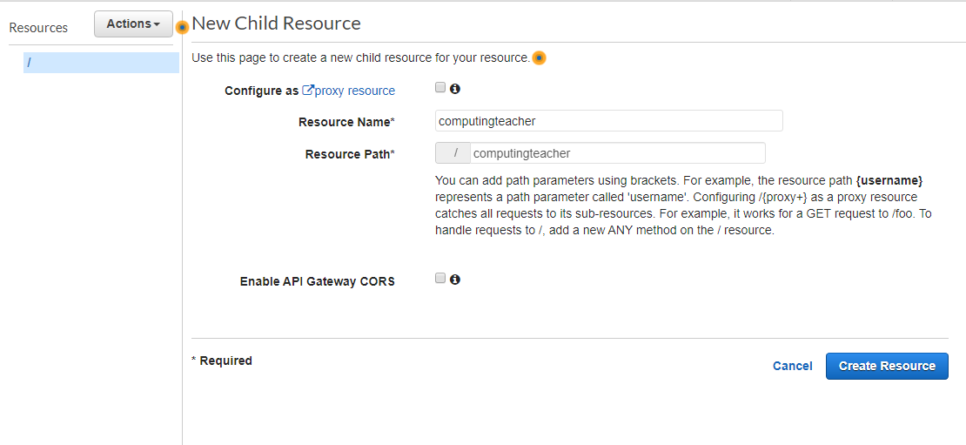
Figure 16 - Implementation - ComputingTeacher Part 8
Creating a resource called computingteacher and showcomputingteacher. These names will be used later as the API will give a link and then using a forwardslash and either of those names after it will activate that resource.
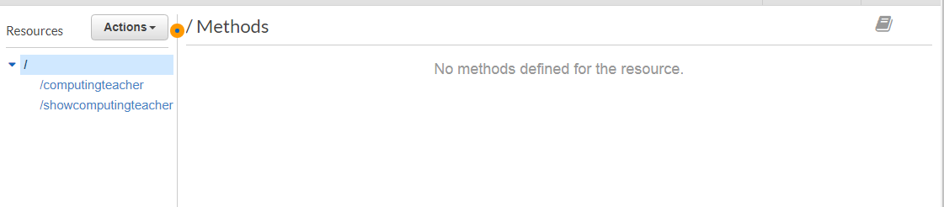
Figure 17 - Implementation - ComputingTeacher Part 9
The above image shows the resoucres after they have been created.
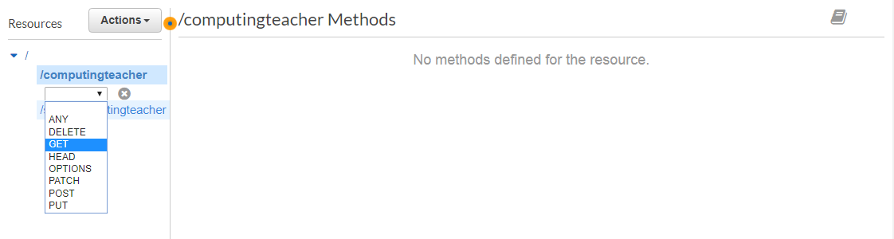
Figure 18 - Implementation - ComputingTeacher Part 10
The computingteacher resource has been given a GET method.
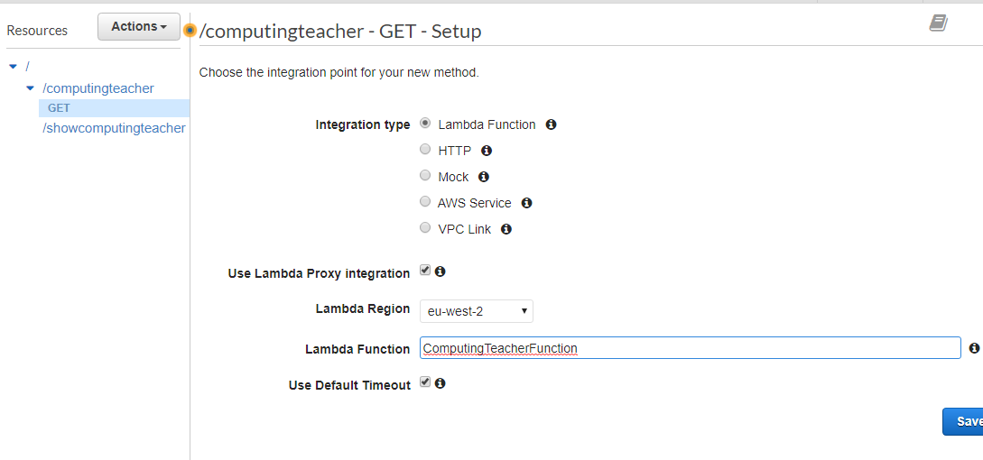
Figure 19 - Implementation - ComputingTeacher Part 11
Use lambda proxy integration has been selected, the lambda region has been set to EU West 2, this is the code for the england and wales as AWS Lambda wants to know which region this method is for. Then the lambda function created earlier ComputingTeacherFunction is selected so that when this resource is called it activates the lambda code in that function.
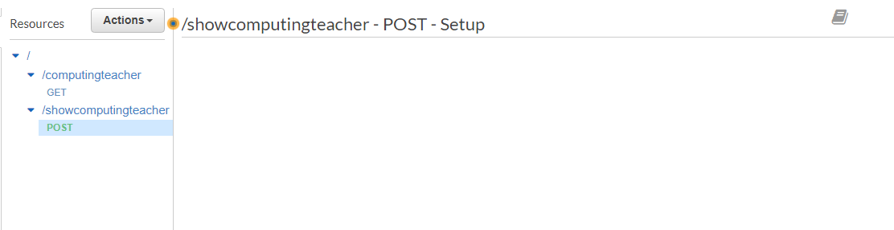
Figure 20 - Implementation - ComputingTeacher Part 12
Then the same is done for the POST method.
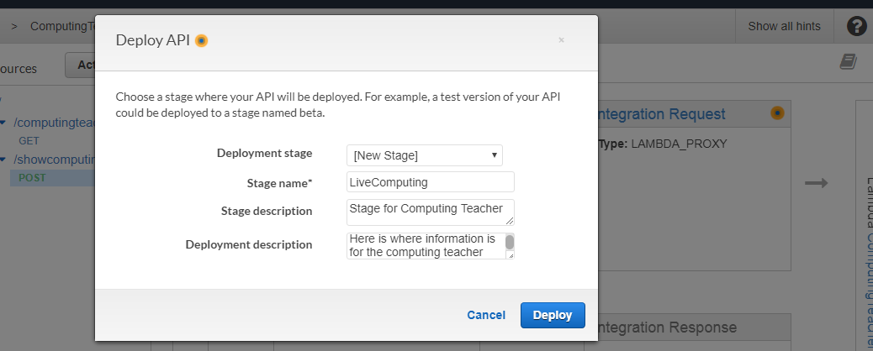
Figure 21 - Implementation - ComputingTeacher Part 13
Finally the API can be deployed. The API needs to be given a stage name, in this case following the naming convention of the other API stages, LiveComputing. The author has also given the API a description.

Figure 22 - Implementation - ComputingTeacher Part 14
AWS Lambda has given the author a link to access this API, using forward slash and the name of the resource with the GET method. This works as intended and displays the teacher name, classroom and which subject they can substitute if needed.
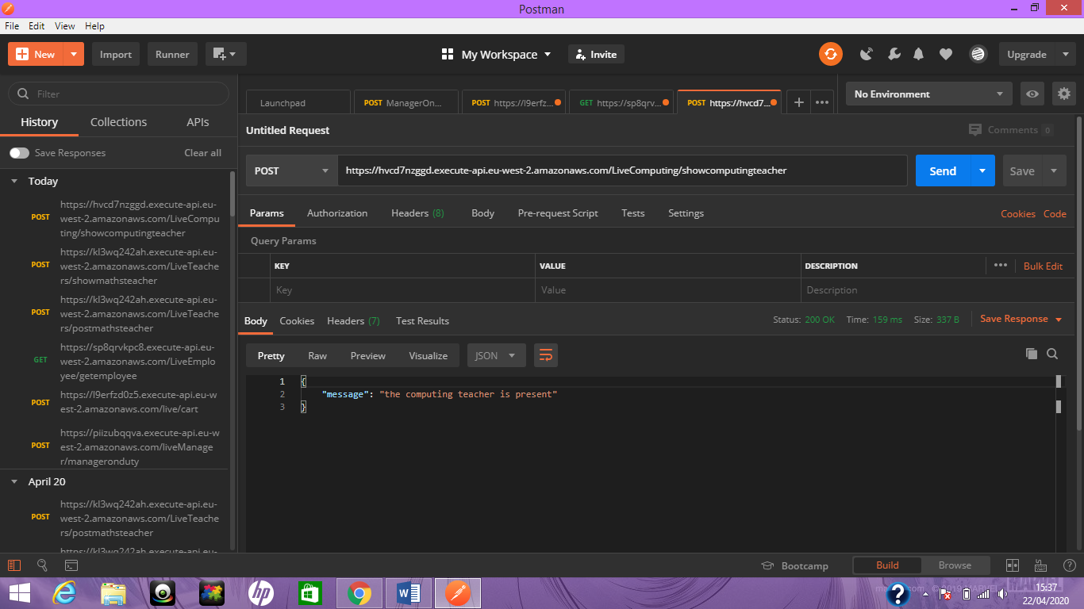
Figure 23 - Implementation - ComputingTeacher Part 15
Finally, using a software that can allow the author to use POST commands the link followed by the resource containing the POST request is entered and the program gives a successful 200 status as well as parsing the data correctly. Then a message is displayed to say that the teacher is present.

English Teacher

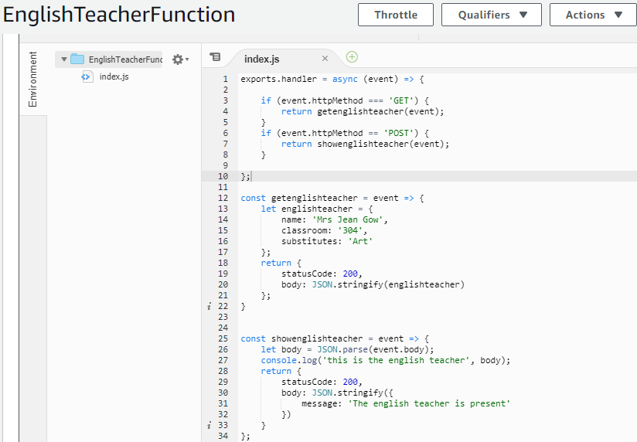
Figure 24 - Implementation - EnglishTeacher Part 1
In the english teacher lambda code a GET and POST is set. The GET is connected to the name classroom and substitute class. The POST parses the information.
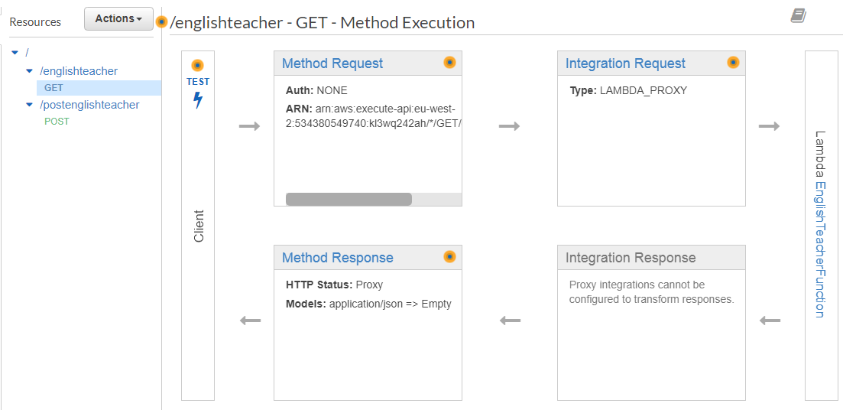
Figure 25 - Implementation - EnglishTeacher Part 2
This is the API for the English teacher functions. Using the same naming convention as the other APIs.

Maths Teacher
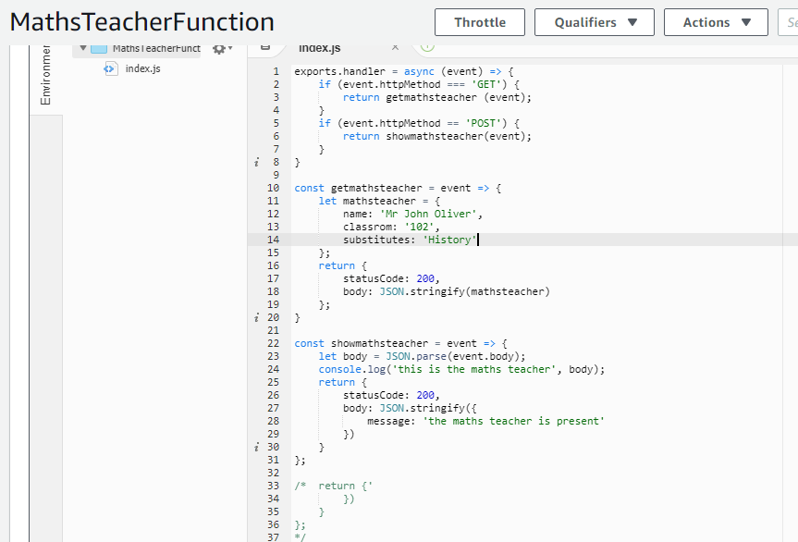
Figure 26 - Implementation - MathsTeacher Part 1
This is the maths teacher function, it GETs an event containing the name of the teacher Mr John Oliver, their classroom number and the class they are able to substitute.
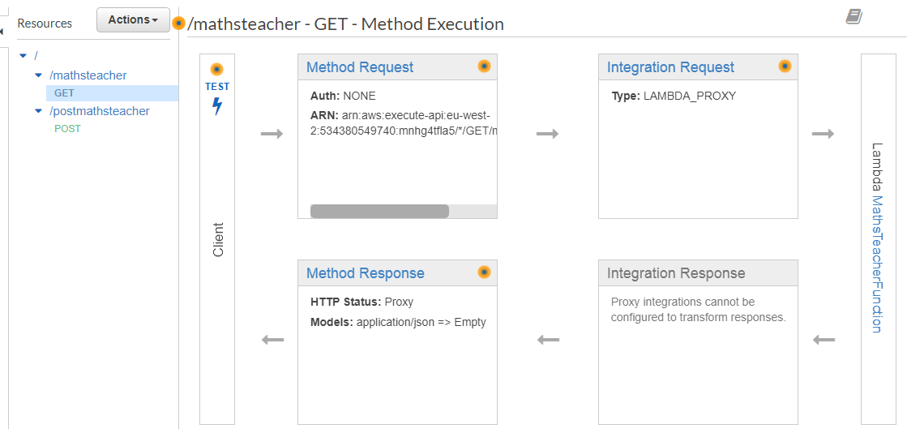
Figure 27 - Implementation - MathsTeacher Part 2
Above is the API for the maths teacher.

Science Teacher

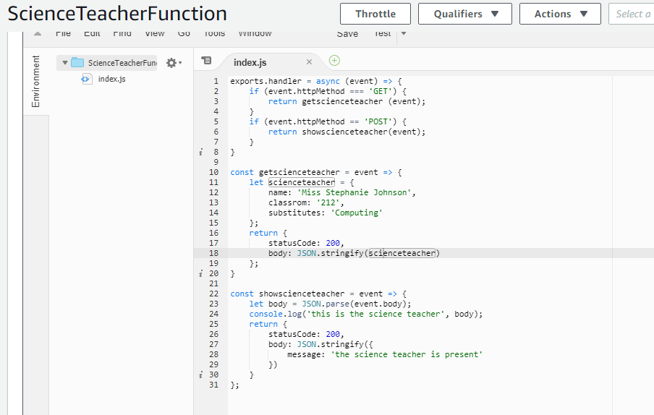
Figure 28 - Implementation - ScienceTeacher Part 1
This is the science teacher function code, the GET contains the information of a science teacher, giving a name, classroom number and a substitute class.
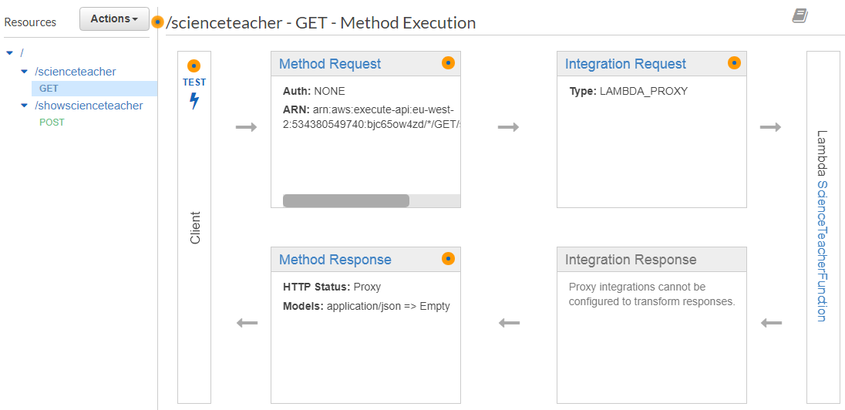
Figure 29 - Implementation - ScienceTeacher Part 2
This is the API for the science teacher function.

Art Teacher

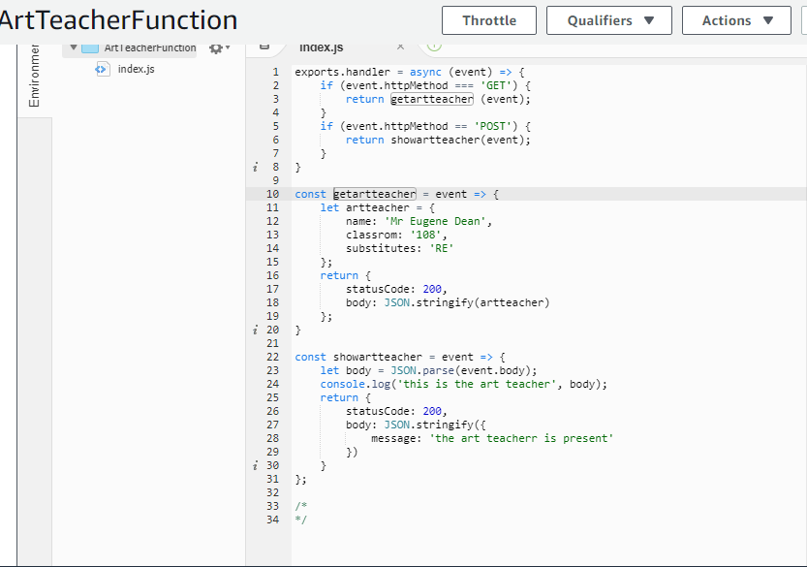
Figure 30 - Implementation - ArtTeacher Part 1
This is the Art Teacher function, the GET event gets the name Mr Eugene Dean, then the room number 108 and the substitute subject of Religious Education. The POST then parses the data.
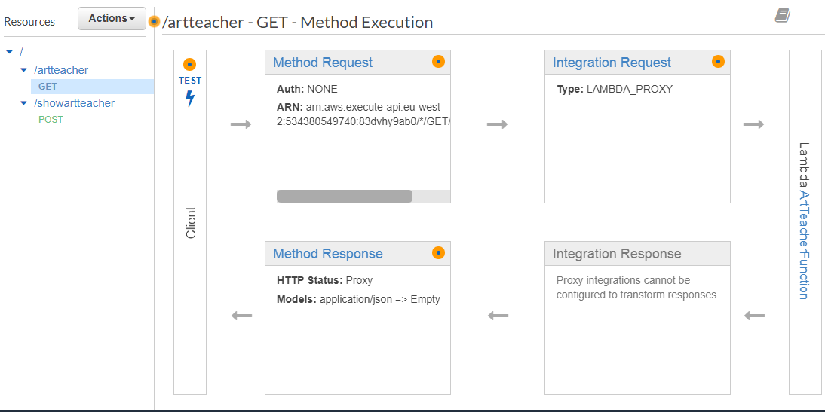
Figure 31 - Implementation - ArtTeacher Part 2
Above is the Art Teacher API.

History

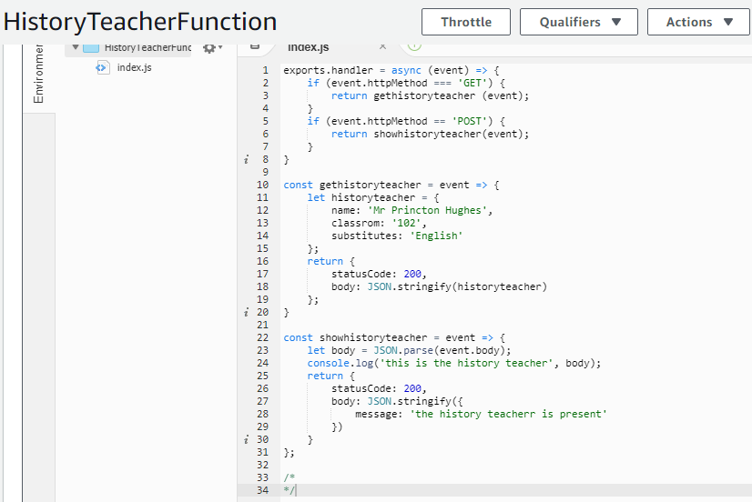
Figure 32 - Implementation - HistoryTeacher Part 1
Next is the history teacher’s information including the name, classroom number and substitute class in the GET event method.
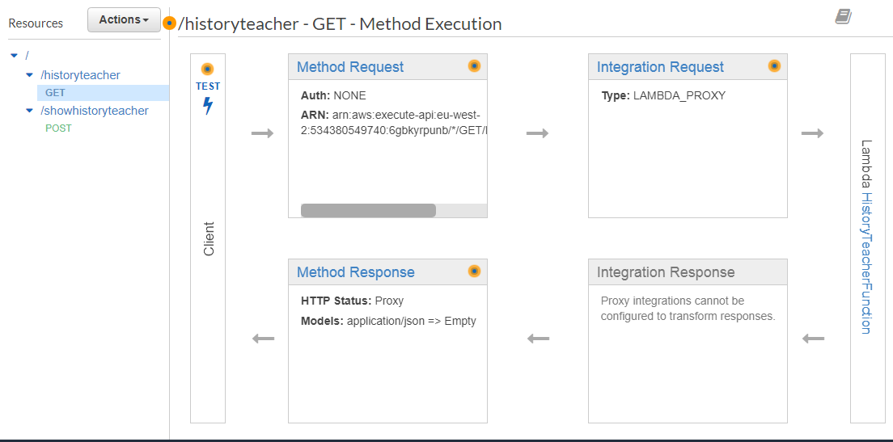
Figure 33 - Implementation - HistoryTeacher Part 2
Next is the API of the history teacher’s functions.

All Teachers API
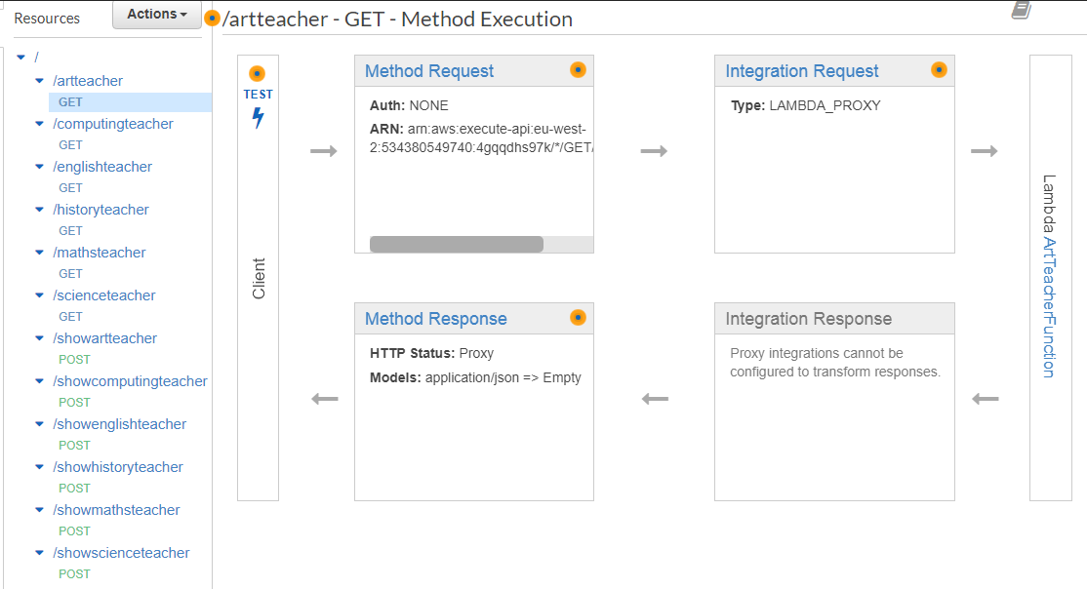
Figure 34 - Implementation - AllTeachers Part 1
Finally, an API could also be created containing all the GETs and POSTs. Each GET and POST is connected to their respective lambda functions. This would be considered the main microservice as this is a collection of functions that can be used as a unit.

Figure 35 - Implementation - AllTeachers Part 2
Using the All Teachers deployment link the author can test for each teacher.

Conclusion
To conclude the design and implementation chapter, the author has created multiple smaller microservice systems for potential use for a school system. These microservices could be used to check the attendance of lecturers and who can substitute when a lecturer is not present on that day. The author has then also merged all these functions into a single API which makes a much larger microservice. This implementation works well and could be placed into a software to call from the AWS Lambda server.

Chapter 5 – Testing

Introduction
In this chapter the author will use the implemented development of microservices and test that the systems are working as intended by the author. When testing the author will show each microservice and test that their gets and posts are operational. As well as this a brief look at the CloudWatch systems in AWS Lambda will also be shown to test that those results are accurate.

Testing

English Teacher

Figure 36 - Testing - EnglishTeacher GET
The above screenshot is calling the English Teacher GET function. This brings up the information about that teacher.
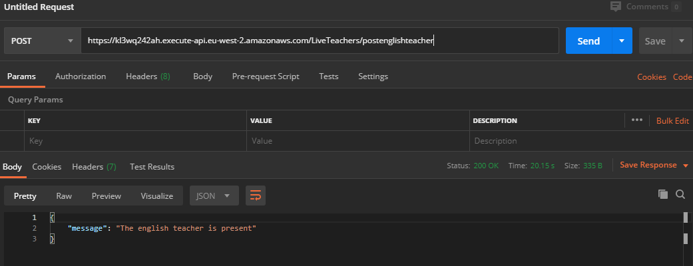
Figure 37 - Testing - EnglishTeacher POST
Using a software capable of testing POST functions, the function is proven to operate as intended as the status shows as 200 and the message has come through.

Maths Teacher

Figure 38 - Testing - MathsTeacher GET

The above screenshot is calling the Maths Teacher GET function. This brings up the information about that teacher.

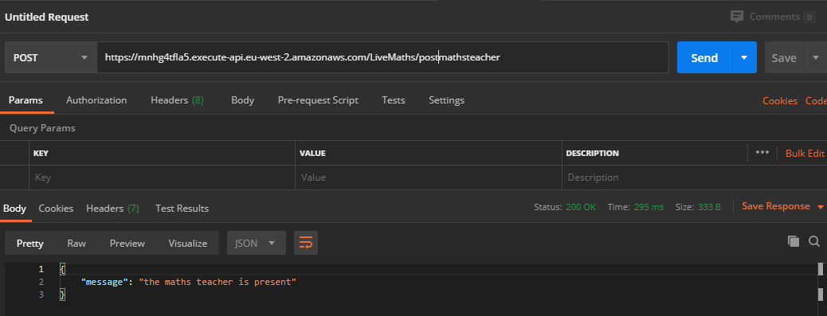
Figure 39 - Testing - MathsTeacher POST
The POST feature for the maths teacher comes back with a 200 status to prove that it has run successfully. It also shows the correct message and so this test has been successful.

Science Teacher


Figure 40 - Testing - ScienceTeahcer GET
The above screenshot is calling the Science Teacher GET function. This brings up the information about that teacher as intended.

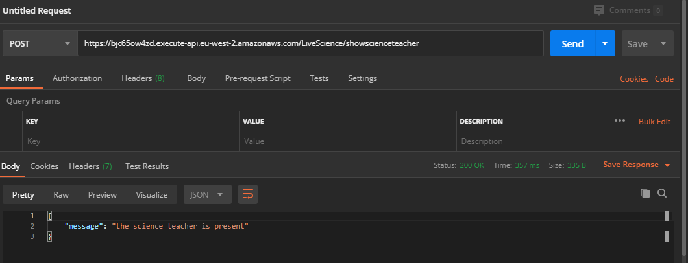
Figure 41 - Testing - ScienceTeahcer POST
The POST request for the science teacher works as intended with the correct teacher information shown, the status also is set to 200 and so this is a successful test.

History Teacher


Figure 42 - Testing - HistoryTeacher GET
The above screenshot is calling the History Teacher GET function. This succesfully displays the information about that teacher.

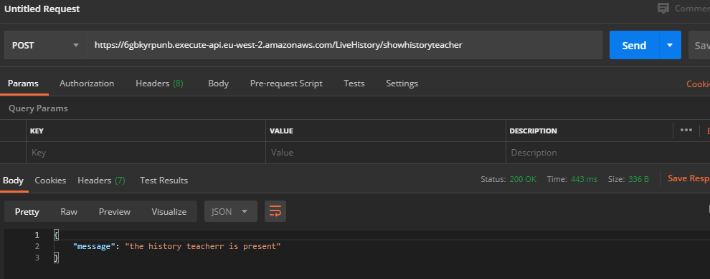
Figure 43 - Testing - HistoryTeacher POST
The POST request for the History Teacher works as intended. A status of 200 is shown and the information is parsed.

Computing Teacher

Figure 44 - Testing - ComputingTeacher GET
The above screenshot was also shown in the implementation showing that the computing teacher information appears when the GET request is called.

Figure 45 - Testing - ComputingTeacher POST
As shown in the implementation chapter of the report, the computing teacher POST requests works as intended.

Art Teacher

Figure 46 - Testing - ArtTeacher GET
The GET feature works as intended as the information about the art teacher appears on the screen when the function is called.
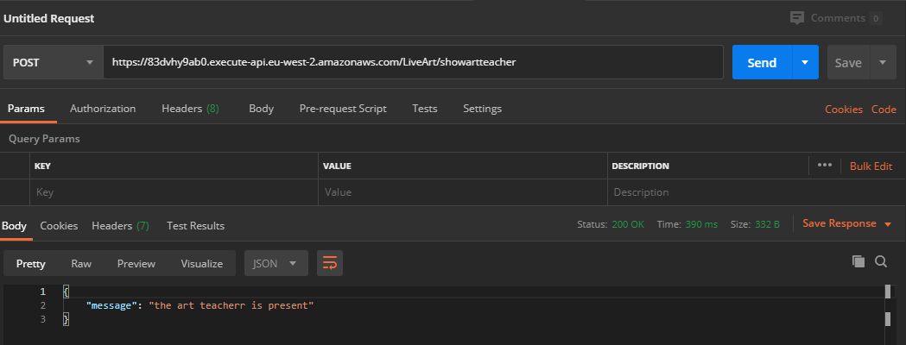
Figure 47 - Testing - ArtTeacher POST
Then the above image shows that the art teacher POST works, it shows and parses the message and shows the intended 200 status.

Cloudwatch Statistics

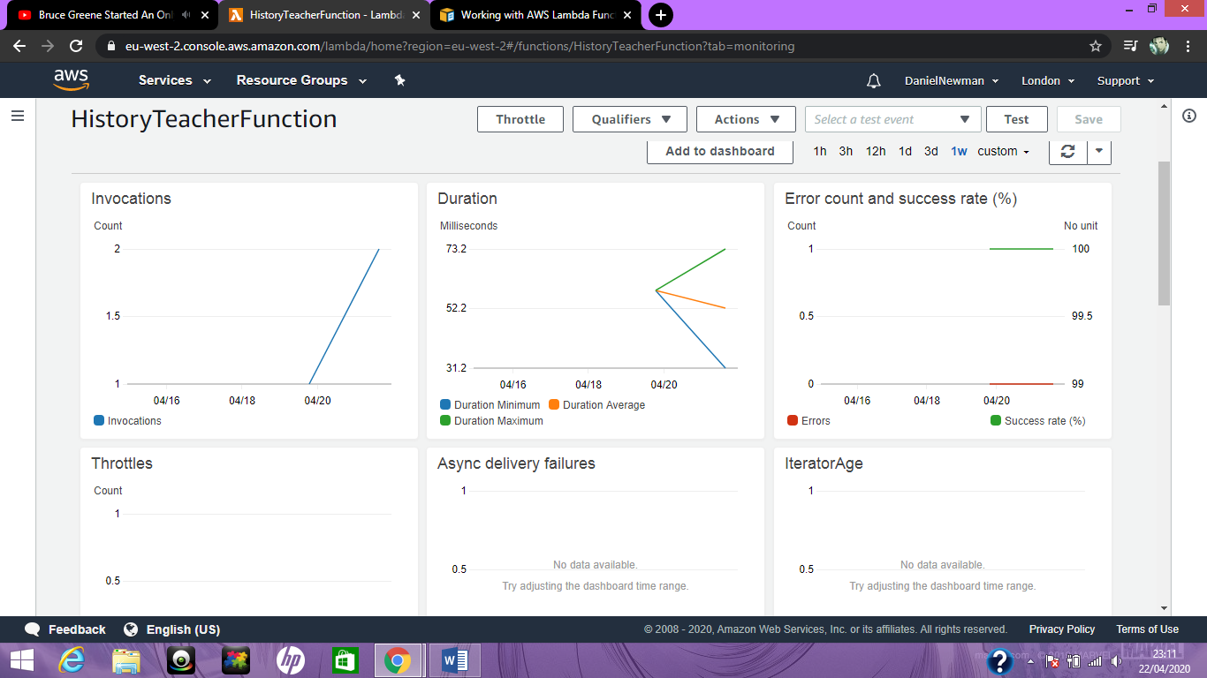
Figure 48 - Testing - CloudWatch 1
The above photo is some cloudwatch statistics available in AWS Lambda. Using the history teacher function as an example, the author is able to see how many invocations the function gets, the duration, the error to success ratio of the microservice and the amount of concurent executions.
The invocations represent the amount of times the function runs, it shows a total of two times that this function had been called, once the previous day and once the next day.
The duration refers to the amount of time taken to load and process the service, out of the two invocations that had been called, the maximum duration of processing power was 73.2 milliseconds, the minimum duration was 31.2 milliseconds. Bearing in mind that the amount of time these functions take to load will effect the amount of expenses that these businesses will be spending using serverless computing technologies and microservices. These statistics will be very different for a business too as they will have a much larger user base to bump these numbers into wildly different directions depending on how many users are using their systems.
Next is the error and success rate. 0% of the runs so far have failed and 100% of them have passed, but again, for a larger business with many more users they should expect more than 0% failure with their runs due to a range of different causes. [52]
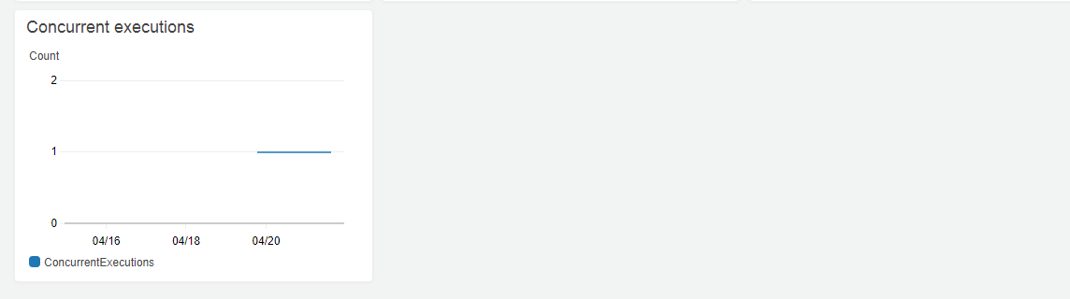
Figure 49 - Testing - CloudWatch 2
Concurrent executions for the author is set to one, this statistic counts how many executions happen at the very same time, in the author’s case they are the only tester for these microservices and so the executions will remain one unless there was a larger user base.

Evaluation
The author is proud of the testing that has been conducted, each test showed the system successfully working. Though errors are to be expected in a system being accessed by thousands of people if it were to be put into a real production environment where real users could use the system, the tests operating as intended at this stage of development is promising for a potential future of this system. The author is also proud of their analysis of the cloud watch statistics as these are built in performance statistics of the services which had to be read and interpreted by the author. Overall the author believes the quality of screenshots, research, testing and analysis was very well done

Chapter 6 – Conclusion and Results

Introduction
In this chapter the author will conclude the dissertations main focus and answer the main question of this report “What are the benefits of microservices and how do they compete with other serverless architectures?”
The author will summarise what the research does to help answer this question and also use their own hypothesises to come to their own conclusions about the topic and answer the question that the author has set out for themselves.

Summary
The author has concluded in this chapter the validity of hypothesises using the developed project as an example for most of these results. The author has concluded that microservices can activate within milliseconds making them extremely fast even with the time taken to get that process from a server. The author agrees with the hypothesis that the pay for what you use system is useful and in most cases is very cheap for smaller businesses, however the idea that a business cannot plan for how much they will be likely to pay for these services can be an issue. The author agrees that microservices are scalable and the scalability of these websites is very useful for businesses that could experience unexpected boosts of activity and traffic on their website. Microservices do allow developers to split up their workload into smaller chunks for ease of development as well as take the responsibility of server side applications away from the developers, meaning shorter development times. The common drawback suggested in research that microservices are hard to understand for developers trying to find what functions relate to what services is believed by the author to be false, microservices that are too large void the purpose of what make microservices great in the first place and so long as proper naming conventions are followed then filtering through these functions should not be too difficult. The author also believes that microservices are very reliable as failure and error does not mean the entire project is at risk, instead if one service is experiencing an error the system can still mostly operate as normal. Finally the author believes that even with newer serverless architectures coming out, there is still a place in the serverless computing world for microservices to thrive, they serve their own purpose with benefits unique to themselves above competitors.

Conclusion
One of the best ways to gather the results for this dissertation is to analyse what the created project can show the author about the hypothesises that were created in the methodology based on the research conducted in the literature review.

Hypothesis 1:
Microservices run quickly, they have very little start up time to have them run.
Figure 50 - Conclusion - Hypothesis 1
As seen in the testing section for the cloudwatch statistics, these services process very quickly, within milliseconds these operations can be gathered from the server and used swiftly, in the testing the microservices took an average of 52 milliseconds to finish processing. These statistics might change depending on certain factors such as concurrent executions during the time of activation and the size of the microservice if a business decides to make much larger microservices. But from this development the author has clearly shown that this hypothesis is accurate to how microservices operate in practice. This is especially helpful to businesses as they will be paying for the length of time these microservices take to process fully and so the less time it takes to process these services the better for these businesses.

Hypothesis 2:
Many microservices can exist at any given time and only charge businesses based on the time that is used by the microservices.

Figure 51 - Conclusion - Hypothesis 2
Based on the amount of microservices created for the development project, it is clear to see that multiple microservices can be used by businesses at any given time. Using the in-built cost analysis system in AWS Lambda the author can see that their development did not cost any momey to produce, this is because the author is using a free account in AWS Lambda, which does not allow free range of all features but is free to use. Businesses however would use a version of AWS Lambda that is uncapped and will be pay to use, though the author cannot test how much their microservices would cost traditionally, it is possible to assume a rough estimate.
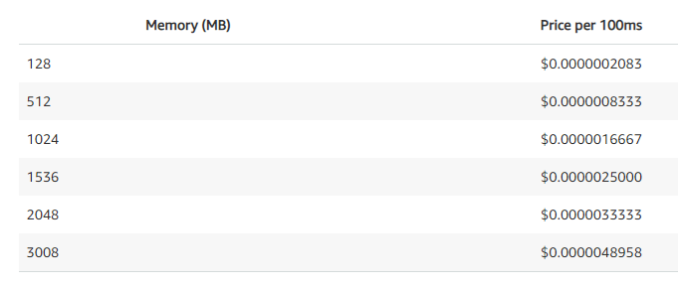
Figure 52 - Conclusion - Hypothesis 2 Part 2
Using the current predicted prices in AWS Lambda, each service the development runs is approximately 400MB for the teachers. The closest memory range AWS Lambda is showing is 512MB. So going of those numbers every 100 milliseconds of processing time would cost a business $0.0000008333. Going from the CloudWatch statistics the author’s services processed for an average of 52 milliseconds. This would mean that to reach $1 of spending in AWS for this memory bracket the service would need to process at 100 milliseconds for 1,200,041 times, as the example code produced by the author averages at 52 milliseconds per operation, this statistic would be doubled. This may seem like a lot at first, especially for the scale of this project but businesses like Twitter receive 500 million posts per day, and that is not the only service that twitter provide so they could potentially be looking at paying a lot of money each month to keep these services running. [53] [54] With that said, the cost of keeping these services running could very well be worth it for businesses as the scalable nature of microservices and the other benefits it offers for anyone using them.

Hypothesis 3:
Microservices allow the programmer to cut up their program into smaller chunks which they can then use to better format their website.
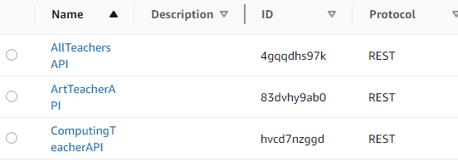
Figure 53 - Conclusion - Hypothesis 3
As shown in the development project by the author, the functions were able to be split up into smaller chunks rather than one big function that does a lot of things. It simplifies the development process and makes understanding the code easier, in the development for example each API created had names like ArtTeacherAPI and so on, these are easy to identify and sort through if the names of each API is consistent. It is also more accessible so long as naming conventions are followed well throughout development. In terms of better formatting, having these functions split up means that developers can implement tools better suited for their microservices and create intersting methods of using them.

Hypothesis 4:
Microservices are scalable to large traffic and changes that a website is experiencing and also allow the businesses to keep using the same microservices over time as they can be reused elsewhere.
The author unfortunately cannot test the scalable nature of microservices this way as the number of concurrent calls are only one. However AWS has stated on their website that they use a scale up method of scaling which means that the more traffic a microservice is receiving at any given time AWS will automatically assign more processors to that task, the general idea being that if a task is having trouble coping on one processor then adding 7 new processors will make that process run at 8 times its usual processing time. [55] Also to be discussed in this hypothesis is the reusability of the microservices. As shown in the author’s implementation when creating a new API to use the services already existing in a separate API the services still worked. In other words, since the developers have created a microservice to perform a specific action this in turn would mean that they could reuse the same microservice in the same application or in a different one as it should perform the same way. An example of this would be if a business has one website and they decided to make the users log into a new website, if they wanted to have a microservice that would contact the server and get information from a database of user information, so long as the correct information is parsed then the same microservice can be reused.

Hypothesis 5:
Microservices allow developers to focus more on other tasks as an external server provider can handle the server side logic.
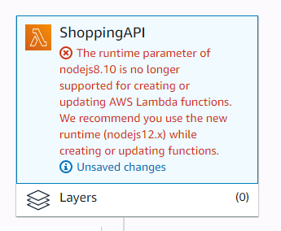
Figure 54 - Conclusion - Hypothesis 5
As demonstrated in the author’s development, when an API was out of date it no longer accepted changes to the functions, though this is a problem for the most part, this can easily be set so that it automatically updates when new versions of the systems come out. So updating does not need to be a concern of the developers as instead the server provider can have these updated automatically throughout the years. When it comes to server side logic such as how the systems should scale or what servers these functions are using will be automatically done by AWS Lambda as well as any other serverless provider that can be used and so developers will not need to concern themselves with these types of problems.

Hypothesis 6:
If a microservice were to stop working or fails an attempt at running the rest of the site can still function as intended.
In the author’s testing there were no failed attempts to get the results they needed. However in the event that errors were to happen it is safe to assume that other functions would be unaffected by the other microservices being inoperable. This is because microservices are split into multiple functions, one function being inoperable should not affect any other function in that microservice. Looking as a grander scale project that uses microservices for a shopping basket and items and log in. If the microservice controlling the website’s shopping basket were to stop working for whatever reason this should not have any detriment on the operability of the other two microservices.

Hypothesis 7:
As an application grows it becomes harder to understand the programs and harder to find each line of code directly linked to a microservice function.
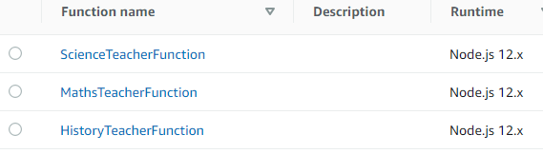
Figure 55 - Conclusion - Hypothesis 7
This is a drawback of microservices that many programmers bring up in their research, what truth is there to this. I think it is fair to say that if a microservice had hundreds of functions within it that it would be difficult to sort through all of the functions, even if proper naming conventions were used appropriately. However, in the author’s opinion it should not be as difficult as most researchers suggest it be, for a start having more functions in each microservice than is necessary could be an issue for the researchers that believe this hypothesis to be true. One of the main selling points for microservices is the pay for what you use system and so filling a microservice with an abundance of functions could very well make the whole point of using them in the first place void as that processing power is going to waste. Another thing researchers could be missing is using naming conventions that make filtering through functions within a microservice easier, if an individual was looking for a function for Year 3 students in a university microservice then it would make sense to have “Year 3” in the function name or the academic level. In the author’s own opinion this hypothesis is not as accurate as others as there are plenty of ways to avoid falling into this microservice trap.

Hypothesis 8 and 9:
There is a higher chance that failures can emerge than in a monolithic system as each microservice must go through a communication stage with the server.
Possible network issues can lead to a website being unusable, or at least make certain aspects of the website unusable.
This hypothesis is controversial, because it really depends on certain circumstances. Monolithic systems are our traditional systems and every one of them runs from a server, meaning that each website has the chance of not operating due to strain of network and server flow and the same can apply to websites using microservices. In reality there is likely a small difference in monolithic applications favour here as both websites are likely running from the same server or very similarly produced servers. Monolithic applications likely experience server faults less than any other system, but this does not mean that microservices are worse. Any monolithic website experiencing large amounts of traffic can begin to experience more faults due to their server logic not being able to scale up to their demand, meanwhile it is built into the microservice websites to scale up where necessary automatically and so though monolithic websites have the upper hand in general outages, microservices are not without their own benefits in this regard. Additionally, monolithic websites may experience errors unrelated to their server and in this event then the webpage may need to be refreshed by the user and in some cases these issues might consist and effect other parts of the website. As previously discussed, microservices have this level of error tolerance built in as if one service no longer works the others should still be fully operational.
In terms of network outages or serverless data centres closing down or being out of action, since Amazon Web Services have been around they claim to have never had a full failure of any of their data centres around the world, though some failures do arise it is reassuring to know that many companies providing serverless systems are not failing at delivering their services any time soon. [56]

Competition
In terms of how microservices compete with other serverless systems such as functions as a service they both serve similar purposes but also have strengths depending on the scale. Though the author did not make a functions as a service system, there is a lot that can be learned from the microservice development when put against the research gathered on functions as a service systems. One of the most interesting differences are the scale of projects a business is likely to use either methods for. Microservices are a great way to break down large projects into smaller chunks, this allows these larger websites to be less complex than they need to and be loosely connected to make a larger picture. Meanwhile the larger a Functions as a Service development project is the harder it becomes to manage and control. Unlike larger microservice systems which can be managed through an idea of togetherness (multiple functions within a single service), functions as a service technologies are not linked in this method and so it becomes very difficult to manage and filter between each function. Functions as a Service is better suited to smaller and medium sized projects, whereas the author would argue that microservices have their uses in small, medium or large sized projects. One thing functions as a service might have over microservices is lower latency times, for example in a microservice system when the user makes a request the system has to go through a group of functions and run the program whilst ignoring the details that are not relevant, this could take a while, still in the milliseconds but longer than say a functions as a service system would need as only the one function is present to be read and completed by the system.

Chapter 7 – Reflections

Introduction
In this final chapter the author will take a look back at their dissertation and hard work to discuss where their strengths were and what they were not so adequate at. Then the author will look at what they think went well and what did not go to plan. To do this the author will first look at their work in the literature review, their implementation and then finally at their work as a whole unit.

Reflection of literature review
The literature review of this report includes discussions on serverless computing, microservices and functions as a service technologies. The author believes the quality of work produced for this section was done to a great standard. Books and journals were explored in good detail as well as references from other sources. When the author first began writing this dissertation in July of 2019 there seemed to be limited resources available about both microservices and functions as a service technologies. The technologies were somewhat new at the time but it was the author’s assumption that there would have been more variety in these sources. This did mean at first that the main resources used at first were mainly online articles. However, as the year went on and gradually more and more sources were made available, in particular more books were published and more journals and industry professionals were created about this topic and the author did well to research those new sources for additional insight on the topics and to analyse the newest research available at the time. The author believes that the quality of analysis was done well, interpreting what other researchers have said about serverless technologies and demonstrating what that means for the bigger picture. The author learned a lot of useful information as a result of conducting a literature review, this information was instrumental to the rest of the dissertation as it helped the author come to conclusions about the research in the latter half of the report. It would have been impossible to have come up with results regarding the implementation and conclusion of the report if no prior research had been conducted before those chapters, this also applies to the hypotheses that were created, they were assumed based off of the literature review and these hypotheses were instrumental in drawing conclusions. The author is proud of the quality of the literature review and believes it to be a good assortment of different styles of ideas and opinions being presented to demonstrate the whole point of these concepts.

Reflection of Implementation
As for the implementation of the project, the author is proud of the fact that they were able to pick up some new concepts and use a serverless architecture completely foreign to themselves before the dissertation. Using AWS Lambda was at first quite challenging as the amount of options of services that AWS offer are very large, but once the author began to get more comfortable with the idea of APIs and the other services that were used everything began to fall into place quite simply. It took a short while to get to grips with using the resources and methods available and especially making sure the code used the GET and POST requests as intended. In one aspect the author is disappointed by the simplicity of the microservices, this was not the fault of the author’s chosen scale of the project, instead it turns out that microservices do exactly what they’re meant to, and reduce developer’s workloads by simplifying tasks into smaller tasks. The author was not expecting the level of simplicity involved before beginning the development as the assumption by the author was that using a server, a new platform for writing code and developing a project within it would take a lot more complex code. So if the author had the chance to ever expand on this dissertation in the future the implementation would certainly be the part that would be expanded upon. The quality of tests and the services themselves however are good, and do tell the author a lot about how these microservices work. The quality of analysis on how these systems work in the author’s implementation and testing chapters is good and could even provide as a good tutorial on how anyone could create their own microservices.

General reflection
In general, the author is proud of the overall dissertation in its entirety. The author would like to thank their project supervisor Michael Dacey for the support for this dissertation. A lot of work and effort was made to produce a dissertation of this quality. In the methodology chapter the author is satisfied with the overall presentation of how the research onion is analysed and which options the author had chosen. The author believes that the aim of this dissertation has been achieved and the objectives stated previously were all discussed and completed to a high level of understanding and quality.

References

[1] | Amazon, “AWS Lambda Pricing,” Amazon, [Online]. Available: https://aws.amazon.com/lambda/pricing/. [Accessed 7 April 2020].
[2] | T. Hou, “IaaS vs PaaS vs SaaS Enter the Ecommerce Vernacular: What You Need to Know, Examples & More,” Big Commerce, [Online]. Available: https://www.bigcommerce.co.uk/blog/saas-vs-paas-vs-iaas/#executive-summary-summing-up-saas-vs-paas-vs-iaas. [Accessed 7 April 2020].
[3] | G. Rama, “Report: AWS Lambda Popular Among Enterprises, Container Users,” awsinsider, 2 April 2020. [Online]. Available: https://awsinsider.net/articles/2020/02/04/aws-lambda-usage-profile.aspx. [Accessed 10 April 2020].
[4] | Microsoft, “What is serverless computing?,” Microsoft Azure, [Online]. Available: https://azure.microsoft.com/en-gb/overview/what-is-serverless-computing/. [Accessed 1 July 2019].
[5] | “What Is Serverless Computing? | Serverless Definition,” Cloud Flare, [Online]. Available: https://www.cloudflare.com/learning/serverless/what-is-serverless/. [Accessed 12 July 2019].
[6] | Amazon, “Serverless,” Amazon Web Services AWS, [Online]. Available: https://aws.amazon.com/serverless/. [Accessed 16 July 2019].
[7] | M. Watson, “What Is Function-as-a-Service? Serverless Architectures Are Here!,” Stackify, 15 May 2017. [Online]. Available: https://stackify.com/function-as-a-service-serverless-architecture/. [Accessed 2 July 2019].
[8] | N. P. Nemanja Novkovic, “What Is FaaS? (Function As A Service),” Dashbird, 10 July 2018. [Online]. Available: https://dashbird.io/blog/what-is-faas-function-as-a-service/. [Accessed 3 July 2019].
[9] | “What Is Function as a Service (FaaS)?,” Cloud Flare, [Online]. Available: https://www.cloudflare.com/learning/serverless/glossary/function-as-a-service-faas/. [Accessed 12 July 2019].
[10] | D. Prothero, “Serverless Architecture - Why Serverless Architecture?,” Twilo Docs, [Online]. Available: https://www.twilio.com/docs/glossary/what-is-serverless-architecture. [Accessed 15 July 2019].
[11] | G. Armstrong, “Serverless and Chatbots: A Match Made in the Cloud,” in Liberty Information Technology QCon, San Francisco, 2019.
[12] | S. F. III, “What serverless computing really means, and everything else you need to know,” ZDNet, 9 April 2019. [Online]. Available: https://www.zdnet.com/article/what-serverless-computing-really-means-and-everything-else-you-need-to-know/. [Accessed 20 June 2019].
[13] | K. Finley, “The Promise of (Practically) ‘Serverless Computing’,” WIRED, 11 November 2018. [Online]. Available: https://www.wired.com/story/promise-practically-serverless-computing/#. [Accessed 20 June 2019].
[14] | W. Schott, “Five advantages of serverless architecture for every app,” Developer Tech, 5 October 2016. [Online]. Available: https://www.developer-tech.com/news/2016/oct/05/five-advantages-serverless-architecture-every-app/. [Accessed 28 October 2019].
[15] | F. Bashir, “What is Serverless Architecture? What are its Pros and Cons?,” Hackernoon, 14 October 2019. [Online]. Available: https://hackernoon.com/what-is-serverless-architecture-what-are-its-pros-and-cons-cc4b804022e9. [Accessed 28 November 2019].
[16] | T. Krazit, “Google’s serverless computing strategy starts to take shape as it chases Amazon Web Services and Microsoft,” GeekWire, 24 July 2018. [Online]. Available: https://www.geekwire.com/2018/googles-serverless-computing-strategy-starts-take-shape-chases-amazon-web-services-microsoft/. [Accessed 16 January 2020].
[17] | A. Monus, “What are microservices? The pros, cons, and how they work,” Raygun, 9 October 20118. [Online]. Available: https://raygun.com/blog/what-are-microservices/. [Accessed 3 July 2019].
[18] | “What are microservices?,” Microservices.io, [Online]. Available: https://microservices.io/. [Accessed 3 July 2019].
[19] | T. Huston, “What is Microservices?,” SMARTBEAR, [Online]. Available: https://www.google.com/search?q=microservices&rlz=1C1RZHW_enGB691GB691&oq=microservices&aqs=chrome..69i57j35i39j0j69i60l3.3800j0j7&sourceid=chrome&ie=UTF-8. [Accessed 9 July 2019].
[20] | M. Brizeno, “5 Traits of a Good Delivery Pipeline,” Thought Works, 12 July 2016. [Online]. Available: https://www.thoughtworks.com/insights/blog/5-traits-good-delivery-pipeline. [Accessed 15 July 2019].
[21] | opensource.com, “What are microservices?,” opensource.com, [Online]. Available: https://opensource.com/resources/what-are-microservices. [Accessed 15 July 2019].
[22] | S. Newman, Building Microservices, O'Reilly Media, Inc, 2015.
[23] | J. Thones, “Microservices,” IEEE Software, vol. 32, no. 1, 2015.
[24] | B. Han, “An Introduction to Serverless and FaaS (Functions as a Service),” Medium, 5 November 2017. [Online]. Available: https://medium.com/@BoweiHan/an-introduction-to-serverless-and-faas-functions-as-a-service-fb5cec0417b2. [Accessed 6 July 2019].
[25] | S. L. Margaret Rouse, “function as a service (FaaS),” Search IT Operations, September 2016. [Online]. Available: https://searchitoperations.techtarget.com/definition/function-as-a-service-FaaS. [Accessed 17 July 2019].
[26] | L. Rice, “Could Zombie Toasters DDoS My Serverless Deployment?,” THE NEW STACK, 10 January 2017. [Online]. Available: https://thenewstack.io/zombie-toasters-eat-startup/. [Accessed 17 July 2019].
[27] | M. Rouse, “vendor lock-in,” WhatIs, [Online]. Available: https://searchconvergedinfrastructure.techtarget.com/definition/vendor-lock-in. [Accessed 12 July 2019].
[28] | E. Baez, “FUNCTION AS A SERVICE (FAAS) EXPLAINED,” Scalyr, 29 January 2019. [Online]. Available: https://www.scalyr.com/blog/function-as-a-service-faas/. [Accessed 12 July 2019].
[29] | Software Testing Fundamentals, “Integration Testing,” Software Testing Fundamentals, [Online]. Available: http://softwaretestingfundamentals.com/integration-testing/. [Accessed 16 July 2019].
[30] | Maruti Techlabs, “What is Serverless Architecture? What are its criticisms and drawbacks?,” A Medium Corporation , 4 May 2017. [Online]. Available: https://medium.com/@MarutiTech/what-is-serverless-architecture-what-are-its-criticisms-and-drawbacks-928659f9899a. [Accessed 16 July 2019].
[31] | M. Roberts, “Serverless Architectures,” MartinFowler.com, 22 May 2018. [Online]. Available: https://martinfowler.com/articles/serverless.html. [Accessed 6 July 2019].
[32] | OODesign, “Single Responsibility Principle,” OODesign, [Online]. Available: https://www.oodesign.com/single-responsibility-principle.html. [Accessed 16 July 2019].
[33] | R. Seroter, “How to Deliver an Event-driven Architecture,” Pivotal, 12 July 2017. [Online]. Available: https://content.pivotal.io/blog/how-to-deliver-an-event-driven-architecture. [Accessed 16 July 2019].
[34] | P. Sbarski, “The essential guide to serverless technologies and architectures,” Tech Beacon, 2017. [Online]. Available: https://techbeacon.com/enterprise-it/essential-guide-serverless-technologies-architectures. [Accessed 16 July 2019].
[35] | S. C. Boucher, “What is a philosophical stance? Paradigms, policies and perspectives,” Synthese, p. 191(10), July 2014.
[36] | “Positivism and Interpretivism in Social Research,” ReviseSociology, [Online]. Available: https://revisesociology.com/2015/05/18/positivism-interpretivism-sociology/. [Accessed 9 April 2020].
[37] | 15 Writers, “Understanding the Research Onion,” 15 Writers, [Online]. Available: https://15writers.com/research-onion/. [Accessed 8 April 2020].
[38] | L. K. Soiferman, “Compare and Contrast Inductive and Deductive,” University of Manitoba, 2010.
[39] | B. J. S. K. Vibha Pathak, “Qualitative research,” Perspectves in Clinical Research, p. 192, September 2013.
[40] | A. Sahay, “Peeling Saunders’s Research Onion”.
[41] | M. B. K. F. Ylona Chun Tie, “Grounded theory research: A design framework for novice researchers,” SAGE, vol. 7, 2019.
[42] | A. Melnikovas, “Towards an Explicit Research Methodology: Adapting,” The General Jonas Žemaitis Military Academy of Lithuania, pp. 29-31.
[43] | K. Cherry, “How Does the Cross-Sectional Research Method Work?,” Very Well Mind, 10 October 2019. [Online]. Available: https://www.verywellmind.com/what-is-a-cross-sectional-study-2794978. [Accessed 8 April 2020].
[44] | “Research Onion,” University of Derby, [Online]. Available: https://onion.derby.ac.uk/. [Accessed 9 April 2020].
[45] | K. E. Howell, An Introduction to the Philosophy of Methodology, SAGE, 2012.
[46] | Amazon, “What Is Amazon CloudWatch Logs?,” AWS Lambda, [Online]. Available: https://docs.aws.amazon.com/AmazonCloudWatch/latest/logs/WhatIsCloudWatchLogs.html. [Accessed 21 April 2020].
[47] | I. J. Dermatol, “Methodology Series Module 3: Cross-sectional Studies,” NCBI, May 2016. [Online]. Available: https://www.ncbi.nlm.nih.gov/pmc/articles/PMC4885177/. [Accessed 21 April 2020].
[48] | Oxford, “API,” Lexico Oxford, [Online]. Available: https://www.lexico.com/en/definition/api. [Accessed 22 April 2020].
[49] | w3schools, “HTTP Request Methods,” w3schools, [Online]. Available: https://www.w3schools.com/tags/ref_httpmethods.asp. [Accessed 22 April 2020].
[50] | Amazon, “AWS Lambda Execution Role,” Amazon, [Online]. Available: https://docs.aws.amazon.com/lambda/latest/dg/lambda-intro-execution-role.html. [Accessed 22 April 2020].
[51] | Amazon, “Amazon API Gateway REST API,” AWS Lambda, [Online]. Available: https://docs.aws.amazon.com/apigateway/api-reference/. [Accessed 22 April 2020].
[52] | Amazon, “Working with AWS Lambda Function Metrics,” AWS Lambda, [Online]. Available: https://docs.aws.amazon.com/lambda/latest/dg/monitoring-metrics.html. [Accessed 22 April 2020].
[53] | D. Sayce, “The Number of tweets per day in 2019,” dsayce, 2019. [Online]. Available: https://www.dsayce.com/social-media/tweets-day/. [Accessed 23 April 2020].
[54] | Amazon, “AWS Lambda Pricing,” AWS Lambda, [Online]. Available: https://aws.amazon.com/lambda/pricing/. [Accessed 23 April 2020].
[55] | S. Buliani, “Real World AWS Scalability,” AWS Lambda, 7 November 2016. [Online]. Available: https://aws.amazon.com/blogs/compute/real-world-aws-scalability/. [Accessed 23 April 2020].
[56] | Y. Sverdlik, “AWS Says It’s Never Seen a Whole Data Center Go Down,” Data Center Knowledge, 29 November 2018. [Online]. Available: https://www.datacenterknowledge.com/amazon/aws-says-it-s-never-seen-whole-data-center-go-down. [Accessed 23 April 2020].

