Developing Relationships and Workplace Achievement
Title: Developing Relationship and Workplace Achievement.
Module Code: BMSK 5002
Student Number:1709425
Student Name: Theresa King Addo-Danquah
Lecturer Name: Dr Olusoyi Ashye
Contents

Introduction: 4
Q1: Critical assessment of the potential benefits to the organisation of developing the individual in the 4
Excellence in the maintenance of product or service quality: 4
Continuous increment in the standard of service: 5
Preparing more knowledgeable workers: 5
Updating the knowledge of the experienced and aged employees: 6
Adapting with the changes in macro-environment or organisational culture promptly: 6
Minimisation of cost with the reduction of errors: 6
Improving the internal communication and relationship among the employees: 6
1.1: Managing the expectation of an individual in respect of personal development: 8
Examination of the expectations and requirements of people 8
Payment: 8
The intrinsic characteristics of the job: 9
Interrelationship among the employees: 9
Task organisation and managerial relation: 9
Development of cutting-edge skills: 9
Administration of people in accordance with guidelines and career pathways: 10
Management of career development of people 10
Q2: Critical evaluation of the development vehicles available for Tesco and their capacity to meet the need of development for the individual employee 11
On-the-job training program: 11
Off-the-job training program: 11
Apprenticeship: 12
Job crafting: 12
Job rotation: 12
Consultation and mentoring: 13
Informal learning facilities and Temporary assignment: 13
Self-assessment procedure: 13
Q3: Generating a detailed plan to meet the development need of an individual in the workplace and management of performance 15
Management of performance and succession planning: 15
Support structure within the organisation: 16
Techniques of supervision and appraisals: 17
Methods of ensuring fair and objective assessment or appraisal 18
Methods to monitor, evaluate, and record individual feedback 19
Reporting performance appraisal including the importance of confidentiality: 20
Mechanisms to provide appropriate feedback of individuals 20
Career development strategies including the wider context of sustainability 21
Conclusion: 22
References: 23

Introduction:
Case study: Motivational theory in practice at Tesco.
Knowledge workers are the assets of the organisation by improving the productivity of the workforce with the assurance of the minimum error rate and amalgamating the talent and knowledge to craft their job (Shujahat, et al. 2019). Therefore, modern organisations are focusing on continuously updating the knowledge of their employees and well as designing appropriate human resource policy to retain the skilled employees and let them be a part of the organisation. The employee development program is now an essential factor for the company to increase the capability of the employees and extract the maximum benefit ensuring the total involvement of the worker (Deryugin, et al. 2017). However, the following discussion will strengthen this issue highlighting the discussion on the assessment of the potential benefits of developing the individual in the workplace, managing individual expectation, evaluating the development vehicles available and generating a comprehensive plan on identified development needs will be based on the selected case of Tesco.

Q1: Critical assessment of the potential benefits to the organisation of developing the individual in the

The whole discussion planned will be based on the selected case of Tesco.

Excellence in the maintenance of product or service quality:
Tesco is the leading retailer of the UK, it is enjoying the marketing leadership now in the UK and the third-largest grocery retailer in the world. The organisation is operating for over a century and the secret of outstanding success is their management efficiency that results in the talented group of employees with a perfect combination of creativity, diversity, and dedication. However, Because of the set of proficient team of employees consisting of more than 360,000 employees (Tesco.com, 2019).
has a set of motivated employees who are highly facilitated with a set of monetary and non-monetary incentives that ensures the loyalty of the employees as believed by the organisation. The decreasing rate of absenteeism of the organisation leads to the minimisation of the error rate of the retailer while serving their ultimate customers (Ebert and Freibichler, 2017). The flexible job design and work structure of Tesco have provided the employees to design their job according to their personal accord to attain the target set by the top management. Therefore, the product and service quality follows a benchmark of standard and mostly it crosses the benchmark that delights their target market.

Continuous increment in the standard of service:
With the training and development facilities offered by Tesco to improve the skills and ability of the employees as a part of their motivation policy “opportunity of advancement” helps to ensure the hard-work from the workforce and greater output with optimum resources. The minimisation of the error rate in service encounter and another part of the value chain and the effort of the satisfied employees in improving their productivity continuously results in the increasing rate improvement in the quality of service (Kahkonen, 2016).

Preparing more knowledgeable workers:
To adapt to the dynamic business world and the excessively competitive retail market of the UK, the demand of the knowledgeable workers or employees is enhancing rapidly over time. The knowledgeable worker has proficiency in sensing the consumer’s psychology while purchasing and he can solve the consumer’s problem or need taking part in their decision making process to find the solution rather just influencing them to buy a particular product (Davenport, 2015). Moreover, it must be mentioned that Tesco provides their customers with limited service at the store to contribute to their decision making process and create an interpersonal relationship among them that penetrates the brand equity of the organisation as well as contributes to the sustainable competitive advantage of the retail brand that helps to compete with discount based retailers.

Updating the knowledge of the experienced and aged employees:
The experienced employees who are involved in the service encounter must be developed with updated information, trends, and other related knowledge in the retail sector and Tesco enjoys this facility with their on-the-job training program (van den Berg, et al. 2019). The employees with experience have a better capacity to solve the subjective problems in the crisis situation as believed by the best retail brand in the UK. They ensure the minimum retention rate with the rewards like flexibility in working, free or reduced rate health benefit, gym membership on a discount, staff discount, competitive salary, and the company share on the basis of performance that is called work in a partnership.

Adapting with the changes in macro-environment or organisational culture promptly:
As the retail marketing environment is highly condensed and turns into a red ocean with a continuous decrease in the marginal profit because of the focus on discount and cutting price. However, in such a competitive and dynamic market, the company needs to ensure the continuous matching with these changes spontaneously sensing the market changes. In these circumstances, the well-trained employee group can adapt the changes continuously and act accordingly doing the right thing on time (Mone and Londo, 2018).

Minimisation of cost with the reduction of errors:
As discussed in the previous points that employee efficiency reduces the cost of error in the service. An error in service not only costs a transaction but also can lose to a profitable loyal customer for the long term (Akkermans and Van, 2018). Therefore, the well trained and the self-motivated employees of Tesco contributes to the brand equity of the organisation directly contributing to minimising the error rate in any stages of the value chain of Tesco as well as in order fulfilment process performing their responsibilities efficiently.

Improving the internal communication and relationship among the employees:
The training and development program creates a gathering of the employees from different department of Tesco that contributes to their interpersonal relationship creating an understanding among them. It is to highlight that the company that conducts business activities with the cross-functional team are more productive than that has expertise in increasing efficiency in each department separately (Nerstad, et al. 2018). However, Tesco encourages the team spirit that assists in ensuring employee engagement and extravagant participation in the company welfare program as they believe in the vision of the organisation.

1.1: Managing the expectation of an individual in respect of personal development:
With the competitive market, the job market has also become competitive as they go hand in hand; therefore, nowadays, instead of being highly concerned about the physiological and safety need, the employees are focusing on the future of their career and as delineated by McGregor in his two factor theory, one of the major factors in hygiene factors of two factors theory is the chances of development or the opportunities to improve the personal skill of an employee.

Examination of the expectations and requirements of people
Tesco ensures the knowledgeability of the employees with the appropriate training and development program that contributes to their personal development plan. The knowledge worker must have more efficiency and competency than that of the beginners and they have particular demand too. However, the expectation and the requirement of the employees of Tesco is given in the following section-

Payment:
The efficient employee can expect more than that of the in-efficient one as the rate of productivity of him is obviously higher. However, money is regarded as the ultimate motivator and has proven to be the most effective incentive for the employees form the very early of the history of management. Moreover, the hierarchy of the organisational structure can be identified also with the difference in payment, therefore, increment in payment reflects their efficiency and differentiation from the novice one. The reward system of Tesco shows that they follow the working as a partnership to motivate the employees with the share of the organisation that is an indirect monetary incentive for the employees (Glazer, et al. 2019). In addition to this. the performance appraisal policy of Tesco reflects that the knowledge workers are going to be rewarded higher according to their performance. In order to retain the skilled employees in the organisation as they are considered as the asset and hard competitive advantage for Tesco, they have a different policy to manage them with the remuneration and compensation pattern.

The intrinsic characteristics of the job:
The developed individual employees are creative and dedicated in nature. The knowledge worker of Tesco prefers the challenging and exciting job that is difficult to perform but interesting to solve. To ensure their continuous improvement, they require new challenges and a vast variety of tasks every day to explore the degree to which they can flourish their talent adding proportionate value to the organisation and their productivity (Noe, et al. 2017). Therefore, Tesco used to ensure the continuous learning process with the challenging tasks for their knowledge workers providing them with a variety of tasks. It also results in the improvement in the competency of the employees, jobs interesting and challenging, as well as adding value to the organisation with an innovative idea and extraordinary contribution in most cases.

Interrelationship among the employees:
The interpersonal relationship among the employees need to be informal, friendly, and obviously, the leader power must be low to facilitate the employees with the job crafting opportunities. It is noted that the relationship with the co-worker has a significant impact on the team, therefore, to overcome the animosity and mismatch of the employees and provide the knowledge worker with a favourable environment, the organisation let them choose their own team and work with it (Nguyen, et al. 2016).

Task organisation and managerial relation:
With the job crafting facilities or flexibility in tasks, Tesco encourages their knowledge worker to face a subjective and unstructured problem that results in challenging and interesting tasks for them. The manager is not bossy to the knowledge worker as the task structure is flexible and he likes to solve the problem with their talent and creativity that ensures the innovative strategy to solve the business problem and the problems related to solve the customer problem (Asfaw, et al. 2015).

Development of cutting-edge skills:
The knowledge workers must be facilitated with the updated knowledge with the training and development program. Tesco ensures the continuous improvement of their knowledge worker and contributes to their skills and competency with the training and development process. It does not only contribute to the personal development of the employees but also increases the efficiency of the organisation in dealing with the end consumers and ensure the increment in customer equity. The on-the-job and off-the-job training and development program of Tesco contributes to developing the cutting-edge (modern) skills of the knowledge workers in all phases of the value chain process (Dysvik,et al. 2016).

Administration of people in accordance with guidelines and career pathways:
Tesco treats their efficient employees as an individual and concentrates on their requirement and expectation separately designing the training and development program for the individual employee according to their career development path. The concentrated treatment of the organisation to their employees contributes to improving the employee relationship with the reduced rate of absenteeism and increment in the employee engagement rate. The immediate reporting manager of the employees try to evaluate the requirement of the employees and ask them about their planning of the career and facilitates the employees with the organisational resources and opportunities to improve their personal skill with the non-repetitive and interesting tasks with cutting edge skills that paves their way to reach the goal of career continuing with the brand (Nelissen, et al. 2017).

Management of career development of people
However, Tesco anticipates the need of training for their employees on a continuous basis and design the employee development program accordingly as a part of their program for motivating the employees. Tesco offers career planning program called “achieve the extraordinary” and with the 360-degree feedback, they monitor the progress of the employees as a result of their motivational program.
All the employees of Tesco used to prepare their personal development plan with the 360-degree feedback from their peers and the managers that contributes to assuring the identification of the skill gaps and the area to be developed. It helps the managers of the organisation to anticipate the training and development program for them as well as providing them with the meaningful and worthy feedback that helps the individual employee to improve their plan further attaining their personal goal. The brand tries to persuade the employees to live with the brand taking the objectives of the organisation as their personal objectives and facilitate them with adequate empowerment and job crafting facilities to utilise their talent to improve their productivity performing their responsibility in the best possible way (Seidle, et al. 2016).

Q2: Critical evaluation of the development vehicles available for Tesco and their capacity to meet the need of development for the individual employee
Tesco believes that the investment in the development of the company results indirectly in the increment of organisational productivity as they actually represent the organisation to the end consumers and maintain the brand community of the organisation. Moreover, according to McKinsey’s 7s’ model, the skill of the employees is one of the hard strategies that can hardly be copied by the competitors. However, to contribute to the personal development process of the individual employees, the organisation provides them with the following development opportunities-

On-the-job training program:
Tesco ensures the continuous development of the individual employee understanding their training needs with their personal development plan and contributes to improving their knowledge with the updated training and knowledge. However, the company contributes to the communication skill, a problem-solving skill critical analysis and decision making the skill of the employees in most cases with an on-the-job training program in general (Raheja, 2015). Moreover, when the employee needs job-specific skills and competencies, this training method also suits then and the supervision of the expert employees or managers helps the employees of Tesco to improve their knowledge about the tasks and facilitates with special customised training.

Off-the-job training program:
Off the job training program is expensive in nature costing additional budget to train the employee as well as losing the production from the employees while they are on training (Oxenford, et al. 2017). At the beginner level or with the major changes in the organisation and organisational culture, Tesco arranges off-the-job training program for their employees to train them to adapt the changes and cope with the upcoming unknown situation as a result of changes.

Apprenticeship:
When the employees especially the beginners need to learn the practical and theoretical knowledge together, they are provided with both on-the-job and off-the-job training program that is called the apprenticeship program. To educate the new employees and trainees with the policy of the organisation and the trainees, Tesco has an apprenticeship program where the employees get training program as well as their regular payment. Apprenticeship improves the skills and quality of the employees and helps to introduce the new employees with the organisational culture, job responsibilities, and the standard of services provided by the organisation (Larsen, 2017).

Job crafting:
Tesco motivates their high performers with the opportunity of flexibility to meet the target set for them with adequate empowerment. The unstructured and flexible tasks help the employees to utilise their hidden talent to meet the goal and contribute to the productivity of the human resources of the organisation along with their personal development (Detsimas, et al. 2016). Job crafting is a unique opportunity in the retail industry of the UK that helps Tesco to improve the customer experience with personalised treatment.

Job rotation:
Job rotation is a medium to improve the knowledge of the employee bout different job responsibilities and enhance his capacity to work in any position facing the challenges and threats. Tesco uses this strategy to minimise the chances of repetitive tasks and make the job interesting for their employees along with developing their skills to be a complete knowledge worker. It has a drawback too with as the frequent job rotation hinders specialisation of the employees on a particular sector and often it creates a situation like the employees become the jack of all trade but the master of none that decreases their productivity ultimately (Ebart and Freibichler, 2017).

Consultation and mentoring:
Tesco ensures the development of their employees providing the opportunity to get guidance and close observation from the expert managers or employees that contribute to the development of the employees making them prepared for the challenges in the job sector by training them, consultation, co-working, and mentoring them to build up their career according to their personal development plan (Davenport, 2015). The company believes that the consultation and mentoring is far more effective than that of any off the job training program as it develops an employee with the customised training according to their personal development plan and improves the interpersonal relationship between the employees and supervisors or mentors.

Informal learning facilities and Temporary assignment:
In the informal learning process, the employees are assigned with a different project to take part in, therefore, they can understand the dynamic business environment faced in different phases of the value chain process and network along with the way to win the situation, as well as improving the personal skills and capacity to improve individual productivity (van der Berg, et al. 2019). Tesco removes the monotony of the job in the same position with the temporary assignment that helps the employees with an opportunity to learn informally and spontaneously from the expert employees and managers along with improving the skills needed to work as a team.

Self-assessment procedure:
The self-assessment procedure is a unique way of personal development for the employees of Tesco in which with the 360-degree feedback procedure, the employees can assess their degree of development, identify their skill gap to attain their personal goal, and find the ways to mitigate the gaps with the skill development opportunities provided by the best brand of the UK formally and informally (Mone and London, 2018). This assessment procedure also helps the moderators or the mentors to understand the appropriate career pathways to suggest for the subordinates and creates their way of development designing it with the adequate opportunity to improve their personal proficiency in this field as well as directly contributing to the standard of operation of Tesco.
The discussion above has highlighted the development opportunities available for the employees that shows the capacity of Tesco to join in the long term development of their employees along with extracting the optimum value from their workforce ensuring the full employee engagement rate more than 86% and improving the productivity of the organisation in creating more satisfied customers in the brand community with personalised experience.

Q3: Generating a detailed plan to meet the development need of an individual in the workplace and management of performance
Tesco believes that the competency of the employees is the major competitive advantage of the organisation in maintaining the market leadership for this long time and it will always be a major strength of the organisation in meeting subjective challenges in the long run in the red ocean of retail industry with a number of new entrants with innovative ideas and the existing giants. Therefore, the organisation arranges customised development plan for individual employees matching with their personal development plan. However, a detailed plan is going to be developed in the following discussion identifying the development needs and matching them with the available development drivers of the organisation.

Management of performance and succession planning:
The development strategies and drivers of Tesco contribute to ensuring an optimum level of performance from the employees along with their personal development according to the plan. Because of the dynamic nature of the business environment, to maintain the standard and the competency of the advantage to differentiate the organisation from the competitors and stay forward in the competition. The 360-degree feedback strategy of the organisation helps the employees to monitor their development and create a plan to improve further with the succession plan with the help of their mentor and the supervisors (Detsimas, et al. 2016). The performance management process of Tesco generally follows the model shown below to improve the personal development of the employees.
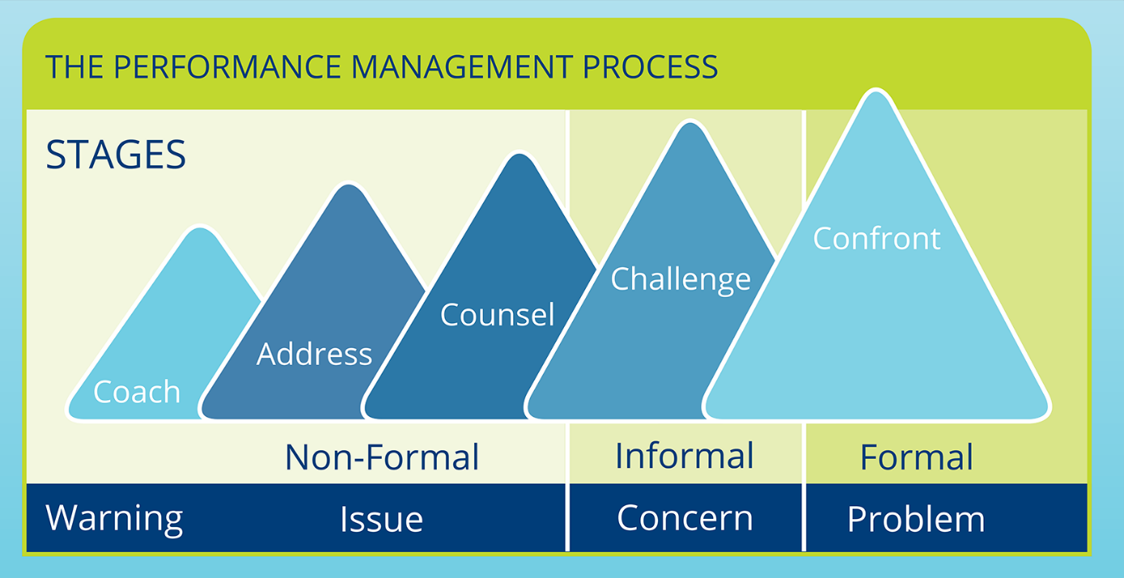
Figure 1: The process of managing performance
source: (Larsen, 2017)
This process shows that the organisation has to use different performance management techniques in different stages; usually, the knowledge workers are managed with the coaching strategy focusing on issues and obviously executing in a non-formal way, addressing and counselling are two other strategies to deal with managing performance with the high performer being in a soft-line. For the potential knowledge worker, to groom them, the organisation needs to go for a slight hard-line challenging them when it becomes an issue to be concerned. In the case of the low performer and who can incur problem, the company goes for a formal performance management process confronting them and direct them according to the plan of the organisation (Oxenford, et al. 2017).

Support structure within the organisation:
Tesco follows a flat organisational structure that facilitates the employees to be closer to the top management with an opportunity to learn informally from them with direct contact and supervision. The organisational structure of Tesco is designed based on the region and each of the regional managers is just after the CEO of the organisation in their organisational chart.
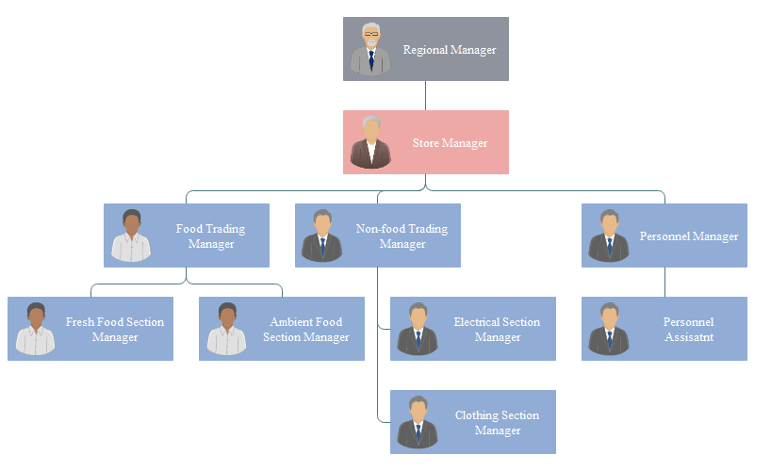
Figure 2: Organisational structure of Tesco
Source: (Tesco.com, 2019)
The organisational structure of Tesco is a flat organisational structure based on products and services provided by the organisation that requires specialisation of the employees in their area of operation. But it is to note that the company is successfully operating cross-functional team as well as the job rotation of the employees from one department to another to facilitate the employees with the competency in adapting in any department and section.

Techniques of supervision and appraisals:
Supervision is a dynamic and social process of regulating the activities of the subordinates complying with the organisational goals and combining the personal development goal of the employees. The supervision techniques can be of following types-
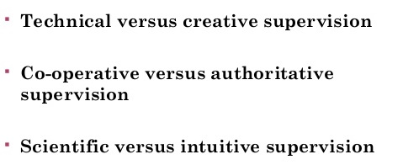
Figure 3: Classification of supervision technique
source: (Whisenhunt, et al. 2017)
The mentors and the supervisors in Tesco are encouraged to follow the creative techniques of supervision to motivate their subordinates taking part in the personal development process and direct them to attain the goal of the organisation. The co-operative supervision technique of the mentors of Tesco contributes to employee satisfaction as well as in the continuous increment in the productivity of the organisation along with improving their interpersonal relationship. The supervisors of Tesco follow the scientific way of supervision calculating the existing skills to improve and the further competencies to be developed and utilising them to improve the productivity of the human resource of the organisation. The performance appraisal process is used to evaluate the productivity of the employees and the area of improvement and development (Raheja, 2015).

Methods of ensuring fair and objective assessment or appraisal
Tesco is highly fair to assess the performance of the employees that contributes to design the motivating plan for the employees to encourage them to generate productivity ensuring the efficient use of the organisational resources. The following performance appraisal process is maintained to ensure the fair and objective assessment –
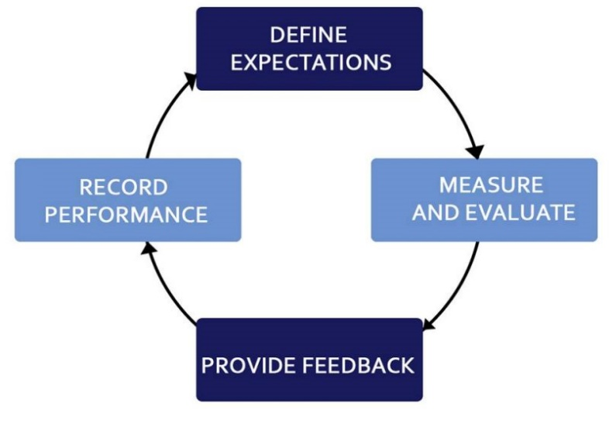
Figure 4: Performance appraisal process and components
source: (Raheja, 2015)
The above chart shows the performance appraisal process of Tesco and the role culture of the organisation focuses on a complex but fair assessment of the performance of the organisation. The process starts with defining the objectives of the organisation and the employees too. After measuring and evaluating the performance of the employees with the management by objectives and 360-degree assessment strategies, the employee performance is evaluated. Then the manager provides the employee with the feedback of improving their skills and performance further and records the performance according to the organisational policy that helps to define their rewards and way of further development.

Methods to monitor, evaluate, and record individual feedback
Tesco uses two ways in monitoring, evaluating, and recording the performance of the employees, such as 360-degree feedback process and management by objectives. In every fiscal year, the organisation sets a target for their employees to attain with a limited resource within the timeframe; at the ending of the session, the manager evaluates the degree to which they have attained the goal and the performance is measured accordingly to design the remuneration, compensation, and reward plan. It is regarded as the management by objective process of evaluating individual performance. It helps to assess the gap of the expected performance and the actual performance by balance sheet only but to understand the actual performance and fair assessment, the organisation uses 360-degree feedback process to understand the actual performance of the individual employee in the team with their fellows collecting feedback from different peers, supervisors, and all possible section that can provide correct information about the performance of the individual employee (Seidle, et al. 2016).

Reporting performance appraisal including the importance of confidentiality:
While reporting the performance appraisal and providing feedback to the employee Tesco emphasises the confidentiality to ensure the credibility of the information reducing exaggeration and fabrication of the information. Moreover, to ensure the privacy of the personal information of the employees and the skill gap, the company is concerned about reporting performance appraisal. To develop trust and build a congenial relationship between the company and the employees, the organisation provides importance on confidentiality in performance appraisal of the individual employee (Rekalde, et al. 2017).

Mechanisms to provide appropriate feedback of individuals
The feedback mechanism used in Tesco follows five strategies like using an anonymous process to collect and provide feedback about the performance of the organisation providing a platform for the employees to provide feedback in an unbiased manner, the managers of Tesco tries to ensure their subordinates that their feedback will reach and destination and this trust motivates the employees to provide confidential feedback, acknowledging the feedback of the peers, and responding to them. The following process is maintained by the organisation to ensure a continuous feedback mechanism (Hendrick, et al. 2016).
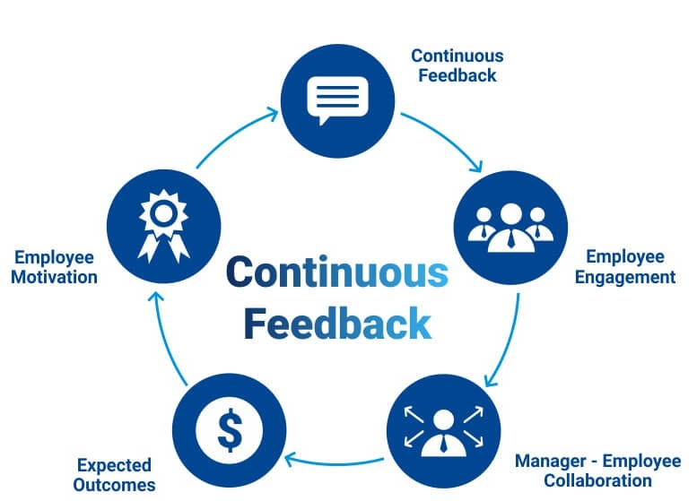
Figure 5: Continuous feedback process
source: (Larsen, 2017)
This process starts with the planning of a continuous feedback process and Tesco manages it with the feedback box open for all. It ensures the employee engagement and the collaboration of employees and managers. When the expected outcome can be generated, the employees get motivated and different reward system of Tesco to add further value to this process.

Career development strategies including the wider context of sustainability
Tesco encourages the employees to design their personal development plan according to the self-assessment report. The organisation encourages its employees to follow the career development model shown below to get sustainable development.
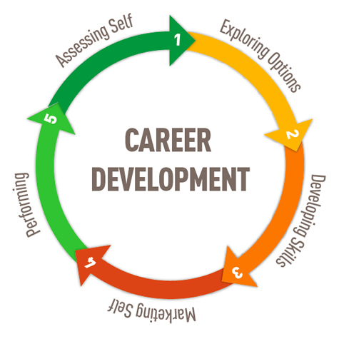
Figure 6: Career development strategy
source: (Shogren, et al. 2016)
The process starts with the self -assessment to understand the passion and the goal of the career the individual cherishes to achieve, he needs to explore the options lies in his zone of competence. He must develop the basic skills as well as some unique skills to differentiate him from the other employees and express his talent and competencies for self-branding. The process will end up with the performance of the employee according to the expectation grown while self-branding.

Conclusion:
The above discussion has provided a highlight of Tesco’s contribution in developing their employees sustainably using the case study on them regarding their application of motivational theories in practice. However, the discussion starts with identifying the benefits of developing the employees, managing the expectations of the employees, development opportunities in Tesco, and ends up with the detailed plan of developing the employing sustainably.

References:
Akkermans, H.A. and Van Oorschot, K.E., (2018). Relevance assumed: a case study of balanced scorecard development using system dynamics. In System Dynamics (pp. 107-132). Palgrave Macmillan, London.
Asfaw, A.M., Argaw, M.D. and Bayissa, L., (2015). The impact of training and development on employee performance and effectiveness: A case study of District Five Administration Office, Bole Sub-City, Addis Ababa, Ethiopia. Journal of Human Resource and Sustainability Studies, 3(04), p.188.
Davenport, T.H., (2015). Process management for knowledge work. In Handbook on Business Process Management 1 (pp. 17-35). Springer, Berlin, Heidelberg.
Deryugin, V.N., Giacomini, P., Makagon, P., Ryabchun, A. and Anisimov, N., Genesys Telecommunications Laboratories Inc, (2017). Method and apparatus for extended management of state and interaction of a remote knowledge worker from a contact center. U.S. Patent Application 14/578,145.
Detsimas, N., Coffey, V., Sadiqi, Z. and Li, M., (2016). Workplace training and generic and technical skill development in the Australian construction industry. Journal of Management Development, 35(4), pp.486-504.
Dysvik, A., Kuvaas, B. and Buch, R., (2016). Perceived investment in employee development and taking charge. Journal of managerial psychology, 31(1), pp.50-60.
Ebert, P. and Freibichler, W., (2017). Nudge management: applying behavioural science to increase knowledge worker productivity. Journal of Organisation Design, 6(1), p.4.
Glazer, S., Mahoney, A.C. and Randall, Y., (2019). Employee development’s role in organisational commitment: a preliminary investigation comparing generation X and millennial employees. Industrial and Commercial Training, 51(1), pp.1-12.
Hendrick, H.W. and Kleiner, B. eds., (2016). Macro ergonomics: theory, methods, and applications. CRC Press.
Kähkönen, S., (2016). Exploring knowledge worker motivation in autonomous and interdependent problem solving tasks on virtual platforms.
Larsen, H.H., (2017). Key issues in training and development. In Policy and practice in European human resource management (pp. 107-121). Routledge.
Mone, E.M. and London, M., (2018). Employee engagement through effective performance management: A practical guide for managers. Routledge.
Nelissen, J., Forrier, A. and Verbruggen, M., 2017. Employee development and voluntary turnover: Testing the employability paradox. Human Resource Management Journal, 27(1), pp.152-168.
Nerstad, C.G., Dysvik, A., Kuvaas, B. and Buch, R., (2018). Negative and positive synergies: On employee development practices, motivational climate, and employee outcomes. Human Resource Management, 57(5), pp.1285-1302.
Nguyen, T., Verreynne, M.L. and Steen, J.T., (2016). Employee development and innovation in emerging economy SMEs. In Academy of Management Proceedings (Vol. 2016, No. 1, p. 14943). Briarcliff Manor, NY 10510: Academy of Management.
Noe, R.A., Hollenbeck, J.R., Gerhart, B. and Wright, P.M., (2017). Human resource management: Gaining a competitive advantage. New York, NY: McGraw-Hill Education.
Oxenford, K., Daley, R., Lewis, C., Hill, M. and Chitty, L.S., (2017). Development and evaluation of training resources to prepare health professionals for counselling pregnant women about non-invasive prenatal testing for Down syndrome: a mixed methods study. BMC pregnancy and childbirth, 17(1), p.132.
Raheja, K., (2015). Methods of training and development. Innovative Journal of Business and Management, 4(02), pp.35-41.
Rekalde, I., Landeta, J., Albizu, E. and Fernandez-Ferrin, P., (2017). Is executive coaching more effective than other management training and development methods?. Management Decision, 55(10), pp.2149-2162.
Seidle, B., Fernandez, S. and Perry, J.L., (2016). Do leadership training and development make a difference in the public sector? A panel study. Public Administration Review, 76(4), pp.603-613.
Shogren, K.A., Gotto, I.V., George, S., Wehmeyer, M.L., Shaw, L., Seo, H., Palmer, S., Snyder, M.J. and Barton, K.N., (2016). The impact of the Self-Determined Career Development Model on self-determination. Journal of Vocational Rehabilitation, 45(3), pp.337-350.
Shujahat, M., Sousa, M.J., Hussain, S., Nawaz, F., Wang, M. and Umer, M., (2019). Translating the impact of knowledge management processes into knowledge-based innovation: The neglected and mediating role of knowledge-worker productivity. Journal of Business Research, 94, pp.442-450.
Tesco.com. (2019). Tesco - Supermarkets | Online Groceries, Clubcard & Recipes. [online] Available at: https://www.tesco.com/ [Accessed 18 Jul. 2019].
van den Berg, J.C., Appel-Meulenbroek, H.A.J.A., Kemperman, A.D.A.M. and Sotthewes, M., (2018). Knowledge worker preferences for physical workplace aspects affecting productivity. In Transdisciplinary Workplace Research Conference (pp. 10-24).
Whisenhunt, J.L., DuFresne, R.M., Stargell, N.A., Rovnak, A., Zoldan, C.A. and Kress, V.E., (2017). Supporting counsellors after a client suicide: Creative supervision techniques. Journal of Creativity in Mental Health, 12(4), pp.451-467.

