

Student name: Okechukwu Samuel Ohiagu
Student ID: 2518547

Module name: Introduction to Health and Social Care
Module code: LCHS4003
Lecturer name: Eleni Koutsogeorgou-Andreou

Content page

Element 1 …………………………………………… Page 3
Element 2 …………………………………………… Pages 4 and 5
References …………………………………………. Pages 6 and 7

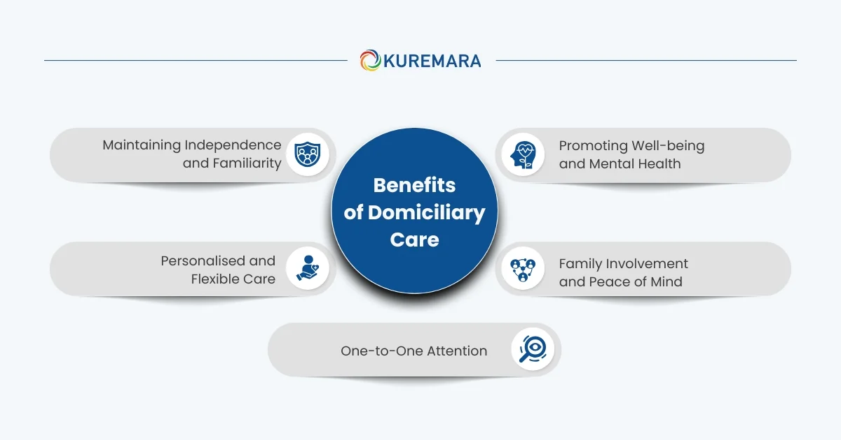
Acheson, M. (2025). What Is Domiciliary Care? A UK Guide (Costs, NHS Support & How It Works). [online] Elder.org. Available at: https://www.elder.org/articles/types-of-care/what-is-domiciliary-care/.
Wardle, C. (2024). The Challenges Facing the Domiciliary Care Market. [online] www.theaccessgroup.com. Available at: https://www.theaccessgroup.com/en-gb/blog/hsc-the-challenges-facing-the-domiciliary-care-market/.

WHAT ARE DOMICILIARY CARE SERVICES?
Domiciliary care services are regulated services provided in clients' homes to promote independence and overall well-being. The Care Act of 2014 governs the legal framework in England, while comparable legislation is in place in Scotland, Wales, and Northern Ireland.
These services are provided by care professionals through care organisations or private arrangements made by the individual. Care is typically delivered through prearranged visits, ranging from a single visit per day to multiple visits spread throughout the day. They are regulated by organisations such as the Care Quality Commission (Acheson, 2025).

CHALLENGES: CARE COORDINATION.
It might be hard to coordinate care for customers who might need more than one service. Home care providers typically work with other healthcare professionals, community groups, and family members to ensure all of a person's care needs are met. If care providers don't use a co-production strategy and don't communicate well with other groups, they risk planning and delivering care that isn't up to par and doesn't meet each person's needs (Wardle, 2024).
STAFF RECRUITMENT AND RETENTION: Home care providers find it hard to hire and retain a well-trained, well-led team. As demand rises, local councils and care providers require additional workers, but budgets typically limit their supply. Long hours and overtime due to shortages are also driving care workers away.
Many care workers quit for financial reasons. Care workers are in short supply due to limited pay rises and the cost-of-living crisis, forcing many to seek higher-paying employment. Thereby restraining care providers and local authorities from offering longer-term contracts; thus, workers leave to find permanent jobs (Wardle, 2024).

CURRENT FUNCTION
Domiciliary care emphasises independence. It improves adult care and significantly elevates the quality of life. Individuals can age without worry because they receive personalised care that meets their specific needs. Providers of domiciliary care can assist with a range of tasks. They can help with dressing, bathing, and meal preparation. They can administer medication, assist with mobility, and provide companionship. This ensures the safety and health of individuals. It also gives them the autonomy and respect they deserve.
For many individuals, receiving care at home offers comfort. It brings a sense of familiarity. It makes their daily routines more normal. Professionals providing domiciliary care work with individuals needing assistance and their families to develop a personalised care plan. Domiciliary care enhances the quality of life for those requiring help. It offers individualised support in their own homes, where they feel safe and satisfied. Domiciliary care excels in this area (Acheson, 2025).
BRIEF HISTORY
The first known instance of home care dates to the 13th century, when Brother Giles of Assisi attended to the sick and old. The Industrial Revolution reduced the need for home care as people relocated to cities and into manufacturing plants. In the Victorian era, charity renewed home care for the impoverished.
In 1948, the National Health Service Act established government-funded home care services. Since 1997, direct payments have afforded individuals greater autonomy over their care costs, enabling them to select optimal services. Home care is a crucial component of health and social care, enabling individuals to live independently and with dignity. (Care, 2024).

(Kuremara.co.uk, 2026)
(Homecare.co.uk, 2026)

Domiciliary Care Services Within the Community
OKECHUKWU SAMUEL OHIAGU, ID 2518547

Element 2
The London Ambulance Service (LAS) is one of the most well-known emergency medical services in the UK. Its history has been shaped by social changes, medical advances, and the needs of a growing city. It began in the late 1800s, when London was quickly changing from a country town to an industrial city. Before that, the ambulance service wasn't always reliable and was mostly run by charities or local groups.
The modern LAS was formed in 1965 when nine local services worked together. After the war, there was a trend to improve the healthcare system and be better prepared for emergencies. This merger was part of that trend. In the past, ambulances were very basic and only moved people and gave them basic first aid. As medical knowledge grew and people wanted more from pre-hospital care, the LAS started to offer more advanced emergency medical services (Langton and Langton, 2025).
Now, they are qualified medical professionals who can give life-saving care right away. Researchers found that getting care right away for things like cardiac arrest, stroke, and significant trauma is important (Cimino and Braun, 2023).

The London Ambulance Service handles millions of 999 and 111 calls each year, making it one of the busiest ambulance services in the world (Matthews and Matthews, 2023). It is made up of a highly skilled group of paramedics, emergency medical technicians, call handlers, and specialist response teams. Modern ambulances have the latest medical instruments, such as defibrillators, airway management tools, and digital communication systems that allow hospitals to know how patients are doing right away (LAS, 2018). According to The Standard, the London Ambulance Service is under increasing pressure as it prepares for an expected 5 million emergency and urgent care calls per year by 2028, with its chief executive noting that London’s ageing population is placing unprecedented demands on the NHS (Keane, 2023).
The LAS is still a work in progress, though. It is enhancing the quality of life for the community through a number of services, such as electric ambulances, mental health joint response teams, and improved triage approaches, among others, ensuring patients receive the finest care (Londono and Londono, 2025). In addition to crews who work together on ambulances, there are also single responders who attend to patients by car, motorcycle, or bicycle. They can administer treatment to patients independently of an ambulance crew or may be dispatched to a patient prior to the arrival of an ambulance, as they possess essential life-saving equipment required in most serious emergencies. A medical team from London's air ambulance might also provide treatment. The helicopter medical crew comprises a physician and a paramedic proficient in managing patients with severe traumatic injuries. The trauma squad of London’s Air Ambulance also operates by road during nighttime (LAS NHS Trust, 2022).
London Ambulance Service (LAS) has picked a dedicated team of specialist clinicians to improve its response to patients experiencing acute mental health crises, as demand for support across the capital continues to increase.
In a first for the capital, four highly trained paramedics are being deployed in rapid-response cars to reach patients with the most complex needs, including those at risk of suicide. Drawing on enhanced clinical training, the specialists will carry out in-depth assessments that consider physical illness, medication issues, substance misuse, social isolation and other factors that can exacerbate mental distress. Specialist medics will also be in triage to receive 999 calls and identify cases that require immediate expert intervention. This will help keep ambulances free for other life-threatening emergencies while delivering more compassionate care at home (Devonshire, 2026).
The London Ambulance Service (LAS) helps make London safe and strong. The LAS makes the city safer and helps people get ready for emergencies by putting on huge events, responding to emergencies, and teaching people. The London Ambulance Service began as a number of tiny local enterprises and has now grown into a sophisticated, professional emergency medical service. Even though there are still problems, the work to make people's health, safety, and quality of life better is very important. The story of the LAS shows how medicine and society have changed over time. It will need to keep changing to meet the requirements of Londoners in the future.

Reference list:
Acheson, M. (2025). What Is Domiciliary Care? A UK Guide (Costs, NHS Support & How It Works). [online] Elder.org. Available at: https://www.elder.org/articles/types-of-care/what-is-domiciliary-care/.
Care, L. (2024). The Evolution of Home Care: From Charity to Essential Service – Lakeshore Care. [online] Lakeshorecare.co.uk. Available at: https://www.lakeshorecare.co.uk/the-evolution-of-home-care-from-charity-to-essential-service/.
Cimino, J. and Braun, C. (2023). Clinical Research in Prehospital Care: Current and Future Challenges. Clinics and Practice, [online] 13(5), pp.1266–1285. doi:https://doi.org/10.3390/clinpract13050114.
Devonshire, J. (2026). New specialist paramedics to lead London mental health emergency response. [online] Emergency Services Times. Available at: https://emergencyservicestimes.com/2026/02/10/new-specialist-paramedics-to-lead-london-mental-health-emergency-response/.
Homecare.co.uk. (2026). Pardon Our Interruption. [online] Available at: https://www.homecare.co.uk/homecare/agency.cfm/id/65432229593.
Keane, D. (2023). London Ambulance Service to receive 5 million calls a year by 2028. [online] The Standard. Available at: https://www.standard.co.uk/news/health/london-ambulance-service-receive-five-million-calls-b1109462.html.
Kuremara.co.uk. (2026). Welcome To Zscaler Directory Authentication. [online] Available at: https://kuremara.co.uk.
Langton, K. and Langton, K. (2025). London Ambulance Service celebrates 60 years of saving lives - London Ambulance Service NHS Trust. [online] London Ambulance Service NHS Trust - accidents, traffic accidents, car, vehicle. Available at: https://www.londonambulance.nhs.uk/2025/03/31/london-ambulance-service-celebrates-60-years-of-saving-lives/.
London Ambulance Service NHS Trust. (2022). Who will treat you. [online] Available at: https://www.londonambulance.nhs.uk/calling-us/who-will-treat-you/.
Londono, A. and Londono, A. (2025). ‘Hear and treat’ frees up thousands of hours for ambulance crews and help Londoners get the right care - London Ambulance Service NHS Trust. [online] London Ambulance Service NHS Trust - accidents, traffic accidents, car, vehicle. Available at: https://www.londonambulance.nhs.uk/2025/04/10/hear-and-treat-frees-up-thousands-of-hours-for-ambulance-crews-and-help-londoners-get-the-right-care/.
Wardle, C. (2024). The Challenges Facing the Domiciliary Care Market. [online] www.theaccessgroup.com. Available at: https://www.theaccessgroup.com/en-gb/blog/hsc-the-challenges-facing-the-domiciliary-care-market/.

