Rhys Whatty
1900045

HTML & CSS Web Development
Internet Technology and Security ACCA4018
Submitted: 7/1/20
Computing: Games Development
Contents
Introduction 2
Requirements 3
Implementation 4
Validation 7
Evaluation 9
Bibliography 12

Introduction

This report documents the creation of a website coded from scratch using HTML and CSS. The website is a professional website for a harpist in order to advertise services to clients online to expand on advertising from social media such as Facebook and YouTube. The requirements section will contain a brief introduction to the website, describing its purpose and subject matter, the target audience and its relevance. The implementation section demonstrates the final design of the website, as well as validation of the code in both HTML and CSS. Finally, the evaluation section discusses Usefulness, Search Engine Optimisation (SEO) and Accessibility in terms of web design, and evaluates the website under these terms.

Requirements
The website has been designed for a professional harpist, on which people can view video clips and images, learn more about the harpist, see booking costs and methods of contacting him. The website consists of 5 main pages; a home page, a gallery, a biography page, a booking page and a contact page. The website also features an attributes page and a confirmation page if the user sends a request using the form in the contacts page.
The target audience for the website will be anyone who has an interest in or is looking to book the harpist. Due to the type of profession, there will be people of all ages that will want to book him, so the website is designed to be easy to use and not difficult to read the information on the screen, to be friendly to different platforms, as younger user will tend to use mobile sites while older people will use larger computer screens.
The website has been created as a step towards professionalism, as running a business through Facebook isn’t very professional, and because is it possible that some people who want to book the harpist may not have a Facebook account, which is where the harpist currently mainly operates. Having a website and a form on which to send off information to the harpist, this both looks more professional and allows for more people to contact him with ease, as people who don’t have a Facebook account can now also contact him for booking requests and can be responded to either via phone or email.
Having a website means that the harpist can be found easier, as putting their name into a search engine will then be able to bring up their website at the top of list, as well as having a website to compete against other harpists should a user simply type in harpist as the search term.

Implementation
Below I will include screenshots of each of the pages on the website, along with a brief description of what each page does.

Home Page
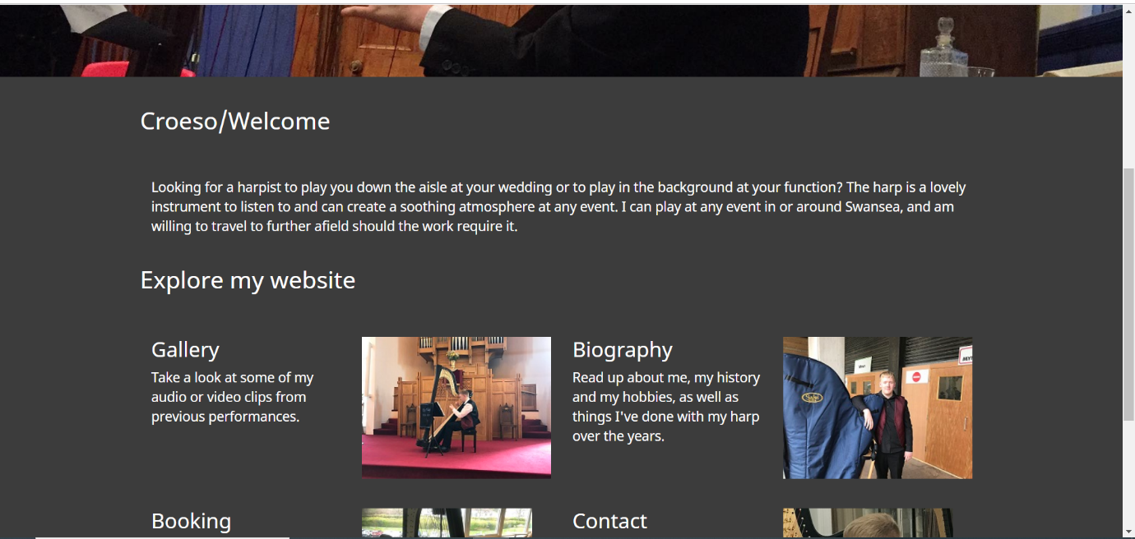
The Home page features a small welcome message and for clickable image links that will take you to each of the 4 other main pages, with a small paragraph describing the contents of each page.

Gallery Page
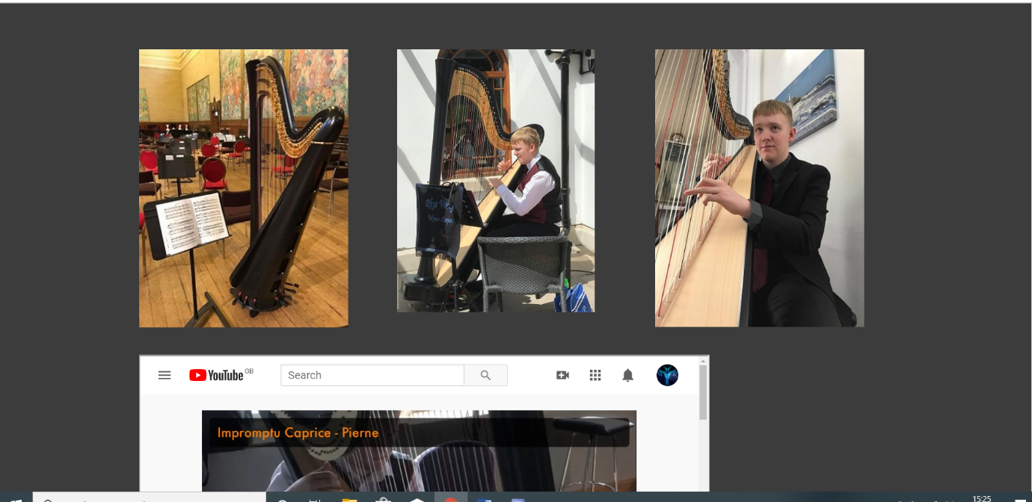
The Gallery page contains some images and YouTube clips of previous harp performances, to show off some of the musical ability of the harpist.

Biography Page
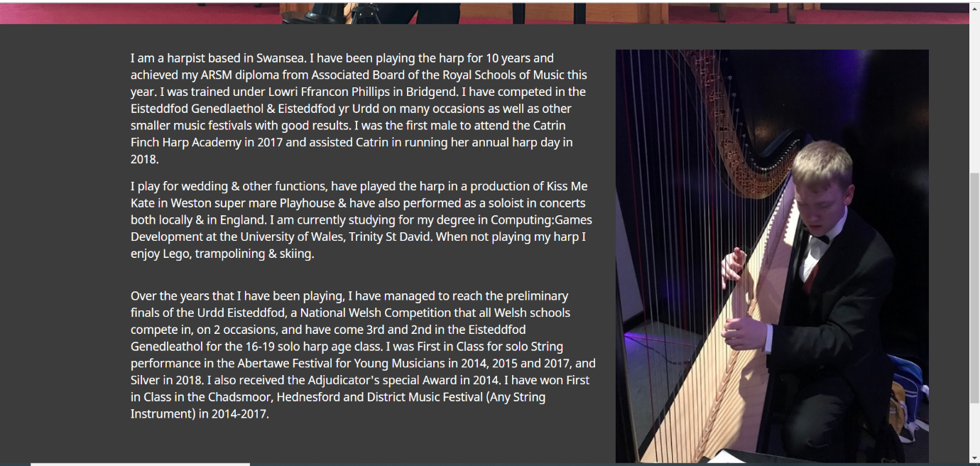
The Biography page features a couple paragraph giving a brief backstory about the harpist, his playing history and some of the achievements he has reached in his life on the harp.

Booking Page
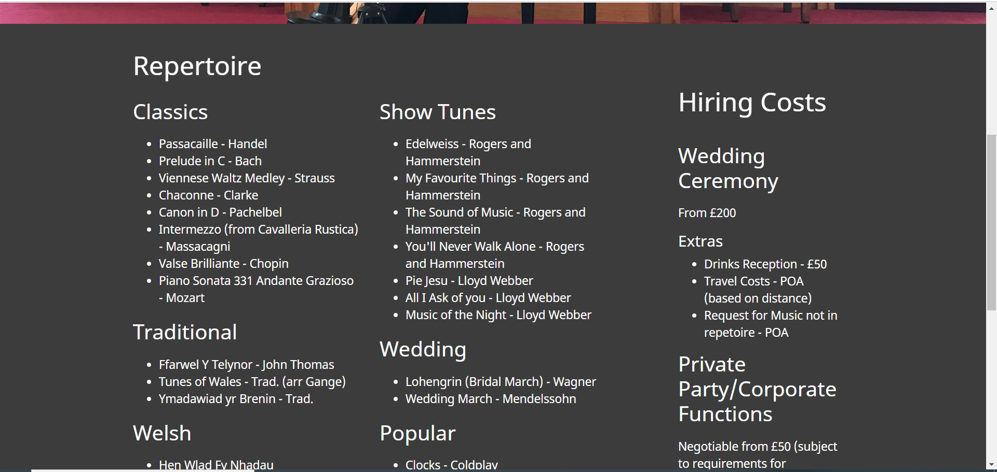
The Booking page features a complete list of the harpist’s repertoire so that people can see and choose what music they specifically wish to hear and a price list for how much it’ll cost to book him for various events.

Contact Page
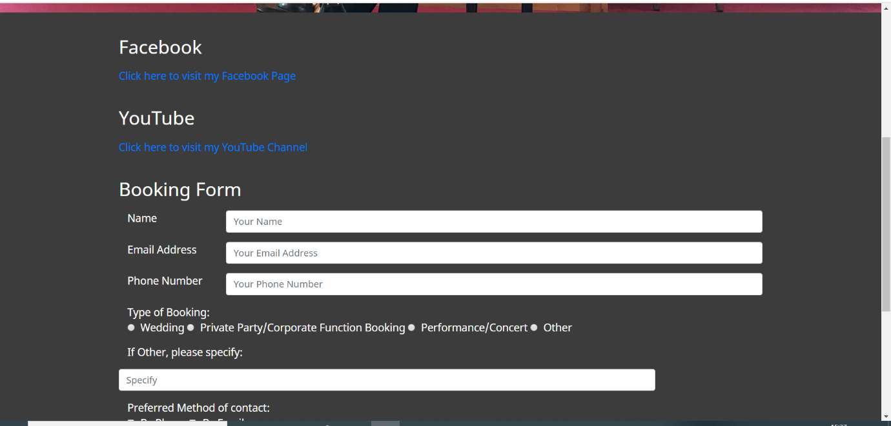
The Contact page contains link to the harpist’s Facebook and YouTube pages so that people can make use of them if they so desire. The page also features a form the user can fill out straight from the website detailing what they wish the harpist to perform, with the intention that the harpist then responds either via email or phone.

Attributes Page
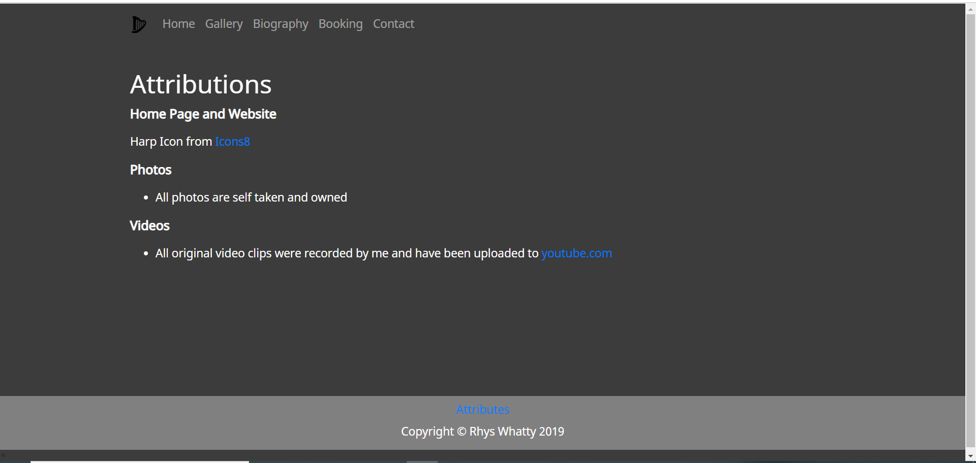
The Attributes page is accessed through the link in the footer of each page. All the Attributes page contains is a list of sources of any externally acquired, such as images. The page is emptier than a lot of website’s may be because all the images are owned by the harpist.

Confirmation Page
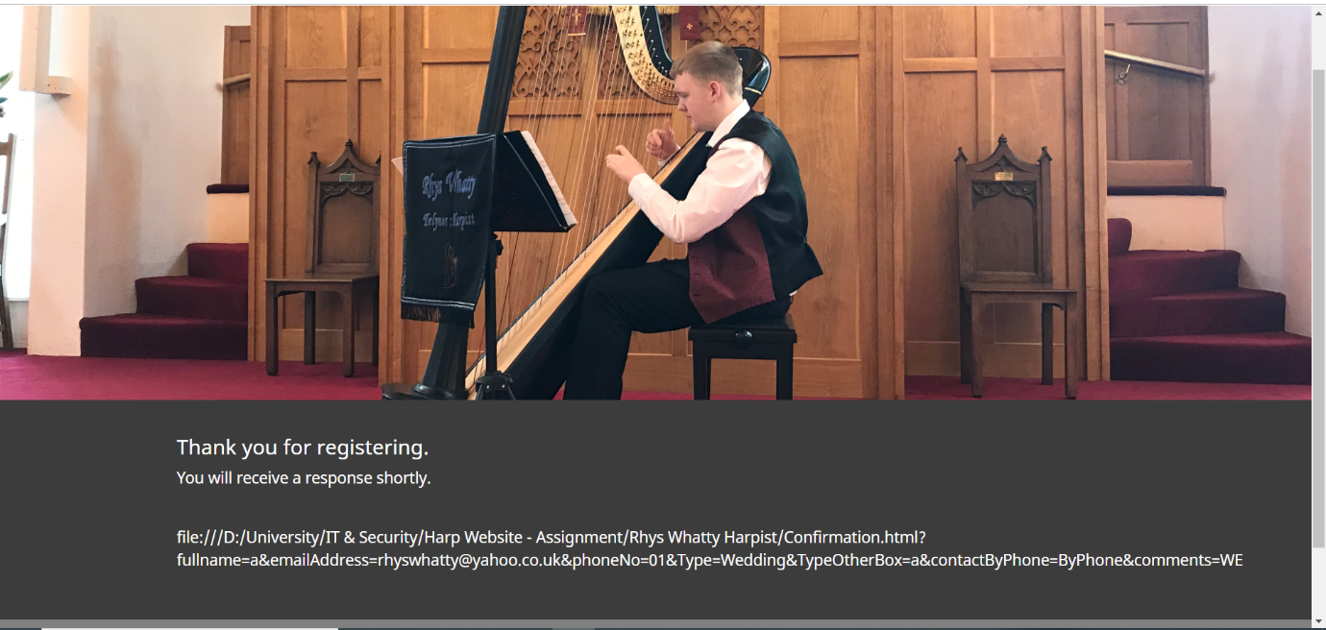
The Confirmation page is simply a page that opens once you click Send on the form on the Contacts Page to confirm that the request has been successfully processed.

Validation
After completing the code, I proceeded to validate the code using the W3 HTML Validator. Here were the errors I came up with:

Element head is missing a required instance of child element title.
From line 7, column 5; to line 7, column 84
=no">↩ <name name="keywords" content="Rhys Whatty, Telynor, Harpist, Swansea, ARSM" />↩ <

This was a spelling error on my behalf, as I had started the tag with <name name>, rather than <meta name>. This has been fixed.

An img element must have an alt attribute, except under certain conditions. For details, consult guidance on providing text alternatives for images.
From line 61, column 21; to line 61, column 71
<img src="Assets/Images/RWHarp-Web-Gallery1.jpg" />↩

A few of the images on the web page were missing an alt tag. This has been fixed.

No p element in scope but a p end tag seen.
From line 160, column 21; to line 160, column 24
</p>↩

Excess </p> which wasn’t deleted with its opposing <p>. This has been fixed.

The value of the for attribute of the label element must be the ID of a non-hidden form control.
From line 75, column 21; to line 75, column 59
<label for="fullname" class="col-sm-2">Name</

This may be because the label is text-based, whereas all other instances of this code for the form were not. This has not been fixed, however it doesn’t appear to impede on the functionality of the page.

After validating the main code, I then used the W3 CSS Validator to validate my CSS Stylesheet. This turned up no errors.

Evaluation
When creating a website, there are 3 important factors that need to be considered while developing. These are Usability, Accessibility and Search Engine Optimisation (SEO). If all 3 are implemented correctly into the website, it improved the experience for users.

Website usability refers to the ease of which the user can navigate and find the information they require. “Web usability is a ‘measure of the effectiveness, efficiency and satisfaction with which a user can achieve his or her goals on a website” [1]. Website usability should test throughout development by somebody who isn’t involved in the design process. Some common problems that emerge from usability testing include; Users being unclear on the concept, words that they are looking for aren’t there and there’s too much going on [2].
I considered a study on the usability of travel websites. The study asked a selection of people on a University campus to collect specific data from 3 different travel websites. They were observed carrying out the task and through observation and question of the participants following, the study details on usability of the site and recommendations for improvement were made. The results could have been different if participants had less prior internet knowledge, which is worth considering in usability testing if the website is likely to be accessed by people of varying backgrounds. [3]

Accessibility overlaps with usability, but “means that websites, tools and technologies are designed and developed so that people with disabilities can use them” [4]. Accessibility needs to encompass auditory, cognitive, neurological, physical, speech and visual disabilities, but can also be useful to people with short-term impairments such as a broken arm and as older people increase their use of technology.
A lot of studies into Accessibility focus on people with visual impairments such as the research carried out into accessibility of library websites. This study looked at the use of screen-readers and asked 6 visually impaired people to navigate 5 different websites, observed by researchers. The study found that libraries should consider a high-level information architecture for screen-readers. [5]

Search Engine Optimisation (SEO) is the process of maximizing the number of hits a website gets when keywords linked to the website are searched for. As a website developer, they need to ensure that their customer’s website is viewed as often as possible by a relevant audience.
A study done into Web Search Engine Optimisation and its application identified that while the Universal Search Engine has improved the retrieval of information from the internet, there is a need for a search engine which can understand the interests and needs of individual users, as the same word can have different meanings in different situation, for example the word Ceramic in relation to Dentistry and Pottery, as discuss in the article. However, a search engine is seen as being the second most used bit of the internet, behind email. [6]

The usefulness of the website is good, allowing the harpist to operate from a more professional standpoint, rather than through Facebook as a main source. Its functionality is suitable for the requirements, with the website allowing for a method for anyone to discover, learn about and book the harpist for various functions, with content that is valid and includes a repertoire list, a small biography and contact links. Its usability is also good, proven by the fact that I had multiple people trial the website, with none of them having issues with how it works. Websites of other harpists were also reviewed before starting the coding process of the website as a reference [7] [8].

To allow for Search Engine Optimisation on the website, the search tags that have been coded into are Rhys Whatty, Harpist, Telynor, Swansea and ARSM. Rhys Whatty has been added so that the page will be easily found if someone is looking specifically for my page. Telynor and Harpist have been added as search terms to what people wish to find if searching generally. Swansea has been added as a location placeholder (for example should somebody search for “Harpist in Swansea”), and while this may impede on other sites about Swansea in general, I imagine that those sites will outdo me enough so that I don’t appear as an irrelevant search result immediately. ARSM has been added as a show of ability and thus the harpist will stand out to customers if they have an official diploma for music.
When it come to website accessibility, there are 4 main principles that developers should abide by. These principles are Perceivable, Operable, Understandable and Robust, and together they are more often referred to as POUR. These principles need to be followed for anyone and everyone to be able to make use of the website. However, there may be many similarities between this and the section on usability, as;
“too many people still separate usability and accessibility into two separate disciplines. Trying to separate principles into mutually exclusive categories of "usability" versus "accessibility" would be pointless. There is too much of an overlap between the two.” [9]
Perceivable covers the ability of getting the information transmitted from the screen into the user’s brain. “All forms of communication require input into the brain via at least one of the senses of the body” [9] and this includes communication through a screen. My website uses white text on a dark background, making it very easy to read. The blue of the hyperlinks is also easily read. In the case of blind people who use screen readers, it has been studied that blind web users will often listen with screen readers to the first few words of an extract and if the start of the extract doesn’t contain key words they are looking for, they skip to the next extract [10]. All my bits of written information start with a sub-header, meaning blind users will know what the following paragraph will be about.
Operable covers the ability to navigate and use the website, which includes people who may not have access or can’t use standard computing peripherals as “not everyone uses a standard keyboard and mouse to access the web.” [9] To counter this, the website is easily navigable by using the Tab button or an equivalent button. Another thing defined by Operable is time constraints. A good website should, where it can, give the user as much time as possible to enter data or navigate before an end termination, because some people will not be as quick as others due to age, thinking speed or mobility issues. There are no time restraints on my website meaning people can have as much time as they need to browse or enter data.
Understandable covers the ability to understand the text that is on screen. This doesn’t just mean the language of the text, but also the simplicity of what’s written, which needs to be readable to anyone regardless of their “educational background, their familiarity with the subject matter, their background knowledge and life experiences, their culture, and so on.” [9]. My website features no complex language and is written in a way that everyone can understand, as proven by the fact that I had multiple people with various degrees of knowledge of the harp and everyone could understand the content.
Robust covers the ability for the website to run on different types of devices and browsers.
“Not everyone uses the same technologies now, nor will they in the future. People use different operating systems, different browsers, and different versions of browsers.” [9]
With people potentially accessing the website on computers, tablets or mobiles, the website needs to be able to adapt to each of these devices. It does so by editing columns on the page as the screen gets smaller, making it still as easy to read on smaller devices. The website also has no features that actively slow the site down, meaning people using older operating systems or browsers are less likely to be interrupted by the website running slower or crashing.

Bibliography

[1] | J. Brech, “Web Usability Definion,” Web Wise Wording, 19 July 2013. [Online]. Available: https://webwisewording.com/usability-definition/. [Accessed 23 December 2019].
[2] | S. Krug, “Typical Problems,” in Don't Make Me Think, USA, New Riders, 2004, p. 137.
[3] | D. S. Carstons, “Usability study of travel websites,” Journal of Usability Studies, vol. 1, no. 1, p. 16, 2005.
[4] | S. L. Henry, “Introduction to Web Accessibility,” W3C, 5 June 2019. [Online]. Available: https://www.w3.org/WAI/fundamentals/accessibility-intro/. [Accessed 23 December 2019].
[5] | K. Yoon, “Call for library websites with a separate information architecture for visually impaired users,” in ASIST '13: Proceedings of the 76th ASIS&T Annual Meeting: Beyond the Cloud: Rethinking Information Boundaries, Montreal, 203.
[6] | W. Z. Huang, “Research on Web Search Engine Optimization and its Application,” Applied Mechanics and Materials, Vols. 687-691, no. 1, p. 163, 2014.
[7] | Blaze Concepts, “Bethan Welsh Harpist,” Blaze Concepts, 2019. [Online]. Available: https://welshharpist.co.uk/gallery/. [Accessed 24 November 2019].
[8] | S. Fairplay, “Shelley Fairplay Professional Harpist,” Shelley Fairplay, 2019. [Online]. Available: https://harpwales.com/on-stage/. [Accessed 23 November 2019].
[9] | WebAIM, “Constructing a POUR Website,” WebAIM, 28 August 2013. [Online]. Available: https://webaim.org/articles/pour/. [Accessed 23 December 2019].
[10] | S. Krug, “The Four Things you can do right night #2 Read an article,” in Don't Make Me Think, USA, New Riders, 2014, p. 179.

