

Student name: Rosa dos santos
Student ID:2512863

Module name: Introduction to Health and social Care
Module code: LCHS4003
Lecturer name Muhammad Aliyu
Content page

Element 1 …………………………………………………………….. page
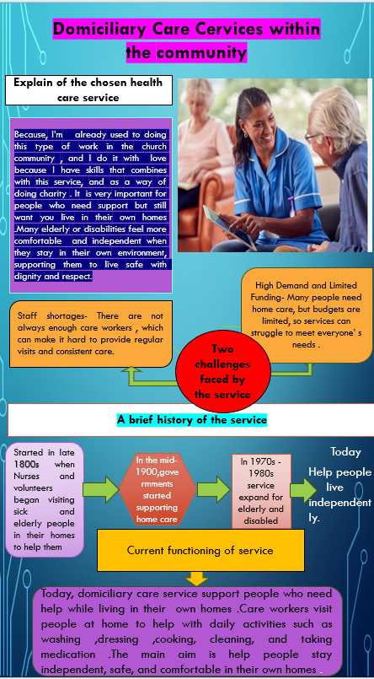
Section Head Here
Text or images here
Section Head Here
Text

Section Head Here
Text

The role and development of Ambulance Services in modern healthcare.
Ambulance services are an essential component of the health care system, which aims to provide rapid emergency medical care and transportation for patients who require urgent medical attention.
These services form part of the broader Emergency Medical Services (EMS) system; they play an essential role in reducing mortality and improve patient outcomes in emergencies. This essay will examine the origins and historical development of ambulance services, evaluate how they function and will discuss their significance in improving the quality of life for people.
The origins of ambulance services dates back several centuries, especially within the military. Early ambulance services were used to transport injured soldiers from battlefields to medical tents, with significant developments arising during the French Revolutionary wars. Dominique-Jean Larrey introduced organised systems for quickly evacuating wounded soldiers. Due to this introduction the survival rates of those on the battlefield were increased because of faster access to medical aid. National academics.
Modern ambulance services began to emerge in the late 19th and early 20th centuries in urban areas. Initially, these services were simple, often operated by police, firefighters, or even taxi drivers who transported injured individuals to hospitals using stretchers or horse-drawn carriages. By the early 1900s motorised ambulances were introduced, this allowed faster response times and more efficient transportation of patients in need of urgent medical care. London ambulance services NHS Trust.
The development of national healthcare systems further formalised ambulance services. For example, the establishment of the National Health Service (NHS) in 1948 in the UK made ambulance provision a formal responsibility of public health care systems; ensuring that emergency transport and pre-hospital care were available to the population. London ambulance services NHS Trust.
A major transformation took place in the 1970s with the professionalisation of ambulance crews and the introduction of paramedic training. Ambulances evolved from simple transport vehicles into mobile medical units capable of delivering life-support interventions such as defibrillation, oxygen therapy and airway management before patients reach the hospital. Goaid.in
Today, ambulance services operate as highly organised emergency response system that provide both clinical care and rapid transportation. Modern ambulances are staffed by trained professionals such as paramedics, emergency medical technicians (EMTs) and emergency care assistants who work together to stabilise patients at the scene of an incident and during the transport to hospital.
Emergency response systems typically operate through centralised control rooms that receive emergency calls and dispatch ambulances based on the urgency of the situation. Advanced technologies such as GPS navigation, electronic health records, and real time communication. These systems allow paramedics to consult with hospital specialists and provide effective treatment during transit. Goaid.in
Additionally, ambulance services are increasingly adopting digital technologies and update response models. For example, modern systems use triage protocols and decision-support tools to prioritise the most critical cases, ensuring that resources are used efficiently and that patients receive appropriate care as quickly as possible. These developments help healthcare systems to manage increasing demand and need for emergency services.
Ambulance services significantly enhance the quality of life for people in the community by providing immediate medical care during emergencies. Rapid response and early intervention can prevent complications, reduce mortality rates and improve recovery outcomes for patients experiencing conditions such as heart attacks, strokes, trauma and severe respiratory distress.
Furthermore, ambulance services support healthcare accessibility by ensuring that patients can reach hospitals safely and quickly. For individuals living in rural or remote areas, ambulance services may represent the primary link between communities and specialised medical facilities. Research highlights that effective pre-hospital care can reduce the burden on emergency departments by establishing patients before arrival and ensuring appropriate triage.
Beyond emergency treatment, ambulance services contribute to wider public health initiatives, including disaster response, community education and preventative healthcare programmes. These roles strengthen the overall resilience of healthcare systems and help ensure fair access to emergency care.
In conclusion, ambulance services have evolved significantly from basic transport systems into highly advanced medical services. Their development has been shaped by historical innovations, technological advancements, and the increasing demand for rapid healthcare responses. Today, ambulance services provide vital pre-hospital care that saves lives, improves patient outcomes and enhance the quality of life for those in the community. As healthcare systems continue to face growing challenges, the importance of efficient and well-resourced ambulance services will remain central to delivering effective emergency care.

References
Brown, J.J.H., Ortega, M. and Whitley, G.A. (2025) ‘Student paramedic and practice educator experiences of ambulance placements: a rapid evidence review’, Health Science Reports, 8(3), e70552. Available at: https://doi.org/10.1002/hsr2.70552
(Accessed: 14 March 2026).

Howarth, U., Zimmerman, P.A. and van de Mortel, T.F. (2024) ‘Paramedics’ experiences of barriers to, and enablers of, responding to suspected or confirmed COVID-19 cases: a qualitative study’, BMC Health Services Research, 24, 678. Available at: https://doi.org/10.1186/s12913-024-11120-x
(Accessed: 14 March 2026).

London Ambulance Service NHS Trust (2024) Our history. Available at: https://www.londonambulance.nhs.uk/about-us/our-history/
(Accessed: 10 March 2026).

Newton, J., Carpenter, T. and Zwicker, J. (2024) ‘Exploring paramedic perspectives on emergency medical service (EMS) delivery in Alberta: a qualitative study’, BMC Emergency Medicine, 24(66). Available at: https://doi.org/10.1186/s12873-024-00986-z
(Accessed: 10 March 2026).

National Academies of Sciences, Engineering, and Medicine (2007) Emergency medical services: At the crossroads. Washington, DC: National Academies Press.

National Health Service (2023) Emergency care assistant. Available at: https://www.healthcareers.nhs.uk/explore-roles/ambulance-service-team/emergency-care-assistant
(Accessed: 13 March 2026).

World Health Organization (2023) Emergency care systems for universal health coverage. Geneva: World Health Organization. Available at: https://www.who.int/publications
(Accessed: 14 March 2026).

Journal of Paramedic Practice (2022) ‘The evolving role of paramedics in modern emergency medical services’, Journal of Paramedic Practice, 14(6), pp. 256–262.

