
Dissertation Proposal
Customer Trust and Security Perceptions of Digital Banking Users in the UK: A Systematic Literature Review
Programme | Master of Business Administration
Module | Dissertation
Module code | LCMB7035
Assessment item | Dissertation Proposal
Student name | Aamir Sohail
Student ID number | 2439807
Supervisor | Mark Piekarz
Word count | 2700 words approx. excluding title page, contents, references, and appendices
Submission date | 11 June 2026

Contents
Table of Contents 2
List of Tables and Figures 2
1. Title 3
2. Introduction, Background, and Research Problem 3
3. Research Aim, Objectives, and Questions 5
4. Preliminary Literature Search 5
Table 2. Preliminary literature map 6
5. Research Methodology 7
5.1 Research design 7
5.2 Search strategy and selection criteria 8
5.3 Quality appraisal and analysis 9
5.4 Ethical considerations 9
6. Risks and Risk Management 10
7. Timeline 10
References 12
Appendix A: Example Search Terms 13

List of Tables and Figures
Table 1. Research objectives and link to the study ...................... 6
Table 2. Preliminary literature map ..................................... 7
Table 3. Proposed search strategy ....................................... 9
Table 4. Inclusion and exclusion criteria ............................... 9
Table 5. Research risks and mitigation .................................. 11
Figure 1. Proposed systematic literature review process ................. 8
Figure 2. Proposed 16-week Gantt chart .................................. 11

1. Title
The proposed dissertation title is: Customer Trust and Security Perceptions of Digital Banking Users in the UK: A Systematic Literature Review. The potential for the dissertation will be a linkage of the discussion on customer trust and security perceptions in digital banking and what this means for the UK. The research will help to determine if banks should be concerned with only technical security or if communication with customers, privacy awareness, fraud assistance, and design of services are involved in the way customers feel they are being supported. The final dissertation will also identify gaps for further research, specifically in relation to digital-only banks in the UK, older consumers, vulnerable and affected consumers, and fraud.

2. Introduction, Background, and Research Problem
Digital banking is now a part of everyday retail banking in the UK. Customers are now using apps and websites to check balances, transfer funds, pay bills, and apply for products and deal with banks. This change can save banks money on branch expenses and improve the speed of services for customers. It can make banking easier for the customers. But the shift to digital also means the dynamic between the bank and the customer has shifted, relating to trust. No one is still measuring the bank by the number of employees, branches, or paper transactions (Merhi, 2019). They also evaluate it based on their login procedures, application alerts, fraud screens, privacy statements, and the transparency of the bank's response when things do go wrong.
The research problem is that there is a tendency to talk about security and trust as synonymous. They do not. There may be robust technical controls in place at the bank, and yet the customer may not feel safe. Another customer might rely on a banking app even if they don't know exactly how secure it is, because it's easy to use. This is significant because perceived security can either drive or obstruct a user from using digital banking, to at least maintain or to reduce their digital banking usage, or to outright not use digital banking (Alberto, 2023). The issues are thus not just technical. It's a business and management issue that's related to customer confidence, service design, risk communication, and regulation.
The importance of this topic is apparent from evidence in the UK. According to UK Finance (2025), in 2024, criminals successfully removed £1.17 billion using authorised and unauthorised fraud, and banks successfully blocked £1.45 billion worth of unauthorised fraud. The same report revealed that 70% of authorised push payment frauds began online and 16% began via telecommunications networks. Given these figures, it is clear that this is a tough problem for banks. Fraud is often initiated outside the bank, and the customer is typically affected in their bank account. If the bank is not the only party at fault, it can undermine trust, too.
The regulatory context also matters. From 7 October 2024, the Payment Systems Regulator has implemented new rules on reimbursements for victims of authorised push payment fraud (Payment Systems Regulator, 2024). While that could enhance consumer security, it is a significant question whether more protection means greater consumer trust or greater consumer awareness that digital payments are not always safe. This proposal thus takes regulation as a component of the trust environment, rather than background.
Security, privacy, and trust were important factors found by Merhi, Hone, and Tarhini (2019) to explain the intention of mobile banking among British and Lebanese consumers. Hanif and Lallie (2021) demonstrated the significance of cybersecurity risk to users 55 years old and over in the UK. Martínez-Navalón, Fernández-Fernández, and Alberto (2023) discovered that privacy and ease of use are the factors that impact trust in digital banking apps in Spain and Portugal. Useful these studies are, but there is a gap also. The UK literature is still not consolidated and is distributed among the mobile banking, online banking, fintech adoption, and older user studies. Some evidence needs to be pulled together and an assessment made as to its implications for the UK digital banking user.
Hence, a systematic literature review will be used for this proposed dissertation. The review will not assume the presence of digital banking as trustworthy or mistrusted. It will examine the definitions of trust found in various studies, security perception measures, user groups examined, and the extent to which findings from non-UK studies apply to the UK. The value of the study will be determined by comparing the evidence and determining where the current knowledge is strong, weak, or too general.

3. Research Aim, Objectives, and Questions
This study aims to undertake a systematic review of the latest academic and industry evidence, and that which has been published in the last few years, to understand how the attitudes and behaviours of digital banking users are influenced by their perception of trust and security in the UK.
Research objective | Link to the proposed study
1. Identify trust and security factors. | Defines main concepts.
2. Compare links between security perceptions and use. | Avoids simple listing.
3. Judge transferability to UK users. | Controls non-UK evidence.
4. Identify gaps and practical lessons. | Links research to banking practice.
Table 1. Research objectives and link to the study.

The research question is: How do trust and security perceptions shape digital banking users' attitudes and behaviour in the UK? The supporting questions are: What are the most prevalent trust and security factors mentioned in current digital banking literature? What is the impact of perceived risk, privacy concerns, and perceived security on adoption, continued use, or avoidance? What makes trust different in the UK context can include fraud exposure, the regulation, etc. What are the missing parts?

4. Preliminary Literature Search
These are the four themes that appeared in the preliminary literature. The first theme is on technology acceptance. Previous models like TAM and UTAUT2 focus on the influence of perceived usefulness, ease of use, and others on technology adoption (Davis, 1989; Venkatesh, Thong, and Xu, 2012). Though these models are helpful, they may be too limited, and seeing trust as simply an additional variable. But trust is not just a motivator of use in the digital banking world. It's also an assessment of risk, the bank, the technology, and the broader payments system.
The second theme is the perceived security and perceived risk. The relevance of Hanif and Lallie (2021) is particularly noteworthy since the study was conducted on the users of the United Kingdom who are aged 55 and above. Their research makes the point that older users are not a homogeneous group of “non-digital” users. Knowledge, confidence, experience, and banks' explanation of risk may be related to security concerns. This is helpful for the suggested review because it can help to be in a better position to read customer trust of various groups of users.
The third theme is on privacy and data handling. Martínez-Navalón, Fernández-Fernández, and Alberto (2023) state that privacy positively affects the level of trust and ease of use in digital banking applications. This is critical since customers may not be able to distinguish between privacy and security. When someone claims an app is “safe”, they could be referring to their money, their data, their bank, or the ease of control over the app. Each study will need to be assessed in terms of the definitions used for these terms before results can be compared in a critical review.
The fourth theme is on trust in fintech and digital finance. Jafri et al. (2024) discovered that trust and security are the core elements in the adoption of fintech in banking. But the literature in the field of fintech can be very general. This can cover digital wallets, alternative finance, open banking, and anything other than regular bank accounts. This leaves a space for this dissertation. There is a need to be more specific in a UK digital banking review, and where possible, the evidence needs to be broken down into evidence on banking apps and evidence on wider fintech services.

Table 2. Preliminary literature map
Source | Context and method | Main value for this proposal | Critical point
Merhi, Hone, and Tarhini (2019) | British and Lebanese mobile banking; UTAUT2. | Security, privacy, and trust shaped intention. | UK-linked but older and mobile-only.
Hanif and Lallie (2021) | UK users aged 55+; mixed methods. | Security risk matters for older users. | Not generalisable to all users.
Martínez-Navalón et al. (2023) | Spain and Portugal: digital banking apps. | Privacy and ease of use influence trust. | Useful, but non-UK.
Jafri et al. (2024) | SLR of fintech banking adoption. | Maps trust and security evidence. | Broader than UK banking.
UK Finance (2025) | UK payment fraud report. | Shows fraud scale and APP context. | Industry context, not academic data.
FCA (2025) | UK consumer survey. | Shows wider financial confidence data. | Not only about digital banking.
Table 2. Preliminary literature map for the proposed systematic review.
At the outset, the difference is apparent. Many studies exist around technology adoption, trust, and risk /privacy; however, they may not relate directly to UK digital banking. There is some evidence from the UK, which is targeted at older consumers, and there is some wider evidence from other countries or fintech services more generally. The proposed review will address this by focusing on the literature in one place on one question: how do trust and security perceptions shape digital banking behaviour in the UK?

5. Research Methodology

5.1 Research design
The dissertation will be based on a systematic literature review. This is appropriate as the research is to examine past evidence rather than gather new survey and/or interview data. Furthermore, a systematic review is more transparently reported than a standard narrative review as it details the process of searching for, screening, selecting, and analysing sources (Tranfield, Denyer and Smart, 2003; Snyder, 2019).
The review will be conducted following PRISMA 2020 guidelines (Page et al., 2021), including identification, screening, eligibility, and inclusion stages. Once the searches have been conducted, a full PRISMA diagram will be made after the end of the process in the final dissertation. Figure 1 presents the proposed work procedure for this proposal. Thematic synthesis is the method that will be used for the final analysis. This is appropriate for the topic as the studies will probably involve various samples, models, and measures, and therefore, a statistical meta-analysis is not appropriate. Findings will be categorized under the clear themes, e.g., institutional trust, technology trust, perceived security, privacy concern, fraud concern, and user age/digital literacy (Thomas & Harden, 2008).
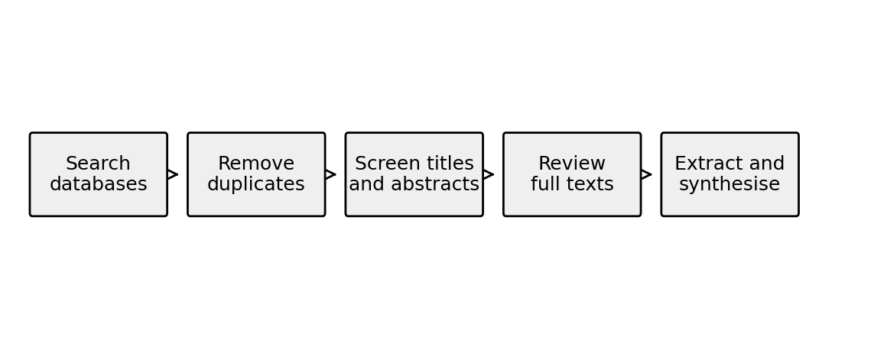
Figure 1. Proposed systematic literature review process.

5.2 Search strategy and selection criteria
The review will utilise academic databases and appropriately selected official sources from the UK. Peer-reviewed journal articles will be included in the core academic data set. The UK business problem will be explained and will be used for context in the official UK reports from the FCA, UK Finance, and the Payment Systems Regulator. In the literature synthesis, they will not be included at the same level as academic studies.
Search element | Planned choice | Reason
Databases | Google Scholar, ScienceDirect, Emerald, Sage, SpringerLink, Taylor & Francis, Wiley, IEEE Xplore. | Covers business, IS, banking, and security.
Date range | 2019-2026, plus older key theory. | Keeps sources current.
Search terms | digital/mobile/online banking; trust; perceived security; perceived risk; privacy; fraud; UK. | Links channel, perception, and context.
Target data | 40 peer-reviewed studies. | Feasible for a Level 7 SLR.
Table 3. Proposed search strategy.
Full analysis will be performed after the inclusion/exclusion criteria are met. The criteria are designed to avoid a scope that is too wide. They also help to make the study repeatable, so that another researcher can understand their reasoning for including or excluding each source.
Include | Exclude
Digital, mobile, online, or fintech banking studies. | Crypto, e-commerce, or non-banking technology.
Trust, perceived security, risk, privacy, or fraud concern. | Papers where these are background only.
UK studies and strong non-UK studies with clear relevance. | Weak methods, promotional reports, or opinions.
2019 onwards, plus older theory if needed. | Old empirical papers have no clear value.
Official UK reports for context. | News, except for the recent policy background.
Table 4. Inclusion and exclusion criteria.

5.3 Quality appraisal and analysis
Selected articles will be entered into a literature extraction table, one for each. Author, year, country, research aim, sample, method, theory, key findings, limitations, relevance to the UK will be recorded in the table. The importance of this is that two studies can find that trust is important, but measure it differently. There can be multiple aspects of trust, such as trust in an app, trust in the bank, or trust in digital finance itself. It would be better to treat them separately.
Sample size, sampling method, clarity of measures, method–research question fit, and limiting the study are factors that will be considered in assessing the quality. It will not be deemed a rejection of studies based on the fact that they are not UK studies, but their transferability will be assessed. For instance, an investigation based in Spain or Portugal could be used to understand privacy and ease of use, but this would be done with caution and sensitivity to understanding UK behaviour.
Thematic and critical analysis will be used. It will initially categorize observations according to general themes and subsequently compare and contrast how well or poorly different studies agree in their conclusions. The review will also seek literature gaps, such as the absence of evidence regarding vulnerable users, older users, digital-only banks, etc., and customers who are experiencing digital banking only due to reduced branch availability, as well as fraud victims. This should produce results that will be of value in both the academic arena and the banking business.

5.4 Ethical considerations
Only secondary data will be used for the study. No customers, bank employees, or senior citizens shall be called. There will be no surveys, interviews, or focus groups conducted. Nevertheless, ethical approval is still essential as the university has an ethical review requirement for both primary and secondary research. The proposal and ethics form will thus include the same method: systematic literature review, published academic papers, and public official reports.
The risks that are associated with the ethics are not zero; they're low, but there are risks. The primary concerns include the case of misrepresenting studies, exaggerating results, relying on unsound sources, and the failure to cite sources appropriately. The review will not identify individual victims of the fraud or contain information from a private source. It will also help to prevent customers from being blamed for fraud if the evidence suggests that there are wider system, platform, or communication problems.

6. Risks and Risk Management
The primary project risks are associated with scope, evidence quality, and time. If the topic is not managed, a systematic review may get too big. The study will therefore rely on literature on trust and security in digital banking in the UK, and wider literature on fintech or international literature only where it directly answers the research questions.
Risk | Why this matters | Mitigation
The scope becomes too broad. | This would become a general digital banking essay. | Keep trust, security, risk, privacy, and fraud concerns.
Few UK-only academic papers. | The UK-only scope may be narrow. | Use non-UK studies only with a transferability judgement.
Review becomes descriptive. | Level 7 needs judgment. | Compare definitions, methods, samples, and findings.
Industry reports are overused. | They are not peer-reviewed studies. | Use them for context only.
Time pressure. | SLR screening takes time. | Use a search log and weekly targets.
Table 5. Research risks and mitigation.

7. Timeline
The dissertation training is organized for a period of 16 weeks. The timeline allows for supervisor feedback, which is crucial since the proposal and ethics form must be approved prior to moving on to the main work. The search, screening, and extraction stages have been broken up as these are typically the time-consuming elements of a systematic review.
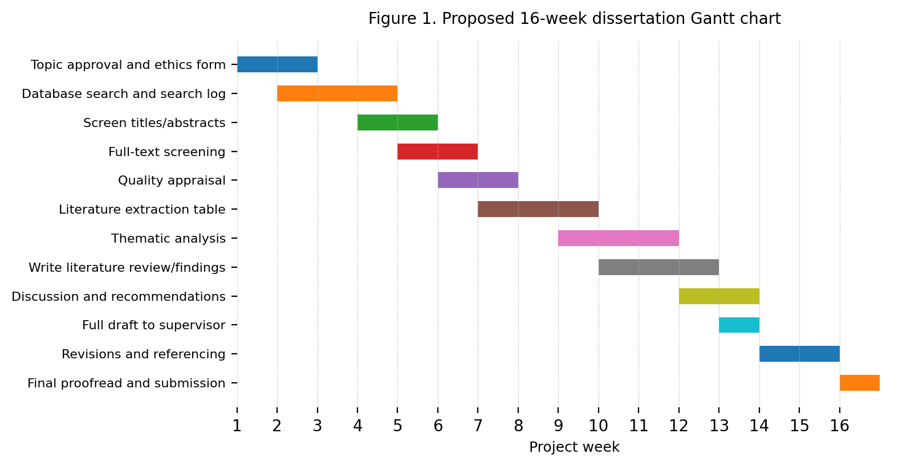
Figure 2. Proposed 16-week Gantt chart for the dissertation project.
The potential for the dissertation is a clear linkage of the discussion on customer trust and security perceptions in digital banking, as well as what this means for the UK. The research will help to determine if banks should be concerned with only technical security or if communication with customers, privacy awareness, fraud assistance, and design of services are involved in the way customers feel they are being supported. The final dissertation will also pinpoint areas requiring further research, particularly with regard to UK digital-only banks, older age groups, vulnerable customers, and those impacted by fraud.

References
Davis, F.D. (1989) “Perceived usefulness, perceived ease of use, and user acceptance of information technology”, MIS Quarterly, 13(3), pp. 319-340. Available at: https://doi.org/10.2307/249008
Financial Conduct Authority (2025) Financial Lives 2024 survey: key findings. London: FCA. Available at: https://www.fca.org.uk/publication/financial-lives/financial-lives-survey-2024-key-findings.pdf (Accessed: 8 June 2026).
Financial Conduct Authority (2025) Financial Lives 2024 survey. London: FCA. Available at: https://www.fca.org.uk/financial-lives/financial-lives-2024 (Accessed: 9 June 2026).
Hanif, Y. and Lallie, H.S. (2021) “Security factors on the intention to use mobile banking applications in the UK older generation (55+): a mixed-method study using modified UTAUT and MTAM with perceived cyber security, risk, and trust”, Technology in Society, 67, 101693. Available at: https://doi.org/10.1016/j.techsoc.2021.101693
Jafri, J.A., Amin, S.I.M., Rahman, A.A. and Nor, S.M. (2024) “A systematic literature review of the role of trust and security on Fintech adoption in banking”, Heliyon, 10(1), e22980. Available at: https://doi.org/10.1016/j.heliyon.2023.e22980
Martínez-Navalón, J.G., Fernández-Fernández, M. and Alberto, F.P. (2023) “Does privacy and ease of use influence user trust in digital banking applications in Spain and Portugal?”, International Entrepreneurship and Management Journal, 19, pp. 781-803. Available at: https://doi.org/10.1007/s11365-023-00839-4
Merhi, M., Hone, K. and Tarhini, A. (2019) “A cross-cultural study of the intention to use mobile banking between Lebanese and British consumers: extending UTAUT2 with security, privacy and trust”, Technology in Society, 59, 101151. Available at: https://doi.org/10.1016/j.techsoc.2019.101151
Page, M.J., McKenzie, J.E., Bossuyt, P.M., Boutron, I., Hoffmann, T.C., Mulrow, C.D. et al. (2021) “The PRISMA 2020 statement: an updated guideline for reporting systematic reviews”, BMJ, 372, n71. Available at: https://doi.org/10.1136/bmj.n71
Payment Systems Regulator (2024) APP fraud performance data. London: PSR. Available at: https://www.psr.org.uk/information-for-consumers/app-fraud-performance-data/ (Accessed: 9 June 2026).
Payment Systems Regulator (2024) PS24/7 Faster Payments APP scams reimbursement requirement: confirming the maximum level of reimbursement. London: PSR. Available at: https://www.psr.org.uk/publications/policy-statements/ps247-faster-payments-app-scams-reimbursement-requirement-confirming-the-maximum-level-of-reimbursement/ (Accessed: 9 June 2026).
Snyder, H. (2019) “Literature review as a research methodology: an overview and guidelines”, Journal of Business Research, 104, pp. 333-339. Available at: https://doi.org/10.1016/j.jbusres.2019.07.039
Thomas, J. and Harden, A. (2008) “Methods for the thematic synthesis of qualitative research in systematic reviews”, BMC Medical Research Methodology, 8, 45. Available at: https://doi.org/10.1186/1471-2288-8-45
Tranfield, D., Denyer, D. and Smart, P. (2003) “Towards a methodology for developing evidence-informed management knowledge by means of systematic review”, British Journal of Management, 14(3), pp. 207-222. Available at: https://doi.org/10.1111/1467-8551.00375
UK Finance (2025) Annual fraud report 2025. London: UK Finance. Available at: https://www.ukfinance.org.uk/policy-and-guidance/reports-and-publications/annual-fraud-report-2025 (Accessed: 9 June 2026).
Venkatesh, V., Thong, J.Y.L. and Xu, X. (2012) “Consumer acceptance and use of information technology: extending the unified theory of acceptance and use of technology”, MIS Quarterly, 36(1), pp. 157-178. Available at: https://doi.org/10.2307/41410412

Appendix A: Example Search Terms
Example search string 1: (“digital banking” OR “mobile banking” OR “online banking”) AND (trust OR “customer trust” OR “institutional trust” OR “technology trust”) AND (UK OR “United Kingdom” OR British).
Example search string 2: (“digital banking” OR “mobile banking app”) AND (“perceived security” OR “security perception” OR “perceived risk” OR privacy OR fraud) AND (customer OR consumer OR user).
Example search string 3: (“authorised push payment” OR APP fraud OR scam) AND (banking OR payment) AND (trust OR confidence OR security perception) AND UK.

