5/12/2023
David Porumboiu
Lecturer: Anupam Mazumdar
Data Analysis & Visualisation

Microsoft Excel is a commonly utilised software application for data pre-processing, analysis, and visualisation within academic writing. This essay aims to assess the utility of Excel for these objectives and deliberate on its benefits and constraints. Pre-processing of data is a crucial step in data analysis that involves cleaning, transforming, and organising raw data to make it suitable for further analysis. Excel is a powerful tool for pre-processing data. This tool possesses the capability to effectively cleanse, structure, and convert data into a comprehensible format that is amenable to analysis. The user-friendly interface of Excel is considered a significant advantage for pre-processing data. The software enables users to expeditiously and effortlessly input, modify, and structure information. Excel also supports a variety of data types, including text, numbers, dates, and formulas, making it a versatile tool for managing and manipulating data. Excel offers a variety of functionalities that render it well-suited for preliminary data manipulation, encompassing sorting, filtering, and conditional formatting. The functionalities of sorting and filtering enable users to systematically arrange data according to predetermined criteria, such as organising in alphabetical order or based on numerical values. Conditional formatting enables users to highlight data based on specific conditions, such as values that are above or below a certain threshold. Excel also provides a range of data analysis tools, including pivot tables and charts. Pivot tables allow users to summarize and aggregate large amounts of data quickly and easily. Charts enable users to visualize data in a variety of formats, such as bar charts, line charts, and scatter plots.
Excel is a proficient instrument for the examination of data. The software offers a variety of statistical functions and formulas that enable the computation of summary statistics, including but not limited to the mean, median, and standard deviation. Furthermore, it facilitates a variety of data analysis methodologies such as regression analysis, hypothesis testing, and data modeling. Excel's flexibility is considered a significant advantage for data analysis. The software enables its users to efficiently and effortlessly carry out intricate computations and evaluations. Microsoft Excel facilitates a variety of data formats such as CSV, TXT, and XML, thereby simplifying the process of importing and exporting data from and to other software tools. Excel offers various sophisticated functionalities that render it suitable for data analysis, such as macros and add-ins. Macros provide the ability for users to automate recurring tasks, including but not limited to data cleansing and transformation. Add-ins offer supplementary features, such as sophisticated statistical analysis and enhanced data visualization. Excel is a potent instrument for representing data visually. The software offers a variety of graphical representations, such as bar charts, line charts, and scatter plots. A variety of formatting options, such as colors, fonts, and styles, can be utilized to customize Excel charts. Excel's ease of use is considered a significant advantage for data visualization purposes. The platform facilitates the expeditious and effortless generation and personalization of charts and graphs, notwithstanding the user's limited proficiency in data visualization. Excel charts possess the capability of being seamlessly incorporated into supplementary documents, such as reports and presentations, with minimal effort. Nevertheless, Excel exhibits constraints as a tool for visualizing data. The tool's design does not cater to the creation of intricate visual representations, such as interactive dashboards or maps. Moreover, certain types of charts have the potential to be misleading, such as 3D charts and pie charts, as they have the ability to alter the data and inaccurately depict the outcomes.

Excel is a robust instrument for data pre-processing, analysis, and visualization in scholarly writing. The software offers a variety of capabilities and operations that facilitate the organization and manipulation of data, the conduct of statistical evaluations, and the generation of visual representations such as charts and graphs. Nevertheless, Excel exhibits certain limitations, particularly in the realm of generating intricate visual representations. Hence, it is imperative for scholarly writers to comprehend the advantages and limitations of Excel and to employ it judiciously in accordance with their particular data analysis requisites. Following an extensive discussion on the manifold benefits of Excel in facilitating our professional endeavors, it is imperative to underscore that the software per se constitutes a potent tool, whose utility transcends the domain of numerical computation exclusively. Prioritizing this task is imperative before delving into the multitude of additional means by which Excel has facilitated our professional endeavors. Apart from its abilities in the domains of accounting and computation, it also renders support in the procedures of strategizing and systematizing. Microsoft Excel is a useful software application that can facilitate the creation of various types of schedules, including calendars. Even mock-ups and prototypes of different design concepts might benefit from using it. Excel can be utilized to enhance one's efficiency by performing tasks such as generating to-do lists, goal planning, checklists, and time records. The utilization of pre-existing Excel templates is a commendable approach for the creation of email lists, customer relationship management systems, and forms within the Excel software, thereby presenting an additional advantageous alternative.

Excel's significance in the business world cannot be minimized in any manner, and there is no way to do so. A person who is capable of using Excel effectively has the opportunity to set themselves apart from the other participants in the market. If you want to maintain accurate financial records, you need to have a fundamental grasp of the primary features that Excel offers. This is not precisely an area of advanced study. When it comes to the requirements for a particular job, this qualification falls somewhere in the center of the pack. If you are able to build effective charts, on the other hand, you will be able to make the visual part of your company reports more attractive and provide credibility to the marketing materials that you design. Conditional formatting in spreadsheets can provide a competitive advantage to users who possess the requisite skills to utilize it effectively. This feature can facilitate the identification of crucial data, enable the comparison of statistics, and detect instances of redundant information. When making important decisions or projections relating to a company's finances, it is beneficial to have the underlying patterns of any data clearly shown and explained. The LOOKUP function enables the user to locate a value within a single column or row range. This value can then be utilized to locate another value in the same position within a separate single column or row range. Either the vector or the array format may be used when working with the lookup function. The LOOKUP function accepts the lookup value, the lookup vector, and the result vector as its arguments. The value being looked up holds paramount significance among the three inputs.
The initial argument of the lookup value parameter denotes the value that will be queried within the lookup. The second option available to the user is the lookup vector, which enables the selection of a search location that possesses a singular row or column. The LOOKUP function operates under the premise that the lookup vector is arranged in ascending order with respect to the keys during its execution. The third option, referred to as a result vector, enables the user to select a result range that encompasses either a single row or a single column. The provision of the Result vector parameter is deemed unnecessary. The LOOKUP function scrutinizes the lookup vector to identify a match in the presence of a result vector and subsequently returns the value in the result vector that corresponds to the identified match. In the event that a match is not located, the function will terminate and generate an error. In the absence of a result vector, the LOOKUP function will yield the value of the identified match in the lookup vector. In the event that the result vector is explicitly defined, the LOOKUP function will generate an error. The utilization of pivot tables within Microsoft Excel is widely regarded as a highly valuable tool for the purpose of data analysis. Pivot tables, referred to as cross-tabulation, are employed to condense data in a manner that enables the user to concentrate on specific components of the information that they wish to acquire further knowledge about. This is achieved by enabling the user to focus on specific aspects of the information. The reordering of fields in a pivot table can be expedited by means of a drag-and-drop operation, thereby obviating the necessity of manual calculation input. Stated differently, the individual will be able to accomplish a greater amount of tasks within a shorter duration. The ability to amalgamate data enhances its versatility and adaptability, thereby facilitating the identification of patterns that may have otherwise remained unnoticed. In the process of constructing a pivot table, it is crucial to have a clear understanding of the desired outcomes. The temporal evolution of my sales, as depicted above, may pique your interest. The process of selecting relevant data for research is comparatively less arduous when a precise research question has been formulated.

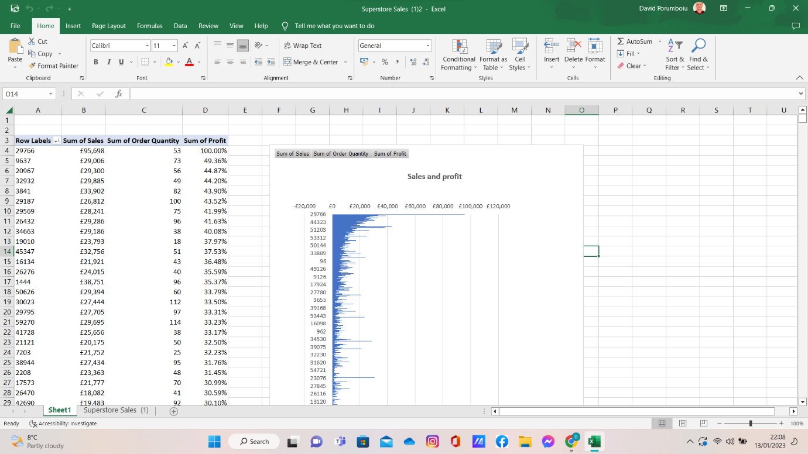
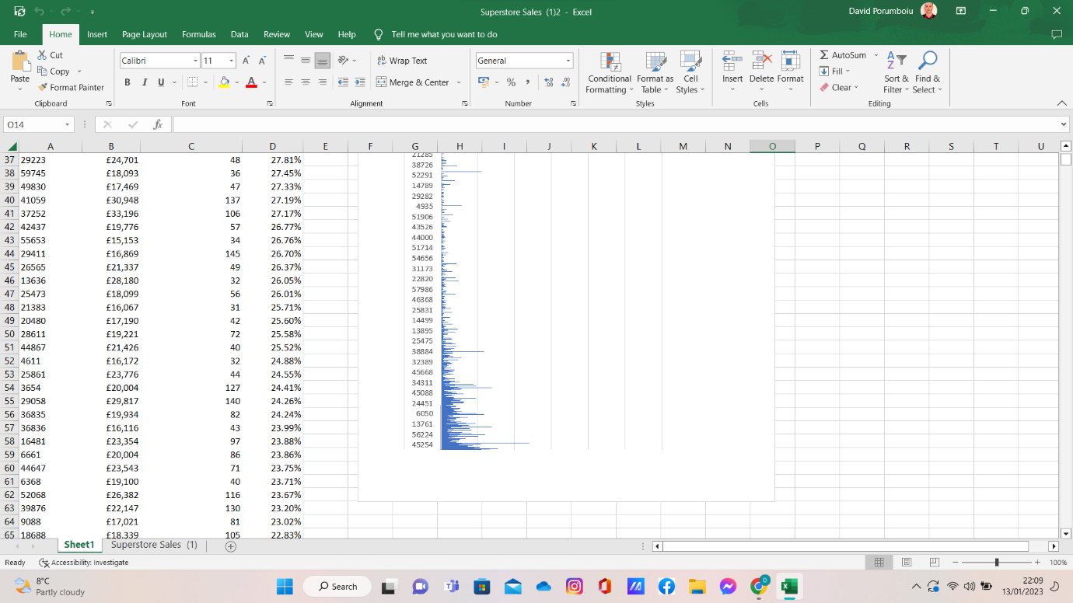
Part 2
2.1 – How many students like vanilla flavour ice-cream?
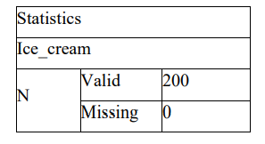
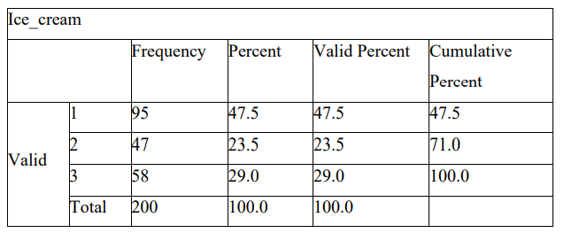
2.2 -How many students are male and female?
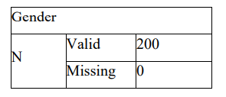
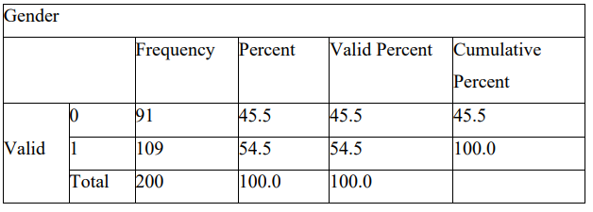
2.3 – What are the mean and median of participants who like chocolate and strawberry flavour ice-cream?
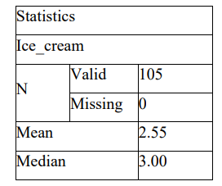
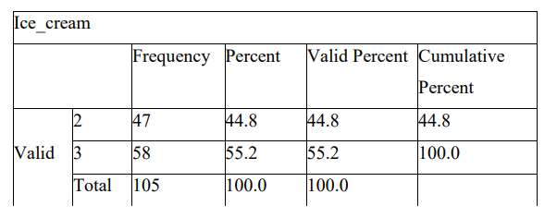
2.5 – Data mining and text mining are two popular techniques used by businesses to extract insights from their data. I will discuss the most common data mining and text mining methods that can be used in business, along with real-world examples:

Data Mining Methods
- Clustering: Clustering is a technique used to group similar data points together based on their similarities. It can be used to identify patterns in data and to segment customers based on their buying behavior. For example, a retailer may use clustering to group customers who frequently buy similar products, such as groceries, and offer them targeted promotions.
- Association Rule Mining: Association rule mining is a technique used to identify relationships between different data items. It can be used to identify patterns in customer behavior and to make recommendations based on those patterns. For example, an e-commerce platform may use association rule mining to recommend products to customers based on their purchase history.
- Regression Analysis: Regression analysis is a technique used to predict future values based on historical data. It can be used to identify trends and to forecast future demand for products. For example, a manufacturer may use regression analysis to forecast demand for a particular product based on historical sales data.
- Decision Trees: Decision trees are a graphical representation of a set of decisions and their possible outcomes. It can be used to identify the most important variables and to make predictions based on those variables. For example, a financial institution may use decision trees to predict the likelihood of a loan default based on the borrower's credit history.
- Neural Networks: Neural networks are a set of algorithms modeled after the human brain. They can be used to identify patterns in data and to make predictions based on those patterns. For example, a credit card company may use neural networks to detect fraudulent transactions based on unusual spending patterns.

Text Mining Methods
- Sentiment Analysis: Sentiment analysis is a technique used to analyze text data and determine the sentiment of the writer. It can be used to monitor social media platforms for customer feedback and to identify areas for improvement. For example, a hotel chain may use sentiment analysis to monitor online reviews and identify areas for improvement in their service.
- Topic Modeling: Topic modeling is a technique used to identify topics in a set of documents. It can be used to identify trends and to monitor customer feedback. For example, a retailer may use topic modeling to identify popular product categories and to develop targeted marketing campaigns.
- Named Entity Recognition: Named entity recognition is a technique used to identify named entities in text data, such as people, places, and organizations. It can be used to monitor news sources and to identify emerging trends. For example, a financial institution may use named entity recognition to monitor news sources for information about potential mergers and acquisitions.
- Text Classification: Text classification is a technique used to categorize text data into predefined categories. It can be used to monitor social media platforms for customer feedback and to identify areas for improvement. For example, an airline may use text classification to categorize customer feedback into categories such as flight delays, lost luggage, and poor customer service.
- Information Extraction: Information extraction is a technique used to extract specific pieces of information from text data. It can be used to monitor news sources and to identify emerging trends. For example, a pharmaceutical company may use information extraction to monitor news sources for information about clinical trials and drug approvals.

Here are some real-world examples of how businesses have used data mining and text mining techniques:

Clustering: Amazon uses clustering to group customers based on their purchase history and browsing behavior. This allows them to offer targeted product recommendations and personalized marketing campaigns.

Association Rule Mining: Netflix uses association rule mining to make a personalized movie and TV show recommendations based on a customer's viewing history.

Regression Analysis: Procter & Gamble uses regression analysis to forecast demand for their products based on historical sales data. This allows them to optimize production and inventory levels.

Decision Trees: Ford uses decision trees to predict the likelihood of a car defect based on historical data. This allows them to identify potential issues before they become widespread.

Neural Networks: Visa uses neural networks to detect fraudulent transactions by analyzing customer spending patterns and identifying unusual activity.

In conclusion, data mining and text mining are powerful techniques that businesses can use to extract insights from their data. The most common data mining techniques include clustering, association rule mining, regression analysis, decision trees, and neural networks. The most common text mining techniques include sentiment analysis, topic modeling, named entity recognition, text classification, and information extraction. By using these techniques, businesses can gain a better understanding of their customers.

2.6 – SPSS (Statistical Package for the Social Sciences) and Excel are two commonly used software tools for data analysis. While both have their advantages and disadvantages, choosing the right tool for a given analysis depends on the nature of the data, the research questions, and the intended analysis outputs. Here, we will discuss the advantages and disadvantages of using SPSS and Excel, using relevant practical examples, and present our discussions in a table format.

SPSS EXCEL
Advantages Disadvantages Advantages Disadvantages
User-Friendly Interface: SPSS has a user-friendly interface that makes it easy to navigate and perform statistical analyses. It has a wide range of features and functions that are easy to use even for novice users. | Cost: SPSS is licensed software and can be expensive for individual users and small businesses. | Wide Availability: Excel is widely available and is installed on most computers. It is easy to access and use, making it suitable for small businesses and individual users. | Limited Statistical Capabilities: Excel has limited statistical capabilities compared to SPSS. It does not have a wide range of statistical tests, making it less suitable for complex statistical analyses.
Statistical Capabilities: SPSS is specifically designed for statistical analysis, and it has a wide range of statistical tests that can be used to analyse data, including t-tests, ANOVA, regression analysis, and factor analysis. | Limited Compatibility: SPSS may have limited compatibility with other software tools, making it difficult to import and export data from other software programs. | Data Management: Excel has powerful data management capabilities that allow users to import, clean, and manage large datasets. It is particularly useful when working with structured data. | Limited Data Manipulation Capabilities: Excel has limited data manipulation capabilities compared to SPSS, making it less suitable for working with large datasets and complex data structures.
Data Management: SPSS has a powerful data management system that allows users to import, clean, and manage large datasets. This is particularly useful when working with complex datasets that require data transformation and cleaning. | Limited Data Manipulation Capabilities: SPSS has limited data manipulation capabilities compared to other software tools such as Excel. It is less suitable for working with large datasets and complex data structures. | Spreadsheet Capabilities: Excel has powerful spreadsheet capabilities that allow users to perform simple arithmetic calculations on data, making it suitable for simple data analysis tasks. | Data Entry Errors: Excel is prone to data entry errors, which can affect the accuracy of the analysis.
Graphics and Visualizations: SPSS has powerful graphics and visualization tools that allow users to create high-quality charts and graphs to communicate statistical results effectively. | Limited Spreadsheet Capabilities: SPSS does not have spreadsheet capabilities, which means that users cannot perform simple arithmetic calculations on data. | Customizable: Excel is highly customizable, and users can create custom formulas, macros, and charts to perform complex analyses. | Limited Graphics and Visualization Capabilities: Excel has limited graphics and visualization capabilities compared to SPSS, making it less suitable for creating high-quality charts and graphs.

In conclusion, both SPSS and Excel have advantages and disadvantages. Choosing the right tool depends on the nature of the data, the research questions, and the intended analysis outputs. While SPSS is better suited for complex statistical analyses and data management, Excel is more suitable for simple data analysis tasks and spreadsheet capabilities. The following table summarizes the advantages and disadvantages of using SPSS and Excel.

References
BRYSON STEMOCK, L. K., 2019. USE OF COMMERCIAL AND FREE SOFTWARE FOR TEACHING STATISTICS. International Association for Statistical Education, 18(2), pp. 54-67.
HILLIER, W., 2022. careerfoundry. [Online]
Available at: https://careerfoundry.com/en/blog/data-analytics/the-data-analysis-process-step-by-step/
[Accessed 09 01 2023].
K. Suoja, J. L. ,. J. ,. H. S. ,. V. ,. V. S., 2018. Application for pre-processing and visualization of electrodermal activity wearable. Industrial and Information Management, Tampere University of Technology, Tampere, Finland, Volume 65, pp. 93-35.
Lawton, G., 2022. techtarget. [Online]
Available at: https://www.techtarget.com/searchbusinessanalytics/tip/How-to-evaluate-and-select-data-visualization-tools
[Accessed 08 01 2023].
Miller, K., 2021. Harvard Business School Online. [Online]
Available at: https://online.hbs.edu/blog/post/data-visualizations-in-excel
[Accessed 09 01 2023].
Muth, L. C., 2019. datawrapper. [Online]
Available at: https://blog.datawrapper.de/prepare-and-clean-up-data-for-data-visualization/
[Accessed 07 01 2023].
Sharma, N., 2018. heartbeat. [Online]
Available at: https://heartbeat.comet.ml/data-preprocessing-and-visualization-implications-for-your-machine-learning-model-8dfbaaa51423
[Accessed 07 01 2023].

