Student name: Andreea Novac
Student number :1813117
Plumbing services
Bathroom and Kitchen fitting renovation
Student name: Mariana Bocut
Student number:1813126
Thermal insulation
Duct fitter
Student name: Liliana Vasile
Student number:1813443
Painting
Decorating
Student name: Cornel Bondor
Student number:1813451
Tiling
Plastering
Module number: LCBB4004
Module title: Marketing Fundamentals
Lecturer: Ze Zook

Building Construction Services
Creating Blog posts

Table of Contents

Introduction 3
Task 1A 3

Conclusion 24
References list 25

Introduction

The purpose of this study is to evaluate different products and services such as thermal insulation, tilling, plastering, Painting through using multiple authentic blogs and other sources of information. For this project we have to work in groups and our team is made up of 4 students. And each of us we do our best to explain the services which one we chose. Additionally, the effectiveness of those blogs and information in developing marketing directives will be determined in this paper as well. In modern business world, marketing is one of the key considerations that is supporting business ventures spontaneously to sustain in competitive market place and to generate revenue in business.

Task 1A
Building services is a service that help with customers’ needs to be more safely, efficiently and comfortable in their place. Building services need to build in the marketing organization possible customers offering different services as: thermal insulation, duct fitter, plumbing, bathroom and kitchen fitting, tiling, plastering, painting and decorating.
Marketing is an organizational function and a set of process for creating, communicating and delivering value to customers and for managing customers relationship in ways that benefit the organization and its stakeholders (Philip Kotler, Kevin Lane Keller 2016).
Thermal insulation
What is the purpose of thermal insulation?
Thermal insulation is a modern term that refers to the reduction of heat transfer between different objects within the thermal contact. The advancement of modern science and technology has evaluated all the steps associated with thermal insulation process. It is possible to achieve thermal insulation through using advanced engineering methods. In this context, the shape and size of the object is one of the major considerations. Insulating capacity of objects differ from each other. In course of thermal insulation process, experts always select the type of material to be used according to their needs. There are multiple insulation materials such as fibreglass, mineral wool, cellulose and others are available in market (globe.gov, 2019).
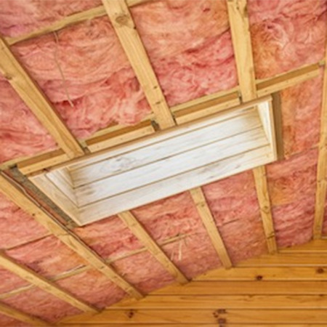
Barbour products(2019)
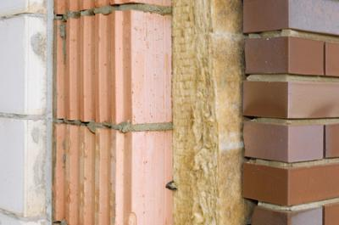
Climate Tech Wiki (2019)
Thermal insulation is the modern approach to prevent thermal stress on roofs. Insulation materials are lighter than concrete and other materials so that insulation process becomes easier. As stated by modern researchers, “we are losing energy from the door, curtains, bricks, roof, walls, windows, and other.” It is also undeniable that we must keep energy losses to a minimum from our homes for reducing the electricity bills and pollution simultaneously (isowall.co.za, 2019). Thermal insulation can be extremely effective in this context. People are showing interest in heat loss prevention. Curtains reduce passing of radiated heat from house. Cavity wall refers to the gap between two walls and to prevent the convection within the cavity, cavity wall foam insulation technique can be used. Thermal insulation methods can be utilised in roof, windows, and doors for reducing the passing of radiated heat from house. Due to high effectiveness of modern thermal techniques and procedures, the market thermal insulation industry is rising day by day and it is expected by the researchers that this figure will reach $37.4billion by 2027 (reliableinsupacks.com, 2019).
By adopting this thermal insulation technique, people would be able to keep their room insulated so that buildings stay cool in summer time and warm during the winter period as well. Apart from this, a building with thermal insulation will need less energy and power for maintaining home equipment’s. In a recent research, it has been evaluated that 1 unit of energy saved is accounted for 2.75 units energy generated. In modern construction and building context, thermal insulation has become an essential part to be used in preventing heat transfer between inside and outside of the house.
Duct fitter
What is the ducting using for?
Ducts refer to passages utilised in ventilation, air conditioning (HVAC) and heating for delivering and removing air. During building house, managing and installing appropriate ventilation system is one of the important considerations. Ventilation system depends on airflow requirements per cubic foot per minute and velocity in a room. Duct fitters analyse the requirements of the customers and then measure the size and space to be used. They use minimal space to reconstruct and modify the ventilation, heating and air conditioning altogether in buildings. Duct fitter is associated with multiple responsibilities such as fabricate, assemble, repair, install sheet metal equipment and products like ducts, drainpipes, and others. They use a range of devices and tools including 30-degree elbow, duct clamps, moisture drain, fitting, flex connections, wye branches, pipe hanger, duct end caps and others.
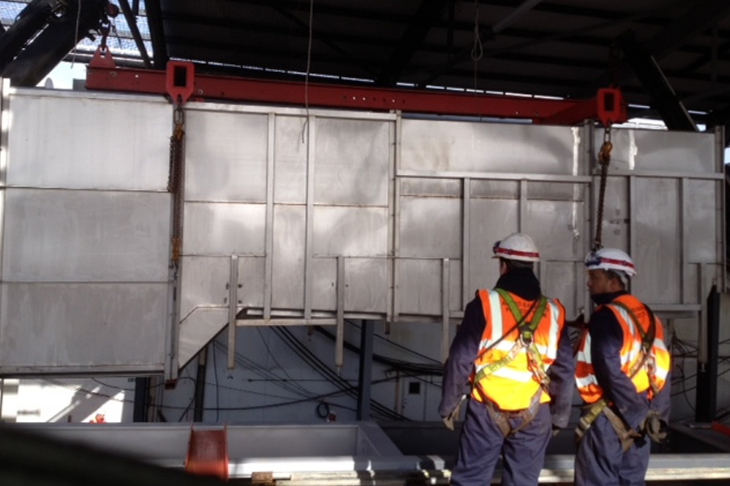
Manpower(2019)
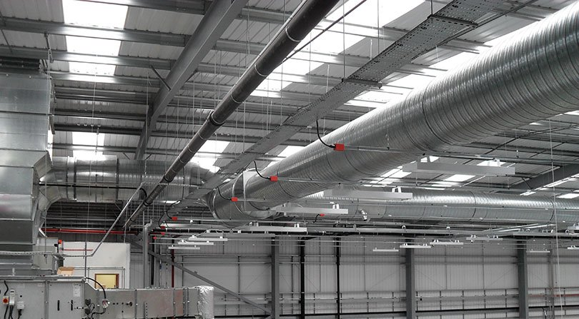

Robert Hurst Group Ltd(2019)

Duct fitter always focuses availing the maximum air in the room and maintaining the heat and air condition of the room in a precise manner to provide the highest comfort and satisfaction to their clients. Different size ducts are used for various purposes. For instance, rectangular ducts and fittings are made from ammonium or stainless steel and it is designed for mostly low and medium –pressure indoor HVAC system. In context of duct fitting, fitters have to take into consideration multiple vital factors including dimension, tightness, marking, design, and others (alnor.com.pl, 2019). Mostly two types of duct designs; class s design and class n design are used in current days.
Apart from this, during selection of metal sheet thickness and dimensional tolerance, multiple criterions are measured and followed by duct fitters. Duct fitters measure dimension of longest side of fitting’s connection cross section and length of a straight duct’s long side. In recent days, this industry is generating high amount of profitability and they are extending their business excellence to improve customer satisfaction level and to attract more numbers of potential customers. Due to great scope and development opportunities in this industry, eligible individuals are showing interest in making their career in this filed (grainger.com, 2019). However, marketing also has deep role in this industry and successful duct fitters use effective marketing tactics to manage their regular and potential customers.

Plumbing services
What is the effectiveness of plumbing rol?
Plumbing is regarded as any system, which conveys fluids for multiple applications. In order to convey fluids, plumbing uses a range of items including valves, plumbing fixtures, pipes, tanks and others important apparatuses. Apart from this, there are multiple plumbing tools such as channel locks, pipe wrench, hole saw, hose cutter, drain augers, basin wrench, metal file, fire resistant cloth and others are used by plumbers to fix fluid issues (plumbingmarketingguy.com, 2019). Plumbers keep these all tools inside their toolbox to be used in any condition and in speedy manner as well. Plumbing services are availed in market to make our life leading style easier and more comfortable. In plumbing industry, plumbers are trained and then they are well equipped to fix any sort of leakage or any other fluid issues.

Artisan plambing (2019)

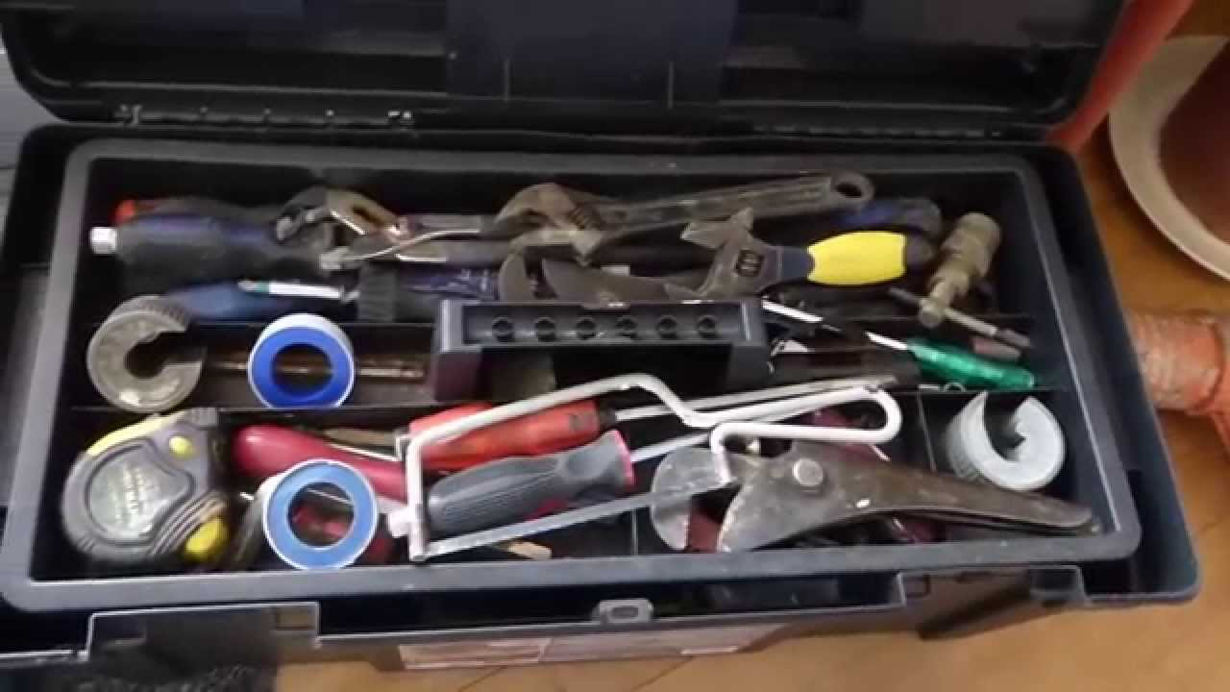
Plumbing tools (2019)
According to statistics, demand of global plumbing product is increasing 3.5% yearly since 2013. This industry is generating almost $55.4 billion revenue in every year. It has also been expected that the market demand will rise with more acceleration in upcoming days. Developed countries and their citizens are well familiar regarding effectiveness of plumbing role. Due to this reason, plumbing industry has great development scope and adoption of modern technology has influenced the industry to achieve peak position in business world (plumbingmarketingguy.com et al., 2019). However, internet marketing is one of the newest and effective approaches that can be used in plumbing industry as well to reach out more numbers of potential customers and informing them regarding effectiveness of the service. Having a plumbing website can be helpful to engage more traffic on online network. Most of the successful plumbing foundations have their own website for business. Small size plumbing companies also can reach out customers by creating and engaging in online platforms. Apart from this, there are also many other marketing options are available to plumbing organizations including paid directory books, billboards, vehicle graphics, commercials, social media promotion and others. Already the industry has captured huge customer base and serving numerous customers around the globe.
Plumbing is not only for generating revenue in business. It also matters to health, safety, water sustainability and more. Plumbing manages innovations to harness precious resource, water to be used safely for better health, well-being, and hygiene altogether. Plumbing equipment are designed to save at least 20% water more (pmmag.com, 2019).
Bathroom and Kitchen fitting renovation
In what ways canany building organization tohelp you to have a bathroom and kitchen fitting?
In this modern era, people are likely to have a well-decorated home, bathroom and kitchen. This has become the basic need of modern customers. As per the point of view of modern customers, unlike rooms, bathroom and kitchen are the special corners of a house that can be decorated to differentiate from neighbours’ buildings. Construction industry is giving focus on managing the bathroom and kitchen in such manner that it can attract customer attention so that selling more flats will be easier to them. All modern bathrooms and modular kitchens are made with the help of professional architects. Architects provide guidance and blue map to their subordinates and team to decorate the bathroom and kitchen effectively to look better and more attractive (Cheever, 2014).
Bathroom and kitchen fitting include a range of products like kitchen jail, kitchen chimney, toilet seat, sink, sanitary, spas and other bathroom products that are generally daily used by us. Thus, most of us are interested in decorating and keeping their bathrooms and kitchen perfectly. People have changed traditional ways of cooking and adopted advance features and facilities of modern kitchen to make their cooking easier as well as time and energy saving. Modern kitchens are designed by engineers and architects to be set in minimal space so that owner does not need to compromise with space issues. During making of these modular kitchen and modern bathrooms, engineers and architects have kept in mind the customer issues and focused on offering maximum facilities, satisfaction, and relaxation and easiness altogether to customers. 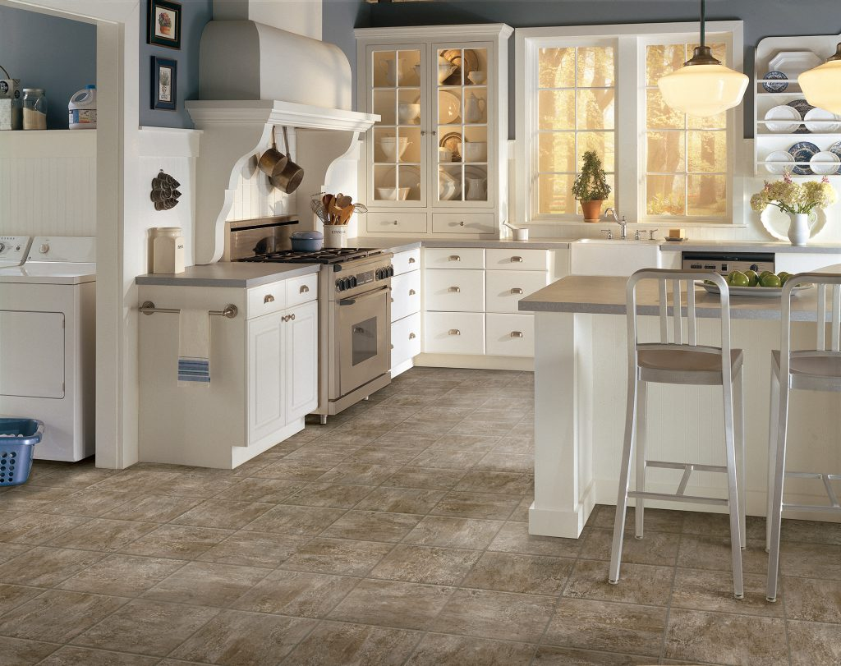
Empire today (2016)
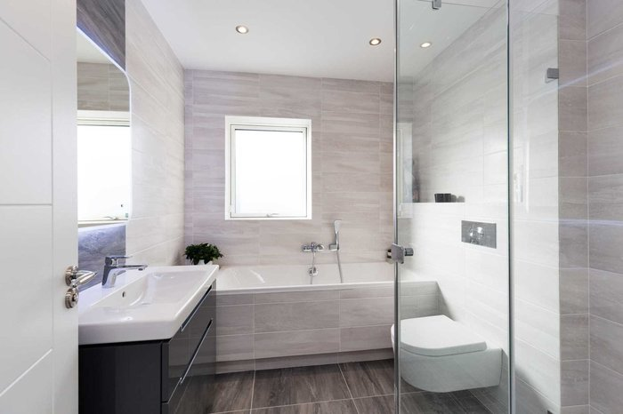
Philipbarron (2019)
However, owner needs to spend a huge amount of capital to avail these luxurious bathroom and modern kitchen facilities. Modern customers are seeking kitchen and bathroom makeover on a budget. People are looking to update their home decor as well as kitchen and bathroom decoration without making huge investment. This has become a challenge to bathroom and kitchen fitting industry to provide maximum facilities and all the needs of the customers within their minimal budget. However, the market share of this industry is high and this share amount is expected to be doubled by 2022. Global smart bathroom and kitchen fitting industry is adopting numerous technologies to bring a radical change in home, bathroom, and kitchen fitting system. In recent days, this industry is working on voice driven user interface that is one of the emerging trends in global smart kitchen and bathroom market.
Tiling
Why do you thing more people start to use tiling?
Tiling is an effective method of decomposing few spaces into multiple little pieces (tiles), which fit together without any overlapping or gap. As per the modern researchers, tiling is everywhere from fields to roads and buildings. Tiling consists of different application of mathematical theories and concepts to fix the tiles without any gap and in the most efficient manner. In tiling method, different types of tiles are used according to the needs and demands of the clients. Some of the most popular types of tiles used in tiling process are limestone tile, travertine tile, terrazzo tile, ceramic tile, marble tile, granite tile and others.


HSS Hire Blog(2019)
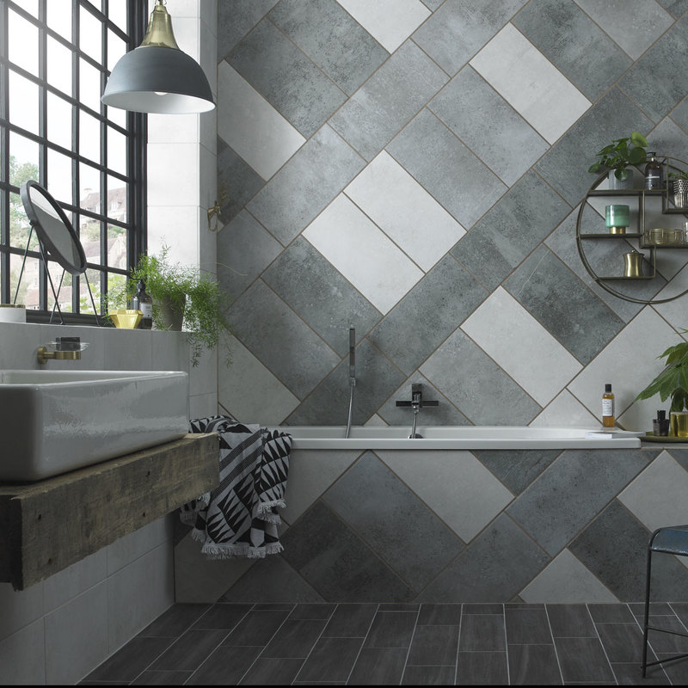
Paul Huggett(2019)
Clients are seeking to have the most durable flooring technique for their home and kitchen. They are seeking for tiling experts those can meet their expectations within their limited budget. Clients like perfect concrete look, spice up their outdoor space and overall improvement of their current home decoration and outlook. The key challenge in this industry is meeting customer expectations and offering them all the required services without exceeding their budget. Tilling experts use effective procedures and modern technologies to fulfil the requirements of the clients and provide them maximum satisfaction through their tiling services (Williams and Galloup, 2014). However, marketing concept and its effectiveness in this business context is undeniable. Tiling experts use different marketing mediums and tools like networking, online promotion, social media marketing, SEO, and others to rank up their designs and works.
Plastering
Plaster is building material used to protect walls and ceilings from damage. It is the method of covering the wall and ceiling with thin layer of cement on the exposed surface for safeguarding wall and ceiling from penetration of rain as well as other multiple atmospheric agencies. Plastering is also called render, while using the building exterior. There are different types of plasters in building constructions such as cement plaster, gypsum plaster, clay plaster, lime plaster and others. Al these types of plastering methods have their own effectiveness to be used in construction industry. Apart from this, plastering also improves the styles, decoration, and outlook of a room. They mainly use multiple tools like plastering trowels, snip, plastering brush, multi tool, float, hand board, and others to complete the plastering process. People are likely to live in decorated and protected rooms since decades. In past, people used multiple types of tree leaves and bulk of trees to decorate their rooms, which alternatively increased strength of their shelters as well. In modern world, advancement of science and technology has provided opportunities to owners to increase the stability and protective power by covering the walls and ceiling with thin layers of cement. Along with this, plastering also increases the attractiveness of rooms. Most common demands of people are living in attractive and protective shelter that has increased the market demand of plastering industry. In modern context, this particular business industry has large scope and upcoming days the demand and scope will be increased to maximum.

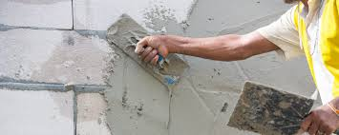
Mark Bunce(2019)

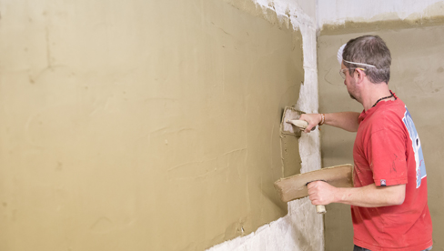
Access Training (2019)
However, in plastering industry, marketing tactics also play a huge role. Due to high market competitiveness, many of the plastering companies are stumbling to sustain in market. Effective marketing activities can bring positive changes in the company as well as can assist to speed up profitability in business. Plasterers use different types of mediums and methods to grab attention of their potential customers. In this purpose, having an appropriate business network is essential to receive client orders in seamless manner (Millar, 2016). Many of the plasterers print business cards for promoting their own brands. Having an own website, where you have enough traffic is always beneficial to accelerate customer engagement of any particular organization. In plastering industry, online platforms and own website can increase the number of sold services and business revenue of the company. Furthermore, flyers are still a reasonable option of getting business in and promoting own plastering skills and excellence to clients.

Painting
Key considerations while choosing wall painting or wallpaper

Do you want to make a change in your house? Why walls changing colour is the easiest mode to do that?
Changing wall colour is a quick and easy way to change the feeling of room.
Whether you choose paint, wallpaper or both is the easiest way to change the feeling of a room. Colour can change out perception of a room size and shape.
Depending on what colour or even different value of the same colour you choose, you can make space look larger or smaller, change the shape of space. Maki it brighter or darker, can accentuate the attention on positive aspects of space and minimize the less attractive features of a room.


Cynthia Bowman(2019)

All WallPapers(2019)

We can give some professional advices.
If you have a large room and you are not feeling comfortable you can paint the ceilings a darker colour than the walls to make it appear lower and feel cosier. On the contrary you can paint the ceiling a lighter colour which will make you feel the room is larger.
If you want to change the shape of a room you can choose the paint strips.
Painting vertical stripes will transform a room space feel taller. On the contrary horizontal stripes make a space feel larger.
But, always, you have to consider how many windows you have in the room.(DiNobile K., 2019)
Another alternative will be choosing wallpaper. But you have to be careful where you want to make the changes.
Our professional advice is not to use the wallpaper in the kitchen and bathroom, because is not suitable for spaces with high humidity levels. That is way for kind of spaces paint is the best option, it can deal with humidity and is mould resistant.
You might change just one of the walls or all of them. You can choose from a wide range modern design.
Thinking at costs, paint can be cheaper than wallpaper, but the longevity of wallpaper is bigger than the paint.
Whatever you do opt, you have choose a quality brand, it will last longer. (Natalie, 2019)
Decorating
Decorating-Why do you need a decorator to transform an ordinary house into a feast for your eyes?
Decoration increases the attractiveness and allows gathering attention of others in a more effective manner.
As Elaine Griffin, a well known interior designer said “ Rooms should always look like the people who live in them. Great design is a combination of where you have been, where you’re at in your life, and where you are going, as there should always be something aspirational in a room.” (Elaine Griffin, 2019)
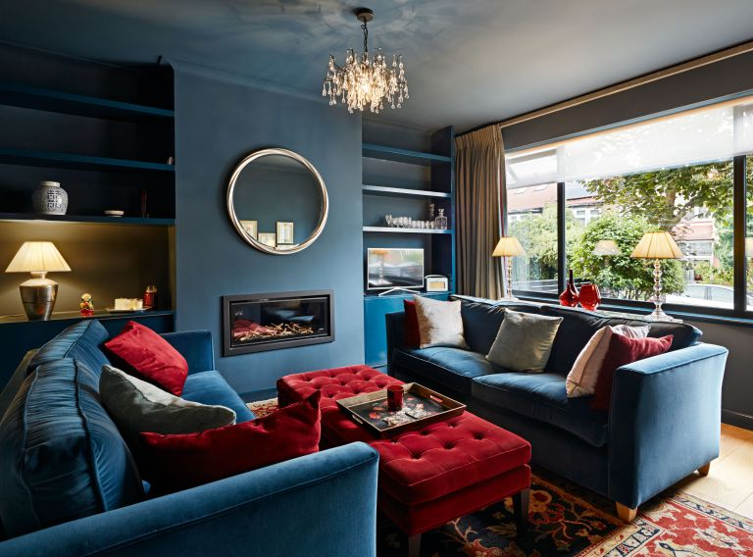
Real Homes (2019)
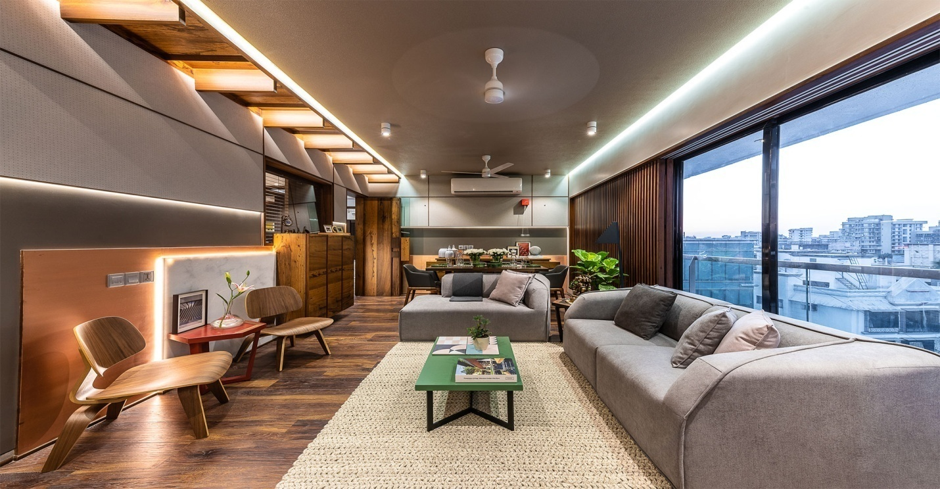
Architectural Digest (2019)
If you read deeply what she said, when you want to make a change in your house you should follow your senses and not the trends. There are a lot of magazines and online stores that can help you with some ideas, but our advices is not to copy paste everything and do it in your own style.
Or, hire a interior design, if you want to get rid of all of burden.
The key aim of decorators is increasing the current look of any particular space and decorating the space according to the needs and demands of the clients.
There are many examples when you can need a professional advice from an interior designer.
When you buy a house and you want to change everything and make it suitable for your life style, or you do not have any ideas to decorate the house. The decorator can helps you to arrange the furniture so that you have more space and make you feel more comfortable. Or maybe your co-worker tells you about feng-shui, a system of harmonizing everyone to their surrounding environment and energies, and makes you curious.
For all of this, you must call a specialist.
A decorator is like a psychologist. He has to listen properly the owner of the house and understands his desires. First, he has to see the location, make a sketch, show it, wait for feedback and accordingly with the owner changes the plan. (Sandu M. and Scarlat S. 2018, pp9)

Conclusion
From the entire description, it is possible to conclude that the marketing effectiveness is undeniable in every aspect of modern business industry. Business organizations coming from any business sector must adopt and implement appropriate marketing strategies to sustain in market and to sell their products to potential customers. In the above portion, different products and services have been discussed along with the role and effectiveness of marketing tactics in selling those products and services to modern customers.

https://bestbuildingservices.blogspot.com/

Reference list

Access Training (2019)[Online] , Plastering ,Courses Available from https://www.accesstraininguk.co.uk/plastering-courses( Accessed 19.08.2019)
All Wallpapers (2019) [Online] Black twisted dots wall mural wallpaper, Available from https://www.homewallmurals.co.uk/black-twisted-dots-wall-mural-wallpaper-1883-p.asp (Accessed 19.08.2019)
Alnor.com.pl(2019). [Online] Alnor.com.pl. Available from https://www.alnor.com.pl/assets/files/katalogi-grupy/EN/SQUER-ventilation-ducts-and-fittings-Alnor.pdf (Accessed 19 Jul. 2019).
Architectural Digest(2019)[Online] Mumbai: Cool hues and a natural palette update this city apartment, Available from https://www.architecturaldigest.in/decorating/ (Accessed 19.08.2019)
Artisan plumbing (2019) [Online] Available from: https://www.bing.com/images/search?q=plumbing+pictures&qpvt=plumbing+pictures&FORM=IGRE
(Accessed 19.08.2019).
Barbour products (2019)[Online] ,The 5 common Thermal Insulation materials, Available from https://www.barbourproductsearch.info/the-5-common-thermal-insulation-materials-blog000424.htmlAccessed 19.08.2019)
Bogue, R. (2014). ‘Deleuze on music, painting, and the arts. Routledge.
Cheever, E. (2014).’ Kitchen & Bath Products and Materials: Cabinetry, Equipment, Surfaces. John Wiley & Sons.
Climate Tech Wiki (2019)[Online] ,Building envelope thermal insulation, Available from https://www.climatetechwiki.org/technology/building-envelope-thermal-insulation (Accessed 19.08.2019)
Cynthia Bowman (2019)[Online] ,Bedroom Paint Ideas: What’s Your Color Personality?, Available from https://freshome.com/bedroom-paint-ideas/ (Accessed 19.08.2019)
Designing buildings Wiki. (2019) [Online] Available from: www.designingbuildings.co.uk (Accessed 29 July 2019).
DiNobile,K.,2019. [Online] How to Use Paint Colours to Change the Feeling of a Room How to Use Paint Colours to Change the Feeling of a Room, Available from https://www.thespruce.com/paint-colors-change-feeling-of-a-room-1835371, (Accessed on: August 06, 201 9).
Elaine G.,2019, [Online] Diversity in Design and Decorating , Available from https://www.elledecor.com/design-decorate/interior-designers/a28414985/designer-elaine-griffin-interview/ (Accessed on: August 05, 201 9).
Empire today (2016) [Online]Available from: https://www.empiretodayblog.com/wp-content/uploads/2016/05/Kitchen-and-Bathroom-Blog.jpg (Accessed 19.08.2019).
globe.gov (2019). Thermal insulation - Community Blogs - GLOBE.gov. [Online] Globe.gov. Available fromhttps://www.globe.gov/globe-community/blogs/community-blogs/-/blogs/37407663/maximized?r_p_id=communitymemberblogsaggregator_WAR_globegovcollabportlet&curPage=18&curDelta=5(Accessed 19 Jul. 2019).
grainger.com (2019). ‘Duct Fittings - Ductwork, Venting, Fittings and Caps - Grainger Industrial Supply’. [Online] Grainger.com. Available from: https://www.grainger.com/category/hvac-and-refrigeration/ventilation-equipment-and-supplies/ductwork-venting-fittings-and-caps/duct-fittings(Accessed 19 Jul. 2019).
HSS Hire Blog(2019)[Online] Tips to Take Your Tiling Skills to the Next Level, Available from https://www.hss.com/blog/tips-and-advice/tips-to-take-your-tiling-skills-to-the-next-level/ (Accessed 19.08.2019)
isowall.co.za (2019). ‘The Main Advantages of Thermal Insulation’. [Online] Isowall Group. Available from: https://www.isowall.co.za/the-main-advantages-of-thermal-insulation/(Accessed 19 Jul. 2019).
Johnson, M.L., Plattner, A.S. and Hundley, L. (2018). Designing a Collaborative Blog about Student Success.
Josh, D., plan, m., kator, A., Pauk, N., Kamal, A., Shrestha, E., Narayan, G., Koch, S., Narayan, G., Koch, S., Eliyahu, Y. and Narayan, G. (2018). Guide Part I: How to Plan Your New Blog Perfectly | Dear Blogger. [online] Dear Blogger. Available from: https://www.dearblogger.org/plan-a-new-blog(Accessed 19 Jul. 2019).
Kotler, P. and Keller, K.L. (2016) ‘Marketing management’. Pearson Education Limited, Edinburg Gate, Harlow. edition15.
Lee, E.J. and Tandoc Jr, E.C., 2017. When news meets the audience: How audience feedback online affects news production and consumption. Human Communication Research, 43(4), pp.436-449
Manpower (2019)[Online] ,Manpower Supply ,Available from http://pleasantqatar.com/products-services/manpower-supply/#tab-id-10( Accessed 19.08.2019)
Mark Bunce(2019)[Online] Plastering in Beds, Herts. & Bucks, Available from https://markbunceplastering.co.uk/ ( Accessed 19.08.2019)
Millar, W. (2016). ‘Plastering: plain and decorative’. Routledge.
Natalie,2019 [Online] Wallpaper vs. Paint , Available from https://www.ratedpeople.com/blog/wallpaper-vs-paint, (Accessed on: August 01, 201 9).
Paul Huggett(2019)[Online] Tiling: trends, installation and maintaining your tiles, Available from https://trustedtraders.which.co.uk/articles/tiling-trends-installation-and-maintaining-your-tiles ( Accessed 19.08.2019)
Philipbarron (2019) [Online] Available from: https://www.bing.com/images/search?q=bathroom+and+kitchen+pictures&id=5D21150F93A4E456A7D84ADC641A8DF3D6FE840C&FORM=IQFRBA (Accessed 19.08.2019).
Plumbing tools (2019) [Online] Available from : https://www.bing.com/images/search?q=Plumbing+Tools&FORM=IRBPRS&=0 (Accessed 19.08.2019).
plumbingmarketingguy.com, P. (2019). ‘Why Having a Plumbing Website Will Help Your Business – The Plumbing Marketing Guy | Plumbing SEO | Plumbing Website Design | Plumbing Social Media’. [Online] Plumbingmarketingguy.com. Available from: http://www.plumbingmarketingguy.com/plumbing-website-will-help-business/ (Accessed 19 Jul. 2019).
plumbingmarketingguy.com. (2019). Plumbing Website Design – The Plumbing Marketing Guy | Plumbing SEO | Plumbing Website Design | Plumbing Social Media. [Online] Plumbingmarketingguy.com. Available from:http://www.plumbingmarketingguy.com/website-design/(Accessed 19 Jul. 2019).
pmmag.com (2019). [Online] Pmmag.com. Available from:https://www.pmmag.com/blogs/20-green-scene-blog/post/97073-why-plumbing-matters-to-health-safety-water-sustainability-and-more(Accessed 19 Jul. 2019).
Qian, X., Hang, T., Shanmugam, S. and Li, M. (2015). Decoration of micro-/nanoscale noble metal particles on 3D porous nickel using electrodeposition technique as electrocatalyst for hydrogen evolution reaction in alkaline electrolyte. ACS applied materials & interfaces, 7(29), pp.15716-15725.
Real Homes(2019)[Online] 19 dark and atmospheric decorating ideas,Available from https://www.realhome.co.uk.com/completed-projects/dark-decorating-ideas (Accessed 19.08.2019)
reliableinsupacks.com, S. (2019). Thermal Insulation | Blog | Reliableinsupacks.com. [Online] Reliableinsupacks.com. Available from: http://www.reliableinsupacks.com/blog-details.php?id=4&blog=Thermal-Insulation(Accessed 19 Jul. 2019).
Robert Hurst Group Ltd(2019)[Online] ,Duct Fitter,Available from http://www.roberthurstgroup.co.uk/job/duct-fitter-warrington/( Accessed 19.08.2019)
Sandu M. and Scarlat S. 2018, Augmented Reality uses in Interior Design, pp9.
Williams, J.M. and Galloup, A.L. (2014). Wind resistant tile roofing system. U.S. Patent 8,661,760.
Yoon, S.U. and Lim, S.J., Electronics and Telecommunications Research Institute, (2014). Apparatus and method for creating 3D content for oriental painting. U.S. Patent 8,682,107

