Report Case Study: The Seacrest Lodge

The module title: Financial Management for the Hotel Industry BMIH5007
Lecturer’s name: Tristan Hawkins
Student name: Anamaria Cristina Salanchi
Student ID: 2206421
Word count: 2026

Executive Summary
The Seacrest Lodge, a UK-based lodge on a beautiful coastline, has experienced a decline in its financial performance over the past three years. This case study interprets the lodge's financial statements, identifies reasons behind its downfall, and suggests strategies to boost profitability.
Interpreting Financial Statements:
- Income Statement: The earned revenue decreased from £1,200,000 in 2021 to £950,000 in 2023, with a negative net income in 2023, indicating a business decline.
- Balance Sheet: The lodge showed losses by 2023, with significant asset depreciation and reduced share of equity. Accounts payable increased in 2023.
- Additional Financial Information: Room rates and occupancy rates have decreased over the three-year period.
Reasons for the Decline:
- Unfavourable economic situation: Inflation and unpredictable market changes affected customer demand and accessibility.
- Brexit: The UK's political situation led to trading contract losses, impacting Seacrest Lodge's economic position.
- Russia-Ukraine war: The conflict increased energy prices, affecting Seacrest Lodge's ability to generate energy and cook food at reasonable costs.
- GDP: Negative economic conditions and low purchasing power in the UK influenced the lodge's financial situation.
- Pricing policy: Competitors' pricing strategies influenced Seacrest Lodge's pricing policy, negatively impacting its performance.
Strategies to Boost Profitability:
- Insurance: Transfer financial risks to an insurance company through premium payments.
- Diversification: Generate multiple income sources instead of relying on one.
- Reduction of maintenance: Control maintenance costs by managing the use of rooms and resources.
- Budget preparation: Anticipate future costs and make informed decisions through budgetary planning.
- Review and detection: Monitor the business's bottom line, productivity issues, and error rates to identify areas for improvement.
Recommendations:
- Cutting down certain expenses: Reduce investments in marketing and focus on crucial fields.
- Fixing the price: Analyse the economic situation and fix rates accordingly.
- Revamping the policies: Modify cancellation and booking policies to make them customer friendly.
- Adapting contemporary ways in marketing: Utilize social media, influencers, and collaborations to reach a wider audience.
- Discount: Offer discounts through online platforms to attract customers.
The Seacrest Lodge can recover and sustain its business by implementing these recommendations and focusing on cost reduction, pricing, policy modifications, marketing, and discount strategies.
Contents
Introduction 5
Interpreting the financial statements of the Seacrest Lodge 6
Elaborating the reasons behind the declination of the Seacrest Lodge 9
Discussing some keen strategies to boost the profitability of Seacrest Lodge 11
Conclusion 14
Recommendations 15
References 17

Introduction
The Seacrest Lodge wants to boost its business operations by analysing its financial performance. This case study report will evaluate the reasons for the poor organisational performance of Seacrest Lodge while aligning with the global economy. The discussion will illustrate this company’s operational performance in three different accounting years such as 2021, 2022 and 2023. In order to provide the organisation with progressive actions, the following section will suggest certain strategies that may refine Seacrest’s financial health. A recommendation portion will be demonstrated in this case study as well which will help the respective business entity to cope with further challenges.

Interpreting the financial statements of the Seacrest Lodge
Income statement
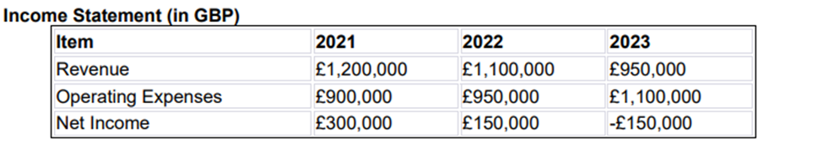
Figure: Income statement of the Seacrest Lodge
Source: Self-made
Interpretation:
The above figure shows the income statement of the Seacrest Lodge over the period of three years starting from 2021. This is a UK-based company that runs a lodge residing is a beautiful coastline. However, the company has failed to meet its targets in recent times. It can be understood from this data, that their earned revenue was £1,200,000 in 2021. This value degraded to £1,100,000 in the following year, then in 2023 it showed a plunge and degraded to £950,000. The net income went to a negative curve in that year also, showing the downfall of the business (Hill, 2023).

Balance sheet
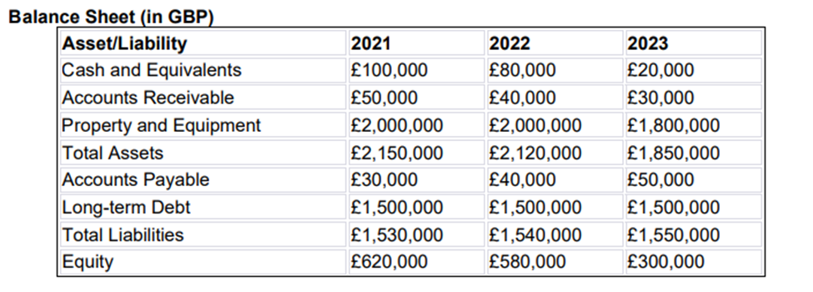
Figure: Balance sheet of the Seacrest Lodge
Source: Self-made
Interpretation:
The balance sheet shows the assets, resources and debts of a company, and it is considered as a reliable financial statement. It can be concluded from the provided balance sheet here that the lodge was running at a loss by the year 2023. Depreciation of the assets was maximum in 2023, which resulted in the loss of assets. The share of equity was £620,000 in 2021 which depreciated to £580,000 in the very next year. This value became significantly low in 2023 which is only £300,000. Moreover, their accounts payable value has also increased in that year (Green, 2023).

Additional financial information
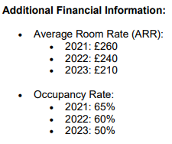
Figure: Additional financial information of the Seacrest Lodge
Source: Self-made
Interpretation:
Seacrest Lodge provides rooms, dining and bar services in their lodge, their room rates have been downgraded over the timeframe of three consecutive years. The room rate of this lodge was £260 pounds in 2021 and £240 in 2022. However, the room rate was downgraded to £210 in the following year. The occupancy rate of the rooms in the lodge has also gone on plunged gradually and became 50% in the year 2023 (quickbooks, 2022).

Elaborating the reasons behind the declination of the Seacrest Lodge
Managing financial risks is a compilation of some serious steps, taken by organisations to recognise the risks, evaluate and understand them as well as forge strategies to manage them.
Initial steps for Seacrest Lodge regarding the concept of risk management:
1. Risks identification
2. Assessment of the risks
There are so many factors that resulted in the downfall of this business, some of them are discussed below:
Unfavourable economic situation
The economic condition in a particular region influences the businesses and industries within it. There must be inflation in the country that has resulted in a decrease in customer demands and accessibility for Seacrest Lodge. Changes in the markets are unpredictable; however, the company has obtained poor strategic plans to counter those challenges and ultimately met a decline (Swain, 2022).
Issue of Brexit
The United Kingdom is going through a hideous economic situation currently due to the incident of Brexit. Like many other businesses, the incident has affected Seacrest Lodge’s economic position too. Various trading contracts with Great Britain have been denied by other countries. The respective lodge profile has encountered enough loss due to this regional as well as political incident (Corvellec et al., 2022). During that time it was having a rough condition that did not allow its operations to be performed in an expected and appropriate to way. Brexit can be considered one of the concrete causes of the decline in Seacrest Lodge’s financial performance.
Russia-Ukraine war
Russia and Ukraine have been going through a conflict since 2014 and its effects can be felt internationally. In addition, Seacrest Lodge operates its business in the UK region which is also involved in the list of those affected countries (Campos et al., 2020). Russia has breached each and every type of contract with Great Britain. Hence, during that period the UK was required to search for other sources of natural gases and energies. This mishap has affected Seacrest Lodge in a negative way and it was one of the reasons for which the organisation faced an economic downturn. Precisely, being a hospitality profile, the respective organisation needed to buy gas and oils to generate energy and cook food (Tisdell, 2020). However, due to a rise in the prices, the business became bound to buy these energy fuels from expensive sources.
The Gross Domestic Product
During the lockdown period, Great Britain faced negative economic conditions as the GDP rate of the country became poor. This adverse economic situation was even influencing the purchasing power of the local people of the country. The demand margin became very low which affected the financial situation of Seacrest Lodge as well (Tisdell, 2020). Moreover, the economic cycle of the UK was going to completely collapse. During that time continuing the business performance and earning profit to compete across the industry became difficult for Seacrest.
Pricing policy
The pricing policy of Seacrest Lodge has been influenced by its competitors' pricing strategies. Certainly, the pricing strategies of other entities are more volatile in comparison to the Seacrest Lodge also changed its pricing policy in accordance with that. The movement in the competitor's pricing policy might have influenced the performance of the organisation.

Discussing some keen strategies to boost the profitability of Seacrest Lodge
The remaining steps for Seacrest Lodge regarding the concept of risk management:
3. Discussing strategies to manage the risks
4. Implementation of the strategies
5. Monitoring the strategies if they are working properly
After critically analysing the financial position of Seacrest Lodge and taking interviews with both the external and internal parties of the business, certain effective strategies are forged below:

Figure: Budgeting strategy
Source: (Thoresson, 2024)
Insurance
The respective hospital business has detected financial risks at its several events which can be mitigated with the insurance policy. In addition, Seacrest can transfer its risks to an insurance company and manage its losses by exchanging premium payments for the transfer (Debela et al., 2024).
Diversification
Seacrest Lodge can use multiple sources of income instead of relying on a particular one. It can provide the business with an enhanced practice of generating more sources of revenue within several streams.
Reduction of maintenance
Every business spends a significant amount of money on its maintenance, and it plays a vital role in the hotel industry too. Being a part of this industry Seacrest Lodge also pays huge amounts of money to different parties such as interior decorators, designers and so on. This money is paid in order to maintain the glaze and glamour of its hotels, restaurants and bars. Therefore, a reduction in this particular section of expenses can help the mentioned hospitality body to enhance its financial health. In order achieve that purpose, the management of Seacrest may search for a way to control its maintenance costs (Thoresson, 2024). Hence, keeping some of the rooms locked for few days and use only the remaining may need few maintenance to pay to entertain the customers.

Budget preparation
One of the old ways and significant strategies that Seacrest Lodge can use to improve the financial health of its business is the preparation of budgetary planning (Brown et al., 2024). This system is able to help Seacrest Lodge to anticipate and understand the upcoming future costs. Thus, making moves according to the scenarios and taking precautions for them can be possible for Seacrest if it prepares a budget.
Review and detection
Continuing the subject mentioned above, Seacrest Lodge can attain an overall review of the whole business. Hence, it may help this particular hospitality profile evaluate the areas where improvement and efficiency did not take place. For example, sometimes certain equipment stops working properly and causes low productivity. Also, high electricity bills can be paid by lodges like Seacrest whether their electronic machineries carry defects. These factors can enormously influence the business scale of the company at some certain point. For the sake of executing new strategies to improve the business of the mentioned lodge, its bottom line can be important. Therefore, by monitoring the overall system of the respective business, its bottom line, productivity issues and error rate can be measured as well (Lonlac et al., 2024). Cultivating progress in these sections, this particular lodge may make its commercial shine brighter.

Conclusion
This case study has shown probable reasons that could lead to the decline of a growing business. The Seacrest Lodge is a UK-based business company that has failed to perform accordingly in recent times. The interpretations of the financial data are included along with the anticipated measures to revamp the business as well. This study also contains the ways to achieve its short-term as well as long-term targets. A brief explanation of the performance of this company over the period of three years is elaborated here. It is hoped that the lodge will meet success in the future again by implementing the insightful measures described in this study.

Recommendations
The Seacrest Lodge is failing to make profits and run their business at present, there are certain reasons behind it that led to the downfall of this trade. Here are some suggestions that might help them to revive their business and sustain it in future.
1. Cutting down certain expenses:
A hotel or lodge has so many domains to invest in, that they have high maintenance costs to make their rooms and surroundings look attractive and tidy. Expenses are incurred on installing smart technologies and so on. There are certain criteria that from which expenses can be cut down to some extent. Marketing or commercialising is one of those domains, the company should reduce their investment here. While the trade is already going on loss there are so many more crucial fields to invest more (cloudbeds, 2022).
2. Fixing the price:
The condition of the economy is one of the factors behind the degradation of this lodge. If there is inflation in the country the demands of the people also change accordingly. The business needs to analyse the economic situation of the region properly and fix their rates in balance. This is how it would be beneficial for both the people and the lodge. Their customers would find it affordable and the company would not face a decrease in demand amid inflation.
3. Revamping the policies:
Traditional and obsolete policies are not going to work while reviving a business. The Seacrest Lodge needs to modify their cancellation and booking policies to make it accessible for the customers. They might install robotics and technological tools to ease these processes, this is how the customers would find the booking and cancellation procedure easy and transparent here. It would attract more people towards their lodge resulting in their profitability (Colcol, 2023).
4. Adapting contemporary ways in marketing:
Nowadays, there are a number of paths to carry out marketing and reach out to the maximum number of people. As provided, the Seacrest Lodge has an awesome location that is a beautiful coastline. They can hold different carnivals, programs and many more events, in this way they can make their lodge popular among people. This generation has so many new ways like influencers, collaborations and so on. The business should focus on these innovative things to make their company hyped.
5. Discount:
People often get attracted by the names of discounts but there should not be any kind of scam and ambiguity. In the present condition when the company is running on loss they might offer a discount to make use of their lodge. They can take the help of social media or online websites to announce these discounts rather than doing it physically only.

References
Campos, D.A., Gómez-García, R., Vilas-Boas, A.A., Madureira, A.R. and Pintado, M.M., (2020). Management of fruit industrial by-products—A case study on circular economy approach. Molecules, 25(2), p.320.
cloudbeds, (2022). 17 effective ways to increase hotel revenue and profit. [Online] Available at: https://www.cloudbeds.com/articles/top-7-ways-to-increase-hotel-sales/ (Accessed: 16 February 2024).
Colcol, S., (2023). Hotel sales strategies to effectively increase revenue. [Online] Available at: https://www.siteminder.com/r/hotel-distribution/hotel-revenue-management/strategies-increase-hotel-room-sales/ (Accessed: 18 February 2024).
Corvellec, H., Stowell, A.F. and Johansson, N., (2022). Critiques of the circular economy. Journal of industrial ecology, 26(2), pp.421-432.
Green, N., (2023). What is a balance sheet and how do I read it?. [Online] Available at: https://www.unbiased.co.uk/discover/tax-business/running-a-business/what-is-a-balance-sheet-and-how-do-i-read-it (Accessed: 14 February 2024).
Hill, D., (2023). The income statement (profit & loss account) explained. [Online] Available at: https://www.informdirect.co.uk/company-records/income-statement-profit-loss-account-explained/ (Accessed 14 February 2024).
Kaso, A.W., Obsie, G.W., Debela, B.G., Tololu, A.K., Mohammed, E., Hareru, H.E., Sisay, D., Agero, G. and Hailu, A., (2024). Willingness to pay for Social Health Insurance and associated factors among Public Civil Servants in Ethiopia: A systematic review and meta-analysis. Plos one, 19(2),
Lewis, R.L., Sutton, N. and Brown, D.A., (2024). How senior managers use interactive control to manage strategic uncertainties: An attention-based view. Management Accounting Research, 62,
quickbooks, (2022). What is financial information? Meaning and examples. [Online] Available at: https://quickbooks.intuit.com/global/resources/accounting-and-bookkeeping/financial-information/ (Accessed: 15 February 2024).
Swain, R., (2022). 6 reasons to get into hotel management. [Online] Available at: https://www.prospects.ac.uk/jobs-and-work-experience/job-sectors/leisure-sport-and-tourism/6-reasons-to-get-into-hotel-management (Accessed: 16 February 2024).
Tchuente, D., Lonlac, J. and Kamsu-Foguem, B., (2024). A methodological and theoretical framework for implementing explainable artificial intelligence (XAI) in business applications. Computers in Industry, 155,
Thoresson, A., (2024). Employer concentration and wages for specialized workers. American Economic Journal: Applied Economics, 16(1),
Tisdell, C.A., (2020). Economic, social and political issues raised by the COVID-19 pandemic. Economic analysis and policy, 68, pp.17-28.

