Programme: Certificate In Higher Education Business in the Workplace
Module Code: LCLM4005
Module Title: Employability and Career Development
Lecturer Name: Dr. Jaya Gopalkrishnan
Assignment Title: Mock Interview

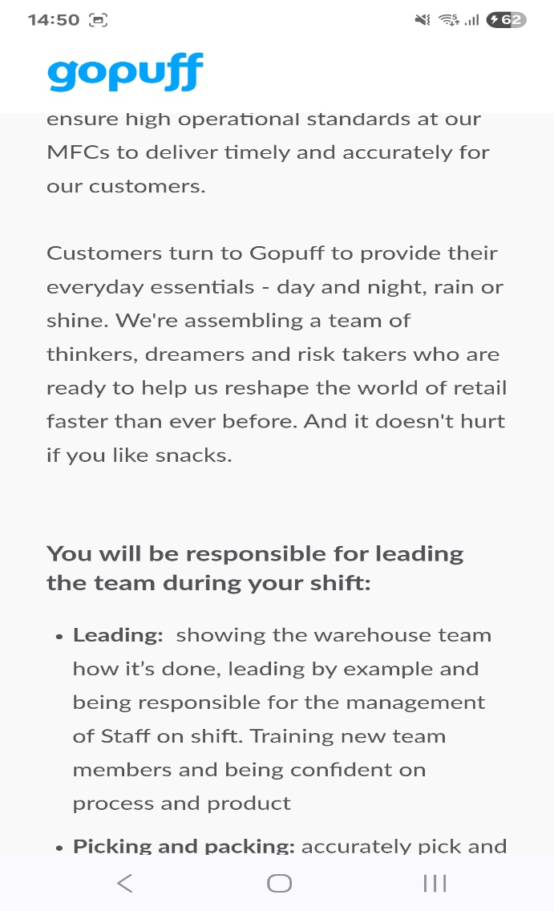
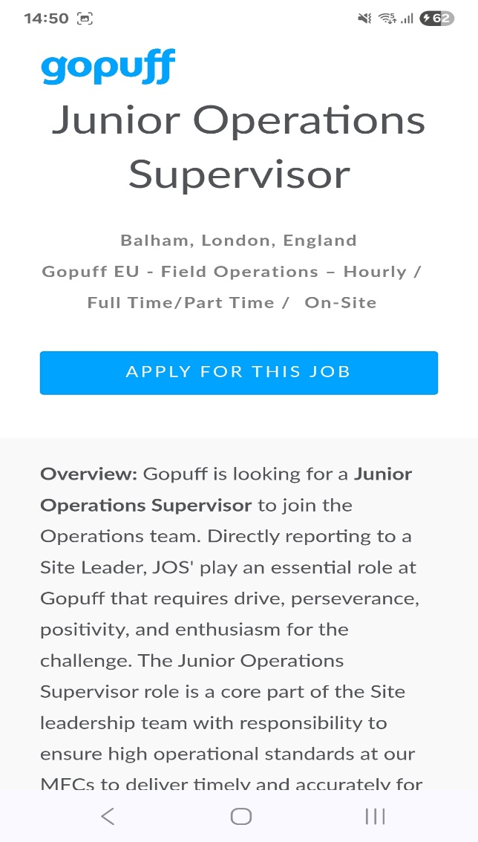
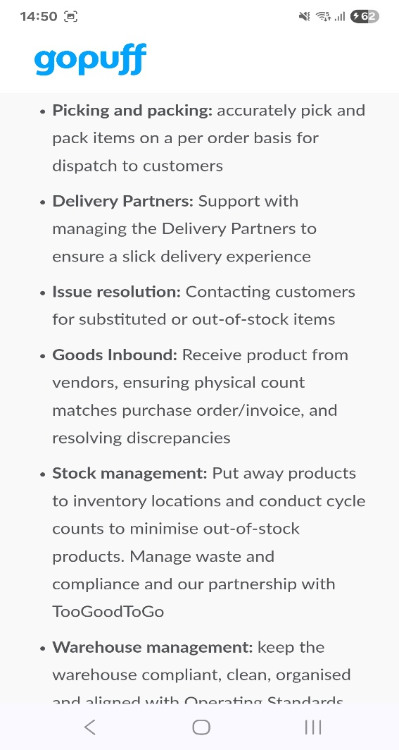

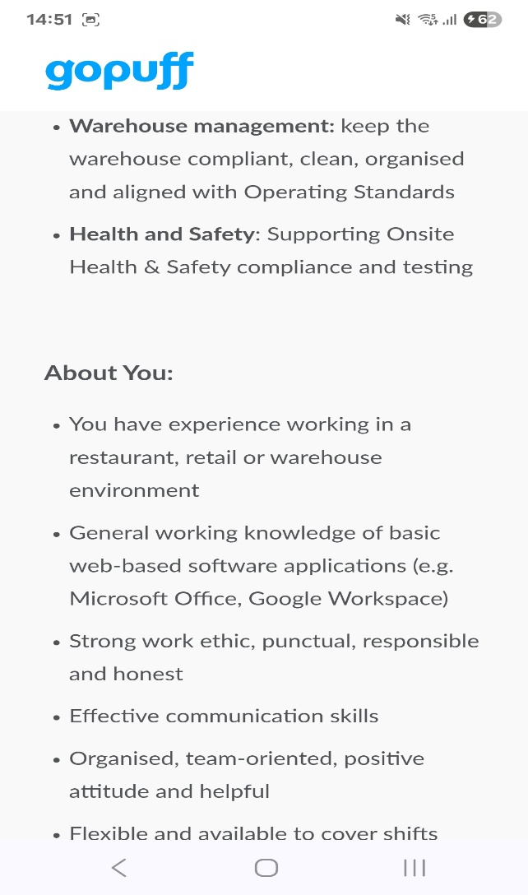

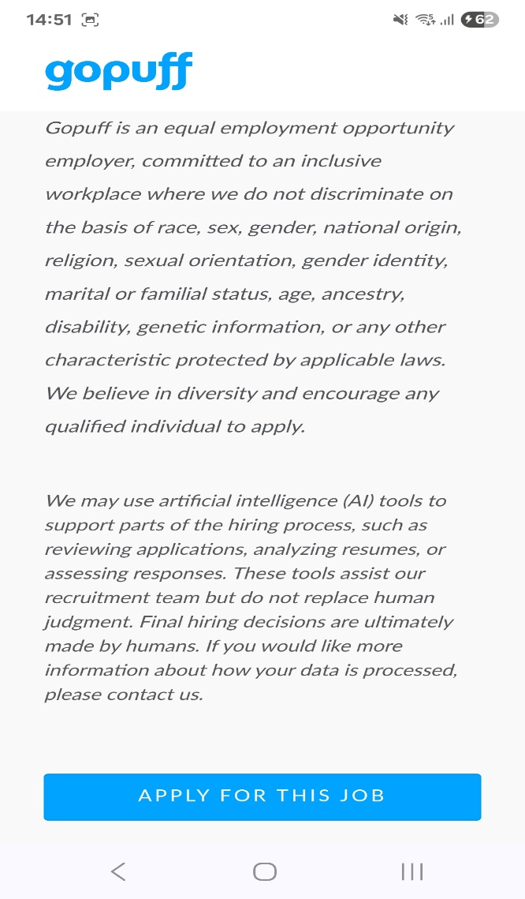
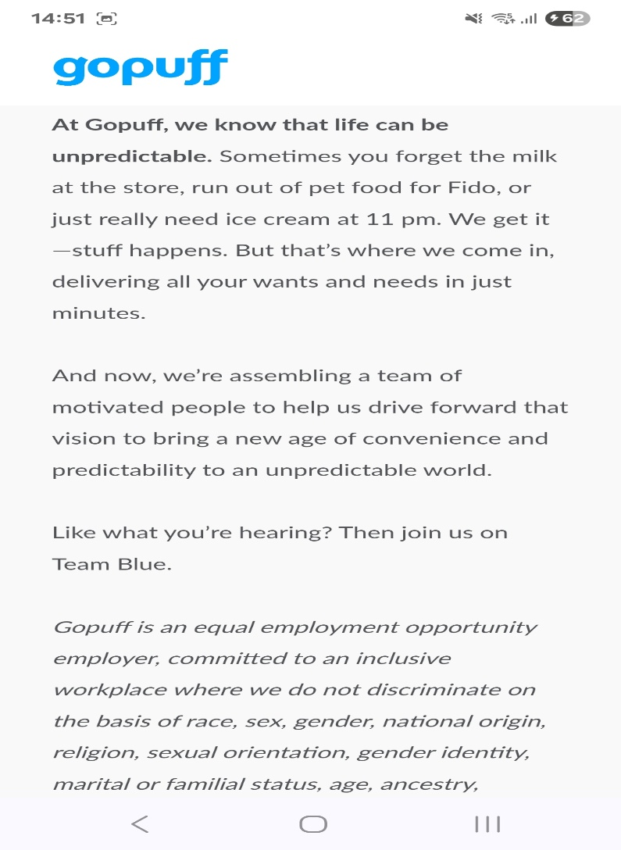
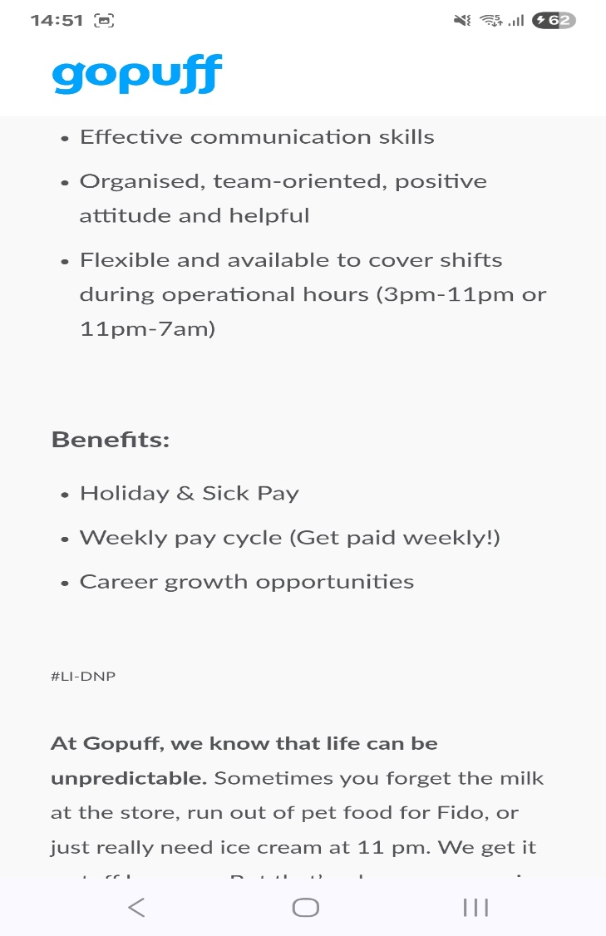

Amina Begum
Email: amina1986@hotmail.co.uk
Hiring Manager
GoPuff
London

03/11/2025

Junior Operations Supervisor Vacancy, Balham

Dear Sir/Madam,
I wish to apply for the role of Junior Operations Supervisor for the Balham site, as advertised on Indeed. Please find enclosed, my CV for your consideration.
As you can see from my attached CV, I have over ten years’ experience in the retail industry, and I believe my time at Wilkos as a Duty Manager makes me the right candidate for the role at Gopuff.
In my last role as a Duty Manager at Wilkos in Ilford, I have been able to increase sales by featuring high interest products within the store for customers to purchase. Ensuring stock is available throughout the day to meet demand was essential to my role.
Health and Safety were paramount for the organisation with checks at the start of the trading day and throughout the day. Appropriate action would be taken to make sure health and safety guidelines and regulations are met.
Working at Wilkos has enabled me to refine my skills in leadership, stock management, and communication skills. In time, this has helped me develop myself and my team to be the best they can be and work to their full potential.
I am confident that I can bring this level of success with me to your organisation and help GoPuff make daily life effortless. With my previous experience and expertise, I believe my contribution will have a significant impact on the smooth running and operations of the business. Using my skills and knowledge I am sure that I can help take GoPuff from strength to strength and become the go to solution for a customer’s everyday needs.

Thank you for taking the time to read this email. I look forward to hearing from you soon.

Yours sincerely,

Amina Begum

Amina Begum

Email: amina1986@hotmail.co.uk

Personal Statement:

With more than ten years of experience in the customer facing retail sector, I became a valued team member for Wilkos (formerly Wilkinsons LTD). Providing extensive support to management in the day to day running of operations within the store. My role involved being customer facing as well as mentoring employees to provide excellent customer service. By working at Wilko’s company, I was able to work up to duty manager level to run the store and managing thirty employees, whilst reporting back to higher management.

Core Skills:

- Customer Service | - Team management
- Time Management | - Prioritising Tasks
- Project planning | - Stock Management

Employment History:

Relief Supervisor/Duty Manager
Wilkos Ilford (Formerly Wilkinsons) – October 2012 to Feb 2019
My duties were as follows:
  - Customer Facing Service on shopfloor and helpdesk.
  - Duty managing
  - Floating tills, end of day cash up
  - Admin tasks (rotas, tasks allocation, wage payments)
  - Promotions management

Picker
Sainsbury’s Fulfilment Centre London - June 2016 to November 2016
Duties included:
- Accurate picking stock for online orders
- Housekeeping in warehouse

Section Leader
Wilkos Ipswich (Formerly Wilkinsons) – September 2007 to September 2012
Duties were as follows:
  - Managing seasonal sections (Gardening, Back to School, Halloween, and Christmas)
  - Putting on layouts and plans
  - Merchandising
  - Customer Facing Service on tills and shopfloor.

Education:

Feb 2025 – University of Wales Trinity St David, London Campus
Dec 2025 Level 4 Certificate in Higher Education, Business Skills for the Workplace Continuing

Feb 2021 - London Free Courses Six Weeks Online Course Autism in Children Pass
Apr 2021

Sep 2003 - Suffolk College Ipswich, Diploma in Business Administration Pass
July 2004

Sep 1998 - Northgate High School, Ipswich, GCSE’s Pass
July 2003

Interests and Hobbies:

In my spare time, I enjoy reading books and puzzle solving in terms of crosswords and wordsearches. While at home, I do love to entertain and host small events with family and friends. Going for long walks and socialising with new and familiar people is also a favourite pastime.

References:

Available on request

