

A final year project
for degree of bSC. Cloud computing
by
Mohammad Fahad
(1303749)

Supervisor: Dr Renuga Jayakumar

Declaration of Originality

I am ……. Mohammad…Fahad……. declare that I am the sole author of this Project; that all references cited have been consulted; that I have conducted all work of which this is a record, and that the finished work lies within the prescribed word limits.

This work has not previously been accepted as part of any other degree submission.

Signed: .... ..Fahad......................................

Date: ...14/03/2019............................................

FORM OF CONSENT

I am ....Mohammad.....Fahad… hereby consent that my Project, submitted in candidature for the B.Sc. (Hons) Cloud Computing degree, if successful, may be made available for inter-library loan or photocopying (subject to the law of copyright), and that the title and abstract may be made available to outside organisations.

Signed: ...............Fahad..............................

Date: 14/03/2019.............................................

Copyright Acknowledgement

I acknowledge that the copyright of this project report, and any product developed as part of the project, belong to University of Wales Trinity Saint David, London.

Acknowledgement
I would like to thank and feel proud to be a student of my honourable lecturer and supervisor Renuga Jayakumar for her valuable advice, comments, and suggestions throughout the course of this project. She has motivated me to continue this project until the last moment of submission. I thank her and appreciate friend’s help, support of resources who help me to complete this project successfully.
Then I also hereby love to say thank to University of Wales Trinity Saint David, London all the members and specially all the lecturers for their kind helps during the project research.

Abstract
Mobile app development has been much popular project for many research categories. Large organisation and companies use mobile app to help customers for flexible services and reduce cost in store. Home search app is a mobile app based on android platform to help of estate agent customer to search properties in various locations. The app provides helpful services such as finding houses, price, pictures and booking for viewing property with seller. The data of app is securely stored in firebase database and loads from the server to individual users including admin console. For this research, the author explained all available details with journals, Google scholars, books and reliable websites throughout the report.

Table of Contents
Chapter 1 Introduction 9
Aim: 9
Objectives: 9
Structure of the project: 10
Chapter 2 RESEARCH & REVIEW OF LITERATURE: 11
Introduction: 11
What is smartphone apps? 11
Mobile App Development mechanism: 12
Android VS iOS: 12
Features of Android OS: 13
Features of iOS: 13
Home Search App: 14
W3ORG: 14
AND HEURISTIC: 14
Development Toots: 15
Android Studio: 15
Development environment: 16
Java: 16
XML: 16
Firebase Console: 17
Other tools: 17
Eclipse: 17
GitHub: 17
Chapter 3 – Research & Development Methodology: 18
Introduction: 18
Waterfall model: 18
Analysis Phase: 19
System design: 19
Architectural design: 20
Implementation phase: 20
Coding phase: 20
Testing phase: 20
Maintenance Phase: 20
Advantage of waterfall model: 20
Conclusion: 21
Chapter 4 - Analysis: 21
Introduction: 21
Requirement analysis: 21
Functional requirements: 22
Non-functional requirements: 23
System requirements: 24
Client requirement: 24
Server requirement: 24
Hardware requirements: 24
- Risk Analysis: 25
Introduction: 25
The Risk Management Process: 25
The impacts of Risk: 26
Low Level risk: 27
Medium level risk: 27
High level risk: 27
Risk Management Plan: 27
Risk Summary: 28
Chapter 5 Design and implementation: 28
Introduction: 28
Navigation Scheme: 28
App Home Page: 29
Booking Page: 30
Registration: 31
Sign in: 32
Adding property: 33
Search activity: 35
Result activity: 36
Admin portal: 37
Chapter 6 -Testing and Evaluation: 39
Evaluation and Reflection: 48
Personal Evaluation: 48
System Evaluation: 49
Reflection: 49
Chapter 7 Conclusion and Recommendations: 50
Conclusion: 50
Recommendations: 50
Chapter 8 References 52
Appendix: 54

Introduction
The use of mobile apps has undergone exponential growth since the innovation of smartphone. According to Cisco & Co, In recent years, The number of smartphone raised by 406 million between 2013-2014 which crossed approximately 1.82 billion devices in a year and online access increased by 81 % via smartphone device. [1] The characteristic of smartphone app has constantly growing in downloading, app purchasing and releasing new version on demand in the market. The most popular platform, android operating system developed by Google reached top sharing open source app platform since the beginning of app market. According to latest statistic rate, the total number of android apps on Google play contains 2.5 million in 2018 which has been double in 2 years. (AppBrain, 2018) [2] However, the challenges of smartphone users are gradually changing to usage of apps preference. A study found by Vision mobile that the highly skilled developed app is gradually falling down in the market due to various interest spread over the people. Not only gaming and social media app has gained popularity but big industry like Foxton has their own developed app to make easier for customer service.
The housing market in England is increasing significantly where 6.9 ratio to 12.88 between 2002 and 2016 raised along in London itself and expected to be double in half century. Due to such popularity, most of the famous company like Foxton, Rightmove, Zoopla and Purple-brick invest a lot of money in developing user-friendly app to communicate and offer various services for their customer. The estate agents advertise offers and services via mobile app and number of developed app available on the market. However, the features and performance should be changing accordance with customer needs and behaviours of management’s services they offer. The "Home Search" is a leading property search estate company in London required to develop a property search android application to feature of developing effective housing search and communication between agent and customer.

Aim:
There are thousands of apps in both google play store and apple app store offering free property search for sale and buy for example, Foxton, Zoopla, Rightmove, Housing, to the public. The most popular company like Foxton has their own individual app in play store for customer support in looking for property, booking, viewing houses, property description, contacting with an agent and budget planning arrangement. However, not all companies create such project design on the mobile app. In this project, the aim is to demonstrate and develop the property search android app to manage services for its customer in the market.

Objectives:
- To develop a friendly mobile app based on android operating system to support "Home Search" administrator.
- To evaluate the project with necessary tools and learning the tools in detail.
- To implement an attractive design effective task in mobile environment.
- To research the tools and take challenges in android studio.
- To identify and discuss the risk and explain details of risk management.
- To compare different property search apps in the market.
- To compare the operating system between IOS and android.
- To analysis further development for future career on this project.

Structure of the project:
The following report of this project is designed based into categories which are separated in different section. The categories include an overall overview of this project containing introductory speech, background study and discussion of the apps available in the market. One of the most important categories is presenting the literature review studied previously on this subject. In the third-category comes the necessary of methodology used throughout the project which is the delivery model and various requirements such as time management. In the last category, it is necessary to explain the design and testing the project which are required to implement the project and finalising with conclusion and future career studies.
This chapter gives a clear view of the project introduction exclusively highlighted the aim and objectives to the reader about the project.
Chapter 1
Introduction

Chapter 2
Research and Literature Review

This chapter illustrates the research and literature review which explains any case study has been done previously about property search app along with background research and project development.

Literature review
Chapter 3
Research Methodology
This chapter explains the development methodology followed during the project lifecycle including comprehensive research and implementation.

Chapter 4
Analysis
This chapter highlights on any problem created with and supports of troubleshooting about the requirements of development, risk management along with mitigation process

This chapter provides the presentation of the project including design implementation and description of the implementation with appropriate screenshot.
Chapter 5
Design and Implementation

Chapter 6
Testing and evaluation
Testing and evaluation chapter identify the development after completion of the project which includes various testing stages, testing screenshot with result and proof working.

Chapter 7
Conclusion & recommendations
The last chapter will summarise the project by explaining short summery that has been created in the development and overall result. This chapter will also provide career achievement and future recommendation.

RESEARCH & REVIEW OF LITERATURE:

Introduction:
In the research and review of literature illustrates clear discussion based on journal articles, online books, conference, govt sites, google scholars and other reliable online sources. In this section, author highlights the structure of the research and analysis its blueprint step by step thoroughly. The background study and research project in the market are reviewed elaborately as well as to compare them with various sources related to the project. Throughout the process of this study, the author of this report preferred to use reliable online library and "IEEE Xplore digital library" "ACM digital library" to research the project.
Xu, Q., Erman, J., Gerber, A., Mao, Z., Pang, J. and Venkataraman, S., (2011) stated that since the innovation of app, it has been increasingly shifting smartphone users to interest in mobile app connected to internet services more than just web browsing. The platform of app marketplaces for Android, iOS, and Windows Phone has created it diverse and attractive to deploy apps for developers as well as free and easy access to discover for user to start using the apps through network operator quickly. For instance, more than 10 billion downloads performed in iOS Appstore from 350K apps in a recent report. Not only smartphone user’s app increases but also in the usage of tablets and iPad which also use the marketplaces are rising the diversity with their user population. Despite such increasing growth of apps as gateways services, it is important to acknowledge the apps services particularly at user’s scale and behaviour by the results. [3]
Chun, B.G. and Maniatis, P., (2009) explained that smartphones enrich a new user experience in computer technology even its hardware, memory, energy service and processor are limited comparing to the traditional computer infrastructure. Connecting with internet access, various services attachment such as GPS, power and sensor are becoming explosive in Apple iPhone, Google Android phone and Windows phones. Due to diverse popularity in application, the developer sets beyond the boarder of personal information and playback music, games rather handle finances, health report and in use of property selling ads. However, these vast application power keeps great responsibilities in platform execution to runway process, memory leaks, malicious intrusions, data disclosure and sucking up power. [4]

What is smartphone apps?
A mobile app or smartphone application refers to a software or computer program which run on mobile devices for example smartphone, tablet, iPad and watch. An app seems to be using in everyday life such as checking whatsup messages, breaking news, chatting in social networking. However, apps or application was particularly designed for assistant productivity for example emailing, contact and calendar which rapidly extended to games, GPS, factory automation, ticket purchasing and order-tracking etc. (bbc, WebWise Team 2012) [5] There are distribution platforms to download the apps from the manufacture of the operating system such as App store for Apple iOS, Play store for Google Android. Some apps are payable a fixed price for both app creator and operating system but most of them are free to use in public. During an app selection, app store takes little bit time to check the compatibility of model then the app download completes it starts installing automatically behind and when the download and installation finished, an icon shows in the home screen. (Siegler, MG 2008) [6]

Telephone calls: In general, primary purpose of smartphone is to deliver outgoing and incoming calls which also provides messaging service just like a cellular phone. An optional function called "speaker phone" attached in every smartphone.
Camera & Video: Smartphone is not limited to calls and messaging services but also include digital camera for taking high quality photographs and videos. It is also possible to share photographs directly from the device to social media, email and text.
Calendar: Smartphone provides calendar service in which any schedule and appointment can be added and edited immediately to share the synchronized update to someone in personal on-line calendar.
Address Book: In earlier age, paper address book was popular in crossing-off, erasing or whiting-out in the page. Those days are gone and with smartphone all contacts can be added, edited and deleted like computer even prompting new contact or update contact in the address book. (Mid Yord, 2012) [7]

Mobile App Development mechanism:
The mobile application development practice is a process of application distribution, examination and different classification from developer's perspective depending on their approach by which an app is developed, published in the market as well as purchased by users. At the beginning, developer starts developing app using development tools until testing and finalise the app to publish on a portal from where the users download onto their mobile devices. This approach involves in two sides with consumers on one side and developers on the other. (Parker, 2005; Rochet and Tirole, 2003; Shapiro and Varian, 1998) In such case, when the number of users increase for a specific portal, platform or mobile device, similarly, the number of developers interested in the portal, platform or device significantly to develop the application. So, in other words, developers are attracted to develop the app by the most popular mobile device using the most popular development tool and publish on the most popular portal to get the highest number of consumers. Consumers have an interest in such popular device in which the platform running many applications. Therefore, this mechanism creates a business plan to choose a successful two-side application portal to lead attraction on the application. (Holzer, A. and Ondrus, J., 2011) [8] Google android and apple ios are the most popular mobile device in the market preferred from both side of developers and consumers.

Android VS iOS:
The innovation of mobile apps for mobile devices brought a huge economic value using internet and accessing information connected through the app. More than six Billion users use the mobile device in everyday life and all device has hardware and software specially known as operating system. (Singla D., Mendiratta L. 2014) [9] There are many operating system available specialized for mobile device which have failed ultimately to deliver the best market share such as Symbian OS, webOS. However, the most effective solution brings in impact by the development of Google Android and Apple iOS operating system. In this chapter, a comparative study is performed with the overall impact on the two major mobile platform Android vs IOS. Google Inc. and Apple Inc have been the major player in developing the mobile platform and ecosystem by their widespread operating systems around the world.
- Android, Inc founded by Andy Rubin in 2005, However, the platform powered by linux kernel finally unveiled with business alliance including Google, HTC, Intel, LG and others on the November 5, 2007. On the other hand, Apple's mobile operating system known as iOS developed particularly for the iphone at the beginning and now it also supports Apple's other devices including ipad, apple watch, itouch and Apple TV. .(Singla D., Mendiratta L. 2014)
- Android is generally built in software stack-set which is required to deliver all functional solution for android devices. The stack-set is the operating system and middleware that is based on key apps, Java like a contact manager and web browser. However, iOS operating system functions with numerous applications which are stored in apple app store. iOS software development kit (SDK) is the development platform that contains information, code and tools to test, develop, run and debug the application.
- The android operating system is an open source and freeware that allows developer to use development tools to develop apps based on java language and consists of android runtime, Core Libraries and application frame work. The network connectivity such as GSM, EDGE, LTE, WiFi supports on Linux OS and voice recognition as well as multi users also included in the external device. On the other hand, iOS operating system is a Unix based OS which attaches four abstraction layers; the Cocoa Touch, the Media layer, the core OS layer and the Core Service layer. iOS offers all network connectivity and provides sensor application for high performance and embedded development system. (Wukkadada, B., Nambiar, R. and Nair, A., 2015) [10]

Features of Android OS:
- Android is an open source platform which supported by a lot of mobile device manufacturer.
- Android OS supports a lot of free and premium apps that are easier to access by the users.
- This OS is capable of multitasking which means to run many apps at the same time.
- Most of the android mobile device offers massive external storage capability and tethering.
- GPS, Bluetooth, compass, EDGE, Wi-Fi, Camera, 3G/4G and accelerometer supports available.
- Gallery and media support for common video, audio and various image formats.
- The open source WebKit engine is based on integrated browser and GSM Telephony.
- Advertising in the apps by Ad mob has creates a huge economic value in the business (Annapurna S., Teja P., & Dr Murty Y. S., 2016) [11]

Features of iOS:
- iOS operating system is very secure and stable OS for mobile devices.
- In the iOS has less bugs and protected locks due to standard of new generation.
- It is the most preferred and loved interface which is beautifully designed including app icons and desktop.
- This operating system supports the latest web standards in high quality.
- Very secured cloud storage with 5GB free cloud storage and monthly subscription fee after any storage usages.
- App adverting provided by Apple's iAd service for iOS devices.
- Developer required to pay £99 to sign up as an app developer to upload to the app store within a year. (Annapurna S., Teja P., & Dr Murty Y. S., 2016) [11]

Home Search App:
Home Search is one of the best online property search mobile app based on android platform distributed by Home-Search organisation in England. The app is designed to look for houses based on location and availability to sell the properties to the customer. This app is easy to download and install into the mobile device including features such as registration, login and search a property and booking an appointment for viewing any house. There are two sites of this app from the admin site and customer site where customer/users must first have to register to search any property. Searching any property is simple in the home screen starting from couple of selection and go. At first user selects the location, then types of property, how many bedroom and range of price. After selecting the all choices, at the bottom down is search bar to search for result. After submission the search, the result appears with list of properties including price, pictures, description. A booking is required to view the house and booking appointment is easy, just pop in the form and fill in the form with valid information to complete the appointment.
In order to start processing of viewing, the final confirmation notifies that the appointment is granted for the desired date and time. The price and description displayed in the app are always changeable according to current market. However, there is no payment and agreement system implemented in the app, therefor any agreement made between customer and agent is under official documents which are not included in the app.

W3ORG:
W3C ORG: Marja-Riitta Koivunen and Matt May (2002) elaborated that development of usability could be defined into three ways; the effectiveness, efficiency and satisfaction which are applied to users to achieve specified goal. In an effectiveness development refers to a completeness and accuracy of the project where users get in convenient environment. The efficiency defines the resources which are in relation to the specified goal. lastly the satisfaction means the comfort and acceptability of the system works to users affected. W3C evaluates the recommendation of the development for accessibility and usability on how much they prevent the using of apps for disabled users. It also develops standard access to irrespective mode of interaction, data process and defective modularity for users. The development that are seemed to be hard-to-use or considered cumbersome generally have not generic defects and accessibility problem only but could cause prevent their use for visual, cognitive or other disabilities. [12]

AND HEURISTIC:
Multimedia and Graphics have important roles in clarifying, explaining, illustrating, grouping, drawing attention and structuring information. The awareness and some effort can make the information available for any user with disabilities. The World Wide Web Consortium's (W3C) Web Accessibility Initiative (WAI) provides guideline for accessible content, user agents and authoring tools. Based on the Accessibility and themes, the principle rules which comes up with accessibility heuristics are six explanation of mark-up language are following.
Provide alternative equivalents: It is important to provide suitable information for visual, auditive and tactile channels. In that case, following the presentation helps while a user has cognitive limitation and some senses that device cannot maintain media services.
Provide means to select equivalent content: A flexible equivalent content should be provided to the users meaning to access any combination which is suitable due to disabilities and limitation.
Provide user control for presentation: Users should be provided a presentation which separates from rest of the content. This helps user device with limited capability.
Provide device independent interaction: Users must allow to interact with different input and output which provides all available functionality. A user agent help accessing to the function with emulating device mouse.
Provide semantics for structure: The alternative way of navigation and orientation help users in the presentation by tools support. Semantics could be offered by element of language to describe the site and page navigation components.
Provide reusable components: This stage provides with media which makes laborious in comparing with components application. (Koivunen M., McCathieNevile C. 2001) [13]

Development Toots:
There are four major players of development of native framework which comes under certain expectation by the users. Educational and governments are often used BlackBerry while Android and iPhone are far widespread users compared to Windows phone being less used by the developers and users. The android framework is designed writing in Java which is developed with any Java tools. The Google and Android community recommend specific tools such as Android studio, Eclipse with android toolkit. (McWherter J. & Gowell S. 2012) [14]

Android Studio:
According to android official site explains that Android studio is the official IDE (Integrated Development Environment) for Android development which is designed on Intelli IDEA. Android studio offers productivity of following features during app development.
- It is a gradle-based flexible system
- An emulator that is fast and feature-rich.
- Developer can develop in a unified environment for all android devices.
- The running app could be pushed and run instantly without building new APK.
- GitHub integration and code templates help to do common features and sample code importing.
- Frameworks and extensive testing tools for higher performance.
- Lint tools to use usability, catch performance, version, combability.
- It supports C++ and NDK.
- It is built in performing for Google Cloud Platform which makes easy integrating Cloud messaging and App Engine.
Each project contains modules with resource files and source code. Such modules include android app modules, Google app engine modules and library modules. The studio displays the project in app screen view and provides quick access to source files which are visible under Gradle Scripts. Each module for app includes the following contents:
- manifests: It contains the specific file named AndroidManifest.xml.
- Java: Java is the primary source code files which includes JUnit test code.
- res: It contains non-code resources for example, XML layouts, bitmap images and Ui strings. (Official android development site) [15]
There are other tools in window to organize the screen space more comfortable and logical area in development environment.
Development environment: John Horton, 2015 explained that a development environment refers to the resources which a developer needs to develop, set up and finally ready to run in one place. Compiling the java code into DEX code runs on the DVM, on user's devices and using a free software known JDK includes other people's code, integrate from the Android API. There are range of tools to develop for android app, all are required the Android API. Such requirements and tools together are collectively called as the Android software development kit (SDK). Downloading only a single application provides these whole bundles together and the application is called Android Studio. [16]

Java:
Java is a high-level computer programming language originally conceived by James Gosling in 1991 which is used to develop software and Android application. Java is an object-oriented language meaning the concept of reusable programming objects based on real-world things. Java language is written in java code which can be structured and used over and over again. The source file is called as compilation unit and all code remained inside a class where the main class should match to hold the program with the name of the file. Java is case sensitive that make sure capitalization should match the class name. java compiler takes the text file to compile into a platform-independent java file. A simple java program starts and finish in three steps; 1. enter the program 2. compile the program 3. Run the program. (Oracle development team) [17] An example is given below;
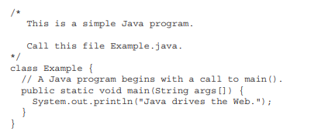

XML:
XML stands for Extensible Mark-up Language much similar to HTML language to describe data. In Android environment, xml is used to design layouts and layout refers to the structure of user interface such as an activity in the app. XML includes shapes, structures, labels and protects information which are embedded in the text called "mark-up". Mark-up identifies the parts which relate to the information by using symbols. Computer programs process the mark-up to electronic documents. When the document has no boundaries or labels then computer program does not know to distinguish the text and, in that case, the entire document would work as a unit by the programmer. XML's mark-up sorts out the document into information containers which is called elements. The container seals up the data, label it and give the information in a package for computer processing. xml documents include all outermost elements and administrative information in the hierarchical structure. (Erik T. Ray, 2003) [18]
XML processor is a software module used to read xml documents and gives access to the structure and content. The application works in the background on behalf of XML processor and describes the specific information required to provide the application. The design of XML should be straightforwardly usable to support variety of application. The xml document should be compatible with SGML and human-legible clear and be prepared quickly in formal, concise way. [19]

Firebase Console:
Firebase is a platform of management which acts as server of web application and mobile application developed by Google Firebase in 2011. The large company Google purchased and further developed to building application such as Android, iOS and website platform. Firebase console offers the most flexible and scalable real-time database for developer to store, synchronise data based on NoSQL cloud database. There is no manual updating of synchronisation among the clients which performs the task while the app is offline. The cross-platform app has a great place in firebase console in either iOS or Android, JavaScript SDKs to share and update automatically by Realtime Database.

Other tools:
Android applications are built-in java programming language and the android itself is nothing but an environment to run apps. As to develop android application any distribution or (IDE) integrated development environment can be used depending on the developer convenience. Android offers open source platform and unified approach for developer to develop in need of different devices which are powered by Android. There are many development tools except Android studio and Eclipse is one of the most popular integrated development environments.

Eclipse:
Eclipse is an IDE to develop application or software in any language. It was begun in proprietary replacement for java founded from IBM and open source in 2001. It is now controlled by non-profitable independent organization known as the Eclipse Foundation. Since Eclipse is being used by over 50 million developers worldwide. It runs on most of the popular operating systems and requires java installed on the machine. There are few reasons to recommend IDE for Android applications; the most fully featured Java IDEs for free in the market that is easy to use for solid, open java development. Eclipse for Android plugin was released by the open Handset Alliance to create specific project, use the emulator to run, compile them and debug them. These tools provide invaluable abilities to create setup elements for example compiler settings and files help save development time and decrease the learning curve. (J.F DiMarzio, 2008) [20]

GitHub:
Zagalsky, A., Feliciano, J., Storey, M.A., Zhao, Y. and Wang, W., 2015 explained that the software development team has been utilizing GitHub as an important platform to manage and operate the software projects. GitHub helped developers improving development work and professional software efficiencies. It not only offers repository for a traceable project but also contribute in social meeting for parties and community supports. [21] It has been an essential tool in widespread adoption of software development technology for education over a shared repository area. In 2012, computer science educator Greg Winson elaborated that “GitHub for Education” isn’t necessarily, “Let’s put educational materials in GitHub”, but rather, “Let’s facilitate a culture of spontaneous-but-structured collaboration and improvement.” [22]
Klint Finley (2012) stated that the GitHub is an open source project of large community site for code sharing as well as publishing services which uses the Git distributed version control system for programmers. A trainer at GitHub named Matthew McCullough described the Git that like control system to store and manage revisions projects. He also explained that Git is used not only in code but to manage other files such as word documents. Git repository is a command line tool which provides hosting services, web-based graphical interface, access control and collaboration features. [23] Apps on GitHub provides development of improving and automating the workflow and it is a great place to share or sell the apps on GitHub Marketplace.

– Research & Development Methodology:

Introduction:
Development methodology is a process of developing software and information technology of computer system that specifies the framework of managing, planning and controlling development approach. In another word, it is also called "Software development life cycle" a term (SDLC) which is utilized in industrial field such as system & software engineering, computer engineering of computer science. SDLC is a fundamental process of information system development used for models and methodologies to develop the software system. The development methodology has been examined by many people which has different types of models found in their research. Each methodology has certain strengths and weakness acknowledgement from the practitioners. The Waterfall, rapid application development, agile software methodology, rapid prototype and spiral development model are the most popular and successful models among the software development methodologies. These all methodology follows a sequence of phases to forward or backward in system designer which must follow to deliver result. In this project, the author followed the most popular Waterfall model throughout the project. (Adetokunbo A.A. Adenowo, Basirat A. Adenowo, 2003) [24]

Waterfall model:
The waterfall model is also called as the cascade model and in 1956, it was first introduced by Benington and after in 1970 was modified by Winston Royce. It has outlined and underpinned other models to create a strong foundation for requirements prior to any development or design to be defined and analysed. The cascade model originated by Bennington suggested that any software is developed according to this model to be in stages; operational analysis - design - coding specifications - development - testing - deployment and evaluation. There has been unforeseen design by recognizing while a baseline created after each stage ends. The waterfall model is the very efficient way of software creating mechanism which includes compilers, relational databases or secure operating systems. (Nayan B. Ruparelia, 2010) [25]
Youssef B. (2012) explains that the waterfall model is a sequential process of software development which steps in downwards consequently in the process of execution phase to build a successful software development. Weisert, C. (2003) has also agreed that the approach of completed phase must not go back due to previous frozen result and any task belongs to following phase should not be allowed on any changing need. [26] The software engineer Winston W. Royce first studied in 1970 and discovered the possibility of new methodology known as linear-sequential life cycle model. He stated in his statement that the development step of consecutive phase must be followed by developer from top to bottom successfully be completed before approaching to the next phase. Every phase of development needs to be sequence of procedures which could include effort, timeframe, budget, equipment, plan and tools to achieve and manage fruitful productivity in less time and in less investment. The SDLC model which was introduced in earlier age used in successful project in software development, was divided into numerous phases and acts outcome during the completion of first phase. In such behaviour, It was named as Waterfall model. [27] In the following diagram, different phases of waterfall model has been presented below.
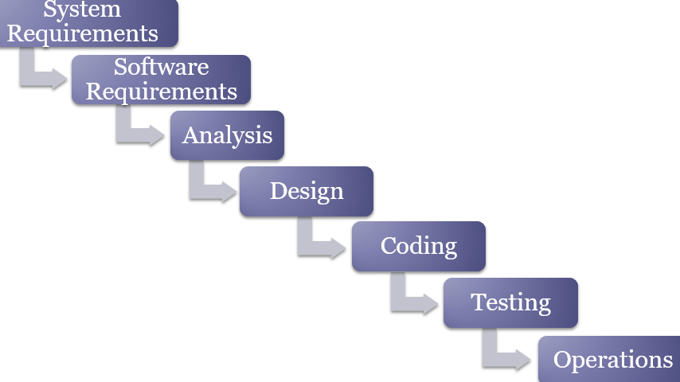
Figure 1: The design of waterfall development model
Analysis Phase: Requirement analysis begins while an organisation enhances, growth and system development when the condition of user cannot change. The changing and modification of development design required public discussion and users experiments to get output result of further development growth. The system should work perfectly as like their user expected the service. User requirement is prioritized significantly which is important to identify and understand the end user condition. The analysis phase implicates business analysts and system identification to explain functional and non-functional requirements.

System design: The objective of design phase starts from system requirement which identifies software requirement system into structure capable of executing programming language. The design phase is the process of problem solving, planning for software development solution. Software developer and designer are implicated the plan for solution that involve in software architecture design, algorithm design, logical diagram design, graphical user interface design and database conceptual schema. The hardware and software layout system are implemented in algorithm programming between analysis and code.

Architectural design: It ensures the software framework of system to produce the specific requirements. The design refers to the major components during interaction and does not explain each structure of the component. The external interfaces as well as tools which are used can be determine of the project by the designer.
Implementation phase: It defines to the utilization of business need and design specifications into a stable executable program, web content, database and software component through deployment and in programming model. In this phase, an operational application is applied to compile and to write the real code where text file and database are created in the application. It is also called a production environment for its converting the requirement and blueprint.
Coding phase: Coding phase is also known as implementation phase which has been discussed earlier. However, particularly in this phase, system stipulation and design are implemented and executed into programming language. When system design is satisfied and completed successfully in accordance with the requirements, then coding phase comes in the following phase. Developers are more likely interested implementing at this stage.
Testing phase: It is also called in sort form as validation and verification which refers to the process of software solution for checking its original requirements and specifications. Specifically, verification is a form of software evaluation to ensure whether development phase is satisfied the condition of the given product at the beginning of that phase. Whereas, validation is a form of software evaluation while the development process ends to determine that it meets specified requirements. [28] Furthermore, the testing phase performs important task including debugging where system glitches during any bug is found, refined and corrected accordingly.
Maintenance Phase: Software maintenance is the last process of waterfall model which refers to modify a software solution after complying its delivery as well as deployment to correct errors, refine output, quality monitoring and improve performance. In addition, the activity of maintenance can be done including software adaptation to its accommodating environment of user requirements as well as reliability of software. (Stellman A., Greene J. 2005) [29]
In some organization, a control board manages the product quality with reviewing the maintenance stage while each stage changes. In each stage, documents which gives details of its objectives and explain the requirements for created phase. Each stage ensures that the project can proceed at the end of its next stage after the review is held. The requirements must be mentioned clearly prior to beginning the design and when the design is completed must be stated prior to starting coding.

Advantage of waterfall model:
Although the waterfall model has negativity and its downside, it is instructive due to important emphasized stage of development project. Even developer does not follow this model but should consider the stages and relationships in the projects for its advantages. In this approach, a useful and predictable process are fixed and documented to provide fruitful result for timeline, budget and scope. There are some important advantages in the following.

- Developer understands its stage and implement into the project in less time and in less effort.
- It relies on the term of sequence of steps which is suited to smaller projects with a fixed time delivery.
- This methodology focuses on clear structure, requirements, design, testing, coding and maintenance.
- The steps of each stage are committed to predict an end goal early
- This approach emphasizes on the information at each step while the project is applied in software setting.
- It reinforces specific habits such as design before code or design before design.
- It identifies deliverables and milestones. (Molokken-Ostvold, K. and Jorgensen, M., 2005) [30]

Conclusion:
There are lots of software development models existed for a long time. As for developer waterfall model is the oldest and widely practise model tending day by day. The development approach is the best flexible for small project in educational testing compared to other models. The review has uncovered that waterfall model is used with regards to duration, cost and quality.

- Analysis:

Introduction:
Analysing the project gives a clear illustration and evaluation of development structure. Any method used to analyse data of the project could bring fruitful result and produces a good formula for the development. There are many methods of analysing the project successfully such as requirement analysis & functional analysis belong to a group of requirements considered to be fundamental content of development design. In qualitative analysis, system development is used to pattern the users need and analyse depending on the structure. Michael Quinn P. (2002) stated that qualitative analysis forms the date of requirement and evaluates the project for long lasting during each inquirer transforms the development. Maintaining, checking, formulating and transmuting data is the first priority task of data analysis that help supporting decision making, system analysis and logical analysis. [31]

Requirement analysis:
The software development of service description is also called requirement analysis which explains functionalities and operation of project architecture. The requirement analysis must be built in features and structure that development behaviour carried out including functional and non-functional requirements. In this project, there are some functional and non-functional requirements required for Home search apps in the following.

Functional requirements:
The functional requirements are the system of app navigation during the usage of the app. The development behaviour works in certain condition to meet the user needs and flexibility. The Home search mobile app has functional requirements which include following.
- Administration regulates the technical system during any occurrence occurs will be carried out immediate action.
- All booking and transaction are subject to review and availability of property viewing.
- Any booking appointed is subject to change, correction and cancellation unless the appointment confirmed.
- The operation and coding are updated in the background by the administration.
- Adding new property, confirming appointment for viewing are authorised by administration.
- Admin controls all appointment in the background coding or firebase console area.
- All authorisation including are subject to control by username and password, However, the username is the email for the general users of the apps.
- In the control panel, admin can add, delete, change picture, price of any property.
- The users who register with the app, the data is securely stored in the firebase database.
- Admin username and password can be changed in the background in case of unauthorised access.
- Any modification required for the apps for future development can be estimated under the functional requirement.
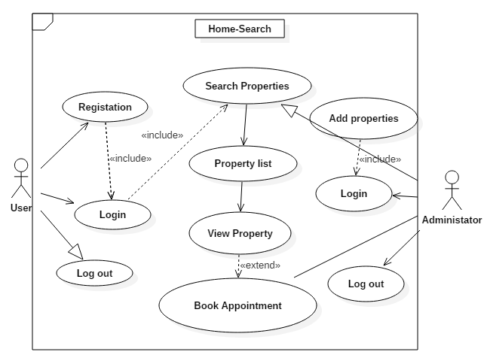
The above Use Case diagram explains an overall design of functionality working in the scene. There are two operational site which are users and admin, however, a controller can be enrolled after the implementation project. Users sign up to access for property search based on certain category and location and when they find a property required to book an appointment for viewing. In the background, administration runs and regulate the working going on between users and admin.

Non-functional requirements:

- Home search mobile app is designed and built in navigation that is based on friendly usage and easy to operate for general people.
- Once the users sign up and login to the app, they can easily search the property and navigate one page to another in user friendly mode.
- The first step after downloading the app is registration for the new user and very simple to do so within a few seconds.
- There are some validation inputs must need to provide during registration including email address, password.
- Unless a valid phone number of users cannot log in to the app and unable to access.
- Users who logged in once, they do not need to sign in again unless the app is deleted or reinstalled.
- After accessing the app as user, there are certain selections including location, type of property, number of bedroom and price.
- A logout button is attached at the corner on the app in case of users need to sign out for security reason.
- After searching, any property choice selected should be booked for viewing and step forward to purchase the estate.
- Appointment form must be filled up property and select business hours from Monday to Friday at 9:00 am to 4:00 pm.
- After confirming the booking, a welcome message will be shown to the user and will be contacted within 24 hours.
- All appointments are subject to review under administration control and can be cancelled for any circumstances.

System requirements:
It is easy to navigate the app and get searching whatever needs to design the whole site in the background. In the system requirement, to run the app smoothly in the device, it required a minimum hard disk, RAM, processor and storage element. There are pictures, documents attached with the logical link with the app and input security system to prevent the app from being unauthorised access for external gateway.

Client requirement:
- It must require active internet connection during app running.
- App must run on Android smart device with version OS 4.1.1
- Google play must be active in any virtual device such as emulator.
- At least 200MHz processor needs to run it.
- Device minimum storage 100MB required
- 32MB RAM required on the device

Server requirement:
- It must have internet access with the service.
- Server must have continuous service to deliver
- All incoming package should accept the users
- Firebase console provides services of server management.

Hardware requirements:
- Android studio setup and updated to latest version
- At least 4GB RAM for the PC to run the android studio and emulator.
- Hardware storage space minimum 10GB in the computer
- Can be developed in Windows, Linux or Mac platform.
- Monitoring resolution should be at least 1280x800.

- Risk Analysis:

Introduction:
Bass, T. and Robichaux, R. (2001) elaborated that Risk analysis is the process of introducing of detection, identification to minimize and to control risk of system management information from vulnerability, critical threats over the fundamental operation for the project. The risk management analyses any threat involved with commercial assets and individual project which are evaluated as well as detected of security risk before further processing mission. Any risk could be fluctuated higher or lower than expected result depends on vulnerability and intersect occurrence. In this project, author explains how important and how could be analysis any risk involved with the project and how to mitigate during the occurrence. [32]

The Risk Management Process:
Dr. E. Wallmüller (n.d) quoted at the Boehm's risk management process in his articles. The risk management process was introduced by Barry Boehm in 1989 for development of a software project. It proceeds to process explicit development of its lunch for software architecture later on in 1980. The development lifecycle model was driven into spiral model by Boehm B and begins processing since his research method steps forward in the fundamental level. He discovered two sub-process in his risk analysis which are “risk control” and “risk assessment” in his risk management process.

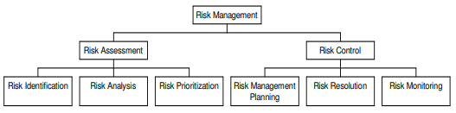
The steps of risk identification comes with project environment of conceivable listing that creates risk checklist, analytical method, brainstorming idea and other important procedures. The risk analysis gives an evaluation of impact during the identification process that may include any possible negative effect and possibility of dangerous occurrence in the event of risk determination. The risk stage is specified to know the sequence of behaviour which should be dealt with in order to prevent any losses or reduce the result during the risk event is evaluated and identified. (Wallmüller, E., 2002) [33]

The impacts of Risk:
The impact and consequences of risk event are the two main factors during the risk management procedures. There are many possible reasons of losing data and could bring dramatic loss in the project. For example, due to faulty pen drive or memory disk, the data which yet to be backed up can be lost permanently and impact level is high during the occurrence. The probability of impact chart help getting the key dimension of risk event. However, Probability of risk event could be raised anytime which could event escalate from 0% to 100% up and down depending on the circumstances. For instance, The data stored in computer system is down temporarily and is unavailable to use until it is fixed but if the system required to erase the storage, the risk level arises high to 100%. Moreover, the impact makes episode by its level and creates bad results after any occurrence happens. Although, the size and level of impact vary depending on the issues such as human life, health & safety and cost. The fundamental formula that Mind Tools developer (n.d) elaborated in the following chart below. In the chart, there are two possible dimensional risks which is shown on one axis of the chart and impact of risk event occurs in the underline dimension.
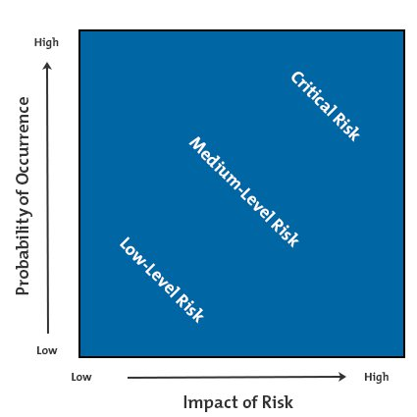
Figure 4: Risk impact and probability chart.
https://www.mindtools.com/pages/article/newPPM_78.htm
There are three circumstances of risk level depending on the consequences and probability of occurrence during the risk event.
Low Level risk: Although risk level is fluctuated over time, however, When the possibility of occurrence is below the level of any threat is called low level risk. In the above matric, the bottom corner starts with low level risk. Such as, data is copied and stored into multiple place has low level risk.
Medium level risk: The impact of medium level risk comes after low level risk which is moderate in occurrence. However, in medium level, management should take pre-procedure and continues plan during the risk case occurs. The impact and probability of risk matric is located in the middle.
High level risk: If the risk level increases into high level there is possibility of losing data higher than expected and it could be completely lost and no other way to get it back. The top right corner of matric explained the critical impact and higher possibility of risk level. [34]

Risk Management Plan:
In the risk management factor, it is widely known the most meticulously project plan could be ruined into water even after a strong project plan laid carefully. Although any unexpected issues could be encountered any situation, risk management plan can analysis and identify the potential risks.
Identify Risk: It is very important to create a checklist of potential risk sources and possible risk events from the past project experience. Potential risk could be based on schedule, technical, weather, cost and environment. When project file is lost from one source like pen drive, possibility of risk identified.
Assess the impact of Risks: When the risk of project data identified, then it should be evaluated its consequences of potential loss. For example, if the project file's pen drive is lost or stolen, the probability of subsequence occurrence can be repeated.
Implement, Monitor and minimization progress: Several approaches can be taken to mitigate the risks and each step can be effective tool to reduce the risk such as risk sharing, risk avoidance, risk reduction and risk transfer are the strategies to test and update the Risk management plan. [35]

Risk Summary:
Risk factors | Circumstances/Consequences | Mitigation
System Crash/ Data loss | All data can be lost due to system failure. Risk level High | Must have a copy of file or alternative real time data saving method.
Personal circumstances | There are other subject to learn with this project and the pressure of doing comes to make difficult for this project. | It can be mitigated with hard work and giving lots of work in studying and researching for the project.
Cloud storage risk | Risk includes lost of password or forgot user id | Alternative way must be kept to store in secured drive.
Learning obstacle | It has been difficult for the first time and risk level medium | Learning and researching more and more can be mitigated.

Design and implementation:

Introduction:
Designing a beautiful app is not only a good credit but also its structure and audience said Lopuck L. (2012). The fulfilment of professional app focuses on business goal of organisation where production process integrates working with technical and visual design. (Dummies, 2012) Over the design and implementation chapter, the author will explain the design of application including screenshot and explanation.

Navigation Scheme:
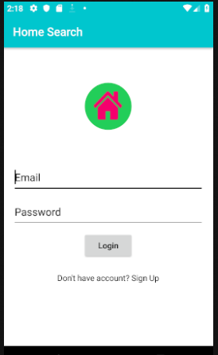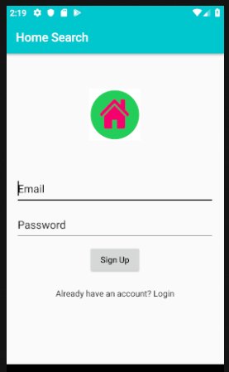
The navigation scheme is structure of application and a plan to ensure how one page relates to each other. In the HomeSearch app the first screen comes with sign in or sign up and either the user can switch to. However, after signing in or sign up the next page is the home page where the main task performs. In the Home page app, there are selection of task for specific searching which takes into result page. In the result page, there are list of properties with photos. After opening the, the image of property including appointment booking information.

App Home Page:
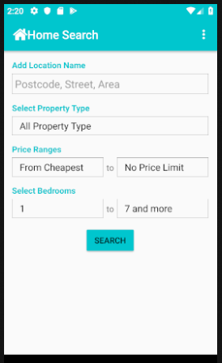
Home page is designed in various functions and relates to all other sub pages to navigate with. For that reason, It is important to make it simple and user friendly to user whatever they feels to do. The HomeSearch home page is designed in unique character with unique selection for a particular result including number of bedrooms, property type, price and location. All search comes up depending on the availability of the property for sale.

Booking Page:
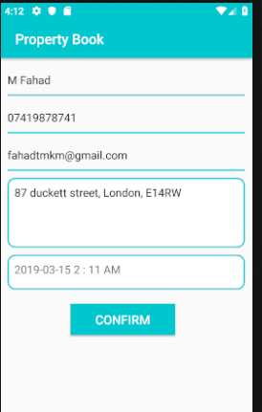
All user can book an appointment depending on availability of a particular house. However, the property reviewing is subject to change on particular day and time. The viewing time must be 9am to 5pm during the working days. All booking can be checked in the firebase database within the time frame after submitting appointment form.

Registration:
Registration is the first process after downloading the application for a new user. As the app is built on android studio and converted to apk format which can be used to download into any android device. There are bunches of codes to work with to link with firebase to register email and password. When the user opens the app the first thing shows sign up and if the user already signed up he can sign in straight way.
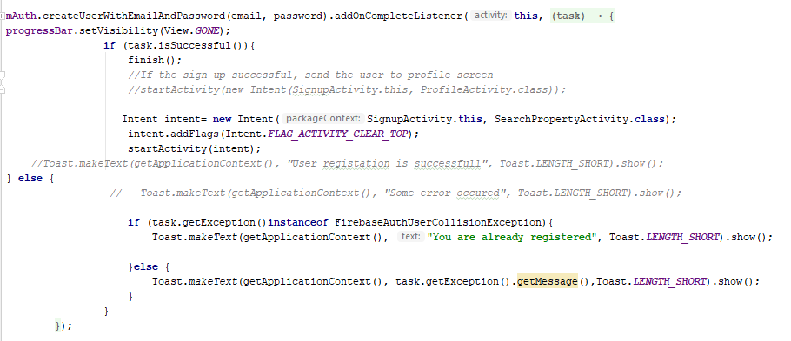
The registration codes are embedded with firebase authentication. The above code explains to the firebase authentication.

Sign in:
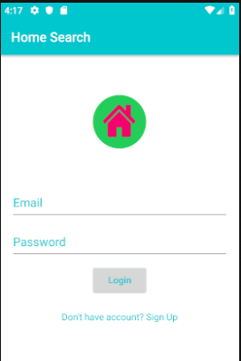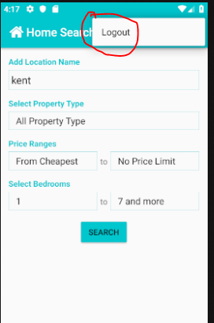
Users can sign in or sign up after operating the registration. The sign in authentication relies on firebase console. All registration data is securely stored in firebase real-time database when the user logged in, the data restored from the firebase where the code links to the app below.

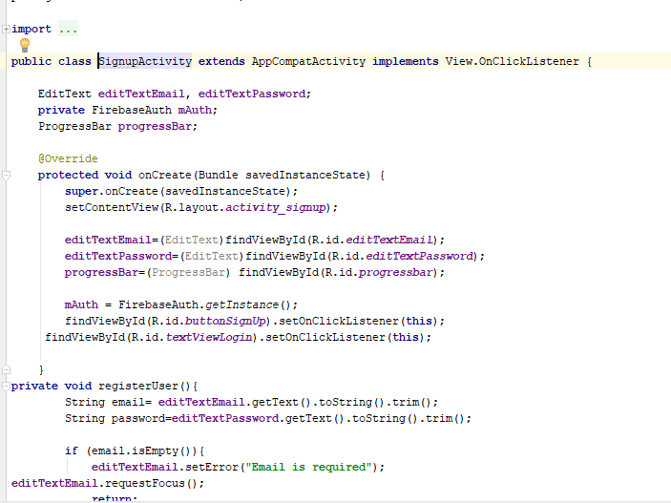

Adding property:
There are two to add properties in the app, one is to be adding by admin portal and another one adding manually in the firebase console area. During adding any property, it’s important to include good image and description of the property. Below is the screenshot of property adding selection.
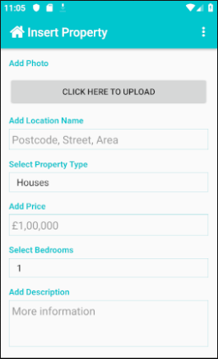
There are six sections of information in the property insertion which are adding photo, location, property types, price, bedroom and description at the bottom. The background coding below shows the connection with firebase insertion adapter and values of each section.
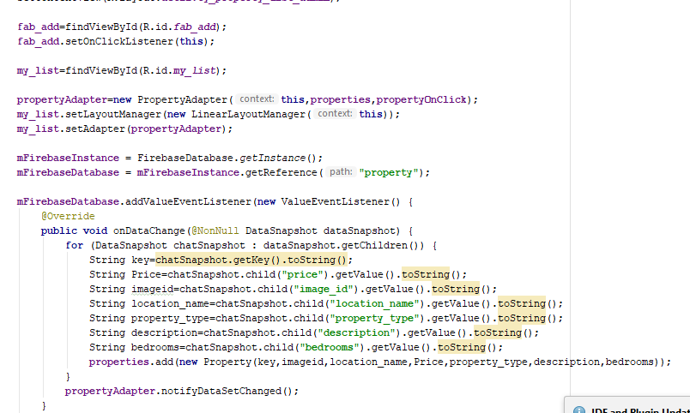

Search activity:
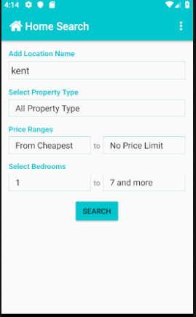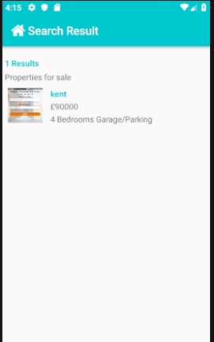
Search option depends on the activity of home page selected item search on. The code shows the mandatory option location and other selection from the home page.
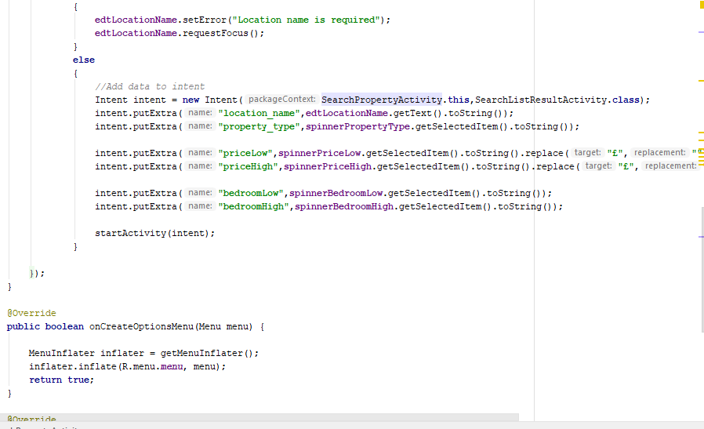
Searching the property is easy in the home page, when users log in to the app the first screen is the selection of data to input and search. The code shows below to define the selection of property to be searched for result.
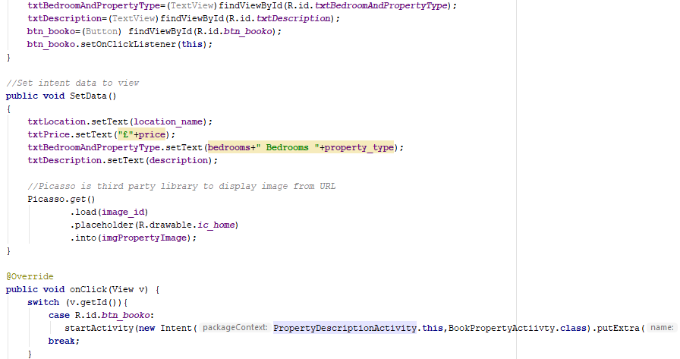

Result activity:
Property shows when any property added in the database by admin within the location. If no property added in the database the search, the result displays “No property found in this area/location” the firebase code called “mfirebaseDatabase” helps to retrieve the data from the data store.
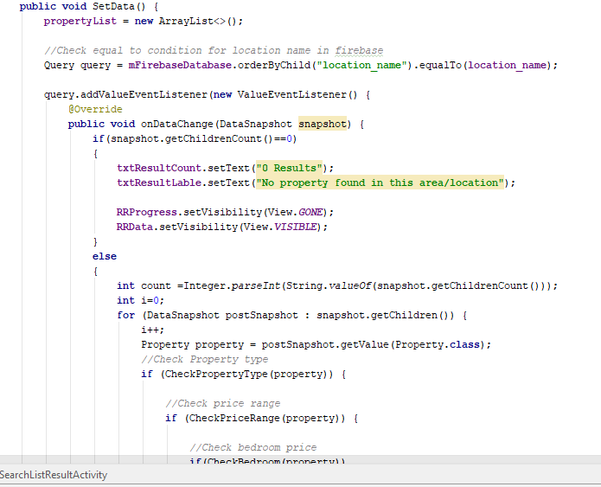

Admin portal:
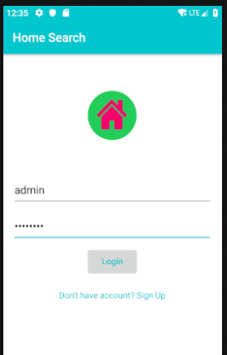
Admin has unique password and username to access the data from the back end. Admin can edit the list of properties and users who book for appointment. The price of property, the picture of property and description can be changed from the admin portal. The below code shows admin authentication of username and password.
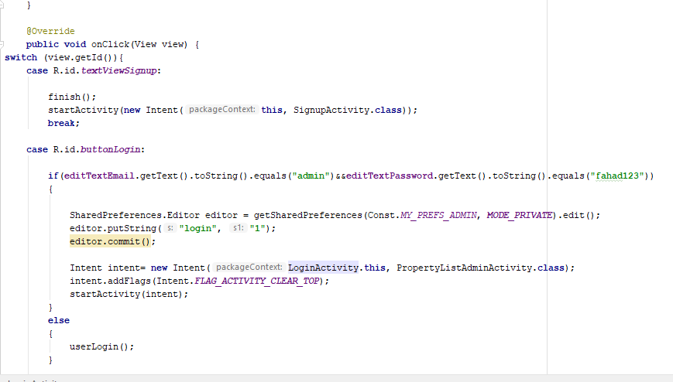

Admin username: admin
Admin password: fahad123

-Testing and Evaluation:

Test case 1: Registration
Test: pass
Test case | Input | Output
Email requirement | 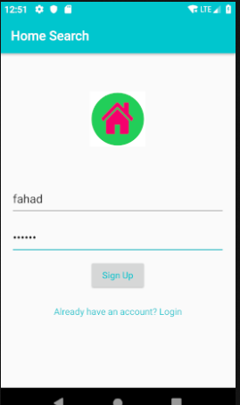 | 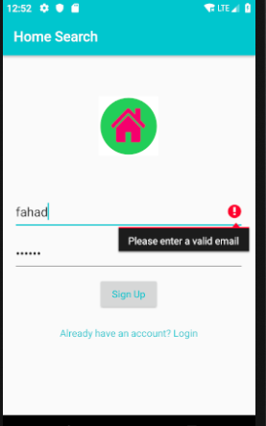
Result | User puts his name without an email formet and put password in. | When user submits to sign Up, the system says to enter a valid password.

Test Case: 2
Activity | Input | Output
Password Validation | 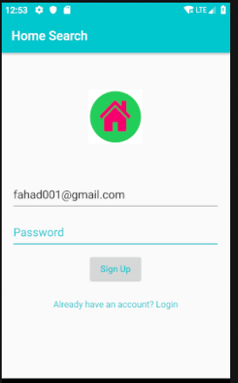 | 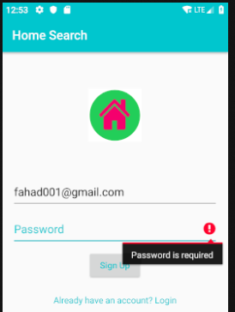
Result | In the picture, No password is given for the output result. | When there’s no password, system says password required to sign up.  Test: Pass

Test Case: 3
Activity | Input | Output
Password Requirement | 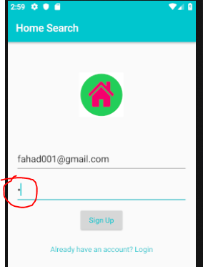 | 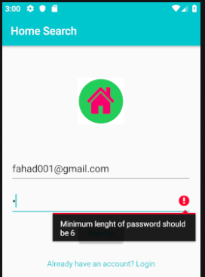
Result | Users tests an invalid password with only one character long. | The system does not accept with a single character password and asking for a minimum 6 character length.  Test: Pass

Test Case: 4
Activity | Input | Output
Appointment form | 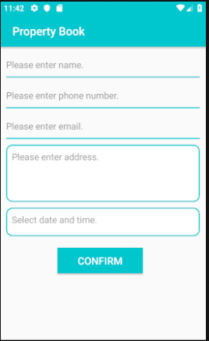 | 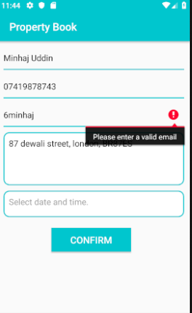
Result | This a black appointment form where user needs to fill in the form | After filling up the form, the system identifies an invalid email.  Test: Pass

Test Case: 5
Activity | Input | Output
Sign up validation | 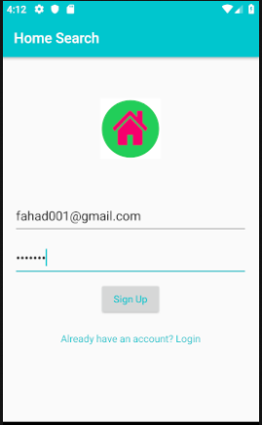 | 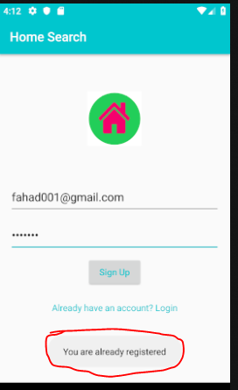
result | User previously signed up and put the same email to re-sign up. | The system revoked the registered email with pop up message.  Test: Pass

Test Case: 6 Login
Activity | Input | Output
Password testing | 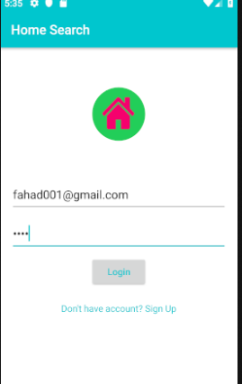 | 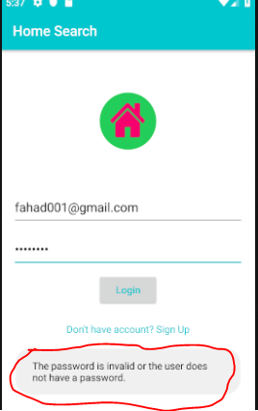
Result | User signed up with the password 123456 and put a wrong password. | The logged in password is wrong and it says invalid password.  Test: Pass

Test Case: 7
Activity | Input | Output
Location requirement | 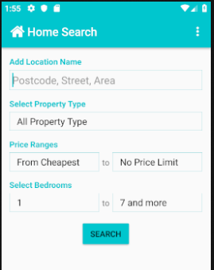 | 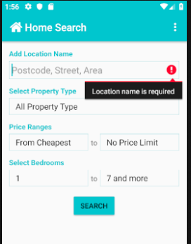
Result | There is activity selected to check any requirements in the home page. | The requirement of location is mandatory and system does not proceed without any place name.  Test: Pass

Test Case: 8
Activity | Input | Output
Admin Login | 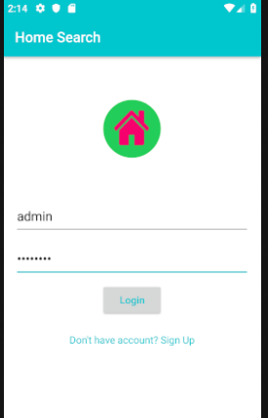 | 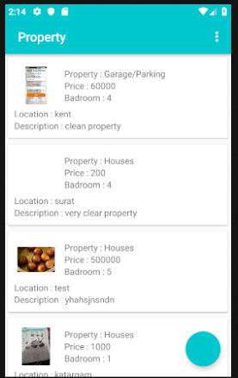
result | Admin authentication has unique username and password. | With correct password, the authorisation is given in the next page of control panel.  Test: Pass

Test case: 9
Activity | Input | Output
Image adding requirement | 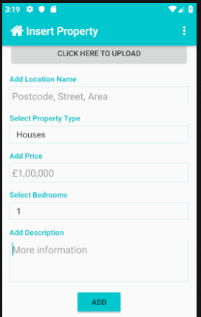 | 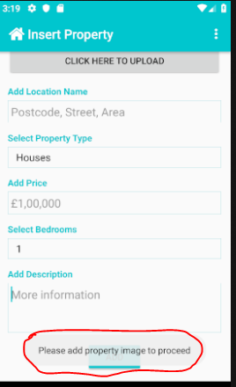
result | During the property adding, The insertion is made without a picture to test. | When user tries to add a property without an image , the pop up warning asked for adding picture.  Test: Pass

Test Case: 10
Activity | Input | Output
Validation update location | 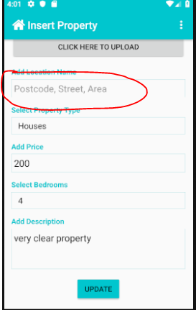 | 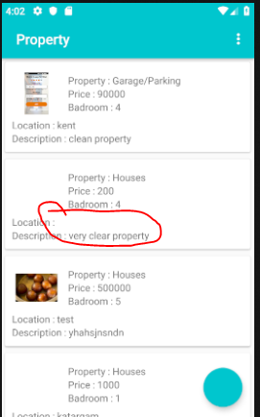
result | In the update, there is no location selected and clicked update. | The system should not take update without location as location is must for property search.  Test: Failed

Evaluation and Reflection:

Personal Evaluation:
A dynamic apps designed to have logical and reliable manner to which user feels the content a smooth performance throughout the app cycle. A user-friendly mobile not only includes an attractive colouring choice but represent a competitive performance in the market. However, for the Home-search application is designed to ensure high combination of accuracy, services and adequate support during the development. Based on the analysis, the project report presented on the basis of leaning obstacle and effective teaching approach studied and identified entirely during the literature review. It has been difficult to research a project with dynamic activities with competitive development approach and with adequate learning resources.

System Evaluation:
Besides the background information and finding suggestion provided, the overall results could be concluded with learning adjustments and project implementation adapting fundamental learning of java language and effective android studio coding. With the help of project framework and design patterns, the development approach helped to identify background problems and solve it by debugging and testing itself. The objectives and main goal have been achieved although not all the corner completely filled within the development project. The most common java frameworks were studied and identified with borderless use of the most common logical features during the development.
The essential software development component embedded features between java language and XML in the android studio. The design pattern starts with simple coding and finishes building large framework using materials in the android studio. If this research project is performed again, more details implementation and instruction including documentation would be given and more time and effort can be provided. The design pattern can also be improved to avoid low performance and increase beast practice in the level of concerns dragging the framework into application layer.

Reflection:
The research of this project has been started since 2017 and an earlier interest of university degree of my foundation program in 2015. The wider field of options and preference have been come to BSC cloud computing which is mainly based on development of the project. My pre-preparation and earlier choice come to end in computer program and mobile apps in the last development project. Although my interest of mobile app development failed in the first attempt of last level but reflected difficulties and continuous learning opportunity in the app development. I have not failed to the project even looks less outcome, however every new project starts with investment of time and effort.

The challenges which I have faced on designing, coding and problem solving, It has never been easier to have learning something alone therefore my senior brother helped and supported me in development. They advised me, send me learning materials and online tools to develop the project. I consider myself organising and developing into a larger project for my second attempt of mobile apps. Although android studio combined with java and XML language which was a bit tough at the beginning but has been a lot easier after following formula.

Conclusion and Recommendations:

Conclusion:
In the conclusion chapter, it is important to explain a short overall summery of all chapter which includes outcomes and results of project discussion. The review of literature provides explanation of app development and background study for example, app content, design structure and framework. The aim and objectives of this project is to develop successful estate agent smartphone android app with real world practice and research of implementation. The waterfall methodology of development lifecycle model has been preferred during the development cycle. As this is an educational project within a fixed time period, this model has been lot easier to develop and implement for successfully completion. The analysis chapter explained a detail requirement of Home search app including functional and non-functional requirements and other hardware necessary activities. After providing an overall analysis, it was also required to explain about risk analysis such as what level of risk could impact the project. Therefore, the design and implementation chapter provide app navigation structure and design framework of each page including screenshot of coding and app page. The testing chapter ensures a clear working checklist in one by on testing and report. During the development and implementation of this project research, the author used online journals with IEEE standard, books and online reliable sources which has been provided as reference list at the last chapter of this report.

Recommendations:
Although Home Search mobile application has been developed within the period of time, but the expectation of project should have improved higher than it does as I have done the similar project in my last level. There is so many lacking on the apps for the requirements for a successful android application. The following features I should develop in future to complete this project.
- Adding name, phone number in the registration/sign up form.
- Device login activation for faster access to the app.
- Adding profile section in the app and keep records of photos, address and email.
- Real-time update on bookings between users and admin.
- Booking date and time update by notification on the app.
- Booking list in the admin control panel to finalise booking confirmation.
- Booking cancelation
- Customer/user review in the app for future improvement and development.

References

[1] | C. &. Co, “Cisco Visual Networking Index: Global Mobile Data Traffic Forecast Update, 2016–2021 White Paper,” Cisco, 26 02 2014. [Online]. Available: http://www.cisco.com/c/en/us/solutions/collateral/service-provider/visual-networking-index-vni/white_paper_c11-520862.html. [Accessed 21 12 2018].
[2] | A. developer, “Number of Android apps on Google Play,” AppBrain, 21 December 2018. [Online]. Available: https://www.appbrain.com/stats/number-of-android-apps.
[3] | Q. E. J. G. A. M. Z. P. J. a. V. S. Xu, “Identifying diverse usage behaviors of smartphone apps,” In Proceedings of the 2011 ACM SIGCOMM conference on Internet measurement conference, no. ACM, pp. 329-344, 2011.
[4] | B. a. M. P. Chun, “Augmented smartphone applications through clone cloud execution,” HotOS, vol. 9, pp. 8-11, 2009.
[5] | W. T. bbc, “What are mobile apps?,” 10 October 2012. [Online]. Available: http://www.bbc.co.uk/webwise/guides/mobile-applications. [Accessed 1 January 2019].
[6] | M. Siegler, “Analyst: There’s a great future in iPhone apps,” 11 06 2008. [Online]. Available: https://venturebeat.com/2008/06/11/analyst-theres-a-great-future-in-iphone-apps/. [Accessed 1 1 2019].
[7] | Mid Yord Library, “What is a smartPhone?,” 1 Feb 2012. [Online]. Available: https://www.midyorklib.org/etraining/files/2012/05/What-is-a-Smartphone.pdf.
[8] | A. a. O. J. Holzer, “Mobile application market: A developer’s perspective,” Telematics and informatics, vol. 28, no. 1, pp. 22-31, 2011.
[9] | L. M. Divya Singla, “ANDROID VS IOS,” INTERNATONAL JOURNAL OF INNOVATIVE RESEARCH IN TECHNOLOGY, vol. 1, no. 5, pp. 592-595, 2014.
[10] | B. N. R. a. N. A. Wukkadada, “Mobile Operating System: Analysis and Comparison of Android and iOS,” International Journal of Computing and Technology, vol. 2, no. 7, pp. 273-275, 2015.
[11] | K. P. T. D. Y. S. M. Smt. Annapurna, “A Comparative Study on Mobile Platforms,” International Journal of Advanced Research in Computer Engineering & Technology (IJARCET), vol. 5, no. 3, pp. 547-550, 2016.
[12] | M.-R. K. a. M. May, “Exploring Usability Enhancements in W3C Process,” W3C, November 2002. [Online]. Available: https://www.w3.org/2002/09/usabilityws.html.
[13] | M. C. Koivunen M., “Accessible Graphics and Multimedia on the Web,” W3.org, 2001. [Online]. Available: https://www.w3.org/2001/05/hfweb/heuristics.htm.
[14] | M. J. &. G. S., Mobile Application Development, Indianapolis: John Wiley & Sons, Inc., 2012.
[15] | Android developer team, “Meet Android Studio,” Offecial android developer, 2019. [Online]. Available: https://developer.android.com/studio/intro/.
[16] | J. Horton, Android Programming for Beginners, Birmingham: Packt Publishing Ltd, 2015.
[17] | oracle development team, “Java fundamentals,” [Online]. Available: http://www.oracle.com/events/global/en/java-outreach/resources/java-a-beginners-guide-1720064.pdf. [Accessed 31 1 2019].
[18] | E. T. Ray, Learning XML, 2nd ed., S. S. Laurent, Ed., Sebastopol: O'Reilly Media, Inc., 2003.
[19] | w. team, “Extensible Markup Language (XML) 1.0 (Fifth Edition),” w3c organisation, 2018. [Online]. Available: https://www.w3.org/TR/xml/.
[20] | J. DiMarzio, Android: a programmer`s guide, New York: The MeGraw-Hill Companies, 2008.
[21] | A. F. J. S. M. Z. Y. a. W. W. Zagalsky, “The emergence of github as a collaborative platform for education,” In Proceedings of the 18th ACM Conference on Computer Supported Cooperative Work & Social Computing, no. ACM, pp. 1906-1917, 2015.
[22] | L. S. C. T. J. a. H. J. Dabbish, “Social coding in github: Transparency and collaboration in an open software repository,” In Proceedings of the ACM 2012 Conference on Computer Supported Cooperative Work, vol. 12, p. 1277–1286, 2012.
[23] | K. Finley, “What exactly is GitHub Anyway?,” Techcrunch, 2012. [Online]. Available: https://techcrunch.com/2012/07/14/what-exactly-is-github-anyway/?guccounter=1.
[24] | B. A. A. Adetokunbo A.A. Adenowo, “Software Engineering Methodologies: A Review of the Waterfall Model and ObjectOriented Approach,” International Journal of Scientific & Engineering Research, vol. 4, no. 7, pp. 427-430, 2003.
[25] | N. B. Ruparelia, “Software Development Lifecycle Models,” ACM SIGSOFT Software Engineering Notes, vol. 35, no. 3, p. 8, 2010.
[26] | C. Weisert, Waterfall methodology: there's no such thing, chicago: Information Disciplines, Inc, 2003.
[27] | B. Youssef, “A simulation model for the waterfall software development life cycle,” International Journal of Engineering & Technology, vol. 2, no. 5, 2012.
[28] | IEEE-STD-610, “A Compilation of IEEE Standard Computer Glossaries,” IEEE Standard Computer Dictionary, 1991.
[29] | J. G. Andrew Stellman, “Applied Software Project Management,” O'Reilly Media, 2005.
[30] | K. a. J. M. Molokken-Ostvold, “A comparison of software project overruns-flexible versus sequential development models,” IEEE Transactions on Software Engineering, vol. 31, no. 9, pp. 754-766, 2005.
[31] | M. Q. P., Qualitative research & evaluation methods: integrating theory and practice, Chicago: SAGE PUBLICATIONS, 2002.
[32] | T. a. R. R. Bass, “Defense-in-depth revisited: qualitative risk analysis methodology for complex network-centric operations,” In Military Communications Conference, 2001. MILCOM 2001. Communications for Network-Centric Operations: Creating the Information Force, vol. 1, no. IEEE, pp. 64-70, 2001.
[33] | E. Wallmüller, “Risk management for IT and software projects.,” In Business continuity, no. Springer, Berlin, Heidelberg, pp. 165-178, 2002.
[34] | M. T. C. Team, “Risk Impact/Probability Chart, Learning to Prioritize Risks,” Mind Tool, [Online]. Available: https://www.mindtools.com/pages/article/newPPM_78.htm. [Accessed 2019].
[35] | P. Schultz, “THE IMPACT OF A RISK MANAGEMENT PLAN,” ADEC INNOVATIONS ESG SOLUTIONS, 9 Aug 2016. [Online]. Available: https://info.esg.adec-innovations.com/blog/the-impact-of-a-risk-management-plan.
[36] | C. Weisert, “Waterfall methodology: there's no such thing,” Information Disciplines, Inc, Chicago, 2003.
[37] | C. &. H. D. HEATH, "Made to stick : why some ideas survive and others die", New York: Random House, 2007.
[38] | M. Q. P., Qualitative research & evaluation methods: integrating theory and practice, Chigago: SAGE PUBLICATIONS, 2002.
[39] | E. Wallmüller, “Risk management for IT and software projects. In Business continuity,” In Business continuity, Springer, Berlin, Heidelberg, pp. 165-178, 2002.
[40] | L. Lopuck, “Web design for dummies,” in John Wiley & Sons Inc, Chanada, 2012.

Appendix:
App login details:
Username: fahad001@gmail.com
Password: 123456
Admin Login details:
Username: admin
Password: fahad123



