Referencing Task
Generate 5 references using sources of your own choice (books, journal articles, periodicals, reports, industrial white papers, websites etc.) relating to your specific stream/area of expertise. You should include at least 1 book, 1 journal article and 1 website.
Remember: The information required will likely change depending on the type of source used. Identify the correct information and reference format using the UWTSD Harvard Referencing guidelines (found in the MS Teams group).
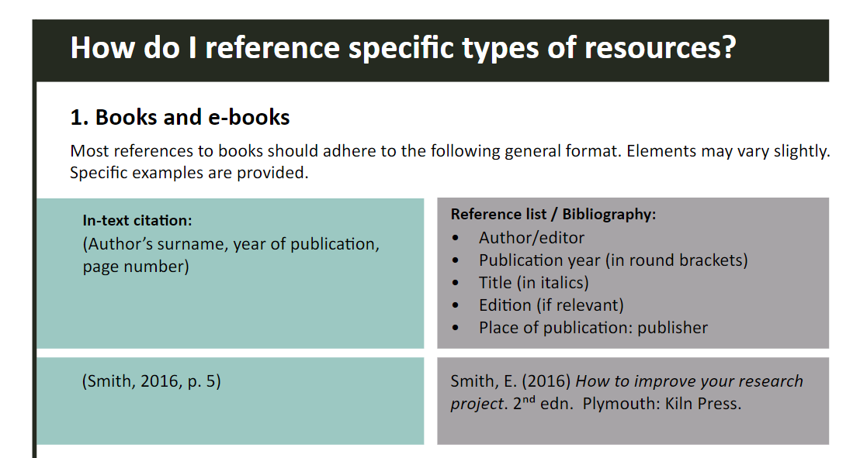
Example 1: Screenshot from UWTSD Harvard Referencing Guidelines
Typical Information Required:

- Authors Name
- Year of Publication
- Page Numbers (if appropriate)
- Publishing Company Name
- Journal/Website Name
- Website URL

