Critical analysis of decision support - Use of Machine Learning to Support the Triage and Workflow of Patient Requests in a GP Practice
The development of online consultation tools is an attempt to improve the signposting opportunities to patients, reduce avoidable appointments and improve the quality of information GP practices are receiving (askmyGP, 2021; eConsult Health Limited, 2021). For patients, it provides round the clock access to care information that is relevant to their locale and allows them to consult with a GP practice at a time that is convenient to them. Online consultation can also help to relieve the pressures on receptionists. By creating an extra channel to access services, receptionists can spend more time on the phone managing queries from those where a digital tool is not suitable. Online consultations use structured forms to guide patients through the expected questions a GP would ask in a consultation. These online forms can be for specific conditions, general symptoms, or to review long term conditions or treatments. The tool then sends the information to the GP practice and is presented to the GP in an accessible way, including highlighting responses of particular concern. This can help a GP by reducing the amount of time it takes to decide the care a patient requires. For example, a GP may choose to book the patient for a face-to-face consultation or use the information provided as greater assurance to prescribe a course of action or medication without further consultation.
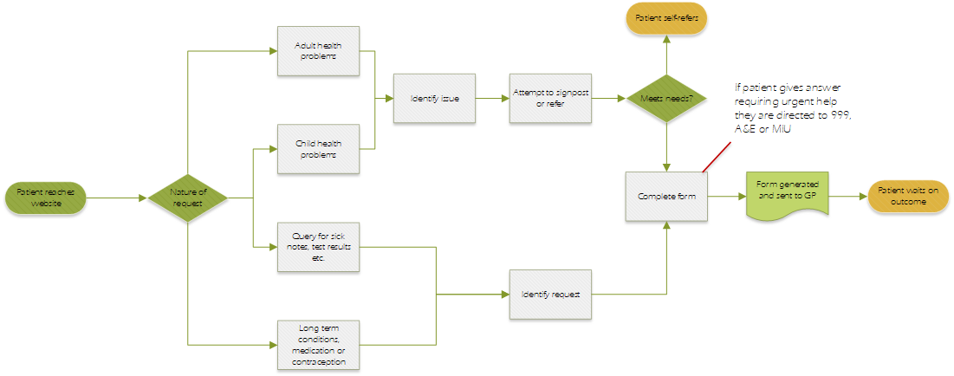
Figure 1 - High level flow of using an online consultation form, based on the user experience of eConsult
However, whilst this improves access to GP services for the population there is concern it will further increase the workload for the GP surgery by removing the incentive to withhold a query or attempt self-care (Casey, Shaw and Swinglehurst, 2017; Banks et al., 2018). Therefore, reducing the time it takes to reach a clinical decision is of no benefit to the GP practice if there are more consultations to complete.
An evolution of providing digital access to GP services is the “digital first total triage” model which attempts to avoid or manage these issues. In this model all queries to access GP services undergo a level of triage using digital tools and the author has co-designed and implemented such a solution prior to the pandemic that later contributed to a national blueprint (NHS England, 2020). The aim of this triaging is to determine:
- Is the query urgent?
- Can the patient be signposted to a more appropriate service? i.e., pharmacy, self-referral
- Can the patient see another member of the team, such as a pharmacist or nurse?
- If the patient needs to see a GP, should it be their usual GP for continuity of care?
- How soon should they see the GP?
This triage is not to determine the care they receive, instead it is ensuring the GP practice uses the best resource to address the patient’s concern. The figure below offers a high-level illustration of this.
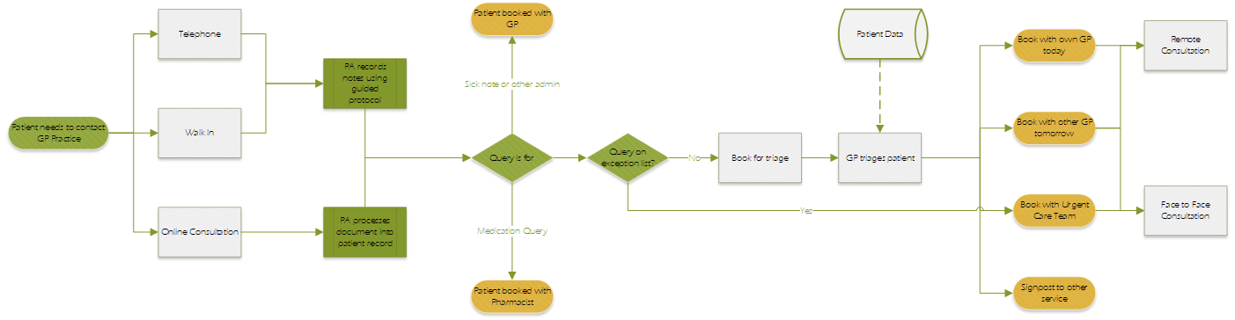
Figure 2 - High level pathway for triaging queries received by a GP practice
A digital protocol, embedded in the clinical system, supports both non-clinical and clinical staff to arrive at an optimum conclusion. To do this, a receptionist/Patient Advisor (PA) uses the protocol to take a basic history from the patient when they call, walk in, or the PA can derive this from a completed online consultation. The protocol will also assist the PA arrive at an initial conclusion on how best to flow the patient. To help reduce the risk of these protocols and create consistency in decision making, the protocol will respond according to existing factors in the medical history. To enable this, reports that analyse SNOMED codes help to segment the population according to a variety of factors such as the prevalence of long-term conditions, current medication, age, frailty, and safeguarding. For example, an adult with no underlying conditions would be in segment one. In this segment the protocol is more likely to assign them to be signposted or see the multi-disciplinary team. An older adult with cancer and diabetes will be in segment five and prioritised to see their usual GP. If the patient cannot be signposted to another service, or the condition is not on an exception list of conditions suitable for booking with the multi-disciplinary team (i.e., cystitis, chickenpox, febrile children), then the PA books the patient for GP led triage. However, this process still heavily relies on a human to comprehend patient provided information and deciding the best care pathway.
A development of this solution is the employment of an Artificial Intelligence (AI) or Machine Learning (ML) model to support the decision making of which queries go to which clinician or service. This provides the release of PA time to support patients directly and the reduction of repetitive tasks that a machine can replicate. For GPs, this could support them by helping ensure consistent decision making or even remove work from them entirely. In this model a ML model compares multiple sources of real time data to conclude the most appropriate care pathway. By comparing factors such as the consultation data in an online consultation form, the available staff on site, and the segment the patient occupies, the tool can de-risk the triaging event so that a non-GP, i.e., physician associate, could lead on triage. Figure 3 illustrates how the pathway may look with the addition of a ML model that is supporting GP led triage as well as automating a portion of triage decisions.
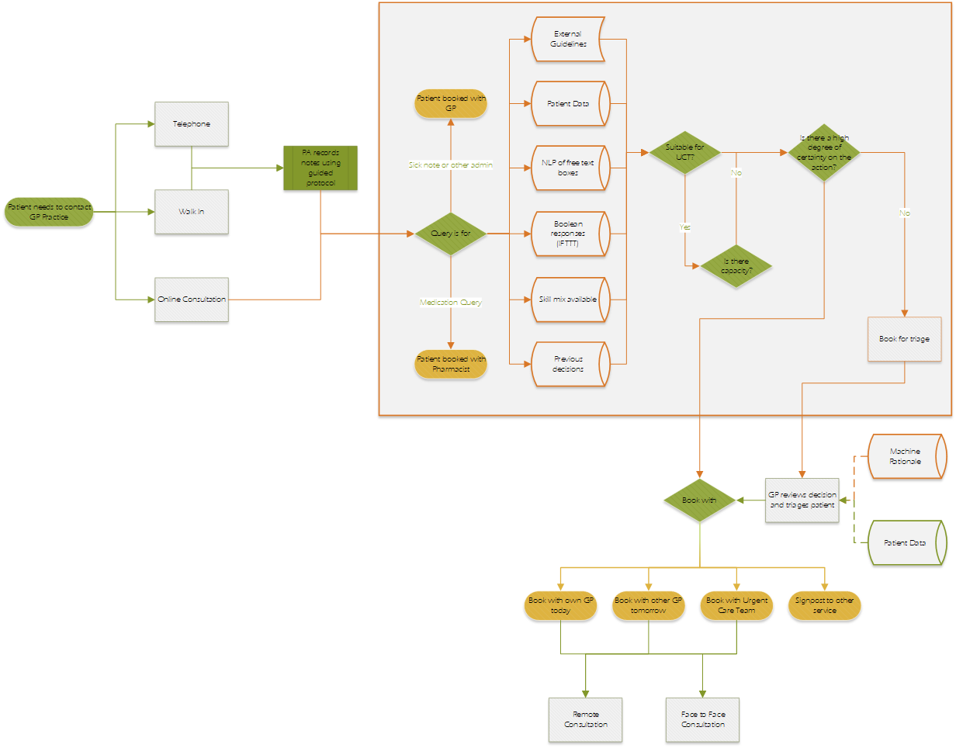
Figure 3 - Role of a ML model and the decisions/actions it would make to support triage. (ML actions/decisions are highlighted as orange lines/boxes)
To accomplish this, the tool would use one or more sources of information that would be available. The below table highlights possible sources
Table 1 - Potential information types and sources that could be made available to the CDS
Type of Information | Source | Example
Closed responses | Online consultation form. Medical questions with Boolean or likert answers. | “Do you have a headache?” Yes/No
Free Text | Online consultation form. Native Language Processing (NLP) could convert using bag of words methodology | “Describe the pain”
Coded data | Patient record, online consultation form. Coded as SNOMED/FHIR entities | Age, Gender, Patient segment
Previous bookings | Appointment data | 1000hrs, Urgent Care Team,
Available clinicians | Appointment data | n Bookings remaining in clinics  Compare name in the clinic list with skills database
Access trends | Booking trends, online consultation platform, external sources | Number of online consultations submitted per hour, per day, per month
The advantage of a CDS powered by a ML model is that the model can apply information more consistently than varying staff with diverse levels of experience and competency.
The advantages of a ML model as a CDS in this context is:
- The ML model can generate learning and experience in real time, there is not a need for investing in staff training in terms of cost or time expenditure
- The model can consider multiple variables consistently and without tiring
- The model can work at all hours and consider resource availability
- The model can identify patterns in patients accessing services and plan longer term to manage workload. For example, learning to offset low urgent work arriving on a Monday to a Wednesday
- Automation of repetitive tasks in the workflow, i.e., sending a standard SMS, and further reduce the reliance on a human to complete a repetitive task
The disadvantages of a ML model as a CDS in this context is:
- It does not help to resolve the workforce issues and could in fact make them worse if policymakers feel the model can replace vacant positions
- GPs train for at least three years after their medical training; a ML model still needs a learning period to gather enough experience to be trusted or accepted by the local practice
Literature Review
A search was performed using the following criteria:
- Any field Contains "decision support" AND Any field contains triage AND Any field contains “machine learning”
- Exclude articles not in English
- The full text is available online
- The articles are in a peer-reviewed journal
- The articles were published after 01/01/2013
A total of eighty-five articles were identified. Two of these were duplicates and removed. For the remaining eighty-three articles, the titles and abstracts were reviewed to assess the theme of the article. Articles were excluded if they satisfied any of the below criteria:
- Focused on imaging and diagnostics i.e., CT scans, X-Ray
- Primarily discussed COVID-19 patient management or mortality prediction
- Discussed triage of a specific condition i.e., sepsis, shock, cardiac arrest
- Did not discuss triage in an acute care setting, unless a systematic review
- Is a systematic review into ML but restricted to a specific clinical condition
This left fifteen articles. These were then categorised based on how the full article provided commentary for the creation of a general triaging tool as described earlier. The below table explains these categories and the number of articles in each.
Figure 4 - Process for selection of Articles to be included in the literature review

Table 2 - Categorisation of articles that were fully read
Category | Criteria | Total Articles
Direct | The article is set in the general practice context and discusses a CDS that utilises machine learning to assist clinicians with triaging patients | 1
Systematic Review | The article is a systematic review of Articles regarding how machine learning is used in CDS tools | 6
Indirect | The article is set in an acute care context and discusses a CDS that utilises machine learning to assist clinicians with triaging patients | 5
Technical | The article is set in an acute care context and discusses a CDS that utilises machine learning to assist with triaging patients but is limited to the technical aspects of the tool, rather than the role of the tool | 2
Feasibility | The article is set in an acute care context and discusses a CDS that utilises machine learning to assist with triaging patients but is limited showing that a model(s) could be used to triage patients | 1

The final list of articles only included articles that fitted in the “Direct” and “Systematic Review” categories. The systematic reviews are as contemporaneous as the indirect article, with only one article published later than the newest systematic review. The table below summarises the seven articles included in the literature review.
Table 3 - Summary of accepted articles
Author | Relevance | Context | Research question | Evidence base | Conclusion
Entezarjou et al. (2020) | Direct | Primary care | Can ML algorithms triage online consultation forms comparably with experienced physicians? | 600 digital medical history reports, no time frame | ML is not ready to automate triage as not all the factors have been identified
Fernandes et al. (2020) | Systematic Review | Emergency care | How are intelligent CDS used for triage contributing to improvements in care in emergency departments? | 62 papers | “…there was an improvement of the health professionals’ decision-making, which was more consistent and reliable.”
Miles et al. (2020) | Systematic Review | Emergency care | What is the accuracy of ML methods in the emergency care system? | 92 models from 25 studies | ML appears to be accurate in triaging patients in emergency care. There is no clear benefit between techniques over another
Lyell et al. (2021) | Systematic Review | Not specific | How is ML used to support clinician decision making and to what extent? | FDA approval database – 49 unique devices across 59 approvals | Generally, ML tools in current use are assistive devices with limited autonomy but do help to reduce risk
Schwartz et al. (2021) | Systematic Review | Hospital | Describe the nature and prevalent of clinician involvement in CDS development, evaluation, and implementation | 80 papers | Most studies are discussing the development stage of the ML model and show little clinician involvement. Other studies show the involvement is restricted to the specification and implementation phase.
Yin, Migam and Teo (2021) | Systematic Review | Not specific | Identify and summarise the existing research on AI applications that have been implemented in clinical practice | 51 studies | Whilst AI in healthcare shows potential, there is minimal evidence to advocate routine use of health care AI.
Boonstra and Laven (2022) | Systematic Review | Emergency care | How is AI being used in emergency departments and how does it alter the work design for clinicians | 34 studies | AI is showing a promise to support clinicians manage workload and risk but is still in the early stages of development and adoption.
Directly relevant literature
The work of Entezarjou et al. (2020) is the only article that is directly comparable to the model explored in this essay. Like the proposed model, Entezarjou et al. used the existing online consultation platform (Doctrin AB, Stockholm, Sweden) as a source of structured medical history that a ML model then analysed. To support the direct validity of this article to inform on the proposed ML model, the table below demonstrates the similarities and differences between the models.
Table 4 - Similarities and differences between the triaging and models between this paper and Entezarjou et al. (2020)
Similarity to Proposed Model | Difference to Proposed Model
Uses an online consultation tool to produce structured medical history that is then triaged by a GP | The ML model does not determine the most suitable clinician or service, restricting itself to acuity and if a face to face visit is needed
The ML model then determines a care route | Online consultation is not the only route in, patients could be led through a basic questionnaire by a PA on the phone or at reception
Both involve analysis of free text and Boolean responses | The patient population is pre-segmented into groups, this would add weighting to the care they should receive
Patients submit a form online in an asynchronous manner | The tool would be a “peer” to a triaging GP who would support the ML model if it was unsure and provide learning
Both are attempts to reduce the workload and time pressure on primary care clinicians
Both scenarios have online consultation as an embedded part of the access offering to patients | The tool proposed would factor in variables such as the skill mix available that day, overall capacity in the practice, and previous decisions made
Therefore, this article has good validity in directing the development of such a model and predicting an outcome of using the model. A key strength of this article is the discussion on the tools used to create the ML model, such as the naïve Bayes approach which other articles also mention. This provides a good footing that the development of the model can begin from. Further, Entezarjou et al. has been able to show the ML model can use free text responses, allowing it to tap a valuable data source that can increase the effectiveness of ML outcomes (Tollinton, Metcalf and Velupillai., 2020). Though, on this occasion, the results in this article did not evidence this. The conclusion of the article was that the ML model was not suitable for the automation of triage, but that there lies the possibility of improving it to do so. Entezarjou et al. suggest that further training of the model may improve performance and that further research into identifying the factors that derive a triage decision warrants study.
However, the author feels that the conclusions of this article are marred by the assessment of the ML model. The outcomes identified by the ML model were compared with the consensus decision of five physicians. These physicians were tasked with reaching a consensus decision for each case; however, a single senior physician curated the training data. This introduced an extraneous variable to the process. Not only is the ML model being assessed against data not created in the same way as the training data, but the triage of patients is also only every completed by a single clinician. Further, consensus was created in an artificial environment that is influenced by social factors amongst the physicians, weighted by the individual experiences of clinicians and with zero clinical risk. Therefore, the outcomes of the ML model, which is assessing in a real-world capacity, are being assessed against a false reality. A more effective means of assessment would have been to create training data from decisions made by each physician and train five separate instances of the model. The ML model could then be assessed in how well it matches with each clinician when both are asked to triage cases in a clinical environment. This would evidence reproducibility at two distinct levels, showing reproducibility when compared with a clinician and that the reproducibility can be shown across different clinicians. From this data, the outcome data could then be challenged to predict where a majority consensus would lie based on each clinician voting with their decided outcome.
Entezarjou et al. (2020) does point out that given the low agreement between the clinicians does question whether the consensus can be used as a gold standard to train and assess the tool. Further, the tool did not show a better congruence to the other senior physicians and suggests triage is a product of experience and risk aversion.
Overall, this article assumes that triage decisions from online consultation are solely reliant on information presented by the patient. However, as clinicians will have access to the patient’s medical notes at review, they will be duty bound to consider the full medical history available to them. This article is an ideal test case from which future models can be generated.
Systematic Reviews
There were seven systematic reviews in the original search, of which one was focused on literature for a particular condition. The remaining six reviews were split into two further categories. Two of the reviews looked at how ML models had been created, how they were used and their accuracy. These reviews provided a comprehensive account that could be accessed by both clinicians and data scientists. This offers a common language that would aid collaboration when designing models. A lack of articles that support this collaboration is highlighted as a weakness of current literature where over 50% of articles do not discuss the role of clinicians in the development of ML models (Schwartz et al., 2021). The other four reviews took a more holistic view that highlighted how ML and AI was being used in settings, common themes in implementation, and the impacts that were being seen.
None of the reviews highlighted or discussed the potential use of ML or AI in assisting triage in a general practice setting. Combined with only one article being directly aligned to primary care, this shows the need for research to attempt tackling the issue, especially considering successes for other ML models. The figure below, from Fernandes et al. (2020, p. 7), illustrates the average performance for ML models in the articles they reviewed.
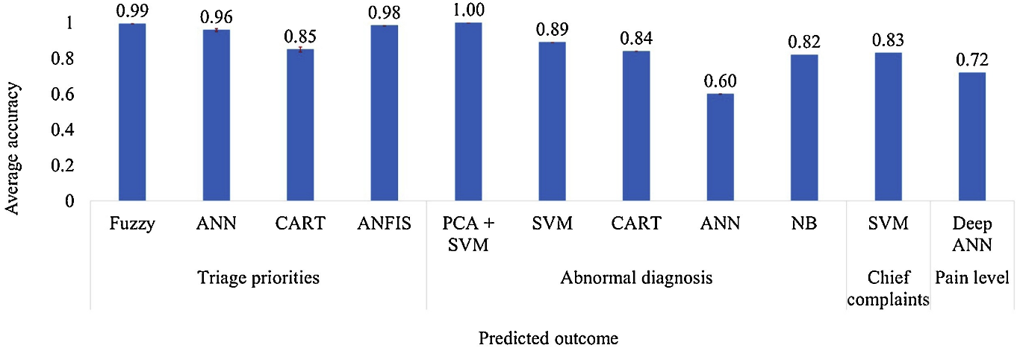
Figure 5 - Average performance in test achieved for each prediction goal, discriminated by technique, in the Articles where the measure of Area Under the ROC Curve (AUC) was presented. LR - logistic regression, ANN - Artificial neural networks, GBoost - gradient boosting, XGBoost - Extreme gradient boosting, SVM - Support Vector Machines, NB - Naïve Bayes, GA - Genetic Algorithm, FDA - Flexible Discriminant Analysis (Fernandes et al., 2020, p. 7).
All the reviews discussed models that require data for variables that need the engagement of a clinician and would not be readily available in the patient’s home, i.e., SpO₂, blood pressure, temperature, or explored the use of medical wearable technology to support diagnosis. The figure below, from Fernandes et al. (2020, p. 5), illustrates the common variables being used in the ML models they reviewed. This highlights a further gap in knowledge about how subjective data can be used to inform a triage ML that is not reliant on having access to the clinical data highlighted. In the model being discussed, it is unlikely this data will be available or clinically sensitive enough for triage. Conversely, this lends strength to the argument that a ML having access to the patient history and can be created and directs where research should focus.
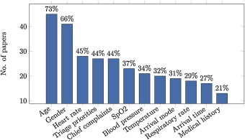
Figure 6 - Most used variables for the development of the triage models, with percentage value in the total number of selected Articles (Fernandes et al., 2020, p. 5).
All the reviews agreed that ML and AI has a place in supporting triage in emergency care settings. However, both Fernandes et al. (2020, p. 10) and Miles et al. (2020, p. 10) highlighted that all the studies reviewed contained an elevated risk of bias as information used was incomplete. Very few models looked at datasets that worked across multiple sites.
The Articles written by Boonstra and Laven (2022), Yin, Ngiam and Teo (2021), and Lyell et al. (2021) did not provide sufficient evidence for how to implement a ML triage tool or how to develop a tool. Instead, their Articles focus on providing a commentary of the current state of ML and AI implementation in healthcare. This often repeated the examples that had been excluded in the literature search and at best lent weight to the argument that ML could be a candidate for supporting triage.
The work of Schwartz et al. (2021) is a strong critique and much needed flag raising that ML and AI tools are being developed without the assistance of clinicians. Their work highlighted that descriptions of clinician involvement were often limited to specification and implementation phases. This could perpetuate the feeling that the ML and AI are black boxes and reduce clinician confidence in the tool. However, Miles et al. (2020, p. 10) disagrees with this and highlights that deep neural network ML models can provide details on how the model is prioritising variables. They have suggested that more research be conducted into the involvement of clinicians and their impact. An important highlight considering Yin, Ngiam and Teo (2021) have shown that several AI were implemented before publicly available research data to show their effectiveness was released.
Overall, the literature for using ML within primary care is next to non-existent without any research or commentary to suggest why this would be the case. The literature around using ML for triage in emergency care, the next analogous area where workload is at the mercy of patient’s daily lives, is strong but still early in showing ML working at scale.
Implementation
Van De Velde et al. (2018) authored an article that defined a checklist that could support professions ensure that a CDS is built with consideration to factors that affect its success. From this checklist the author has identified some key factors that would require particular attention.
“The quality of the patient data is sufficient” (Van De Velde et al., 2018)
A significant issue to the implementation of the proposed ML model is the ability to train the ML, ensure that bias is not included, and market it for scale to attract funding for research. This requires an accurate database of data that illustrates a gold standard for triaging patients in primary care. This in turn also requires the data to be in a structure and of good quality that the ML model can understand the data. The solution used by Entezarjou et al. (2020) saw a single senior physician assigning outcomes to over three hundred medical histories. This is not a large enough database from which to train a valid ML model. There will be bias towards the trends that exist in this dataset when scaled up. Instead, a retrospective analysis of data could be conducted. However, this is only applicable where a GP surgery has kept accurate records of where a patient was seen and whether a better option was available. If poor booking decisions are being made, the ML model will learn these decisions. Instead, a training dataset from GP practices that have adopted the digital first total triage model would be curated over an extended period of a year. This would ensure data that is relevant across all trends that occur during the year. Once a training model is created, this could be actively evaluated in a passive mode against triaging GPs over a period of 6 weeks to get an indication of the model’s success. The match between decisions could then be assessed to see if the model requires further training, changes to the algorithm or can be deployed as a CDS. The only alternative data source would be using data from GP practices who run triaging “eHubs” (Dyer-Smith and Badial, 2019). These hubs have been around prior to the pandemic, will have structured data on outcomes, and could offer a quick win source of data to assess the validity of the model. However, this data is biased towards avoiding GP workload as a commercial model. Therefore, the validity would only apply to commercial setups and not to GP practices.
Domain 3: The CDS System
In this domain, Van De Velde et al. (2018) highlight a CDS should be easy to use, well delivered, delivers the decision support to the right user and is available at the right time. This requires interoperability with the existing clinical system to enable access to medical data. Unless a system can integrate various tasks to be performed staff will need to transfer data between systems, and this will not release staff time. However, it is unlikely that a one of the three principal suppliers would support this unless being delivered at scale. Instead, using the Interface Mechanism 1 API standards created by NHS Digital would help in enabling access and potentially creating an interface that could be used by a triaging GP, thus reducing the number of clinicians impacted by the digital change (NHS Digital, 2022). Medlock et al. (2016) also highlight the importance in being able to model clinical decisions to inform development of CDS. Time spent working with clinicians and PAs to model the factors that impact their choices will help to inform the weight the ML model should apply to different sources and how to account for gaps in the cognitive-behavioural knowledge.
“The decision support is relevant and accurate” and “The content provides trustworthy evidence-based information” (Van De Velde et al., 2018)
Assuring GPs that the model is competent and safe to be used to support decisions or automate them is another issue. Because the ML model is not assessed or observed in the same way as training GPs, providing complex models to illustrate this may not be accepted by clinicians. Instead, this could be counteracted in two ways. First, the ML model could be allowed to observe triage, but only allowed to offer an outcome for certain online consultation questionnaires until it is signed off as showing it is competent. This is a step wise process but more familiar to clinicians. Another could be conducted using a double-blind trial where the model is not allowed to accept new knowledge and neither the triaging GP nor researchers know which patients the ML model will also triage. The outcomes of the ML can then be assessed again and presented retrospectively as a point in time. This could be done regularly to demonstrate either growing competence or achievement of competence.
The Map of Medicine is another structured data source that could help structure and inform decisions being made by the ML model. Brennan, Mattick and Ellis (2011) described examples of how the Map of Medicine had been shown to reduce the number of inappropriate referrals. By showing how a tool, that is both familiar and easy enough to conceptualise, is being used in structuring decisions, GPs may find assurance in the ML models decision.
“Stakeholders and users accept CDS” (Van De Velde et al., 2018)
What is the patient reaction when “the computer says no” or starts to exhibit a Hal 9000 person? Whilst a comically extreme suggestion, the sentiment is that patients have bias towards accepting the view of their GP over other clinicians and an AI is not likely to be accepted (Shaffer et al., 2013; Paddison et al., 2018; Longoni, Bonezzi and Morewedge, 2019). Longoni, Bonezzi and Morewedge (2019) describe how consumers of healthcare are more resistant to AI that replaces the decision made by a human rather than supporting it. This is because they perceive the AI to be unable to account for their uniqueness as an individual. In the short term this issue is mitigated by only using the ML model to help support GP triage. This reduces the burden on the GP and still delivers benefits to the practice in terms of consistency and time release. Being able to allow the ML model to automate decisions will rely on being able to personify the ML model and make it seem like it is considering uniqueness. This could be done by visualising the decision process in realtime through a user interface when submitting the consultation. The ML model could explain the steps it is taking to arrive at a decision and emphasising these in terms that are important to the user. For example, “We see that you are a [age] old [gender] with a history of [long term condition]. You are experiencing [chief complaint] for the last [timeline] [hours/days/months/years]. We are recommending you see [identified pathway], do you agree?” The addition of a patient agreeing with the pathway presents the option to control the AI and this has been shown to reduce the negative connotations associated with AI (Shaffer et al., 2013; Longoni, Bonezzi and Morewedge, 2019).
Evaluation
User experience
To assess the user experience for staff and critical patient stakeholders (such as the Patient Participation Groups), the suggestion would be to use semi-structured interviews with various staff involved with the triage pathway. These interviews would allow for the exploration of specific themes about their role, workload, current triage processes and their views on the use of ML models to support the triage process. This would facilitate the baselining of views as well as present as an opportunity to inform the development of the new process. After the ML model has been trained, another round of interviews that discuss the results of the initial assessment would be conducted to see if there are any changes in the views of the staff having been presented the new data. Further interviews would be conducted after a period of the tool supporting a triaging GP and a more detailed assessment of the model conducted. A final round of interviews would then be conducted once the tool is used in automating decisions.
Automated surveys can also be sent to patients who submit an online consultation. These would check if the patient felt their query has been resolved, dealt with by the correct member of the clinical team and to rate the overall process. This can then be cross referenced with any decisions that were made with the support of the ML model.
GPs and clinicians involved in the triage decisions would be invited to regular workshops to assess the human factors related to the triage experience. In the author’s previous role one of the issues clinicians voiced was with triaging alone in a room all morning or afternoon. This was described as lonely, not an enjoyable experience, or something that were willing to do when deciding to be a GP, a view also supported by Turner et al. (2022). Therefore, capacity to manage the human factors that are identified because of the changes need to be reserved.
Effectiveness
The goal of this tool is to reduce the administrative burden of triaging patients on the triaging GP and PAs, to increase the number of patients being signposted to more appropriate services, increase consistency, reduce risk, and remove the burden of extra work created by online consultations. Therefore, the effectiveness needs to be measured against these.
Assessment of patients being seen by an alternative service can be confirmed in two ways. Firstly, the automated survey that asks the patient if their query has been resolved could be matched to triage events and note the outcome. However, surveys do not often have high response rates. Therefore, a second and additional option would be to look for other flags in the record after the triage event that may suggest the patient appearing in another service. For example, if the patient is advised to seek a self-referral with their local physiotherapy department, then the expectation that a SNOMED code for referral received would appear in the hospital record of the patient. Additionally, to check for where advice was not heeded or appropriate, SNOMED codes for admittance to A&E regarding the same complaint can be identified.
One of the symptoms of staff workload is staff sickness and lack of retention. Levels of staff sickness or comments about workload in exit surveys could be assessed against the ML model being more integrated into the triage process.
A final measure would be to assess if the tool does improve how patients choose to access their care. The current literature shows that GPs report and evidence a greater workload from introducing online consultation (Casey, Shaw and Swinglehurst, 2017; Banks et al., 2018). This can be driven by an unmet demand as well as a loss of barrier to getting a request seen by a GP. If this increase in workload is purely unmet demand, then we would expect to see a drop in requests over a long period and less cases of conditions being unmanaged for an extended time. If this workload is created by a loss of a barrier that is instead replaced by greater assurance to signpost patients, then we would expect to see a quick drop in cases of patients with acute conditions. These are more difficult to assess, but the critical variable will be “How long have you been experiencing these symptoms?.”
Safety
Risk can be assessed by matching patients who either attend A&E, or are hospitalised, or seen by a 999 or 111 service, or die within 7 days for the same condition or a related complication. Complaints made to the GP practice and reporting systems such as the yellow card system can also be used to contribute to the assessment of risk mitigation or creation.
A governance strategy would need to be created to continually review the ML model performance and review if the ML model has contributed towards any harm. One way to do this would be to compare ML model decisions against decisions of a group of clinicians. However, rather than assessing to see if the ML model makes the same decision as the consensus, the test will be if there is a consensus that the outcome led to harm. This removes the bias on the tool which will not be making decisions based on the group. Test patients could also be fed to the ML model to assess the consistency of decision being made and the predictability of the tool.
The ML model would also need to provide a rationale for its decision and place this in the clinical record if accepted by the triaging GP or is working automatically. This would remove the “black box” concern but also ensure that lessons can be learned should the tool make a mistake (Miles et al., 2020). If clinicians are to be held to a standard of keeping contemporaneous notes, then the ML model should also be. Work would be needed to ensure the tool has a lay language it can use to express the factors it identified as important in arriving at a conclusion and reference any IFTTT rules or external guidelines that directed its decision.
Efficiency
It would be wrong to suggest that the efficiency of the tool is how many more patients can be treated in a day or week. Especially as logic would suggest the more patients seen in a day the greater the risk of a clinical mistake due to fatigue. Further, this could encourage policymakers to place undue reliance on ML models to allow them to reduce a drive to recruit more clinicians. The result will inevitably produce bias which will be introduced to the model and encourage risky behaviour.
Instead, the efficiency gains of the tool would be time release for the GP practice to increase consultation times, conduct more care home visits, access research, and run quality improvement projects. This is a more holistic measure and can be assessed through the semi-structured interviews conducted to discuss the user experience.
Longer term, the prevalence of longer-term conditions within the population could be assessed to see if early interventions were able to prevent the occurrence of complications that require more intensive care measures.
Conclusion
There is a sparse amount of literature looking at ML models assisting with GP triage of online consultations. Without more research or strategic direction, it will be some time before a model is introduced. This maybe a missed opportunity given that it straightforward enough to create logic to support PAs with flowing patients and supporting GPs with triage.

References
askmyGP (2021) What We Do - askmyGP. Available at: https://askmygp.uk/what-we-do/.
Banks, J. et al. (2018) “Use of an electronic consultation system in primary care: a qualitative interview study,” British Journal of General Practice, 68(666), pp. e1–e8. Available at: https://doi.org/10.3399/bjgp17x693509.
Boonstra, A. and Laven, M. (2022) “Influence of artificial intelligence on the work design of emergency department clinicians: a systematic literature review,” BMC Health Services Research, 22(1), pp. 1–10. Available at: https://doi.org/10.1186/s12913-022-08070-7.
Brennan, N., Mattick, K. and Ellis, T. (2011) “The Map of Medicine: a review of evidence for its impact on healthcare,” Health Information and Libraries Journal, 28(2), pp. 93–100. Available at: https://doi.org/10.1111/j.1471-1842.2011.00940.x.
Casey, M.E., Shaw, S. and Swinglehurst, D. (2017) “Experiences with online consultation systems in primary care: case study of one early adopter site,” British Journal of General Practice, 67(664), pp. e736–e743. Available at: https://doi.org/10.3399/bjgp17x693137.
Dyer-Smith, R. and Badial, G. (2019) “eHub: Enhancing the emergence of the electronic consultation,” British Journal of General Practice [Preprint]. Available at: https://doi.org/10.3399/bjgp19x703673.
eConsult Health Limited (2021) How online GP consultations can improve your NHS GP practice. Available at: https://econsult.net/primary-care/benefits.
Entezarjou, A. et al. (2020) “Human- Versus Machine Learning–Based Triage Using Digitalized Patient Histories in Primary Care: Comparative Study,” JMIR Medical Informatics, 8(9), p. e18930. Available at: https://doi.org/10.2196/18930.
Fernandes, M. et al. (2020) “Clinical Decision Support Systems for Triage in the Emergency Department using Intelligent Systems: a Review,” Artificial Intelligence in Medicine, 102, p. 101762. Available at: https://doi.org/10.1016/j.artmed.2019.101762.
Longoni, C., Bonezzi, A. and Morewedge, C.K. (2019) “Resistance to Medical Artificial Intelligence,” Journal of Consumer Research, 46(4), pp. 629–650. Available at: https://doi.org/10.1093/jcr/ucz013.
Lyell, D. et al. (2021) “How machine learning is embedded to support clinician decision making: an analysis of FDA-approved medical devices,” BMJ Health & Care Informatics, 28(1), p. e100301. Available at: https://doi.org/10.1136/bmjhci-2020-100301.
Medlock, S. et al. (2016) “Modeling information flows in clinical decision support: key insights for enhancing system effectiveness,” Journal of the American Medical Informatics Association, 23(5), pp. 1001–1006. Available at: https://doi.org/10.1093/jamia/ocv177.
Miles, J. et al. (2020) “Using machine-learning risk prediction models to triage the acuity of undifferentiated patients entering the emergency care system: a systematic review,” Diagnostic and Prognostic Research, 4(1). Available at: https://doi.org/10.1186/s41512-020-00084-1.
NHS Digital (2022) Interface Mechanism 1 API standards. Available at: https://digital.nhs.uk/developer/api-catalogue/interface-mechanism-1-standards (Accessed: February 17, 2023).
NHS England (2020) Advice on how to establish a remote ‘total triage’ model in general practice using online consultations. Available at: https://www.england.nhs.uk/coronavirus/wp-content/uploads/sites/52/2020/03/C0098-total-triage-blueprint-september-2020-v3.pdf (Accessed: February 20, 2023).
Paddison, C. et al. (2018) “What happens to patient experience when you want to see a doctor and you get to speak to a nurse? Observational study using data from the English General Practice Patient Survey,” BMJ Open, 8(2), p. e018690. Available at: https://doi.org/10.1136/bmjopen-2017-018690.
Schwartz, J. et al. (2021) “Clinician involvement in research on machine learning–based predictive clinical decision support for the hospital setting: A scoping review,” Journal of the American Medical Informatics Association, 28(3), pp. 653–663. Available at: https://doi.org/10.1093/jamia/ocaa296.
Shaffer, V.A. et al. (2013) “Why Do Patients Derogate Physicians Who Use a Computer-Based Diagnostic Support System?,” Medical Decision Making, 33(1), pp. 108–118. Available at: https://doi.org/10.1177/0272989x12453501.
Tollinton, L., Metcalf, A.L. and Velupillai, S. (2020) “Enhancing predictions of patient conveyance using emergency call handler free text notes for unconscious and fainting incidents reported to the London Ambulance Service,” International Journal of Medical Informatics, 141, p. 104179. Available at: https://doi.org/10.1016/j.ijmedinf.2020.104179.
Turner, A. et al. (2022) “Unintended consequences of online consultations: a qualitative study in UK primary care,” British Journal of General Practice, 72(715), pp. e128–e137. Available at: https://doi.org/10.3399/bjgp.2021.0426.
Van De Velde, S. et al. (2018) “The GUIDES checklist: development of a tool to improve the successful use of guideline-based computerised clinical decision support,” Implementation Science, 13(1). Available at: https://doi.org/10.1186/s13012-018-0772-3.
Yin, J., Ngiam, K.Y. and Teo, H.-H. (2021) “Role of Artificial Intelligence Applications in Real-Life Clinical Practice: Systematic Review,” Journal of Medical Internet Research, 23(4), p. e25759. Available at: https://doi.org/10.2196/25759.

